What are Middleware and why do we use them?

-----------------------------------------------------------------

**Node.js middleware** are functions that have access to the request and response objects,

and can modify the request or response before passing it to the next middleware or route handler.

They provide a flexible and modular way to add functionality to your Node.js applications.

**Key features and purposes of middleware:**

**Request and response processing:** Middleware can parse request bodies, validate input data, authenticate users,

and modify responses before sending them to the client.

- **Error handling:** Middleware can be used to catch and handle errors that occur in your application.

- **Cross-Origin Resource Sharing (CORS):** Middleware can configure CORS settings to allow requests from different domains.

- **Compression:** Middleware can compress responses to reduce bandwidth usage and improve performance.

- **Static file serving:** Middleware can serve static files like HTML, CSS, and JavaScript.

- **Custom logic:** Middleware can be used to implement custom logic for specific use cases, such as rate limiting, caching, or security measures.

**Common middleware examples:**

- **Body-parser:** Parses request bodies, such as JSON or URL-encoded data.

- **Cookie-parser:** Parses cookies from requests.

- **Morgan:** A logger middleware that logs HTTP requests and responses.

- **Helmet:** A security middleware that helps protect your application from common web vulnerabilities.

- **Passport:** An authentication middleware that supports various authentication strategies.

**How to use middleware:**

1. **Install the middleware:** Use `npm install` to install the desired middleware package.

2. **Import the middleware:** Import the middleware module into your application.

3. **Use the middleware:** Use the `app.use()` method to register the middleware with your Express application.

**Example:**

```javascript

const express = require('express');

const bodyParser = require('body-parser');

const app = express();

// Use body-parser middleware to parse JSON request bodies

app.use(bodyParser.json());

// Define a route handler

app.post('/data', (req, res) => {

const data = req.body;

console.log(data);

res.send('Data received');

});

app.listen(3000, () => {

console.log('Server listening on port 3000');

});

```

In this example, the `body-parser` middleware is used to parse JSON request bodies, making the parsed data accessible in the

`req.body` object within the route handler.

By using middleware, you can add various functionalities to your Node.js applications in a modular and reusable way, making your

code more organized and efficient.

Now why do we need middleware?

------------------------------------------

**Middleware in Node.js** is a crucial component that plays a vital role in handling requests and responses within your web application. It provides a flexible and modular way to perform various tasks, such as:

**1. Request and Response Processing:**

- **Parsing:** Parsing request bodies, such as JSON or URL-encoded data.

- **Validation:** Validating input data to ensure it meets specific requirements.

- **Authentication:** Authenticating users and verifying their credentials.

- **Authorization:** Authorizing users to access specific resources based on their permissions.

- **Logging:** Logging request and response details for analysis and debugging.

- **Data transformation:** Transforming data before sending it to the client or after receiving it from the client.

**2. Error Handling:**

- **Catching errors:** Intercepting errors that occur in your application.

- **Logging errors:** Logging errors for debugging and analysis.

- **Sending appropriate responses:** Sending error responses to the client with relevant information.

**3. Cross-Origin Resource Sharing (CORS):**

- Configuring CORS settings to allow requests from different domains.

**4. Compression:**

- Compressing responses to reduce bandwidth usage and improve performance.

**5. Static File Serving:**

- Serving static files like HTML, CSS, and JavaScript.

**6. Custom Logic:**

- Implementing custom logic for specific use cases, such as rate limiting, caching, or security measures.

**Benefits of Using Middleware:**

- **Modularity:** Middleware functions can be easily reused and combined to create different application behaviors.

- **Flexibility:** You can easily add or remove middleware to customize your application's functionality.

- **Maintainability:** Middleware can help organize your code and make it easier to maintain and understand.

- **Efficiency:** Middleware can improve performance by optimizing tasks like request parsing, data validation, and response handling.

By effectively using middleware, you can create more robust, scalable, and maintainable Node.js applications.

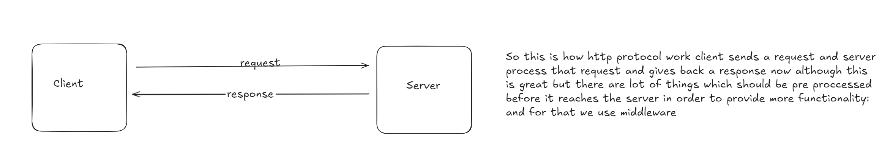

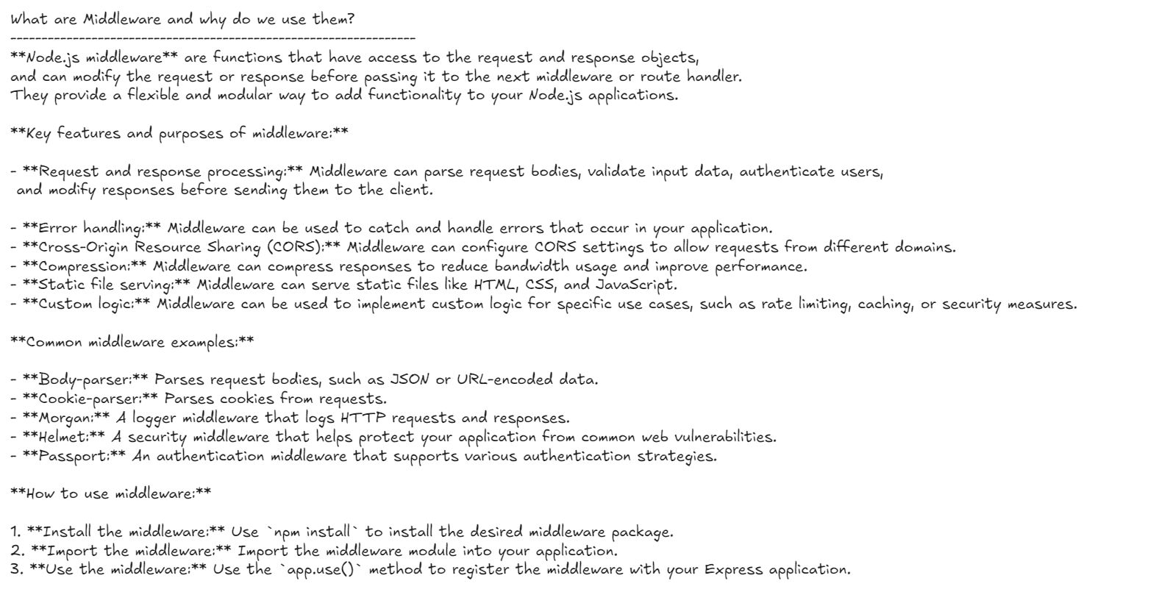

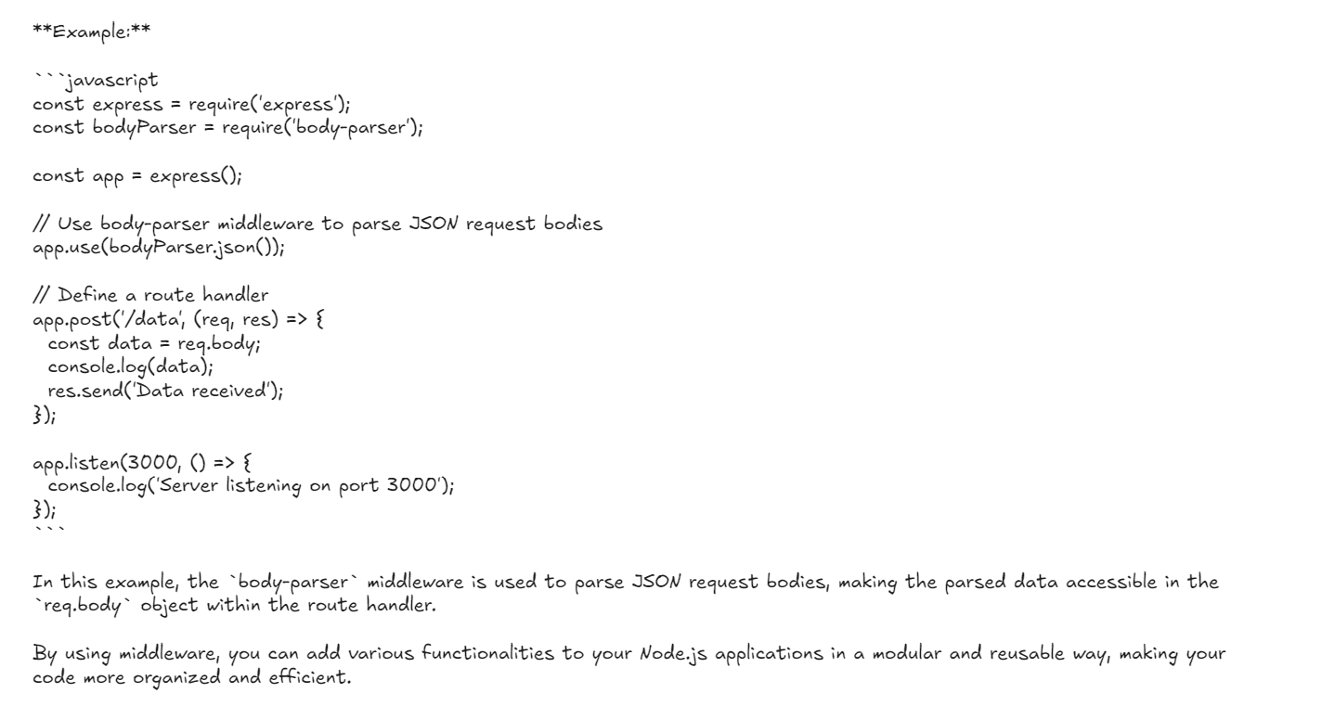

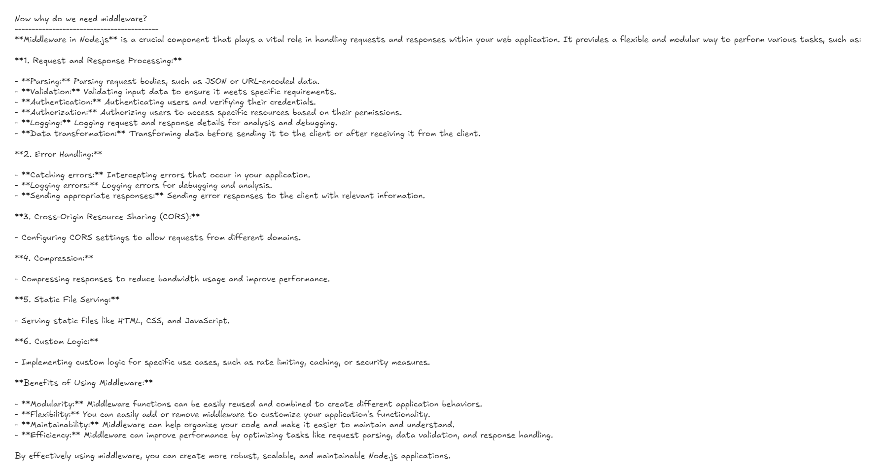

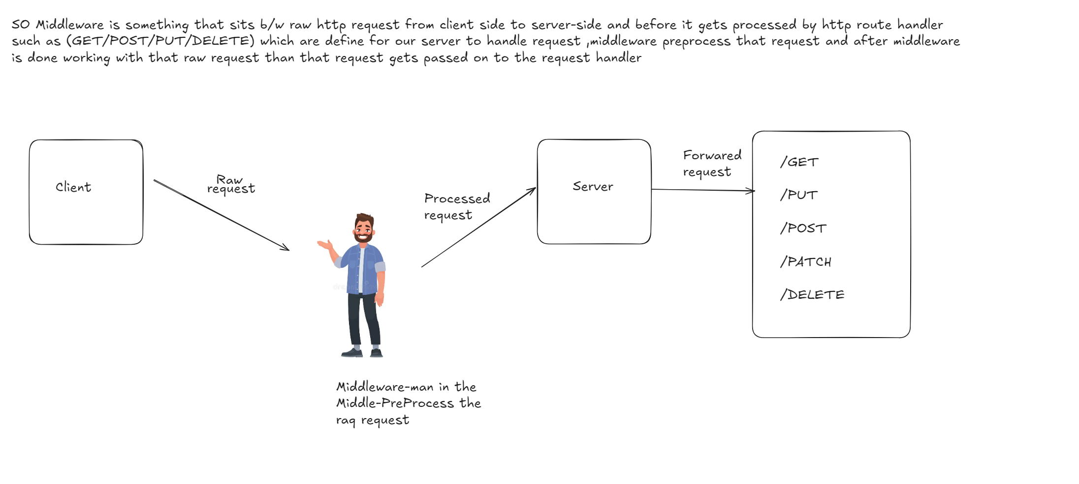



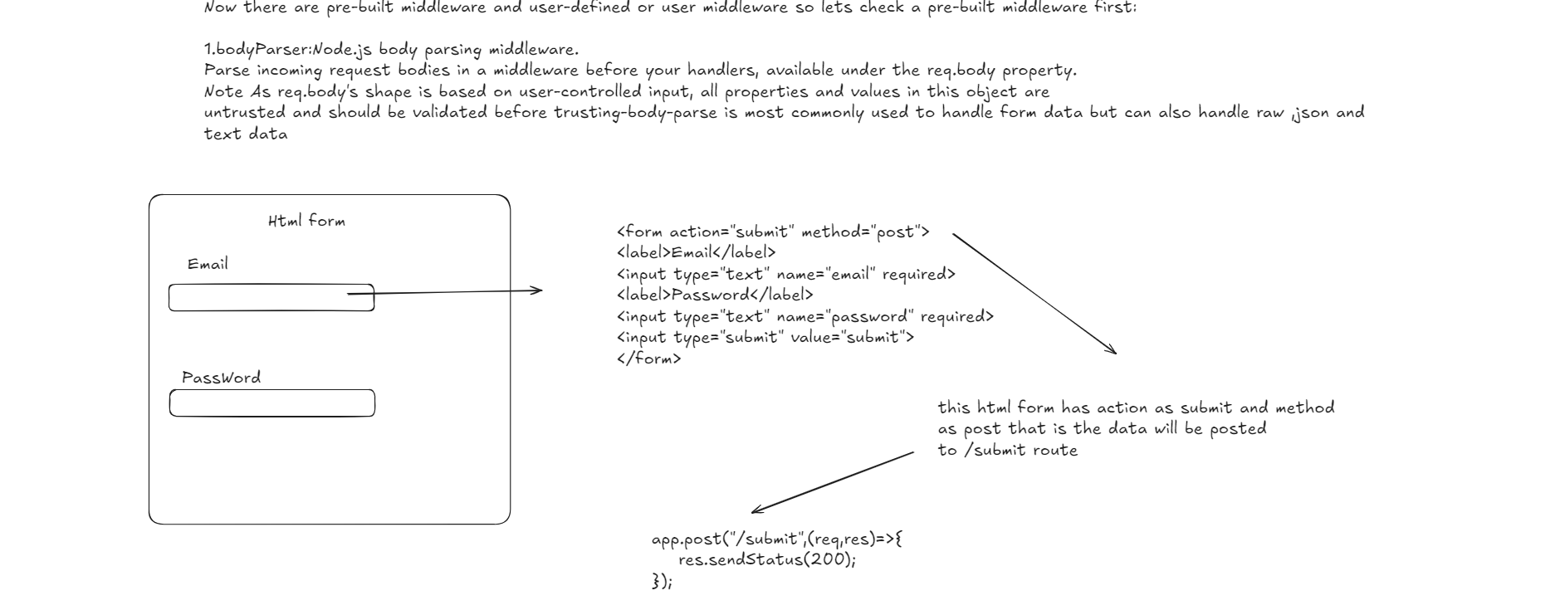

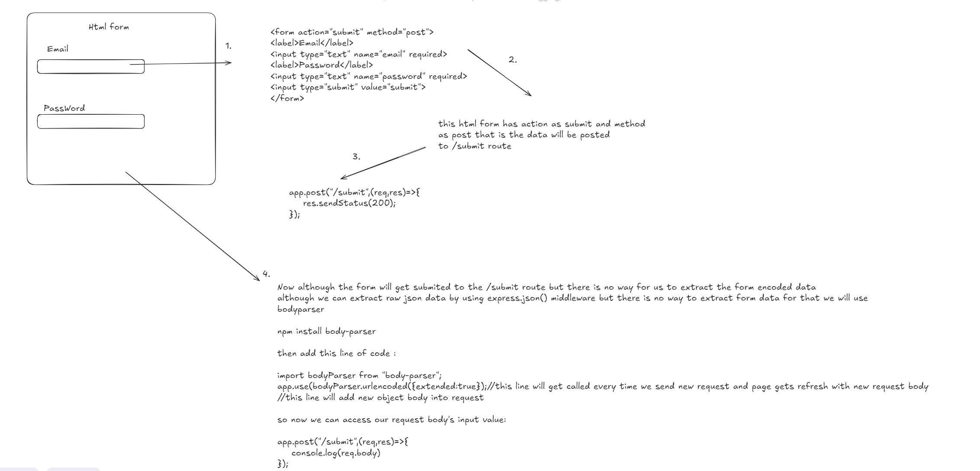

Another Pre-Built Middleware is morgan it's a logger middleware which logs the details about request:

Let see it in action :

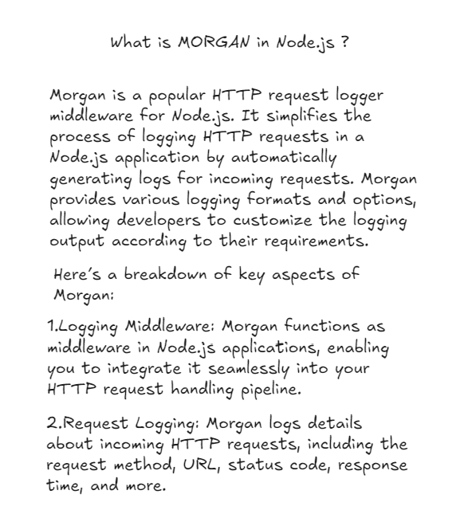

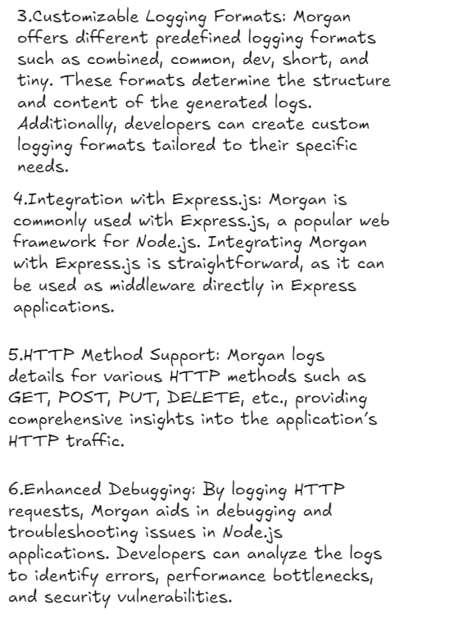

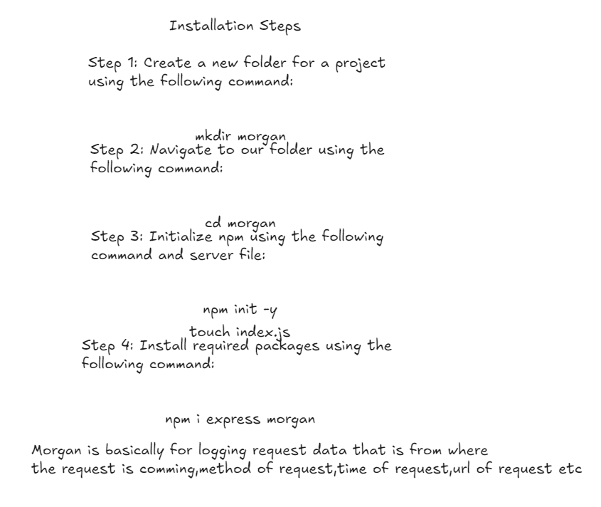

Morgan is a middleware library for Node.js that is used with the Express framework. It’s designed to log HTTP requests in a format that makes it easy to track and debug interactions with your server.

Here’s a basic overview of what Morgan does and how it’s used:

1. **Logging HTTP Requests**: Morgan provides a variety of logging formats to track requests to your server. You can log details such as the HTTP method, URL, response time, and more.

2. **Customization**: It allows you to customize the log format to suit your needs. You can use predefined formats like 'combined', 'common', 'dev', and 'short', or create your own custom format.

3. **Integration**: Morgan integrates seamlessly with Express. You simply need to add it as middleware in your Express app, and it will automatically log HTTP requests.

Here’s a basic example of how you might use Morgan in an Express app:

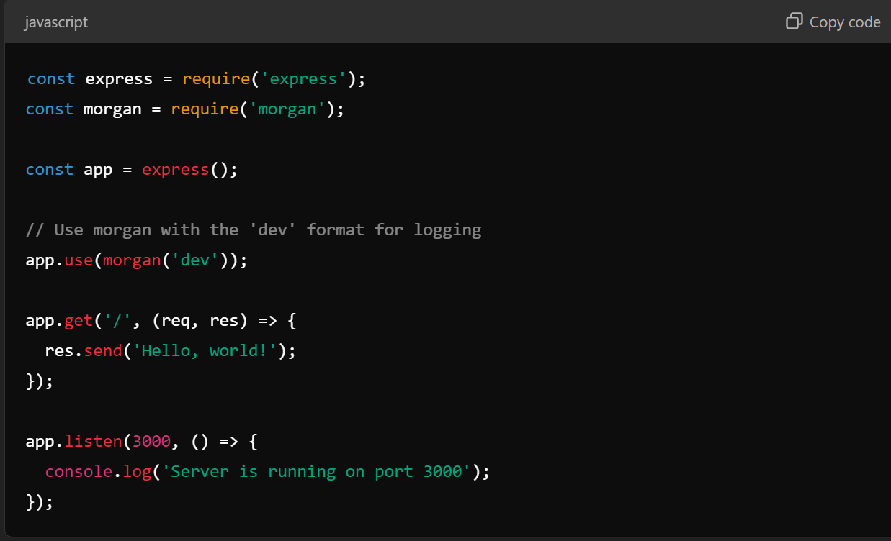

In this example, `morgan('dev')` is used to log requests in a concise, colored format suitable for development. For production environments, you might use a different format or even log to a file instead of the console.

Sure! To convert the code to use ES modules with `import` instead of CommonJS `require`, you’ll need to update the file to use ES module syntax. Here's how you can rewrite the code using `import` statements:

1. **Ensure your Node.js environment supports ES modules.** This usually means using Node.js version 12 or later and setting `"type": "module"` in your `package.json` file. If you haven't done that yet, add the following to your `package.json`:

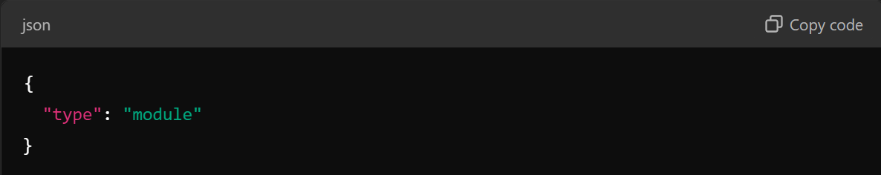

2. **Convert the code**:

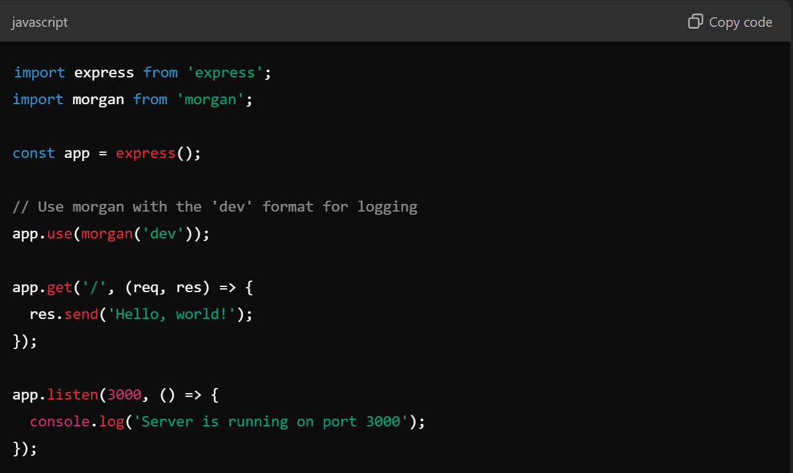

### Explanation

- `import express from 'express';` replaces `const express = require('express');`

- `import morgan from 'morgan';` replaces `const morgan = require('morgan');`

With these changes, your code uses ES module syntax and should work correctly as long as your environment is properly set up to handle ES modules.

So Till Now we Have Seen Two pre-built middleware that is body-parser and morgan its time we make our own middleware:

