JSON is JavaScript Object Notation which is based on JavaScript Object

Where in JS we define object using the below syntax:

let object1={

name:”Shivansh”,

age:20};

similarly we define json :

{

“name”:”Shivansh”,

“age”:21

}

The only difference between js object and json is the key in json are stringified but if study js object carefully we would know that even js interpreter also convert js object key to string for hashing but on top level js object key are not quote enclosed and json key are quote enclosed

But the problem with js object that although it’s a good data structure for computation and storing value,it is not a good data structure or more technically not a good format to transfer data across internet in it cause

a js object typically needs to be contained in some variable and then we will have to move that variable across the internet :

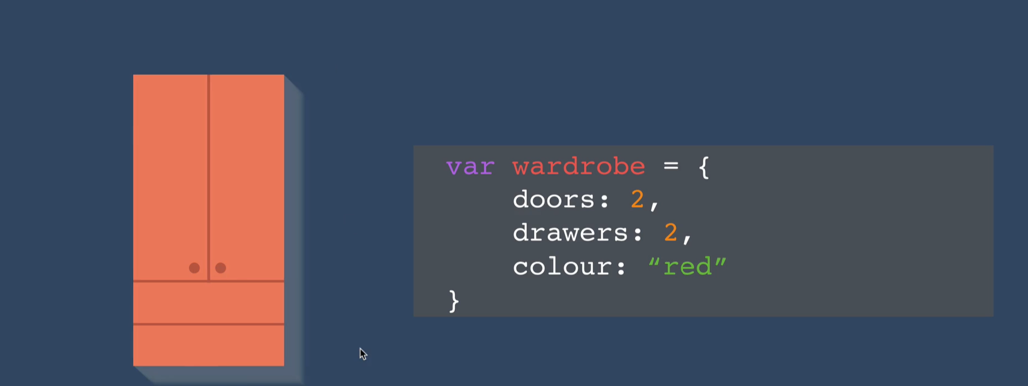

So if we imagine a js object as a cupboard then we can see that a wooden cupboard is not very portable and it will be very hard to move with it from one point to another but think if instead of a non-dismantlable cupboard we have a dismantlable cupboard like a **IKEA flatpacks**

Then it would be so easy for us to move around well json are like **IKEA flatpacks we can enclose whole json in quote**

**“{“name”:”shiv”,”age”:20}” like this in one line without even assigning it to a variable**

**Plus js object is of variable size that is the size they occupy in memory is variable length like**

let object1={

name:”Shivansh”,

age:20};

**🡪it carries two different data structure int and string so it will take variable size in memory (where it will take both size of int and string)**

**But when it comes to json we enclose it in double quote or single to stringify whole json so it will take the fix size of string ie char is of 1 byte:**

**So 1*number_of_char so this is much efficient**

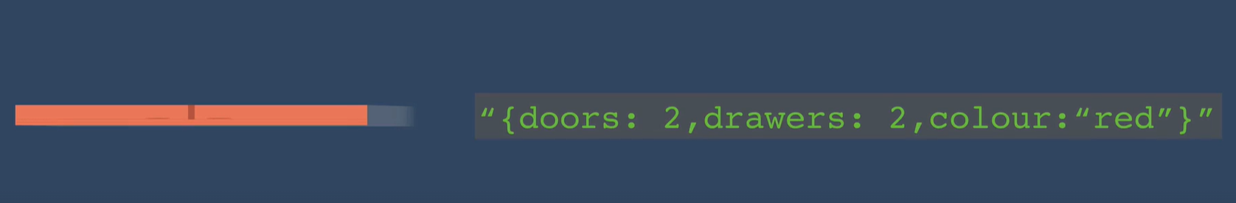



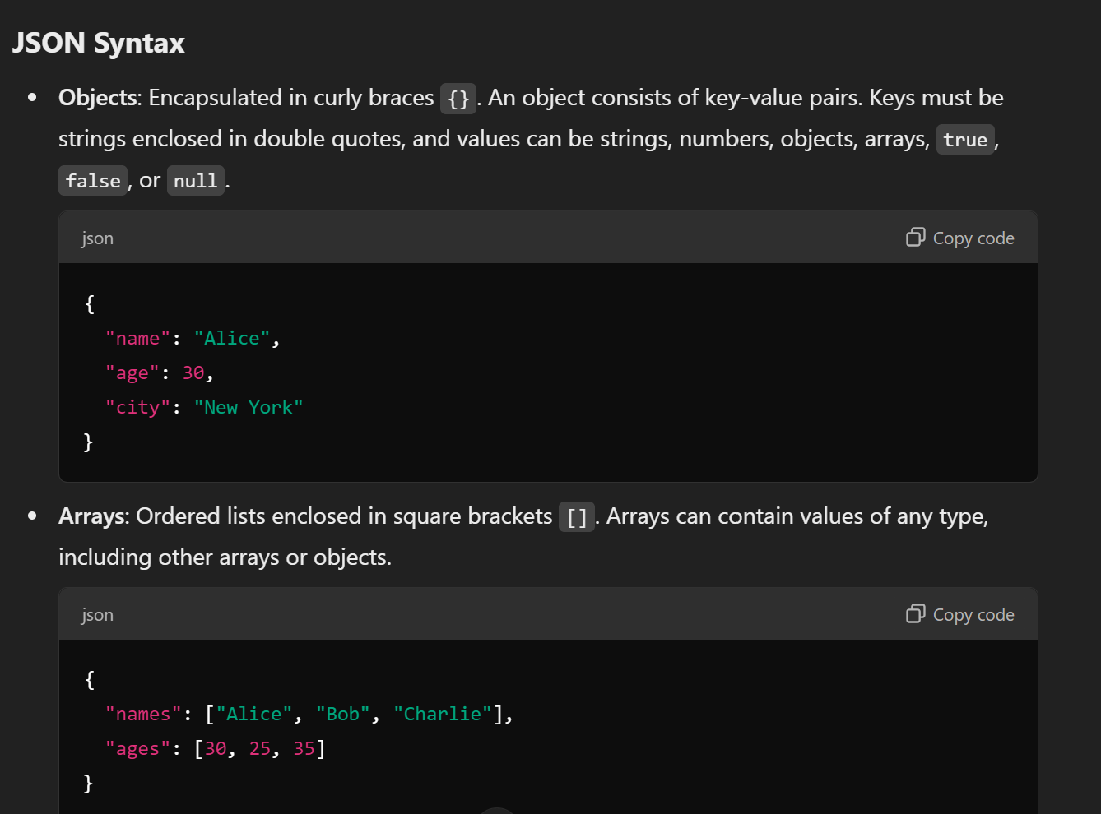

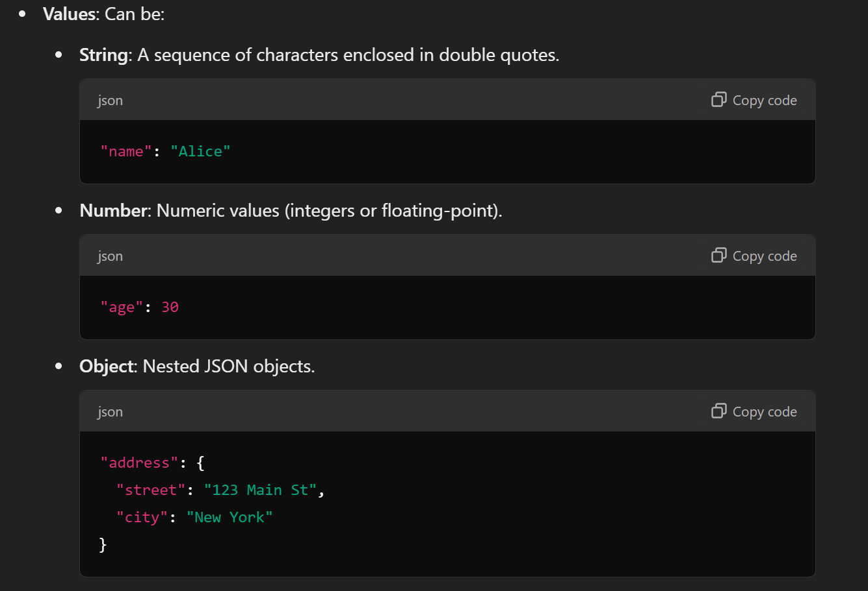

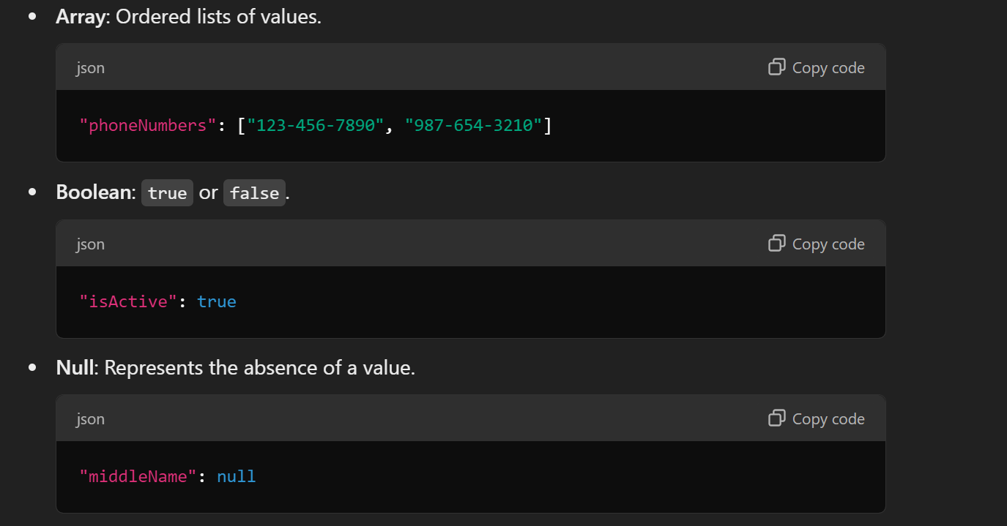

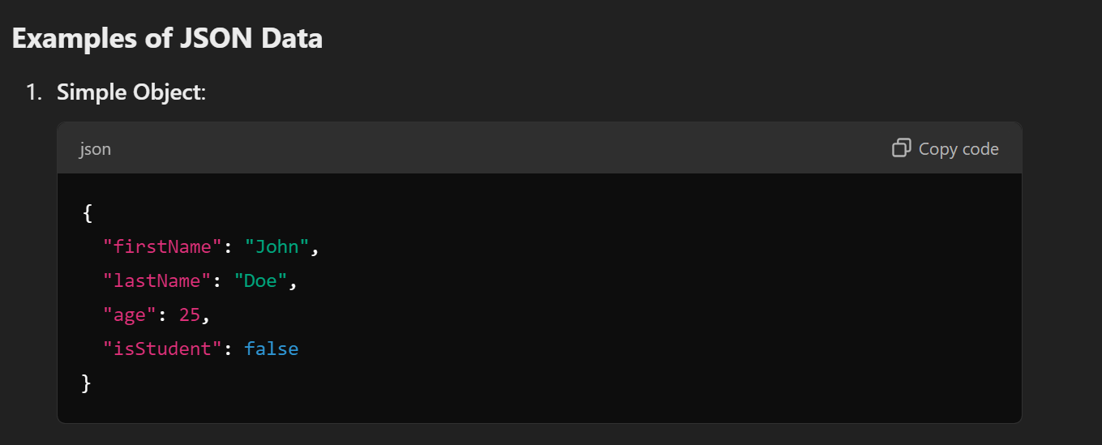

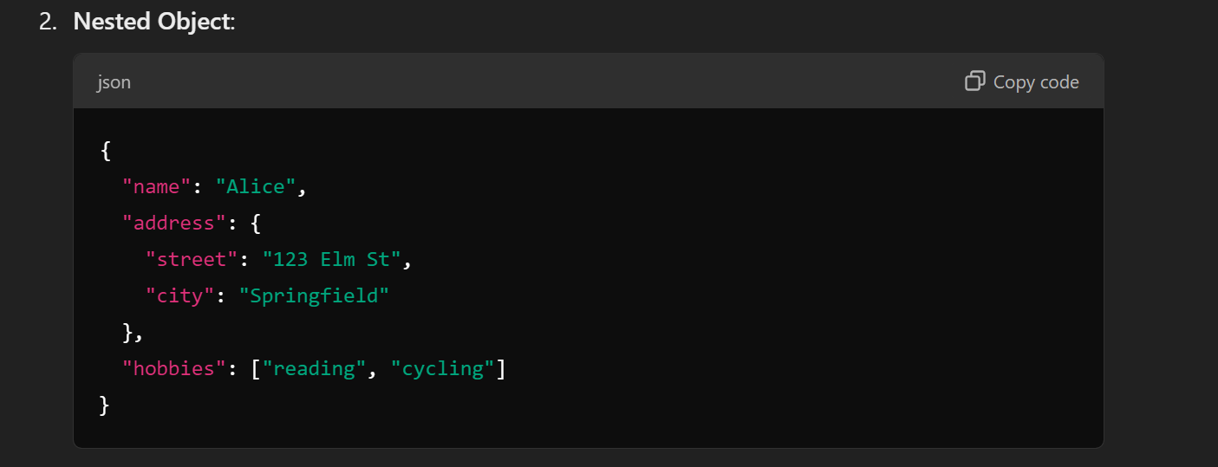

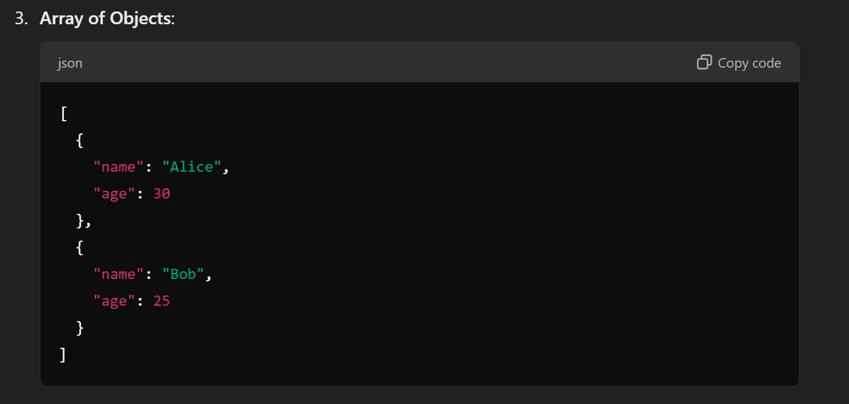



**Parsing json into js-object for retrieval of data**

