Now Lets Understand What is Display property and why do we need it in CSS to style the website

lets understand this via taking a example of a Html code

HTML code

------------

<html>

<head>

<title>WebSite Example</title>

</head>

<body>

<img src="cloud.png" alt="cloud">

<h1>I'am Shivansh Kumar</h1>

<p>I am a programmer</p>

<img src="cloud.png" alt="cloud">

<img src="hill.jpg" alt="hill">

</body>

</html>

Now when we will run this website , we will get a website like this:



So this will be our output ,but now lets use the chrome extension tool html pesticide which breaks

our html elements into boxs:

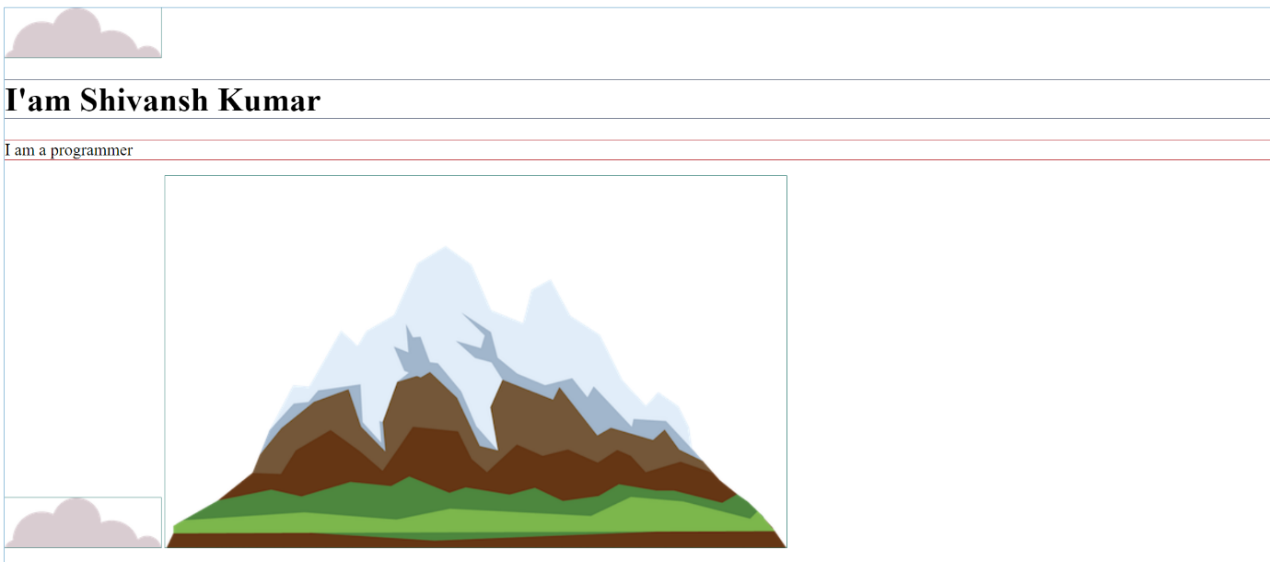



So Now everything enclose in this box is our html element and every different element is enclosed

inside different box .There are total 5 box and total of 5 tags in our html code





Now if we see both 4 and 5 box are of img tag now although in html script we used this two tag in

two different line ie something like this :

[<img src="cloud.png" alt ="cloud">]

[<img src="hill.png" alt ="hill">]

--Still in output they are shown in same line and not two different line

But this is not true for our heading and paragraph tag ,unlike those image tag img which were

used in different line but there output was shown in same line ,heading and paragraph tag is also

used in different line but there output is also in different line -- why is that meaning why our

output is not in same line as of those image tag

so lets use our pesticides tool again and we will see that



the heading and paragraph tag use alot more amount of space then there required space by the content

and that is due to dislay property of html tag .

Now CSS offers 4 display property to configure our html tag those are :-

1)Inline

2)Block

3)Inline Block

4)None

But before looking into these property inndividually lets look

at a challenge :

challenge:Given a staticn website underline the word "pro" in programmer using CSS

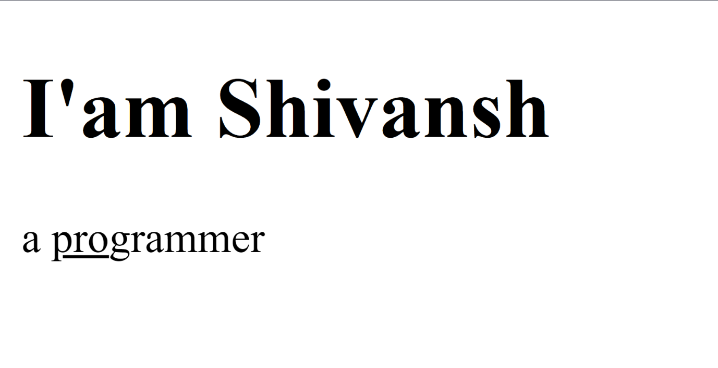

1)First method is to use :<u> underline tag which will underline a word enclosed in those tag

<html>

<head>

<title>Site</title>

</head>

<body>

<h1>I'am Shivansh</h1>

<p>a<u>pro</u>grammer</p>

</body>

</html>



But in this method haven't used any css , we just used a simple html element tag <u> to underline the

word pro ,challenge is to use CSS so how will we use css

For that we use css text property which is (text-decoration) lets see how to do it .

<html>

<head>

<title>Site</title>

</head>

<body>

<h1>I'am Shivansh</h1>

<p>a programmer</p>

</body>

</html>

CSS:

p{text-decoration:underline;}

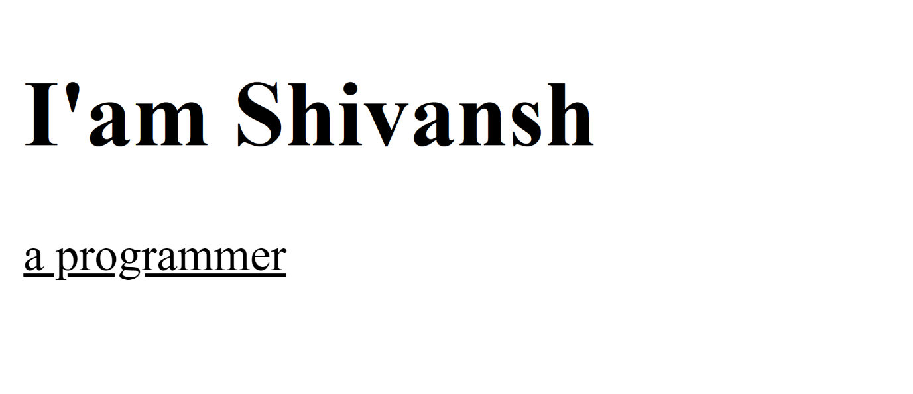

This Method will underline the whole programmer and not just part pro so lets seprate part

pro .

Another way is :

<html>

<head>

<title>Site</title>

</head>

<body>

<h1>I'am Shivansh</h1>

<p class="pro">pro</p>

<p>grammer</p>

</body>

</html>

CSS:

.pro{text-decoration:underline;}

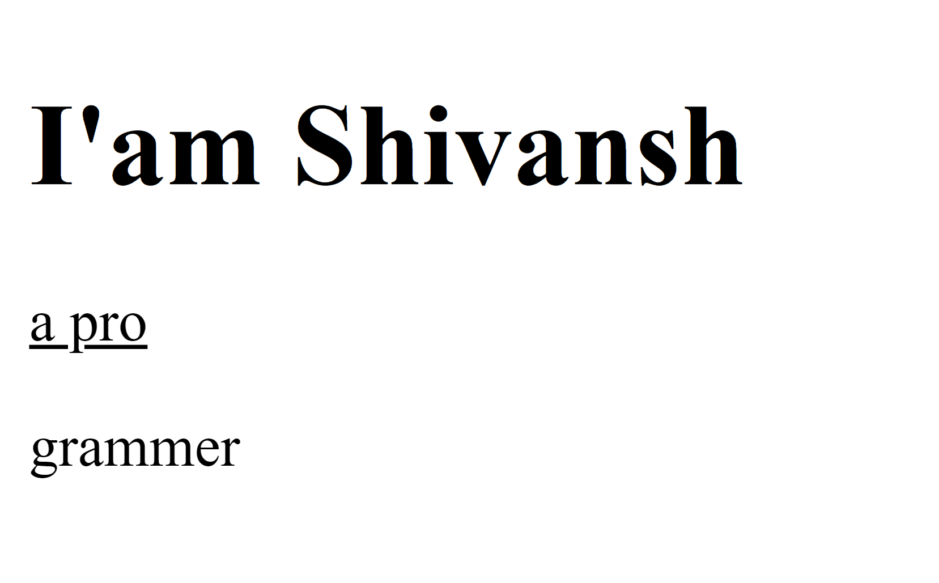

So it did underline the pro part but pro and pro and grammer are in two different line because <p> tag's

is a block tag which takes up the entire block of line

So now how to find provide underline to pro part of progrmmer without getting grammer onto

next line ie we need to underline the "pro", but not grammer and programmer should be in one line.

pro

---

grammer (wrong approach)

programmer (right approach)

---

Well to do that we need to learn about another html tag that is <spam>

HTML <span> tag

------------------

=>HTML <span> tag is used as a generic tag same as <div> and <main> container tag and it is also

a container of inline elements.It is used for styling purpose to the grouped elements/word using

class and inndividually

=>The span tag does not have any default meaning or rendering

=>The <span> tag does not have any default meaning or rendering

=>The <span> tag can be useful for the following takes

->[To change the language / property of part of the text

->[To change the color , font ,background-color of a part of the text using CSS

->[To apply JS to perticular part of the text

So,

<p>I am a programmer</p>

-So we want to change "Pro" part ie we need to underline but since it is in <p> tag which is a block

tag if we apply style it will get apply to whole text or we change / shift pro in one <p> tag and grammer

in other <p> tag that will also not work.

So to style the pro part we can insert pro in an inline tag <span>,which will take onl required

amount of space and then insert <p> tag into it

<html>

<head>

<title>Site</title>

</head>

<body>

<h1>I'am Shivansh</h1>

<p><span id="pro">programmer</span></p>

</body>

</html>

