CSS Position

---------------

Before CSS Positioning we need to / have to understand that without any external

CSS also different browser apply different css property by default .

And for that we need to understand few important things about structuring website using

HTML

1)Content is everything in HTML/website

=>Now we know that the inline tag only take width as much as content needs and with

block tag although they take 100% line the height is still determined by the content

unless we specify it externally using CSS but without CSS it depends on Content .

EX:

<body>

<h1>I Love Bacon</h1>

<p>bacon,bacon,bacon,bacon,bacon,bacon</p>

<p>bacon,bacon,bacon,bacon,bacon,bacon</p>

<p>bacon,bacon,bacon,bacon,bacon,bacon</p>

<img src=”bacon.png”>

</body>

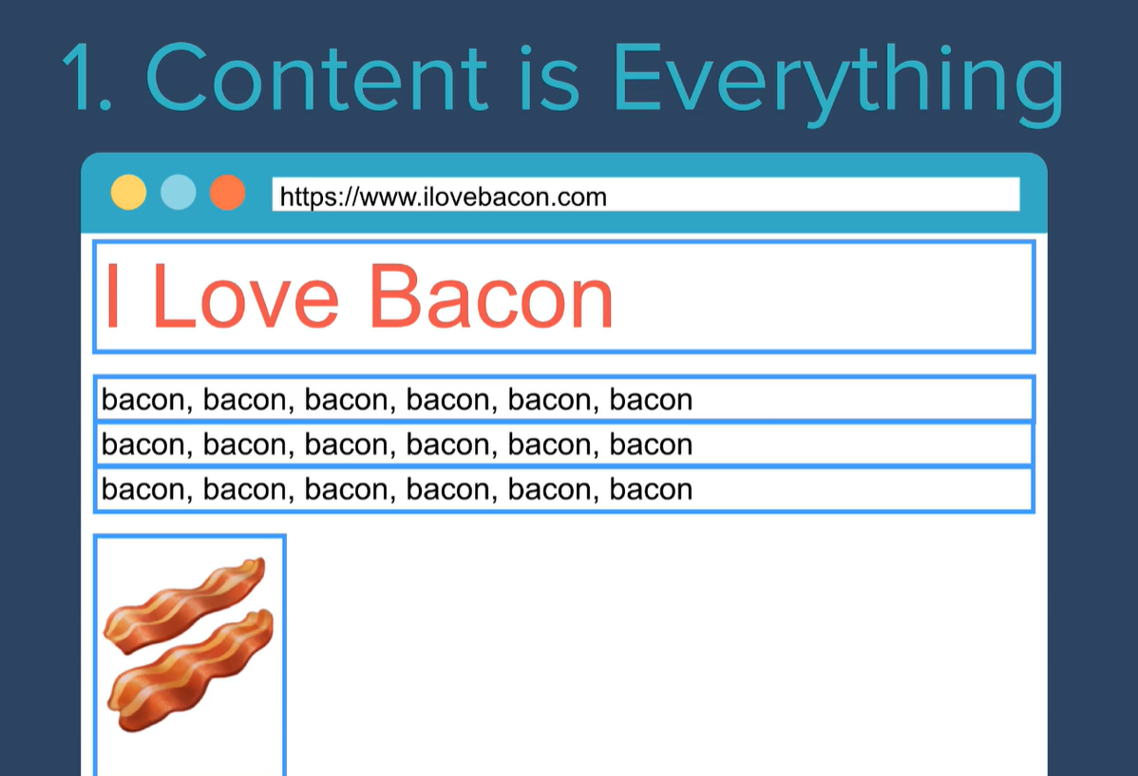

So since both heading and paragraph are block tag they will take whole line as width but there height depends upon content height in particular font and same goes for image tag which is a inline tag.

2)Order of elements come from HTML code

=>The order of content like heading , paragraph , link and image comes from the order

of those tag in html code :

Ex

---

<html>

<head>

<title>Hey</title>

<head>

<body>

<h1>I LOVE BACON</h1>

<p>bacon</p>

<p>bacon</p>

<img src="bacon.jpg">

</body>

</html>

So the content will also be rendered the way it is written in HTML code that is:

first : heading

second :paragraph

third :image

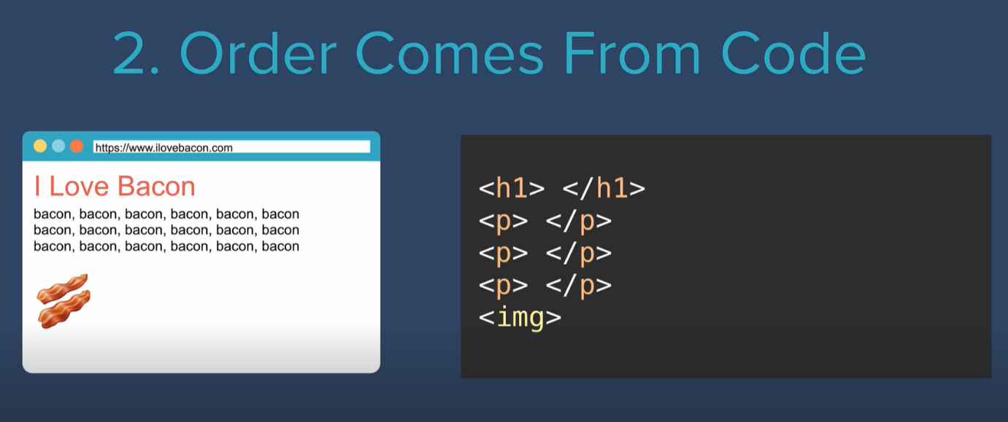

3)Children sit on parents lets Understand it with example

lets take a div tag :

<body>

<div>

</div>

</body>

provide some style to it lets make the div square :

CSS:-

div{width:100px; height:100px; background-color:red;}

add a h1 tag inside it .

<div>

<h1>a programmer</h1>

</div>

Now we can see <h1> is on div ie div is parent(container) to h1 element(which is child to parent)

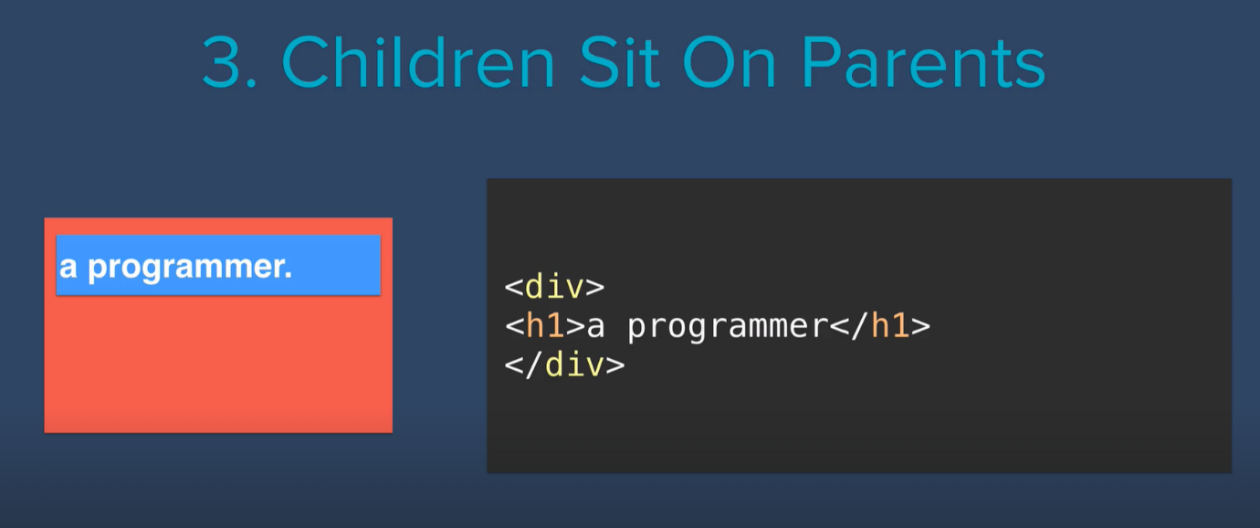

And just like how div can act as parent tag the h1 tag can also act as parent tag if we embed some other tag inside it like this :

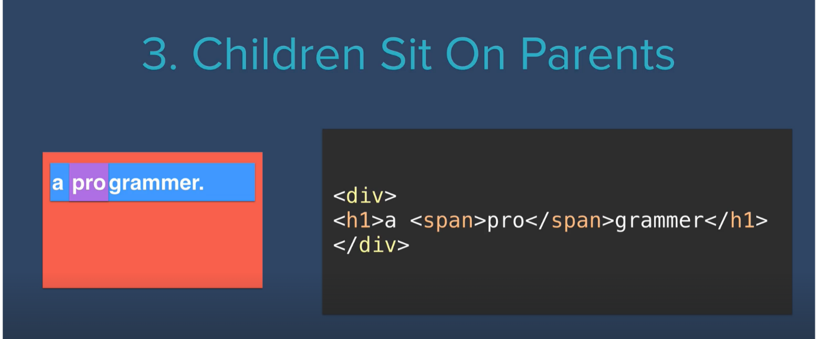

*Outer tag are parents and inner tag are child .

This <h1> heading will sit on top of div ie <h1> will be more towards viewer and far

from back screen and div will be far from viewer and closer to back screen.

This introduces the concept of Z direction,ie on display we have X and Y axis which is for the parent tag.

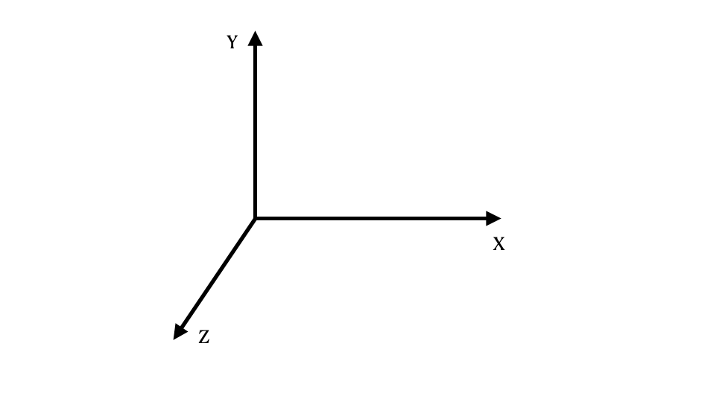and Z axis will be toward Screen for child tag .

Z axis is for child element and for viewer display

X-Y axis plane

Is for the parent tag

Now these 3 are the basic HTML property which Position tag by default.

Apart from them we can also set CSS Positioning property to set the Position of tag

on screen .

*Position property

->There are 4 Position property:

1)static

2)relative

3)absolute

4)fixed

I)Static

---------

This is by default Position for html element.It always positions element according

to the normal flow of the page .It is not affected by the top,bottom,left and

right property

II)Relative:

------------

What this does is it allows us to position

the element that we select relative to it current or static position

in the html document

Lets undertand with example:

<body>

<div>

</div>

</body>

css:

div

{

width: 100px;

height: 100px;

background-color: red;

position: relative;

left: 20px;}

Now what this css code will do is it will set

the div position to relative of it current

position in the right side by 20px when we set it left coordinate to

20 px :

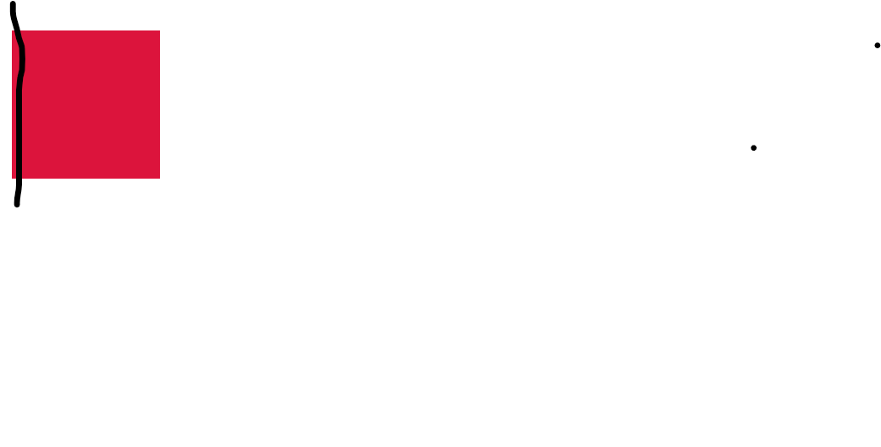

Intial left edge set at static display

After changing display to relative and setting left :20px

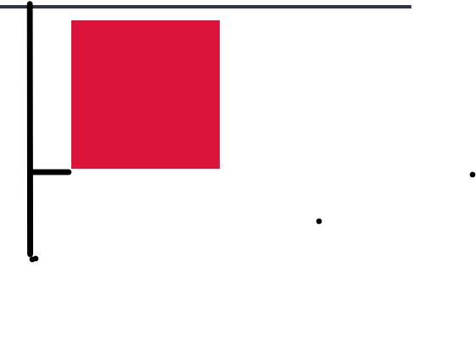

The div is pushed 20 px right from its initial left edge

What it does is it takes the left edge of div as

the main axis

and will shift the element to the right if the value is positive

and if the value is negative it will shift to right

lets see for all the four coordinate ;

a)top(positive):

Initial(static display)

<body>

<div>

</div>

</body>

css:

div

{

width: 100px;

height: 100px;

background-color: red;

}

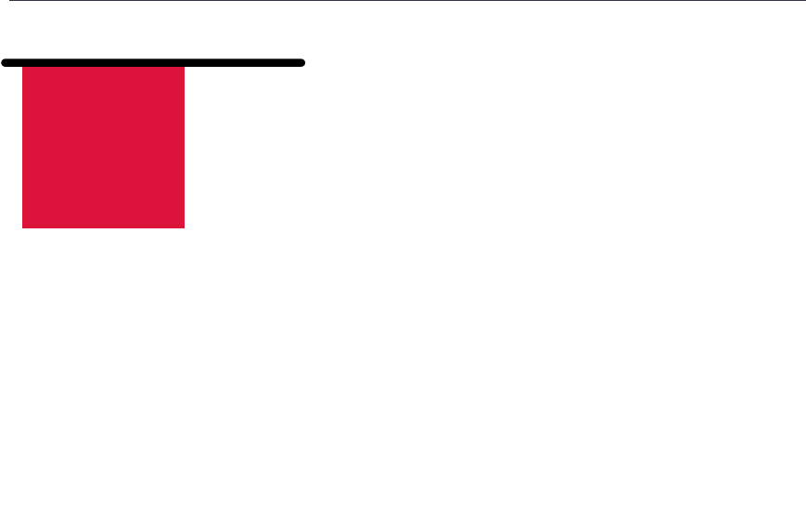

Intial top edge position

Relative Positioning

<body>

<div>

</div>

</body>

css:

div

{

width: 100px;

height: 100px;

background-color: red;

position: relative;

top:50px;

}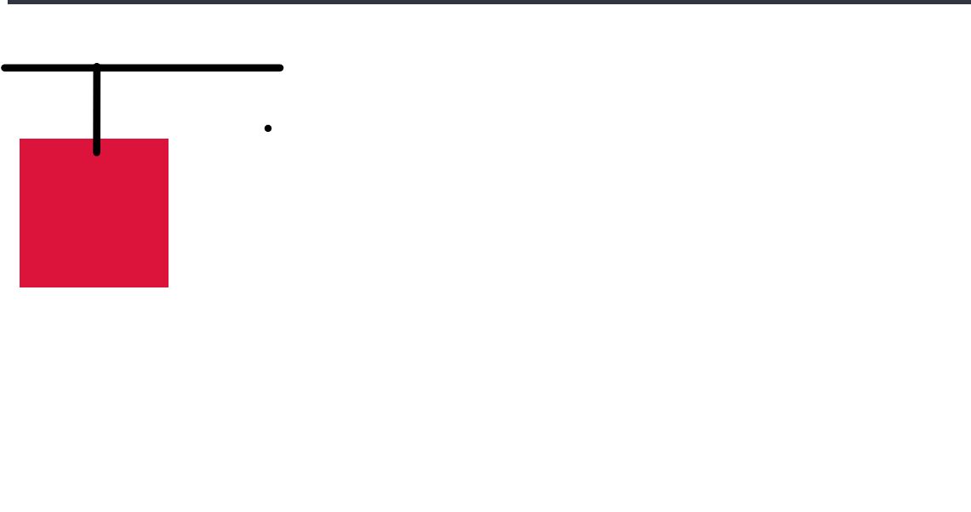

this will push the div 50px below the original position,from top edge of initial position of

div

top(negative)

<body>

<div>

</div>

</body>

css:

div

{

width: 100px;

height: 100px;

background-color: red;

position: relative;

top:-30px;

}

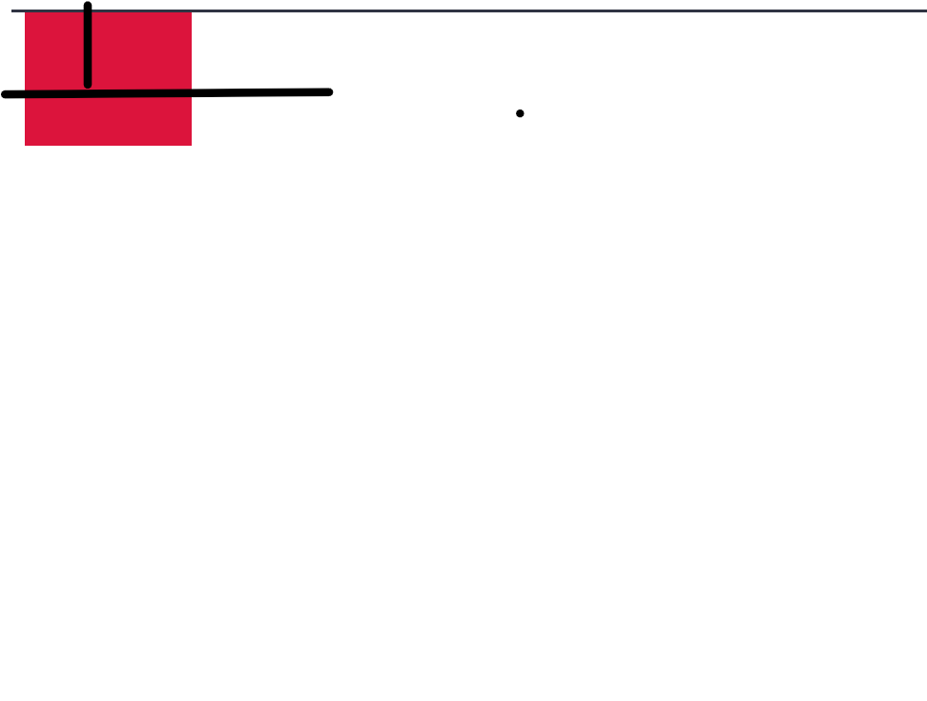

this will push the div 30 px above the original position of the div from it initial top edge

b)bottom(positive):

Initial(static)

<body>

<div>

</div>

</body>

css:

div

{ width: 100px;height: 100px; background-color: red;}

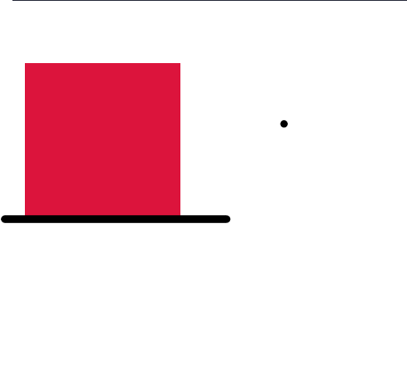

Intial bottom

Edge of div element

Relative bottom Positioning(of div)

<body>

<div>

</div>

</body>

css:

div

{

width: 100px;

height: 100px;

background-color: red;

position: relative;

bottom:20px;

}

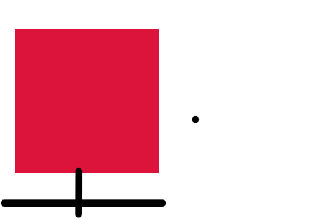

will push the div 20px above the bottom edge

from actual position

Initial bottom edge

bottom(negative):

<body>

<div>

</div>

</body>

css:

div

{

width: 100px;

height: 100px;

background-color: red;

position: relative;

bottom:-60px;

}

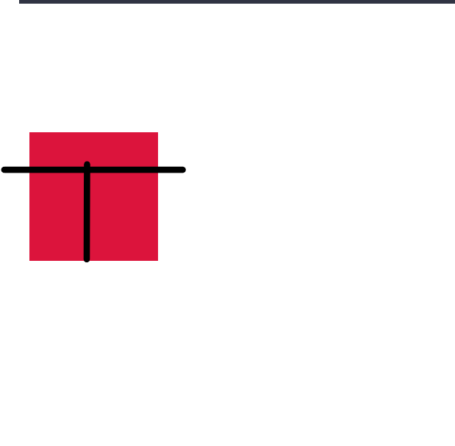

ill push the div 60 px below the bottom edge from it’s intial position

Initial bottom edge position

c)left(positive)

intial(static)

<body>

<div>

</div>

</body>

css:

div

{

width: 100px;

height: 100px;

background-color: red;}



Relative Positioning

c)left(positive)

<body>

<div>

</div>

</body>

css:

div

{

width: 100px;

height: 100px;

background-color: red;

position: relative;

bottom:20px;

}



will push element 20 px away from the left edge

of the div current position toward right

left(negative)

---------------

<body>

<div>

</div>

</body>

css:

div

{

width: 100px;

height: 100px;

background-color: red;

position: relative; left:-30px;}

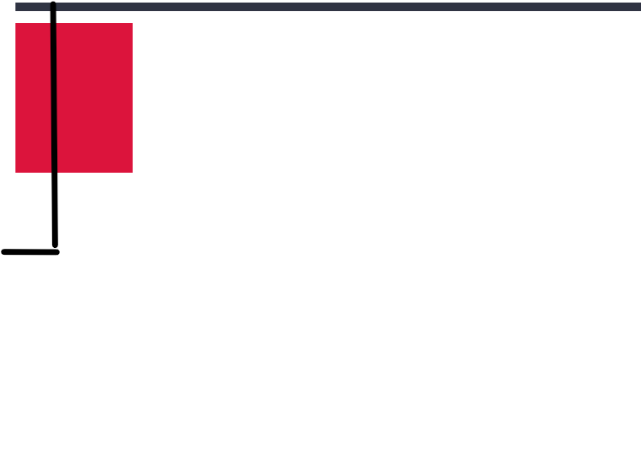

vertical black line denotes

The intial left edge

And horizontal denote the amount it is shifted

will push 30 px toward left edge of screen from the left edge of element

d)right(positive)

Initial(static position)

<body>

<div>

</div>

</body>

css:

div

{

width: 100px;

height: 100px;

background-color: red;

}

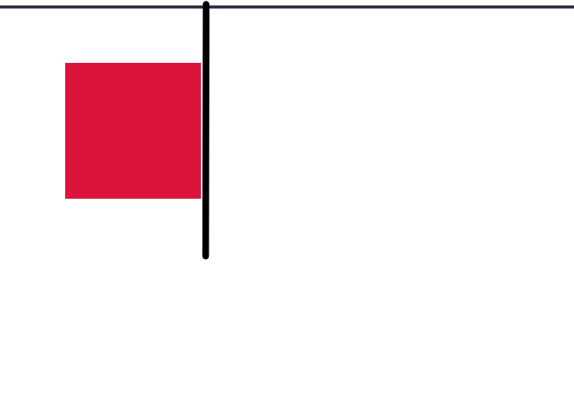

d)right(positive)

<body>

<div>

</div>

</body>

css:

div

{

width: 100px;

height: 100px;

background-color: red;

position: relative;

right:40px;

}



Vertical black line shows the initial right

Edge of element

And horizonatl line shows the distance by it is shifted from right edge

will push the element away from the right

edge of the element's current position towards

left edge of screen

right(negative)

<body>

<div>

</div>

</body>

css:

div

{

width: 100px;

height: 100px;

background-color: red;

position: relative;

right:-20px;

}

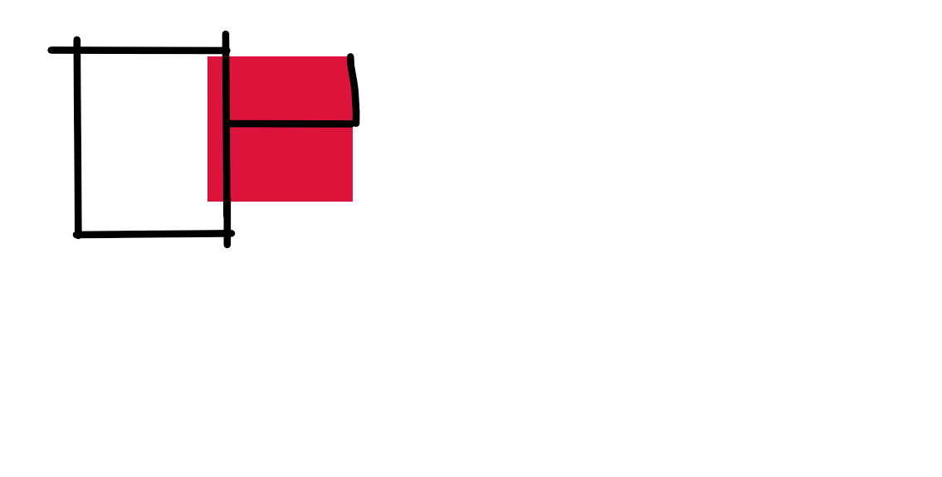

The black square box shows the initial

Position of div and the horizontal line from right edge shows the amount of distance it

Is shifted from right edge

will push the element away from the right edge of the element's current position towards right edge of screen

***Priority of coordinates :***

***top coordinate will always have Priority above bottom coordinate***

***and left side will have priority above right .***

Things to Note while changing the position and coordinates of the element:

1)When we change a element position , there is no change in other elements position

Lets understand it with a example :

Suppose we have two divs let it be stacked one on another:

<body>

<div class="top" bgcolor:"red">

</div>

<div class="bottom" bgcolor:"yellow">

</div>

</body

***#the bgcolor is not for div tag so :***

***use style***

<body>

<div class="one" style="width:200px; height: 200px;background-color: red;">

</div>

<br/>

<div class ="two" style="width:200px; height: 200px;background-color: black;">

</div>

</body>

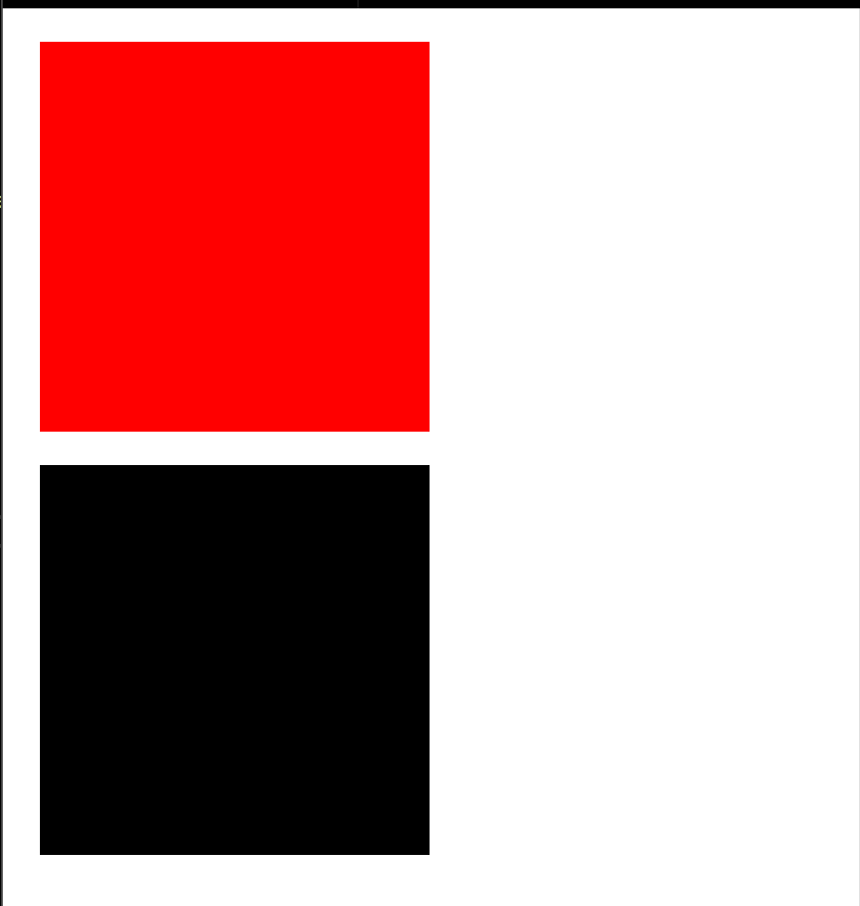

Now lets apply position on div 1 :

.one{

position:relative;

top:70px;}

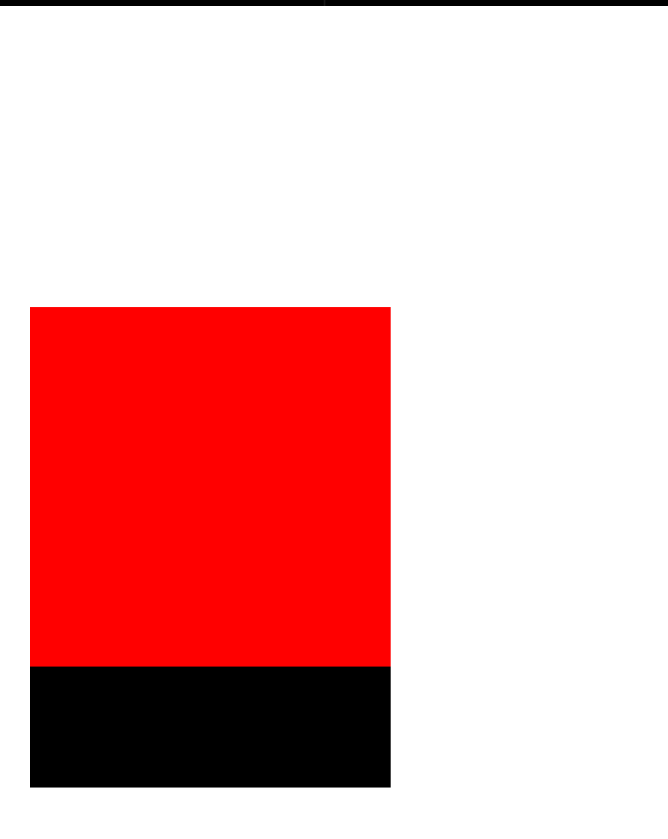

SO as we can see the div1 overlaps with div2 cause when

we change the position of a element it does not affect the

other element

2)Second Point to note is :

When we move the position of a element to top , bottom and left ,right it creates a margin between it initial

position ie initial edge from where it is moved and current edge

III)Absolute-Positioning

Unlike relative position where we move element position from it current/initial position to specified position

in absolute position we move element relative to body ie when we say right:20px in Absolute it means position the html element 20px away from html page’s right edge and not position the element 20px away from its initial right edge of(element).

So suppose we have a website with a div about 100 px wide and 100px in height:

<body>

<div>

</div>

</body>

css:

div

{

width: 100px;

height:100px;

background-color:red;

}

Intial visual of element position:



Now lets apply position to it .

Updated Css

---------------

css:

div

{

width: 100px;

height:100px;

background-color:red;

position:absolute;

right:20px;

}

Updated Visual of element position

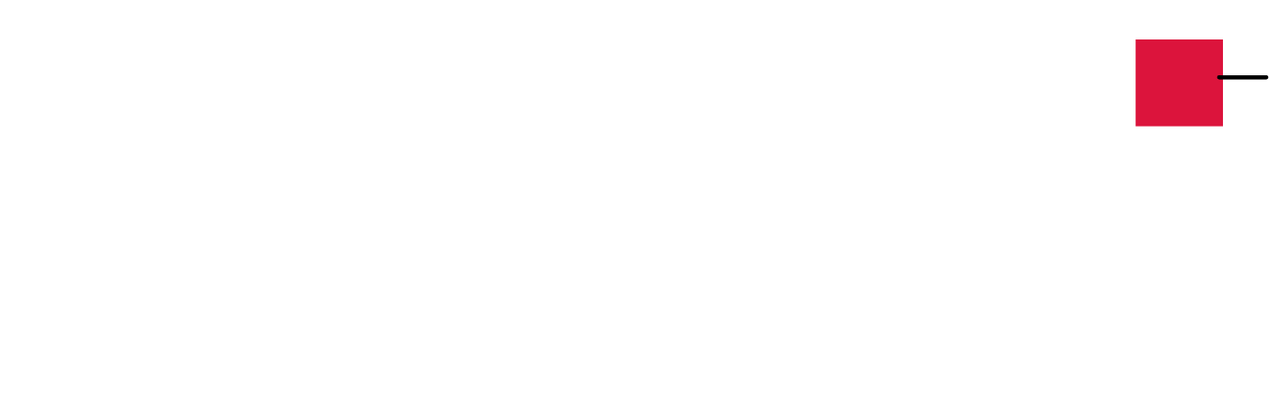

As it can be seen as we set the position property to absolute and gave right coordinate the value of 20px the element shifted toward the right edge of page with a distance of 20px

will position image at a distance of 20px from image right edge to body right edge

Lets see the same thing for the top,bottom,left and right coordinate with both negative and positive coordinate.

1)Left

a)left(positive)

intial position in page

<body>

<div>

</div>

</body>

div

{

width: 100px;

height:100px;

background-color:red;

}



Let’s update the css

Lets see the same thing for the top,bottom,left and right coordinate with both negative and positive coordinate.

<body>

<div>

</div>

</body>

div

{

width: 100px;

height:100px;

background-color:red;

position:absolute;

left:20px;

}



will position the div 20px away from the html page left edge

will position the div 20px away from the html page left edge

b)left(negative)

<body>

<div>

</div>

</body>

div

{

width: 100px;

height:100px;

background-color:red;

position:absolute;

left:-20px;

}

so unlike the relative position where when we set the

positive value the div move away from left edge

of body and also left edge of element

in absolute its simple the more u decrease the value

it will come close to perticular edge of body.

2)top

Initial Position

<body>

<div>

</div>

</body>

div

{

width: 100px;

height:100px;

background-color:red;

}



Let’s update the Css

<body>

<div>

</div>

</body>

div

{

width: 100px;

height:100px;

background-color:red;

position:absolute;

top:80px;}

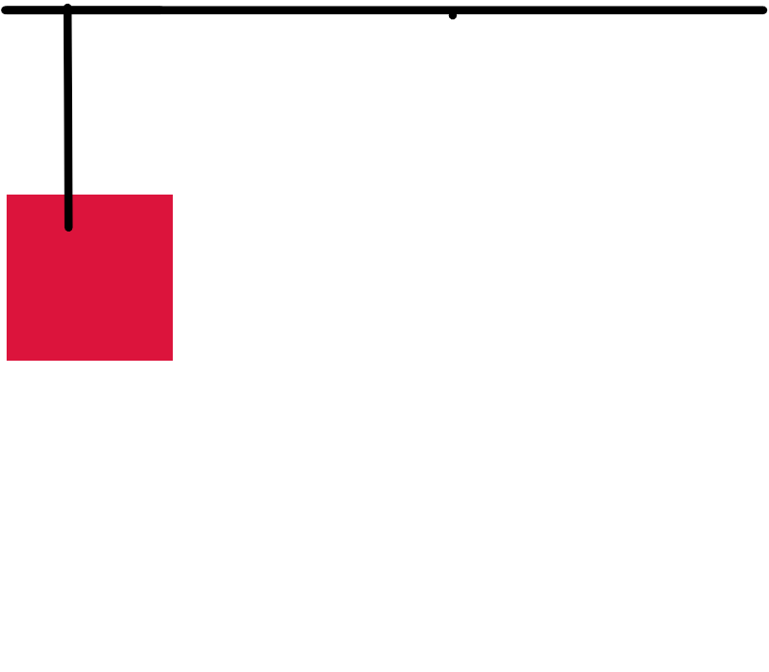

move the element 80 px away from top edge of body.As we reduce the number of pixel the element will get closer to html page edge.

3)bottom

Intial Position

<body>

<div>

</div>

</body>

div

{

width: 100px;

height:100px;

background-color:red;

}



Lets update the Css

<body>

<div>

</div>

</body>

div

{

width: 100px;

height:100px;

background-color:red;

position:absolute;

bottom:30px;

}



will move the div element toward bottom edge but 30px away from bottom edge.

4)right

Intial Position

<body>

<div>

</div>

</body>

div

{

width: 100px;

height:100px;

background-color:red;

}



Lets Update the CSS

<body>

<div>

</div>

</body>

div

{

width: 100px;

height:100px;

background-color:red;

position:absolute;

right:20px;

}



will position image at a distance of 20px from image right edge to body right edge

Note in absolute position Parent tags

plays an important role that is if the parent tag

is not A body tag of html but some other tag like

main,aside or div the position of there child in

absolute mode will be relative to them and not the

html or web page body.

lets understand with example

<body>

<div class = "container">

<div class = "child">

</div>

</div>

</body>

css

-----

.container

{

width:300px;

height:300px;

background-color:red;

position:relative;

}

.child

{

width:100px;

height:100px;

background-color:yellow;

position:absolute;

}

Now lets change the position of our child div

.container

{

width:300px;

height:300px;

background-color:red;

/*position:relative;*/

Position:absolute;

}

.child

{

width:100px;

height:100px;

background-color:yellow;

position:absolute;

right:20px;}

|_>This will shift our div away 20px from container right edge of parent div and not html

body tag right edge

Initial Phase before changing the position

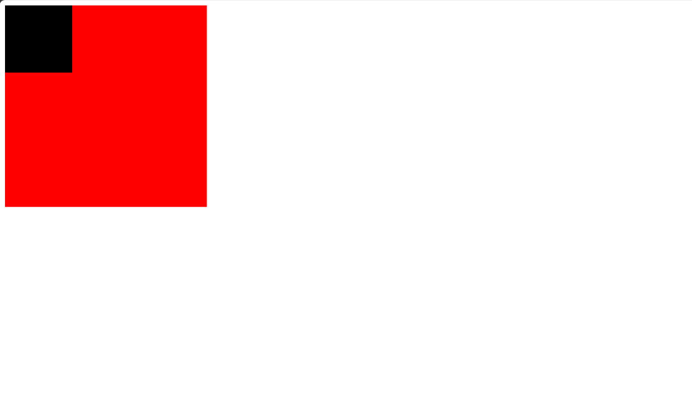

After Changing the position

