IAM  
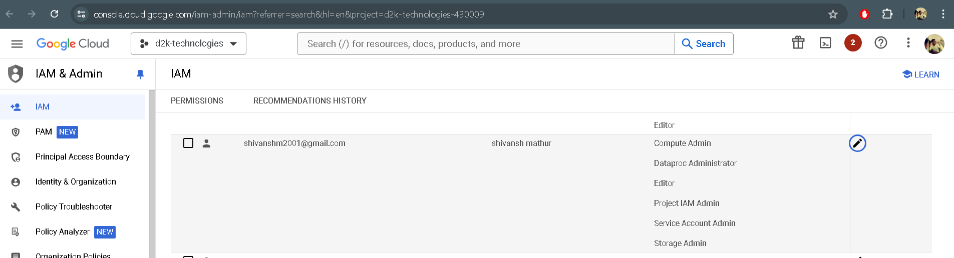

Cloud Storage  
  
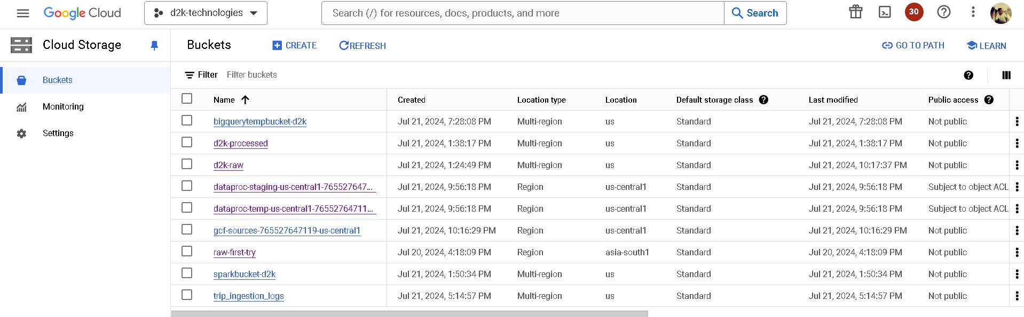

Raw-first-try

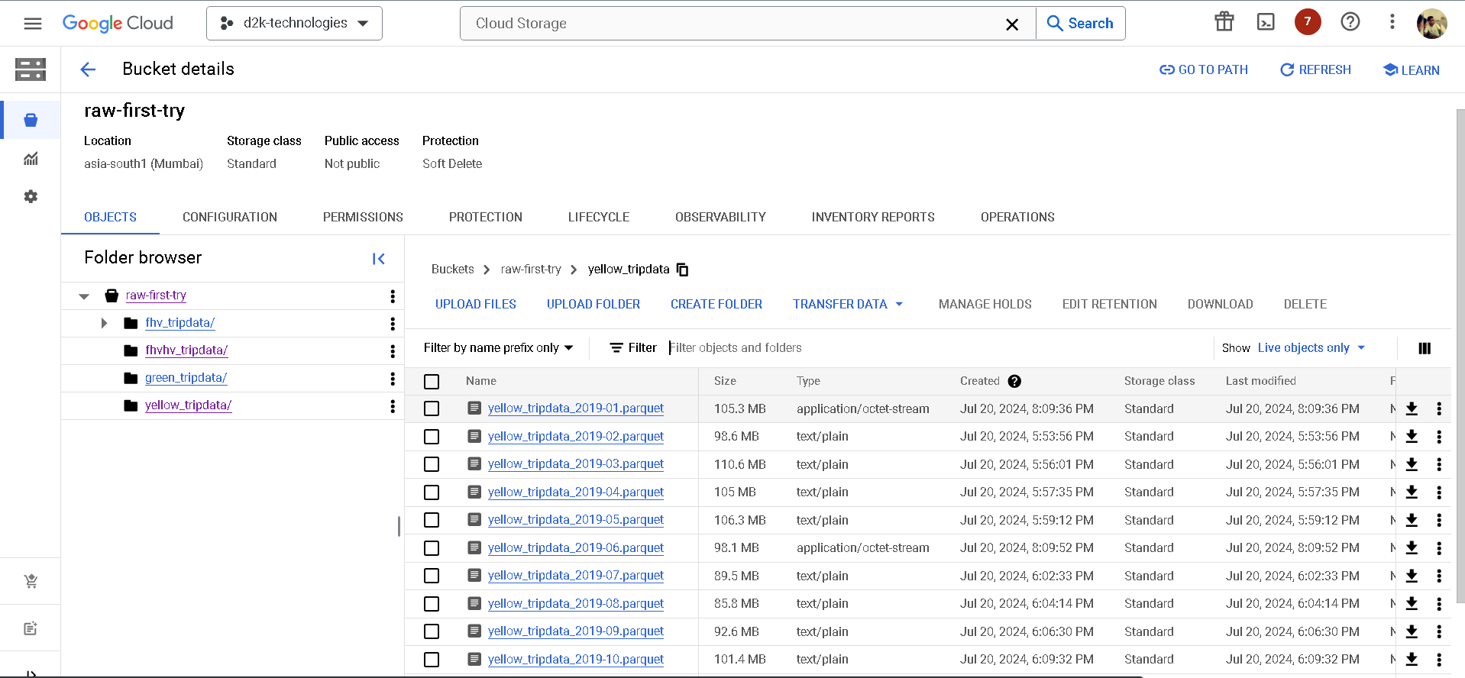

D2k-raw  
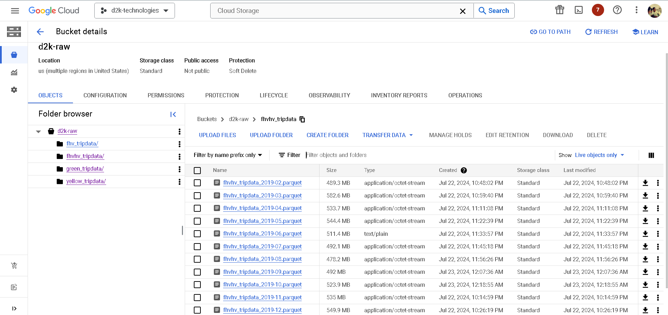

D2k-processed  
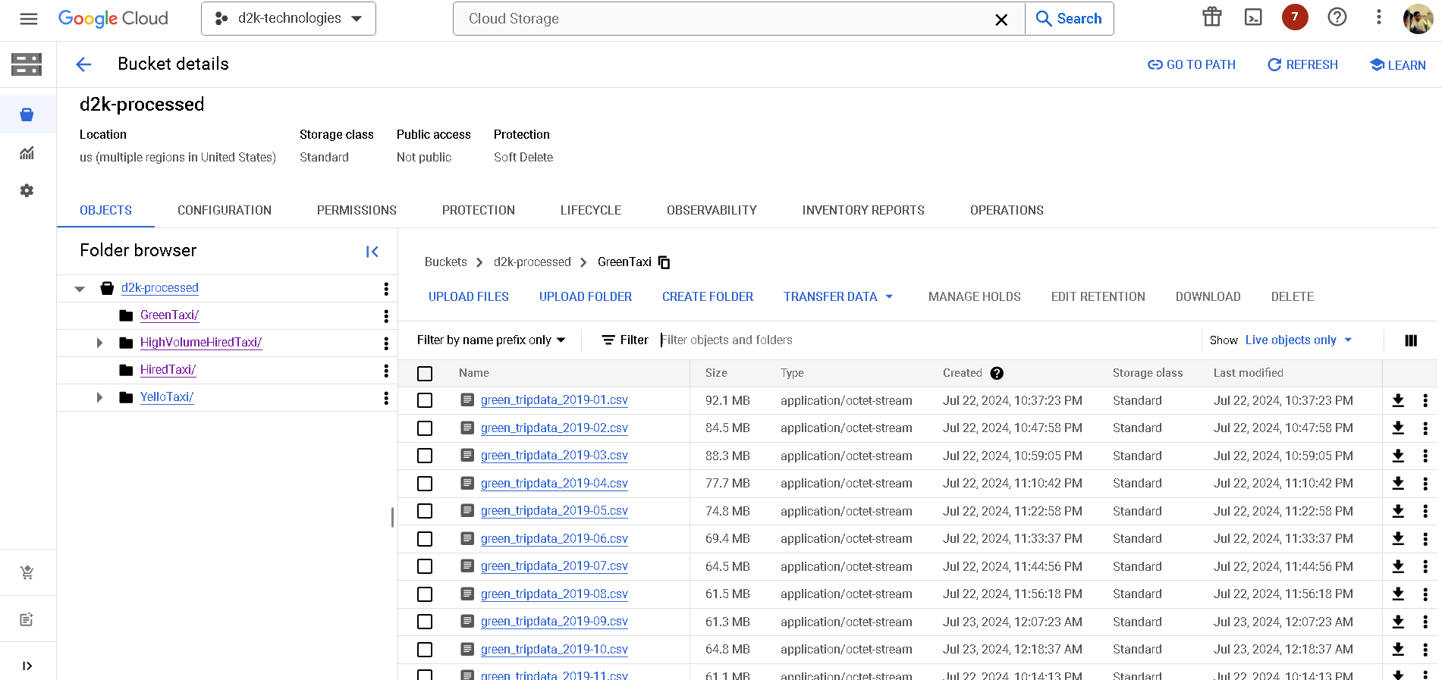

Logs

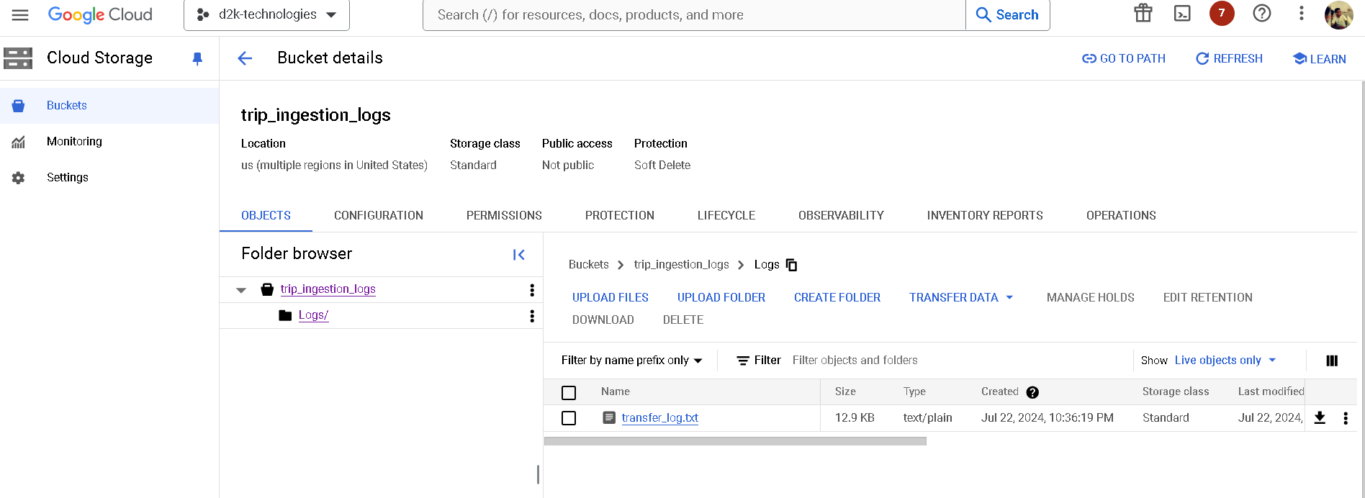

Cloud Functions  
  
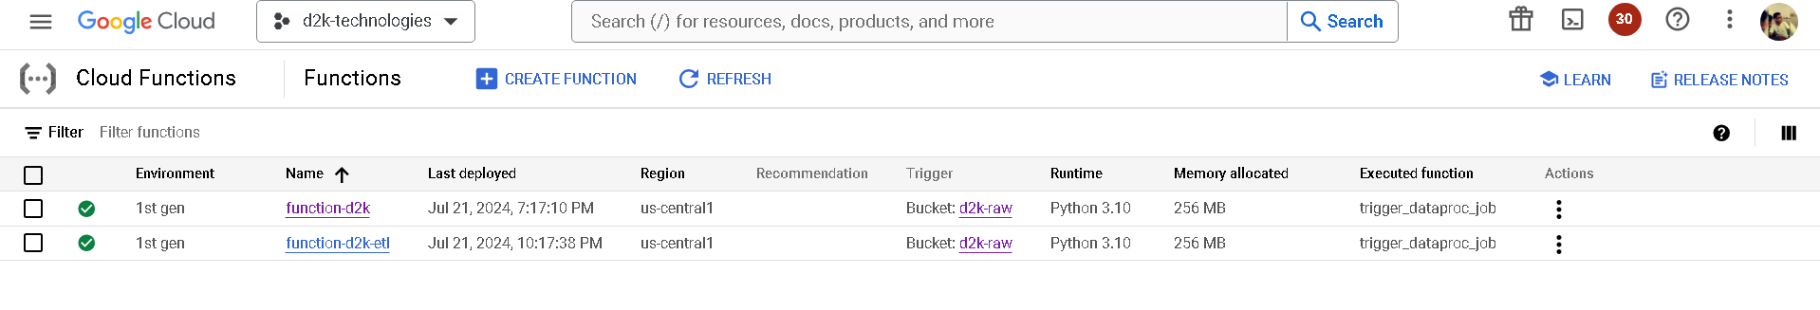

Compute Engine

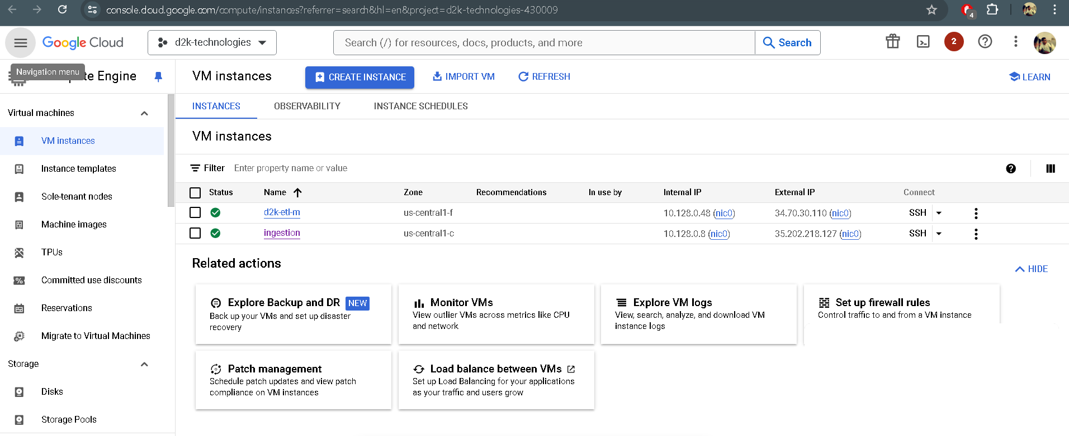

Ingestion ssh:  
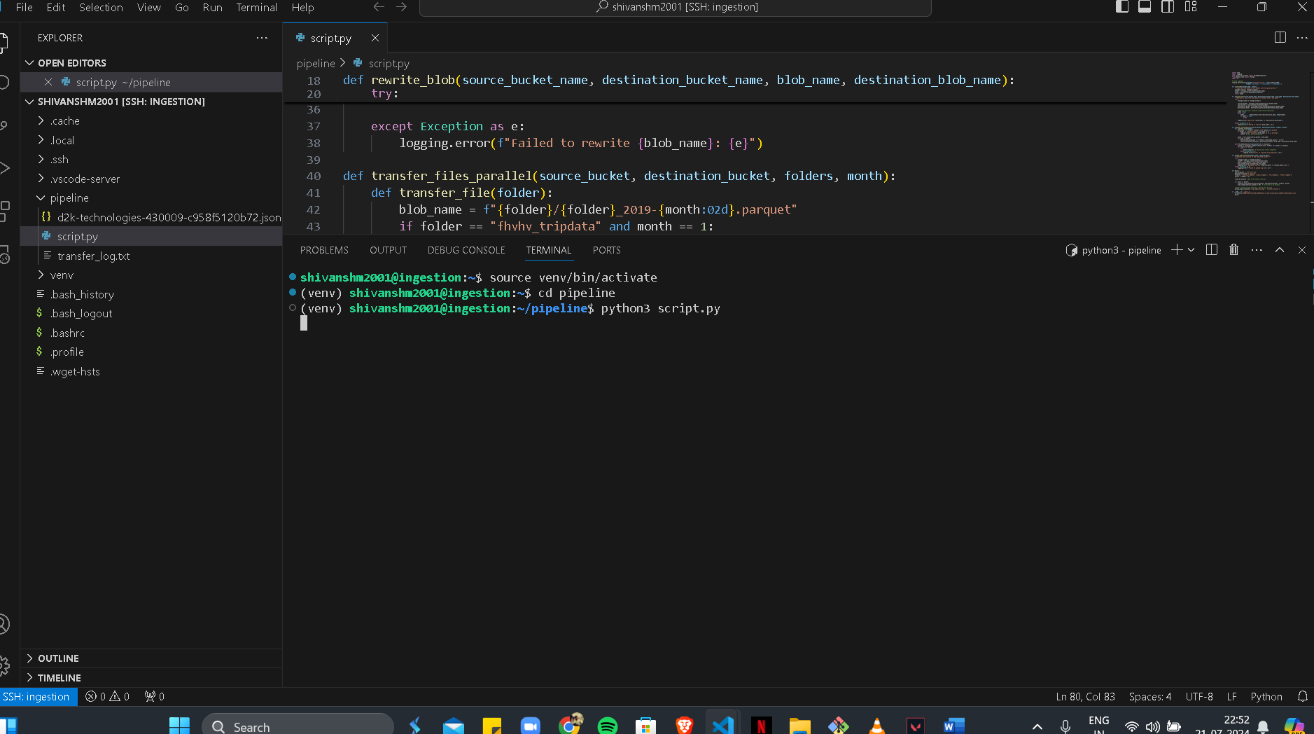

Dataproc

Clusters:

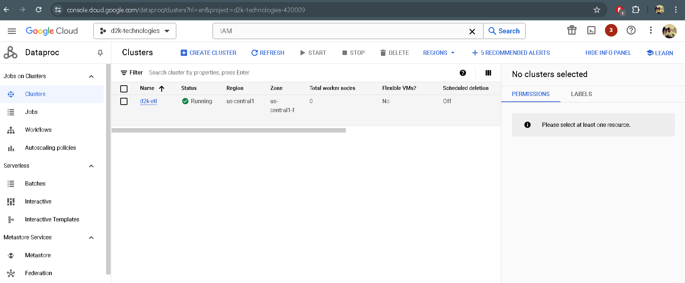

Jobs:  
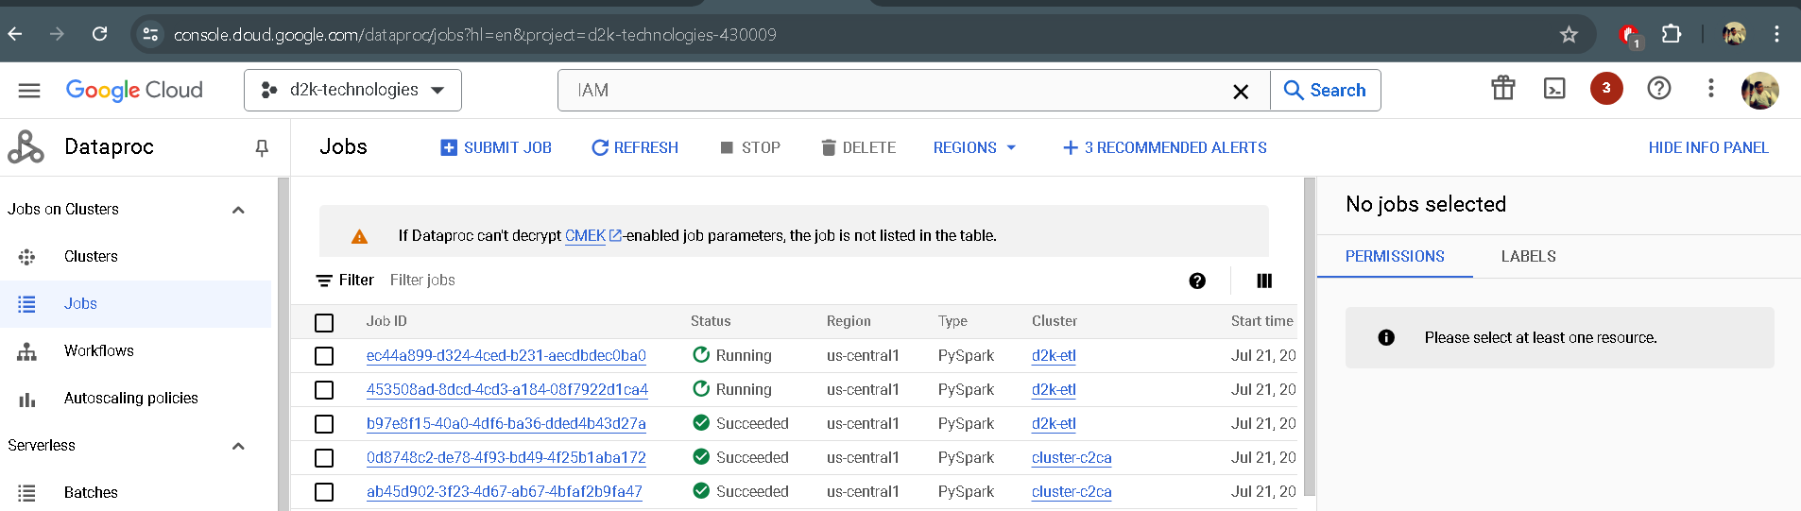

Cloud Monitoring   
  
Alerts:  
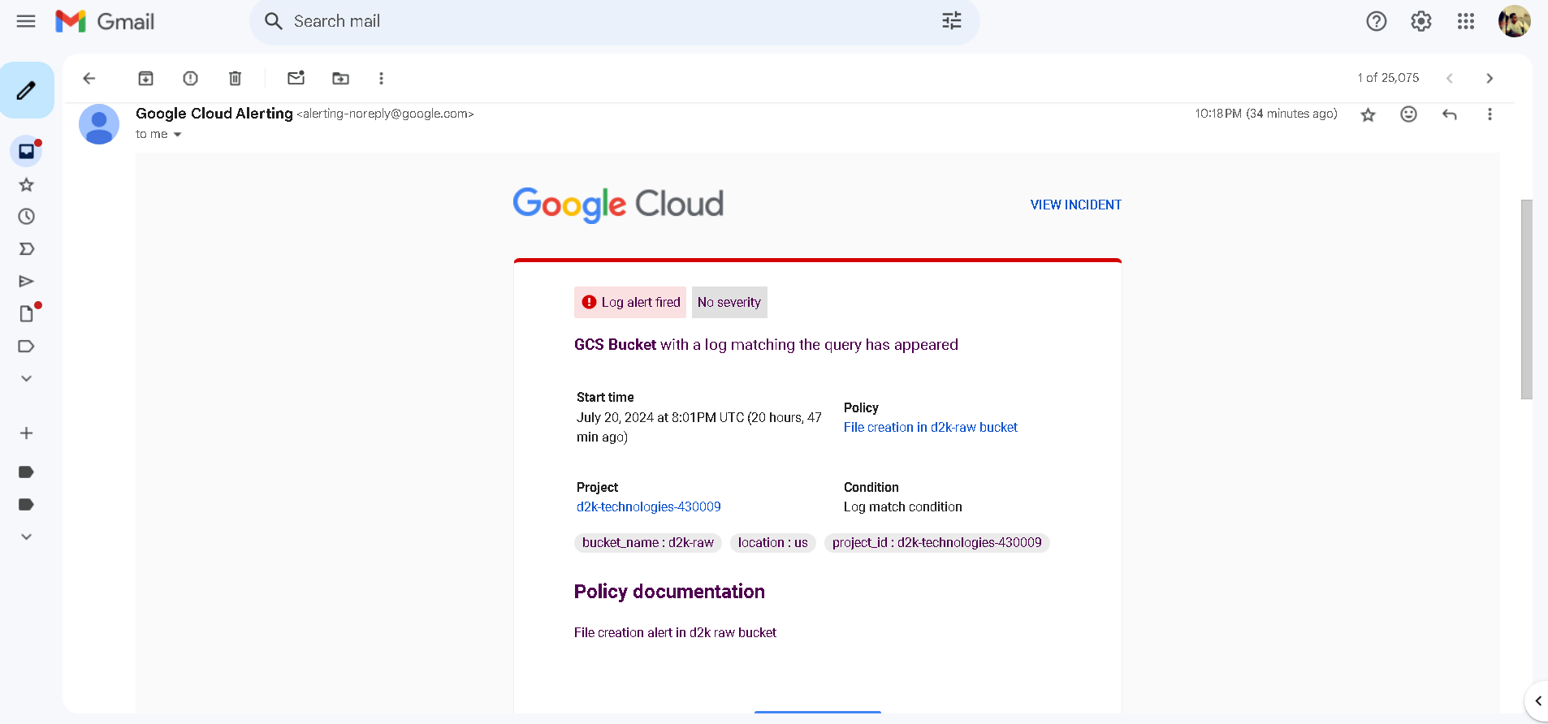

BigQuery:

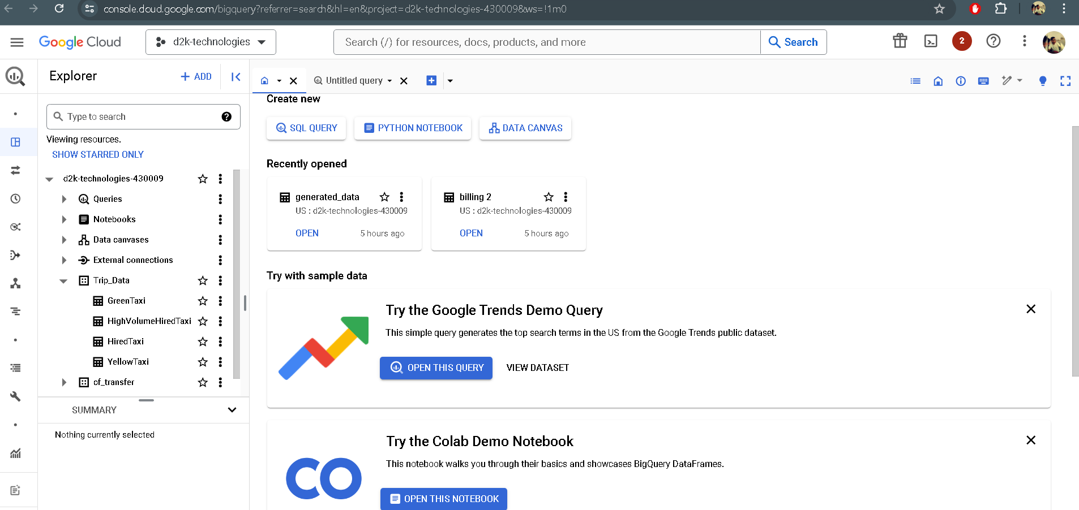

Queries->  
1. SELECT

DATE(tpep_pickup_datetime) AS trip_date, COUNT(*) AS total_trips, AVG(fare_amount) AS average_fare

FROM

` d2k-technologies-430009.Trip_Data.YellowTaxi`

WHERE

EXTRACT(YEAR FROM tpep_pickup_datetime) = 2019

GROUP BY

trip_date

ORDER BY

trip_date;

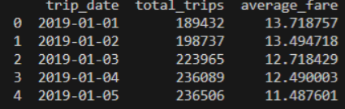

2. SELECT

EXTRACT(HOUR FROM tpep_pickup_datetime) AS hour,

COUNT(*) AS total_trips

FROM

` d2k-technologies-430009.Trip_Data.YellowTaxi`

GROUP BY

hour

ORDER BY

total_trips DESC;

3. SELECT

            passenger_count,

            AVG(fare_amount) AS average_fare,

            COUNT(*) AS total_trips

FROM

            ` d2k-technologies-430009.Trip_Data.YellowTaxi`

   GROUP BY

            passenger_count

   ORDER BY

            passenger_count;

4. SELECT

            EXTRACT(MONTH FROM tpep_pickup_datetime) AS month,

            COUNT(*) AS total_trips,

            AVG(fare_amount) AS average_fare

  FROM

            ` d2k-technologies-430009.Trip_Data.YellowTaxi`

  WHERE

            EXTRACT(YEAR FROM tpep_pickup_datetime) = 2019

 GROUP BY

            month

 ORDER BY

            month;