
Department of Computer Science and Engineering
ALGORITHMIC PROBLEM-SOLVING HACKATHON (APSH 2026)
PROJECT DOCUMENTATION
Date: 03-10-2026 | Venue: 3rd Floor, A & B Blocks
Field | Details
Project Title | Smart Student Attendance System (AttendX)
Team Name / Team No. | 05
Year / Semester / Section | II Year B.Tech / ___ Sem / ___
Algorithm Paradigm Used | MERN stack: REST API (client–server), MVC-style layers, JWT authentication with role-based access control
Programming Language / Tools | MongoDB, Express.js, React.js, Node.js, Mongoose, Vite, Recharts, VS Code, Git/GitHub
Team Members
S.No | Name of the Student | Roll No. | Role
1 | Shivansh Mishra | 25MVCSMR0358 | Team Lead
2 | Rohan Kumar Samal | 25MVCSMR0349
3 | Kunal Mogra | 25MVCSMR0320
4 | E. Harshith Goud | 25MVCSMR0303

1. Problem Statement
Build a MERN-based smart student attendance system that tracks attendance and generates reports.
Inputs: student records (name, roll no, section), subjects, date, and a present/absent status for each student; login credentials.
Outputs: stored attendance records, per-student and per-subject attendance percentages, low-attendance alerts, charts and a downloadable CSV report.
Constraints: MongoDB must be the database, React the user interface, Node.js + Express.js the backend REST APIs; the system must support adding, viewing, updating and managing records, with authentication and role-based access (admin, teacher, student). One student can have only one record per subject per day.

2. Objectives
1. Demonstrate MERN stack development with a clean separation of database, API and user interface.
2. Implement full CRUD operations on students, subjects and attendance records using MongoDB.
3. Build secured REST APIs with JWT authentication and role-based access (admin / teacher / student).
4. Generate clear reports (percentages, low-attendance flags, charts, CSV) so teachers can act quickly.

3. Proposed Approach
Paradigm: three-tier client–server architecture. React (presentation) talks over JSON REST APIs to Express/Node (logic), which stores data in MongoDB (data). Stateless JWT tokens carry the login, and a middleware checks the token and the role before each protected route (role-based access control).
Why it suits the problem: attendance is naturally document-shaped (student + subject + date + status), MongoDB handles it without joins, and React lets a teacher mark a full class on one screen. Saving a whole class uses one bulk upsert, so it is fast and idempotent (saving twice never creates duplicates, enforced by a unique compound index).
Alternatives considered: (a) relational database (MySQL/PostgreSQL) — fine, but needs more schema and join work for this use case; (b) server-side sessions instead of JWT — needs server memory/state; (c) QR / biometric capture — better automation but outside the project scope and hardware-dependent.

4. Algorithm / Pseudocode
A. Login: receive email + password -> find user by email -> compare password with the stored bcrypt hash -> if valid, sign a JWT {id} (7 days) and return it with the user; else return 401.
B. Protect a route: read "Authorization: Bearer <token>" -> verify the JWT -> load user -> if the route lists allowed roles and user.role is not in the list, return 403; else continue.
C. Mark attendance (teacher/admin): GET sheet(subject, date) = all students + existing status. Teacher sets Present/Absent for each. POST bulk(subject, date, records): for each valid record, UPSERT on key (student, subject, date) and set status and markedBy.
D. Attendance report: records = find(attendance filtered by subject/date range; if role is student, only own). Group records by student in a Map. For each student: present = count(status = "present"), total = count(records), percent = present / total x 100. Mark "low" if total > 0 and percent < 75. Return rows sorted by roll number.
E. Dashboard: compute the same tally overall, per subject, and per class day (last 10 days) for the charts.

5. Complexity Analysis
Mark a class of n students: O(n) time (one bulk upsert; each upsert uses the unique index, O(log N) per lookup), O(n) space for the request.
Generate a report: one pass over R matching records to group them into a Map (O(R)), then one pass over S students (O(S)), so O(R + S). The DB sorts students by roll number (O(S log S) worst case). Space is O(R + S) for the grouped records and result rows.
Login / token check: O(1) apart from the database lookup by indexed email / id (O(log N)); bcrypt hashing cost is a fixed work factor.
Complexity | Best Case | Average Case | Worst Case
Time | O(S) (no records) | O(R + S) | O(R + S log S)
Space | O(S) | O(R + S) | O(R + S)
6. Implementation
Platform / tools: Node.js runtime, Express.js 4, MongoDB with Mongoose ODM, React 19 with React Router, Vite build tool, Recharts for charts, bcryptjs, jsonwebtoken, VS Code, Git/GitHub.
Backend modules: models/ (User, Subject, Attendance schemas), middleware/auth.js (JWT + role check), routes/ (auth, users, subjects, attendance, reports), seed.js (demo data), index.js (app start + MongoDB connection).
Frontend modules: App.jsx (routes + role guards), auth.jsx (login state with React Context), pages/ (Login, Dashboard, Mark, Records, Students, Subjects, Reports), components/ (Layout, Modal, Toast).
Data structures: Mongoose documents and arrays; JavaScript Map to group attendance by student; unique compound index (student, subject, date) in MongoDB. Collections: users, subjects, attendance.
Security: passwords stored as bcrypt hashes, JWT tokens, role-based route protection on the server (not only hidden buttons in the UI), input validation, helmet headers.

7. Results and Test Cases
Test cases executed against the running system (all passed):
1. Wrong password -> 401 "Wrong email or password". 2. Request without a token -> 401. 3. Student calls the student list or creates a subject -> 403.
4. Teacher saves attendance for 10 students -> 10 records stored; saving the same sheet again -> still 10 (no duplicates). 5. Teacher flips a record to absent -> updated; student tries the same -> 403.
6. Student lists attendance -> sees only their own roll number. 7. Invalid date in the sheet request -> 400. 8. Duplicate email on sign-up -> 409.
9. Report with demo data: 10 students, 3 flagged low (49%, 59.2%, 71.4%); CSV export downloads; a student cannot export the CSV (403).
Screenshots: Dashboard, Mark Attendance and Reports pages (below).
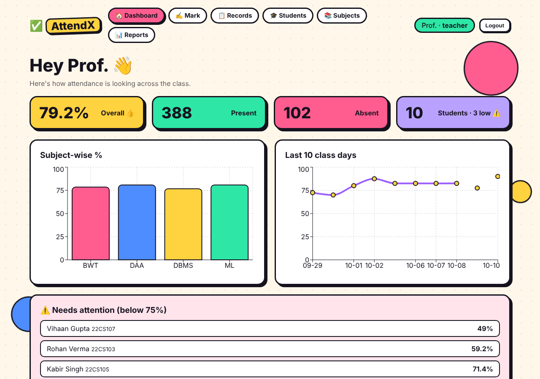
Figure: Dashboard (teacher view)
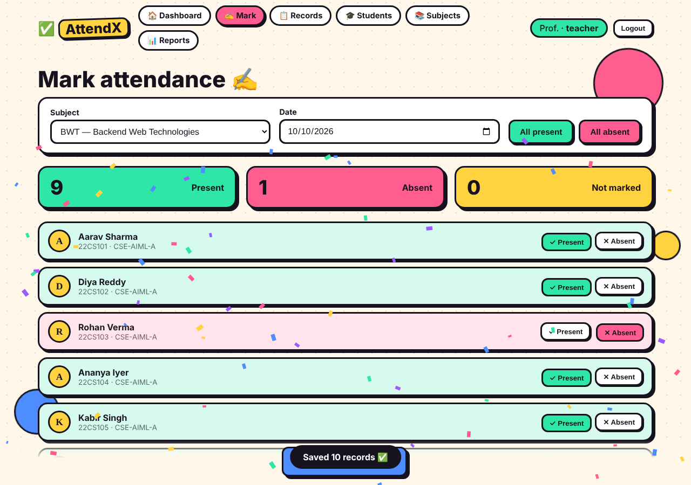
Figure: Mark Attendance screen
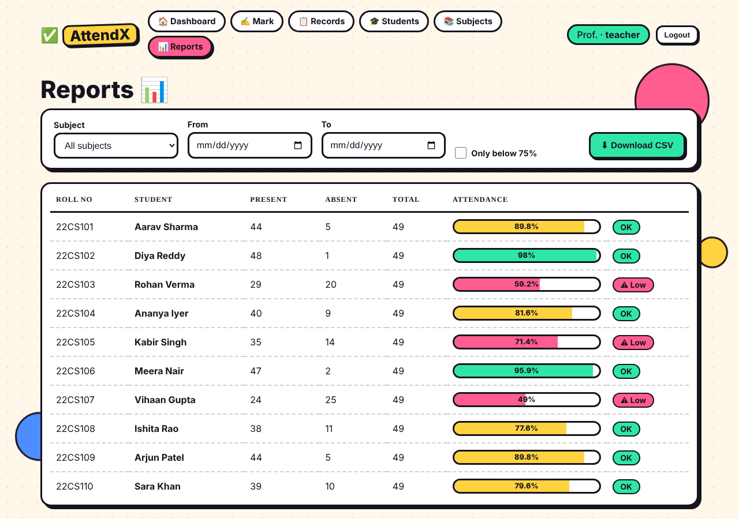
Figure: Attendance report with low-attendance flags

8. Conclusion and Future Scope
Outcome: a working MERN application where teachers mark a whole class in one click, admins manage people and subjects, and students see only their own attendance, with reports, charts and CSV export protected by JWT and role-based access.
Future scope: QR-code / face-recognition based marking, email or SMS alerts for low attendance, timetable integration, per-period attendance, a mobile app (React Native), and cloud deployment with MongoDB Atlas.

9. References
[1] MongoDB Inc., "MongoDB Manual." [Online]. Available: https://www.mongodb.com/docs/manual
[2] Express.js Documentation. [Online]. Available: https://expressjs.com
[3] Meta Open Source, "React Documentation." [Online]. Available: https://react.dev
[4] Node.js Documentation. [Online]. Available: https://nodejs.org/docs
[5] Mongoose Documentation. [Online]. Available: https://mongoosejs.com/docs
[6] M. Jones, J. Bradley, N. Sakimura, "JSON Web Token (JWT)," RFC 7519, IETF, May 2015.

