DESIGN AND ANALYSIS OF ALGORITHMS
Hackathon Project Report
Maze Solver Arena
Comparing BFS, DFS and Backtracking on the Same Maze
Detail | Information
Project Title | Maze Solver Arena (Problem 19: Maze Solver Game)
Student Name(s) & Roll No(s). | Shivansh Mishra - 25MVCSMR0358  Rohan Kumar Samal - 25MVCSMR049  Kunal Mogra - 25MVCSMR0320  E. Harshith - 25MVCSMR0303
Department | Computer Science and Engineering (AI & ML)
College | Malla Reddy Vishwavidyapeeth Technical Campus, Hyderabad
Date | 3rd October 2026
Academic Year | [2026-27]

1. Abstract and Introduction

1.1 Project overview
Maze Solver Arena is a Python application that solves one maze with three classic algorithms, Breadth-First Search (BFS), Depth-First Search (DFS) and Backtracking, and compares them on the same input. For every run it reports the length of the path found, the number of cells explored and the execution time. It also shows each search as a step-by-step animation so a user can see how the algorithms behave differently.

1.2 Problem background
Finding a route through a maze is the simplest example of a graph search problem. The same idea is behind GPS navigation, game AI, robot movement and network routing. Students usually learn BFS, DFS and Backtracking separately, and the textbook only says that BFS gives the shortest path and DFS may not. It is hard to see how big the difference is without running them side by side on real inputs.

1.3 Proposed solution
A single tool that (a) generates a random maze or accepts a user-made maze, (b) runs all three algorithms on exactly the same grid, (c) records path length, cells visited and time for each, and (d) shows the results as a table, charts and an animation, with a short explanation of why each algorithm behaved as it did.

1.4 Purpose of the project
- Demonstrate the three DAA techniques on a real, visual problem.
- Give measured evidence (not only theory) about their time and search behaviour.
- Provide a learning aid that students can use to understand graph search.

2. Problem Statement, Objectives and Scope

2.1 Problem statement
Generate or accept a maze and let users compare BFS, DFS and Backtracking solutions by path length, visited cells and execution time. (Problem 19, Maze Solver Game, from the DAA Hackathon problem list.)

2.2 Project objectives
- Implement BFS, DFS and Backtracking for a grid maze.
- Generate random mazes of any size and also accept a maze typed or pasted by the user.
- Measure and compare path length, cells visited and execution time for each algorithm.
- Visualise each search step by step and explain the result in simple words.
- Analyse how the algorithms scale as the maze grows.

2.3 Project scope
In scope | Out of scope
2D grid mazes with walls and open cells | Weighted cells (cost per step)
Movement in 4 directions (up, down, left, right) | Diagonal movement and 3D mazes
One start cell and one end cell | Multiple goals or moving obstacles
Single-user local web app | User accounts, cloud deployment, database

2.4 Target users
- Students learning graph algorithms in a DAA course.
- Teachers who need a live demo to explain BFS, DFS and Backtracking.
- Beginners in game development interested in pathfinding.

3. Features and Functional Requirements

3.1 Main features
Feature | Description
Random maze generator | Creates a maze using randomized DFS. User sets size (11 to 61 cells), amount of extra loops and a seed. The same seed always gives the same maze.
Custom maze input | User pastes a maze as text: # is a wall, space is open, S is start, E is end.
Three solvers | BFS, DFS and Backtracking run on the same grid.
Comparison panel | Table and bar charts of path length, cells visited and time, plus a line naming the shortest path and the algorithm that explored the fewest cells.
Step-by-step animation | Slider and Play button replay the visited cells in order and then draw the final path.
Explanations | A short plain-language note under each algorithm explaining its behaviour.

3.2 User functionalities
- Choose to generate a maze or paste their own.
- Change size, extra loops and seed from the sidebar and see results update instantly.
- Click New random maze to get a different maze.
- Select an algorithm and play or scrub through its search.
- Set a step limit for Backtracking to keep it from running too long.

3.3 CRUD operations
The application does not store data, so there is no database and no traditional CRUD. The nearest equivalents are listed below.
Operation | In this project
Create | Generate a random maze or paste a new one
Read | View the maze, the comparison table, charts and animation
Update | Change size, loops, seed or step limit; the maze and results are recomputed
Delete | Replace or reset the maze; nothing is kept after the session ends

3.4 Authentication and validation
Authentication is not needed because the tool is a local, single-user learning application with no personal data. Input validation is applied where it matters:
- A pasted maze must contain exactly one start (S) and one end (E); otherwise an error message is shown.
- Rows of different lengths are padded with walls so the grid is always rectangular.
- Generated maze sizes are forced to odd numbers, which the generation method requires.
- Backtracking has a configurable step limit (default 200,000) so a hard maze cannot freeze the app.
- If no path exists, every algorithm reports 'No path' instead of failing.

3.5 System requirements
Item | Requirement
Operating system | Windows 10/11, Linux or macOS
Python | 3.9 or newer (tested on 3.12)
Libraries | streamlit, matplotlib, numpy, pandas
Browser | Any modern browser (Chrome, Edge, Firefox)
Hardware | Any laptop with 4 GB RAM; no GPU needed

3.6 Non-functional requirements
- Performance: a 101 x 101 maze is solved by all three algorithms in well under a second.
- Usability: all controls are in one sidebar; results appear without extra clicks.
- Reproducibility: seeded generation lets anyone repeat an experiment.
- Maintainability: algorithms are separated from the user interface in their own module.

4. Algorithms and Methodology

4.1 System workflow
The maze is treated as a graph. Every open cell is a node, and two open cells that touch (up, down, left, right) are connected by an edge. All three solvers search this graph from the start node for the end node.
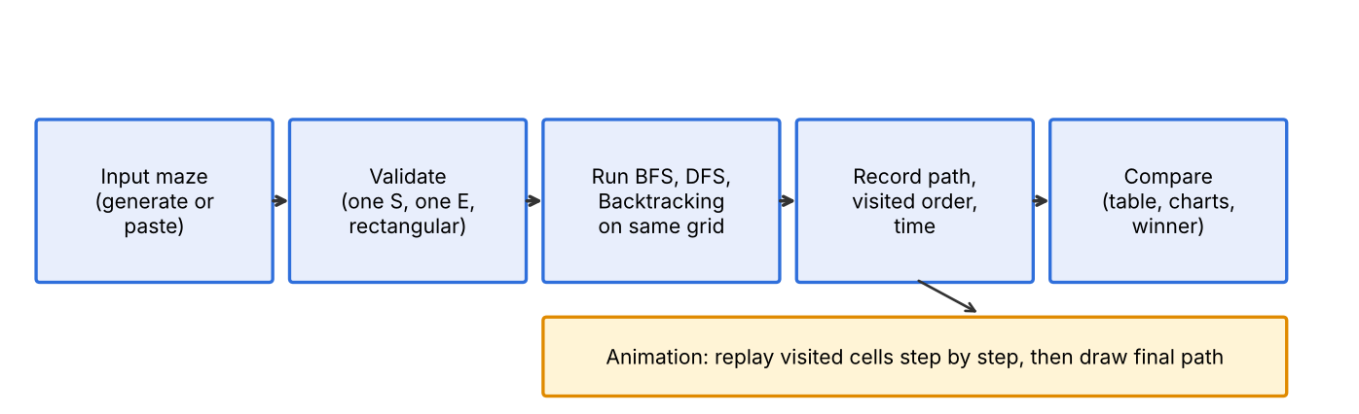
Figure 1: System workflow

4.2 Algorithms used

Breadth-First Search (BFS)
BFS uses a queue. It visits all cells one step away from the start, then all cells two steps away, and so on. Because it expands in order of distance, the first time it reaches the end cell is by a path with the fewest steps.
BFS(grid, start, end):
queue = [start]; parent[start] = None
while queue is not empty:
cell = queue.pop_front()
if cell == end: return path built from parent
for each open neighbour n of cell not yet seen:
parent[n] = cell; queue.push_back(n)
return no path

Depth-First Search (DFS)
DFS uses a stack. It follows one corridor as far as it can, and only when it hits a dead end does it go back and try another. Each cell is expanded once. It can be fast when it picks a good direction, but the path it finds is not guaranteed to be the shortest.
DFS(grid, start, end):
stack = [start]
while stack is not empty:
cell = stack.pop()
if cell already seen: continue
mark cell seen
if cell == end: return path built from parent
push all unseen open neighbours (set their parent = cell)
return no path

Backtracking
Backtracking builds the path one cell at a time. After each choice it checks the constraint (the cell is open and is not already on the current path). If a choice leads to a dead end, it is undone and the next choice is tried. Only cells on the current path are blocked, so after backtracking a cell can be entered again from a different route. This is why Backtracking can repeat a lot of work on mazes that have loops.
Backtrack(path, end):
if last(path) == end: return path # goal
for each open neighbour n of last(path):
if n not in path: # constraint check
add n to path # choose
result = Backtrack(path, end)
if result: return result
remove n from path # undo
return fail

The implementation uses an explicit stack instead of recursion, so large mazes do not hit Python's recursion limit.

Maze generation: randomized DFS
A random cell-by-cell walk (a recursive backtracker) carves passages through a grid of walls until every cell is reached. The result is a 'perfect' maze with exactly one route between any two cells. To create several routes, a chosen fraction of the remaining walls is removed ('extra loops'). This is what makes the three algorithms behave differently.

4.3 Complexity summary
V is the number of open cells and E the number of connections between them. For a grid, E is at most 2V.
Algorithm | Time | Space | Shortest path?
BFS | O(V + E) | O(V) for queue and visited set | Yes, always
DFS | O(V + E) | O(V) for stack and visited set | No
Backtracking | O(V + E) on a tree-like maze; exponential in the worst case with loops | O(V) for the current path | No

4.4 Development methodology
The project was built in small, tested steps (an iterative approach):
- Step 1: grid representation and maze generator.
- Step 2: each solver written and checked on small hand-made mazes.
- Step 3: unified result format and comparison logic.
- Step 4: Streamlit interface, charts and animation.
- Step 5: automated test cases and the size benchmark.

4.5 Data flow
Stage | Input | Process | Output
1. Input | Size, loops, seed or pasted text | Generate or parse maze, validate | 2D grid, start and end cells
2. Solve | Grid, start, end | Run BFS, DFS and Backtracking | One Result object per algorithm
3. Compare | Three Result objects | Compute path length, visited count, time; find winners | Table, charts, summary line
4. Visualise | Visited order and path | Draw grid at the chosen step | Animated maze image

5. Technologies and Implementation

5.1 Frontend technologies
- Streamlit: builds the web interface (sidebar controls, tables, charts, buttons) using only Python.
- Matplotlib: draws the maze grid as a coloured image for the animation.

5.2 Backend technologies
- Python 3: all logic. The solvers use collections.deque (queue), lists (stack), sets and dictionaries (visited and parent tracking).
- NumPy: builds the image array that Matplotlib draws.
- Pandas: holds the comparison table.

5.3 Database
No database is used. The maze and results live in memory for the current session only.

5.4 Tools and APIs
- pip and a virtual environment for installing libraries.
- Git and GitHub for version control and submission.
- Python's time.perf_counter() for timing each solver.
- No external web APIs are used.

5.5 Implementation details
The code is split into two modules plus tests and a benchmark script:
File | Purpose
maze.py | Maze generator, text parser, and the three solvers (solve_bfs, solve_dfs, solve_backtracking)
app.py | Streamlit interface: controls, comparison table and charts, animation
tests.py | Nine automated test cases
bench.py | Benchmark of time and cells visited against maze size
requirements.txt, README.md | Install list and run instructions

Every solver returns the same Result object, which makes comparison simple:
@dataclass
class Result:
name: str # 'BFS', 'DFS' or 'Backtracking'
path: list # cells from start to end
visited: list # cells in the order they were explored
time_ms: float # run time in milliseconds
found: bool # was a path found?
capped: bool # stopped early by the step limit?

Two details are worth noting. First, the Backtracking solver marks only the cells on the current path, and removes the mark when it backs out. This is the true 'choose, check, undo' pattern and the reason it can be slow on loops. Second, DFS and BFS keep a global visited set, so each cell is expanded at most once.
To run the project: install the libraries with pip install -r requirements.txt, then start the app with streamlit run app.py.

6. Results, Testing and Performance

6.1 Project results
The first example is a 31 x 31 maze (seed 7). The table shows what each algorithm found.
Maze type | Algorithm | Path length (steps) | Cells visited
No loops (single route) | BFS | 180 | 219
No loops (single route) | DFS | 180 | 191
No loops (single route) | Backtracking | 180 | 439
10% extra loops | BFS | 68 | 479
10% extra loops | DFS | 84 | 92
10% extra loops | Backtracking | 88 | 89

When the maze has only one route, all three algorithms must find the same path, so path length is identical. Once loops are added there are several routes. BFS finds the shortest (68 steps), while DFS and Backtracking return longer paths (84 and 88 steps). DFS explored far fewer cells (92 against 479) because it did not have to check every cell near the start, but the path it found is 24% longer than the best one.
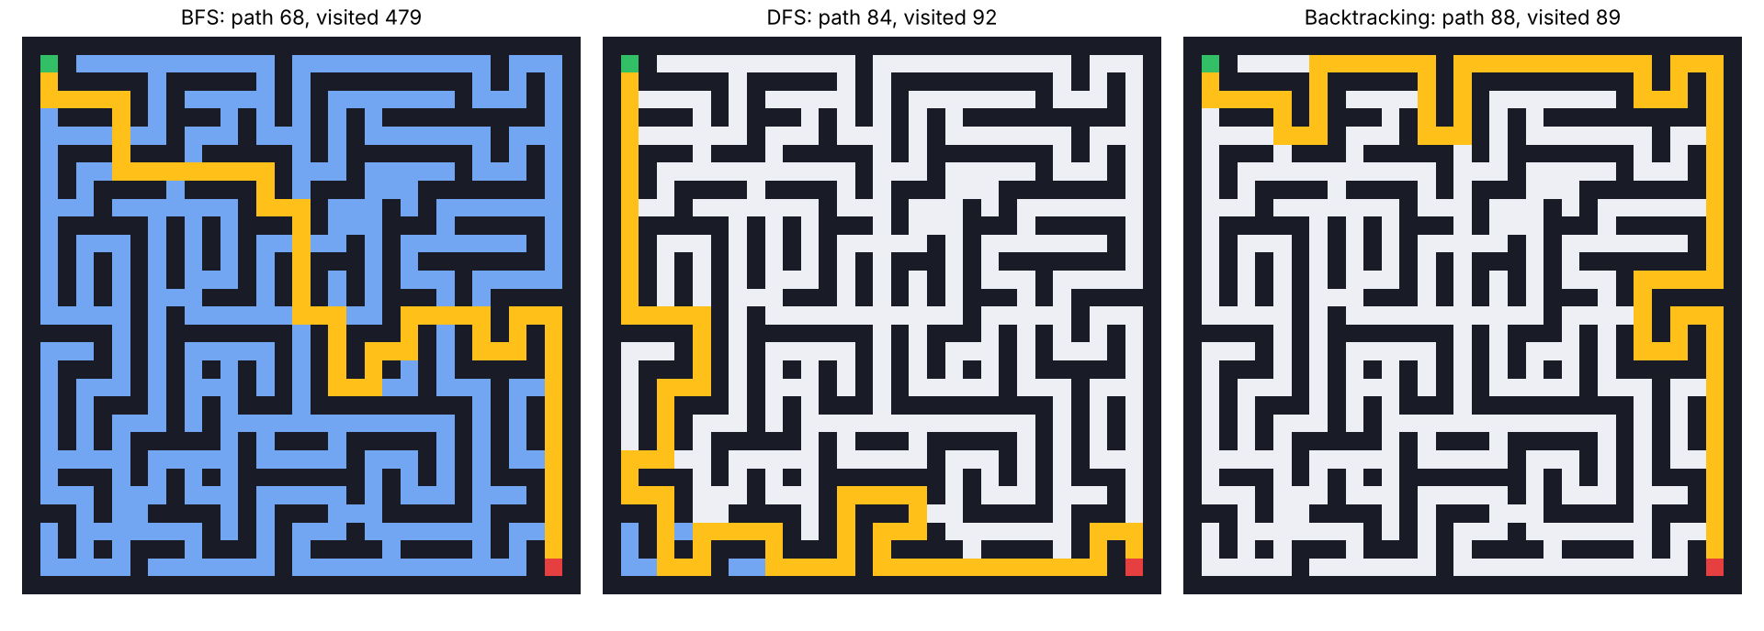
Figure 2: Output on the 31 x 31 maze with 10% loops. Green = start, red = end, blue = explored, gold = final path.

6.2 Test cases
ID | Test case | Expected result | Result
TC1 | Perfect maze (31x31, no loops) | All three find a valid path of equal length (180) | Pass
TC2 | Maze with 10% loops | BFS path is the shortest (68 vs 84 and 88) | Pass
TC3 | Start and end separated by a wall | All report 'no path' and an empty path | Pass
TC4 | Pasted maze with no E | Error message, no crash | Pass
TC5 | Start next to end | Path of 1 step for all three | Pass
TC6 | Large maze (101x101) | All three solve it | Pass
TC7 | Backtracking with a very small step limit | Stops at the limit and reports it | Pass
TC8 | Same seed twice | Identical mazes | Pass
TC9 | 50 random mazes, BFS and DFS | Every path starts at S, ends at E, uses only open cells and moves one step at a time | Pass

All 9 test cases pass (run with python tests.py).

6.3 Testing methods
- Unit testing: automated checks on the solvers and generator (tests.py).
- Property checking: a path validator confirms every returned path is continuous and avoids walls.
- Boundary testing: no-path maze, start next to end, invalid input, very small step limit.
- Randomised testing: 50 different seeded mazes.
- Manual testing: run the app and check the controls, charts and animation in the browser.

6.4 Performance analysis
To see how the algorithms scale, each one was run on mazes from 21 x 21 to 201 x 201 cells, 10 different random mazes per size, and the results were averaged. Times are in milliseconds and were measured on one machine, so exact values will differ on another computer; the pattern is what matters.
Table A: mazes with 10% extra loops (several routes)
Size | BFS ms | DFS ms | Backt. ms | BFS cells | DFS cells | Backt. cells
21 x 21 | 0.3 | 0.1 | 0.1 | 206 | 91.1 | 92.2
41 x 41 | 1.0 | 0.4 | 1.8 | 750 | 327 | 1,031
61 x 61 | 2.4 | 0.9 | 3.1 | 1,808 | 572 | 2,243
81 x 81 | 4.3 | 0.9 | 10.0 | 3,383 | 693 | 7,001
101 x 101 | 6.7 | 1.3 | 33.0 | 5,324 | 978 | 21,903
151 x 151 | 15.8 | 3.3 | 54.0 | 12,052 | 2,359 | 35,549
201 x 201 | 26.9 | 8.9 | 139 | 21,458 | 6,604 | 97,140

Table B: average path length found (10% loops)
Size | BFS | DFS | Backtracking
21 x 21 | 45.6 | 74.8 | 71.8
41 x 41 | 97.2 | 189 | 207
61 x 61 | 153 | 335 | 332
81 x 81 | 192 | 496 | 538
101 x 101 | 250 | 618 | 532
151 x 151 | 362 | 1,560 | 1,195
201 x 201 | 471 | 2,004 | 979

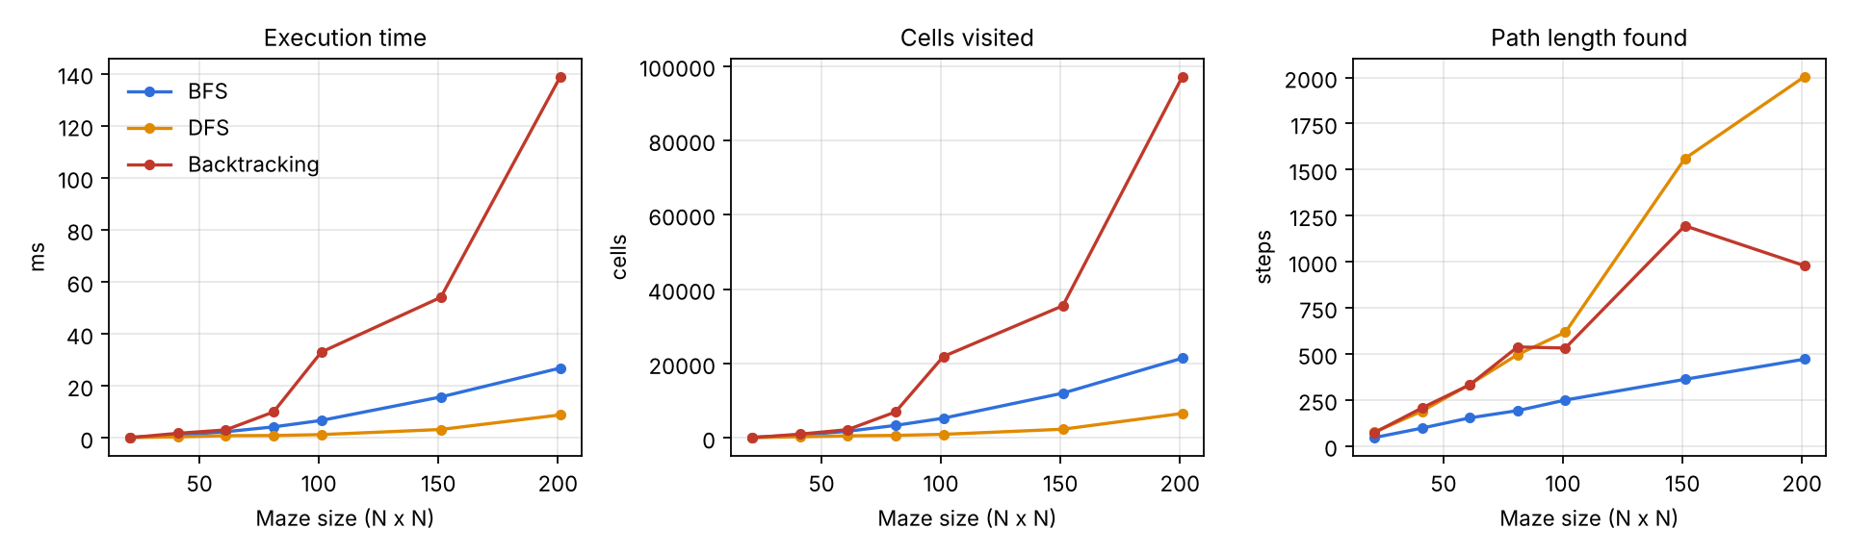
Figure 3: Time, cells visited and path length against maze size (10% loops)
Table C: perfect mazes with no loops (one route only)
Size | BFS ms | DFS ms | Backt. ms | BFS cells | DFS cells | Backt. cells
21 x 21 | 0.2 | 0.2 | 0.1 | 133 | 129 | 131
41 x 41 | 0.6 | 0.7 | 0.5 | 544 | 569 | 484
61 x 61 | 1.2 | 1.4 | 1.1 | 1,037 | 1,153 | 1,038
81 x 81 | 2.3 | 2.2 | 4.6 | 1,925 | 1,816 | 2,238
101 x 101 | 3.9 | 4.0 | 3.8 | 3,471 | 3,290 | 3,275
151 x 151 | 9.6 | 10.6 | 9.1 | 8,266 | 7,108 | 7,695
201 x 201 | 16.3 | 19.1 | 16.5 | 13,572 | 13,127 | 12,668

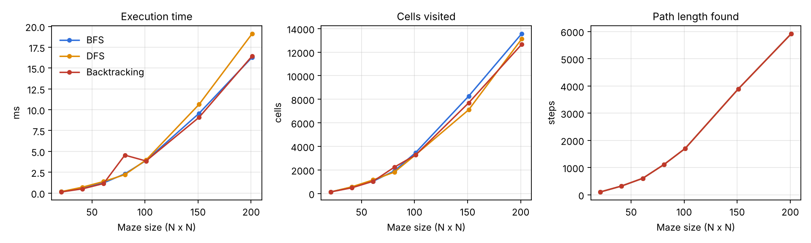
Figure 4: Same comparison on perfect mazes (no loops)

Observations
- On perfect mazes the three algorithms are almost identical. There is only one route, so each must find it, and the times grow in a straight line with maze size (about 16 to 19 ms at 201 x 201).
- With loops, BFS always returned the shortest path, and its path stayed far shorter than the others as the maze grew (471 steps against 2,004 for DFS at 201 x 201).
- With loops, DFS was the fastest (8.9 ms at 201 x 201) and explored the fewest cells, but its paths were up to four times longer than the best.
- With loops, Backtracking was the slowest by a wide margin (138.8 ms at 201 x 201, about 5 times slower than BFS and 15 times slower than DFS) and visited about 97,000 cells, more than four times as many as BFS. This matches the theory: it re-enters cells that it has already tried through other routes.
- BFS time grows steadily with the number of open cells, in line with O(V + E).

6.5 Screenshots and output
Replace the placeholders below with screenshots taken from your running application.
[Insert screenshot: Comparison table and bar charts]

[Insert screenshot: BFS animation (Watch it solve section)]

[Insert screenshot: DFS or Backtracking animation]

[Insert screenshot: Custom maze input in the sidebar]

7. Conclusion, Future Scope and References

7.1 Conclusion
Maze Solver Arena meets the problem statement: it generates or accepts a maze, solves it with BFS, DFS and Backtracking, and compares them on path length, cells visited and execution time. The measured results agree with the theory:
- BFS always gives the shortest path and scales smoothly, but it explores the most cells around the start.
- DFS is often the quickest and uses little memory, but it can return a path several times longer than needed.
- Backtracking is simple and flexible for constraint problems, but it becomes very slow on mazes with loops because it repeats work.
So the right choice depends on the goal: BFS when the shortest route matters, DFS when any route will do and speed matters, and Backtracking when the problem has rules to check at every step. The project also gives students a visual way to see these differences.

7.2 Future enhancements
- Player-versus-algorithm mode, where the user solves the maze by hand and races the solvers.
- A* and Dijkstra with weighted cells (for example mud or water tiles) to compare informed search with BFS.
- Diagonal movement, multiple goals and 3D mazes.
- Saving and loading mazes, and exporting results as CSV.
- Public deployment so classmates can use it from a link.

7.3 References and documentation
- T. H. Cormen, C. E. Leiserson, R. L. Rivest and C. Stein, Introduction to Algorithms, 4th ed., MIT Press, 2022 (chapters on graph search: BFS and DFS).
- J. Buck, Mazes for Programmers, Pragmatic Bookshelf, 2015 (maze generation methods).
- Python documentation: https://docs.python.org/3/
- Streamlit documentation: https://docs.streamlit.io/
- Matplotlib documentation: https://matplotlib.org/stable/
- DAA Hackathon Problem Statements document (Problem 19: Maze Solver Game).
- Project source code: [GitHub repository link]

