Become.
WEBSITE · SECTION-BY-SECTION REVIEW
What each section shows, what it conveys, and why it is there.
Every section is captured as it renders in the browser.
16 sections · captured at 1600 × 950 · 4 August 2026
Use the “Changes I want” box under each section to mark up edits.

The design language
Before the sections, the system they all share. Understanding these four rules explains most of the decisions on the page.
Colour — The page is built on near-black (--void #08080a, --ink #0c0c0f) with off-white paper (#f5f3ef) for text, and a single signature accent — ember orange (#ff5c2b). The ember is rationed deliberately: the full stop after the wordmark, active states, progress fills, and primary buttons. Because it appears rarely, it always means “this matters” or “this is where you act”.
Light / dark rhythm — Three sections invert to paper white — Manifesto (03), Products (07) and Why Become (11). These are the reflective, human parts of the argument. The dark sections are the demonstrative, cinematic ones. The alternation gives a very long page a breathing pattern and stops it becoming a single dark tunnel.
Typography — Three families do distinct jobs. Inter Tight (sans) carries headlines and body — tight, modern, confident. Instrument Serif (italic) appears only for emphasis inside headlines — “built for business”, “LivingOS”, “different”, “what is next” — marking the emotional word in each. JetBrains Mono (mono) handles labels, section numbers, tags and stat readouts, which is what gives the page its technical, instrument-panel feel. Headline sizes are fluid and scale with the viewport.
Numbering and motion — Every section is numbered (01–11) in its eyebrow label, so the page reads as a structured document rather than a scroll of blocks. Motion is scroll-driven throughout — reveals, marquees, parallax, pinning and progress meters — and the site respects prefers-reduced-motion. A boot loader with a percentage counter runs before first paint, and a custom cursor ring follows the pointer.

Contents
00 Global Chrome — Navigation Bar Persistent wayfinding and the standing call-to-action.
01 Hero — “Become intelligent.” The opening statement. First five seconds of the entire site.
02 Capability Ticker A breath between the hero and the argument — and a fast scan of scope.
03 Manifesto — “That is why Become exists.” The argument. Establishes the problem before any solution is offered.
04 Convergence — “Nine words. One outcome.” The brand crescendo. Pure theatre, no information.
05 Solutions — Seven capabilities The service menu. What you can actually buy.
06 Artificial Intelligence — Live demo console Proof. The single most persuasive section on the page.
07 Products — Become LivingOS + The Family The flagship product, and the argument that it is a platform rather than a one-off.
08 Selected Work — Case carousel Evidence. Six transformations expressed as before → after.
09 Industries — Where we work Self-identification. Helps a visitor find themselves on the page.
10 Technology — The stack underneath Engineering credibility for the technically literate reader.
11 Why Become — Three chapters How the work is done. Differentiation on method rather than capability.
12 Process — How it goes Removes procurement anxiety by making the engagement legible.
13 Contact — Tell us what should be different Conversion. The commercial purpose of the whole page.
14 Finale — Become what is next The closing frame. Last emotional beat and second conversion chance.
15 Footer Deep navigation, legal, and one last brand impression.

SECTION 00

Global Chrome — Navigation Bar
header.nav · fixed, always present
Role — Persistent wayfinding and the standing call-to-action.
What you see
A slim fixed bar across the very top of every screen. On the left sits the wordmark “Become.” with the dot set in ember orange. Centred are six text links — Solutions, AI, Products, Work, Company, Contact — rendered small, in wide-tracked uppercase-feeling type. A soft rounded “pill” highlight slides horizontally between links to mark the section you are currently scrolled into. On the right is a filled ember button, “Start a transformation”. The bar itself is near-transparent over the hero and picks up a dark blur as you scroll.
What it conveys
That this is a serious, product-grade company rather than a brochure. The pill that tracks your scroll position quietly tells the visitor “you are here, there is more”, and the permanent ember button means the conversion path is never more than one click away.
Why it matters
It is the only element on screen 100% of the time, so it carries the brand and the CTA through every other section. The scroll-tracking pill is also the site's main orientation device on a page this long.
Motion & interaction
Blur/darkening on scroll; magnetic hover on the button; the pill animates between links; a thin ember progress bar sits directly beneath the bar showing total page progress. On mobile this collapses to a hamburger that opens a full-screen menu overlay.
Section 00 — Global Chrome — Navigation Bar
CHANGES I WANT IN THIS SECTION

SECTION 01

Hero — “Become intelligent.”
#top
Role — The opening statement. First five seconds of the entire site.
What you see
A full-viewport dark stage. Behind everything is a warm, dark, out-of-focus photographic field (hero-flow.jpg) with embers of orange drifting through it, overlaid by a generative particle canvas and a dark veil so text stays legible. Top-left, a small ember dash and the tracked-out label “TECHNOLOGY THAT TRANSFORMS BUSINESSES”. Dominating the screen is a two-line headline at enormous scale: “Become” in off-white, and beneath it a rotating italic word in ember — visible / connected / relevant / intelligent / digital / automated / future-ready / extraordinary / limitless — each with a full stop. Below sits the supporting line “We build software, AI and digital experiences that help businesses become what they are meant to be.”, then two buttons: a filled ember “Start a transformation” and an outlined “See Become LivingOS”. A rail pinned to the bottom edge carries three credibility facts — PRODUCTS: BUILT IN-HOUSE · AI: APPLIED, IN PRODUCTION · DELIVERY: DESIGN + ENGINEERING — with a “SCROLL” cue at far right.
What it conveys
The entire brand thesis in one image: transformation. The company name is literally a verb, and the rotating second word performs the promise in front of you — you watch a business ‘become’ nine different things without the page moving. Confident, cinematic, premium.
Why it matters
This is the highest-traffic pixel real estate on the site and it does three jobs at once: states the positioning, demonstrates craft (which is the actual product being sold), and splits traffic between the sales path and the product path.
Motion & interaction
Letter-by-letter type-on/type-off of the rotating word; drifting ember particles on canvas; the background image parallaxes at 0.16 speed against the scroll; buttons are magnetic (they lean toward the cursor); the scroll cue pulses. A looping video at assets/video/hero.mp4 will automatically take over from the still if you add one — that file is currently absent.
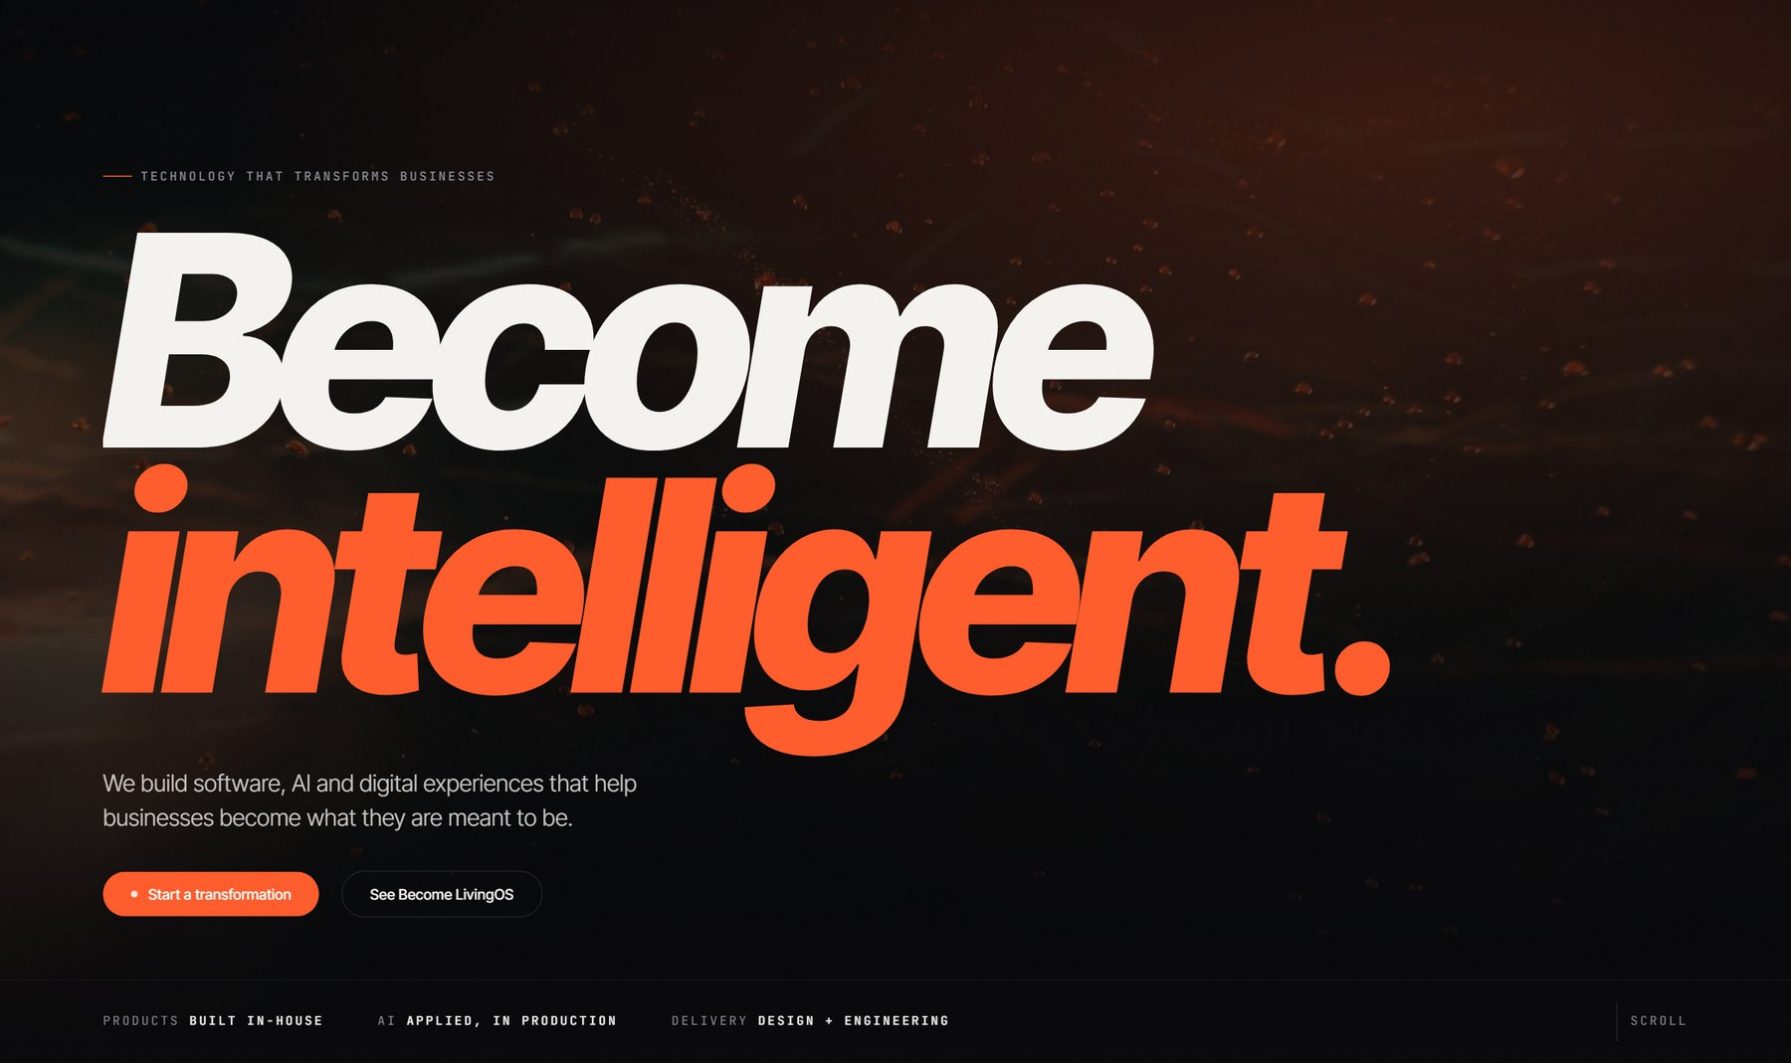
Section 01 — Hero — “Become intelligent.”
CHANGES I WANT IN THIS SECTION

SECTION 02

Capability Ticker
.ticker · between Hero and Manifesto
Role — A breath between the hero and the argument — and a fast scan of scope.
What you see
Two thin horizontal bands of large outlined/ghosted type sliding in opposite directions. The words are the company's capability set: Software · Artificial Intelligence · SaaS Products · Automation · Cloud · Mobile · Computer Vision · Brand · Data, repeating seamlessly. The top row travels left, the lower row travels right, creating a counter-scrolling weave.
What it conveys
Breadth, momentum and machinery. Without asking anyone to read a list, it plants the idea that this company covers a lot of ground and that things here are in motion.
Why it matters
It is the visual hinge between the emotional hero and the sober manifesto. It also seeds vocabulary the visitor will meet again in Solutions and Technology, so those sections feel familiar rather than new.
Motion & interaction
Continuous marquee, speed-linked to scroll (data-marquee -0.45 and 0.3), so scrolling faster accelerates and skews the bands. Decorative only — hidden from screen readers.
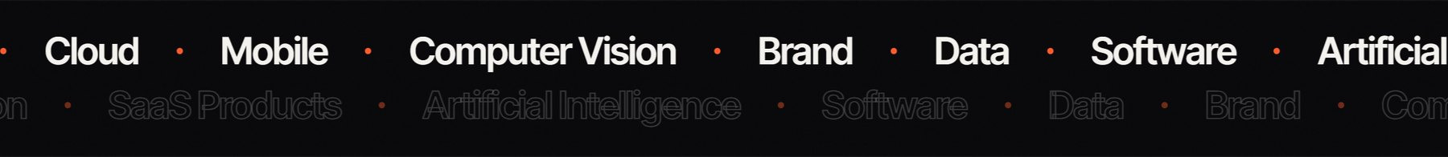
Section 02 — Capability Ticker
CHANGES I WANT IN THIS SECTION

SECTION 03

Manifesto — “That is why Become exists.”
#manifesto · light section
Role — The argument. Establishes the problem before any solution is offered.
What you see
A deliberate inversion — the page flips from near-black to warm paper white (#f5f3ef), which is visually jarring in the intended way. Narrow left column holds “01 MANIFESTO” and the small line “A point of view, written before the first line of code.” The wide right column carries a large editorial statement in near-black: “Businesses do not need more software. They need clarity. They need speed. They need automation. They need growth. They need technology that actually solves problems.” Beneath it, three labelled definitions sit side by side — Clarity, Speed, Growth — each with a plain-English gloss. It closes on “That is why Become exists.” with Become in italic serif.
What it conveys
Intellectual honesty and restraint. By opening with what businesses do *not* need — more software — the company positions itself as a thinking partner rather than a vendor. The light background reads as ‘the clear-headed part of the site’.
Why it matters
This is the credibility section. Everything after it is a claim; this is the reasoning that earns the right to make those claims. It also gives the eye a rest between two dark, heavily animated sections.
Motion & interaction
The headline uses a “lit-text” treatment — words illuminate from dim to full black progressively as the block scrolls through the viewport, so the statement reads itself to you. The three definitions fade up in sequence at 0/110/220ms.
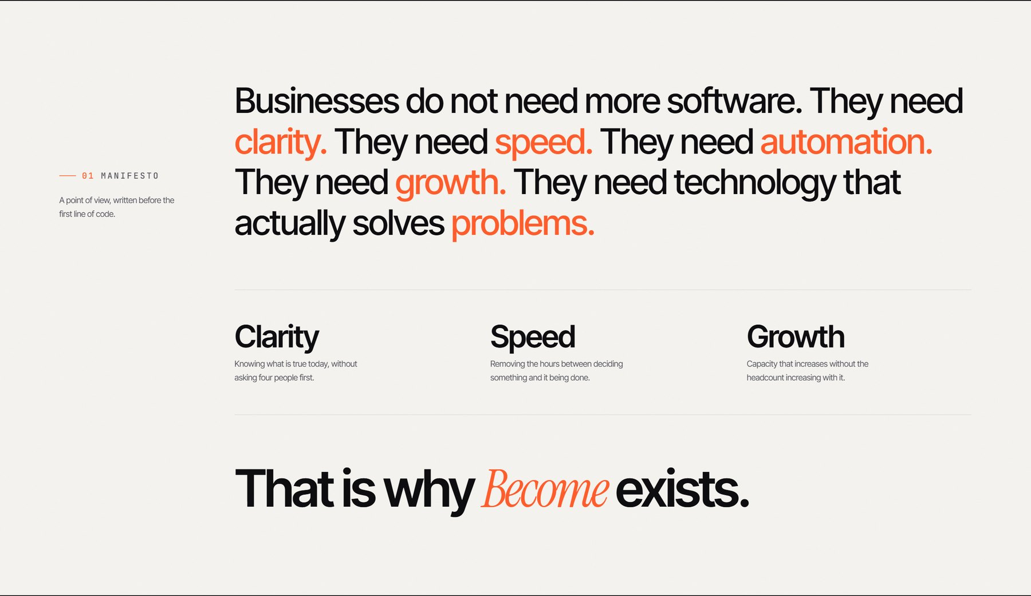
Section 03 — Manifesto — “That is why Become exists.”
CHANGES I WANT IN THIS SECTION

SECTION 04

Convergence — “Nine words. One outcome.”
#converge · pinned scroll section (~4,000px tall)
Role — The brand crescendo. Pure theatre, no information.
What you see
Back to black, and this time full-bleed with no container. A dark atmospheric image sits far behind a thin ember circle outline and a warm radial glow at centre. Scattered across the field are individual words — Visible. Automated. Connected. Intelligent. Scalable. Digital. Powerful. Trusted. Modern. Faster. Global. Relevant. — which fly inward and collapse into the single enormous wordmark “Become.” with the ember full stop. Under it, small tracked type: “NINE WORDS. ONE OUTCOME.” Along the bottom edge runs a progress readout labelled TRANSFORMATION with a rule that fills ember from 0% to 100% as you scroll through.
What it conveys
That every scattered ambition a business has — visibility, automation, scale, trust — resolves into one word, which happens to be the company's name. It is the logo justifying itself.
Why it matters
It is the most memorable moment on the page and the strongest brand-recall device. Because the section is pinned, the visitor is held still while it plays — they cannot scroll past it accidentally, which makes the payoff land.
Motion & interaction
Scroll-pinned: the section is roughly 4,000px tall but the visuals stay fixed while the words converge, driven by scroll progress. The 0→100% counter is literal scroll position. Screenshot shown here is captured at the fully-converged state.
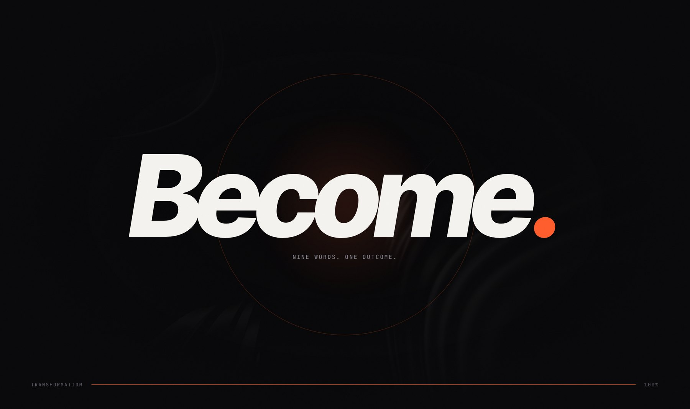
Section 04 — Convergence — “Nine words. One outcome.”
CHANGES I WANT IN THIS SECTION

SECTION 05

Solutions — Seven capabilities
#solutions
Role — The service menu. What you can actually buy.
What you see
Split header: “02 SOLUTIONS” and the headline “Solutions.” on the left, with the qualifying line “Seven capabilities, one company…” on the right. Below, a two-column layout. The left column is a numbered accordion list — 01 Software Engineering, 02 Artificial Intelligence, 03 Web Experiences, 04 Mobile Applications, 05 Brand Growth, 06 Automation, 07 Cloud Infrastructure — each row divided by a hairline rule with a circular +/− toggle at the right edge. The open item expands to reveal a bolded promise line, a paragraph, and a row of pill-shaped tags (e.g. PLATFORMS · INTERNAL TOOLS · APIS · INTEGRATIONS). The right column is a large rounded image panel that swaps to match the open item, captioned “01 / 07”, the title, and the promise line, with a segmented progress meter beneath.
What it conveys
Depth without a wall of text. Only one capability is exposed at a time, so seven services feel considered rather than scattergun. Each has a one-line ‘promise’ written in plain, slightly contrarian language (“Models put to work, not put on stage”) which reads as opinionated, not generic.
Why it matters
This is the commercial spine of the site — the section a prospect scans to decide whether you do the thing they need. The paired image panel keeps it from feeling like an FAQ.
Motion & interaction
Click/hover to open an item; the image panel cross-fades; the segmented meter tracks which of the seven is active and auto-advances. Header elements reveal on scroll.
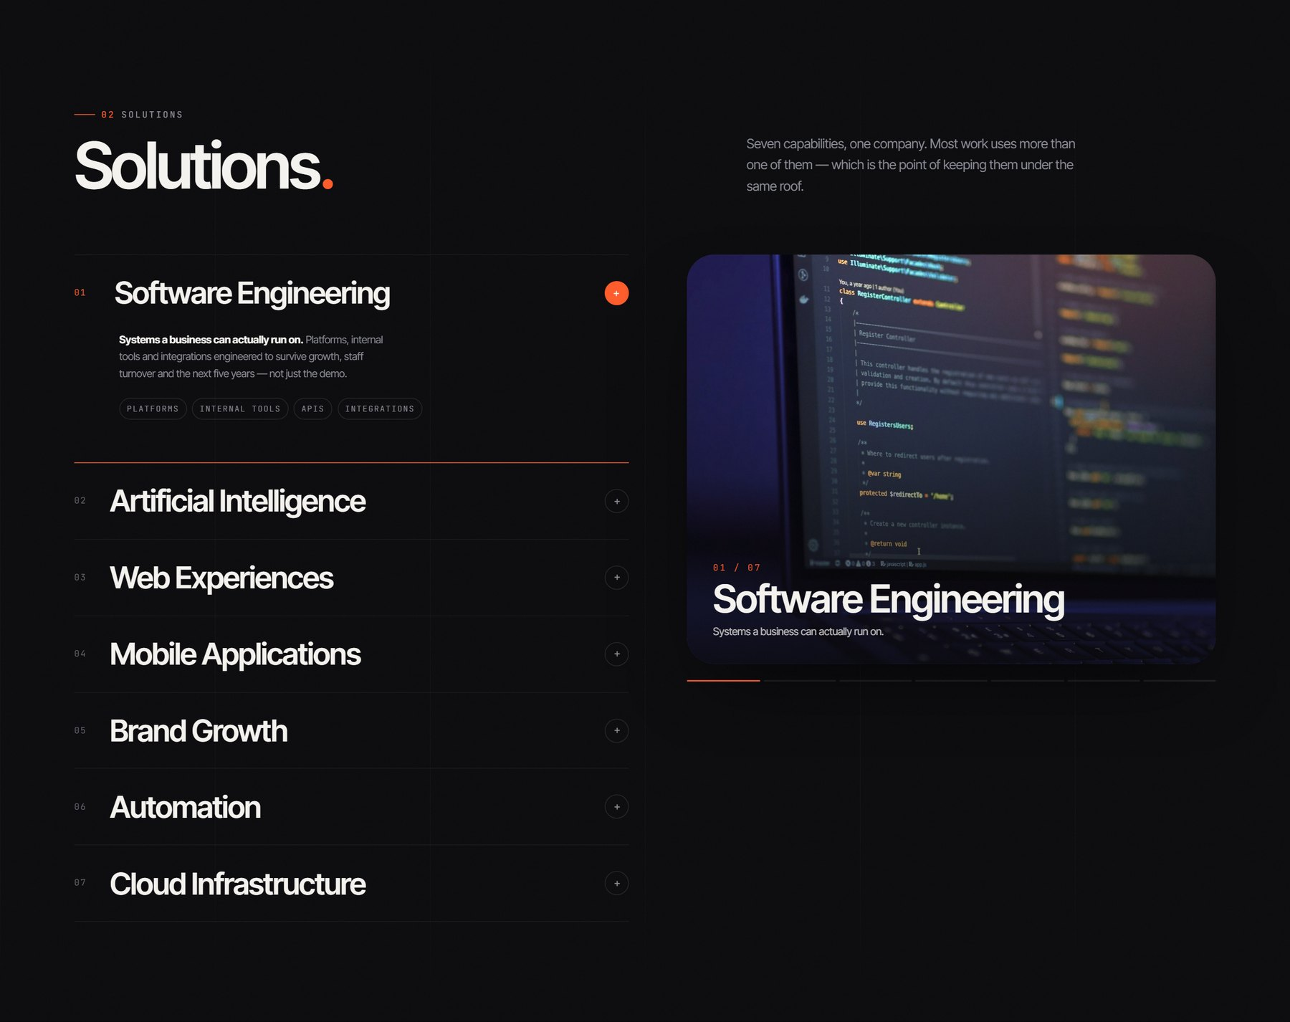
Section 05 — Solutions — Seven capabilities
CHANGES I WANT IN THIS SECTION

SECTION 06

Artificial Intelligence — Live demo console
#ai
Role — Proof. The single most persuasive section on the page.
What you see
A soft sphere-like glow image bleeds behind the top of the section. Header reads “03 ARTIFICIAL INTELLIGENCE” with the two-line headline “Intelligence, / built for business.” (second line italic serif) and the positioning line “Not a chatbot bolted onto a website…”. The centrepiece is a simulated application window: a title bar with three traffic-light dots, the breadcrumb “become / intelligence / production”, and a status chip reading “Simulated”. Inside, five tabs — Assistant · Vision · Voice · Documents · Forecast — switch the view. The default Assistant tab plays a scripted conversation: a question about unpaid dues, a grounded answer, and a source citation (“SOURCE · BILLING-POLICY.PDF, LEDGER”), alongside stat readouts (14,200 sources indexed · 1.2s latency · citations always on) and the trust chips GROUNDED / PRIVATE / AUDITED. Below the console sits a nine-card grid of capabilities, each numbered and status-tagged LIVE / DEPLOYED / PRODUCT — AI Chatbots, Computer Vision, Voice AI, Knowledge Assistants, AI Automation, Virtual Try-On, Speech Analytics, Document Intelligence, Predictive Analytics. The section closes with six outcome pairs (Better decisions, Faster operations, Less manual work, New experiences, Scalable intelligence, Connected knowledge).
What it conveys
That the AI claim is operational, not aspirational. Showing a working console instead of describing capabilities is the difference between “we do AI” and “here it is running”. The honest “Simulated” chip and the LIVE/DEPLOYED/CONCEPT status tags build trust rather than undermine it — they signal a company that does not overstate.
Why it matters
AI is the most crowded, most distrusted claim in the market right now. This section is engineered to defeat that scepticism through demonstration, citation and candour. It is also the longest section on the page, which correctly signals where the company's centre of gravity is.
Motion & interaction
Console scales into view; tabs switch the demo view; the assistant conversation types itself out line by line; stat numbers count up; capability cards lift on hover.
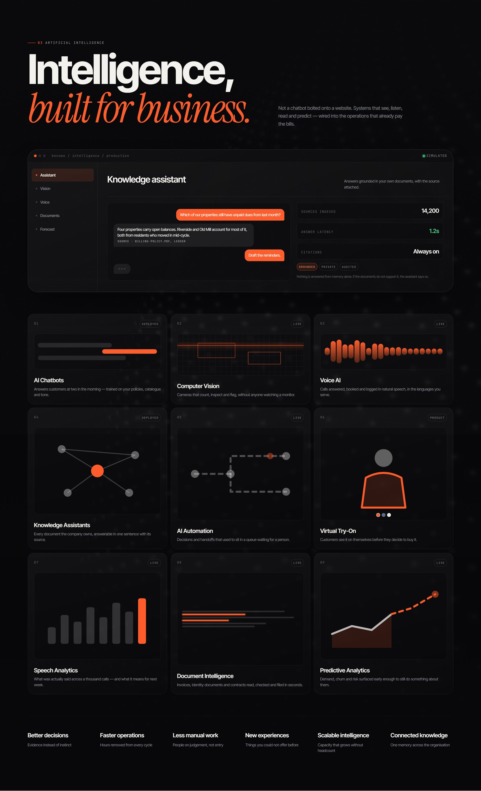
Section 06 — Artificial Intelligence — Live demo console
CHANGES I WANT IN THIS SECTION

SECTION 07

Products — Become LivingOS + The Family
#products · light section
Role — The flagship product, and the argument that it is a platform rather than a one-off.
What you see
Second flip to paper white. Header pairs “04 PRODUCTS” and the title “Become LivingOS” (LivingOS in italic serif) with a pulsing green “LIVE PRODUCT” chip and the descriptor about hostels, hotels and PGs. The hero element is a full device mock-up: a laptop screen showing a working dashboard UI — left sidebar (Overview, Rooms 128, Residents 302, Billing 9, Housekeeping, Maintenance 4, Reports), a property header “Riverside House · Live · updated 4s ago”, four KPI tiles (OCCUPANCY 94% +6%, COLLECTED 88% +11%, OPEN TICKETS 4 −3, CHECK-INS 17 today), a 12-month occupancy bar chart, a room grid, and a live activity feed (“Rhea K. checked into 214 — now”). Overlapping it at the lower right is a phone showing the companion mobile view. Beneath runs a four-item rail: Live occupancy · Money that reconciles · Operations on rails · Residents in the loop. The section then continues into “05 THE FAMILY — One architecture. Many industries.”: a central orbiting diagram with concentric rings, “Become. CORE PLATFORM” at the nucleus, and four satellites — RetailOS (IN DEVELOPMENT), SchoolOS, ClinicOS, RestaurantOS (all CONCEPT).
What it conveys
That the company ships its own products and does not only take client briefs — which changes how a buyer values it. The live-updating dashboard says the software is real and operational. The orbit diagram reframes LivingOS from ‘a hostel app’ to ‘the first instance of a reusable core’, which is a far larger story.
Why it matters
This is the differentiator versus an agency. Owning a live product is the strongest possible proof of engineering capability, and the roadmap satellites — honestly labelled as concepts — show ambition without lying about what exists.
Motion & interaction
The device tilts subtly with cursor position; the dashboard animates (activity feed updates, numbers tick, chart bars grow); the orbit rings rotate slowly and satellites hold position around the core.
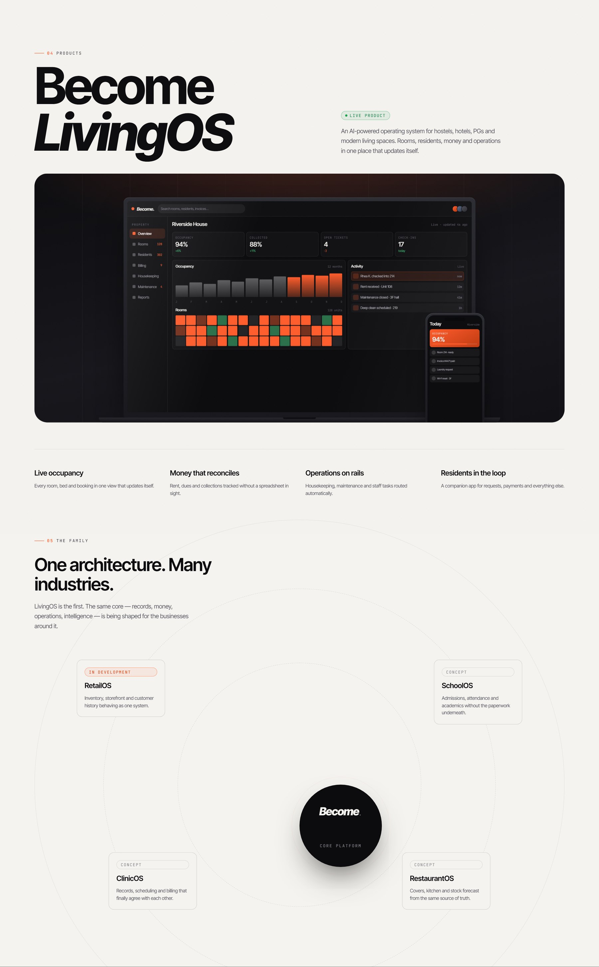
Section 07 — Products — Become LivingOS + The Family
CHANGES I WANT IN THIS SECTION

SECTION 08

Selected Work — Case carousel
#work
Role — Evidence. Six transformations expressed as before → after.
What you see
Header: “06 SELECTED WORK” with the two-line headline “What transformation / actually looks like.” and the framing line about change of state. Below is a horizontal drag carousel of large image cards, each showing a sector photograph with an overlay. Every card follows the same rigid grammar: sector label (HOSPITALITY), then the before state struck through or dimmed (NIGHT-SHIFT PHONE CALLS) → the after state in ember (AUTOMATED CHECK-IN), then a headline (“The property that runs itself at night”), a short paragraph, and technique tags (PRODUCT · MOBILE · AUTOMATION). The six cases are Hospitality, Restaurants, Retail, Education, Manufacturing and SaaS. Beneath the track sits a control bar: the hint “DRAG · SCROLL · ARROW KEYS”, a slim progress rail with a draggable thumb, and circular previous/next buttons.
What it conveys
Outcomes, not deliverables. The before→after pair is the most efficient possible way to express value, and it repeats six times so the pattern becomes the message: this company changes what a business is capable of. Notably there are no client logos or names — the focus stays on the nature of the change.
Why it matters
Prospects buy on evidence of similar problems solved. The sector spread also quietly demonstrates range, setting up the Industries section that follows.
Motion & interaction
Drag with the mouse, scroll horizontally, or use arrow keys; the thumb reflects position; cards parallax slightly and images scale on hover. Keyboard-accessible via the focusable viewport.
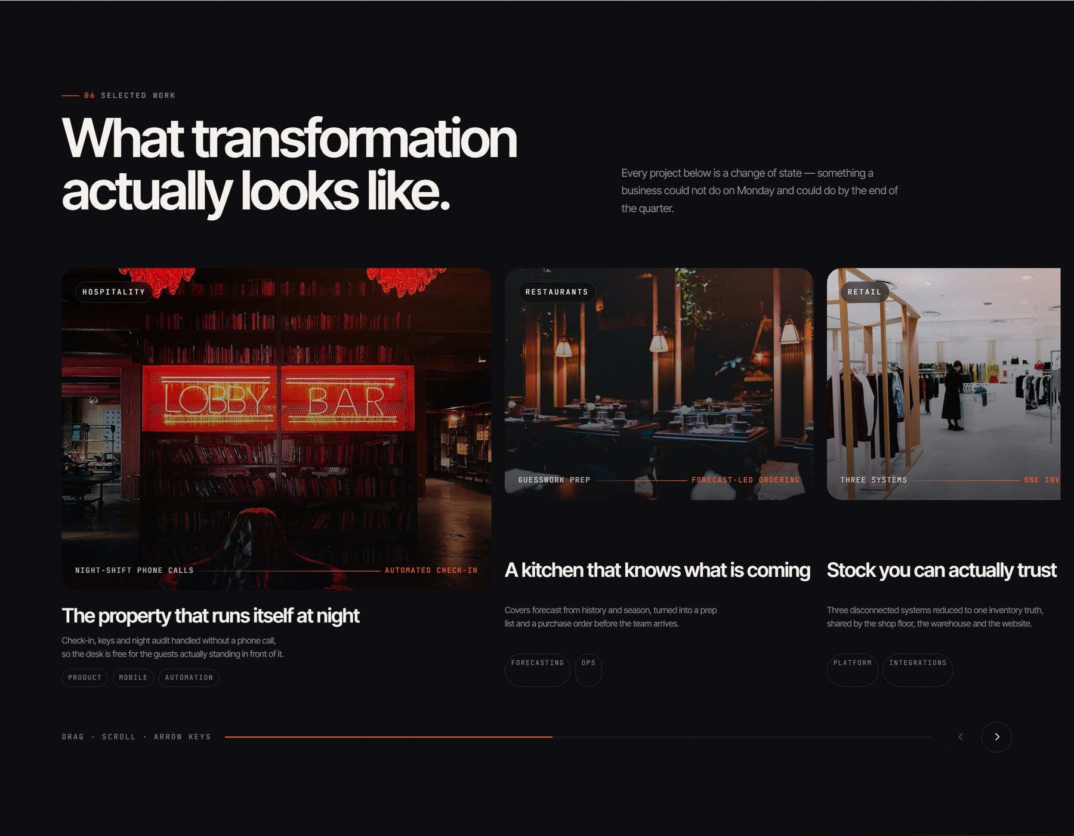
Section 08 — Selected Work — Case carousel
CHANGES I WANT IN THIS SECTION

SECTION 09

Industries — Where we work
#industries
Role — Self-identification. Helps a visitor find themselves on the page.
What you see
A soft ember bloom glows in the top-right corner. Header reads “07 INDUSTRIES” with the headline “Where we work.” and the line “Different floors, same problem underneath: information that lives in too many places and work that repeats itself.” Below is a mosaic of six large photographic tiles of uneven size, each numbered and captioned: 01 Hospitality, 02 Healthcare, 03 Retail, 04 Education, 05 Manufacturing, 06 SMEs — each with a single explanatory sentence over a darkened image.
What it conveys
Two things at once: “we have worked in your world” and, through the header line, “your problem is not actually unique”. That second point is strategically important — it justifies a shared platform core rather than bespoke builds for everyone.
Why it matters
Industry pages are how most B2B buyers self-qualify. The mosaic makes six sectors scannable in about three seconds, and the inclusion of SMEs signals the company is reachable, not enterprise-only.
Motion & interaction
Tiles reveal on scroll in a staggered sequence; images scale gently and the overlay lightens on hover.
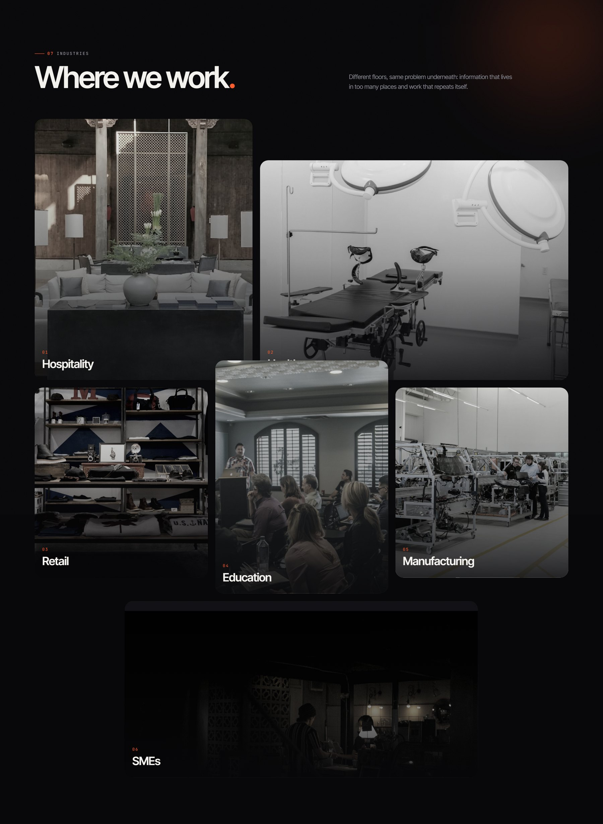
Section 09 — Industries — Where we work
CHANGES I WANT IN THIS SECTION

SECTION 10

Technology — The stack underneath
#tech
Role — Engineering credibility for the technically literate reader.
What you see
Header: “08 TECHNOLOGY”, headline “The stack underneath.”, and the caveat “Tools are a means, never the story.” The body is two counter-scrolling marquee rows of technology chips, each pairing a name with a role — Python/LANGUAGE, React/INTERFACE, Next.js/FRAMEWORK, FastAPI/SERVICES, PostgreSQL/DATA, Docker/RUNTIME, AWS/CLOUD, Azure/CLOUD, OpenAI/MODELS, TensorFlow/ML, PyTorch/ML, YOLO/VISION, OpenCV/VISION. Beneath sit three short principles: “Chosen, not collected”, “Portable by default”, “Boring where it counts”.
What it conveys
Competence with a point of view. Anyone can list logos; the three principles are what actually signal seniority — deliberately small stacks, no vendor lock-in, and unglamorous proven foundations under the interesting parts. The vision-specific entries (YOLO, OpenCV) also substantiate the computer-vision claims made earlier.
Why it matters
It de-risks the buy for a CTO or technical evaluator without derailing the narrative for a non-technical one — the marquee is skimmable, and the substance is in three sentences.
Motion & interaction
Two marquee rows moving in opposite directions, scroll-speed linked. A visually-hidden list carries the same names for screen readers and SEO.
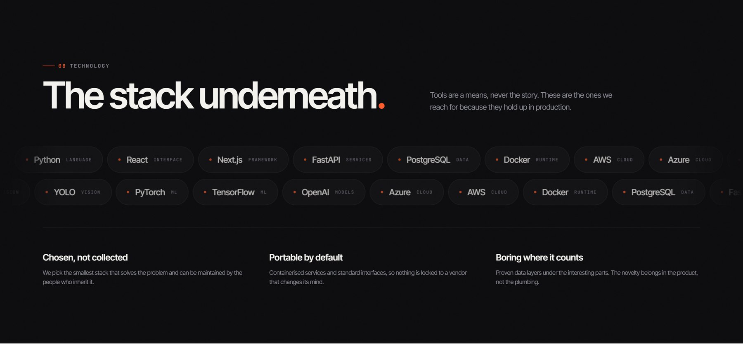
Section 10 — Technology — The stack underneath
CHANGES I WANT IN THIS SECTION

SECTION 11

Why Become — Three chapters
#why · light section
Role — How the work is done. Differentiation on method rather than capability.
What you see
Third flip to paper white. Header: “09 WHY BECOME”, headline “Three chapters.”, and the line “How the work is done matters more than the list of things we can do.” Below, three large stacked panels, each with a photographic image and a chapter label: CHAPTER 01 Think. — about refusing to answer a question nobody asked, and being willing to say the answer is not software; CHAPTER 02 Build. — design and engineering in the same room, handovers that are documented and understandable; CHAPTER 03 Scale. — software is not finished when it ships. Each carries three tags (DISCOVERY / OPPORTUNITY MAPPING / HONEST SCOPE, then DESIGN / ENGINEERING / QUALITY, then DEPLOY / AUTOMATE / EXTEND).
What it conveys
Maturity and a willingness to lose a sale. “We are willing to tell you the answer is not software” is the single most trust-building sentence on the page. Framing method as three *chapters* also implies a long relationship rather than a transaction.
Why it matters
Capability lists are commoditised — every competitor claims the same services. Method is where real differentiation lives, and this is the section that answers “why you and not them”.
Motion & interaction
Panels reveal in sequence as they enter the viewport; light background gives the eye its second rest before the process timeline.
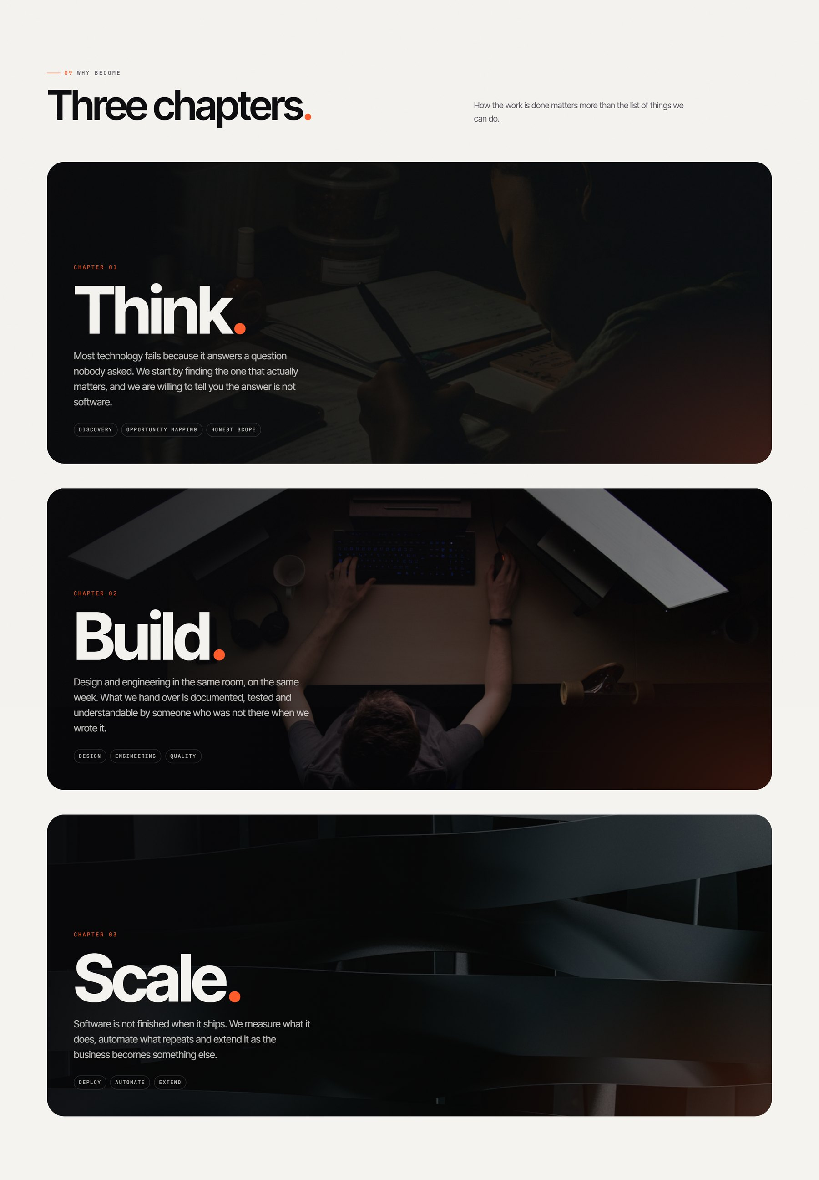
Section 11 — Why Become — Three chapters
CHANGES I WANT IN THIS SECTION

SECTION 12

Process — How it goes
#process
Role — Removes procurement anxiety by making the engagement legible.
What you see
Header: “10 PROCESS”, headline “How it goes.”, and the line “Five stages, run collaboratively. You are in the room for all of them.” Below runs a horizontal timeline: a thin ember rule connecting five filled ember circles numbered 01–05. Under each node sits a stage name and description — 01 Discover (“We sit with the problem before we touch a tool”), 02 Design, 03 Develop, 04 Deploy, 05 Grow. Critically, each stage ends with an ember arrow and a stated deliverable: → A DECISION, NOT A DECK · → A PROTOTYPE YOU CAN USE · → WORKING SOFTWARE · → LIVE, AND OBSERVABLE · → COMPOUNDING RETURNS.
What it conveys
Predictability and discipline. The named output per stage is the strategic move — it converts an abstract process into five things the client will physically receive. “A decision, not a deck” is a direct swipe at consultancy theatre.
Why it matters
The most common reason a qualified buyer stalls is uncertainty about what happens after they sign. This section answers that immediately before the contact form, which is exactly the right position for it.
Motion & interaction
The connecting ember line draws itself left-to-right as the section scrolls into view, and the nodes light up in sequence.
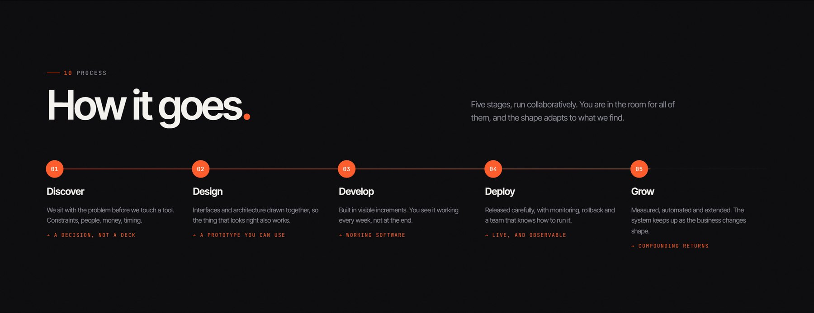
Section 12 — Process — How it goes
CHANGES I WANT IN THIS SECTION

SECTION 13

Contact — Tell us what should be different
#contact
Role — Conversion. The commercial purpose of the whole page.
What you see
A dark atmospheric curve image sits behind a two-column layout. Left: “11 CONTACT” and the headline “Tell us what should / be different.” (‘different’ in italic serif), with the instruction “Bring the problem, not the specification. If software is the wrong answer we will say so.” Beneath it a definition list of details — EMAIL hello@become.example · PHONE +00 00000 00000 · STUDIO Studio address, City, Country · HOURS Mon–Fri, 10:00–19:00 — and social links (LinkedIn, Instagram, X, GitHub). Right: a glass-panelled form with paired fields — Your name / Email, then Company / What do you need (a nine-option dropdown from Software product through to “Not sure yet”) — followed by a large textarea labelled “What should be different?” with the placeholder “The thing that is slow, manual, invisible or breaking.” Footer note and an ember “Send it over” button.
What it conveys
Low friction and consultative intent. Asking “what should be different?” instead of “your message” keeps the whole page's thesis alive right up to the point of conversion, and the “Not sure yet” option removes the last excuse a hesitant lead could use.
Why it matters
Everything preceding exists to deliver a visitor here. The qualifying dropdown also routes and pre-qualifies enquiries before a human reads them.
Motion & interaction
Fields animate on focus with inline validation messages; the form panel scales in on scroll; the submit button is magnetic.
⚠ Needs attention before launch — Placeholder data — the email, phone and studio address are all dummy values, and the form currently opens the visitor's own email client rather than posting to a backend. Both need to be replaced before launch.
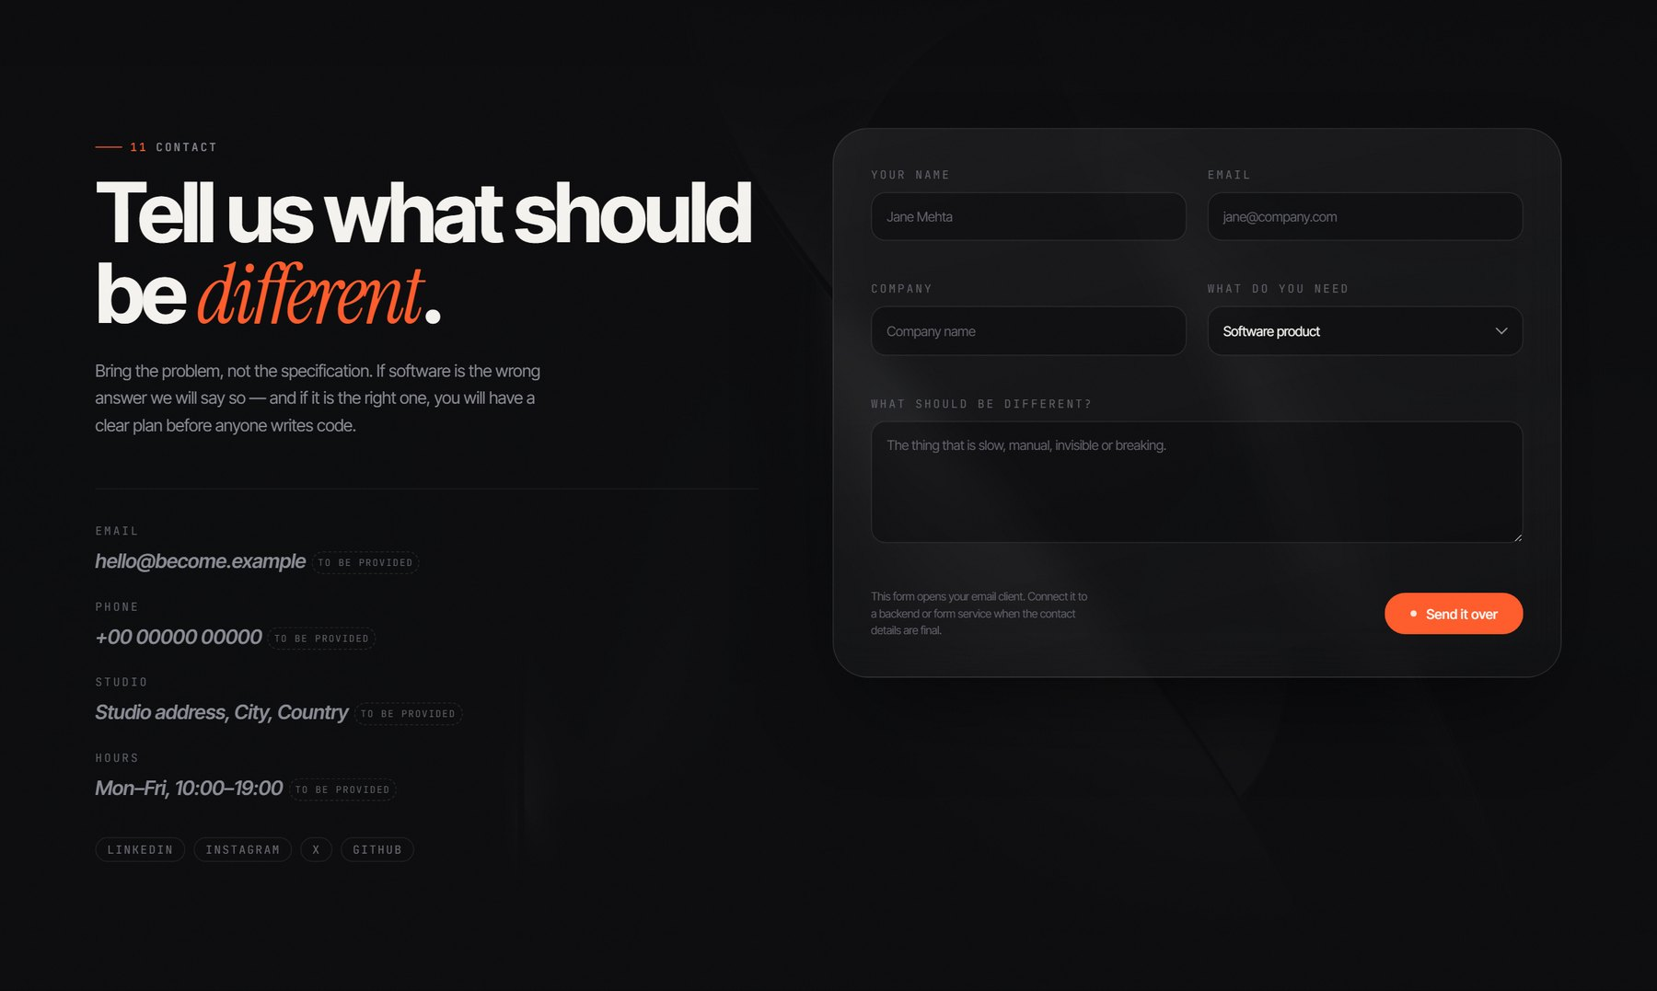
Section 13 — Contact — Tell us what should be different
CHANGES I WANT IN THIS SECTION

SECTION 14

Finale — Become what is next
#finale
Role — The closing frame. Last emotional beat and second conversion chance.
What you see
Full-bleed dark tunnel image (accent-tunnel.jpg) under a veil, with everything centred. The wordmark “Become.” sits large with the ember stop, then “Become what is next.” with ‘what is next’ in italic serif, then the closing thought: “Every business is on its way to being something else. The only question is whether that happens on purpose.” Two buttons follow — filled ember “Let's build together” and outlined “Explore the products”.
What it conveys
Inevitability, and a challenge. The final line reframes the entire decision: change is happening to you regardless, so the only real choice is whether you direct it. That converts hesitation into urgency without any discount-and-deadline pressure.
Why it matters
It captures visitors who scrolled the whole page without converting, and it is the last thing anyone remembers. Offering both a sales CTA and a product CTA respects that not every visitor is ready to talk.
Motion & interaction
The wordmark scales in, lines rise in sequence at 120/220/300ms, background parallaxes at 0.12. A looping film at assets/video/finale.mp4 will replace the still if added — currently absent.
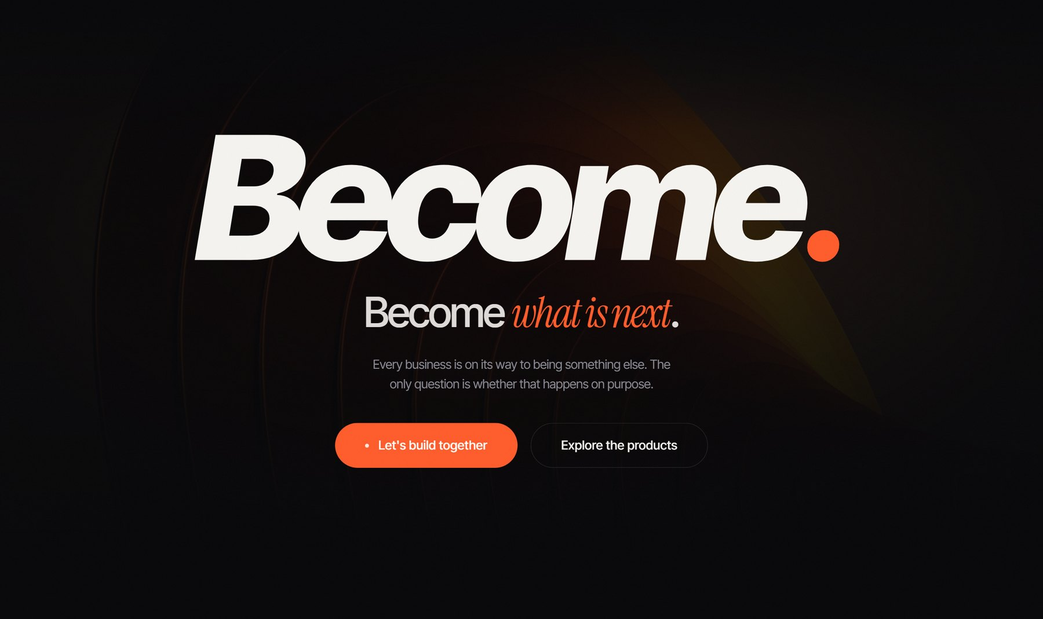
Section 14 — Finale — Become what is next
CHANGES I WANT IN THIS SECTION

SECTION 15

Footer
footer.footer
Role — Deep navigation, legal, and one last brand impression.
What you see
A four-column grid on near-black. Left column holds the Become. logo image, the tagline “Technology that transforms businesses.”, and an arrow link “Start a transformation →”. The three link columns are PRODUCTS (Become LivingOS, RetailOS, SchoolOS, ClinicOS, RestaurantOS), SOLUTIONS (all six service lines) and COMPANY (Why Become, Process, Selected Work, Industries, Contact). A divider rule sits above the bottom bar carrying “© 2026 Become. All rights reserved.” and Privacy / Terms / Cookies links. Beneath everything, an oversized ghosted “Become.” watermark spans the full width.
What it conveys
Completeness and permanence — the roadmap products appearing as real footer links makes the platform story feel committed rather than speculative. The giant watermark leaves the name as the final visual impression.
Why it matters
Footers carry a meaningful share of navigation for users who scroll to the end looking for something specific, and the link structure is significant for SEO.
Motion & interaction
Mostly static; links have arrow/underline hover states. A circular “back to top” button floats at the bottom-right corner of the viewport throughout the page.
⚠ Needs attention before launch — Privacy, Terms and Cookies all currently link to #top — they need real pages before launch.
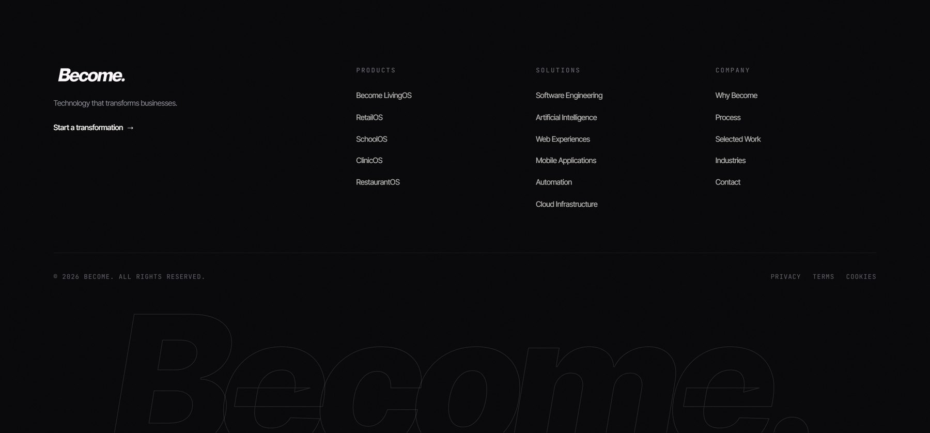
Section 15 — Footer
CHANGES I WANT IN THIS SECTION

Open items across the site
Things that are placeholder or missing rather than designed, noted here so they are not mistaken for creative decisions:
- Contact details are dummy values — hello@become.example, +00 00000 00000, “Studio address, City, Country”.
- The contact form opens the visitor's email client instead of posting to a backend or form service.
- Privacy, Terms and Cookies all link to #top; no legal pages exist yet.
- assets/video/hero.mp4 and assets/video/finale.mp4 are absent, so the Hero and Finale fall back to stills. Both sections are already wired to use the video automatically once the files are dropped in.
- Selected Work carries no client names or logos — deliberate for now, but worth revisiting for credibility.
- The AI console is explicitly labelled “Simulated”, which is honest; swapping in a genuinely live demo would make the strongest section on the page stronger still.

