USER MANUAL
GraphRAG-Powered Cyber Threat Intelligence Platform
CTI Workstation — installation, operation and administration
Item | Value
Version | 1.0 (Review III), October 2026
Audience | SOC analysts, CTI leads, platform operators, and engineers integrating firewalls, EDR or SIEM
Authors | Shivansh Sharma (23BCE0254)  Himali Sharma (23BCE0317)  Aayush Sinha (23BCE0558)
Institution / guide | VIT Vellore · Dr. Lydia Jane G
Source | github.com/Shivansharmaaaa/graphrag

Contents
Section | Page
1. About This Manual | 3
2. System Overview | 3
3. Installation | 5
4. Signing In | 6
5. Using the Console | 8
6. Walkthroughs | 15
7. Enforcement API for Security Tools | 16
8. Inspecting the Databases Directly | 17
9. Configuration Reference | 20
10. Administration and Maintenance | 20
11. Troubleshooting | 21
12. Glossary | 21

1. About This Manual
This manual explains how to install the CTI Workstation, use each page of the analyst console, connect enforcement tools, and keep the platform healthy. Design rationale and measurements are in the separate Final Report.
If you are… | Read
an analyst | Sections 4, 5 and 6
a CTI lead or detection engineer | also 5.4 (blocklist), 5.6 (ingest) and 7
a platform operator | Sections 3, 8, 9 and 10
integrating a firewall, EDR or SIEM | Section 7
showing the databases themselves | Section 8

Conventions. Commands are shown in a monospace box and run from the project folder (nosql/). Text in monospace is typed exactly. Screens are shown in the console's dark theme.

2. System Overview
The workstation stores cyber threat intelligence in four databases, each used for what it does best, and answers questions in plain English using all four at once.
Store | Holds | You see it in
Neo4j | the threat graph: actors, campaigns, malware, infrastructure, techniques, victims, indicators, reports | Graph explorer; graph hops in GraphRAG answers
MongoDB | full reports, STIX bundles, users, audit log, ingest log | Report browser; documents in answers; Audit
Redis | the live IOC blocklist, each entry expiring after its TTL | IOC blocklist; IOC state in answers
Qdrant | report passages as vectors for similarity search | Semantic search; passages in answers

GraphRAG answers. When you ask a question, the system retrieves passages, graph paths, reports and IOC states, and a local language model writes the answer. Every sentence must cite evidence; sentences without a valid citation are removed, and if too few remain the answer is replaced by an evidence-only summary or a refusal.
Roles and clearance. Each account has a role that limits what it can change and a TLP clearance that limits what it can read.
Role | Can | Cannot
analyst | ask questions, browse the graph and reports, search, view the blocklist and own audit entries | publish IOCs, ingest, run admin actions
lead | everything an analyst can, plus publish and revoke IOCs and ingest reports or STIX bundles | re-seed, reindex, delete reports
admin | everything, including re-seed, vector reindex, report deletion and all users' audit entries | —

TLP | Meaning for this platform (FIRST TLP 2.0)
WHITE / CLEAR | no restriction
GREEN | community use; visible to GREEN clearance and above
AMBER | limited distribution; hidden from GREEN accounts (list, search and GraphRAG), detail page returns 403
RED | named recipients only; visible to RED clearance

3. Installation

3.1 Requirements
Component | Requirement
Operating system | macOS, Linux, or Windows with WSL 2
Docker | Docker Desktop or Docker Engine with Compose v2; at least 4 GB of memory for the containers
Python | 3.10 or newer (3.11 tested)
Node.js | 18 or newer, for the console
Ollama (optional) | for fluent answers; without it the platform answers in retrieve-only mode
Ports | 5173 (console), 8000 (API), 7474/7687 (Neo4j), 27017 (MongoDB), 6379 (Redis), 6333 (Qdrant), 11434 (Ollama)

3.2 Option A — run the API and console locally
cp .env.example .env
docker compose up -d # Neo4j, MongoDB, Redis, Qdrant (wait ~30 s)
python3 -m venv .venv && .venv/bin/pip install -r backend/requirements.txt
make api # terminal 1: API on http://localhost:8000
make web # terminal 2: console on http://localhost:5173
On its first start the API creates the database schema and loads the seed corpus into all four stores; this takes a few seconds. API documentation is served at http://localhost:8000/docs.

3.3 Option B — everything in containers
cp .env.example .env
docker compose --profile app up -d --build # stores + API + console on :5173
To stop: docker compose --profile app stop. Stop the containerised API and console before using Option A, because both use ports 8000 and 5173.

3.4 Local language model
ollama pull llama3.2:3b # default model, meets the 15 s answer target
ollama pull llama3.1 # optional: fuller answers, slower (set OLLAMA_MODEL=llama3.1)
The llm dot in the console sidebar turns green when Ollama is reachable and the configured model is pulled. In containers, the API reaches Ollama on the host through host.docker.internal; to run Ollama in a container instead, add --profile llm and set OLLAMA_URL_DOCKER=http://ollama:11434 in .env.

3.5 Check the installation
curl -s http://localhost:8000/api/health # "startup": {"ok": true, "detail": "ready"}
make test # 18 unit tests, no databases needed
make test-integration # 16 API tests against the running stores

3.6 Real threat intelligence (optional)
The seed corpus is small and curated. To add real, public threat intelligence on top of it, run:
make import-feeds # MITRE ATT&CK, abuse.ch Feodo Tracker, Emerging Threats (a few minutes)
# then restart the API (stop make api, start it again)
This downloads MITRE ATT&CK Enterprise (178 groups, 842 malware families and tools, 227 techniques, 57 campaigns), the abuse.ch Feodo Tracker botnet C2 list and the Emerging Threats compromised-host list. ATT&CK groups that already exist in the corpus (APT28, Sandworm …) are merged, not duplicated. Every group and campaign gets a report in the Report browser, and the feed IPs go on the blocklist with a TTL of one to seven days. Run it again to refresh; run it again after make seed, which removes it.

3.7 Hosted databases (optional)
Instead of local containers, the four databases can run on their vendors' free cloud services: Neo4j AuraDB, MongoDB Atlas, Redis Cloud and Qdrant Cloud. docs/cloud-setup.md explains how to create each one. Put the connection details in .env.cloud (never commit it), then:
make cloud-check # connects read-only; every line must say OK … hosted
make cloud-seed # schema + seed corpus into the hosted databases
make cloud-import-feeds # real threat intelligence (about 5 minutes)
make cloud-api # API on :8000 against the hosted databases; then make web
Operations then shows each store's cloud hostname. MongoDB Atlas only accepts computers whose IP address is on its access list: if make cloud-check reports an SSL or TLS error for MongoDB, add your current IP under Atlas → Security → Network Access.

4. Signing In
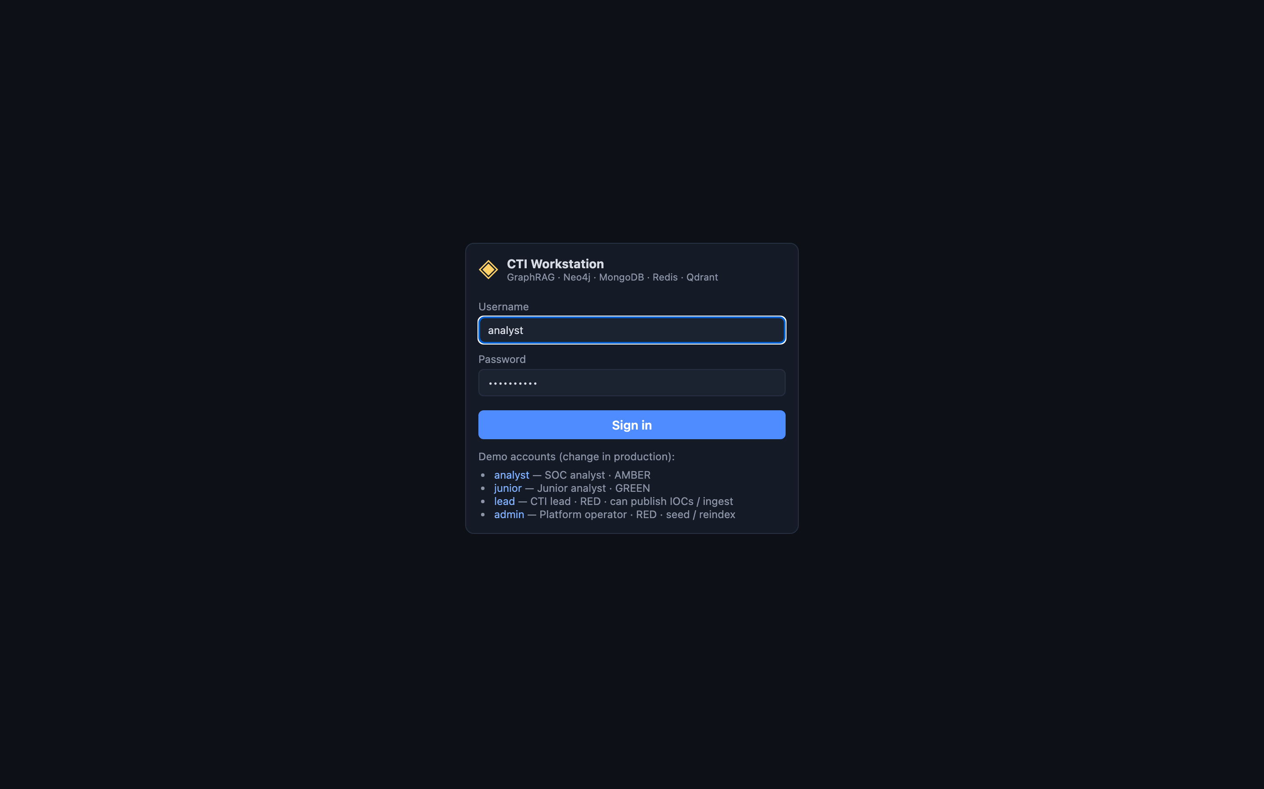
Figure 1. Sign-in page with the demo accounts.
Account / password | Role | Clearance | Use it to
analyst / analyst123 | analyst | AMBER | explore and ask questions
junior / junior123 | analyst | GREEN | see TLP filtering (AMBER hidden)
lead / lead123 | lead | RED | publish IOCs and ingest
admin / admin123 | admin | RED | re-seed, reindex, delete reports

Click an account name to fill the form, or type the credentials and press Sign in. A session lasts eight hours; when it expires you are returned to this page. The sidebar shows your name, role and clearance, the health of each store, and Sign out.
Change these passwords and the session secret before using the platform outside a lab (JWT_SECRET in .env). The demo accounts are created automatically when the user collection is empty.

5. Using the Console

5.1 GraphRAG console
Type a question, or click one of the six example questions, and press Ask. hops (1–3) sets how far the graph is expanded from the entities named in the question, top-k chunks how many passages are retrieved, and use local LLM switches between a written answer and an evidence-only (retrieve-only) answer.
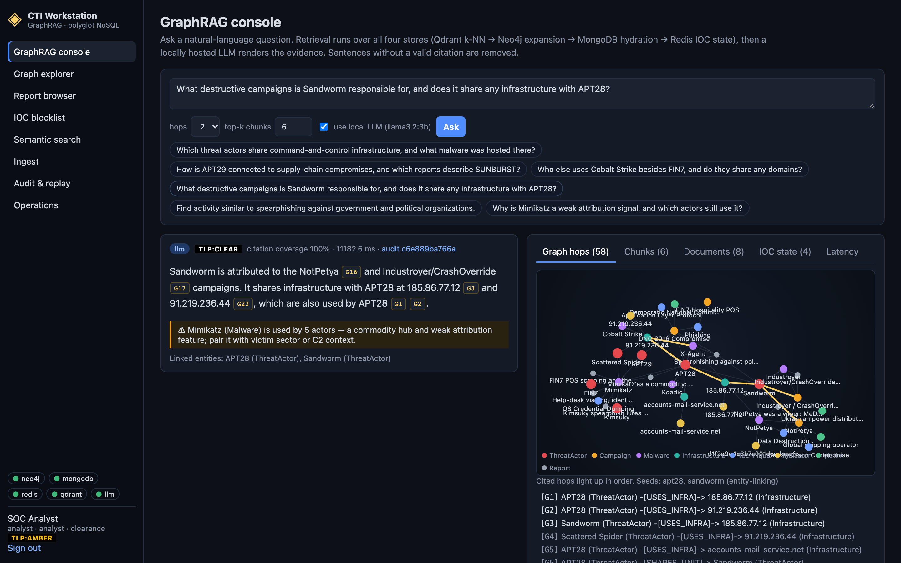
Figure 2. A cited answer with a commodity-tool caution and the evidence panel.
Element | Meaning
mode badge | llm (written by the model) or retrieve-only (evidence sentences; used when the LLM is off, down, or its answer failed the citation check)
TLP badge | the highest TLP among the reports the answer cites
citation coverage | share of the model's sentences that carried a valid citation; below 50% the answer is refused
citation chips | G = graph edge, C = passage, R = report, I = IOC state; click one to highlight it in the evidence panel
⚠ caution | shown when a tool used by many actors (for example Mimikatz) appears: it is weak evidence of attribution
removed sentences | expand to see sentences the groundedness gate dropped
audit link | opens the stored record of this answer for replay

The evidence panel has five tabs: Graph hops (an animated graph and the numbered facts), Chunks (passages with similarity scores and a 2-D similarity map), Documents (reports used, with their report-specific fields), IOC state (live or expired on the blocklist, with remaining TTL) and Latency (time spent in each store and the model).
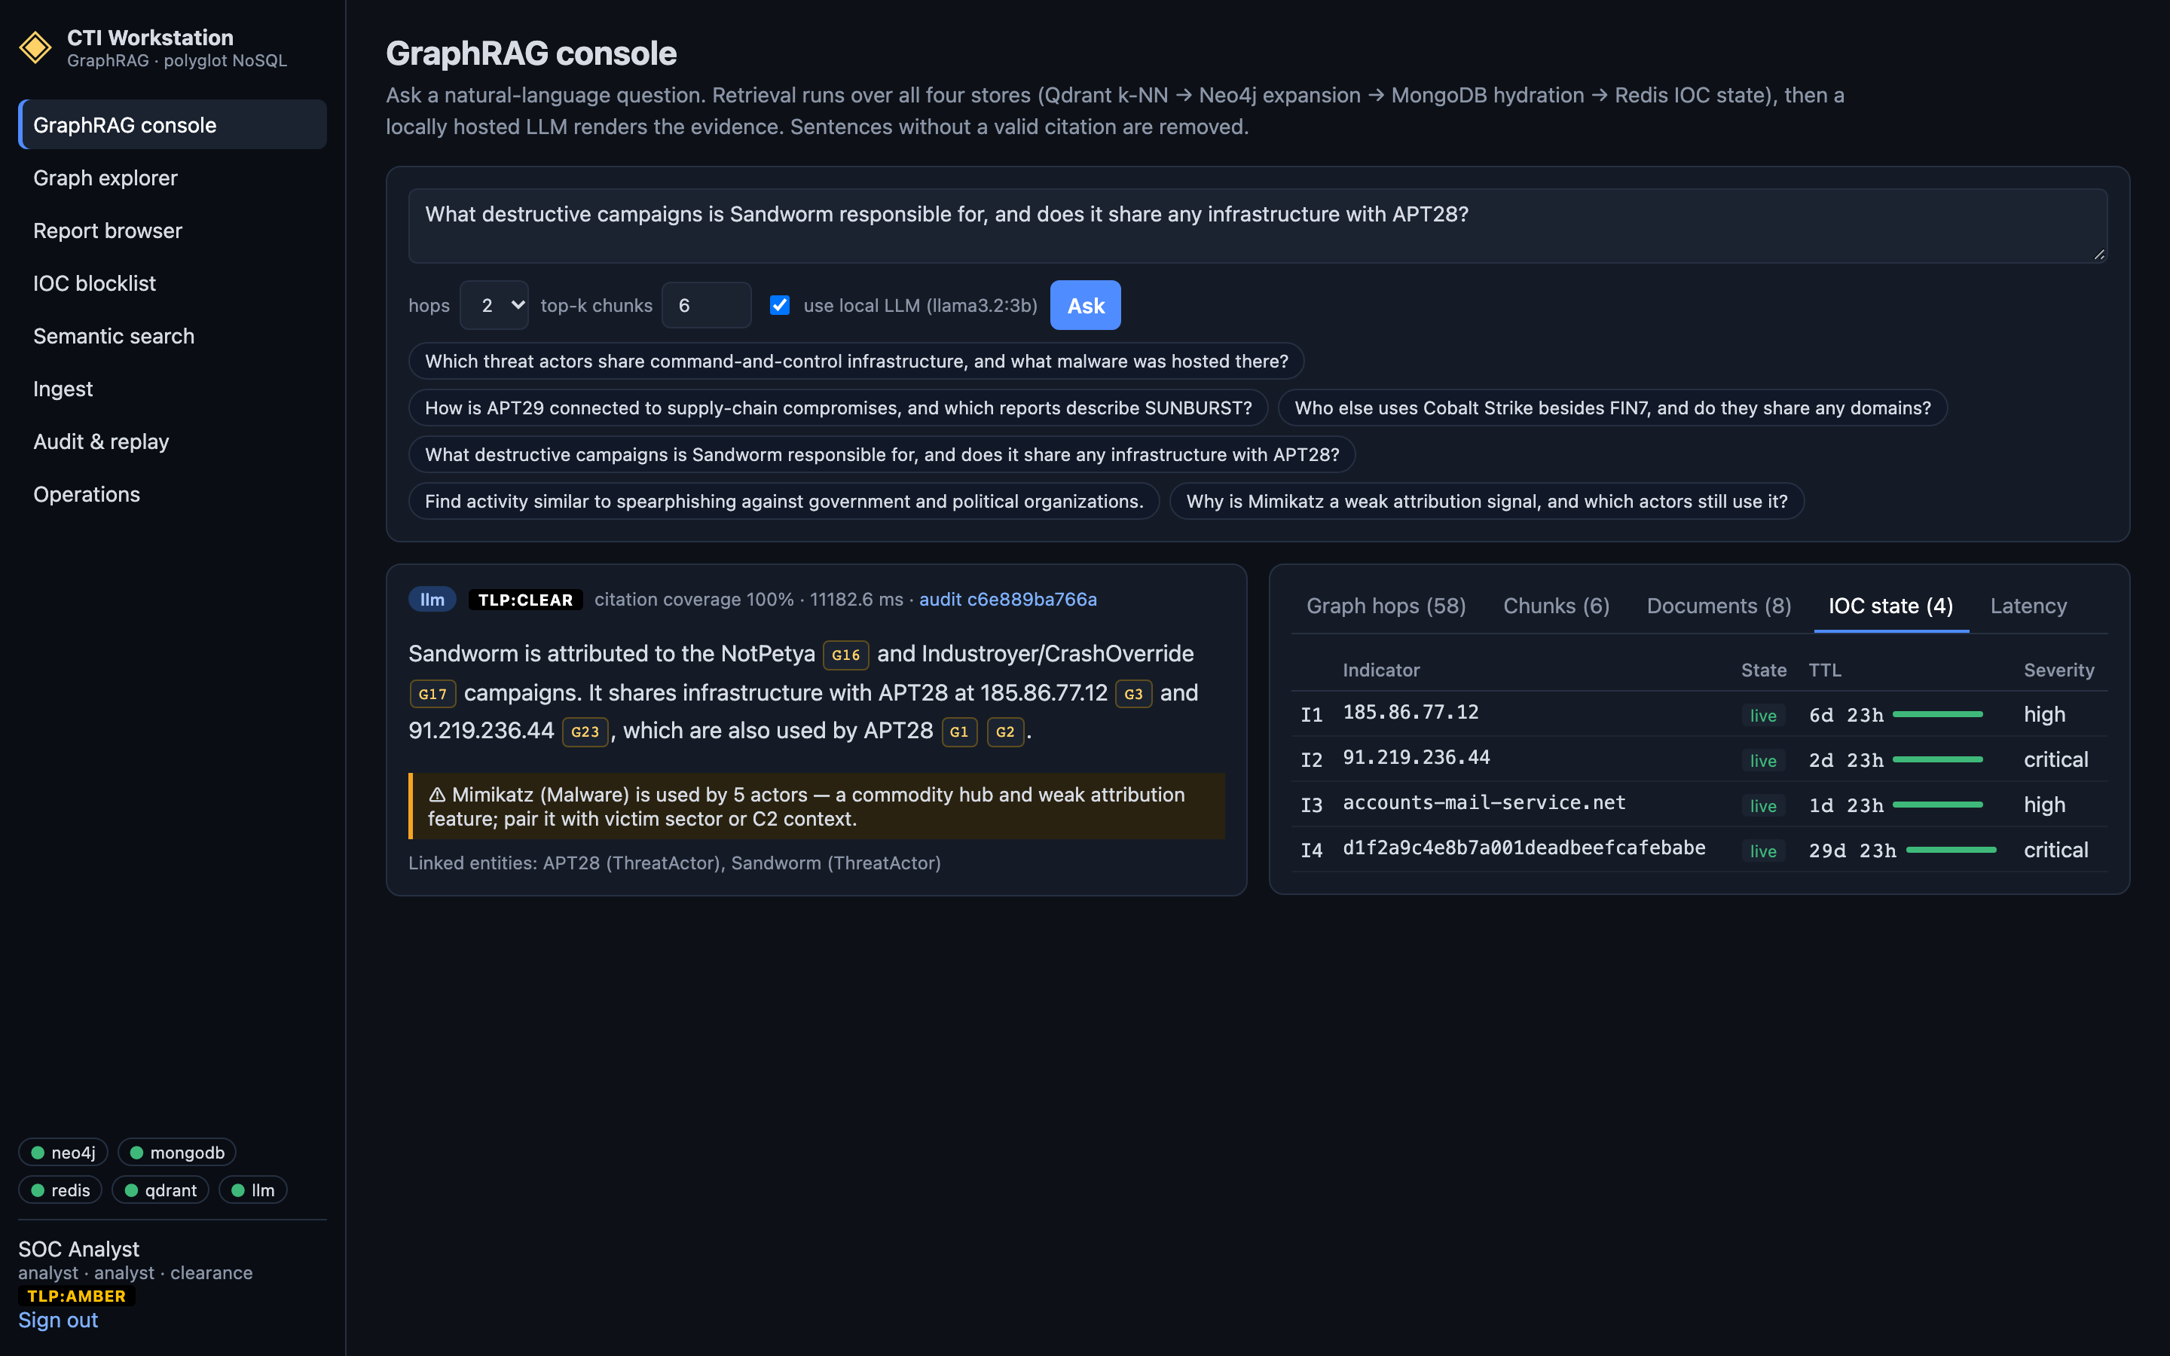
Figure 3. IOC state tab: whether each indicator in the evidence is live on the blocklist.

5.2 Graph explorer
Shows the whole graph (reports hidden). Search by name, alias, id or IOC value; click a node to open its neighbourhood; run the presets — shared infrastructure, shared tooling, common victims, tool users — or find the shortest path between two ids. Traversals stop at commodity hubs so that tools such as Cobalt Strike do not swamp the view.
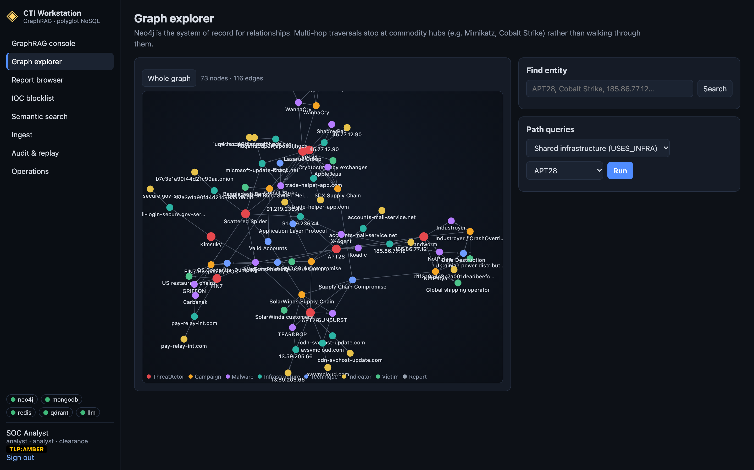
Figure 4. Graph explorer.

5.3 Report browser
Lists the reports your clearance allows, newest first, with their report-specific fields; filter by text, actor id or TLP. Opening a report shows the full body, linked actors, campaigns, malware and IOCs. An administrator can delete a report, which also removes its passages and graph links. Accounts without clearance see a notice of how many reports are hidden, and opening one returns “withheld by TLP policy”.
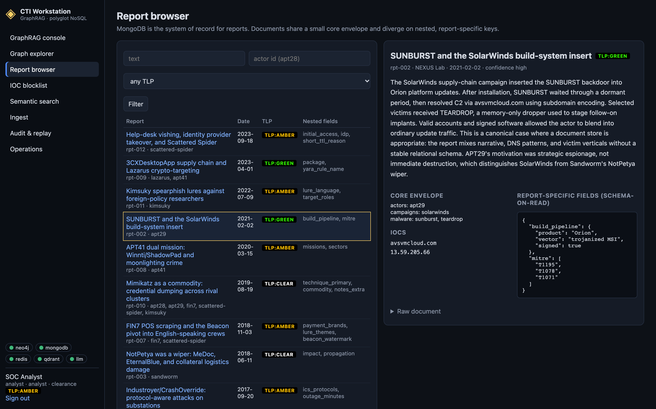
Figure 5. Report detail, including fields specific to this report (build pipeline, MITRE techniques).

5.4 IOC blocklist
The hot set lists live indicators with severity, actor or campaign, publisher and a ticking TTL. When a TTL reaches zero the indicator moves to Recently expired: it is no longer enforced, but show historical graph presence proves the graph still records it. O(1) lookup checks a single value the way a firewall would.
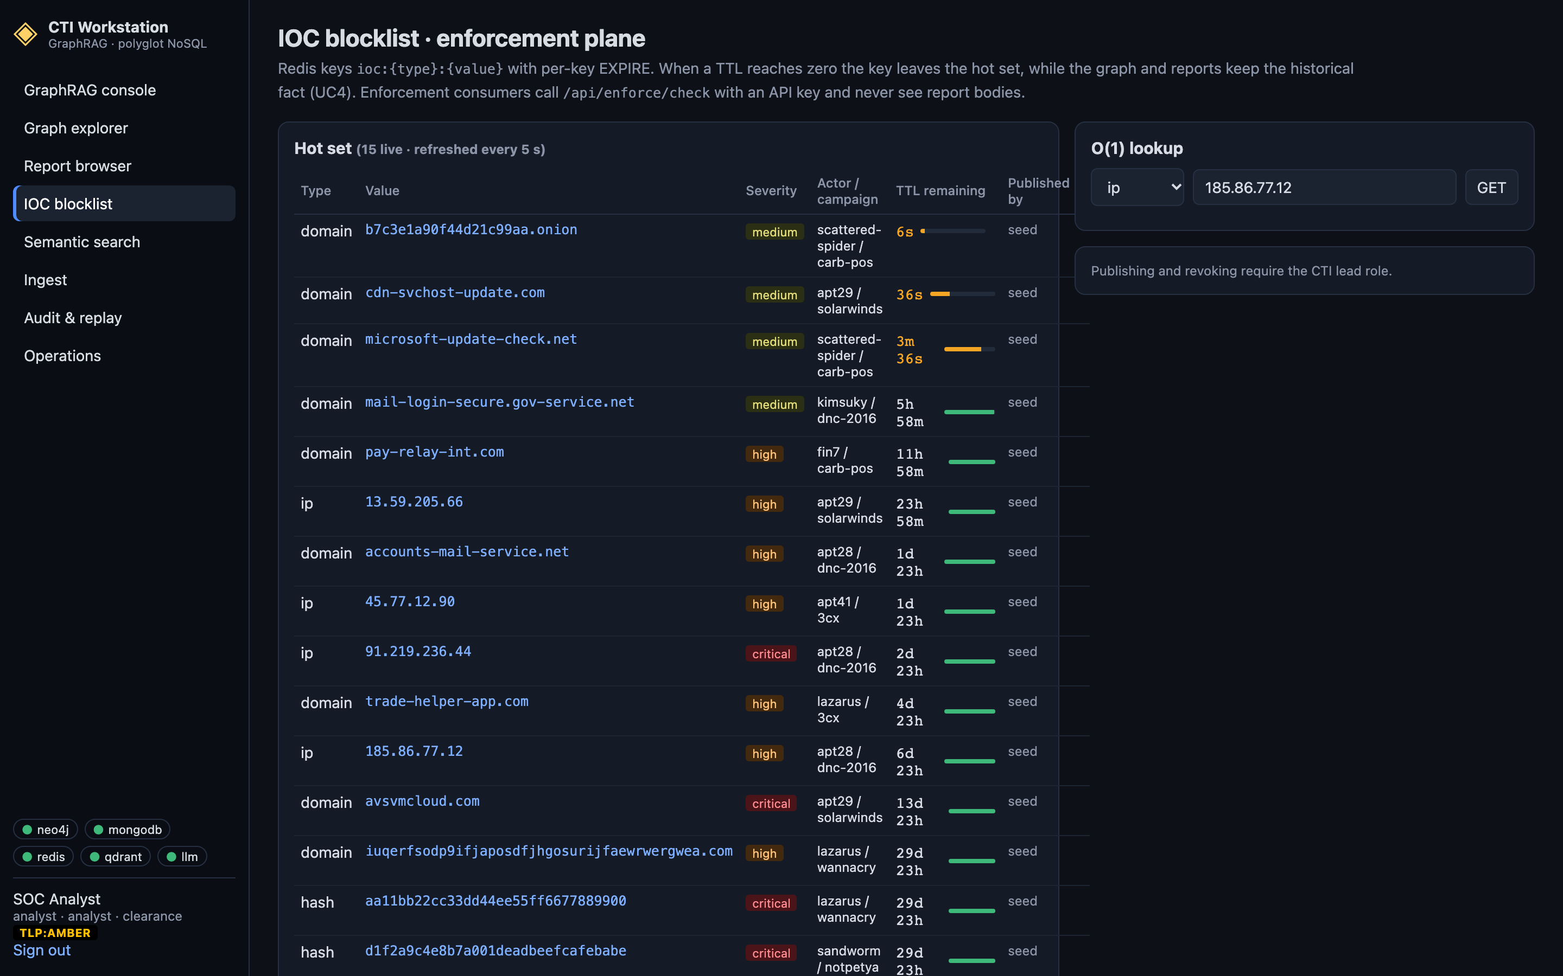
Figure 6. IOC blocklist with live TTLs.
Requests blocked by the API. Any request to the platform's API from an IP address that is live on this blocklist is refused with HTTP 403 — the address is treated as hostile. Each refusal appears in this card with its time, source IP, request and the blocklist key that matched. The log is kept in MongoDB and deleted automatically after 7 days (a TTL index); the block itself ends when the blocklist entry's TTL runs out or it is revoked.
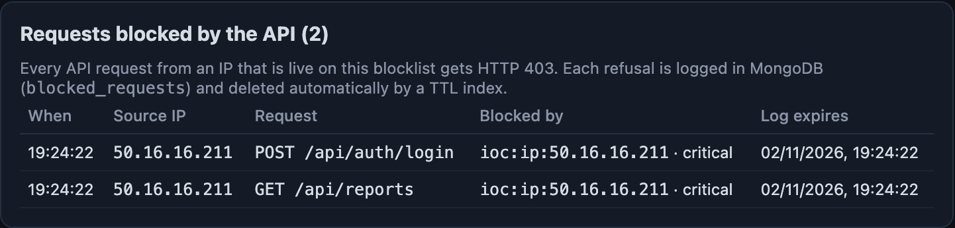
Figure 7. Requests from the QakBot C2 address 50.16.16.211 (abuse.ch Feodo Tracker) refused by the API.
Publishing (lead or admin). Fill in type (ip, domain, hash, url), value, TTL in seconds (up to 90 days), severity and optionally actor and campaign, then press SET … EX. revoke removes an entry immediately. Neither action changes the historical graph.

5.5 Semantic search
Finds passages that mean something similar to your text, not just matching words. Filter by actor ids, TLP levels and a date range; results show the score, report, TLP and passage, plus a similarity map. Use it for questions like “what else looks like this lure?”; use the graph explorer for “who is connected to whom?”.
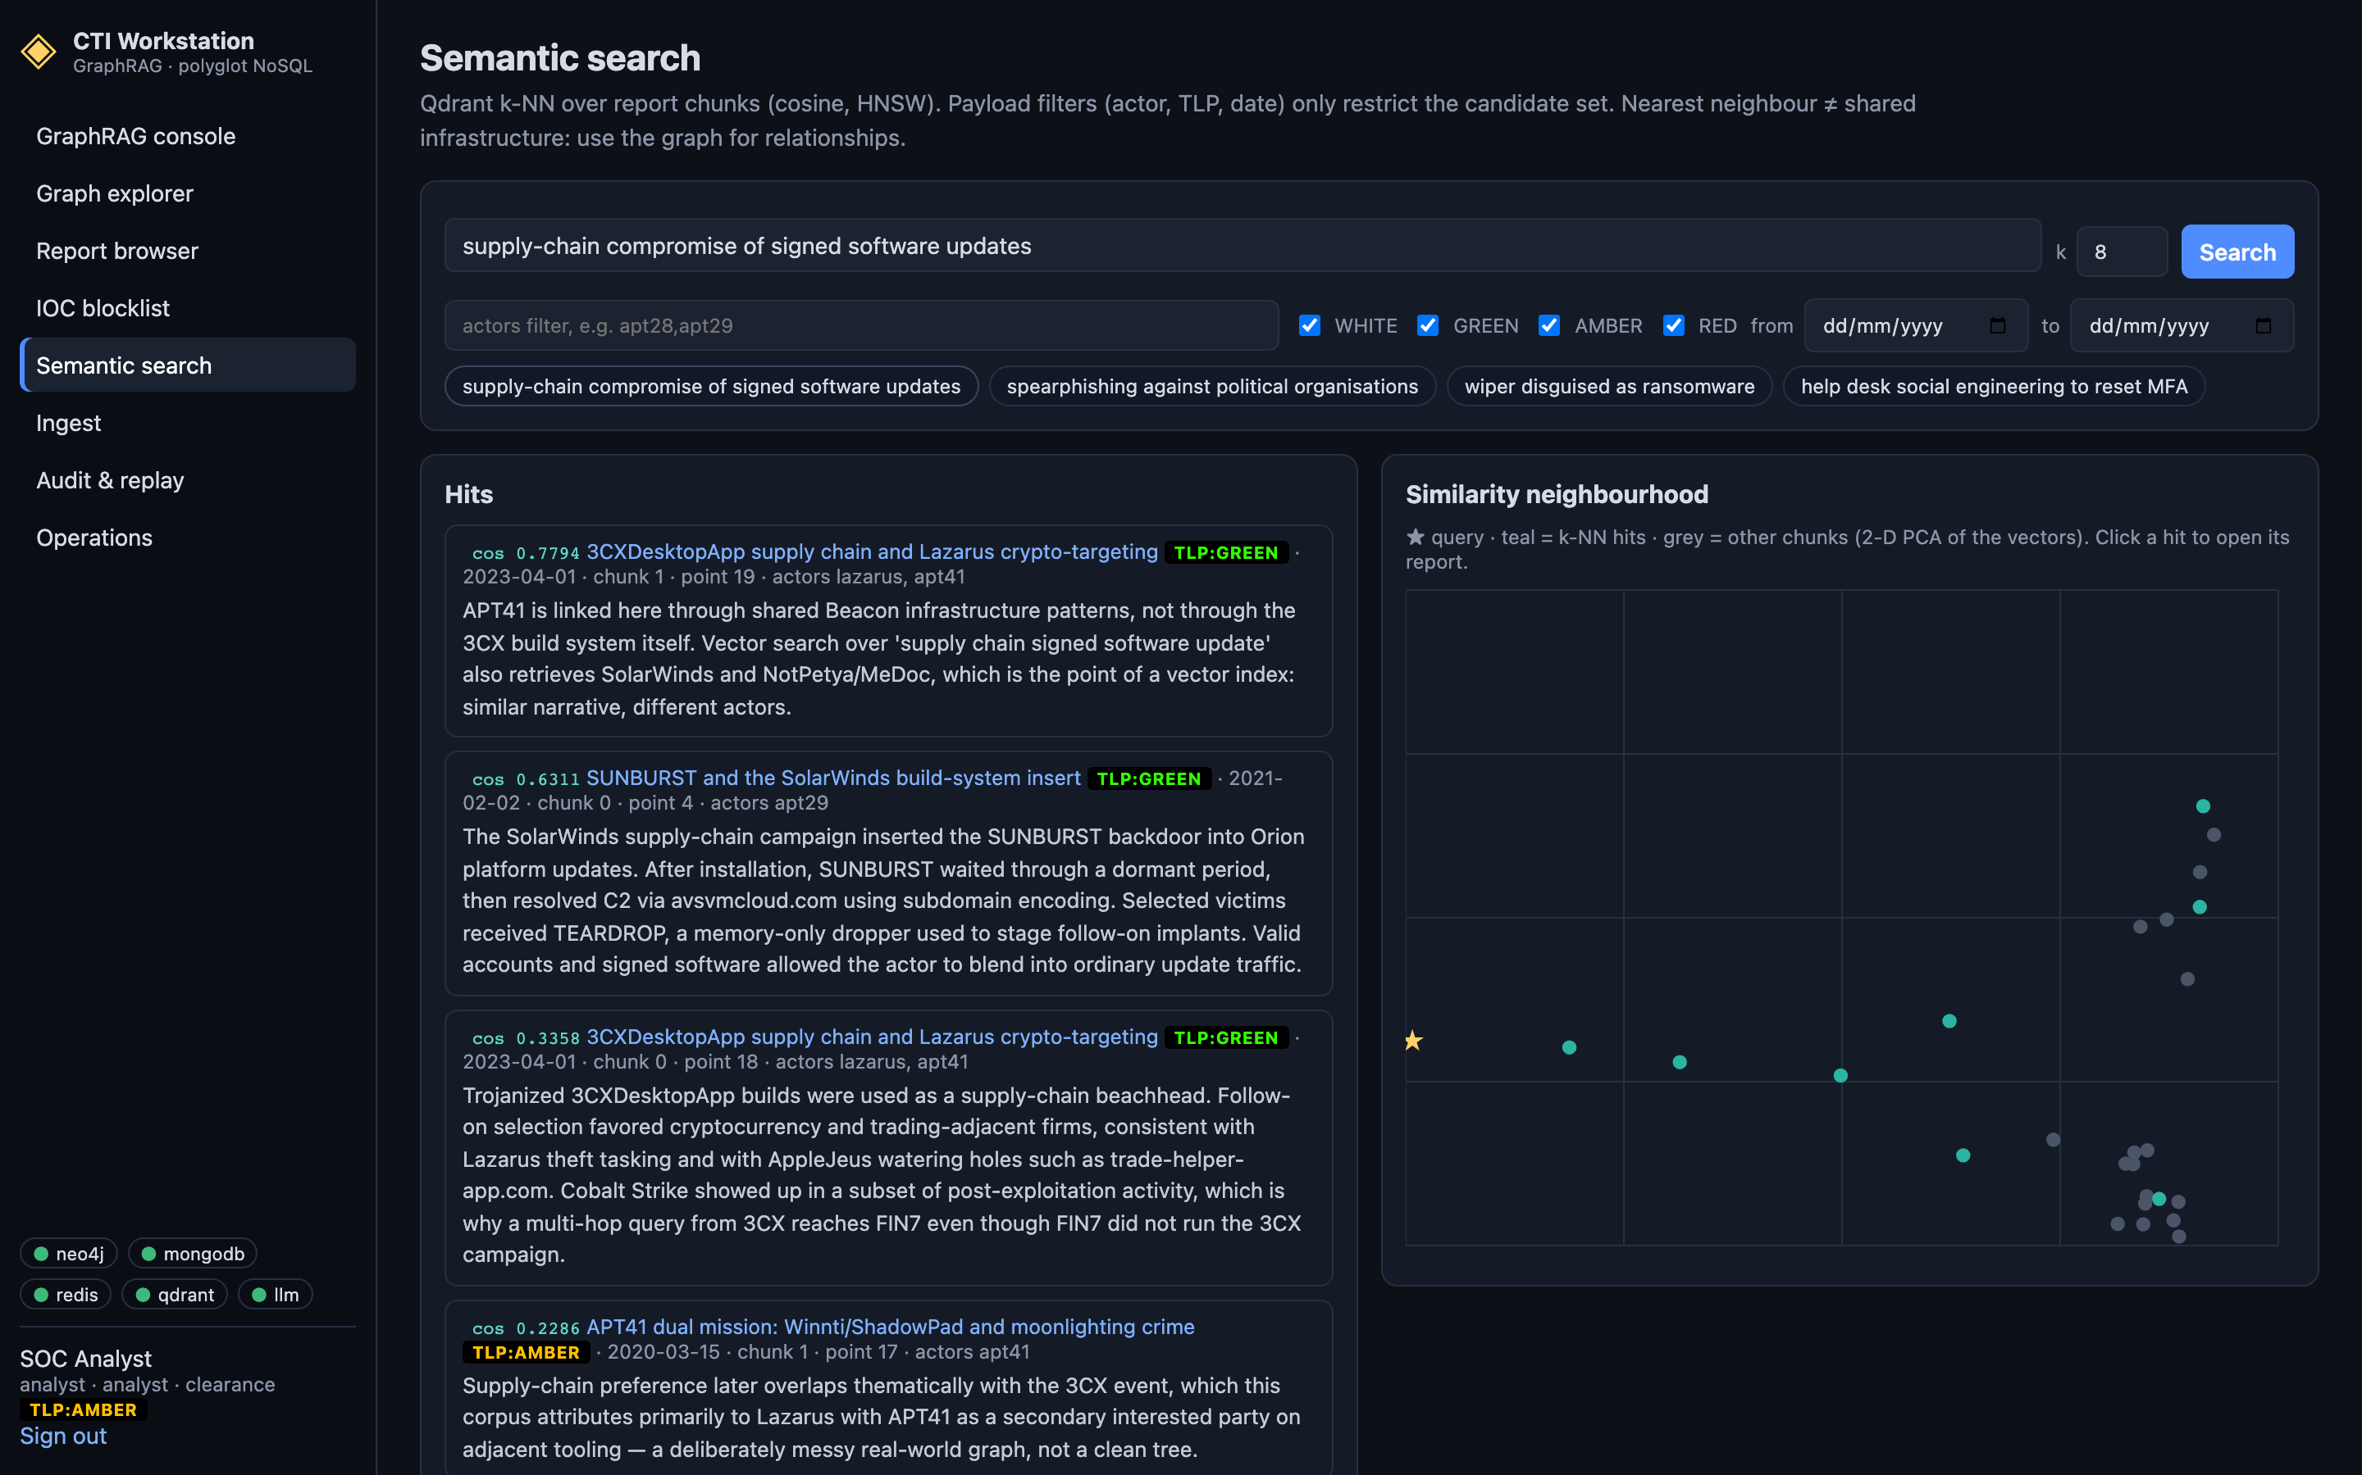
Figure 8. Semantic search.

5.6 Ingest (lead or admin)
Free-text report: enter title, body, source, date, TLP and optional report-specific fields as JSON. Entities and IOCs are found automatically, and defanged IOCs (hxxp, [.]) are restored. STIX 2.1 bundle: choose a .json file or paste a bundle; TLP is read from marking definitions, and valid_until becomes the blocklist TTL if publish indicators is ticked.
Run ingest job writes to Neo4j, MongoDB, Qdrant and (if requested) Redis, showing each step's status and time. If a step fails, fix the cause and press retry: the job resumes from the first step that did not finish.
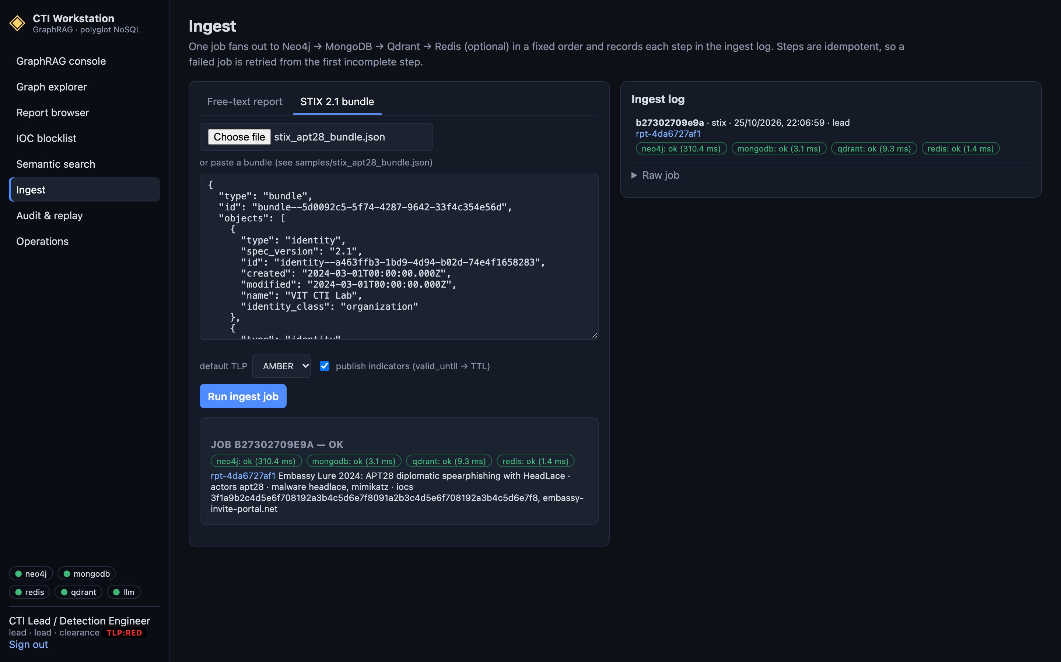
Figure 9. Ingesting the sample STIX bundle: each store's step and the resulting report.

5.7 Audit and replay
Every answer is recorded with the hops, passages, reports and IOC states it used. Select an entry and press Replay against the stores to check each item still exists and whether any IOC has changed state since — for example, an indicator that has expired.
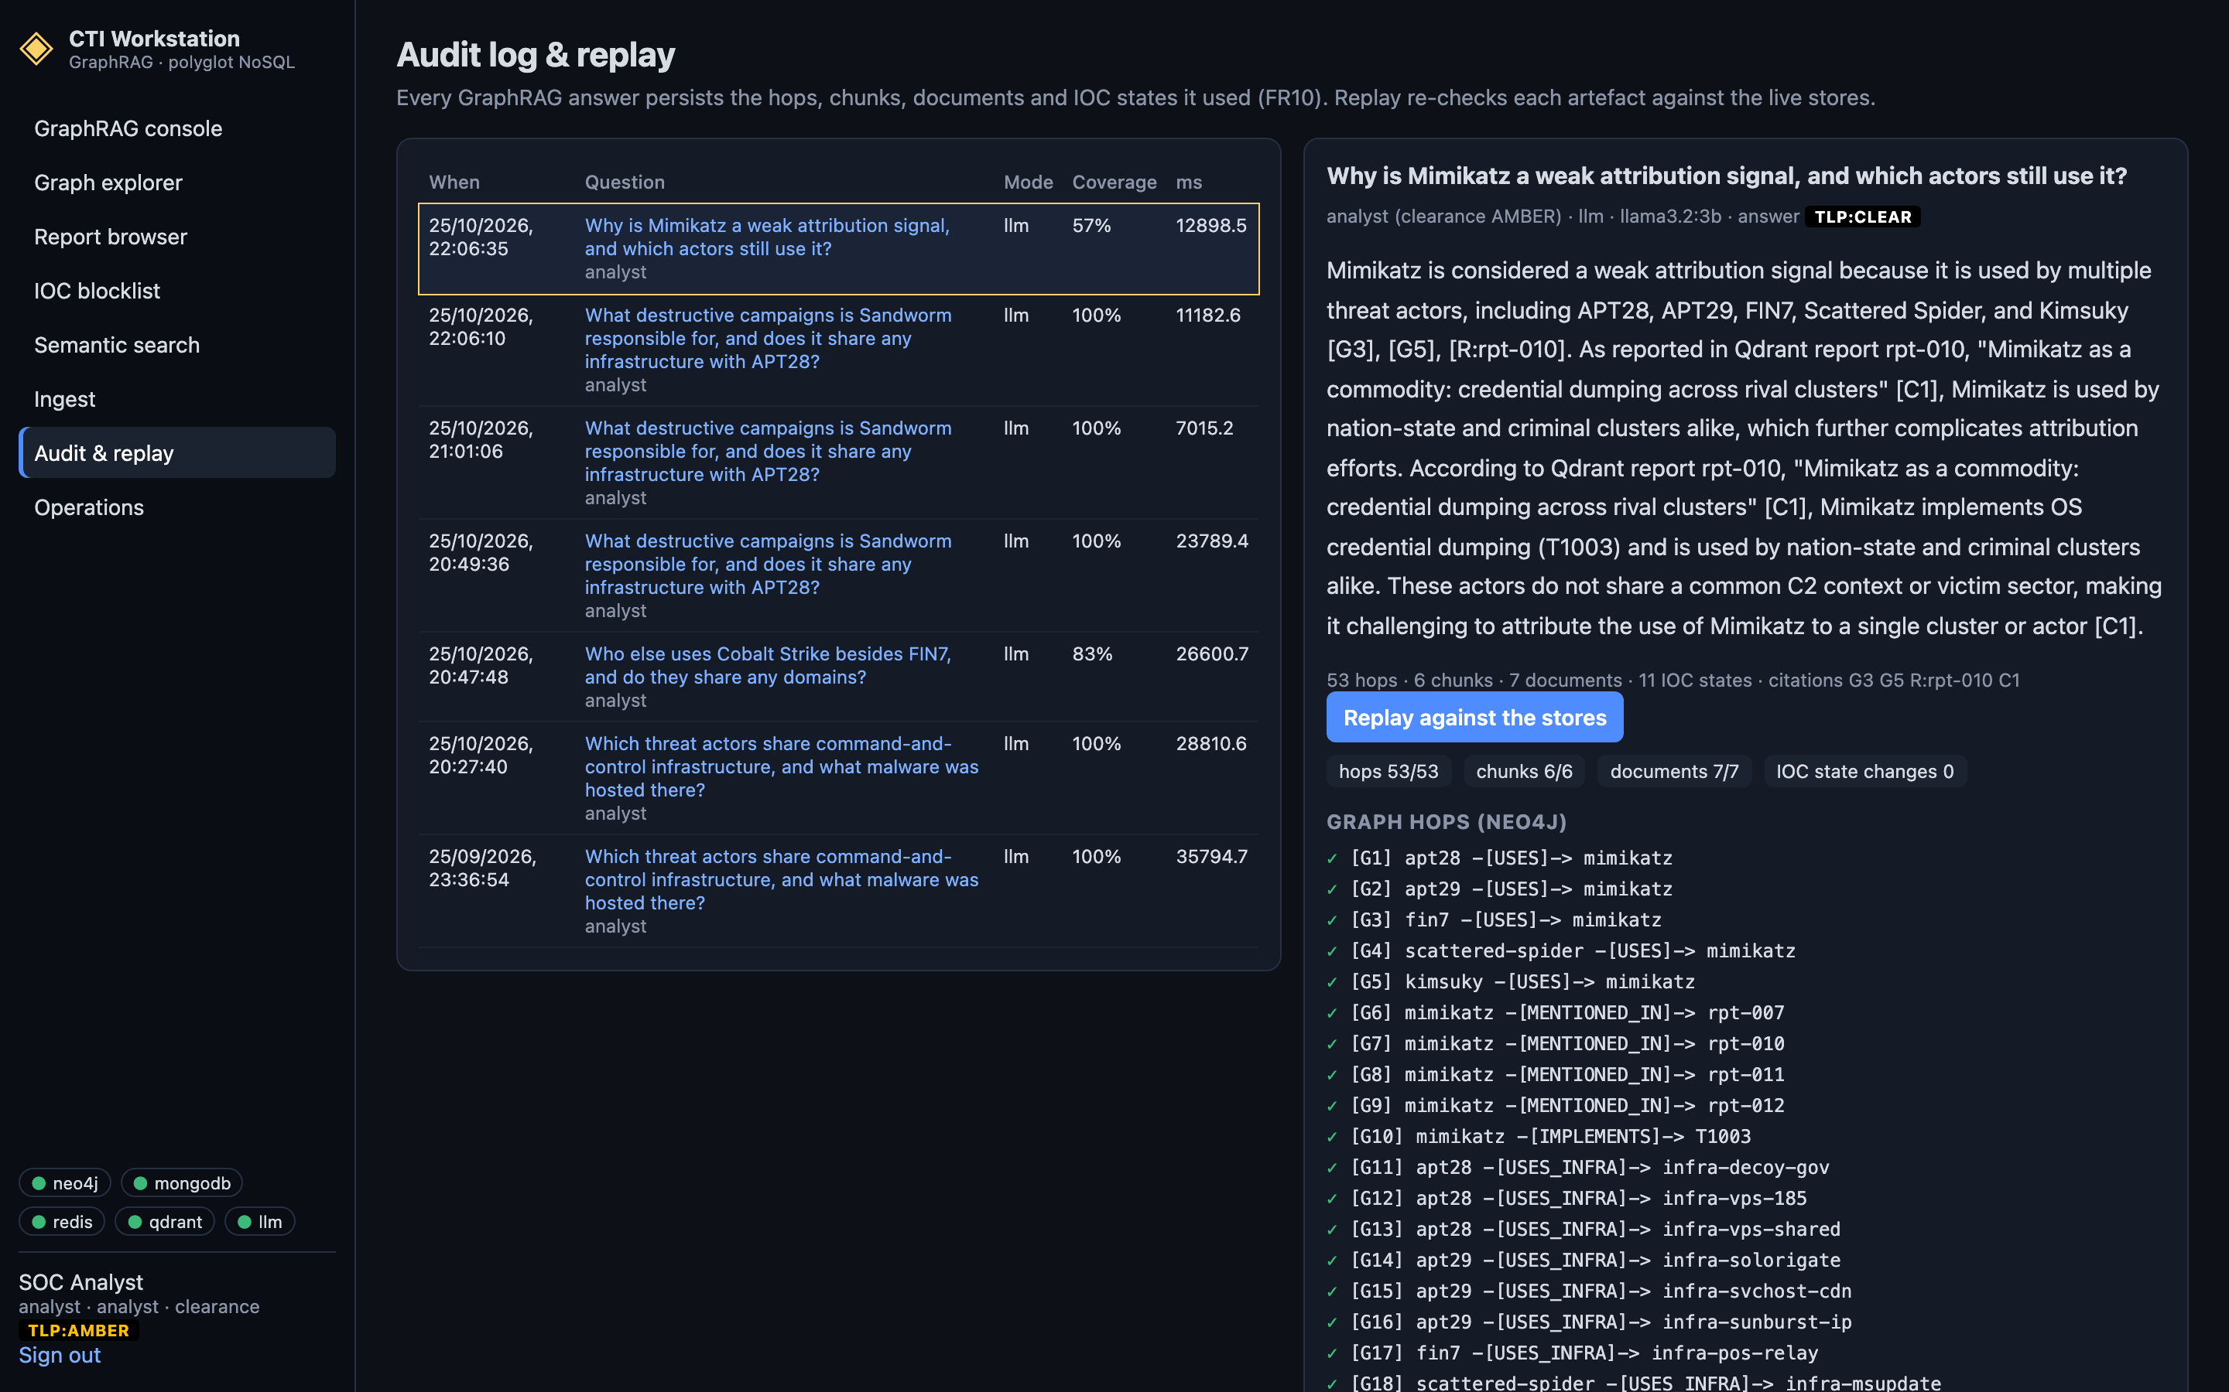
Figure 10. Audit entry replayed against the live stores.

5.8 Operations
Shows each store's status and round-trip time, latency percentiles per store against their targets (Redis p99 < 5 ms, Neo4j p95 < 500 ms, GraphRAG p95 < 15 s), the graph inventory and the cross-store integrity check. Administrators can re-seed (reload the initial corpus; removes ingested data) and rebuild the vector index.
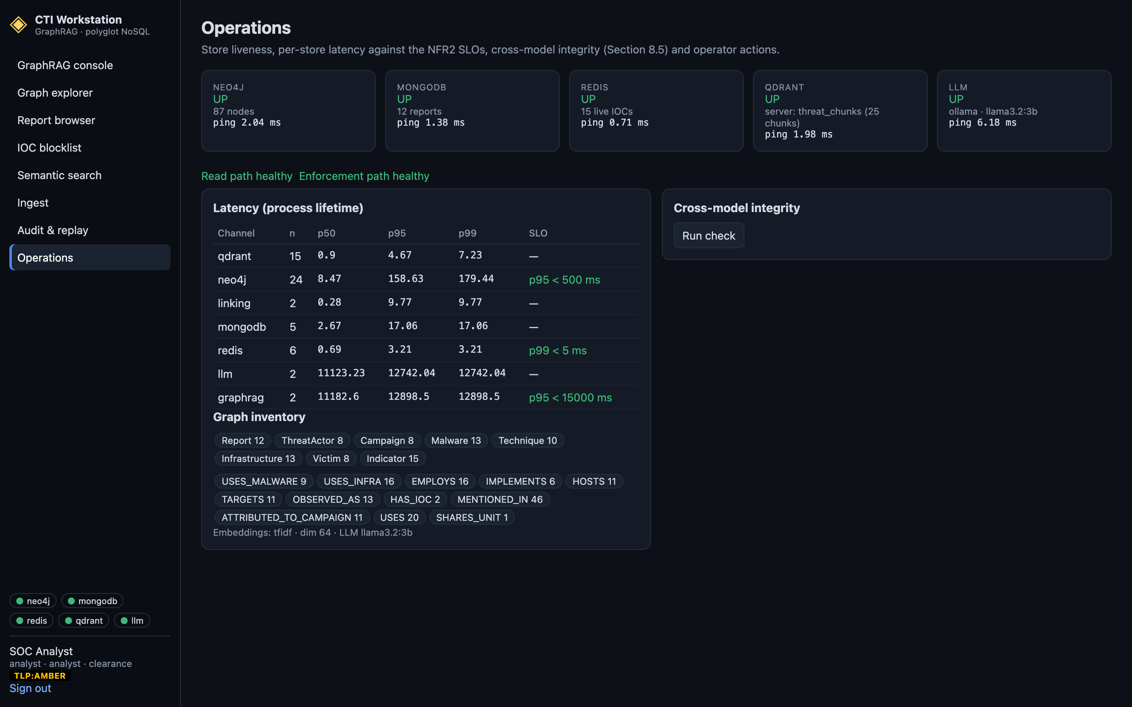
Figure 11. Operations: store health, latency against SLOs and integrity.

6. Walkthroughs
The walkthroughs below are the use cases the platform was designed for. They work on a freshly seeded stack (make seed).

6.1 Shared infrastructure (UC1)
- Sign in as analyst and open the GraphRAG console.
- Ask: “Which actors share C2 infrastructure with APT28?”
- The answer names Sandworm (shared VPS 185.86.77.12) and Scattered Spider (91.219.236.44) and cites report rpt-001.
- Open IOC state to see whether those IPs are live on the blocklist.

6.2 Similar activity (UC2)
- Ask: “Find activity similar to spearphishing against government and political organizations.”
- The Chunks tab shows the DNC passages first; the graph expands to APT28 and APT29; Documents lists the full reports.

6.3 Commodity tools (UC3)
- Ask: “Why is Mimikatz a weak attribution signal, and which actors still use it?”
- The answer lists five actors and shows the ⚠ caution: a tool shared by many actors is weak evidence of who is behind an intrusion.

6.4 Indicator expiry (UC4)
- Re-seed (make seed), then open the IOC blocklist within a minute.
- Three seeded IOCs have 90 s, 120 s and 300 s TTLs; watch them count down and move to Recently expired.
- Click show historical graph presence: the graph still records the indicator although it is no longer enforced.

6.5 Block a client IP
This shows that an address on the blocklist cannot use the platform. Because every request on your own computer comes from 127.0.0.1, the test sends the client address in an X-Forwarded-For header, which the API trusts only when started with TRUST_FORWARDED_FOR=true (as it would be behind a reverse proxy).
- Start the API with TRUST_FORWARDED_FOR=true make api (or make cloud-api) and run make import-feeds so the feed IPs are on the blocklist.
- Run curl -i -H 'X-Forwarded-For: 50.16.16.211' http://localhost:8000/api/reports — the answer is 403 “50.16.16.211 is on the IOC blocklist”. The same request from another address gets 401 (sign-in required) instead.
- Open IOC blocklist: the refusal is listed under Requests blocked by the API with the time its log entry expires.
- As a lead, publish a test address (for example 203.0.113.99) with a 60 s TTL: it is refused within 5 seconds, and accepted again once the TTL runs out.

6.6 TLP filtering
- Sign out and sign in as junior (GREEN).
- The report browser hides AMBER reports and shows how many are hidden.
- Open /reports/rpt-001: the report is withheld. Ask the UC1 question again: AMBER reports are not used and the answer is labelled GREEN or lower.

6.7 Ingest a STIX bundle
- Sign in as lead, open Ingest → STIX 2.1 bundle and choose samples/stix_apt28_bundle.json.
- Tick publish indicators and press Run ingest job; all four steps turn green.
- Ask “diplomatic invitation lures against foreign ministries”: the new report (Embassy Lure 2024) is retrieved.

7. Enforcement API for Security Tools
Firewalls, EDR and SIEM tools use a separate API that reads only the Redis blocklist. They authenticate with the X-API-Key header (CONSUMER_API_KEY in .env), not with a user account.
curl -H "X-API-Key: edr-consumer-key" \
"http://localhost:8000/api/enforce/check?type=ip&value=185.86.77.12"
{"blocked": true, "ttl_remaining": 604010, "severity": "high"}

curl -H "X-API-Key: edr-consumer-key" "http://localhost:8000/api/enforce/export?format=txt"
ip,185.86.77.12
domain,avsvmcloud.com
Situation | Response
indicator live | 200, blocked: true, remaining TTL and severity
indicator absent or expired | 200, blocked: false — never looked up in any other database
wrong or missing key | 401
Redis unavailable | 503 with blocked: true and fail_closed: true — treat as block

8. Inspecting the Databases Directly
Each database can be opened in its own tool, independently of the CTI console — useful for checking data, teaching, and showing that the four stores are real database servers rather than files. Start the two extra consoles with make dbui; Neo4j and Qdrant include their own.
Database | Console | What to look at
Neo4j | http://localhost:7474 (user neo4j, password from NEO4J_PASSWORD) | run Cypher; CALL db.schema.visualization() draws the live schema
MongoDB | http://localhost:8081 (mongo-express), or MongoDB Compass at mongodb://localhost:27017 | database cti → reports; compare rpt-002 and rpt-004
Redis | http://localhost:8082 (Redis Commander) | ioc → ip → a key: JSON value and TTL
Qdrant | http://localhost:6333/dashboard | threat_chunks → Points, Info (HNSW), Visualize

The MongoDB and Redis consoles are read-only and listen only on this machine. For typing commands, use the database shells: docker exec -it cti-neo4j cypher-shell -u neo4j -p ctiplatform, docker exec -it cti-mongo mongosh cti, docker exec -it cti-redis redis-cli. A step-by-step tour with queries is in review3/DATABASE_TOUR.md.
Hosted databases. With the hosted setup (Section 3.7), each vendor's web console shows the same data: AuraDB's Query tab runs Cypher, Atlas's Data Explorer browses the cti collections, Redis Cloud opens Redis Insight, and Qdrant Cloud's cluster Dashboard shows threat_chunks. Redis Commander can also be pointed at Redis Cloud (Figure 16).
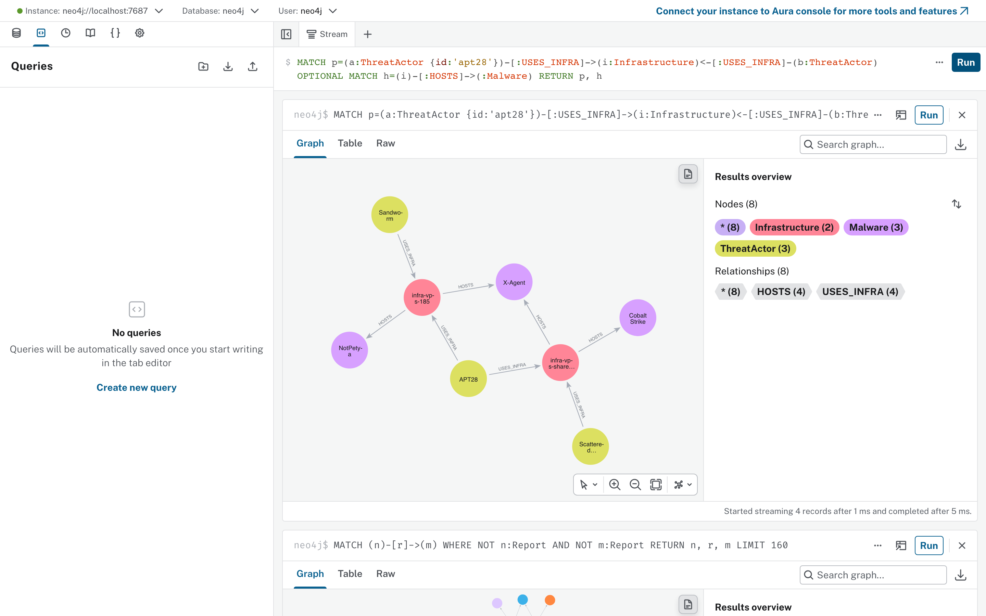
Figure 12. Neo4j Browser: a Cypher query showing APT28 and Sandworm sharing a C2 server.
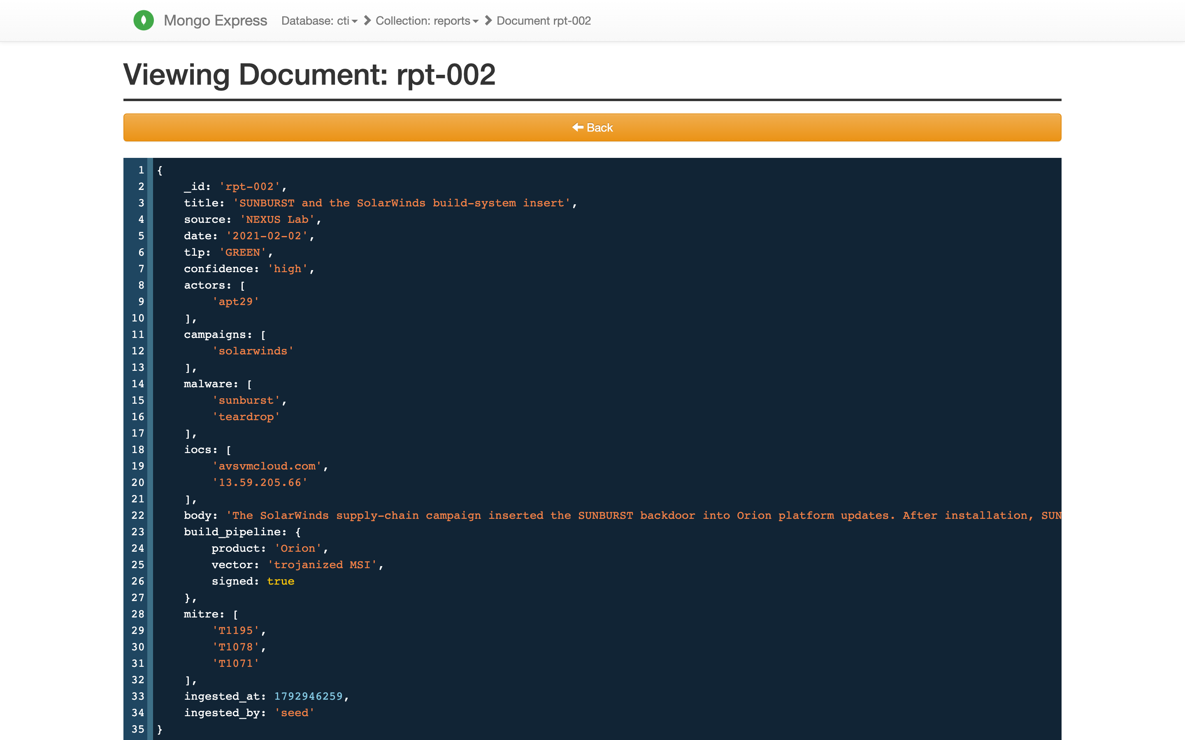
Figure 13. mongo-express: report rpt-002 with its report-specific nested build_pipeline field.
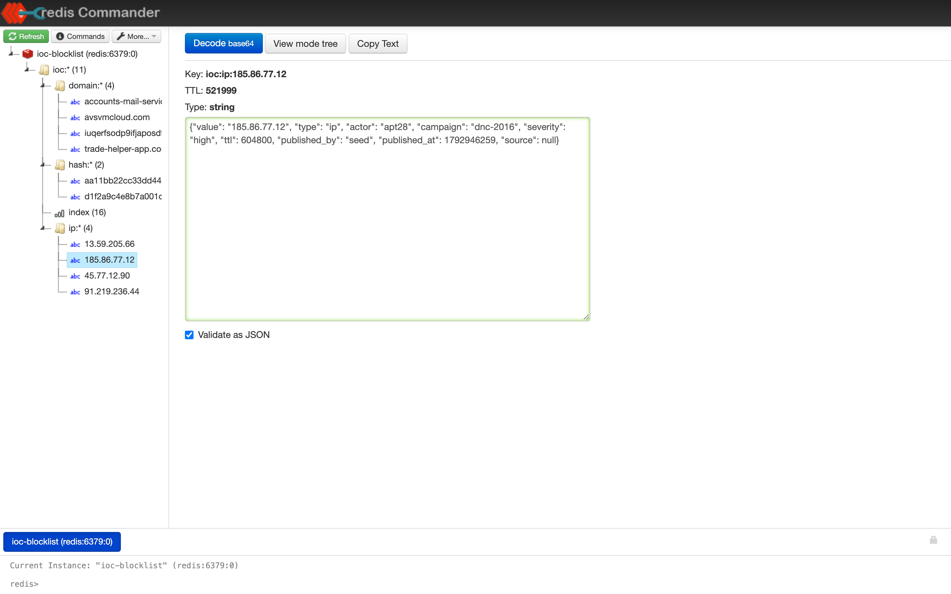
Figure 14. Redis Commander: an IOC key with its JSON value and remaining TTL in seconds.
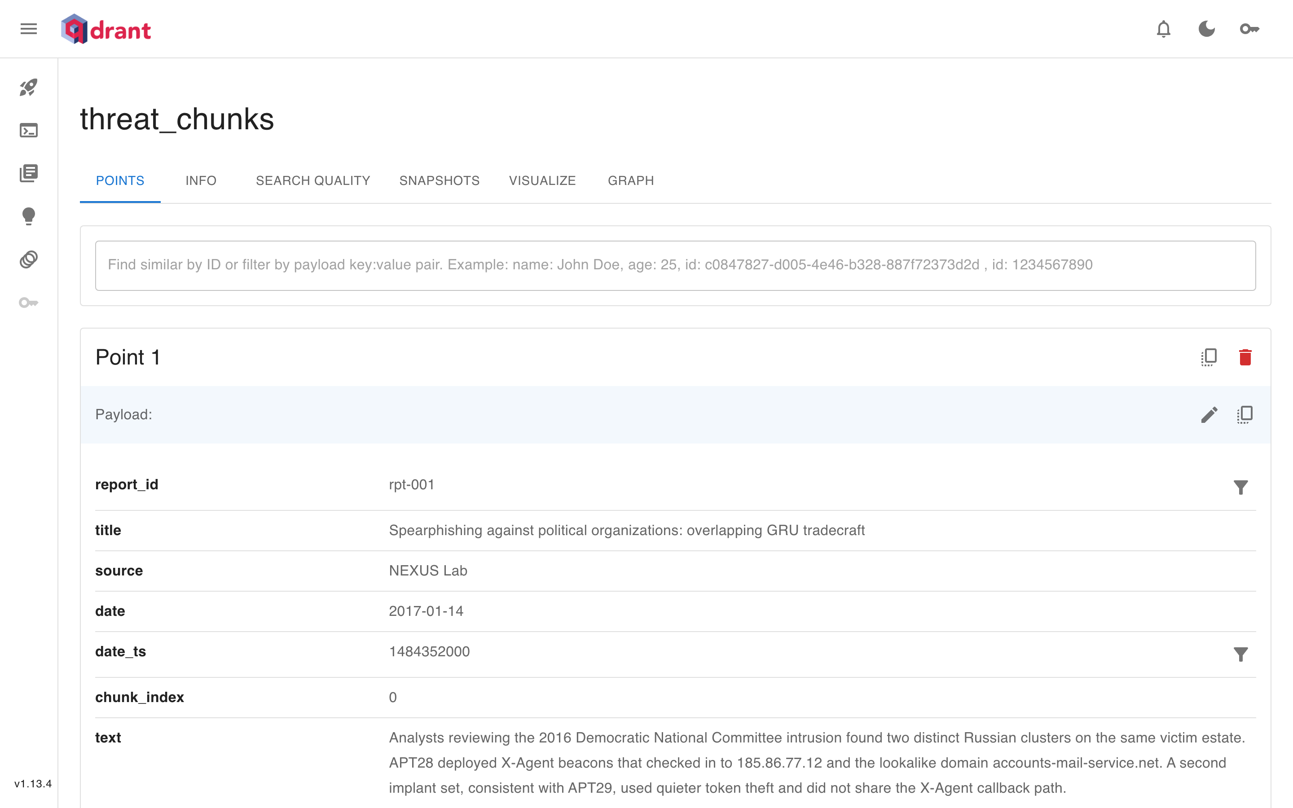
Figure 15. Qdrant dashboard: a vector point of the threat_chunks collection with its payload.
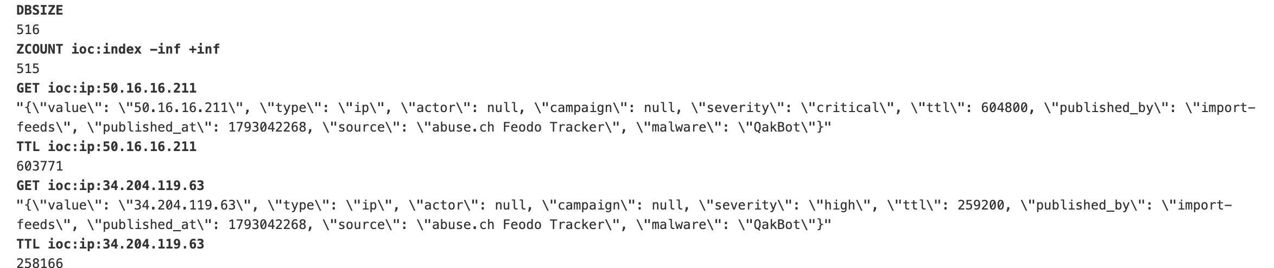
Figure 16. Redis Commander connected to Redis Cloud: blocklist keys of two Feodo Tracker C2 servers and their remaining TTL in seconds.

9. Configuration Reference
Settings are read from .env in the project folder (copy .env.example). Environment variables override the file.
Setting | Default | Purpose
NEO4J_URI / USER / PASSWORD | bolt://localhost:7687, neo4j, ctiplatform | graph store
MONGO_URI / MONGO_DB | mongodb://localhost:27017, cti | document store
REDIS_URL | redis://localhost:6379/0 | blocklist
QDRANT_HOST / QDRANT_PORT | localhost, 6333 | vector store (embedded fallback if unreachable)
QDRANT_URL / QDRANT_API_KEY | (empty) | hosted Qdrant cluster; overrides host and port
CTI_ENV_FILE | (unset) | extra settings file read last, e.g. .env.cloud for the hosted databases
ENFORCE_CLIENT_IP | true | refuse API requests from IPs live on the blocklist
TRUST_FORWARDED_FOR | false | take the client IP from X-Forwarded-For (only behind a trusted proxy)
BLOCKED_LOG_TTL_S | 604800 | how long refused requests stay in the log (seconds)
OLLAMA_URL / OLLAMA_MODEL | http://localhost:11434, llama3.2:3b | local language model
LLM_TIMEOUT_S | 60 | give up on the model after this many seconds (retrieve-only answer)
EMBEDDER / OLLAMA_EMBED_MODEL | tfidf, nomic-embed-text | offline TF-IDF embeddings, or a neural model via Ollama
JWT_SECRET | change-me… | signs sessions — change outside a lab
CONSUMER_API_KEY | edr-consumer-key | key for the enforcement API — change outside a lab
CORS_ORIGINS | http://localhost:5173,… | browser origins allowed to call the API
MAX_HOPS / HUB_DEGREE_THRESHOLD / MAX_NEIGHBOURS_PER_NODE | 3, 5, 12 | graph expansion limits and when a tool counts as a commodity hub
VECTOR_TOP_K / MIN_CITATION_COVERAGE | 6, 0.5 | passages per question; refusal threshold
LLM_MAX_FACTS / DOCS / DOC_CHARS / MAX_IOCS | 30, 6, 300, 12 | how much evidence the model sees (more = slower, fuller)
LLM_NUM_PREDICT / LLM_KEEP_ALIVE | 320, 30m | answer length cap; how long the model stays loaded
AUTO_SEED | true | load the seed corpus when the stores are empty
DATA_DIR | backend/data | fitted embedder and embedded-Qdrant files

10. Administration and Maintenance
Task | How
Restore the demo data and fresh TTLs | make seed or Operations → re-seed (removes ingested data)
Load or refresh real threat intelligence | make import-feeds (hosted: make cloud-import-feeds), then restart the API
Check the hosted databases | make cloud-check (read-only)
Rebuild the vector index | Operations → rebuild vector index, or POST /api/admin/reindex (needed after changing EMBEDDER)
Restore the snapshots | ./scripts/restore_databases.sh dumps (seed mode: … seed)
Run the tests | make test; with the stores running, make test-integration
Check answer quality and SLOs | make eval-check (fails if a gold fact or report is missed)
Benchmark | docker compose --profile app stop, then make bench (uses its own throwaway stores)
Change the model | ollama pull <model>, set OLLAMA_MODEL, restart the API
Logs | docker logs cti-api, or the terminal running make api
Stop everything | docker compose --profile app down (data volumes are kept; add -v to delete them)

11. Troubleshooting
Symptom | Likely cause | Fix
Console shows a red neo4j dot after start | Neo4j needs ~30 s to start | wait; check docker compose ps until healthy
llm dot red, answers say retrieve-only | Ollama not running or model not pulled (the tag must match exactly) | start Ollama; ollama pull llama3.2:3b
Answers are slow (> 15 s) | a large model, or the model was unloaded | use llama3.2:3b; keep LLM_KEEP_ALIVE; lower LLM_MAX_* settings
“Insufficient evidence…” | the evidence did not support any cited sentence | rephrase with entity names, increase hops or top-k
Blocklist almost empty | seeded TTLs expired (days later) | make seed
Port 8000 or 5173 in use | both the containerised and local app are running | docker compose --profile app stop, or stop make api / make web
403 when opening a report | report TLP above your clearance | sign in with a higher clearance
Enforcement API returns 503 | Redis is down — the API fails closed | restart Redis (docker compose up -d redis)
Every request returns 403 “… is on the IOC blocklist” | your address (or the X-Forwarded-For value) is on the blocklist | revoke it on the IOC blocklist page from another address, or wait for its TTL
make cloud-check: MongoDB SSL/TLS handshake failed | this computer's IP is not on the Atlas access list | Atlas → Security → Network Access → Add current IP
Hosted setup is slow | each store is a round trip over the internet | expected on free tiers; pick regions near you, or use the local stack for timing
Semantic search returns nothing | vector collection missing | Operations → rebuild vector index
Storage folder … already accessed | two processes using embedded Qdrant | start the Qdrant container, or run a single API process

12. Glossary
- CTI — cyber threat intelligence: knowledge about threat actors, their tools, infrastructure and behaviour
- IOC — indicator of compromise: an IP, domain, URL or file hash associated with malicious activity
- TTL — time to live: seconds until a blocklist entry expires
- TLP — Traffic Light Protocol: sharing restriction on a report (WHITE/CLEAR, GREEN, AMBER, RED)
- STIX 2.1 — standard JSON format for exchanging CTI objects and their relationships
- ATT&CK — MITRE's catalogue of adversary techniques (for example T1566 Phishing)
- GraphRAG — answering questions with evidence retrieved from a graph and a vector index before generation
- Commodity hub — a tool used by many unrelated actors, and therefore weak evidence of attribution
- Retrieve-only — an answer made of evidence sentences without the language model
- Groundedness gate — the check that removes uncited sentences and refuses unsupported answers
- Hot set — the IOCs currently live in the Redis blocklist

