Task 1: Sales & Customer Analytics Report
Shivanshi Gupta
Data Analyst, Future Interns
1. Problem Statement
In today’s competitive business environment, organizations rely heavily on data-driven insights to improve sales performance, understand customer behavior, and identify growth opportunities. The objective of this project is to analyze real-world retail transaction data to uncover meaningful business insights related to revenue trends, product performance, regional contribution, and customer segmentation.
The goal is to provide actionable recommendations that can help the business optimize marketing strategies, improve customer retention, and drive sustainable revenue growth.

2. Dataset Overview
The dataset contains transactional retail data with the following attributes:
- InvoiceNo – Unique transaction identifier
- StockCode – Product code
- Description – Product description
- Quantity – Number of units sold
- InvoiceDate – Date and time of transaction
- UnitPrice – Price per unit
- CustomerID – Unique customer identifier
- Country – Customer location
Total clean records used for analysis: 397,884
This dataset represents real-world transactional data, making it suitable for sales performance analysis and customer behavior analytics.

3. Data Cleaning and Preprocessing
To ensure data quality and reliability of insights, the following preprocessing steps were performed:
- Removed rows with missing Description and CustomerID values.
- Filtered out transactions with negative quantities and zero or negative prices, as they represent cancellations or invalid entries.
- Converted InvoiceDate to proper datetime format.
- Created new derived features for analysis:
  - Revenue = Quantity × UnitPrice
These steps resulted in a clean and structured dataset suitable for accurate business analysis.

4. Exploratory Data Analysis (EDA)
4.1 Overall Business Performance
Key performance indicators (KPIs) were calculated to assess overall business health:
- Total Revenue
- Total Orders
- Total Customers
- Total Quantity Sold
- Average Order Value
These metrics provide a comprehensive overview of the company’s sales scale and transaction patterns.

4.2 Revenue Trend Analysis
Monthly revenue trends were analyzed to understand how sales change over time.
Key Observations:
- The business exhibits clear seasonality, with peak sales observed during November and December.
- A consistent upward trend during year-end indicates strong holiday-driven demand.
- Lower revenue months highlight periods of reduced customer activity, indicating opportunities for promotional campaigns.
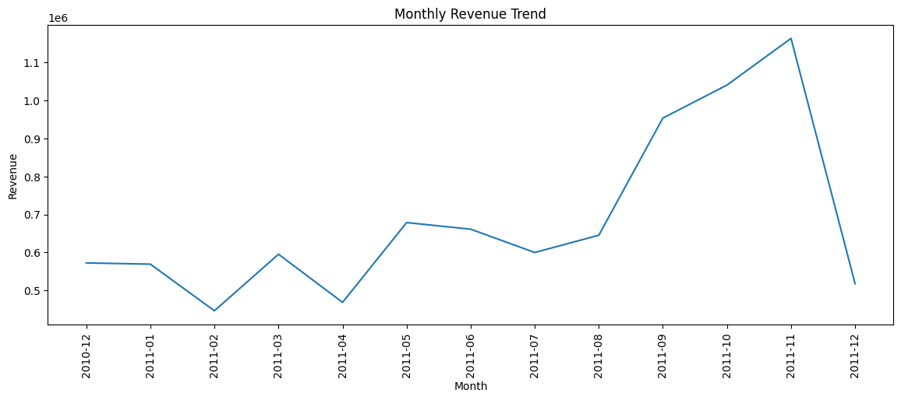

4.3 Product Performance Analysis
Top products were identified based on total revenue contribution.
Key Observations:
- A small group of high-performing products generates a major share of total revenue.
- Several low-cost but high-volume products dominate sales, indicating bulk purchasing behavior.
- Revenue concentration among a few SKUs suggests opportunities for focused inventory optimization and targeted marketing.
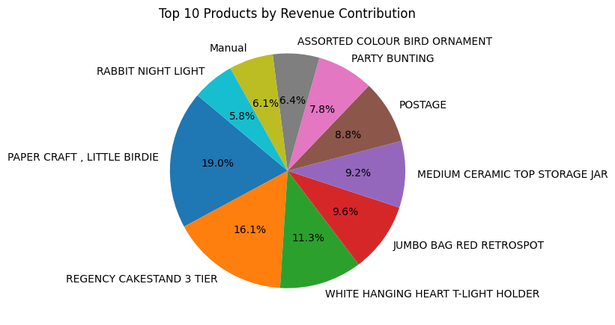

4.4 Country-wise Sales Analysis
Revenue contribution was analyzed across different countries.
Key Observations:
- The United Kingdom dominates total revenue, making it the primary market.
- Other European countries such as France, Germany, and the Netherlands show strong sales potential.
- Significant growth opportunities exist in non-UK markets through regional expansion strategies.
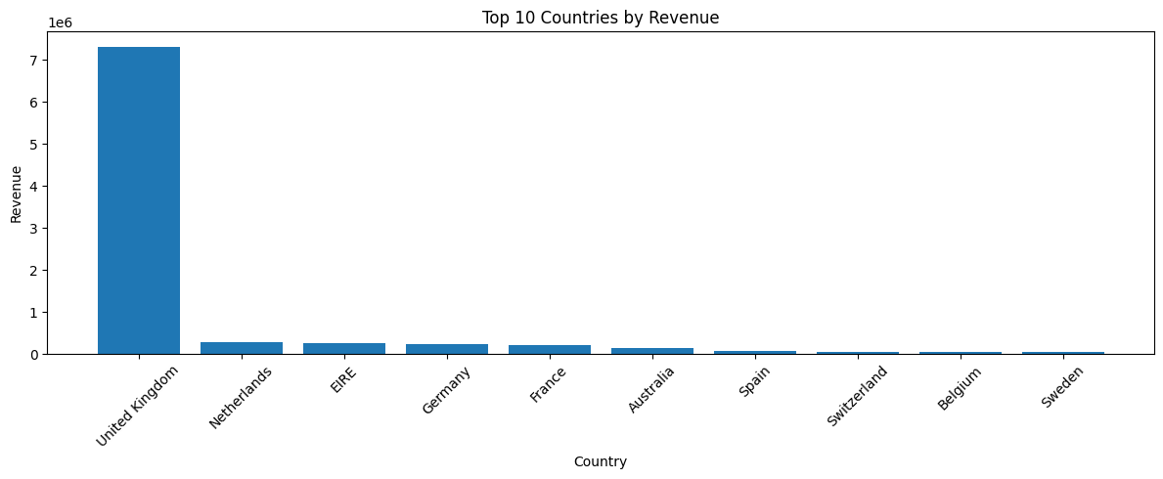

4.5 Customer Analysis
Customer-level analysis revealed important insights:
- Pareto Principle Observed:
Approximately 20% of customers generate nearly 75% of total revenue, highlighting a strong concentration of revenue among high-value customers.
- This indicates that customer retention strategies targeting top customers can significantly improve profitability.
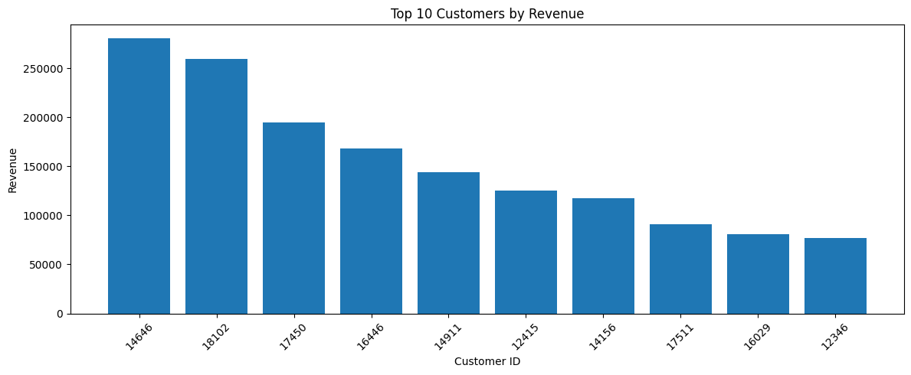

5. RFM Customer Segmentation
To gain deeper customer insights, RFM (Recency, Frequency, Monetary) analysis was applied.
5.1 RFM Concept
- Recency (R): How recently a customer made a purchase
- Frequency (F): How often a customer purchases
- Monetary (M): Total spending of the customer
Each customer was scored and segmented into meaningful categories.

5.2 Customer Segments
Based on RFM scoring, customers were grouped into the following segments:
- Champions – Most valuable and loyal customers
- Loyal Customers – High-frequency repeat buyers
- Potential Loyalists – Customers with high growth potential
- Need Attention – Moderate engagement, possible churn risk
- At Risk – Customers likely to churn
This segmentation allows the business to design targeted marketing and retention strategies for different customer groups.
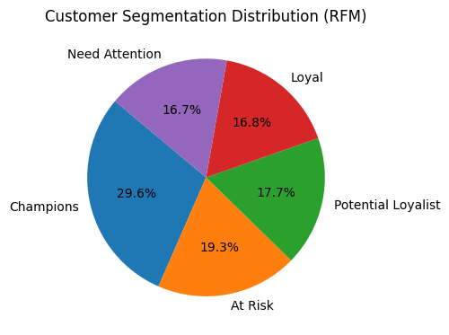
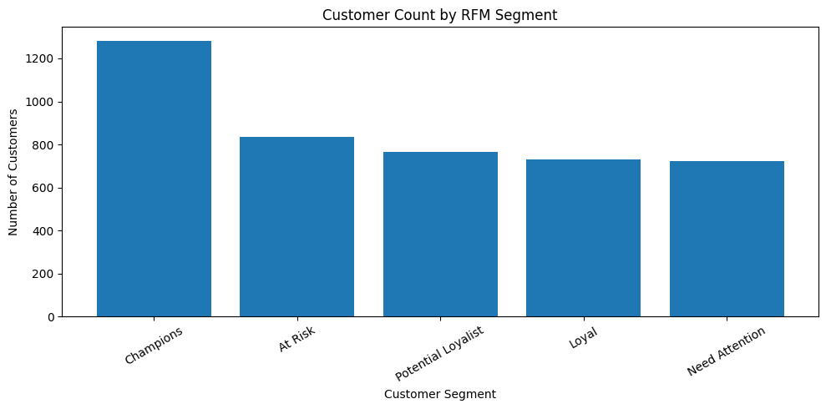

6. Key Business Insights
- Sales demonstrate strong seasonal patterns, with maximum revenue during year-end.
- A small set of products drives the majority of revenue, indicating product concentration risk and opportunity.
- The UK is the dominant market, while other European countries show high expansion potential.
- Customer spending follows Pareto behavior, where 20% of customers generate ~75% of revenue.
- RFM segmentation highlights the importance of Champions and Loyal customers for long-term growth.

7. Business Recommendations
7.1 Product Strategy
- Focus marketing and inventory planning on top-performing products.
- Bundle slow-moving products with bestsellers to improve overall product sales.

7.2 Regional Growth Strategy
- Increase marketing investments in high-growth European countries.
- Implement region-specific promotions and pricing strategies.

7.3 Customer Retention Strategy
- Introduce VIP loyalty programs for Champions and Loyal customers.
- Personalized offers and exclusive deals for high-value customers.
- Re-engagement campaigns for At-Risk customers to reduce churn.

7.4 Operational Optimization
- Optimize inventory management during seasonal demand peaks.
- Use sales forecasting to reduce stockouts and overstocking.

8. Conclusion
This project demonstrates how data-driven sales and customer analytics can provide meaningful insights for business growth. By combining revenue analysis, product intelligence, regional evaluation, and RFM-based customer segmentation, the project delivers a comprehensive analytical framework that supports strategic business decision-making.

