Task 3: Customer Retention & Business Growth Analysis Report
Shivanshi Gupta
Data Analyst, Future Interns
Objective: To analyze customer churn patterns, identify key retention drivers, evaluate customer lifetime trends, quantify revenue leakage, and propose actionable business strategies to reduce churn and improve long-term growth.

1. Executive Summary
Customer churn is one of the most critical challenges for subscription-based businesses, directly impacting revenue, growth, and profitability. This project performs an end-to-end churn and retention analysis using customer demographic, subscription, service usage, and financial data.
The analysis reveals a high churn rate of 26.54%, leading to a substantial annual revenue leakage of ₹16.7 lakh and total lifetime revenue loss exceeding ₹28.6 lakh. The majority of churn occurs within the first 12–18 months of customer lifecycle, indicating significant gaps in onboarding, early engagement, and perceived value.
Through advanced analytics, this study identifies the key churn drivers, high-value customer profiles, pricing sensitivity, and early churn prediction logic, enabling data-driven business strategies to improve customer retention, lifetime value, and overall business growth.

2. Dataset Overview
Total Customers: 7,043
Total Features: 21
Key Variable Categories:
- Demographic: gender, senior citizen, partner, dependents
- Subscription: tenure, contract, payment method, paperless billing
- Services: internet service, tech support, online security, backup, streaming
- Financial: monthly charges, total charges
- Target Variable: churn
Data Quality:
- No missing values
- No duplicate records
- Appropriate data type conversions applied
- Feature engineering performed for business KPIs

3. Key Business KPIs
Metric | Value
Total Customers | 7,043
Churned Customers | 1,869
Churn Rate | 26.54%
Average Customer Tenure | 32.37 months
Average Monthly Revenue | ₹64.76
Business Insight:
A churn rate above 25% is significantly higher than industry benchmarks (5–10%), indicating severe customer attrition and revenue instability. However, relatively high average tenure suggests strong long-term product value, highlighting onboarding and early experience as the main improvement areas.

4. Churn Pattern Analysis
4.1 Churn by Customer Lifetime (Tenure)
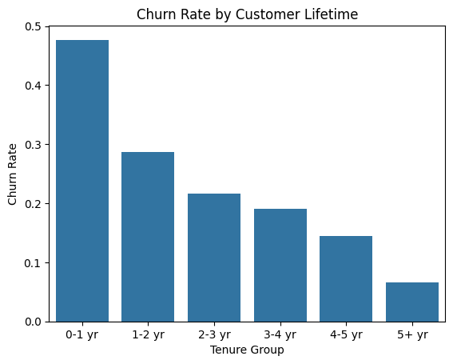
Key Findings:
- Highest churn observed within 0–12 months
- Churn reduces significantly after 24 months
- Customers beyond 2 years show strong retention behavior
Business Interpretation:
Most customers decide whether to stay or leave within the first year. Weak onboarding, poor early engagement, and unmet expectations drive early churn, making the initial customer experience the most critical retention lever.

5. Churn Driver Analysis
5.1 Contract Type vs Churn
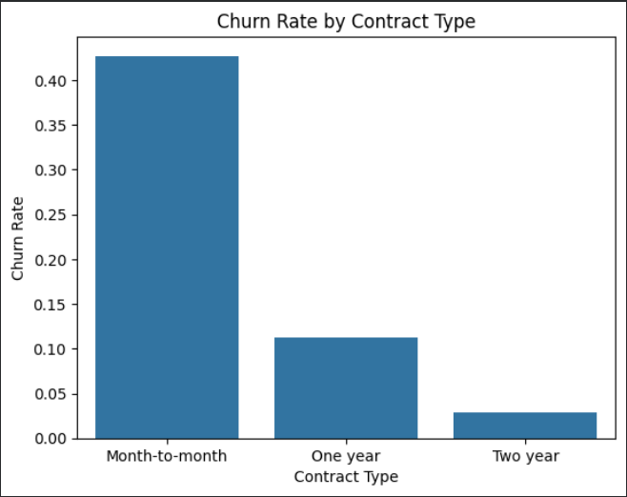
Findings:
- Month-to-month customers show very high churn
- Long-term contracts (1-year & 2-year) show substantially lower churn
Business Meaning:
Longer commitments directly improve retention. Encouraging customers to migrate toward annual and multi-year plans can significantly reduce churn.

5.2 Service-Based Churn Drivers
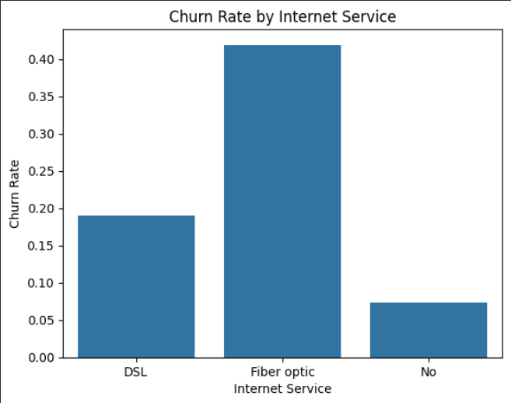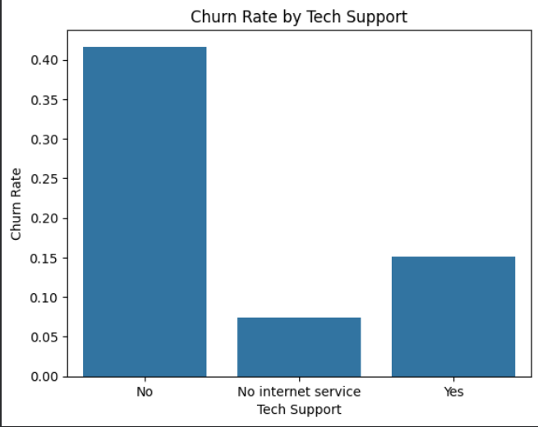
Factor | Impact | Business Meaning
No Tech Support | High churn | Support improves satisfaction & trust
Fiber Internet Users | High churn | High price & performance expectations
No Security / Backup | Increased churn | Add-ons improve retention
Interpretation:
Service quality, support availability, and add-on engagement significantly influence customer loyalty.

5.3 Payment Method vs Churn
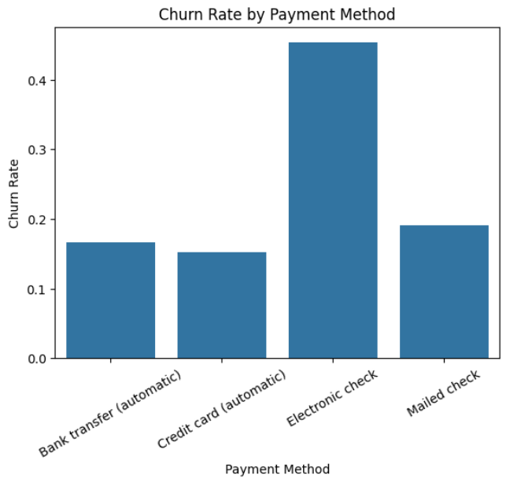
Key Finding:
- Electronic check users exhibit highest churn
- Automatic payments show lowest churn
Business Meaning:
Friction in payment processes increases churn risk. Automated payment methods significantly enhance customer continuity.

6. Cohort Retention & Lifetime Trend Analysis
6.1 Cohort Retention Heatmap
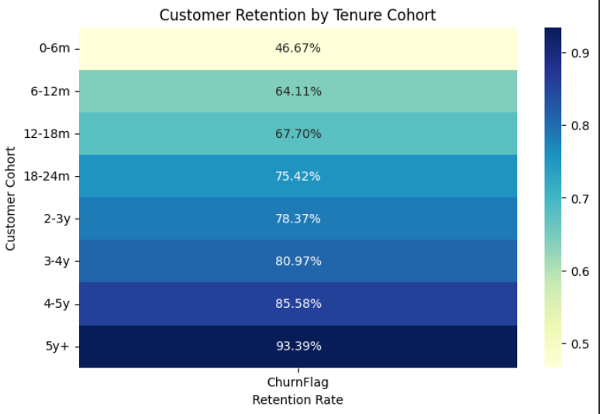Insights:
- Lowest retention observed in 0–6 month and 6–12 month cohorts
- Retention steadily improves with tenure
Business Interpretation:
Early-stage customer engagement is the dominant driver of long-term retention.

6.2 Customer Survival Curve
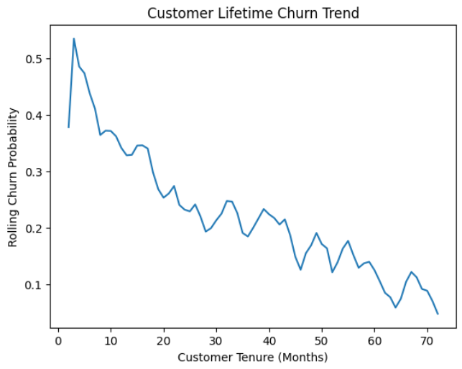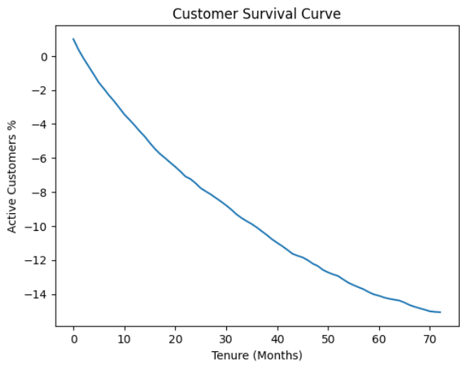
Insights:
- Sharp drop in customer base during first 12–18 months
- Stable retention beyond 24 months
Business Meaning:
Customers surviving beyond two years show high loyalty, confirming strong product-market fit among long-term users.

7. Revenue Leakage Analysis
7.1 Financial Impact of Churn
Metric | Value
Monthly Revenue Lost | ₹1,39,130
Annual Revenue Leakage | ₹16.7 lakh
Lifetime Revenue Lost | ₹28.6 lakh
Executive Insight:
Customer churn results in severe revenue leakage. Even a 10% reduction in churn could recover over ₹1.7 lakh annually, making retention improvement one of the highest ROI strategies for business growth.

8. High-Value Customer Profiling
High-Value Customers Identified: 1,952 (~28% of total users)
Ideal Customer Profile (ICP)
Attribute | Dominant Pattern
Contract | Two-year
Internet Service | Fiber optic
Tech Support | Yes
Payment Method | Credit card (automatic)
Interpretation:
High-value customers commit long-term, adopt premium services, enable support, and use frictionless payment methods. Business strategies should focus on migrating new and mid-term users toward this profile.

9. Pricing Sensitivity Analysis
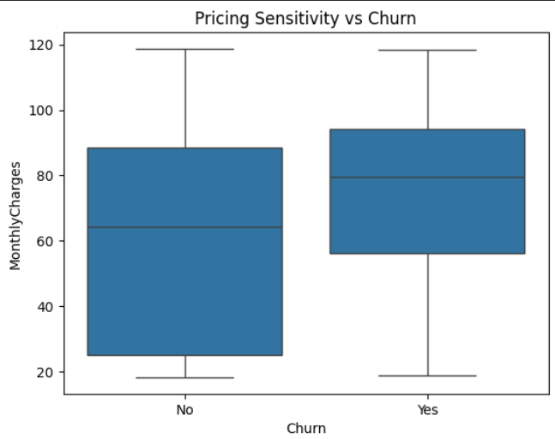
Customer Group | Avg Monthly Charges
Retained | ₹61.27
Churned | ₹74.44
Key Insight:
Customers paying ~21% higher monthly charges are significantly more likely to churn, indicating strong price sensitivity and perceived value mismatch.
Strategic Meaning:
Instead of reducing prices, businesses should improve value perception through service bundling, premium features, and personalized pricing strategies.

10. Early Churn Prediction Logic
High-Risk Customers Defined As:
- Tenure ≤ 6 months
- Month-to-month contract
- No tech support
Segment | Churn Probability
Normal Customers | 20.3%
High-Risk Customers | 65.7%
Key Insight:
High-risk customers are 3.2 times more likely to churn, enabling early detection and proactive intervention.
Business Impact:
Predictive churn risk identification allows businesses to proactively save customers before they leave, drastically improving retention and revenue recovery.

11. Strategic Business Recommendations
11.1 Onboarding & Early Engagement Optimization
- Guided onboarding journeys
- First 90-day engagement campaigns
- Dedicated customer success support
🎯 Target: Reduce early-stage churn

11.2 Contract Strategy
- Discounts for annual & 2-year plans
- Loyalty rewards
- Upgrade nudges
🎯 Target: Increase long-term commitment

11.3 Service Bundling
- Bundle tech support, security, backup & streaming
- Premium onboarding packs
🎯 Target: Improve perceived value & retention

11.4 Pricing Strategy
- Personalized discounts for high-risk customers
- Tiered pricing upgrades
- Value-based messaging
🎯 Target: Reduce price-sensitive churn

11.5 Predictive Retention Strategy
- Deploy early churn risk flags
- Proactive support outreach
- Personalized offers
🎯 Target: Prevent churn before it occurs

12. Final Business Impact
If implemented, the above strategies can:
- Reduce churn by 10–20%
- Recover ₹1.7–₹3.4 lakh annually
- Increase customer lifetime value
- Strengthen long-term profitability

13. Deliverables Submitted
- Google Colab Notebook (complete analytics pipeline)
- Business Analytics Report
- Strategic Retention Recommendations

14. Project Conclusion
This project demonstrates a complete real-world SaaS churn & retention analytics workflow, combining descriptive, diagnostic, and predictive analytics to generate business-driven insights and strategies. The approach reflects industry-grade analytics practices used by product, growth, and strategy teams in subscription businesses.

