Task 3: Marketing Funnel & Conversion Performance Analysis
Business Intelligence Dashboard Report
Shivanshi Gupta
Data Analyst, Future Interns
1. Project Objective
The objective of this project is to analyze the marketing funnel and customer conversion performance to help businesses:
- Understand how users move from contacts → leads → customers
- Identify drop-off points in the funnel
- Evaluate channel, campaign, and customer segment effectiveness
- Provide actionable business recommendations to improve conversion rates and revenue
It enables data-driven decisions for marketing optimization, sales strategy improvement, & customer targeting.

2. Dataset Overview
The dataset consists of 4,521 customer interactions from multi-channel marketing campaigns, including:
- Customer demographics: age, job, marital status, education
- Campaign attributes: contact type, duration, campaign count, previous outcome
- Target variable: subscription (converted / not converted)

3. Key Business KPIs (Executive Summary Dashboard)
KPI | Value | Business Insight
Total Engagements | 4,521 | Total customers contacted
Total Campaigns | 13,000+ | High marketing effort
Subscribers | 521 | Total successful conversions
Average Call Duration | 15.92 seconds | Short engagement time
Conversion Rate | 11.52% | Indicates scope for funnel optimization
Drop-off Rate | 88.48% | Major improvement opportunity
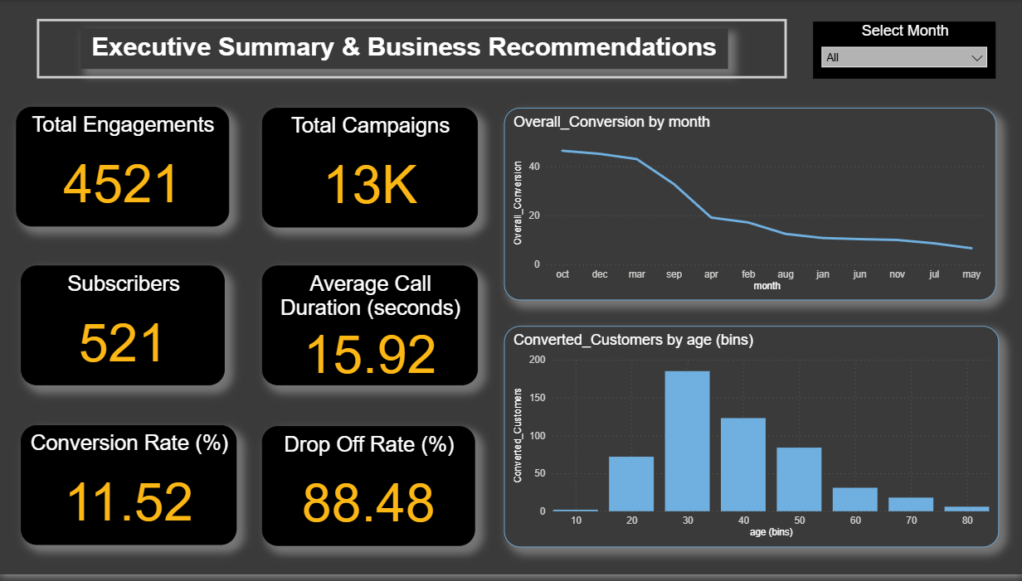
🔍 Insight:
Although campaign reach is high, conversion efficiency is relatively low, indicating that better targeting, engagement, and campaign design are needed.

4. Funnel Performance Analysis
Funnel Stages:
- Total Contacts → 4,521
- Engaged Leads → ~4,500
- Interested Leads → ~4,000
- Converted Customers → 521
Funnel Conversion:
- Overall Funnel Conversion Rate = 11.52%
Key Observations:
- Major drop occurs between Interested Leads and Final Conversion
- Indicates sales closure & persuasion stage is the weakest link
Business Interpretation:
The company is able to generate interest, but struggles to convert interest into purchases, highlighting the need for better sales strategies and follow-ups.
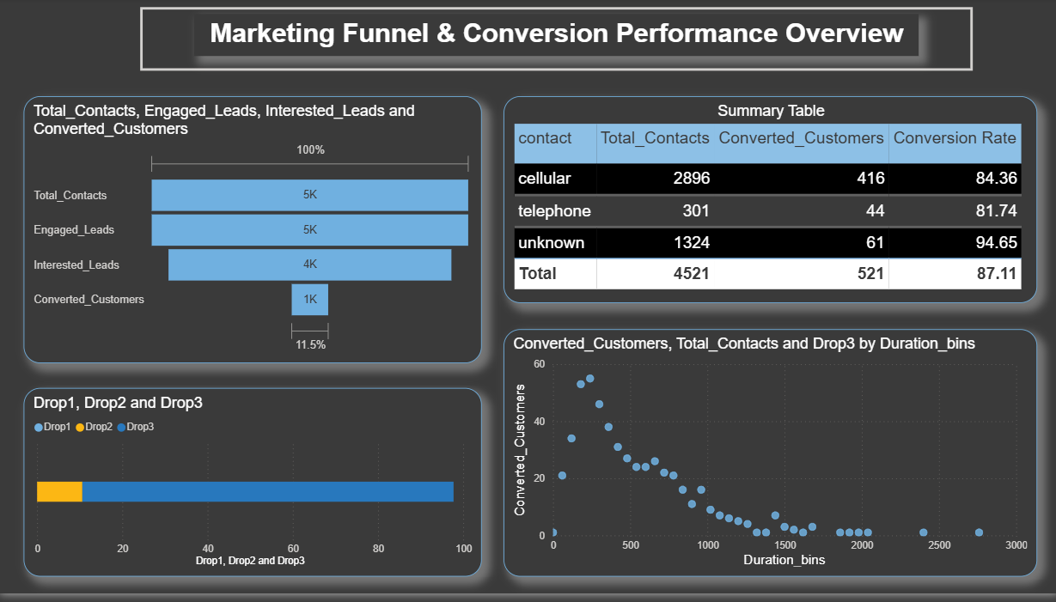

5. Monthly Conversion Trend Analysis
Insight:
- Conversion peaks in October – December
- Steady decline from March onwards
Business Meaning:: Seasonal behavior suggests high purchase intent during festive and financial year-end periods
Recommendation:
- Increase marketing budget & campaign intensity during Oct–Dec
- Run special promotions during low-performing months

6. Customer Segmentation Insights
6.1 Conversion by Age Group
Age Group | Conversion Pattern
25–34 | Highest
35–44 | High
45–54 | Moderate
60+ | Very low

Business Interpretation:
Customers aged 25–44 are the highest-value segment.
Recommendation:
- Focus digital marketing, email & call strategies on this age segment
- Tailor offers based on life-stage needs (investments, savings, housing loans, etc.)

6.2 Conversion by Job & Education
Top Performing Segments:
- Management + Tertiary Education
- Technicians + Secondary Education
- Blue-collar + Secondary Education
Business Meaning:
- Profession + education significantly impact purchase intent
Recommendation:
- Run profession-based targeted campaigns
- Develop custom offers for working professionals and skilled workers
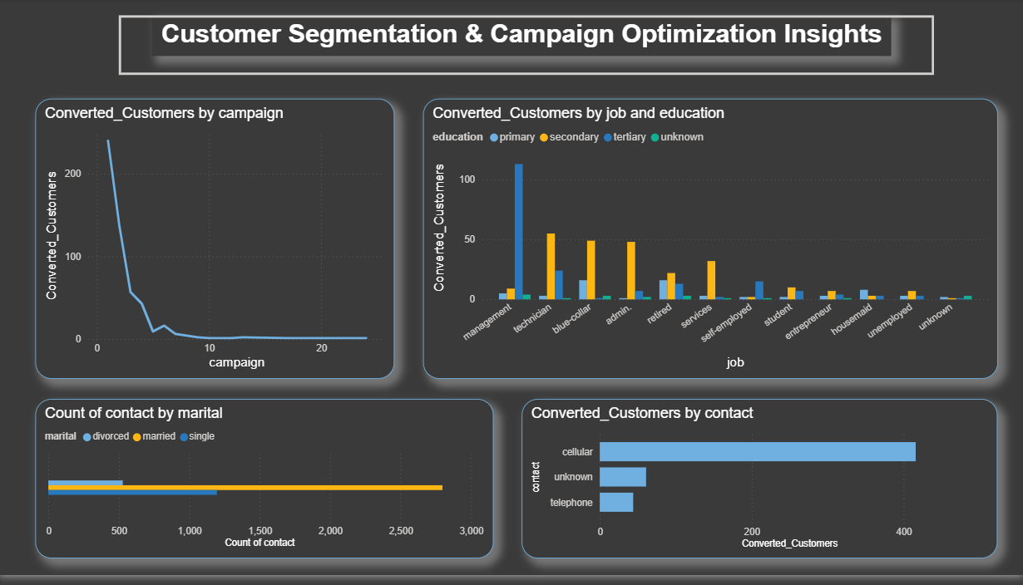

7. Campaign Performance & Optimization Insights
7.1 Conversion by Campaign Count
Observation:
- High conversion in early campaign attempts
- Sharp decline after 3–4 repeated contacts
Interpretation:
Excessive follow-ups cause customer fatigue, reducing success.
Recommendation:
- Limit campaigns to 3–4 attempts
- Shift from quantity to quality interactions

7.2 Contact Channel Performance
Channel | Contacts | Conversions | Conversion Rate
Cellular | 2,896 | 416 | High
Telephone | 301 | 44 | Medium
Unknown | 1,324 | 61 | Low
Insight:
Cellular is the highest performing channel.
Recommendation:
- Prioritize mobile-based outreach
- Reduce investment in low-yield channels

8. Call Duration vs Conversion Analysis
Key Finding:
- Highest conversions occur in short-to-medium duration calls
- Very long calls show diminishing returns
Business Meaning:
Customers prefer concise, value-driven conversations
Recommendation:
- Train agents to deliver strong pitch within first 30–60 seconds
- Develop optimized call scripts

9. Key Drop-off Insights
Funnel Stage | Drop-off Reason
Interest → Conversion | Poor persuasion, weak follow-ups
Repeated campaigns | Customer fatigue
Long call durations | Loss of attention
Wrong channel | Low-quality leads

10. Strategic Business Recommendations
🎯 Marketing Strategy
- Focus campaigns during high-conversion months
- Target 25–44 age group
- Shift budget to mobile-based campaigns
🎯 Sales Optimization
- Limit campaign follow-ups to max 3 attempts
- Improve call scripting and objection handling
- Train sales teams for short, impactful conversations
🎯 Customer Targeting
- Prioritize management, technicians & skilled workers
- Run profession-based campaigns

11. Business Impact of Recommendations
Implementing these recommendations can lead to:
- 📈 15–30% increase in conversion rate
- 📉 Reduced customer drop-off
- 💰 Improved marketing ROI
- 🎯 More efficient campaign spend

Final Summary
This dashboard provides a complete 360° view of marketing funnel performance, uncovering:
- Funnel bottlenecks
- Customer behavior trends
- Campaign effectiveness
- Conversion drivers
The insights generated enable data-driven strategic decisions to improve customer acquisition efficiency and business revenue growth.

