Q1.Write the HTML code for the following Table and write some text in each cell.

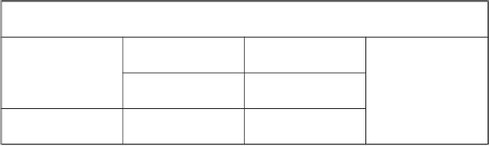

|  |  |  |  |  |  |  |  |  |  |
| --- | --- | --- | --- | --- | --- | --- | --- | --- | --- |
|  | | | | | | | | | |
|  | | | |  | | | | | |
|  | |  | |  | |  | |  | |
|  | |  | |  | |
|  | |  | |  | |
|  |  | |  | |  | |  | |  |

Q2.Write the HTML code for the following Table.

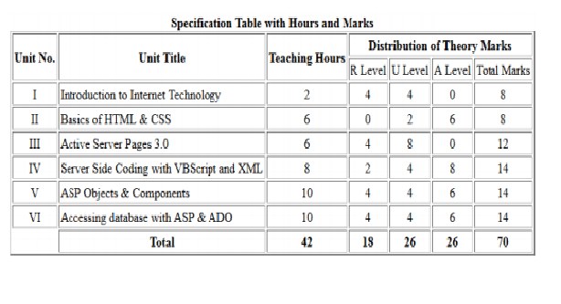

Q3.Write the HTML code, which defines all the formatting tags of HTML in tabular format.

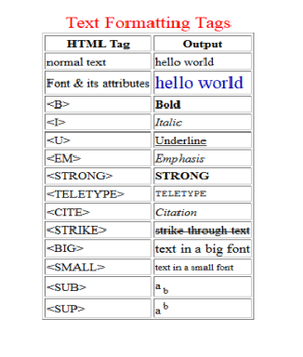

Q4.Write the HTML code to display Uttarakhand map.

And also display districts detail after clicking on a particular district.

