**Web Development Assignment-2**

**PCS-693**

1. WAP in HTML to implement a frame.

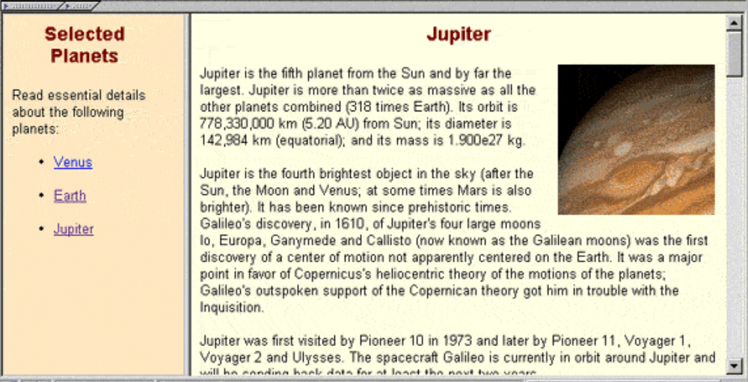

1. WAP in HTML to implement a table.

