AI Impact on Job Market:
Benefits vs Risks Analysis
A Data Analytics Project
Prepared by: Shivanshi
AKS University, Satna, Madhya Pradesh
BharatCares Data Analytics with AI Internship

1. Introduction
Artificial Intelligence (AI) is transforming how work is performed across nearly every industry. While AI creates new opportunities - higher productivity, new job categories, and improved decision-making - it also raises concerns about automation replacing certain roles. This project uses a real-world-style dataset of job listings to explore both sides of this story: where AI is creating benefit, and where it is creating risk.

2. Problem Statement
Does AI adoption create more opportunity (benefit) for the job market, or does it primarily increase the risk of job displacement (loss)? Specifically, this project investigates:
- Which industries have the highest automation risk?
- Do high-automation-risk roles pay less than low-risk roles?
- Which industries show the strongest job growth projections?
- Does company size influence how much AI is adopted?

3. Dataset Description
Name: AI-Powered Job Market Insights
Source: Kaggle - https://www.kaggle.com/datasets/uom190346a/ai-powered-job-market-insights
Size: 500 rows, 10 columns
Columns:
- Job_Title, Industry, Company_Size, Location
- AI_Adoption_Level (Low / Medium / High)
- Automation_Risk (Low / Medium / High)
- Required_Skills, Salary_USD, Remote_Friendly
- Job_Growth_Projection (Growth / Stable / Decline)
Note: This dataset is synthetic (computer-generated) but designed to reflect realistic modern job market patterns. Conclusions drawn represent statistical patterns found within this dataset, not verified real-world employment statistics.

4. Methodology
The analysis follows the Observation -> Insight -> Hypothesis -> Recommendation framework:
- Observation: What does the data show directly? (facts/numbers)
- Insight: What does that observation mean in context?
- Hypothesis: Why might this be happening?
- Recommendation: What action should follow from this?
Tools used: Python (pandas, matplotlib, seaborn) in Google Colab.

5. Key Findings

5.1 AI Adoption Level by Industry
This chart shows how AI adoption (Low/Medium/High) is distributed across industries.
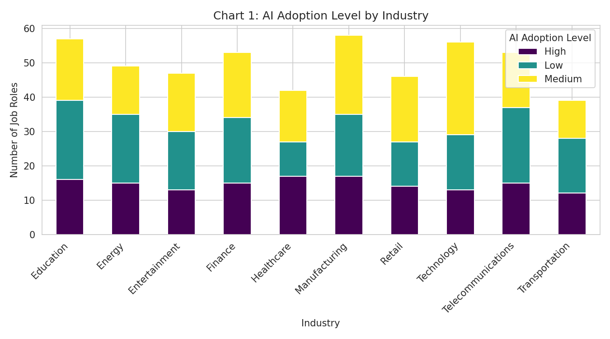

5.2 Automation Risk Distribution
Roughly one-third of all job roles in the dataset fall into each automation risk category.
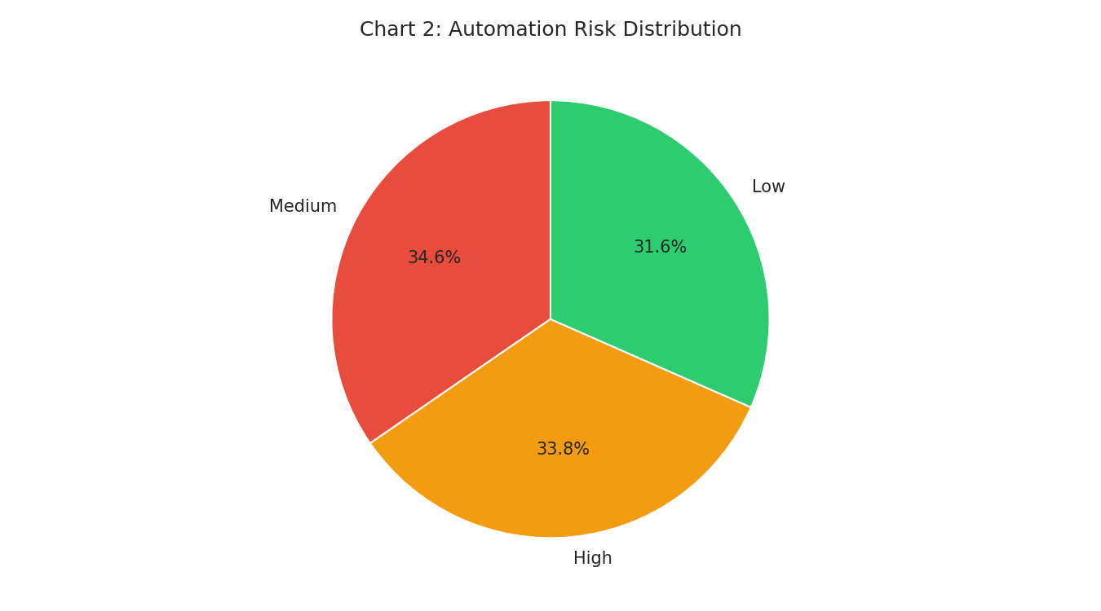

5.3 Salary by Automation Risk
This box plot compares salary distributions across Low, Medium, and High automation-risk roles. Notably, High-risk roles do not show a lower median salary than Low-risk roles.
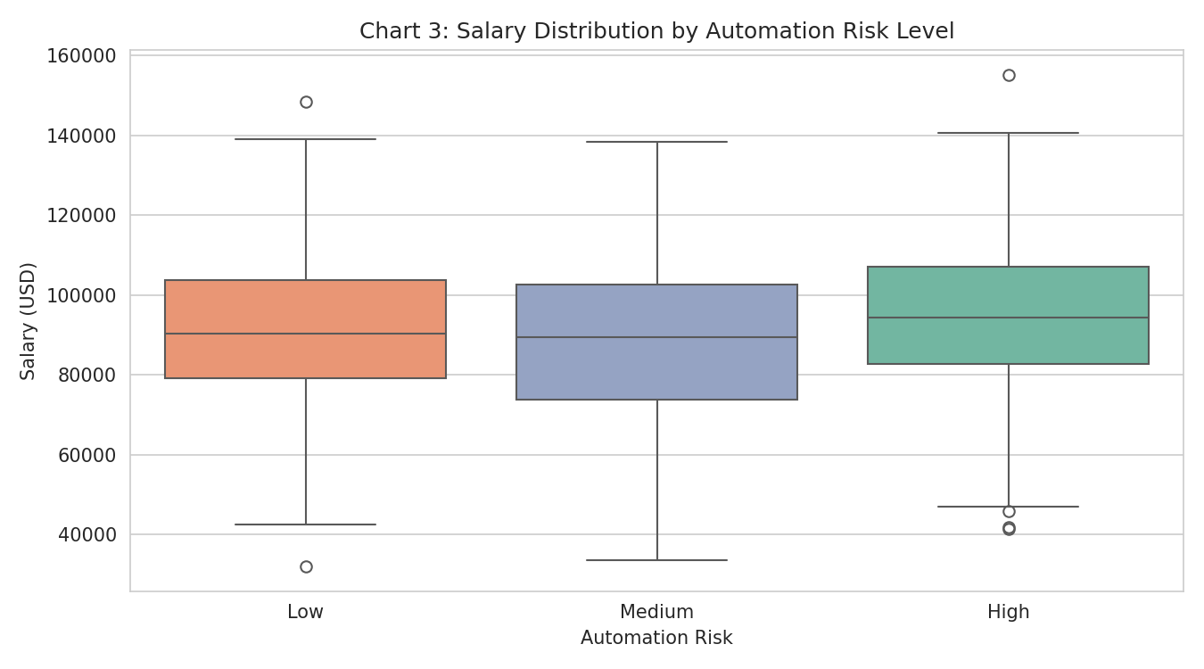

5.4 Job Growth Projection by Industry
This chart shows how Growth, Stable, and Decline projections are distributed across industries.
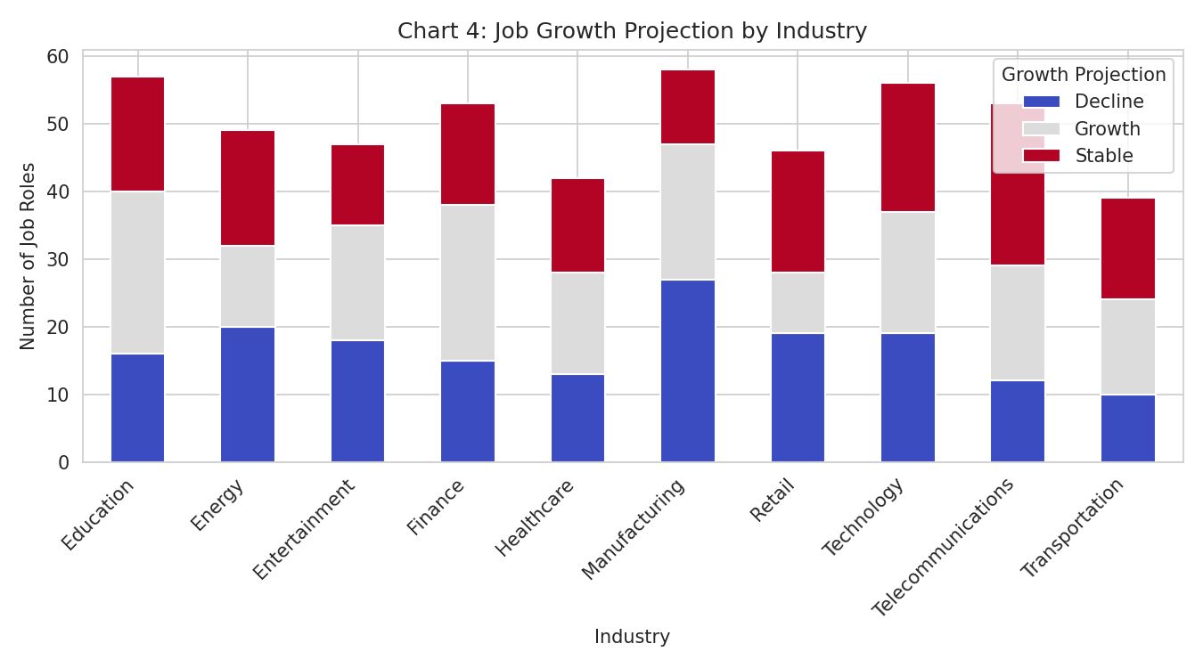

5.5 Company Size vs AI Adoption Level
This chart compares AI adoption levels across Small, Medium, and Large companies.
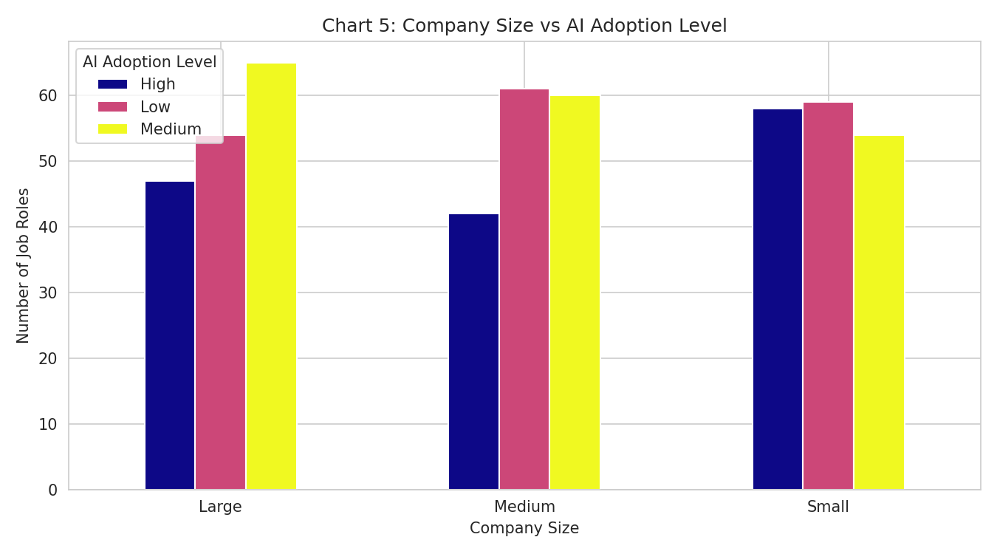

6. Observations, Insights, Hypotheses & Recommendations

6.1 Observations
- About 34% of job roles fall under High automation risk.
- Average salary for High-risk roles (~$93,900) is comparable to, and even slightly above, Low-risk roles (~$92,100).
- Education is the industry with the highest count of High-risk roles in this dataset.
- Job growth projections are almost evenly split: ~34% Growth, ~34% Decline, ~32% Stable.
- Education also has the highest number of roles projected for Growth.

6.2 Insights
- Automation risk does not show a large salary penalty in this dataset - high-risk roles are not necessarily low-paying, suggesting risk is tied to the type of tasks in a role, not the skill/pay level of the role.
- Growth and Decline projections are spread fairly evenly across industries, meaning AI's impact is uneven even within the same sector - not every role in a 'growing' industry is safe.
- Company size does not strongly determine AI adoption level, suggesting AI tools have become accessible even to smaller companies, not just large enterprises.

6.3 Hypotheses
- If automation risk does not correlate strongly with salary, then earning a higher salary may not protect a role from AI-driven disruption - the nature of daily tasks likely matters more than pay grade.
- If growth/decline is spread unevenly within industries rather than by industry as a whole, employees should evaluate their own role's task composition rather than relying only on their industry's overall reputation.

6.4 Recommendations
- Reskilling programs should target specific high-automation-risk roles across all industries and salary bands, not just low-paying jobs.
- Professionals should track role-level AI exposure (their own day-to-day tasks) rather than relying on broad industry-level narratives about AI being 'good' or 'bad' for their sector.
- Organizations should pair AI adoption with structured upskilling paths for roles flagged at High automation risk, regardless of company size.

7. Conclusion
The data suggests that AI's impact on the job market is not a simple 'benefit vs loss' story. Automation risk is spread fairly evenly across industries and salary levels, meaning no single sector or income bracket is fully safe from disruption, nor is any sector purely benefiting. The evidence points toward a more nuanced conclusion: AI's impact is best understood at the level of individual job tasks, not entire industries or companies. This favors reskilling strategies that are targeted and task-specific rather than broad, industry-wide policies.

8. Limitations
- The dataset is synthetic; findings reflect statistical patterns within this dataset, not confirmed real-world labor statistics.
- No time-series data is available, so year-over-year AI adoption trends could not be analyzed.
- Automation risk and AI adoption levels are pre-labeled in the dataset as Low/Medium/High rather than derived from raw task-level data.

