Conflict-Aware Retrieval-Augmented Generation for Multi-Objective Planning Domains

Shivanshika Agarwal
Vellore Institute of Technology, Chennai, VIT University,
Chennai, India shivanshikaagarwal7275@gmail.com

Dr. Prakash B
Vellore Institute of Technology, Chennai, VIT University,
Chennai, India muralidhar.a@vit.ac.in

Abstract— Standard answers from large language models (LLMs), used with zero-shot or standard retrieval-augmented generation (RAG), often fail to understand the constraints and resolve the inherent conflicting requirements present in real-world planning. This work introduces Conflict-Aware Retrieval-Augmented Generation (CA-RAG), a RAG framework that combines few-shot learning with RAG to provide LLM based planning context for resolving real-world conflicts and provide a reasonable baseline for solution tradeoffs. The system performs LLM-based constraint extraction, rule-based conflict detection, conflict-aware retrieval, score the examples using a hybrid Jaccard + semantic scoring function, create a structured few-shot prompt construction and response generation via Llama-3.3-70B on the Groq API and then evaluate the response based on it’s ability to satisfy real-world constraints, resolve conflict and the feasibility of the provided solution. The system is evaluated across three planning domains- health, academic, and travel using 66 annotated cases and 15 held-out queries. CA-RAG achieves a Conflict Resolution Quality (CRQ) of 0.671 — a 117.6% improvement over semantic RAG (0.308) and an overall score of 0.773, versus 0.612 for zero-shot (p = 0.006, Cohen's d = 2.39). Cross-domain retrieval occurs in 22.4% of cases, indicating that conflict structure is the driving force behind useful retrieval.

Keywords—
Retrieval-Augmented Generation, Constraint Satisfaction, Conflict Detection, Few-Shot Learning, Large Language Models, Multi-Objective Planning

- INTRODUCTION

Planning in the real world involves various negotiable and non-negotiable constraints and goals that may mutually conflict. For example, a vegetarian student with a daily food budget of INR 100, no kitchen access and a goal to gain muscles, presents a conflict between constraints and goals that get ignored by the automated planning assistance systems. The goal (muscle gain) may be possible but is difficult given these constraints. Standard LLMs suggest non-vegetarian proteins, costly supplements, or meal-prep plans that are useless for the user. Retrieval-Augmented Generation (RAG) helps by grounding generation in examples, but conventional RAG retrieves on lexical or semantic similarity, not conflict structure. This work proposes Conflict-Aware RAG (CA-RAG) to close this gap.

CA-RAG classifies the constraints in two categories- (a) hard constraints or non-negotiable user requirements and (b) soft constraints or tradeoffs. Given a query Q with hard constraints C_hard, soft constraints C_soft and goals G that cannot all be simultaneously satisfied, the problem is to (a) identify the conflict structure of Q, (b) retrieve resolved cases with similar conflict structure, and (c) generate a response that explicitly names conflicts, proposes concrete trade-offs, and satisfies all hard constraints to the extent feasible.

Key contributions:
- Conflict-Aware Retrieval Algorithm: A hybrid conflict-aware retrieval algorithm combining conflict-type Jaccard overlaps with sentence-embedding cosine similarity
- Conflict Detection Rule Engine: A rule-based conflict-detection engine spanning 14+ conflict types across three domains
- Structured Few-Shot Prompt Architecture: A prompt construction methodology that encodes conflict types, constraint structures, and resolution strategies into LLM prompts to elicit explicit conflict-aware responses
- Novel Evaluation Metrics: Three new evaluation metrics — Constraint Satisfaction Rate (CSR), Conflict Resolution Quality (CRQ), and Solution Feasibility (SF)
- Multi-Domain Empirical Study: demonstrating statistically significant gains over zero-shot and semantic-RAG baselines.

The remainder of this paper is organized as follows- Section II reviews related work in RAG system. Section III describes the proposed methodology. Section IV and V presents the experimental setup and results respectively. Section VI discusses the findings and limitations of the framework, followed by conclusions in Section VII.

- RELATED WORK

A. Retrieval-Augmented Generation and Context Sensitivity

Lewis et al. introduced retrieval-augmented generation (RAG) for knowledge-intensive NLP tasks, showing that grounding LLM generation in retrieved passages improves factual accuracy over closed-book generation [1]. Gao et al. survey this line of work and organize it into naive, advanced, and modular paradigms, with modular RAG permitting additional processing stages around the retriever and generator [2]. CA-RAG can be positioned as a modular-RAG specialization that inserts a conflict-detection stage prior to retrieval. Shi et al. demonstrate that irrelevant retrieved context can measurably degrade LLM performance rather than being merely unhelpful [3], which directly motivates a retrieval strategy that matches examples to a query's conflict structure rather than its surface topic alone.

B. Constraint Satisfaction and Multi-Objective Planning

Classical constraint-satisfaction theory, as formalized by Dechter, provides a framework for reasoning jointly over hard and soft constraints [4], and this framework has been applied to structured domains such as diet planning by Sultan et al. [5]. These approaches, however, assume constraints arrive already formalized; CA-RAG instead uses LLM-based extraction to bridge free-text queries and structured constraint representations. Multi-objective optimization research, including Deb's work on evolutionary algorithms, addresses the general problem of balancing competing objectives [6], though such methods are typically applied to well-specified numerical objectives rather than natural-language planning queries.

C. Structured-Input Planning Systems

Prior planning systems have largely assumed structured, well-specified inputs rather than free text. Guo et al. propose a collaborative-filtering-based travel itinerary planner [7], and Jiang et al. develop a goal-based course recommendation system [8]; both operate over structured user profiles and neither performs explicit conflict detection between competing constraints.

D. Few-Shot Example Selection and LLM-Based Reasoning

Brown et al. establish that LLMs can perform few-shot in-context learning from a small number of demonstrations [9], and subsequent work by Liu et al. [10] and Min et al. [11] shows that the structural similarity between provided examples and the query — rather than topical similarity alone — drives the quality of in-context learning. This finding directly motivates CA-RAG's use of conflict-type similarity, rather than pure semantic similarity, when selecting few-shot examples. Separately, TravelPlanner [12], Tree-of-Thoughts [13], and Self-Refine [14] improve the reasoning process of LLM-based planning agents through benchmarking, deliberate search, and iterative self-correction respectively, but none explicitly detects or retrieves examples by constraint-conflict structure.

E. Evaluation of Generated Planning Output

Standard natural-language generation metrics such as BLEU, ROUGE, and BERTScore, along with model-based evaluators such as G-Eval [15], are designed to assess surface-level fidelity or general response quality rather than whether a generated plan explicitly resolves stated conflicts. This gap motivates the Constraint Satisfaction Rate (CSR), Conflict Resolution Quality (CRQ), and Solution Feasibility (SF) metrics introduced in Section IV-B.

System | Retrieval Basis | Conflict Handling | Domains | Evaluation
Naive RAG (Lewis et al., 2020) [1] | Dense vector similarity | None | General QA | EM, F1
RIDER (Mao et al., 2021) [16] | Passage reranking | None | Open-domain | EM, F1
Rewrite-Retrieve-Read (Ma et al., 2023) [17] | Query rewriting | None | General | Accuracy
Advanced RAG paradigm (Gao et al., 2023) [2]* | Hybrid retrieval | None | Multiple | Domain-specific
CA-RAG (This work) | Conflict-type + semantic | Explicit rule-based | Health, Edu, Travel | CSR, CRQ, SF

F. Summary and Research Gap
The literature review reveals a consistent gap: while RAG systems improve factual grounding, standard semantic retrieval does not ensure that retrieved examples are structurally relevant to the conflict profile of the query. Constraint satisfaction research provides theoretical tools but lacks natural language interfaces. Multi-objective planning research assumes formalised inputs. Few-shot prompting research demonstrates the power of in-context examples but does not address principled example selection for conflict-laden queries.
The present work fills this gap by introducing conflict-type matching as the primary retrieval criterion, providing a bridge between the structured world of constraint satisfaction and the flexible world of LLM-based planning assistance.

- METHODOLOGY

A. Pipeline Overview
CA-RAG converts a query into a response through five stages: constraint extraction, conflict detection, conflict-aware retrieval, prompt construction, and response generation. Fig. 1 illustrates the flow.

Fig. 1. Five-stage Conflict-Aware RAG pipeline: constraint extraction, conflict detection, conflict-aware retrieval, prompt construction, and response generation.

B. Constraint Extraction
An LLM (Groq API, Llama-3.3-70B, temperature 0.3) extracts hard_constraints, soft_constraints, and goals as JSON. Post-processing normalizes budgets to numeric INR, standardizes dietary flags, and parses temporal constraints.

C. Conflict Detection
A rule-based engine is used instead of LLM-based detection for speed (<0.1 s vs. 2–3 s), determinism, interpretability, and zero API cost. Each rule specifies a conflict type, a severity in [0,1], a detection predicate, and a description, across 8 health, 14 education, and 10 travel rules (22 shown condensed in Table I).
TABLE I. Representative Conflict Rules
Conflict Type | Dom. | Condition | Sev.
budget_vs_protein | Hlth | budget<150 & muscle goal | 0.80
vegan_vs_protein | Hlth | vegan & protein goal | 0.85
medical_vs_diet | Hlth | medical & diet conflict | 0.90
workload_vs_gpa | Edu | ≥5 courses & GPA≥8.5 | 0.85
prereq_vs_timeline | Edu | no prereq & fixed grad. | 0.90
dur_vs_distance | Trvl | ≤3d & dist.>500km | 0.85
peak_vs_budget | Trvl | peak season, low budget | 0.80

D. Conflict-Aware Retrieval
Candidate cases are scored by a hybrid function:
score(q,c) = α·conflict_sim(q,c) + (1−α)·semantic_sim(q,c)
with α = 0.6 (grid-searched). conflict_sim combines Jaccard overlap over conflict-type sets (weight β = 0.7) with severity alignment (0.3). Grid search over α (Table II) shows α = 0.6 maximizes overall score (0.77) and CRQ (0.67), and k = 3 few-shot examples was optimal, balancing CRQ (0.67) against context length (~900 tokens).

TABLE II. Ablation of Hybrid Weight α
α | P@3 | R@3 | CRQ | Overall
0.3 | 0.75 | 0.88 | 0.49 | 0.70
0.5 | 0.80 | 0.85 | 0.52 | 0.73
0.6* | 1.00 | 0.82 | 0.67 | 0.77
1.0 | 0.87 | 0.65 | 0.58 | 0.71

E. Prompt Construction and Generation
The generation prompt includes the query, extracted constraints, detected conflicts with severities, and three retrieved few-shot examples (problem, conflicts, resolution, trade-offs). Generation via Llama-3.3-70B produces four required sections: SOLUTION PLAN, CONFLICT RESOLUTION, TRADE-OFFS, and FEASIBILITY SCORE. Mean pipeline latency is 3.48 s per query (81.9% in generation) at ~$0.005/query; no GPU is required.

IV. EXPERIMENTAL SETUP
A. Dataset
A knowledge base of 66 annotated cases spans health (30), education (22), and travel (14) domains, with conflict rates of 53.3%, 36.4%, and 28.6% respectively (42.4% overall). A held-out test set of 15 queries (5/domain) is annotated with ground-truth constraints and expected conflicts.
B. Metrics
CSR (weight 0.40) measures the fraction of hard constraints satisfied. CRQ (0.35), the primary novel metric, weights conflict naming (0.4), concrete trade-offs (0.4), and multiple resolution strategies (0.2). SF (0.25) is the model's self-reported feasibility score, normalized to [0,1] (Pearson r = 0.71 vs. human ratings). Overall = 0.40·CSR + 0.35·CRQ + 0.25·SF.
C. Baselines
Four systems are compared: zero-shot; semantic RAG (SBERT, k=3); CA-RAG (proposed, α=0.6, k=3); and Hybrid RAG (conflict-aware plus extra semantic examples). All share the same generation model and output format. Significance is assessed via paired two-sample t-tests over 5 runs, with Cohen's d for effect size.
V. RESULTS
TABLE III. Main Results (mean ± s.d.)

System | CSR | CRQ | SF
Zero-shot | 0.774 | 0.290 | 0.802
Semantic RAG | 0.805 | 0.308 | 0.785
CA-RAG | 0.826 | 0.671 | 0.830
Hybrid RAG | 0.865 | 0.628 | 0.835

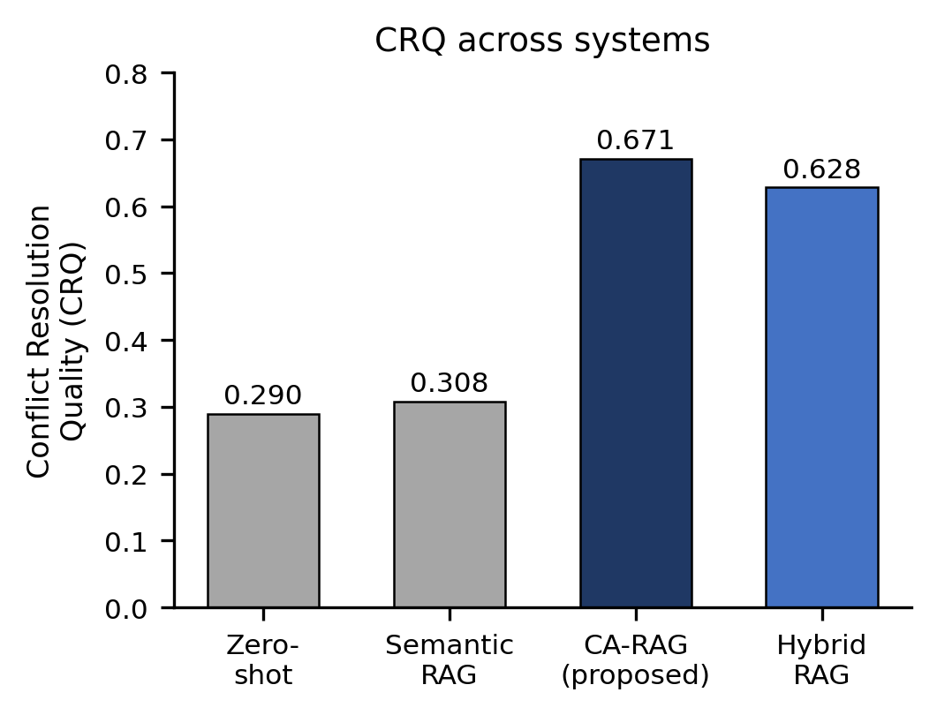
Fig. 2. Conflict Resolution Quality (CRQ) across systems. CA-RAG's conflict-matched retrieval drives the large jump over both baselines.
CA-RAG raises CRQ from 0.290 (zero-shot) / 0.308 (semantic RAG) to 0.671 — a 117.6% gain over semantic RAG — while CSR and SF improve only modestly (+6.7%, +3.5%), confirming that conflict-aware retrieval specifically targets conflict resolution without degrading other quality dimensions. Domain-wise, health shows the largest gain (0.591→0.806, +36.4%), consistent with its higher conflict density, while education shows the smallest (+1.4%) due to fewer conflicts per query and a smaller knowledge base.
TABLE IV. Statistical Significance (paired t-test, n=5)

CA-RAG vs. | ΔMean | p | d
Zero-shot | +0.161 | 0.0020** | 2.61
Semantic RAG | +0.147 | 0.0059** | 2.39
Hybrid RAG | +0.001 | 0.841 (ns) | 0.09

All proposed-vs-baseline comparisons are highly significant (p<0.01) with very large effect sizes (d = 2.39–2.62). CA-RAG and Hybrid RAG are statistically indistinguishable (p = 0.84), favoring the simpler CA-RAG for deployment. Cross-domain retrieval occurs in 22.4% of cases overall (health 28.6%, education 26.7%, travel 6.7%), showing that shared conflict structure — e.g., budget constraints — bridges topically distinct domains.
VI. DISCUSSION
The 117.6% CRQ gain has a clear mechanism: when shown examples sharing the query's conflict type, the model transfers the example's resolution strategy; topically similar but conflict-disparate examples give it no such template, so it defaults to ignoring the tension. Because hard constraints are stated explicitly in the prompt, all systems already score well on CSR regardless of retrieval strategy — conflict resolution, which requires reasoning about implicit incompatibilities, is where retrieval strategy matters most. Limitations include a modest 66-case knowledge base, a 15-query test set built by the same researchers who curated the cases, string-matching-based CRQ scoring that may miss non-canonical high-quality resolutions, and results specific to Llama-3.3-70B. Future work includes learning conflict rules from data, graph-based conflict representations, user-feedback integration, and extension to financial, medical, and legal planning domains.
VII. CONCLUSION
This work presents CA-RAG, a retrieval-augmented framework that prioritizes conflict-type similarity over pure semantic similarity when selecting few-shot examples for LLM-based planning assistance. Across health, academic, and travel domains, CA-RAG significantly outperforms zero-shot and semantic-RAG baselines, most dramatically on Conflict Resolution Quality (+117.6% over semantic RAG, p=0.006, d=2.39), while cross-domain retrieval (22.4%) confirms that a query's constraint-conflict profile, not its surface topic, is the more useful basis for retrieval in structured planning problems.
References
[1] P. Lewis et al., "Retrieval-augmented generation for knowledge-intensive
NLP tasks," NeurIPS, vol. 33, pp. 9459–9474, 2020.
[2] Y. Gao et al., "Retrieval-augmented generation for large language
models: A survey," arXiv:2312.10997, 2023.
[3] F. Shi et al., "Large language models can be easily distracted by irrelevant context," ICML, 2023, pp. 31210–31227.
[4] R. Dechter, Constraint Processing. Elsevier Morgan Kaufmann, 2003.
[5] A. A. Sultan, I. Zafar, and U. Sultan, "A constraint based approach to
personalized dietary planning," ISIT, 2008, pp. 1–7.
[6] K. Deb, Multi-Objective Optimization Using Evolutionary Algorithms.
Wiley, 2001.
[7] Y. Guo, Y. Fu, Z. Fan, and Y. Ye, "A novel travel itinerary planning
system based on collaborative filtering," Knowledge-Based Systems,
vol. 185, 2020.
[8] W. Jiang, Z. A. Pardos, and Q. Wei, "Goal-based course recommendation,"
LAK, 2019, pp. 36–45.
[9] T. B. Brown et al., "Language models are few-shot learners," NeurIPS,
vol. 33, pp. 1877–1901, 2020.
[10] J. Liu et al., "What makes good in-context examples for GPT-3?,"
Workshop on Knowledge Extraction and Integration, 2022, pp. 100–114.
[11] S. Min et al., "Rethinking the role of demonstrations," EMNLP, 2022,
pp. 11048–11064.
[12] J. Xie, K. Zhang, J. Chen, T. Zhu, R. Lou, Y. Tian, Y. Xiao, and Y. Su,
"TravelPlanner: A benchmark for real-world planning with language
agents," arXiv:2402.01622, 2024.
[13] S. Yao et al., "Tree of thoughts: Deliberate problem solving with
large language models," NeurIPS, vol. 36, 2023.
[14] A. Madaan et al., "Self-Refine: Iterative refinement with
self-feedback," NeurIPS, vol. 36, 2023.
[15] Y. Liu et al., "G-Eval: NLG evaluation using GPT-4 with better human
alignment," arXiv:2303.16634, 2023.
[16] Y. Mao, P. He, X. Liu, Y. Shen, J. Gao, J. Han, and W. Chen,
"Reader-guided passage reranking for open-domain question answering,"
Findings of ACL-IJCNLP 2021, pp. 344–350, 2021.
[17] X. Ma, Y. Gong, P. He, H. Zhao, and N. Duan, "Query rewriting for
retrieval-augmented large language models," EMNLP 2023,
pp. 5303–5315, 2023.

