**Speakic – Synopsis**

**Index-**

|  |  |  |  |
| --- | --- | --- | --- |
| Sr. No. | Topic | Page No. | Remarks |
| 1. | Abstract | 02 |  |
| 2. | Introduction | 03 |  |
| 3. | Purpose | 04 |  |
| 4. | Tech-Stack | 05 |  |
| 5. | Flowchart | 09 |  |
| 6. | Functionalities | 10 |  |
| 7. | Key Features | 13 |  |
| 8. | Further Work | 14 |  |
| 9. | Conclusion | 15 |  |

1. **Abstract**

Speakic stands out as a comprehensive solution for conquering language barriers. Whether users are looking to learn a new language, translate text, or facilitate communication through speech conversion, Speakic offers a versatile platform that meets diverse linguistic needs. With its user-friendly interface and powerful features, Speakic empowers users to communicate confidently and effectively across different languages.

Speakic is an innovative language learning and communication application designed to transcend linguistic barriers and foster global connectivity. With its comprehensive features, including interactive language learning modules, accurate translation services, and real-time speech conversion capabilities, Speakic offers users a versatile platform to enhance their language skills and facilitate seamless communication across different languages. Leveraging advanced machine learning algorithms and scalable cloud infrastructure, Speakic ensures a seamless user experience, robust functionality, and reliable performance. Whether users are beginners embarking on a journey to learn a new language or seasoned linguists seeking to enhance communication efficiency, Speakic provides a transformative solution that empowers users to navigate the diverse linguistic landscape with confidence and ease. Through its intuitive interface and powerful features, Speakic exemplifies the potential of technology to bridge divides and promote understanding in an increasingly interconnected world.

1. **Introduction**

Speakic is a cutting-edge application designed to overcome language barriers seamlessly. With a user-friendly interface and robust functionality.

Speakic offers three core features: language learning, translation, and speech conversion.

Speakic provides users with an immersive language learning experience. Through interactive lessons, exercises, and quizzes, users can enhance their proficiency in a new language.

Speakic excels in bridging communication gaps by offering accurate and efficient translation services. Users can effortlessly translate text from one language to another with just a few taps.

Speakic revolutionizes the way users interact with language through its innovative speech conversion feature. With the ability to convert both text to speech and speech to text, the app facilitates effortless communication in any situation. Users can simply speak into their device, and it will accurately transcribe their words into text or vocalize written content aloud.

1. **Purpose**

The purpose of Speakic is to empower users to overcome language barriers and facilitate seamless communication across different languages. Whether users aim to learn a new language, translate text, or enhance communication through speech conversion, Speakic provides a comprehensive platform to meet their linguistic needs. By offering interactive language learning modules, accurate translation services, and real-time speech-to-text and text-to-speech conversion capabilities, Speakic aims to enable users to communicate confidently and effectively in any language context. Ultimately, the purpose of Speakic is to promote global connectivity and understanding by breaking down linguistic barriers.

1. **Tech-Stack**

Speakic harnesses a sophisticated tech stack to craft an effortless user experience and ensure robust functionality. At its core, advanced machine learning algorithms drive accurate language translation and speech recognition, fostering seamless communication across diverse linguistic contexts. The backend infrastructure, supported by scalable cloud services, ensures reliable data processing and storage, guaranteeing smooth operations even during peak usage. The interactive frontend, built with modern web technologies and frameworks, offers intuitive navigation and responsive design, facilitating seamless interaction across devices. Moreover, integration with third-party APIs enriches Speakic's capabilities, expanding language offerings and enhancing overall user satisfaction. With a meticulously designed tech stack, Speakic delivers unparalleled ease-of-use and performance, making language learning and communication effortless and enjoyable for users worldwide.

1. React JS - In Speakic, React serves as the foundational framework for its dynamic and interactive frontend interface, enabling seamless user interaction and responsive design across various devices. Leveraging React's component-based architecture, developers have modularized the frontend codebase, enhancing maintainability and scalability. With React's virtual DOM rendering, Speakic delivers a smooth and efficient user experience, minimizing page reloads and ensuring swift navigation between different sections of the application. The declarative nature of React simplifies state management and enables developers to efficiently update the UI in response to user actions or data changes. Additionally, React's ecosystem offers a plethora of libraries and tools that augment Speakic's frontend development, facilitating tasks such as routing, state management, and UI styling. Overall, React empowers Speakic to deliver a visually appealing, highly responsive, and user-centric frontend experience, driving engagement and satisfaction among its diverse user base.
2. React Router - In Speakic, React Router plays a pivotal role in managing the routing of different pages within the application, ensuring a seamless and intuitive navigation experience for users. By leveraging React Router's declarative routing system, developers can define a hierarchy of routes that correspond to distinct pages or views within Speakic. Whether users are accessing language learning modules, utilizing translation services, or engaging with speech conversion features, React Router dynamically renders the appropriate components based on the URL, facilitating smooth transitions between different sections of the application. Additionally, React Router's support for nested routes enables Speakic to organize complex page structures efficiently, enhancing clarity and usability. Through its robust routing capabilities, React Router empowers Speakic to deliver a cohesive and immersive user experience, enabling users to effortlessly explore and engage with the diverse features and functionalities offered by the application.
3. Firebase- Firebase serves as a powerful backend infrastructure for Speakic, providing a host of services that enable seamless data management, real-time updates, and secure authentication. Speakic leverages Firebase's real-time database to store user-generated content, language learning progress, and other application data, ensuring that information is synchronized across devices instantaneously. Firebase Authentication enhances security by allowing users to sign in securely using email/password, social media accounts, or third-party providers, while Firebase Cloud Firestore facilitates scalable and efficient data storage and retrieval. Additionally, Firebase Cloud Functions enable Speakic to execute server-side logic in response to events, such as user interactions or data updates, enhancing application functionality and responsiveness. Through its comprehensive suite of backend services, Firebase empowers Speakic to deliver a reliable, scalable, and secure platform for language learning and communication, ensuring a seamless user experience for learners worldwide.
4. SCSS- In Speakic, SCSS (Sassy CSS) serves as a cornerstone for crafting a visually appealing and maintainable frontend interface. SCSS extends the capabilities of traditional CSS, offering features such as variables, mixins, nesting, and inheritance, which streamline the styling process and promote code reusability. By organizing stylesheets into modular components, SCSS enhances code organization and scalability, facilitating efficient development and maintenance workflows. Speakic utilizes SCSS to define consistent design patterns, typography, color schemes, and layout structures across the application, ensuring a cohesive and polished user interface. Additionally, SCSS's support for nested selectors enables Speakic developers to write cleaner and more readable CSS code, reducing redundancy and improving maintainability. Through its powerful features and flexibility, SCSS empowers Speakic to create an immersive and visually engaging frontend experience that resonates with users and enhances overall usability.
5. NodeJS- In Speakic, Node.js plays a fundamental role in powering the backend infrastructure, delivering scalability, efficiency, and flexibility to support the application's diverse functionalities. By leveraging Node.js, Speakic can handle concurrent requests and manage asynchronous operations seamlessly, ensuring responsive performance for users accessing language learning modules, translation services, and communication features. Node.js's event-driven architecture allows Speakic to efficiently manage real-time data processing, such as user interactions and updates, enhancing the responsiveness and interactivity of the platform. Additionally, Node.js's extensive ecosystem of modules and packages provides Speakic with a rich toolkit for integrating third-party services, implementing security measures, and optimizing performance.
6. MongoDB- In Speakic, MongoDB serves as a pivotal component of the backend infrastructure, facilitating efficient and scalable data management for various aspects of the application. MongoDB's flexible document-based data model allows Speakic to store and organize diverse types of data, including user profiles, language learning progress, translation records, and communication logs. This flexibility enables Speakic to adapt to evolving user needs and accommodate complex data structures with ease. Additionally, MongoDB's distributed architecture and horizontal scalability support Speakic's growing user base, ensuring optimal performance and reliability even under high loads. By leveraging MongoDB's powerful query language and indexing capabilities, Speakic can retrieve and manipulate data quickly and efficiently, enabling seamless user interactions and data-driven insights.

**5. Flowchart**

The flowchart begins with the user's initial interaction, whether it is downloading the app or visiting the website. From there, the flow branches into different paths based on the user's goals and actions. For instance, users may choose to sign up for an account to access personalized language learning features, or they may opt to explore Speakic's translation services without creating an account. As users navigate through the app, the flowchart outlines key decision points and possible outcomes, such as selecting a language to learn, entering text for translation, or utilizing speech conversion tools. Additionally, the flowchart may include loops or feedback mechanisms to accommodate user input errors or provide guidance when needed. Ultimately, the flowchart provides a visual roadmap of the user experience, helping designers and developers understand the user journey and optimize the application for usability and efficiency.

The proposed flowchart of the speakic app is given below:

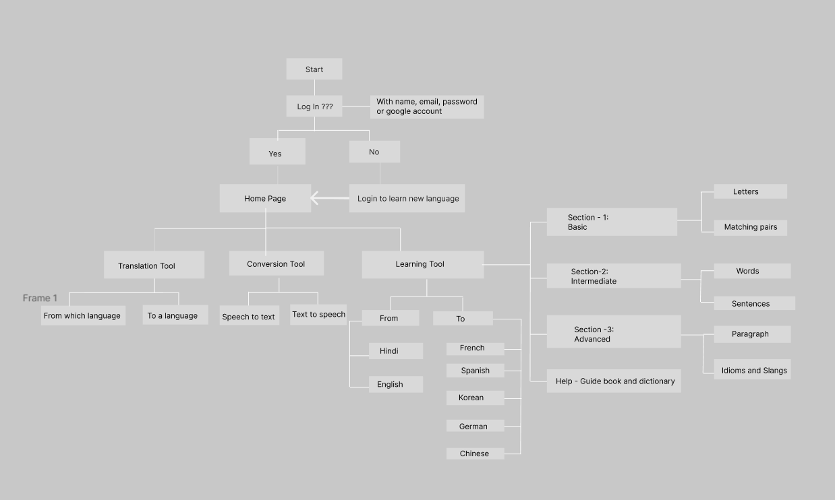

**6. Functionalities**

1. Translation

Speakic excels in bridging communication gaps by offering accurate and efficient translation services. Users can effortlessly translate text from one language to another with just a few taps.

With its text translation capability, users can input or select text from various sources and receive accurate translations in real-time. The app boasts extensive multilingual support, accommodating a wide range of language pairs to suit diverse linguistic needs. Notably, Speakic goes beyond mere word-for-word translation, prioritizing contextual accuracy to ensure that translated content maintains its intended meaning. Leveraging advanced machine learning and natural language processing techniques, Speakic considers the context of the text to deliver translations that are contextually relevant and comprehensible. Moreover, the app may offer additional features such as bilingual dictionaries, pronunciation guides, and grammar correction tools to further enrich the translation experience.

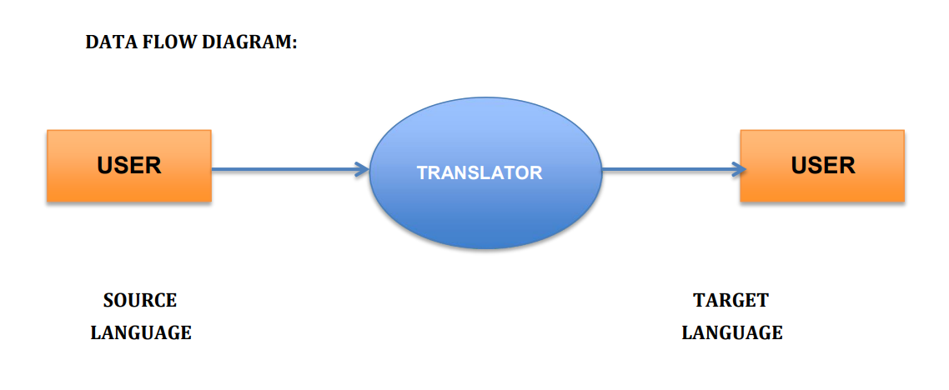

1. Speech Conversion

Speakic revolutionizes the way users interact with language through its innovative speech conversion feature. With the ability to convert both text to speech and speech to text, the app facilitates effortless communication in any situation. Users can simply speak into their device, and Speakic will accurately transcribe their words into text or vocalize written content aloud. This feature is particularly useful for language practice, accessibility, and enhancing communication efficiency.

Through text-to-speech conversion, users effortlessly translate written content into natural-sounding audio, aiding those with visual impairments and language learners alike. Conversely, speech-to-text conversion empowers users to transcribe spoken words into written text, facilitating swift and accurate capture of verbal information for note-taking or communication purposes. Operating in real-time, Speakic ensures instantaneous conversion results, enhancing communication fluidity across various contexts.

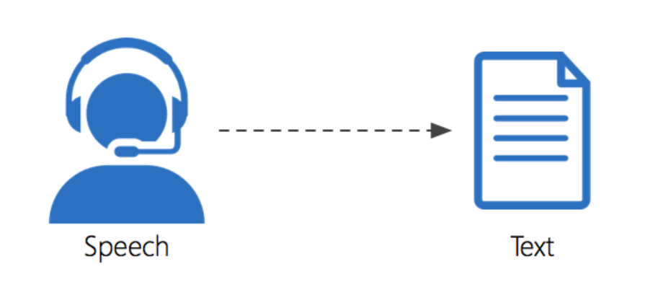

1. Language Learning

Speakic provides users with an immersive language learning experience. Through interactive lessons, exercises, and quizzes, users can enhance their proficiency in a new language. The app offers a wide range of languages to choose from, catering to diverse linguistic needs. Whether users are beginners or advanced learners, Speakic offers personalized learning paths to suit individual preferences and learning styles.

Through interactive lessons tailored to users' proficiency levels, learners engage in comprehensive exercises covering vocabulary, grammar, pronunciation, and real-life scenarios. Personalized learning paths ensure targeted instruction, aligning with individual goals and abilities. Practical exercises provide immersive experiences, enabling users to apply newfound skills in authentic contexts. Progress tracking tools empower learners to monitor their advancement, while community engagement features facilitate peer support and collaborative learning.

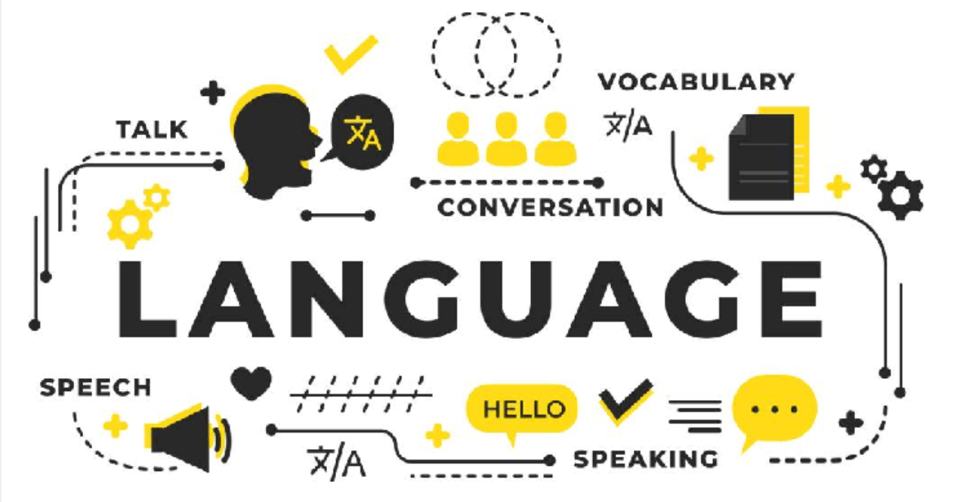

**7. Key Features:**

* Interactive language learning modules.
* Wide selection of languages available.
* Accurate and efficient text translation.
* Real-time speech-to-text and text-to-speech conversion.
* Personalized learning paths.
* Intuitive user interface for seamless navigation.
* Regular updates and improvements for optimal performance.
* Multi-modal Learning Resources.
* Practical Language Learning.
* Progress Tracking.
* Accurate Translation Services.
* User-friendly Interface.
* Accessibility.
* Secure Account Management.
* Regular Updates and Improvements.
* Customer Support.

**8. Further Work:**

Till Now, we have completed the basic structure and functional layout of the application, make the flowchart and userflow for easier implementation of functionalities.   
  
On the development node, we have created the frontend of signup and login feature , the home screen, navbar, and completion of the components of translation and conversion .

For the deployment purpose, we have deployed it on Netlify , so anyone with the link can use it.

Further more, we are going to make the learning path , and providing user authentication, progress tracking connecting backend , and some other work.

**9. Conclusion:**

In conclusion, Speakic emerges as a transformative solution poised to revolutionize language learning and communication on a global scale. With its comprehensive features, including language learning modules, accurate translation services, and real-time speech conversion capabilities, Speakic empowers users to break down linguistic barriers effortlessly. By leveraging a sophisticated tech stack, Speakic ensures a seamless user experience, robust functionality, and scalable backend infrastructure. Whether users are embarking on a journey to learn a new language, seeking to facilitate communication across different languages, or aiming to enhance accessibility through speech conversion, Speakic stands as a beacon of innovation and connectivity. With its intuitive interface and powerful features, Speakic paves the way for a more interconnected and understanding world, where language is no longer a barrier but a bridge to shared experiences and mutual understanding.