**shivanshu singh**

MODULE-4

[Automation Core Testing]

1/2/2024

* Which components have you used in Load Runner?
* How can you set the number of V-users in Load Runner?
* What is Correlation?
* What is the process for developing a V-user Script?
* How Load Runner interacts with the application?
* How Load Runner interacts with the application?
* What is the relationship between Response Time and Throughput?
* To test the Performance testing on “Tops Technologies website” :- <https://wwwsaucedemo.com/>

1. to Record all top level menu
2. to Record minimum 10 V-user on this website
3. save all (Script, Design, Graph)

* create a normal script of above website with correlate using hp default website.

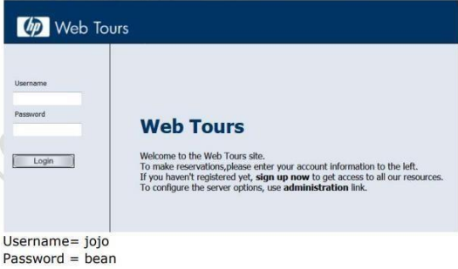

* What is Automation Testing?
* Which Are The Browsers Supported By Selenium Ide?
* What are the benefits of Automation Testing?
* What are the advantages of Selenium?
* Why testers should opt for Selenium and not QTP?
* To validate the tops technologies website Contact us page and enter your friend detail at last “Login and side menu” <https://www.saucedemo.com/>

DISCRIPTION

**Tops technologies**

1. Which components have you used in load runner?

* V-user generator – For generating Scripts.
* Controller – For creating and executing scenarios.
* Analyzer – To analyse results.

1. How can you set the number of V-users in Load Runner?

* You can set the number of V-users in the **controller** section while creating your

**scenarios**. Many other **advanced options like** **ramp-up**, **ramp-down** of **V-users**

are also available in the Controller section.

1. What is correlation?

* '**Correlation**' term refers to the handling of dynamic values coming from the

server. These dynamic values are the unique values that are generated by

the server for security purposes like the session ID, **authorization** token etc.

1. What is the process for developing a V-user Script?

* Step 1- **Record the V-user Script.**
* Step 2- **Playback and improve the recorded v-user script.**
* Step 3- **Define and test the different run-time parameters.**
* Step 4- **Use the script in a LoadRunner scenario**.

1. How Load Runner interacts with the application?

* LoadRunner simulates user activity by **generating** messages between

application components or by **simulating interactions** with the user interface

such as key **presses or mouse** movements.

6. What is the relationship between Response Time and Throughput?

* **Response** time and **throughput** are related. The response time for an **average transaction**

tends to **decrease** as you **increase overall throughput.**

* 7. To test the Performance testing on “Tops Technologies website” :- <https://wwwsaucedemo.com/>
* 
* **"\shivanshu singh\New folder (2)\Sauce demo.rar"**

8. create a normal script of above website with correlate using hp default website.

* "\shivanshu singh\New folder (2)\WebHttpHtml2.rar"

9. What is Automation Testing?

* Test automation is the use of software to **control the execution** of the tests the **comparison**

Of actual outcomes to **predicted outcomes**, the setting up of **test preconditions** and other

Test control and **test reporting functions**

**Approach to test automation**

* **Code-driven testing**
* **Graphical user interface testing**
* 10. Which Are the Browsers Supported By Selenium Ide?
* The supported browsers include **Mozilla Firefox, Google Chrome**,

**Microsoft Edge**, **Safari**, and **Opera**, **among** others.

11. What are the benefits of Automation Testing? 1011010

* Saving Costs.
* Faster Feedback Loop.
* Better Allocation of Resources.
* Guarantees Higher Accuracy.
* Increased Test Coverage.
* Detects bugs earlier.
* Test at Scale.
* Maximizes ROI.
* Speed
* Reliable

12. Why testers should opt for Selenium and not QTP?

* Selenium, however, supports a wide range of programming languages.

QTP/UFT test scripts run only on the Windows environment. They cannot

be run across all browsers. On the other hand, Selenium is OS independent

and allows test scripts to run across all browsers