Topic 2: Regional Disparities in Testing Resources

Research framework
Research question:
‘Do regions with fewer testing or preparation resources also show lower GED exam participation or lower GED completion?’

Key Takeaways
- Exam participation changes little across states, so resource differences do not seem to strongly affect whether candidates take an exam.
- GED completion varies much more across states, making resource inequality more relevant for completion than for participation.
- Prep access shows only a weak relationship with exam participation, but a somewhat clearer positive relationship with GED completion.
- Logit model 1&2 show that testing-center availability does not significantly affect exam-taking, but it does significantly improve the likelihood of GED completion.
- Prep-related resource measures are not statistically significant in the main completion model.

3. Data summary
Source CSV rows: 25,657; unique candidates: 4,691
Candidate-level rows: 4,691
State-level rows (all C_STATE): 52

4. Variable definitions

Raw quantities (building blocks)
Counts are derived from the cleaned exam-candidate file and rolled up to each candidate’s home state (C_STATE).
- n_testing_centers: number of distinct testing centers
- n_candidates: number of distinct candidates
- n_prep_center_users: candidates with a non-missing prep-center identifier
- n_exam_takers: candidates with at least one exam signal (RESULT_ID, EXAM_START, or SCORE non-missing)
- n_completers: candidates with a credential date or ENROLLMENT_STATUS equal to 4

State-level metrics
- center_density = n_testing_centers / n_candidates (testing centers per candidate in the state)
- prep_coverage = n_prep_center_users / n_candidates (share of candidates using a prep center)
- enrollment_rate = n_exam_takers / n_candidates (share taking at least one GED exam)
- completion_rate = n_completers / n_candidates (share earning the GED credential)
- prep_center_density = n_prep_centers / n_candidates (distinct prep-center IDs per candidate, from prep-center supply merged at state level)

Data construction and design choices
The pipeline aggregates multiple exam rows per candidate to one row per CANDIDATE_ID, then to state-level metrics for charts and correlations.
- Testing-center supply is counted by the physical center state (T_STATE) and aligned to C_STATE for merging, so resource intensity reflects how many centers exist in a candidate’s home state rather than where each exam was administered.
- Enrollment rates are typically high across states, so scatter plots often show only a weak visual link between center density and participation.
- Completion rates vary more across states; scatter plots and state-level correlations suggest a somewhat clearer positive association of completion with both center density and prep coverage.
- All descriptive relationships are associational and do not imply causality.
- Rows with non-U.S. or UNKNOWN C_STATE may appear in the raw data. They are kept in descriptive tables for transparency but excluded from the main logistic models, which restrict to VALID_STATES (50 states plus DC) as in the notebook.

5. Figures
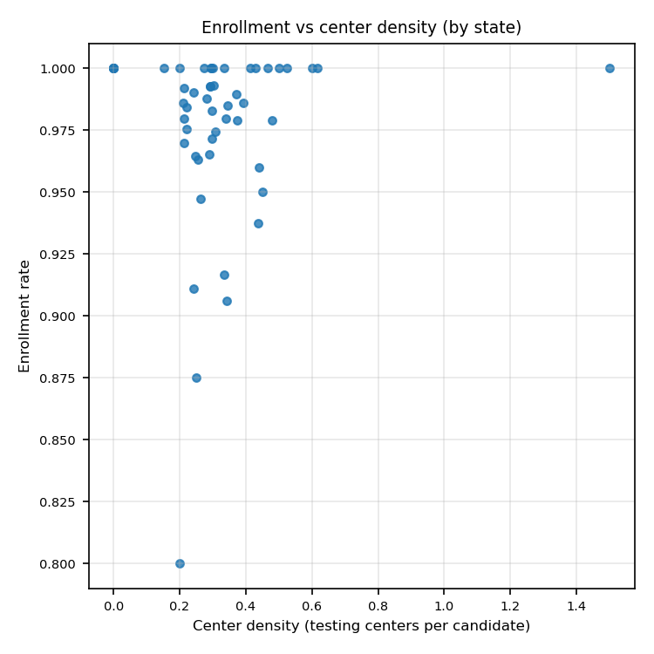
Enrollment vs center density (by state)—No Clear Patterns
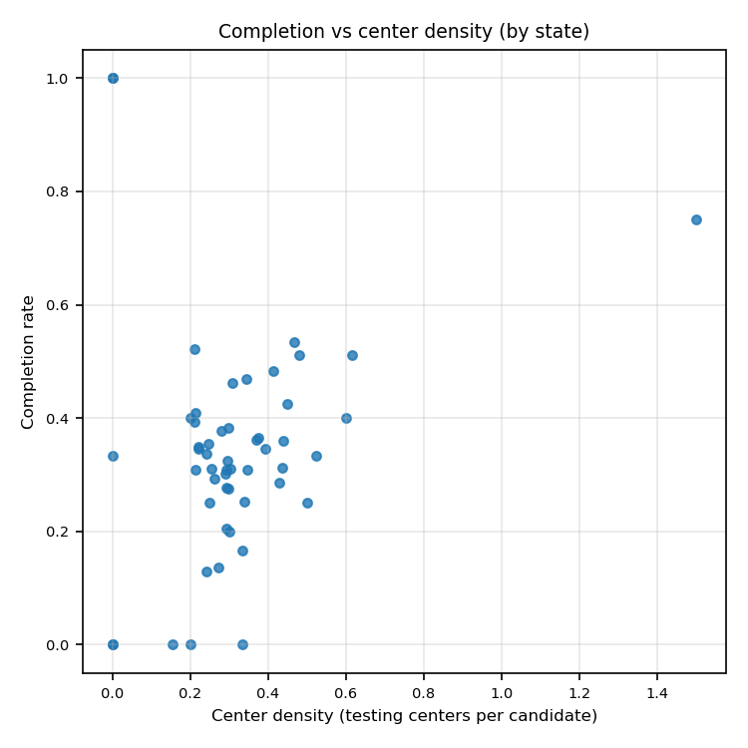
Completion vs center density (by state)—Clear Pattern
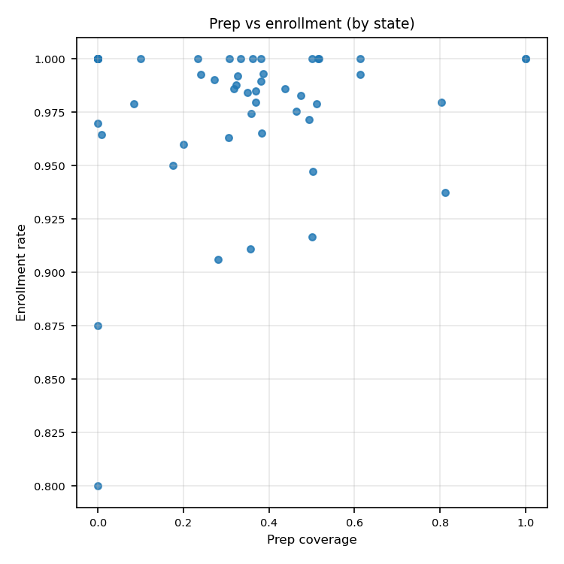
Prep vs enrollment (by state)-- A Little Pattern
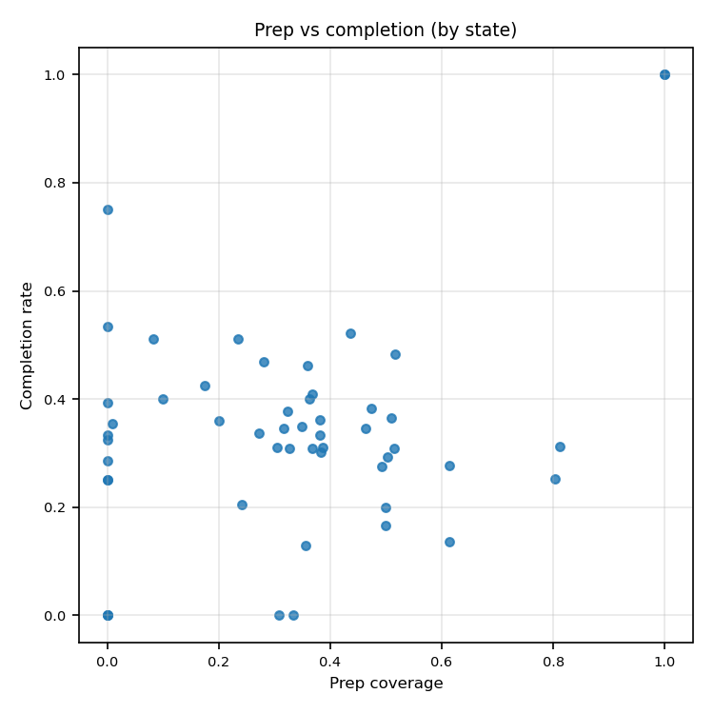
Prep vs completion (by state) -- A Little Pattern

6. Tables — Descriptive
Table A — Census region metrics (aggregated)
census_region | n_candidates | n_testing_centers | enrollment_rate | completion_rate | prep_coverage | center_density
Midwest | 900 | 281.0000 | 0.9851 | 0.3012 | 0.3333 | 0.2969
Northeast | 516 | 151.0000 | 0.9625 | 0.3198 | 0.3798 | 0.2249
South | 1899 | 535.0000 | 0.9820 | 0.3175 | 0.2795 | 0.4094
West | 1329 | 341.0000 | 0.9684 | 0.4086 | 0.3505 | 0.2616

- The South has the highest testing-center density.
- The West has the highest completion rate.
- Higher center density does not automatically translate into higher completion.
- Regional completion differences are likely influenced by factors beyond resource density alone.

Table B — State-level metrics (all C_STATE)
C_STATE | n_exam_takers | n_completers | prep_coverage | n_candidates | n_testing_centers | n_prep_centers | census_region | prep_center_density | center_density | enrollment_rate | completion_rate
AK | 21 | 7 | 0.3810 | 21 | 11.0000 | 8 | West | 0.3810 | 0.5238 | 1.0000 | 0.3333
AL | 96 | 35 | 0.3814 | 97 | 36.0000 | 24 | South | 0.2474 | 0.3711 | 0.9897 | 0.3608
AR | 94 | 49 | 0.0833 | 96 | 46.0000 | 9 | South | 0.0938 | 0.4792 | 0.9792 | 0.5104
AZ | 200 | 68 | 0.2723 | 202 | 49.0000 | 33 | West | 0.1634 | 0.2426 | 0.9901 | 0.3366
CA | 341 | 110 | 0.3051 | 354 | 90.0000 | 72 | West | 0.2034 | 0.2542 | 0.9633 | 0.3107
CO | 162 | 50 | 0.5029 | 171 | 45.0000 | 43 | West | 0.2515 | 0.2632 | 0.9474 | 0.2924
CT | 44 | 6 | 0.6136 | 44 | 12.0000 | 15 | Northeast | 0.3409 | 0.2727 | 1.0000 | 0.1364
DC | 13 | 0 | 0.3077 | 13 | 2.0000 | 4 | South | 0.3077 | 0.1538 | 1.0000 | 0.0000
DE | 11 | 2 | 0.5000 | 12 | 4.0000 | 5 | South | 0.4167 | 0.3333 | 0.9167 | 0.1667
FL | 535 | 223 | 0.3681 | 546 | 116.0000 | 71 | South | 0.1300 | 0.2125 | 0.9799 | 0.4084
GA | 380 | 118 | 0.3264 | 383 | 82.0000 | 62 | South | 0.1619 | 0.2141 | 0.9922 | 0.3081
HI | 15 | 8 | 0.0000 | 15 | 7.0000 | 1 | West | 0.0667 | 0.4667 | 1.0000 | 0.5333
IA | 3 | 1 | 0.0000 | 3 | 0.0000 | 1 | Midwest | 0.3333 | 0.0000 | 1.0000 | 0.3333
ID | 80 | 32 | 0.3625 | 80 | 16.0000 | 16 | West | 0.2000 | 0.2000 | 1.0000 | 0.4000
IL | 205 | 58 | 0.4929 | 211 | 63.0000 | 51 | Midwest | 0.2417 | 0.2986 | 0.9716 | 0.2749
IN | 7 | 2 | 0.0000 | 7 | 3.0000 | 1 | Midwest | 0.1429 | 0.4286 | 1.0000 | 0.2857
KS | 68 | 21 | 0.5147 | 68 | 20.0000 | 22 | Midwest | 0.3235 | 0.2941 | 1.0000 | 0.3088
KY | 144 | 37 | 0.8027 | 147 | 50.0000 | 60 | South | 0.4082 | 0.3401 | 0.9796 | 0.2517
LA | 4 | 1 | 0.0000 | 4 | 2.0000 | 1 | South | 0.2500 | 0.5000 | 1.0000 | 0.2500
MA | 29 | 15 | 0.2812 | 32 | 11.0000 | 9 | Northeast | 0.2812 | 0.3438 | 0.9062 | 0.4688
MD | 83 | 26 | 0.3837 | 86 | 25.0000 | 21 | South | 0.2442 | 0.2907 | 0.9651 | 0.3023
ME | 1 | 1 | 1.0000 | 1 | 0.0000 | 1 | Northeast | 1.0000 | 0.0000 | 1.0000 | 1.0000
MI | 141 | 44 | 0.3873 | 142 | 43.0000 | 43 | Midwest | 0.3028 | 0.3028 | 0.9930 | 0.3099
MN | 94 | 35 | 0.5104 | 96 | 36.0000 | 27 | Midwest | 0.2812 | 0.3750 | 0.9792 | 0.3646
MO | 2 | 0 | 0.0000 | 2 | 0.0000 | 1 | Midwest | 0.5000 | 0.0000 | 1.0000 | 0.0000
MS | 71 | 23 | 0.0000 | 71 | 21.0000 | 1 | South | 0.0141 | 0.2958 | 1.0000 | 0.3239
MT | 1 | 1 | 1.0000 | 1 | 0.0000 | 1 | West | 1.0000 | 0.0000 | 1.0000 | 1.0000
NC | 109 | 40 | 0.0088 | 113 | 28.0000 | 2 | South | 0.0177 | 0.2478 | 0.9646 | 0.3540
ND | 15 | 5 | 0.8125 | 16 | 7.0000 | 10 | Midwest | 0.6250 | 0.4375 | 0.9375 | 0.3125
NE | 24 | 9 | 0.2000 | 25 | 11.0000 | 4 | Midwest | 0.1600 | 0.4400 | 0.9600 | 0.3600
NH | 1 | 0 | 0.0000 | 1 | 0.0000 | 1 | Northeast | 1.0000 | 0.0000 | 1.0000 | 0.0000
NJ | 62 | 22 | 0.3492 | 63 | 14.0000 | 20 | Northeast | 0.3175 | 0.2222 | 0.9841 | 0.3492
NM | 38 | 18 | 0.3590 | 39 | 12.0000 | 13 | West | 0.3333 | 0.3077 | 0.9744 | 0.4615
NV | 32 | 13 | 0.0000 | 33 | 7.0000 | 1 | West | 0.0303 | 0.2121 | 0.9697 | 0.3939
NY | 184 | 26 | 0.3564 | 202 | 49.0000 | 38 | Northeast | 0.1881 | 0.2426 | 0.9109 | 0.1287
OH | 162 | 62 | 0.3232 | 164 | 46.0000 | 40 | Midwest | 0.2439 | 0.2805 | 0.9878 | 0.3780
OK | 38 | 17 | 0.1750 | 40 | 18.0000 | 8 | South | 0.2000 | 0.4500 | 0.9500 | 0.4250
OR | 172 | 67 | 0.4743 | 175 | 52.0000 | 47 | West | 0.2686 | 0.2971 | 0.9829 | 0.3829
PA | 143 | 50 | 0.3172 | 145 | 57.0000 | 37 | Northeast | 0.2552 | 0.3931 | 0.9862 | 0.3448
RI | 20 | 4 | 0.5000 | 20 | 6.0000 | 9 | Northeast | 0.4500 | 0.3000 | 1.0000 | 0.2000
SC | 136 | 38 | 0.6131 | 137 | 40.0000 | 40 | South | 0.2920 | 0.2920 | 0.9927 | 0.2774
SD | 29 | 14 | 0.5172 | 29 | 12.0000 | 9 | Midwest | 0.3103 | 0.4138 | 1.0000 | 0.4828
TN | 3 | 0 | 0.3333 | 3 | 1.0000 | 2 | South | 0.6667 | 0.3333 | 1.0000 | 0.0000
TX | 8 | 6 | 0.0000 | 8 | 12.0000 | 1 | South | 0.1250 | 1.5000 | 1.0000 | 0.7500
UNKNOWN | 47 | 24 | 0.2340 | 47 | 29.0000 | 9 |  | 0.1915 | 0.6170 | 1.0000 | 0.5106
UT | 70 | 37 | 0.4366 | 71 | 15.0000 | 15 | West | 0.2113 | 0.2113 | 0.9859 | 0.5211
VA | 131 | 41 | 0.3684 | 133 | 46.0000 | 32 | South | 0.2406 | 0.3459 | 0.9850 | 0.3083
VT | 7 | 2 | 0.0000 | 8 | 2.0000 | 1 | Northeast | 0.1250 | 0.2500 | 0.8750 | 0.2500
WA | 158 | 56 | 0.4630 | 162 | 36.0000 | 37 | West | 0.2284 | 0.2222 | 0.9753 | 0.3457
WI | 136 | 28 | 0.2409 | 137 | 40.0000 | 21 | Midwest | 0.1533 | 0.2920 | 0.9927 | 0.2044
WV | 10 | 4 | 0.1000 | 10 | 6.0000 | 2 | South | 0.2000 | 0.6000 | 1.0000 | 0.4000
WY | 4 | 0 | 0.0000 | 5 | 1.0000 | 1 | West | 0.2000 | 0.2000 | 0.8000 | 0.0000

Table C — Pearson correlation (valid US states, state-level aggregates)
center_density | prep_coverage | enrollment_rate | completion_rate
1.0000 | -0.2243 | 0.0633 | 0.2096
-0.2243 | 1.0000 | 0.1309 | 0.3420
0.0633 | 0.1309 | 1.0000 | 0.2393
0.2096 | 0.3420 | 0.2393 | 1.0000

7. Model Result (logistic regression)

Model 1 — Enrollment (has_exam_attempt_i)
logit P(has_exam_attempt_i=1) = β₀ + β₁·center_density + β₂·prep_coverage + β₃·prep_center_density + β₄·age + Σ controls + region FE + quarter FE
- where controls include:
- GENDER
- LAST_YEAR_INCOME
- HIGHEST_GRADE_COMPLETED
- ETHNICITY
- TESTING_REASON
- LANGUAGE_CODE
Standard errors are cluster-robust by C_STATE.

Model 2 — Completion (is_completer_i)
logit P(is_completer_i=1) = β₀ + β₁·center_density + β₂·prep_coverage + β₃·prep_center_density + β₄·age + Σ controls + region FE + quarter FE
- where controls include:
- GENDER
- LAST_YEAR_INCOME
- HIGHEST_GRADE_COMPLETED
- ETHNICITY
- TESTING_REASON
- LANGUAGE_CODE
Standard errors are cluster-robust by C_STATE.
Table D — Model setup summary (both models share the same X)
Setting | Description
Research topic | Regional disparities in testing resources (GED)
Sample restriction | Candidates merged to C_STATE in VALID_STATES (50 states + DC); inner join with state_metrics
N candidates (merged, after listwise deletion) | 4644
N states (after collinearity drop) | 46
P(has_exam_attempt_i=1) | 0.977
P(is_completer_i=1) | 0.3299
Core state-level regressors | center_density, prep_coverage, prep_center_density (merged from state_metrics; testing centers counted by T_STATE supply)
Individual controls (categorical dummies, drop_first) | GENDER, LAST_YEAR_INCOME, HIGHEST_GRADE_COMPLETED, ETHNICITY, TESTING_REASON, LANGUAGE_CODE
Age | acct_setup_year - BIRTH_YEAR, clipped to [15, 80]
Fixed effects — region | Census region dummies (prefix reg_, drop_first)
Fixed effects — time | Account setup year-quarter dummies (prefix time_, drop_first)
State FE | Not included together with state-level resource regressors (collinearity)
Interpretation: estimates are associational. State-level resource variables vary between states but are constant within state; therefore state fixed effects are not included together with those regressors.
Table E — Model 1&2 Key coefficients: resources + age
(cluster SE by state)
model | variable | coef | cluster_SE | p-value
Model 1: enrollment (has_exam_attempt_i) | center_density | -0.0398 | 1.0942 | 0.9710
Model 1: enrollment (has_exam_attempt_i) | prep_coverage | 0.0946 | 1.1591 | 0.9349
Model 1: enrollment (has_exam_attempt_i) | prep_center_density | 0.3095 | 2.0105 | 0.8777
Model 1: enrollment (has_exam_attempt_i) | age | -0.0098 | 0.0097 | 0.3125
Model 2: completion (is_completer_i) | center_density | 1.9840 | 0.6369 | 0.0018
Model 2: completion (is_completer_i) | prep_coverage | 0.1411 | 0.5266 | 0.7887
Model 2: completion (is_completer_i) | prep_center_density | -0.7178 | 1.0412 | 0.4906
Model 2: completion (is_completer_i) | age | -0.0345 | 0.0048 | 0.0000

Table F — Model fit overview
Model | N | K_params | Pseudo_R2_McFadden | Log-Likelihood | AIC | BIC | Converged
Model 1 — Enrollment (has_exam_attempt_i) | 4644 | 46 | 0.2506 | -381.5871 | 855.1742 | 1151.5675 | True
Model 2 — Completion (is_completer_i) | 4644 | 46 | 0.2015 | -2351.4419 | 4794.8837 | 5091.2770 | True

Table — Model 1 — full coefficient table (enrollment)
Variable | Coef. | Std.Err. | z | P>|z| | [0.025 | 0.975]
const | 6.0046 | 1.1752 | 5.1095 | 0.0000 | 3.7013 | 8.3079
center_density | -0.0398 | 1.0942 | -0.0363 | 0.9710 | -2.1844 | 2.1049
prep_coverage | 0.0946 | 1.1591 | 0.0816 | 0.9349 | -2.1771 | 2.3663
prep_center_density | 0.3095 | 2.0105 | 0.1539 | 0.8777 | -3.6311 | 4.2501
age | -0.0098 | 0.0097 | -1.0101 | 0.3125 | -0.0288 | 0.0092
GENDER_1 | -0.6117 | 0.4863 | -1.2579 | 0.2084 | -1.5648 | 0.3414
GENDER_2 | -1.1920 | 0.4810 | -2.4781 | 0.0132 | -2.1348 | -0.2492
GENDER_4 | 0.2405 | 0.4907 | 0.4901 | 0.6241 | -0.7212 | 1.2021
LAST_YEAR_INCOME_1 | -0.4189 | 0.7373 | -0.5682 | 0.5699 | -1.8639 | 1.0262
LAST_YEAR_INCOME_2 | -0.8473 | 1.2346 | -0.6863 | 0.4925 | -3.2670 | 1.5724
LAST_YEAR_INCOME_3 | -0.5628 | 0.9826 | -0.5728 | 0.5668 | -2.4887 | 1.3630
LAST_YEAR_INCOME_4 | 2.9655 | 0.6299 | 4.7078 | 0.0000 | 1.7309 | 4.2001
LAST_YEAR_INCOME_5 | 2.5258 | 0.5417 | 4.6630 | 0.0000 | 1.4641 | 3.5875
LAST_YEAR_INCOME_6 | 1.8932 | 0.5540 | 3.4172 | 0.0006 | 0.8073 | 2.9791
LAST_YEAR_INCOME_7 | 1.7971 | 0.6012 | 2.9892 | 0.0028 | 0.6188 | 2.9755
LAST_YEAR_INCOME_8 | 0.5283 | 1.0625 | 0.4973 | 0.6190 | -1.5542 | 2.6109
HIGHEST_GRADE_COMPLETED_1 | -3.6879 | 1.1559 | -3.1906 | 0.0014 | -5.9534 | -1.4225
HIGHEST_GRADE_COMPLETED_2 | 0.2112 | 1.2204 | 0.1730 | 0.8626 | -2.1807 | 2.6030
HIGHEST_GRADE_COMPLETED_3 | -1.6341 | 0.4820 | -3.3900 | 0.0007 | -2.5788 | -0.6893
HIGHEST_GRADE_COMPLETED_4 | -1.2279 | 0.5034 | -2.4391 | 0.0147 | -2.2147 | -0.2412
HIGHEST_GRADE_COMPLETED_5 | -1.6296 | 0.5629 | -2.8952 | 0.0038 | -2.7328 | -0.5264
HIGHEST_GRADE_COMPLETED_6 | -1.6626 | 0.5493 | -3.0269 | 0.0025 | -2.7391 | -0.5860
HIGHEST_GRADE_COMPLETED_7 | -1.5310 | 0.6604 | -2.3182 | 0.0204 | -2.8254 | -0.2366
HIGHEST_GRADE_COMPLETED_8 | 0.0534 | 1.6160 | 0.0330 | 0.9736 | -3.1140 | 3.2208
HIGHEST_GRADE_COMPLETED_9 | 3.5006 | 0.7833 | 4.4690 | 0.0000 | 1.9654 | 5.0359
ETHNICITY_1 | 0.4100 | 0.3563 | 1.1508 | 0.2498 | -0.2883 | 1.1084
ETHNICITY_2 | 0.5938 | 0.5843 | 1.0162 | 0.3095 | -0.5514 | 1.7391
TESTING_REASON_1 | 2.5334 | 0.6471 | 3.9148 | 0.0001 | 1.2650 | 3.8017
TESTING_REASON_2 | 2.4341 | 0.6477 | 3.7578 | 0.0002 | 1.1645 | 3.7036
TESTING_REASON_3 | 2.2110 | 0.6595 | 3.3525 | 0.0008 | 0.9184 | 3.5036
TESTING_REASON_4 | 1.6932 | 0.8908 | 1.9007 | 0.0573 | -0.0528 | 3.4392
TESTING_REASON_5 | 2.0650 | 0.7948 | 2.5982 | 0.0094 | 0.5072 | 3.6228
LANGUAGE_CODE_2 | -0.3493 | 0.6791 | -0.5143 | 0.6070 | -1.6802 | 0.9817
reg_Northeast | -0.8575 | 0.3628 | -2.3634 | 0.0181 | -1.5687 | -0.1464
reg_South | -0.0240 | 0.3485 | -0.0689 | 0.9451 | -0.7070 | 0.6590
reg_West | -0.6023 | 0.3525 | -1.7085 | 0.0875 | -1.2932 | 0.0887
time_2020Q2 | -1.0153 | 0.8080 | -1.2566 | 0.2089 | -2.5989 | 0.5683
time_2020Q3 | -1.2454 | 0.9125 | -1.3648 | 0.1723 | -3.0339 | 0.5431
time_2020Q4 | 0.1358 | 1.4276 | 0.0951 | 0.9242 | -2.6623 | 2.9338
time_2021Q1 | -0.2647 | 1.2614 | -0.2099 | 0.8338 | -2.7371 | 2.2076
time_2021Q2 | -0.7610 | 1.1803 | -0.6448 | 0.5191 | -3.0743 | 1.5523
time_2021Q3 | 5.3343 | 1.0092 | 5.2856 | 0.0000 | 3.3563 | 7.3123
time_2021Q4 | -0.4651 | 0.9907 | -0.4695 | 0.6387 | -2.4069 | 1.4767
time_2022Q1 | -1.3935 | 1.0806 | -1.2896 | 0.1972 | -3.5113 | 0.7243
time_2022Q2 | -2.3379 | 0.9990 | -2.3403 | 0.0193 | -4.2959 | -0.3799
time_2022Q3 | -3.9336 | 1.0016 | -3.9274 | 0.0001 | -5.8966 | -1.9705

Table — Model 2 — full coefficient table (completion)
Variable | Coef. | Std.Err. | z | P>|z| | [0.025 | 0.975]
const | -3.8622 | 0.5130 | -7.5286 | 0.0000 | -4.8676 | -2.8567
center_density | 1.9840 | 0.6369 | 3.1152 | 0.0018 | 0.7358 | 3.2323
prep_coverage | 0.1411 | 0.5266 | 0.2680 | 0.7887 | -0.8909 | 1.1731
prep_center_density | -0.7178 | 1.0412 | -0.6894 | 0.4906 | -2.7585 | 1.3229
age | -0.0345 | 0.0048 | -7.1323 | 0.0000 | -0.0439 | -0.0250
GENDER_1 | 2.8937 | 0.6267 | 4.6170 | 0.0000 | 1.6653 | 4.1221
GENDER_2 | 2.4682 | 0.6322 | 3.9040 | 0.0001 | 1.2290 | 3.7073
GENDER_4 | 2.9067 | 0.6028 | 4.8217 | 0.0000 | 1.7252 | 4.0883
LAST_YEAR_INCOME_1 | 0.5862 | 0.1584 | 3.7006 | 0.0002 | 0.2757 | 0.8967
LAST_YEAR_INCOME_2 | 0.3455 | 0.2611 | 1.3231 | 0.1858 | -0.1663 | 0.8573
LAST_YEAR_INCOME_3 | 0.5990 | 0.2376 | 2.5215 | 0.0117 | 0.1334 | 1.0647
LAST_YEAR_INCOME_4 | 0.6364 | 0.3468 | 1.8352 | 0.0665 | -0.0433 | 1.3161
LAST_YEAR_INCOME_5 | 0.8570 | 0.4123 | 2.0785 | 0.0377 | 0.0489 | 1.6652
LAST_YEAR_INCOME_6 | 1.3856 | 0.5697 | 2.4323 | 0.0150 | 0.2691 | 2.5021
LAST_YEAR_INCOME_7 | 1.6659 | 0.5528 | 3.0137 | 0.0026 | 0.5825 | 2.7494
LAST_YEAR_INCOME_8 | -0.1190 | 1.3095 | -0.0909 | 0.9276 | -2.6855 | 2.4475
HIGHEST_GRADE_COMPLETED_1 | 1.2673 | 0.9060 | 1.3987 | 0.1619 | -0.5085 | 3.0431
HIGHEST_GRADE_COMPLETED_2 | 1.7876 | 0.7175 | 2.4912 | 0.0127 | 0.3812 | 3.1939
HIGHEST_GRADE_COMPLETED_3 | 1.6595 | 0.7145 | 2.3227 | 0.0202 | 0.2592 | 3.0599
HIGHEST_GRADE_COMPLETED_4 | 2.0759 | 0.7113 | 2.9182 | 0.0035 | 0.6817 | 3.4701
HIGHEST_GRADE_COMPLETED_5 | 2.1165 | 0.6898 | 3.0683 | 0.0022 | 0.7645 | 3.4684
HIGHEST_GRADE_COMPLETED_6 | 2.0949 | 0.6979 | 3.0018 | 0.0027 | 0.7271 | 3.4628
HIGHEST_GRADE_COMPLETED_7 | 1.7802 | 0.6842 | 2.6017 | 0.0093 | 0.4391 | 3.1212
HIGHEST_GRADE_COMPLETED_8 | 7.9239 | 1.4557 | 5.4434 | 0.0000 | 5.0708 | 10.7770
HIGHEST_GRADE_COMPLETED_9 | 2.3465 | 0.7314 | 3.2082 | 0.0013 | 0.9130 | 3.7801
ETHNICITY_1 | 0.0095 | 0.1081 | 0.0882 | 0.9297 | -0.2024 | 0.2215
ETHNICITY_2 | -0.3953 | 0.1230 | -3.2136 | 0.0013 | -0.6365 | -0.1542
TESTING_REASON_1 | -0.9871 | 0.8875 | -1.1122 | 0.2661 | -2.7265 | 0.7524
TESTING_REASON_2 | -0.9267 | 0.8752 | -1.0588 | 0.2897 | -2.6420 | 0.7887
TESTING_REASON_3 | -1.1046 | 0.8855 | -1.2475 | 0.2122 | -2.8402 | 0.6309
TESTING_REASON_4 | -0.9484 | 0.9321 | -1.0175 | 0.3089 | -2.7752 | 0.8785
TESTING_REASON_5 | -1.1029 | 0.8402 | -1.3127 | 0.1893 | -2.7497 | 0.5439
LANGUAGE_CODE_2 | 0.2627 | 0.2164 | 1.2138 | 0.2248 | -0.1615 | 0.6868
reg_Northeast | -0.1817 | 0.2679 | -0.6783 | 0.4976 | -0.7069 | 0.3434
reg_South | 0.2822 | 0.1301 | 2.1688 | 0.0301 | 0.0272 | 0.5373
reg_West | 0.2772 | 0.1305 | 2.1250 | 0.0336 | 0.0215 | 0.5329
time_2020Q2 | -0.0256 | 0.2686 | -0.0952 | 0.9242 | -0.5521 | 0.5010
time_2020Q3 | 0.2528 | 0.1804 | 1.4014 | 0.1611 | -0.1007 | 0.6063
time_2020Q4 | 0.3223 | 0.1959 | 1.6449 | 0.1000 | -0.0617 | 0.7063
time_2021Q1 | 0.4486 | 0.1832 | 2.4489 | 0.0143 | 0.0896 | 0.8077
time_2021Q2 | 0.1841 | 0.2102 | 0.8761 | 0.3810 | -0.2278 | 0.5961
time_2021Q3 | 0.3055 | 0.1520 | 2.0093 | 0.0445 | 0.0075 | 0.6035
time_2021Q4 | 0.0475 | 0.1837 | 0.2589 | 0.7957 | -0.3124 | 0.4075
time_2022Q1 | -0.0781 | 0.2006 | -0.3892 | 0.6971 | -0.4711 | 0.3150
time_2022Q2 | -0.1339 | 0.2002 | -0.6691 | 0.5034 | -0.5263 | 0.2584
time_2022Q3 | -1.3355 | 0.2170 | -6.1542 | 0.0000 | -1.7608 | -0.9102

8. Tables — Rankings
Table G — Top 15 States by enrollment rate
C_STATE | n_exam_takers | n_completers | prep_coverage | n_candidates | n_testing_centers | n_prep_centers | census_region | prep_center_density | center_density | enrollment_rate | completion_rate
AK | 21 | 7 | 0.3810 | 21 | 11.0000 | 8 | West | 0.3810 | 0.5238 | 1.0000 | 0.3333
IN | 7 | 2 | 0.0000 | 7 | 3.0000 | 1 | Midwest | 0.1429 | 0.4286 | 1.0000 | 0.2857
WV | 10 | 4 | 0.1000 | 10 | 6.0000 | 2 | South | 0.2000 | 0.6000 | 1.0000 | 0.4000
UNKNOWN | 47 | 24 | 0.2340 | 47 | 29.0000 | 9 |  | 0.1915 | 0.6170 | 1.0000 | 0.5106
TX | 8 | 6 | 0.0000 | 8 | 12.0000 | 1 | South | 0.1250 | 1.5000 | 1.0000 | 0.7500
TN | 3 | 0 | 0.3333 | 3 | 1.0000 | 2 | South | 0.6667 | 0.3333 | 1.0000 | 0.0000
SD | 29 | 14 | 0.5172 | 29 | 12.0000 | 9 | Midwest | 0.3103 | 0.4138 | 1.0000 | 0.4828
RI | 20 | 4 | 0.5000 | 20 | 6.0000 | 9 | Northeast | 0.4500 | 0.3000 | 1.0000 | 0.2000
NH | 1 | 0 | 0.0000 | 1 | 0.0000 | 1 | Northeast | 1.0000 | 0.0000 | 1.0000 | 0.0000
MS | 71 | 23 | 0.0000 | 71 | 21.0000 | 1 | South | 0.0141 | 0.2958 | 1.0000 | 0.3239
MO | 2 | 0 | 0.0000 | 2 | 0.0000 | 1 | Midwest | 0.5000 | 0.0000 | 1.0000 | 0.0000
ME | 1 | 1 | 1.0000 | 1 | 0.0000 | 1 | Northeast | 1.0000 | 0.0000 | 1.0000 | 1.0000
LA | 4 | 1 | 0.0000 | 4 | 2.0000 | 1 | South | 0.2500 | 0.5000 | 1.0000 | 0.2500
KS | 68 | 21 | 0.5147 | 68 | 20.0000 | 22 | Midwest | 0.3235 | 0.2941 | 1.0000 | 0.3088
MT | 1 | 1 | 1.0000 | 1 | 0.0000 | 1 | West | 1.0000 | 0.0000 | 1.0000 | 1.0000

Table H — Top 15 States by completion rate
C_STATE | n_exam_takers | n_completers | prep_coverage | n_candidates | n_testing_centers | n_prep_centers | census_region | prep_center_density | center_density | enrollment_rate | completion_rate
MT | 1 | 1 | 1.0000 | 1 | 0.0000 | 1 | West | 1.0000 | 0.0000 | 1.0000 | 1.0000
ME | 1 | 1 | 1.0000 | 1 | 0.0000 | 1 | Northeast | 1.0000 | 0.0000 | 1.0000 | 1.0000
TX | 8 | 6 | 0.0000 | 8 | 12.0000 | 1 | South | 0.1250 | 1.5000 | 1.0000 | 0.7500
HI | 15 | 8 | 0.0000 | 15 | 7.0000 | 1 | West | 0.0667 | 0.4667 | 1.0000 | 0.5333
UT | 70 | 37 | 0.4366 | 71 | 15.0000 | 15 | West | 0.2113 | 0.2113 | 0.9859 | 0.5211
UNKNOWN | 47 | 24 | 0.2340 | 47 | 29.0000 | 9 |  | 0.1915 | 0.6170 | 1.0000 | 0.5106
AR | 94 | 49 | 0.0833 | 96 | 46.0000 | 9 | South | 0.0938 | 0.4792 | 0.9792 | 0.5104
SD | 29 | 14 | 0.5172 | 29 | 12.0000 | 9 | Midwest | 0.3103 | 0.4138 | 1.0000 | 0.4828
MA | 29 | 15 | 0.2812 | 32 | 11.0000 | 9 | Northeast | 0.2812 | 0.3438 | 0.9062 | 0.4688
NM | 38 | 18 | 0.3590 | 39 | 12.0000 | 13 | West | 0.3333 | 0.3077 | 0.9744 | 0.4615
OK | 38 | 17 | 0.1750 | 40 | 18.0000 | 8 | South | 0.2000 | 0.4500 | 0.9500 | 0.4250
FL | 535 | 223 | 0.3681 | 546 | 116.0000 | 71 | South | 0.1300 | 0.2125 | 0.9799 | 0.4084
WV | 10 | 4 | 0.1000 | 10 | 6.0000 | 2 | South | 0.2000 | 0.6000 | 1.0000 | 0.4000
ID | 80 | 32 | 0.3625 | 80 | 16.0000 | 16 | West | 0.2000 | 0.2000 | 1.0000 | 0.4000
NV | 32 | 13 | 0.0000 | 33 | 7.0000 | 1 | West | 0.0303 | 0.2121 | 0.9697 | 0.3939

