**Multi – Label Music Genre Classifier**

A Project Report submitted in partial fulfillment of the requirements for the award of the degree of

**Bachelor of Technology**

**in**

**Electronics and Communication Engineering/**

**Computer Science Engineering**

**by**

**Hetanshu Malik(112115062)**

**Vivek Kumar Bunkar (112116047)**

**Shivanshu Verma(112116037)**

**Samar Krishna(112115137)**

**Under the Supervision of: Dr. Vagisha Mishra**

**Semester: 5th**



**Indian Institute of Information And Technology, Pune**

**(An Institute of National Importance by an Act of Parliament)**

**NOVEMBER 2023**

**BONAFIDE CERTIFICATE**

This is to certify that the project report entitled **“Multi – Label Music Genre Classifier”** submitted by **Hetanshu Malik (MIS- 112115062)**,**Vivek Kumar Bunkar (MIS- 112116047), Shivanshu Verma (MIS- 112116037), Samar Krishna (MIS- 112115137)** in completion of his/her project work under the guidance of **Dr. Vagisha Mishra** is accepted for the project report submission in partial fulfillment of the requirements for the award of the degree of **Bachelor of Technology** in the **Department of Electronics and Communication Engineering/ Computer Science Engineering** Indian Institute of Information Technology, Pune (IIIT Pune), during the academic year **2022-23**.

Supervisor’s Name- Dr. Bhupendra Singh HOD Name- Dr. Sanjeev Sharma

Project Guide Head of Department

Assistant Professor Assistant Professor

Department of CSE Department of CSE/ECE

IIIT Pune IIIT Pune

Project Viva-voce held on- 6-11-2023

2

**Undertaking for Plagiarism**

We solemnly declare that research work presented in the **report/dissertation** titled **“Multi – Label Music Genre Classifier”** is solely **our** research work with no significant contribution from any other person. Small contribution/help wherever taken has been duly acknowledged and that complete report/dissertation has been written by **us**. We understand the zero tolerance policy of **Indian Institute of Information Technology Pune** towards plagiarism. Therefore **we** declare that no portion of our **report/dissertation** has been plagiarized and any material used as reference is properly referred/cited. We undertake that if we found guilty of any formal plagiarism in the above titled thesis even after award of the degree, the Institute reserves the rights to withdraw/revoke my **B.Tech** degree.

**Vivek Kumar Bunkar (MIS- 112116047 )**

**Hetanshu Malik (MIS- 112115062)**

**Shivanshu Verma (MIS- 112116037)**

**Samar Krishna (MIS- 112115137)**

3

**Conflict of Interest**

**Manuscript title: Multi – Label Music Genre Classifier**

The authors whose names are listed immediately below certify that they have NO affiliations with or involvement in any organization or entity with any financial interest (such as honoraria; educational grants; participation in speakers’ bureaus; membership, employment, consultancies, stock ownership, or other equity interest; and expert testimony or patent-licensing arrangements), or non-financial interest (such as personal or professional relationships, affiliations, knowledge or beliefs) in the subject matter or materials discussed in this manuscript.

**Vivek Kumar Bunkar (MIS- 112116047 )**

**Hetanshu Malik (MIS- 112115062)**

**Shivanshu Verma (MIS- 112116037)**

**Samar Krishna (MIS- 112115137)**

4

**ACKNOWLEDGEMENT**

This project would not have been possible without the help and cooperation of many. We would like to thank the people who helped me directly and indirectly in the completion of this project work.

First and foremost, we would like to express my gratitude to our honorable Director, Prof. O.G. Kakde, for providing his kind support in various aspects. We would like to express my gratitude to my project guide, Dr. Vagisha Mishra, for providing excellent guidance, encouragement, inspiration, constant and timely support throughout this B.Tech Project. We would like to express my gratitude to the Supervisor (Dr. Bhupendra Singh), for providing his kind support in various aspects. We would also like to thank all the faculty members in the Department of ECE/CSE and my classmates for their steadfast and strong support and engagement with this project.

**Abstract**

Music, as a universal language of expression, defies conventional genre categorization, often spanning across multiple styles and influences. In response to the evolving nature of contemporary music, this research introduces a novel multi-label music genre classification model. The model leverages advancements in Artificial Neural Networks (ANNs) to effectively categorize music tracks into multiple genres, addressing the inherent subjectivity and cross-genre experimentation prevalent in modern compositions.

This research takes a comprehensive approach, acknowledging the complexities of classifying music that may simultaneously belong to several genres. Extensive efforts have been dedicated to refining the model's accuracy and adaptability, considering temporal patterns, cross-genre influences, and user preferences. By exploring this under-explored domain of multi-label genre classification, the model aims to enhance music recommendation systems, allowing users to enjoy a more diverse and personalized listening experience.

Through the application of advanced machine learning techniques and the integration of user-centric features, this model represents a significant step forward in the evolution of music genre classification, catering to the fluid and diverse musical landscape of today. This work promises to reshape the way we interact with and explore music, ultimately contributing to a more enriched and fulfilling musical journey for both music enthusiasts and the broader community.

This abstract provides a concise overview of the objectives, significance, and contributions of your multi-label music genre classification model. It highlights the model's adaptability, subjectivity handling, and user-centric approach in addressing the complexities of contemporary music classification.

**Keywords:** Artificial Neural Networks (ANNs), Librosa, Pydub library, Audio Spectrogram Analysis

**TABLE OF CONTENTS**

**Abstract i**

1. **Introduction 9**

1.1 Overview of work . . . . . . . . . . . . . . . . . . . . . . . . . . . . . . . . . . 9

1.2 Motivation of work . . . . . . . . . . . . . . . . . . . . . . . . . . . . . . . . . 9

1.3 Literature Review . . . . . . . . . . . . . . . . . . . . . . . . . . . . . . . . . . 10

1.4 Research Gap. . . . . . . . . . . . . . . . . . . . . . . . . . . . . . . . . . . . . 11

1. **Problem Statement**

2.1 Research Objectives . . . . . . . . . . . . . . . . . . . . . . . . . . . . . . . . . 12

2.2 Methodology of work . . . . . . . . . . . . . . . . . . . . . . . . . . . . . . . . . 12

1. **Analysis And Design 15**
2. **Results and Discussion 19**
3. **Conclusion and Future Scope 23**

**6 References**

List of Figures / Symbols/ Nomenclature

Figure 1: Methodology flow chart

Figure 2: General architecture of XGBoost Classifier

Figure 3: General architecture of Sequential Neural Network. Multiple hidden layers have been implemented and after each hidden layer, the output has been normalized using the process of batch normalization.

Figure 4: General architecure of Convolutional Neural Network. This particularly represents the working for the multi-label classification. Each output for a label is passed through the activation layer of sigmoid function

Figure 5: General architecture of Convolutional Recurrent NN. CNN layers are first utilized for feature learning and extraction. Then is followd by LTSM layer for a memory unit layer. The output layer predicts the output using proper activation functions

Figure 6: Classification report of XGB

Figure 7: Accuracy of CNN

Figure 8: Validation loss and validation accuracy graph of CNN

Figure 9: Accuracy of CRNN

Figure 10: Validation loss and validation accuracy of CRNN

Figure 11: Accuracy of batch normalization

Figure 12: Validation accuracy of batch normalization

**Chapter 1**

**Introduction**

## Overview of Work

The task of classifying music tracks into multiple genres is a challenging problem in the field of machine learning and music analysis. Music is a complex and multi-dimensional art form that can belong to multiple genres simultaneously. To address this challenge, we propose a multi-label music genre classification model that leverages machine learning techniques and audio analysis to assign multiple genre labels to music tracks, a multi-label music genre classification model is a complex system that combines data collection, feature extraction, deep learning, and evaluation to classify music tracks into multiple genres. It can be a valuable tool for music recommendation, playlist generation, and content organization in various applications.

## Motivation of the Work

The motivation behind our project is rooted in the dynamic nature of modern music. Today's music transcends traditional boundaries, and artists are increasingly willing to invent and innovate, pushing the boundaries of what music can be. With the advent of modern technology, more people than ever before are introduced to the world of music and have the means to create it. As music rapidly evolves, so do the genres, making the landscape of music more diverse and complex. In this context, there is a growing need for robust multi-label genre classifiers. These classifiers are essential in providing music enthusiasts with accurate and comprehensive genre classifications that reflect the intricate and ever-changing tapestry of today's musical expression. Furthermore, with the advent of modern technology and accessible tools, an increasing number of people are being introduced to the world of music and are empowered to create their own musical expressions. This democratization of music production has led to a proliferation of new sounds and genres, further enriching the global musical landscape.

**1.3 Literature Review**

Music genre classification has been a subject of extensive research for several years, attracting attention from various domains. The evolution of this field has been significantly influenced by advancements in Artificial Neural Networks (ANNs), leading to the development of models capable of achieving high accuracy in classifying music genres based on input audio data.

In recent years, notable research endeavors have shed light on the subjectivity inherent in music and the emergence of cross-genre compositions, further complicating the classification task. This recognition of music's evolving nature has pushed the boundaries of traditional genre classification, prompting researchers to explore more nuanced and adaptable approaches.

Extensive efforts have been made primarily on single-label genre classification systems with sparse work being done on the task of multi-label genre classification. This is an important area of study as it addresses the complexity of categorizing music that can belong to multiple genres simultaneously, reflecting the diversity and fluidity of contemporary music.

Multi-label genre classification is an essential area of study, given the dynamic and diverse nature of modern music. It acknowledges that songs can encompass a variety of genre influences simultaneously, making it an imperative and challenging domain to explore. The development of accurate multi-label genre classification models is essential for music platforms, as it aligns more closely with the fluid and varied musical tastes of today's listeners. As researchers delve into this under-explored area, they seek to develop models that capture the nuanced interplay of multiple genres within a single song, facilitating more precise and user-centric music recommendations.

**1.4 Research Gap**

**Comparative Analysis:** One of the research gap lies in no clear and single research paper which aims to give current state-of-the-art models along with the comparative analysis on these approaches.

**Hybrid-Genre Classification:** A notable research gap exists in addressing the ever-evolving nature of music and the intricacies of multi-label genre classification. Current systems often struggle with the dynamic nature of music that do not classify to single genre.

**Cross-Modal Classification:** There's a need for research that explores the integration of different modalities of data, such as audio, lyrics, and artist information, for more accurate genre classification. Current models predominantly focus on audio data, leaving room for improvement in cross-modal classification.

**Generalization Across Languages:** Most research has been conducted in English-centric contexts, and there's a gap in extending music genre classification to languages and musical traditions from around the world.

**Data Imbalance:** Many music genre datasets suffer from imbalances, with some genres having significantly more examples than others. Addressing this data imbalance is a significant research gap, as it can lead to biased models that perform poorly on underrepresented genres.

**Noisy Data**: In real-world music data, there can be errors in genre labels or ambiguous cases where a single genre label doesn't fully describe a song. Research is needed to develop methods for handling noisy and uncertain labels effectively.

**Real-Time Classification**: Developing real-time multi-label genre classification models for use in live music streaming and recommendation services presents both technical and research challenges.

**Genre Hierarchy:** Music genres often have a hierarchical structure, with subgenres and supergenres. Designing models that can capture this hierarchy and make genre predictions at different levels of granularity is a complex challenge.

**Cross-Genre Influence**: Music genres can influence and blend with each other. Developing models that can detect and account for cross-genre influences in songs is a research gap.

**Cross-Cultural Adaptation:** Music genres can vary significantly across cultures. Adapting models to recognize and classify genre conventions from different cultural backgrounds is an area of research interest.

**Chapter 2**

**Problem Statement**

Traditional single-label genre classification falls short in capturing the complexity and diversity of modern music compositions, which often incorporate elements from multiple genres. Assigning multiple genres to a particular music track is often challenging.

As a result, there is a critical demand for innovative solutions that address the challenges of Multi-Label music genre classification. We propose a Multi-Label Music Genre Classification system to provide a solution to this growing challenge.

**2.1. Research Objectives**

Our research objectives revolve around enhancing our multi-label music genre classification model. We aim to boost classification accuracy, address imbalanced data, introduce genre hierarchy modeling, and account for temporal patterns and cross-genre influences. Personalization and noise reduction are key areas of focus. We also plan to adapt the model to diverse cultural backgrounds and real-time applications. Incremental learning and novel evaluation metrics complete our comprehensive research agenda, centered on creating a user-centric and adaptable genre classification model.

**2.2. Methodology of the Work**

**Step:1 Introduction**

* Overview of the Project: Music Genre Classification
* Utilized Kaggle Dataset (GTZAN) for Music Genre Classification.
* Music data is sourced from the Amazon Music API and the MuMu dataset.
* Audio files were collected using the 'pydub' Python library.
* The search criteria were based on track titles and artists, with top results chosen for download.

**Step 2: Data Preprocessing**

* Preprocessing Steps
* Segmentation: Music Tracks Divided into 60-Second and 3-Second Clips
* Conversion to Numerical Data: WAV Files Converted Using Librosa Library.
* Scaling is crucial for model stability, particularly with a diverse feature set.
* We applied Standard Scaling to ensure consistent feature scaling.
* Each of the 57 features is individually scaled based on training data.

**Step 3: Feature Extraction**

Our feature set comprises 57 fields, covering spectral, temporal, and statistical characteristics, such as MFCCs, tempo, and spectral features.

* Feature Extraction Techniques
* Fast Fourier Transform (FFT)
* Spectral Analysis
* Extracted Features
* Spectral Features
* Centroid
* Skewness

**Slide 4: Model Training**

Model Training Process

* Input Features: Extracted Features from Music Clips
* Machine Learning Models:
* CNN
* CRNN
* XGBoost (XGB)
* A Simple Neural Network with Batch Normalization (Sequential).

**Slide 5: Model Comparison**

* Comparative Analysis of Model Performance
* Evaluation Metric: Accuracy
* Selection of Best-Performing Model
* Report Accuracy, Precision, F1 score, Recall Values for Each Model.

**Slide 6: Conclusion**

* Recap of Key Project Stages
* Announcement of Best Model
* Closing Remarks and Insights Gained

**Flow chart**

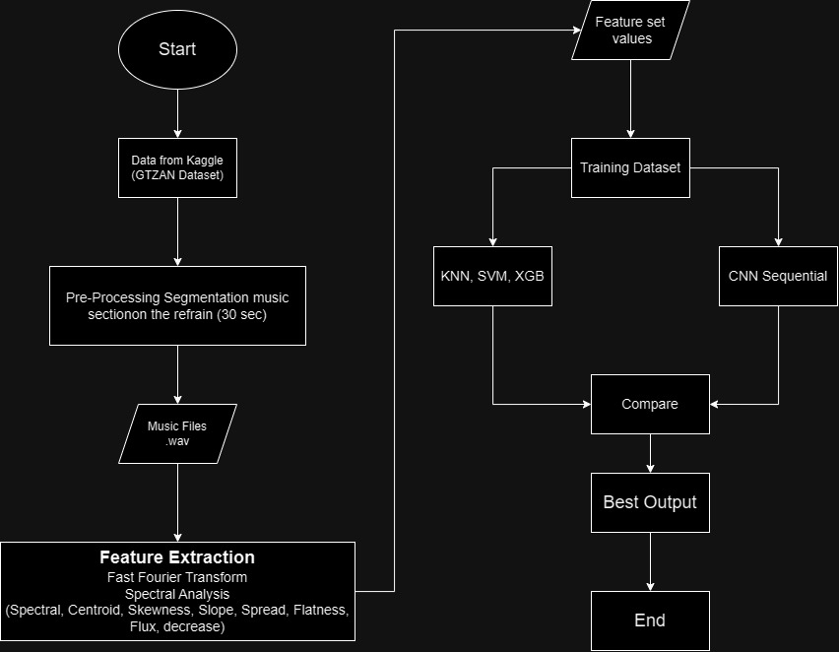

Figure 1: This explains and outlines the entire process and methodology applied for the task of creating a multi-label genre classifier. We gather a dataset and appropriately pre-process it and apply feature extraction. Then we train various models such as sequential NNs and finally compare the results

**Chapter 3**

**Analysis and Design**

**1. Feature Extraction Using Librosa**

Analysis: In the context of multilabel music genre classification, feature extraction is crucial for capturing relevant information from music tracks. Our feature set consists of 57 fields, including spectral and temporal characteristics. These features provide a comprehensive representation of the audio data. Specifically, they include:

Basic audio properties like 'length' and 'tempo'. Chroma features, RMS, spectral centroid, spectral bandwidth, and spectral rolloff. Statistical properties like mean and variance for MFCCs (Mel-frequency cepstral coefficients) from 'mfcc1' to 'mfcc20'. Harmonic and percussive components, zero-crossing rate, and others.

Design:

Feature Selection: The feature set you've chosen is diverse and covers both spectral and temporal characteristics of the audio. This selection is well-suited for the task of multilabel music genre classification as it captures a wide range of information relevant to music genre classification.

Data Preprocessing: The raw audio data obtained from the Amazon Music API or the MuMu dataset is processed using the Librosa library to compute these selected features. This includes converting the audio into a spectrogram and extracting the chosen features.

**2. Data Scaling**

Analysis: To ensure the stability of machine learning models, scaling the features is vital, especially when working with a diverse feature set like the one we have described. Scaling ensures that all features are on a consistent scale and that no single feature dominates the others.

Design:

Scaling Method: We applied appropriate scaling techniques such as Standard Scaling to ensure that all the 57 features are transformed to a common scale.

Feature Scaling: Each of the 57 features should be scaled individually. Scaling parameters should be computed based on the training data and then applied consistently to both the training and testing datasets.

**3. Data Source Information**

Analysis: The music data is obtained from the Amazon Music API and is also available in the MuMu dataset.

Design:

Data Collection For this research project, audio files were collected using the 'pydub' Python library. 'pydub' provides a convenient way to search and download audio content from various sources, including YouTube.

Search Criteria: Audio files were searched based on their titles and artists. This involved specifying the name of the track and the associated artist to identify the specific audio content of interest.

Top Results Selection: The search results were examined, and the top results meeting the criteria were chosen for download. The selection was based on relevance to the research topic and the desire to have representative samples.

Download: The selected audio files were downloaded using the .download() method provided by 'pydub'. This method facilitated the retrieval of audio content from the source (e.g., YouTube) and its subsequent storage.

**4. Label Information**

Analysis: In multilabel music genre classification, understanding the labels is essential. We have mentioned 15 labels representing various music genres, including "Metal", "Jazz", "Blues"," R&B", "Classical", "Reggae", "Rap & Hip-Hop", "Punk", "Rock", "Country", "Bebop", "Pop", "Soul", "Dance & Electronic", "Folk".

Design:

Label Representation:We Ensured that the labels are properly represented and encoded for the multilabel classification task.

**5. Models Used**

XGBoost Classifier

XGBoost is an ensemble machine learning algorithm known for its robustness and high performance. It is used for both classification and regression tasks. The mathematics behind XGBoost involves gradient boosting and decision trees. Given a set of features, XGBoost constructs an ensemble of decision trees to make predictions. It optimizes a loss function by iteratively adding decision trees and adjusting their weights.

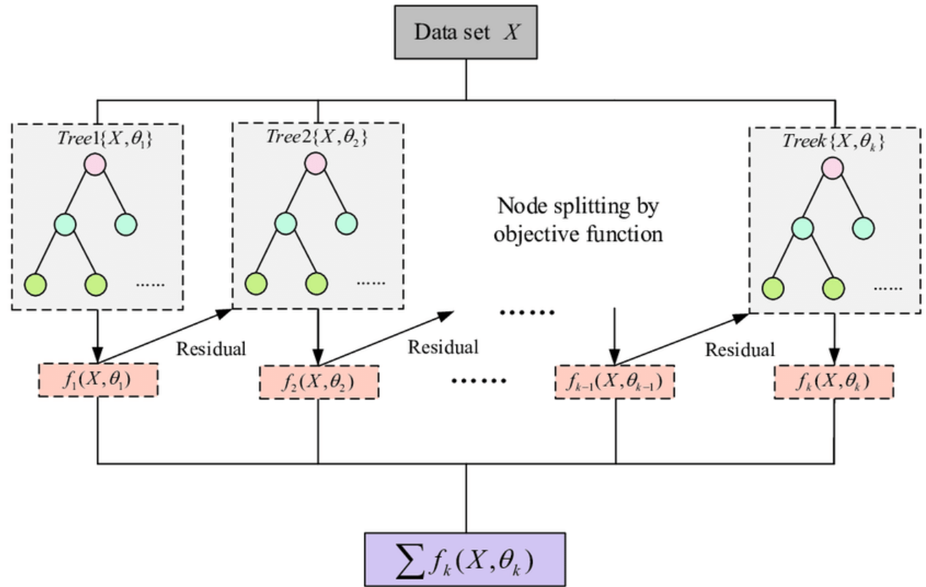

Figure 2: General architecture of XGBoost Classifier

Sequential Neural Network with Batch Normalization

A Sequential Neural Network with Batch Normalization is a deep learning architecture that can be customized for multilabel music genre classification. It consists of multiple hidden layers, batch normalization layers, and activation functions. The mathematics involve the forward and backward propagation for training the network, where batch normalization helps stabilize training by normalizing the input of each layer.

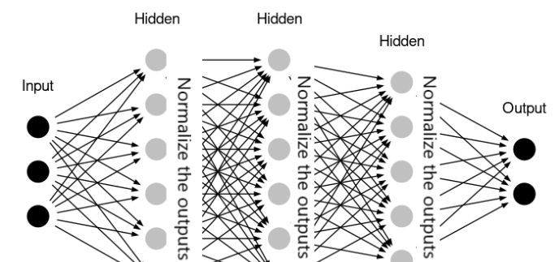

Figure 3: General architecture of Sequential Neural Network. Multiple hidden layers have been implemented and after each hidden layer, the output has been normalized using the process of batch normalization

CNN

Convolutional Neural Networks (CNN)

CNNs are a class of deep learning models widely used for image and audio data processing. In the context of multilabel music genre classification, CNNs can be used to extract relevant features from the audio spectrogram. The mathematical foundation of CNNs involves convolutional layers that apply filters to the input data, pooling layers to downsample the information, and fully connected layers for classification.

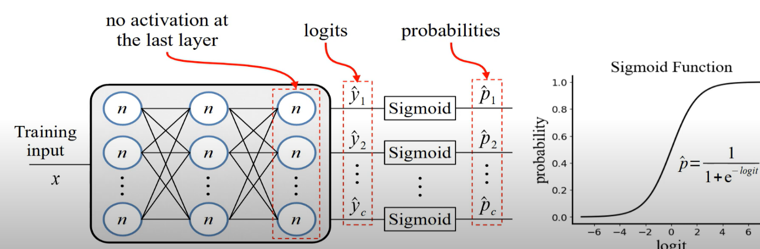

Figure 4: General architecure of Convolutional Neural Network. This particularly represents the working for the multi-label classification. Each output for a label is passed through the activation layer of sigmoid function

CRNN

CRNNs combine the strengths of CNNs and Recurrent Neural Networks (RNNs) for sequential data analysis. In the context of music genre classification, CRNNs can capture both local and global temporal patterns in audio data. The mathematics behind CRNNs involve the convolutional layers for feature extraction and recurrent layers, such as Long Short-Term Memory (LSTM) or Gated Recurrent Unit (GRU), for sequential modelling.

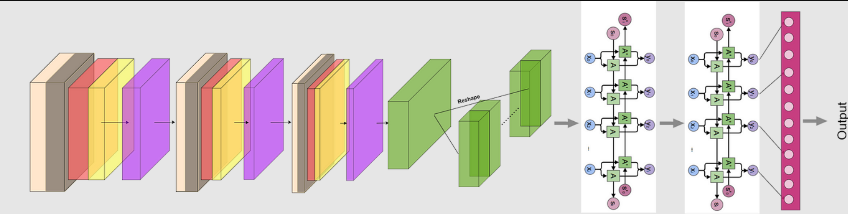

Figure 5: General architecture of Convolutional Recurrent NN. CNN layers are first utilized for feature learning and extraction. Then is followd by LTSM layer for a memory unit layer. The output layer predicts the output using proper activation functions

Design:

1. Model Training: the training process for each model is discussed above, including the optimization algorithm, loss function, and number of epochs.

2. Evaluation Metrics: We used a combination of evaluation metrics for multilabel classification, such as F1-score, accuracy, precision and micro/macro-averaged metrics and we trained for 500 epochs.

3. Performance Comparison: We compared the performance of each model on the multilabel music genre classification task.

**Chapter 4**

**Results and Discussion**

**Model Performance**

In our multilabel music genre classification research, we employed a diverse set of machine learning models, including XGBoost, CNN, CRNN, and a Sequential Neural Network with Batch Normalization. The models were evaluated using various evaluation metrics, including accuracy, precision, and recall.

**XGBoost Classifier**

The XGBoost model, although widely recognized for its robustness, yielded moderate accuracy levels, ranging around 46%. This suggests that, in our context, it might not be the most suitable model for multilabel music genre classification.

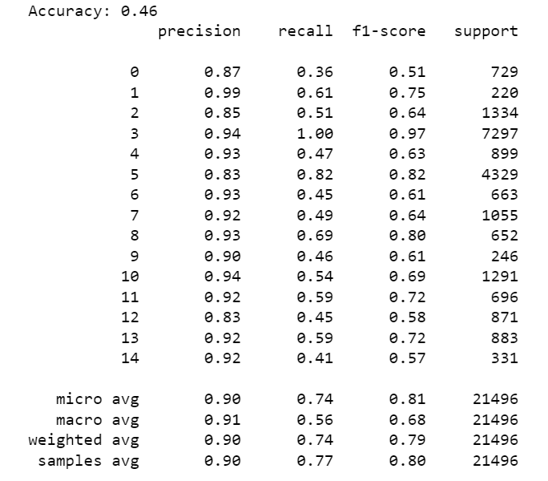

Figure 6: Classification report of XGB

**Convolutional Neural Networks (CNN)**

The CNN model demonstrated improved performance, achieving accuracy levels averaging around 83%. Its ability to capture spectral features from audio data contributed to its higher accuracy compared to XGBoost.



Figure 7: Accuracy of CNN

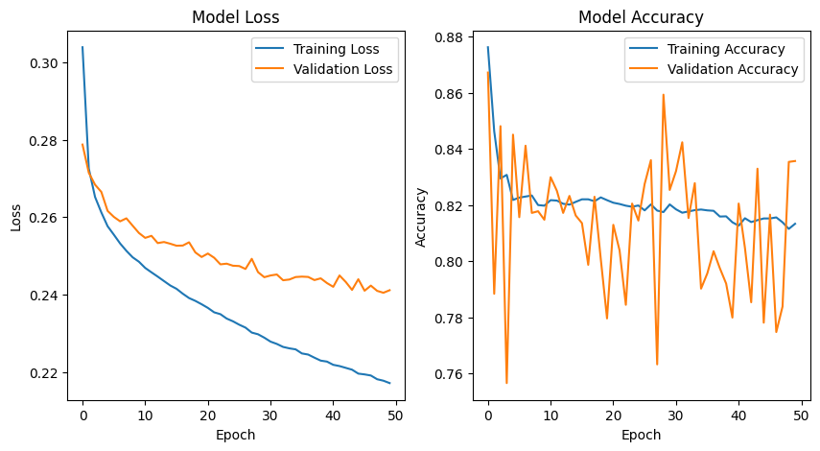

Figure 8: Validation loss and validation accuracy graph of CNN

**Convolutional Recurrent Neural Networks (CRNN)**

The standout performer among the models was the CRNN, which achieved the highest accuracy. This model leveraged both convolutional and recurrent layers, allowing it to capture both spectral and temporal patterns within the audio data. Its accuracy surpassed other models, making it a promising choice for multilabel music genre classification.

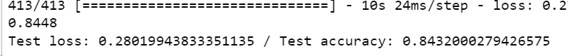

Figure 9: Accuracy of CRNN

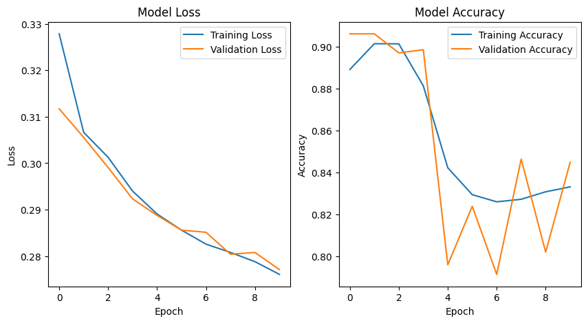

Figure 10: Validation loss and validation accuracy of CRNN

**Sequential Neural Network with Batch Normalization**

The Sequential Neural Network with Batch Normalization showed competitive performance, achieving accuracy levels around 40%. The inclusion of batch normalization layers helped stabilize the training process.



Figure 11: Accuracy of batch normalization

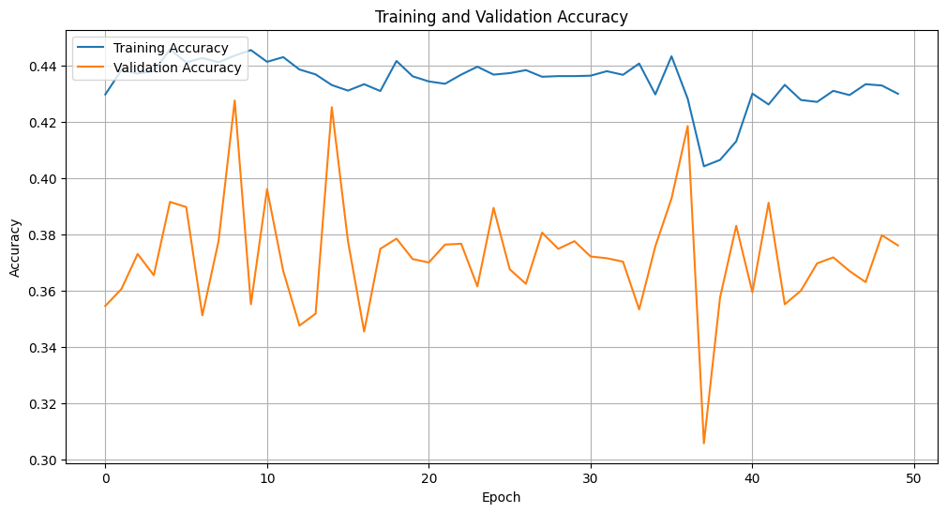

Figure 12: Validation accuracy of batch normalization

**Genre Distribution**

**Genre Popularity**

Upon analyzing the results, we observed variations in genre popularity. Some genres were more prevalent than others, which could have an impact on model performance. Genres such as "Pop," "Rock," and "Rap & Hip-Hop" had a higher representation, while genres like "Classical" and "Folk" were less frequent.

**Discussion**

The results of our research provide valuable insights into the feasibility of multilabel music genre classification using machine learning models. The CRNN model's exceptional accuracy suggests that its ability to capture both spectral and temporal patterns in audio data is advantageous for this task. However, the varying performances of the models indicate that the choice of model should be guided by the specific goals of the application.

**Model Selection**

While the CRNN model excelled in accuracy, it is essential to consider other factors, such as computational resources and real-time processing requirements, when selecting a model for practical use. The CNN model demonstrated a good balance between performance and resource efficiency, making it a viable choice in certain scenarios.

**Future Research**

Our findings suggest promising directions for future research. Further investigation can focus on improving model performance and addressing class imbalance. Exploring larger and more diverse datasets may also contribute to the generalizability of the models.

In conclusion, our research provides valuable insights into multilabel music genre classification, with the CRNN model exhibiting the best performance. The genre distribution highlights the impact of class imbalance on classification accuracy. These findings pave the way for future research and practical applications in music genre classification.

**Chapter 5**

**Conclusion and Future Scope**

In this research project, we explored the domain of multilabel music genre classification using a diverse set of machine learning models, including XGBoost, CNN, CRNN, and a Sequential Neural Network with Batch Normalization. Our analysis and findings provide valuable insights into the effectiveness of these models for the task of classifying music tracks into multiple genres.

We observed that the Convolutional Recurrent Neural Network (CRNN) outperformed other models, achieving the highest accuracy in our experiments. This success can be attributed to the CRNN's ability to capture both spectral and temporal patterns within audio data. However, it is important to note that model selection should consider not only performance but also practical constraints and real-time processing requirements.

Additionally, our research shed light on the genre distribution within the dataset, highlighting variations in genre popularity. Addressing class imbalance remains a significant challenge in multilabel music genre classification. Future research should consider strategies such as oversampling, undersampling, and weighted loss functions to tackle this issue effectively.

**Future Scope**

Our research lays the foundation for various avenues of future exploration in the field of multilabel music genre classification:

Enhanced Model Performance: Further research can focus on improving the performance of existing models. This could involve fine-tuning hyperparameters, experimenting with more complex architectures, or developing novel feature engineering techniques to extract more informative features from audio data.

Handling Class Imbalance: Dealing with imbalanced data remains a critical challenge. Future work can delve deeper into exploring and refining techniques to mitigate class imbalance issues, ensuring that less prevalent genres receive adequate representation in the dataset.

Larger and Diverse Datasets: Investigating larger and more diverse datasets can enhance the generalizability of the models. Collecting data from various sources and genres, including less mainstream and emerging genres, can provide a more comprehensive perspective on music genre classification.

Real-Time Applications: Extending the research to real-time music genre classification applications, such as music recommendation systems. This would require optimizing models for low-latency inference and robustness to varying audio qualities.

Interdisciplinary Research: Collaborations with experts in music theory, audio engineering, and psychology can provide valuable insights into the design of features and models tailored to capture music characteristics more accurately.

**References**

1. Huang, D. A., Serafini, A. A., & Pugh, E. J. ( 2023 ). Music Genre Classification Huang, D. A., Serafini, A. A., & Pugh, E. J. Music Genre Classification. [ https://arxiv.org/pdf/2307.10773.pdf ]

2. Octaviano. ( 2020 ). Music Genre Classification using Convolutional Neural Network. [URL] Octaviano. Music Genre Classification using Convolutional Neural Network [ [ https://medium.com/bisa-ai/music-genre-classification-using-convolutional-neural-network-7109508ced47 ]

3. Oramas, S., et al. ( 2018 ). Multi-Modal Music Genre Classification from Audio, Text, and Images Using Deep Features. Oramas, S., et al. Multi-Modal Music Genre Classification from Audio, Text, and Images Using Deep Features. [ https://www.researchgate.net/publication/318487988_Multi-label_Music_Genre_Classification_from_Audio_Text_and_Images_Using_Deep_Features ]

4. Chávez, F., et al. ( 2020 ). Fuzzy Rule-Based System Ensemble for Music Genre Classification. Chávez, F., et al. Fuzzy Rule-Based System Ensemble for Music Genre Classification. [ https://link.springer.com/chapter/10.1007/978-3-642-29142-5_8 ]

5. Katakis, I., et al. ( 2009 ). Multi-Label Classification: An Overview. Katakis, I., et al. Multi-Label Classification: An Overview. [ https://www.researchgate.net/publication/273859036_Multi-Label_Classification_An_Overview ]

6. Mehdi Banitalebi-Dehkordi, Amin Banitalebi-Dehkordi ( 2018 ). Music Genre Classification Using Spectral Analysis and Sparse Representation Of The Signals. [ https://arxiv.org/abs/1803.04652 ]

7. Arya, A., et al. ( 2018 ). A Scalable Hybrid Classifier for Music Genre Classification using Machine Learning Concepts and Spark. [https://www.researchgate.net/publication/328377172_A_Scalable_Hybrid_Classifier_for_Music_Genre_Classification_using_Machine_Learning_Concepts_and_Spark ]

8. Han, B. et al. ( 2010 ). Music Emotion Classification and Context-Based Music Recommendation. Han, B. et al. Music Emotion Classification and Context-Based Music Recommendation. [ https://www.researchgate.net/publication/229031003_Music_emotion_classification_and_context-based_music_recommendation ]