Learnings and Reflection Report
CE725 Topic 2 · structure as in section 7 of the course brief · 1 Nov 2026
Disclosure: This draft was written with AI assistance (Claude, Anthropic) from the team's tool, results and notes, and is listed in the AI usage log. Sections 1–4 and 6 must be read, checked against the tool and rewritten in the team's own words before submission. Section 5 is left for each member to write personally.

1. Subject learnings
12 inputs are illustrative placeholders and 13 are assumptions, so the numbers below show how the tool works, not a real investment answer. They will update when the team's sample project replaces the placeholders.

Timing, not just profit, decides a land deal
Our illustrative base case makes a profit on cost of 16.0%, above the 15% rule of thumb, yet its NPV at a 15% hurdle is −₹6.35 cr. The difference is time. Land, stamp duty and premiums are paid at the start, while buyers pay in stages over the following years. An undiscounted margin hides that; present worth (Ch 5) does not. This is the clearest lesson from the course applied to a real decision.
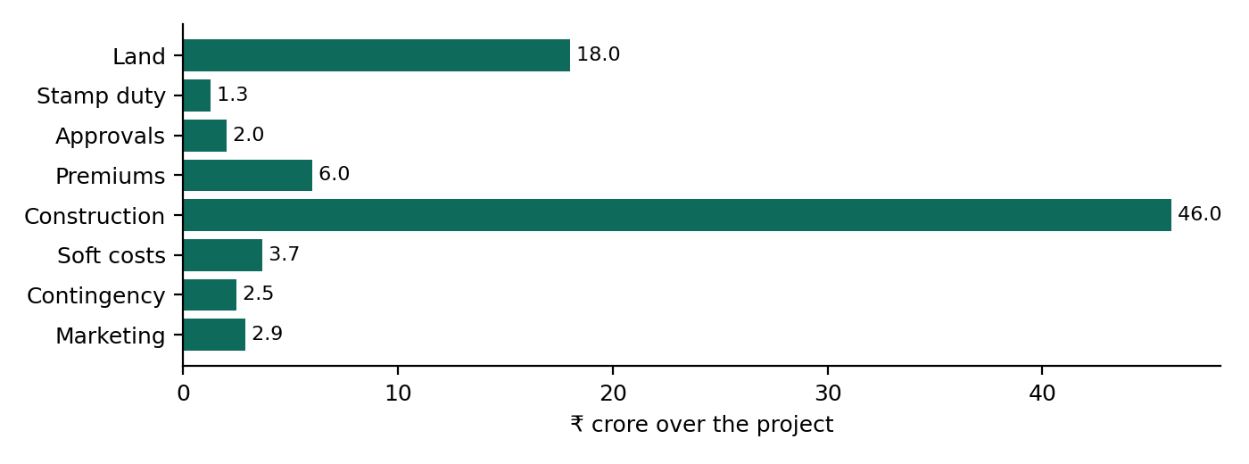
Where the money goes over the project (₹ crore).
Quarterly modelling also needed the effective-rate idea from Ch 2: a 15% annual hurdle is 3.56% a quarter, not 3.75%. Using the nominal quarter rate would have overstated the discounting slightly in every period.
The same chapter caught a mistake in our own model. We first treated the 12% loan rate as an effective annual rate (2.87% a quarter). Banks quote a nominal annual rate and charge interest monthly, which is 3.03% a quarter. Finance cost moved from ₹0.89 cr to ₹0.94 cr. Nominal versus effective rates is not a textbook detail: it changes what a developer pays.

Peak funding is the number a developer lives or dies by
The project needs up to ₹36.47 cr of outside money, reached in Q8 (₹30.00 cr equity and ₹6.47 cr loan). Profitable developers fail when they cannot fund that gap, which is why the tool leads with it.
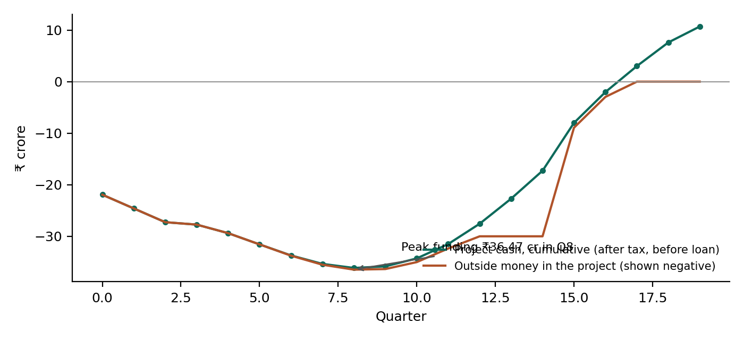
Cumulative project cash and outside money in the project, by quarter.

The RERA account changes when cash is available
RERA sends 70% of collections to a separate account that can be drawn only in step with construction. In our base case the account never holds cash, because spending runs ahead of sales and every deposit can be withdrawn at once. When sales are fast and start before construction (25% of area a quarter from Q0), the account holds up to ₹5.85 cr that the developer cannot touch. Modelling the rule, rather than assuming 30% free cash, showed us that the constraint depends on the sales pattern.

IRR needs care with real estate cash flows (Ch 7–8)
The project IRR is 8.1% and the equity IRR 7.7%. The project cash flow changes sign 1 time(s). Development cash flows can change sign more than once (for example a late cost after sales), and then several IRRs can exist. The tool counts sign changes, warns, and falls back on NPV and MIRR, as in course problems PS2 #15 and #17, which its automated checks reproduce.

Break-even analysis becomes a negotiating number (Ch 12)
Solving NPV = 0 for the land price gives the residual land value: ₹10.80 cr against an assumed ₹18.00 cr. Solving for the sale price gives ₹11,395/sq ft. These two numbers turn the appraisal into something a developer can take into a land negotiation.

Escalation against price growth (Ch 9) and tax (Ch 11)
Construction cost escalates at 7.7% a year in our inputs while prices grow at 5.0%. Every quarter of delay therefore widens the gap: a 4-quarter delay moves NPV from −₹6.35 cr to −₹10.41 cr, before counting buyer interest under RERA Section 18. Tax is modelled on cumulative profit with losses carried forward; loan interest is deductible, which lowers the effective cost of debt, as in the taxation lecture.
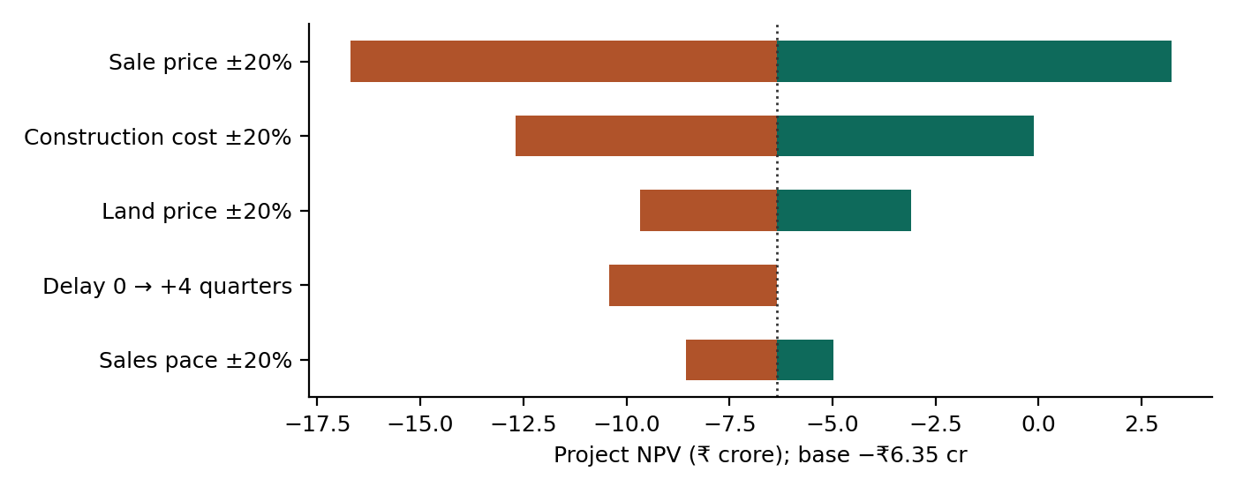
Project NPV with one input moved ±20% (delay: 0 vs +4 quarters).

2. AI capability assessment
Where AI accelerated the work. Structuring the model into small testable steps, writing the Streamlit app, the website and its charts, generating automated checks, searching for market reports, and drafting the documents from live results. Work that would have taken days took hours.
Where AI was wrong or unreliable (specific examples):
- Wrong figure relayed from a summary. A web-search summary reported ANAROCK construction-cost growth as about 6.9% a year. Recomputing from the two published values (₹2,681 in 2021, ₹3,604 in 2025) gives 7.7%. The weekend plan page had already quoted 6.9%; the tool uses 7.7%.
- Conflicting sources presented together. Search results on Maharashtra ready reckoner rates for 2026-27 included both "rates frozen" (several sources) and "revised about 5%" (one article). The AI flagged the conflict, but a careless reader could have used either.
- Unsourced blog figures. Several construction-cost-per-sq-ft results were marketing blogs with no stated source or scope; they were not used.
- Missing data, correctly left blank. No current construction-finance interest rate was found, so the loan rate is an assumption to replace with a term sheet rather than an invented market figure.
- Logic bugs in AI-written code. The break-even sentence gave the wrong direction when NPV was negative, and a RERA warning described normal behaviour as a problem. Both were found by reading the outputs, not by the code running without errors.
- Tool limits. The web fetch tool could not read the Knight Frank PDF (compressed binary); the figures had to be extracted locally and checked page by page.
- A bug that ran without errors. Choosing the Downside case made the tool shock the deal twice when showing the downside NPV (−₹31.25 cr instead of −₹18.55 cr), and the verdict used that number. The AI-written code passed every check at the time; it was found only when we re-verified by comparing the card with a direct calculation.
- Silent assumptions. The code quietly cut fractional quarters (12.7 became 12) and treated the loan rate as an effective rate. Neither broke anything visibly; both changed numbers without saying so.
- A website that looked finished. Every tab's content was being shown at once, because one style rule overrode the hidden attribute. An earlier check confirmed that each tab had content, but not that the others were hidden: a lesson in checking what the user actually sees.
TEAM TO COMPLETE: Add your own examples from your AI usage log: prompts where the AI produced a wrong formula, assumption, data point or code, how you noticed, and what you did.

3. Validation insights
The automated checks (sources equal uses of cash every quarter, NPV zero at the IRR, collections equal bookings, break-evens giving NPV = 0) caught structural errors early. They cannot catch a wrong method that is applied consistently; only the independent benchmark can.
TEAM TO COMPLETE: What the comparison with your hand-built Excel benchmark revealed: which outputs matched, which did not, the causes, and what you would check first next time.

4. Practical relevance
Would a developer use it? It answers the question a small or mid-size developer asks before a land deal, leads with peak funding and a maximum land price, and shows every input's source. To be used for real it would need the developer's own data, joint-development and phased-project structures, an export to the lender's format, and agreed definitions of the lender ratios.
Would a lender trust it? The tool shows loan-to-cost, debt service cover and receivables cover with plain definitions, but lenders usually rebuild numbers in their own templates. The validation report and the audit trail of inputs are what would earn trust.
Open questions to test with users: does the developer use residual land value or only profit on cost; which cost line surprises them most; would a lender accept the tool's ratios; which assumption is hardest to source; what would make them trust this over their own spreadsheet.
TEAM TO COMPLETE: Record the 1–2 interviews or the practitioner test: who (role only), what they said, what you changed. This also earns the brief's bonus credit.

5. Individual reflections

Ojas Somani (23B4225) · Project lead and finance modeller
TEAM TO COMPLETE: Half a page in your own words, without AI: your role, what you built or checked, what you learnt about construction economics, and one thing you would do differently.

Shivam Shankar (23B1851) · AI and tool developer
TEAM TO COMPLETE: Half a page in your own words, without AI: your role, what you built or checked, what you learnt about construction economics, and one thing you would do differently.

Mrunal Pachpande (23B0723) · Validation engineer and data lead
TEAM TO COMPLETE: Half a page in your own words, without AI: your role, what you built or checked, what you learnt about construction economics, and one thing you would do differently.

Shivansh Chaudhary (24B2456) · Team member (role to confirm)
TEAM TO COMPLETE: Half a page in your own words, without AI: your role, what you built or checked, what you learnt about construction economics, and one thing you would do differently.

Arya Chourasia (24B3034) · Team member (role to confirm)
TEAM TO COMPLETE: Half a page in your own words, without AI: your role, what you built or checked, what you learnt about construction economics, and one thing you would do differently.

6. Ethics and limitations
- Data reliability. Every input carries a source, date and flag. Illustrative placeholders are labelled on screen, in the memo and in these documents, so they cannot be mistaken for market data.
- Over-reliance on AI. AI wrote much of the code and the first drafts. The team's safeguards are the independent benchmark, the automated checks, and the requirement that every member can explain every formula.
- Accountability. The tool supports a decision; it does not make it. The developer who signs the land deal, and the lender who funds it, remain responsible.
- Privacy. Run locally, nothing leaves the computer. On the hosted website, inputs go to a calculation function on Vercel's servers and are not stored; a visitor's inputs are kept only in their own browser. The memo is written by a fixed template, not an AI service. Confidential deals should be run locally.
- Model limits. Single phase; no joint-development deals; simplified tax timing; RERA account released at possession; verdict thresholds that still need validation with developers.

Sources
- Knight Frank, India Real Estate: Residential and Office Market, January–June 2026.
- ANAROCK construction-cost data 2021–2025, reported by Free Press Journal, 5 Sep 2026; ANAROCK Q3 2026 residential update (Business Today, 29 Sep 2026).
- Reserve Bank of India, House Price Index, Q1 2026-27 release.
- IGR Maharashtra, Annual Statement of Rates 2026-27 (eASR).
- Real Estate (Regulation and Development) Act 2016, Sections 4(2)(l)(D), 13 and 18.
- CE725 lecture notes and practice problem sets (time value of money, PW, IRR, MIRR, inflation, taxation, break-even).

