RISKTWIN NEXUS
Detailed UML Diagrams & Backend Workflows
Policy lifecycle • Mock payments • Risk intelligence • Mitigation • Notification & Audit • Admin ROI

Document purpose | Explain the main system structure and end-to-end workflows with UML-style diagrams.
Implementation basis | Routes and payload details are drawn from the updated API map and saved project code excerpts.
Payment boundary | Mock payment only; no real payment gateway or money movement.
Accuracy note | Where controller evidence was incomplete, routes are marked for verification rather than invented.

1. Scope and notation
This document complements the updated User Journey / Backend API workbook. It focuses on the workflows implemented or referenced in the current RiskTwin Nexus project: business profiles, standard policies, policy tenure and payment frequency, underwriting decisions, simulated payment, risk assessments, risk simulations, mitigation tracking, notifications/audit integration, and the admin ROI dashboard.
Diagram conventions: solid arrows represent requests or direct interactions; dashed arrows represent returns or discovery/registration where labelled. A route shown exactly is supported by the available API-service/controller excerpts. A route described as “verify” must be reconciled with the current controller before being treated as confirmed.

Main backend route inventory
Area | Known API contract | Notes
Standard policy catalogue | GET /api/policies/standard; GET /api/policies/standard/{id} | Angular PolicyApiService contract
Policy lifecycle | POST /api/policies; GET /api/policies/owner; GET /api/policies; GET /api/policies/{policyId}; PUT /api/policies/{policyId}; POST /api/policies/{policyId}/submit; PATCH /api/policies/{policyId}/status?status=... | Backend role and ownership checks are authoritative
Mock payments | POST /api/payments/policies/{policyId}; GET /api/payments/policies/{policyId} | PaymentResponse includes transactionReference
Risk assessment | GET/POST /api/risk/assessments; GET /api/risk/assessments/{id}; GET /api/risk/assessments/business/{businessId} | Risk-read roles and owner scope apply
Risk simulation | GET/POST /api/risk/simulations; GET /api/risk/simulations/{id} | Creation role is ADMIN / RISK_ENGINEER in saved access rules
Risk mitigation | GET/POST /api/risk/mitigations; GET /api/risk/mitigations/{id}; GET /api/risk/mitigations/assessment/{assessmentId}; PATCH /api/risk/mitigations/{id}/status | Create/update permissions and valid state transitions enforced server-side
Admin ROI dashboard | GET /api/admin/analytics/dashboard | Confirm Gateway route and data sources in current configuration
Cancellation / notification reads | Exact routes not included here | Confirm against current controller before publishing as exact endpoints

2. Component / deployment architecture
The Angular client enters through the API Gateway. The Gateway routes requests to domain services; the shared Notification & Audit service is called by backend workflows. Eureka supports service discovery. Database names and precise route predicates remain configuration-specific.
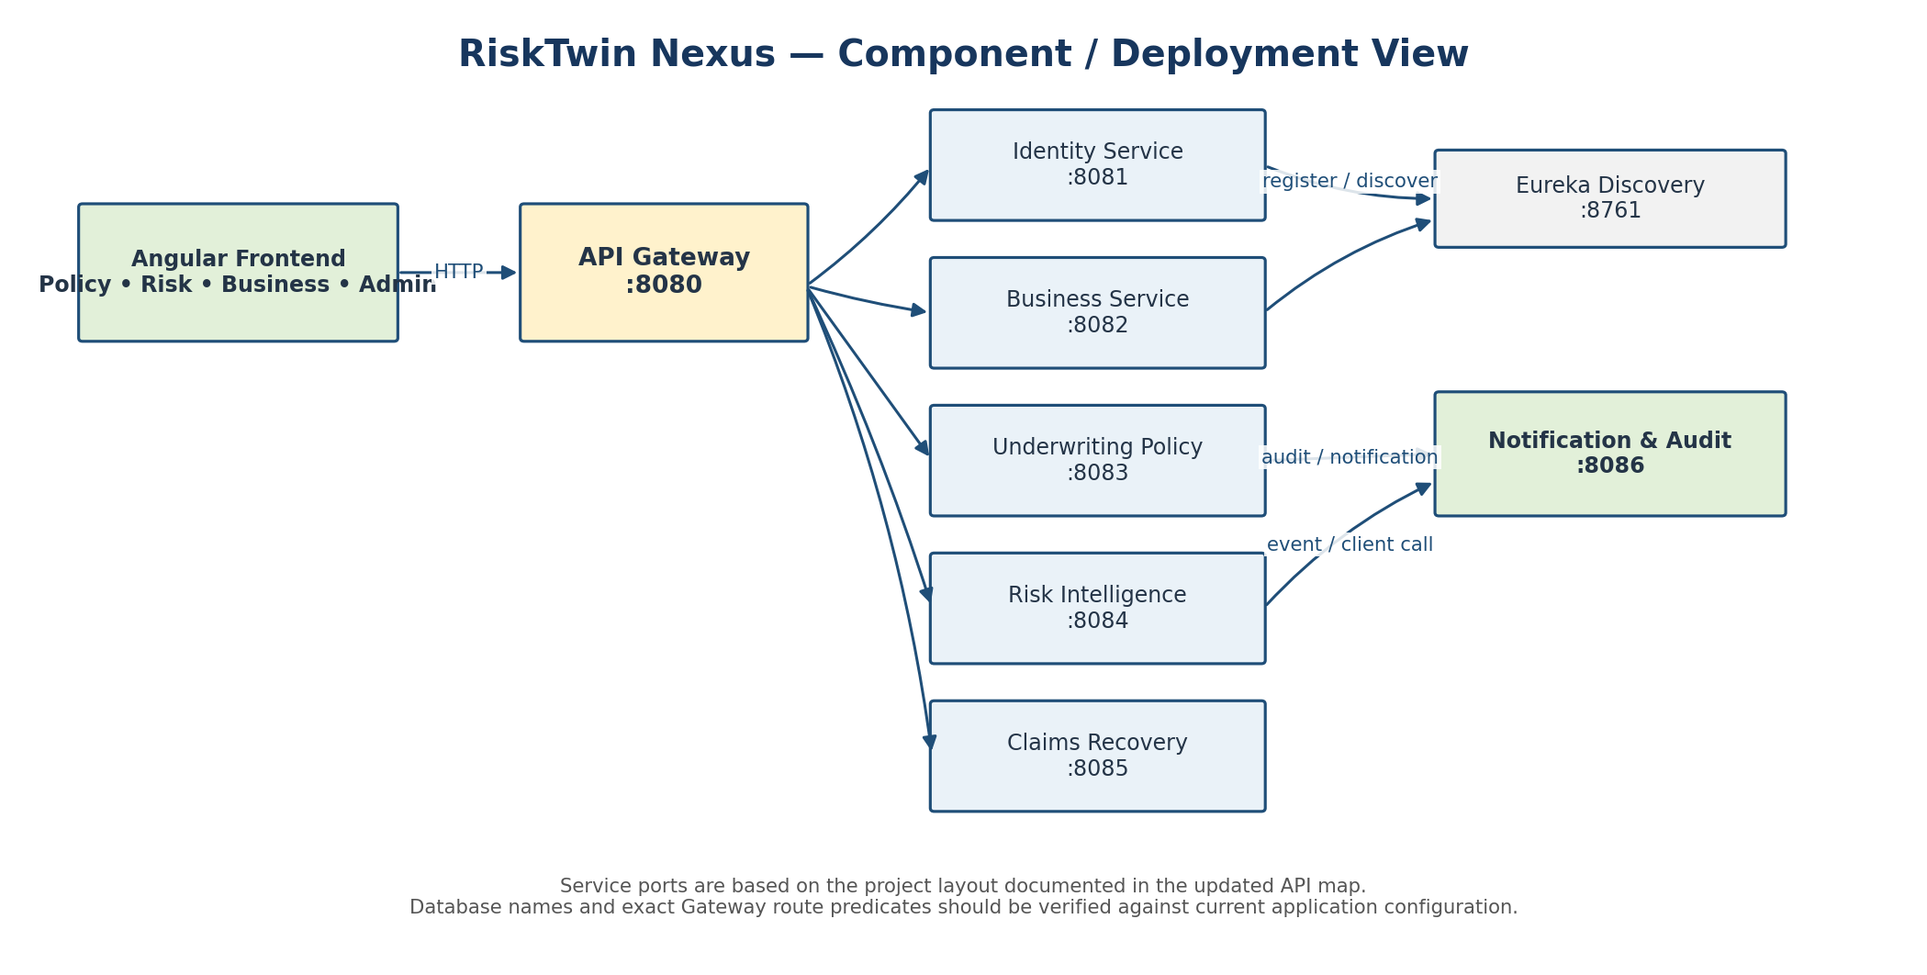

3. UML use case view
The diagram groups the major user goals by actor. The Business Owner creates business/policy records and pays; Underwriter/Admin handles controlled decisions and admin analytics; Risk Engineer manages assessments and mitigations; Claims Adjuster uses the existing claims/recovery module and permitted risk views.
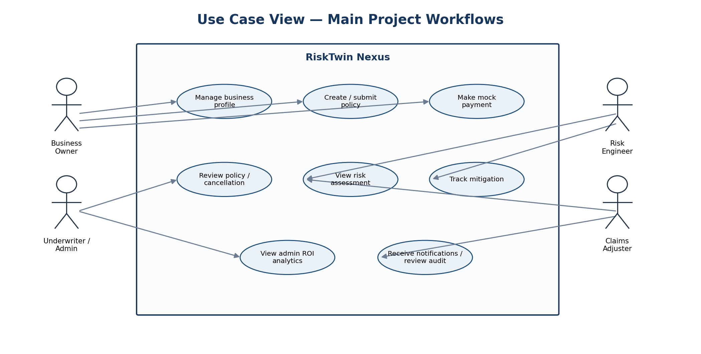

4. Activity diagram — policy lifecycle
This activity flow connects the standard-policy catalogue, draft creation, submission, underwriting decision and simulated payment. A policy must not be treated as active solely because the UI initiated payment; activation depends on the backend’s successful result and configured lifecycle rules.
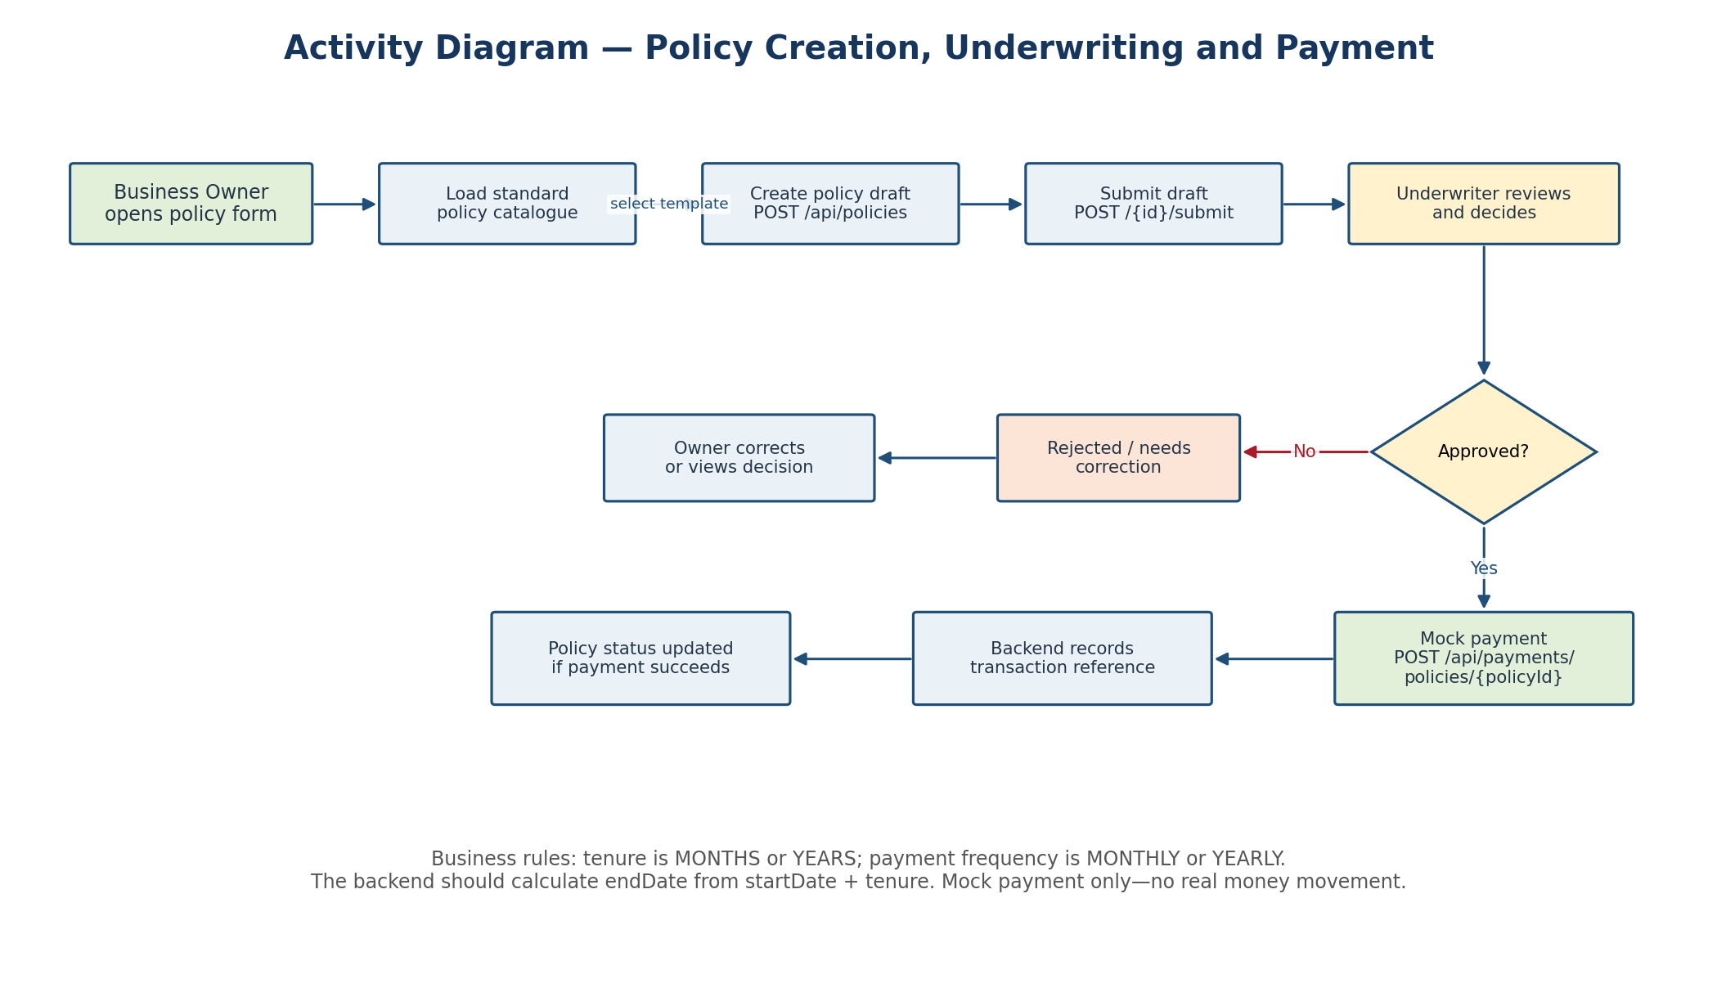

5. Sequence diagram — mock payment
The backend must verify that the authenticated caller can access the policy and that its state is eligible before recording a simulated transaction. The response should contain the transaction reference. Payment history is retrieved through the same resource path with GET.
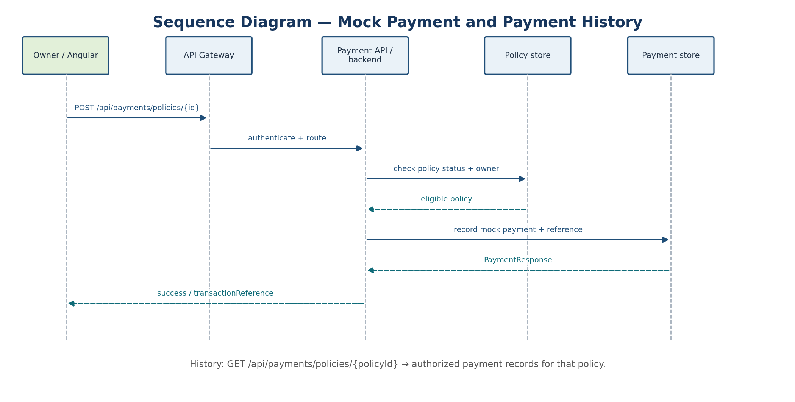

6. Sequence diagram — risk assessment and mitigation
Risk assessment creation persists the assessment result. Mitigation creation references an assessment and records the creator. The mitigation workflow calls the NotificationAuditClient where wired. Exact message delivery/read endpoints are deliberately omitted until the notification service controller is verified.
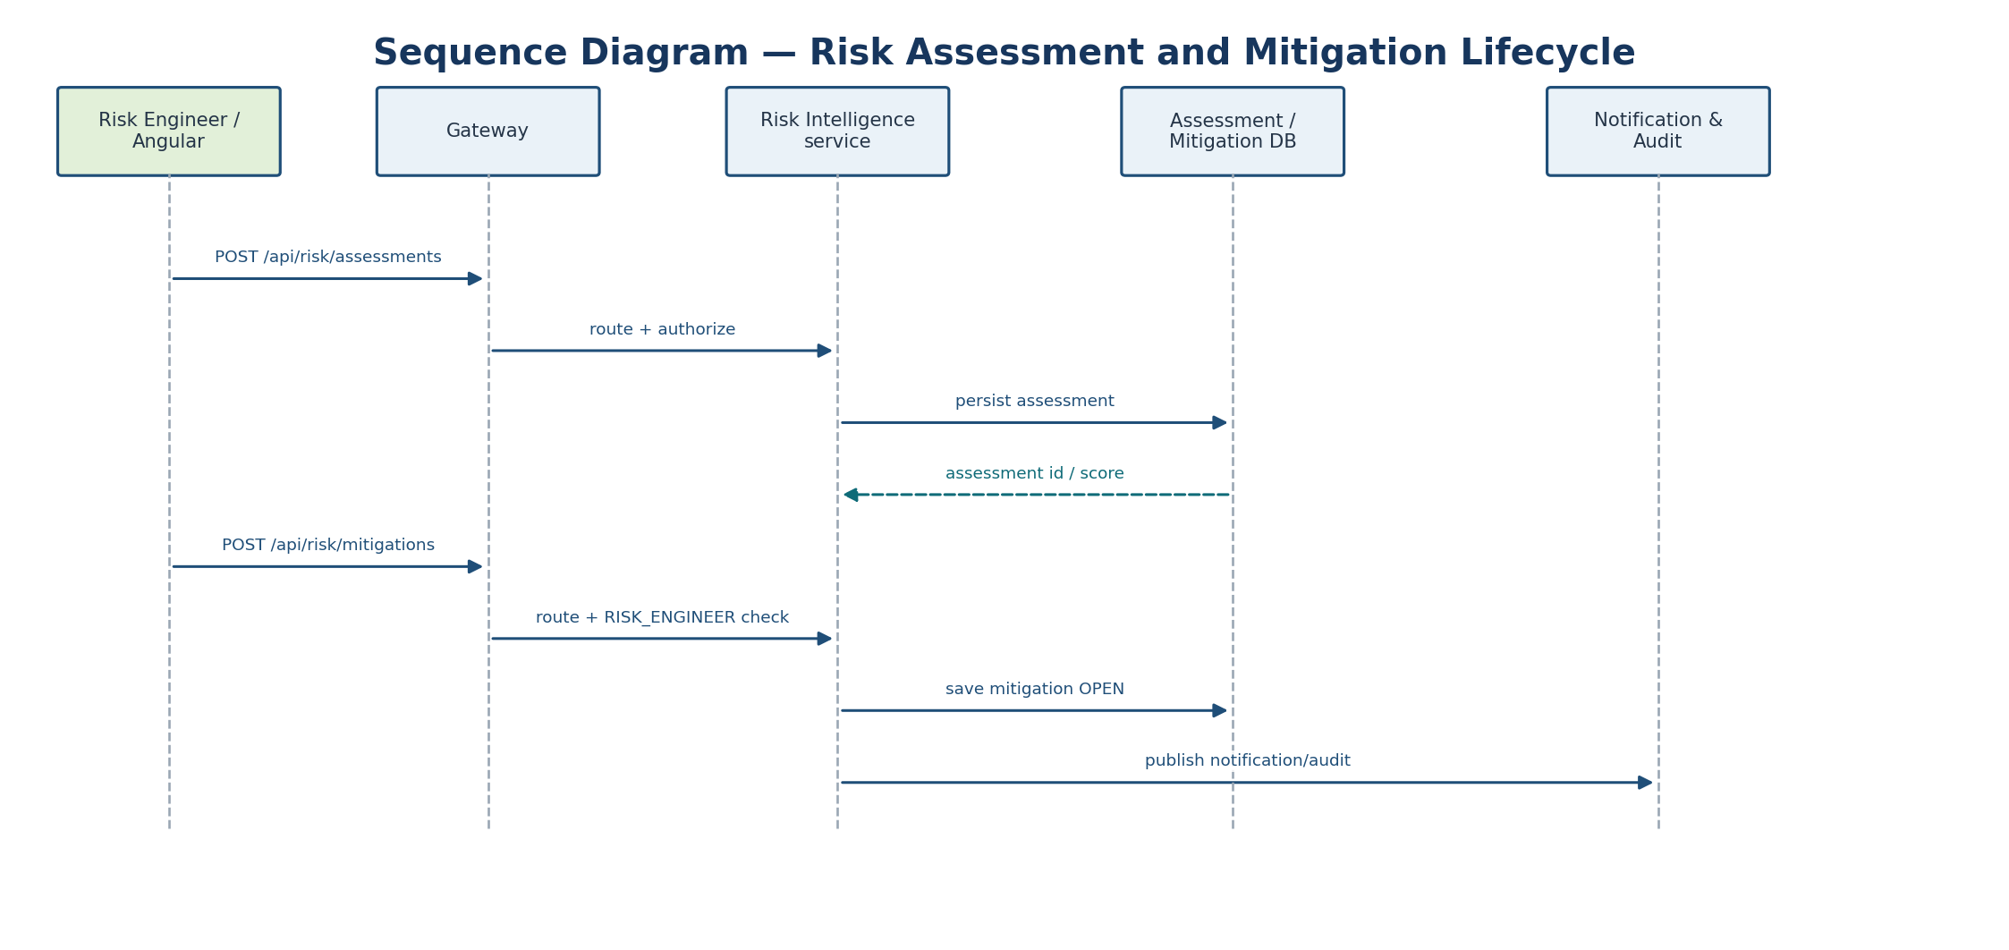

7. State machine — mitigation status
The documented status model includes OPEN, IN_PROGRESS, COMPLETED and CANCELLED. OPEN can move to IN_PROGRESS or CANCELLED; IN_PROGRESS can move to COMPLETED or CANCELLED. COMPLETED and CANCELLED are terminal states in the current workflow description. Backend rules must reject invalid transitions.
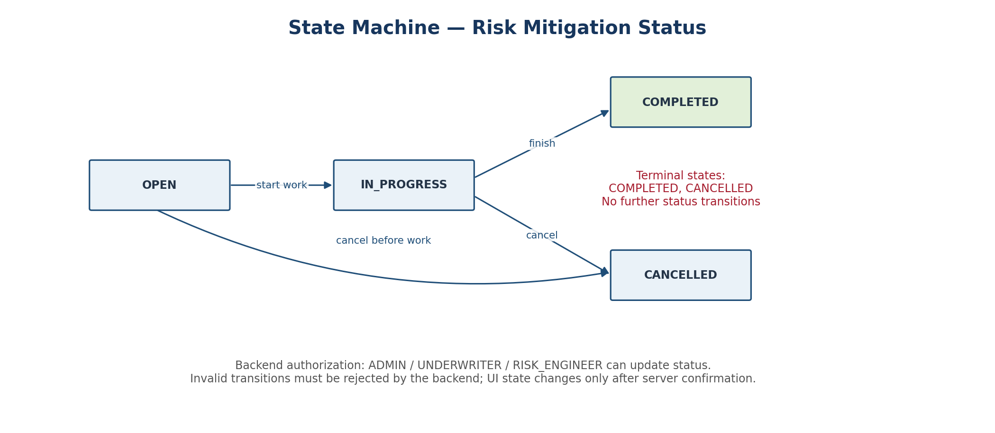

8. Notification & Audit integration
Policy submission and mitigation creation integrate with the combined Notification & Audit service through the internal client. This is an interaction diagram, not a claim that the service exposes a particular notification-list or audit-search REST path.
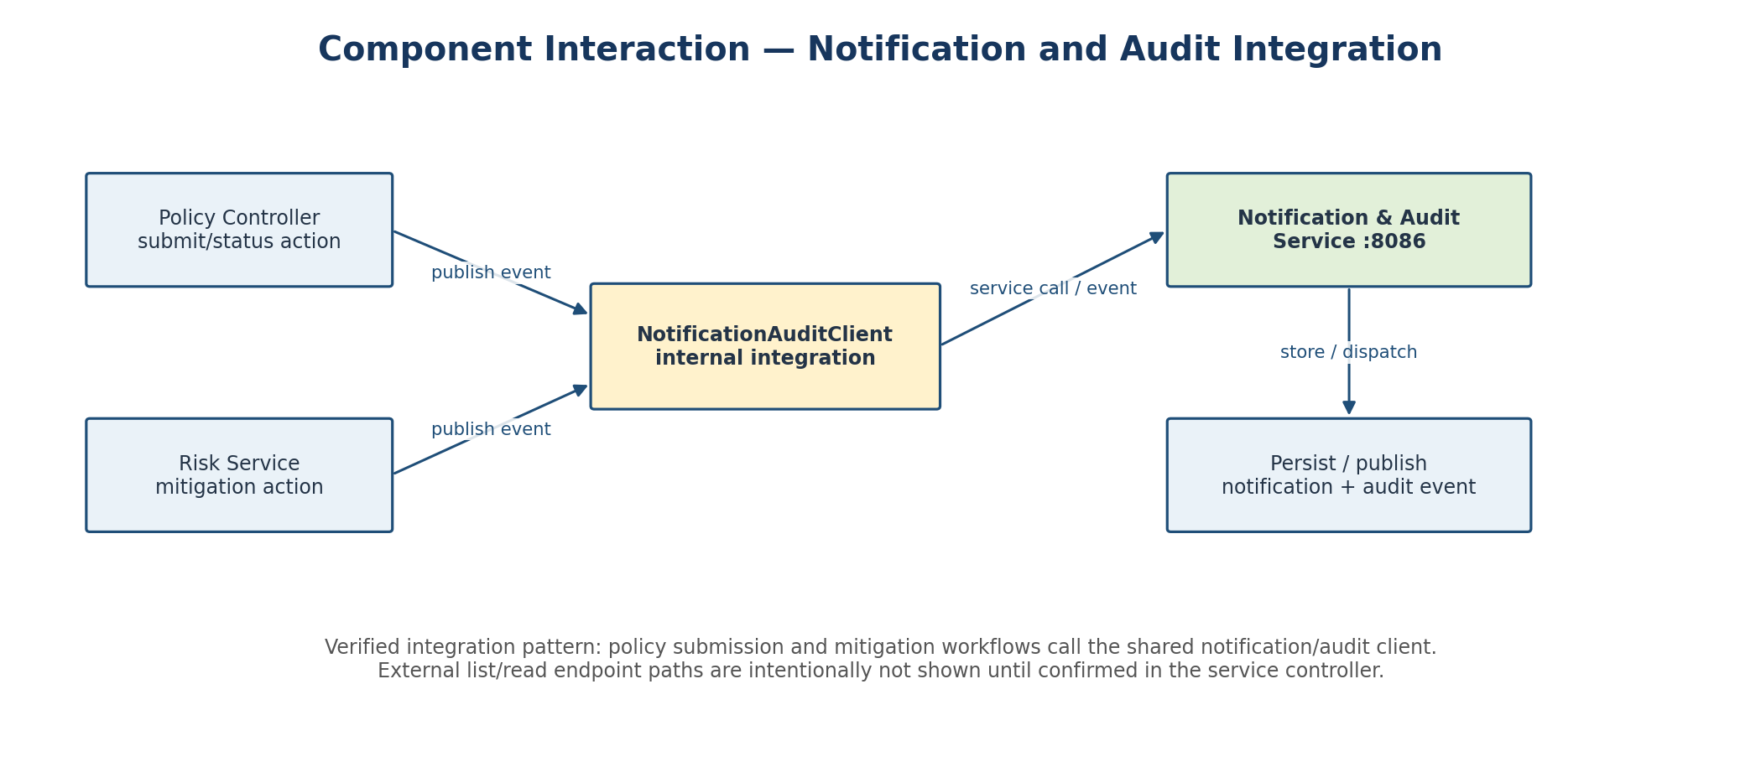

9. Admin ROI dashboard data flow
The dashboard endpoint aggregates available business data. Premium totals, collected payments, claims-to-premium ratio and profit are different measures: do not equate policy premium with cash collected. Profit needs a defensible cost basis, and claims-to-premium requires compatible claim and premium periods.
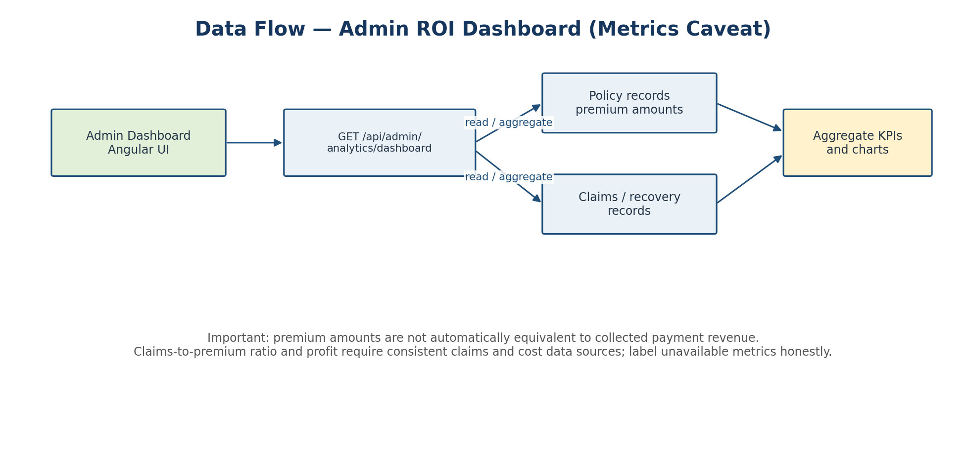

10. Backend validation and access-control rules
- Policy ownership: The backend must validate that a Business Owner owns the selected business/policy. UI visibility alone is not authorization.
- Policy lifecycle: Draft submission and underwriting status changes must follow valid transitions. Underwriter/Admin permissions are enforced server-side.
- Payment: Mock payment is limited to an eligible policy and an authorized owner/role. Do not activate a policy on a client-side success message alone.
- Risk assessment: RISK_ENGINEER can create assessments; read access is role-scoped and Business Owners must only see their own business records.
- Mitigation creation: RISK_ENGINEER only. Payload fields: assessmentId, mitigationTitle, description, priority, assignedTo, targetDate.
- Mitigation validation: Priority values: LOW, MEDIUM, HIGH, CRITICAL. targetDate cannot be in the past. The referenced assessment must exist.
- Mitigation status: ADMIN, UNDERWRITER and RISK_ENGINEER can update status according to the saved access rules. Invalid transitions and terminal-state edits must be rejected.
- Notifications / audit: Publish only from confirmed backend workflow points. Do not fabricate delivery or audit success if the service call fails.
- Analytics integrity: Label data period and source. If claims/cost/payment data are absent, show the KPI as unavailable rather than using an unsupported proxy.

11. Routes that must be verified before final submission
The following are intentionally not represented as confirmed exact paths in this UML document because the available snippets did not show the complete current controller mapping:
- Policy cancellation request and cancellation review endpoints.
- Business deletion-request / deactivation endpoint.
- Notification list, notification-read/mark-as-read endpoints.
- Audit event list/search endpoint.
- Exact Gateway route predicates and service target for the admin analytics endpoint.
- Exact Claims Recovery endpoints.
Before final delivery, compare these entries with the current controller annotations, Gateway route configuration, DTOs and security configuration. This avoids submitting diagrams that look precise but do not match the running backend.

12. Suggested verification checklist
☐ Run each exact route through the Gateway, not only directly against a service port.
☐ Verify 401 and 403 responses for missing authentication and unauthorized roles.
☐ Verify a Business Owner cannot read or pay for another owner's policy.
☐ Verify payment creates one mock transaction with a stable transactionReference and does not call a real payment provider.
☐ Verify mitigation creation rejects a missing assessment, invalid priority and past target date.
☐ Verify mitigation status transitions and terminal-state restrictions on the backend.
☐ Verify policy endDate calculation for both MONTHS and YEARS tenure values.
☐ Verify Notification & Audit failure behavior and whether the main transaction should fail or continue.
☐ Check analytics metrics against actual source records and label proxy/estimated measures.

Appendix — Matching the companion workbook
Use this document for visual UML/workflow explanations and the companion Excel workbook for endpoint-by-endpoint contracts, detailed journey steps, requirement traceability, role matrix, status workflows and assumptions.

