1)



2)





3)



4)

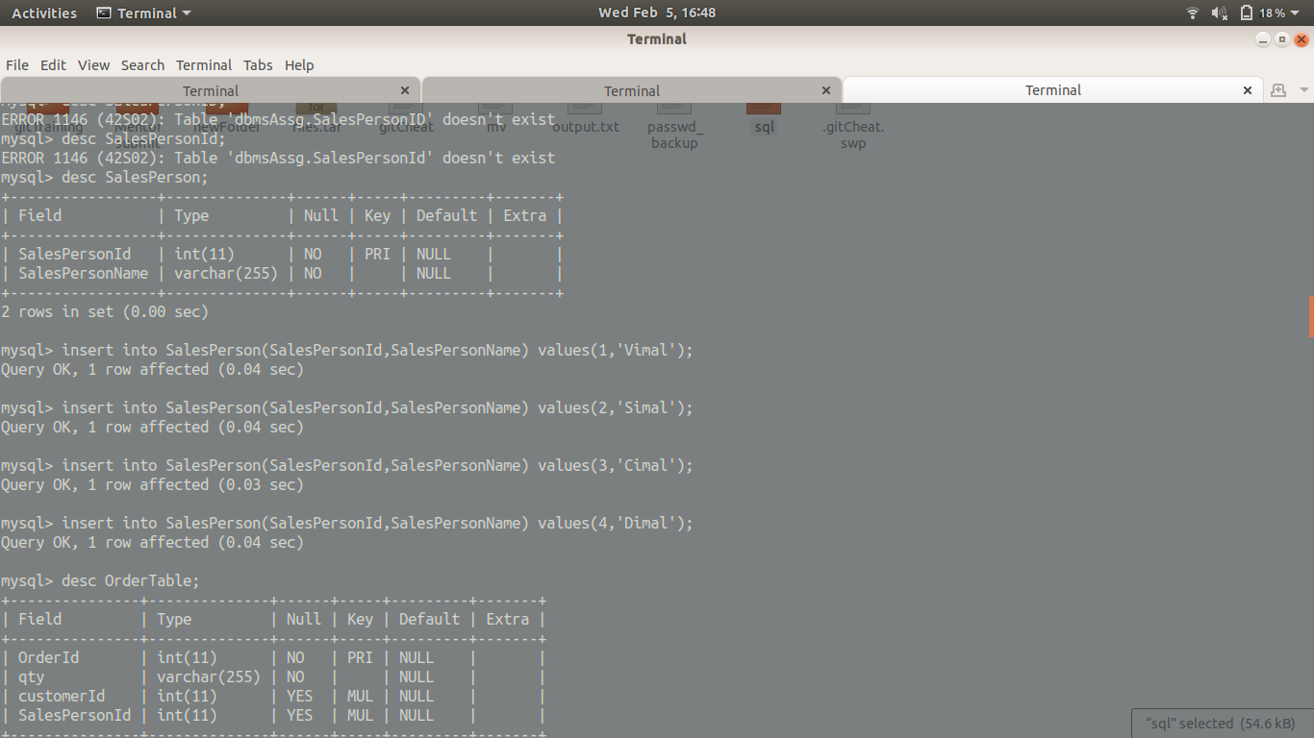



5) select SalesPersonName from SalesPerson where (select count(\*) from OrderTable where SalesPerson.SalesPersonId = OrderTable.SalesPersonId)>1

6)select \* from SalesPerson right join OrderTable ON SalesPerson.SalesPersonId = OrderTable.SalesPersonId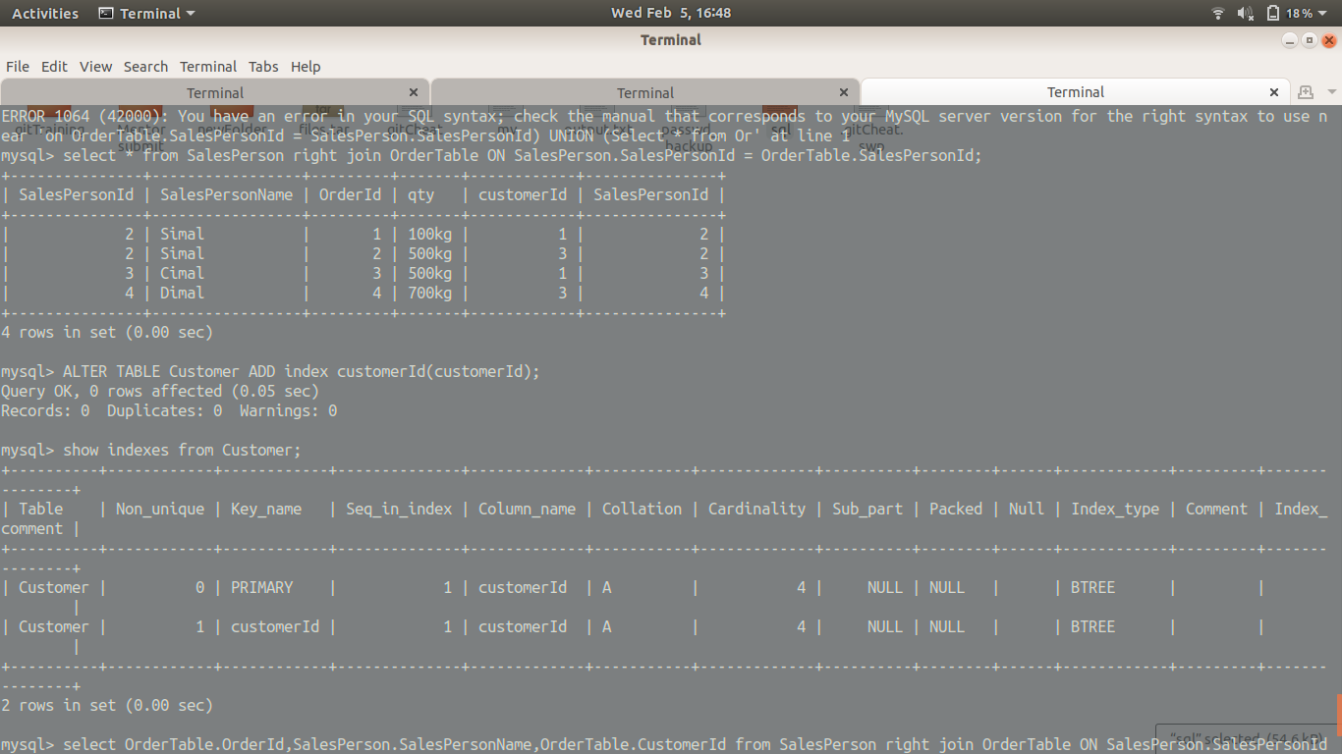

7)



8)

9)select OrderTable.OrderId,SalesPerson.SalesPersonName,OrderTable.CustomerId from SalesPerson right join OrderTable ON SalesPerson.SalesPersonId = OrderTable.SalesPersonId;

