**DAY2 GIT (VCS)**

1. **Set up git - done on laptop -**

**git config --global user.name "Your Name”**

**git config --global user.email "youremail@domain.com"**

1. **Git init**

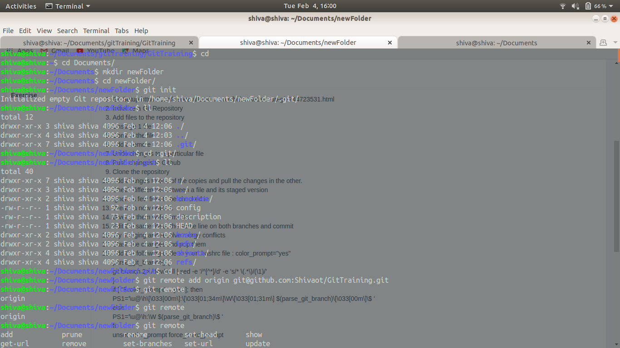

**3)git add .**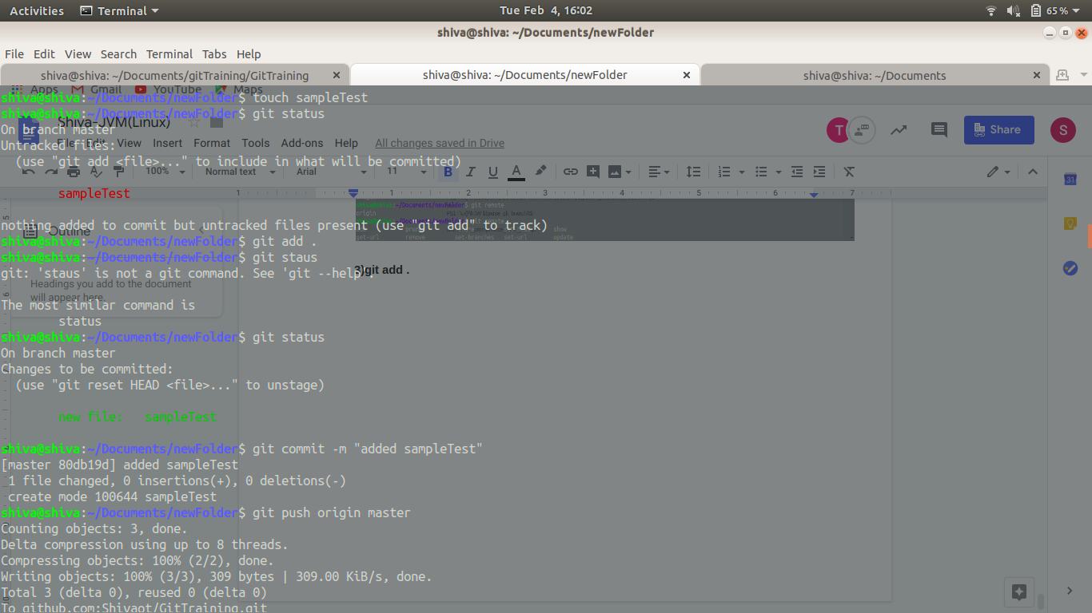

**4) git reset filename**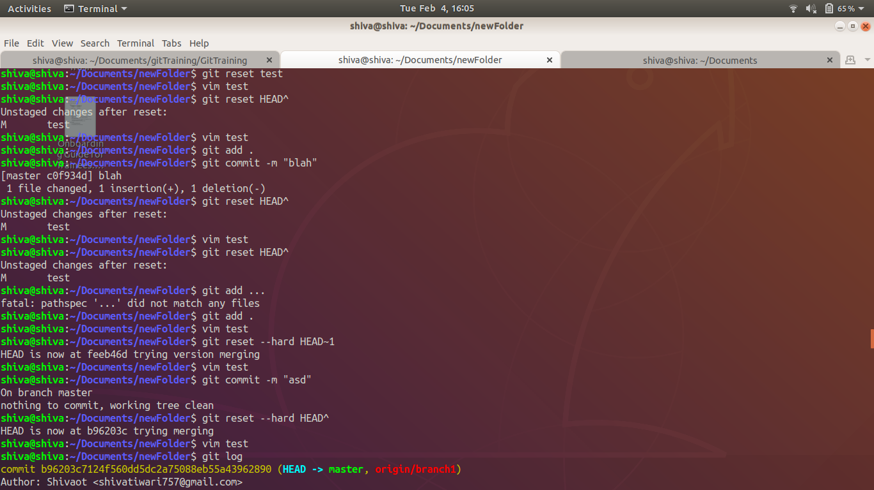

**5) git commit -m “commit message”**

**6)git remote add origin git@github.com:Shivaot/GitTraining.git**



**7)git reset --hard HEAD~1**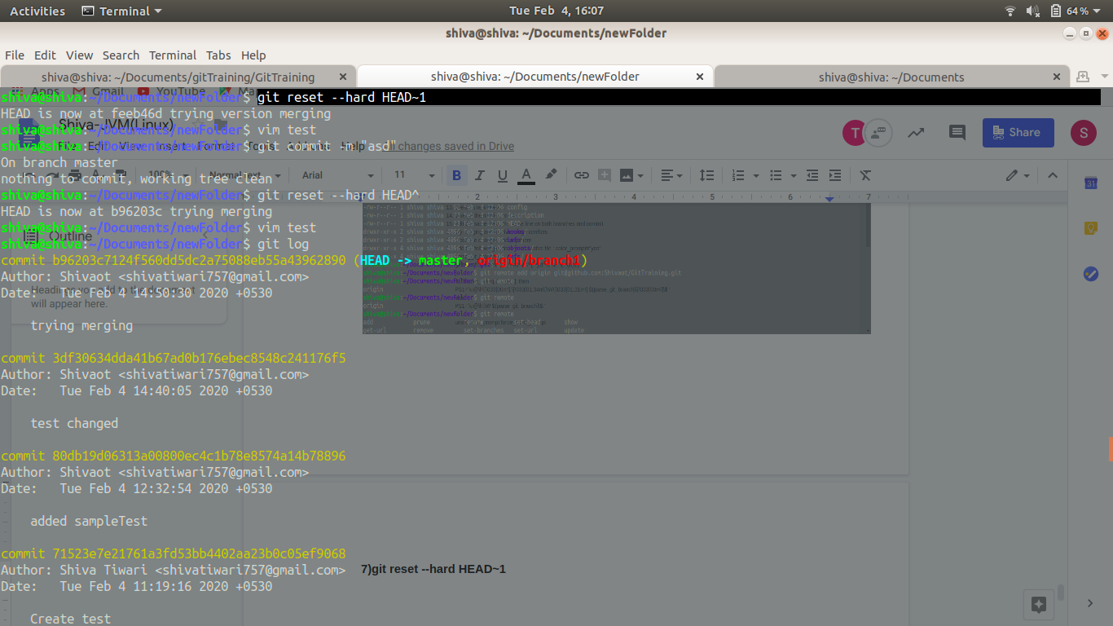

**8)git push origin master(branch name)**



**9) git clone <sshurl>**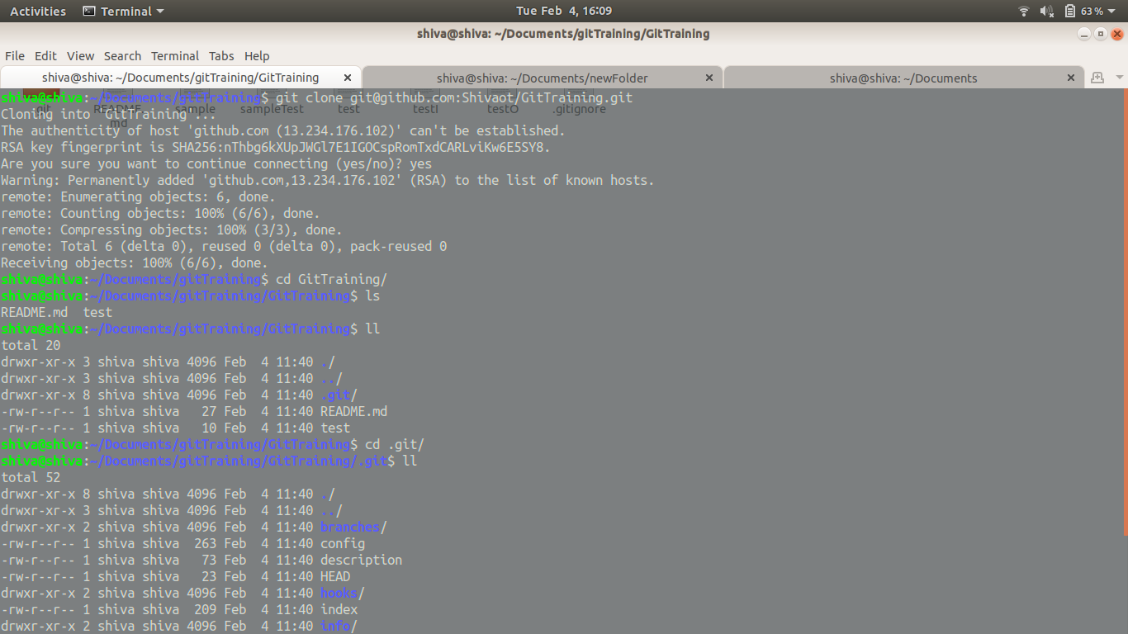

**10)git add .**

**Git commit -m “msg”**

**Git checkout branchname**

**Git merge prevBranchName**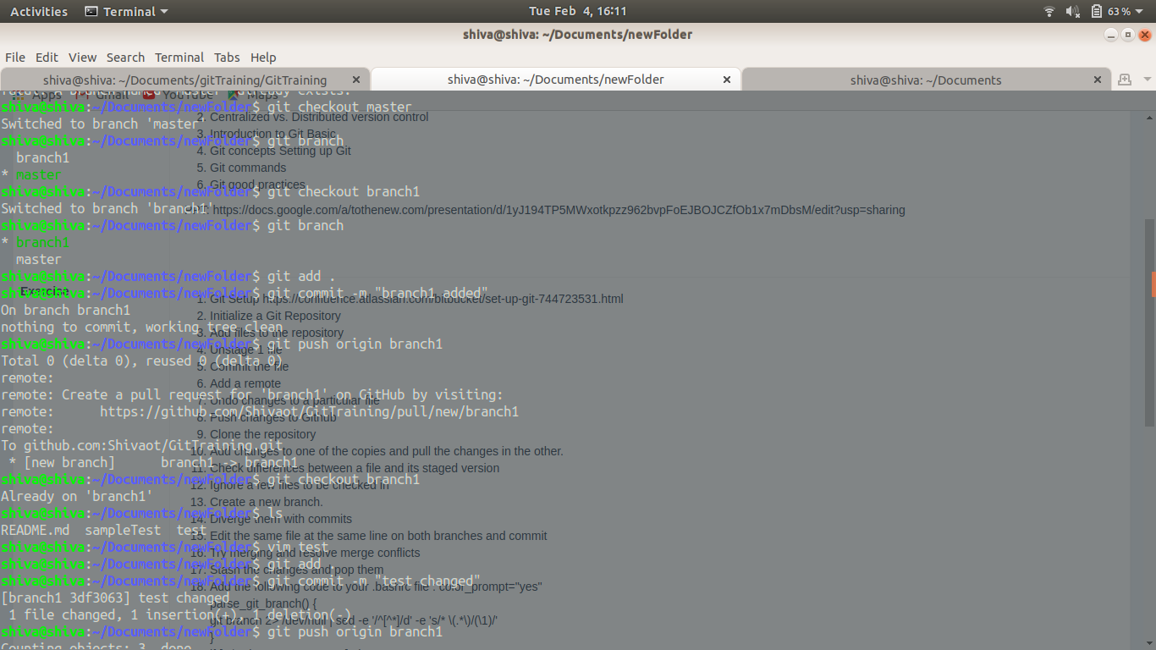

**11)git diff --cached**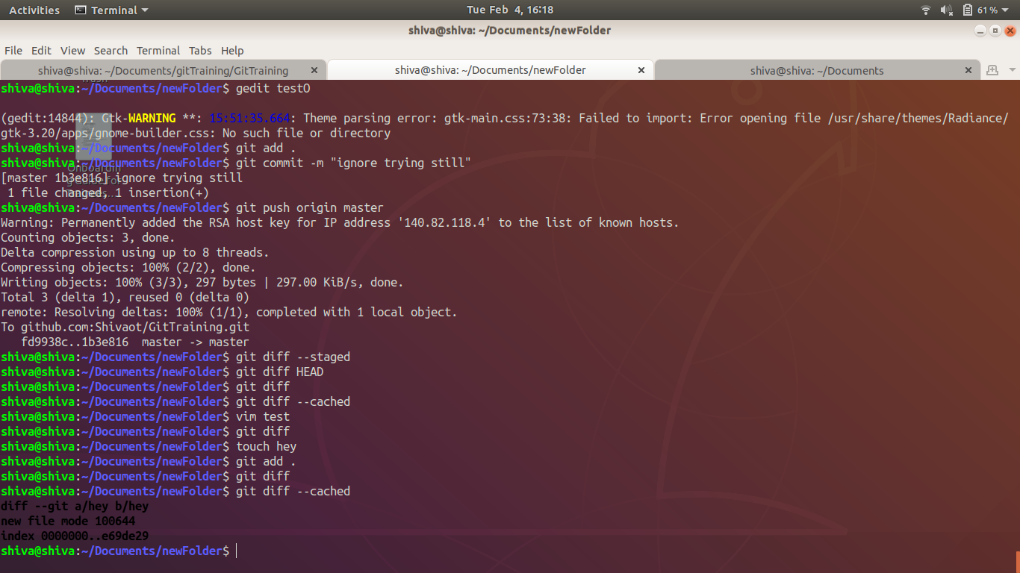

**12).gitignore** 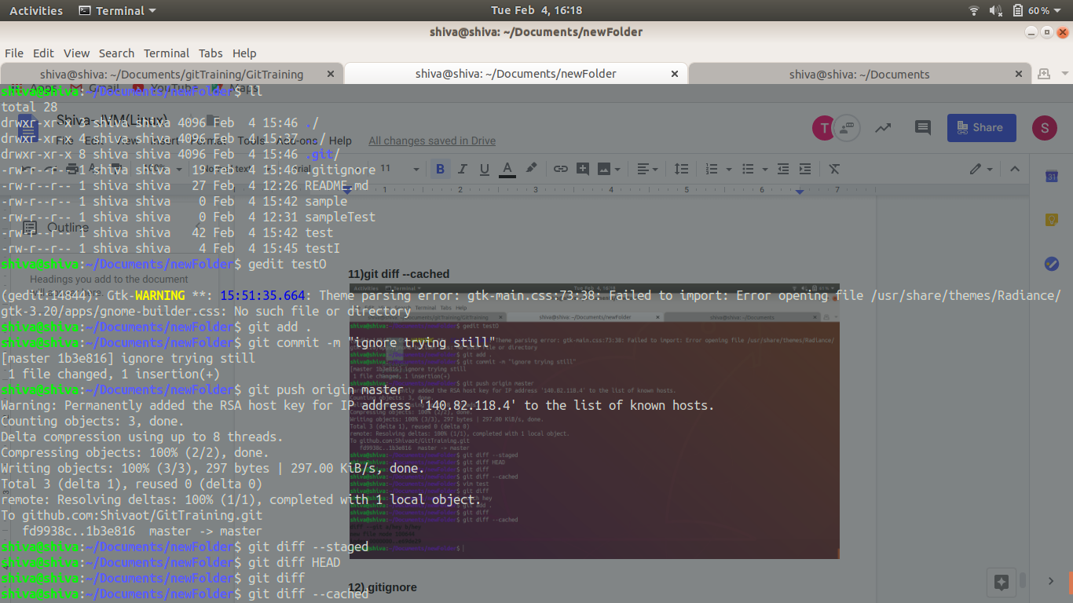

**13)git checkout -b branch1**

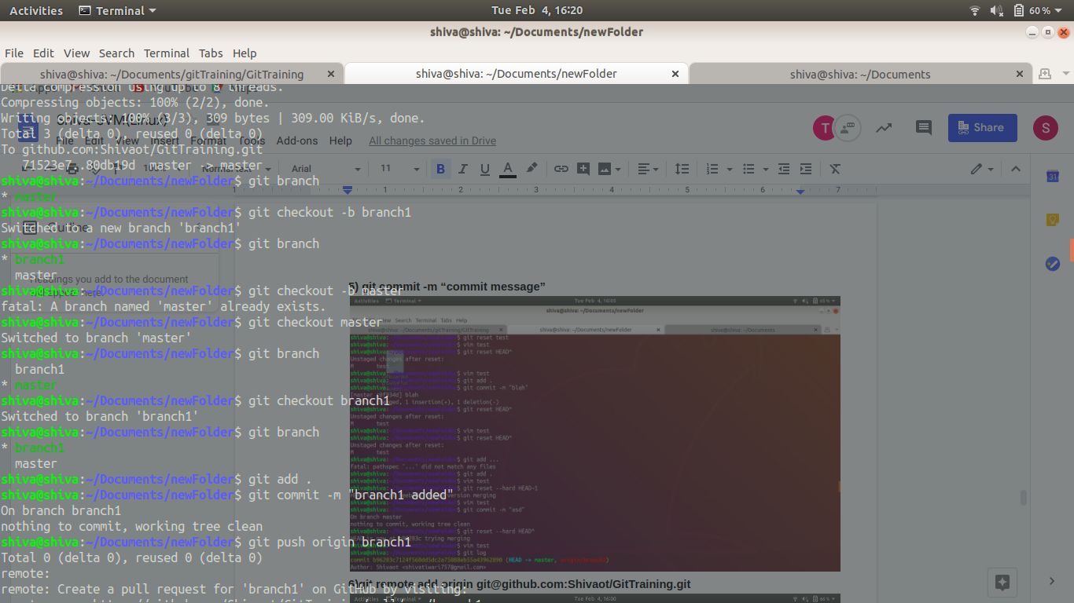

**14) steps -**

**Git checkout branch1**

**Change file**

**Git add .**

**Git commit -m “msg”**

**Git checkout master**

**Change file**

**Git add .**

**Conflict comes**

**Select the one which want to continue with**

**Git add .**

**Git commit -m “msg”**

(same thing is done on screenshots)

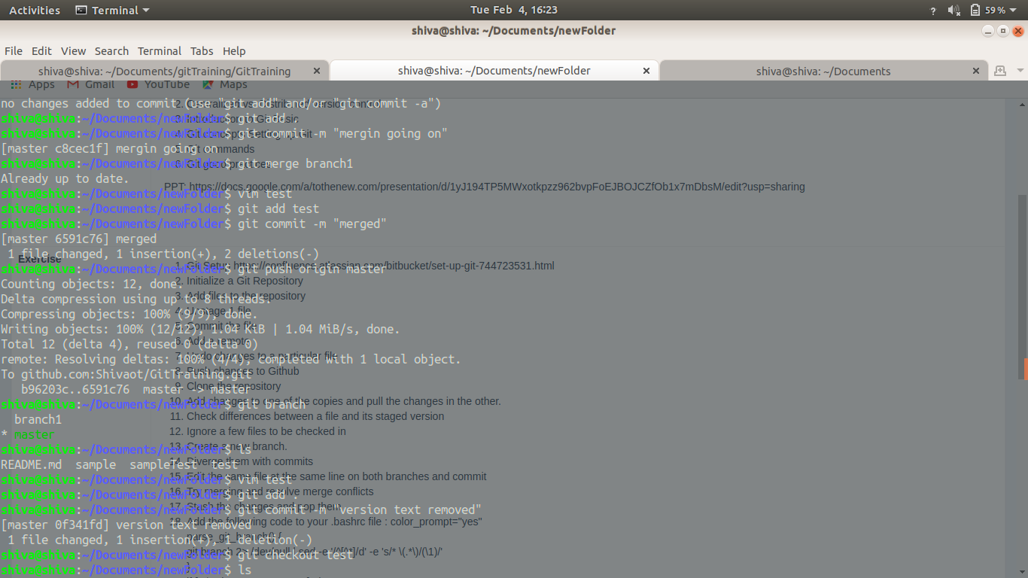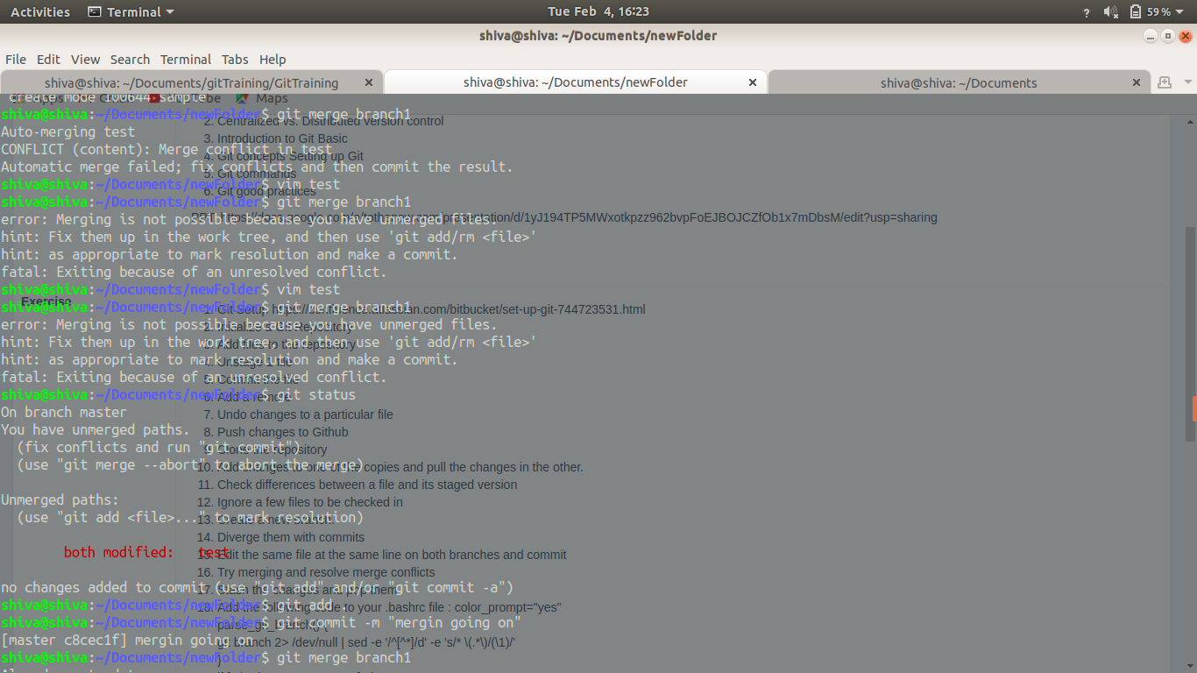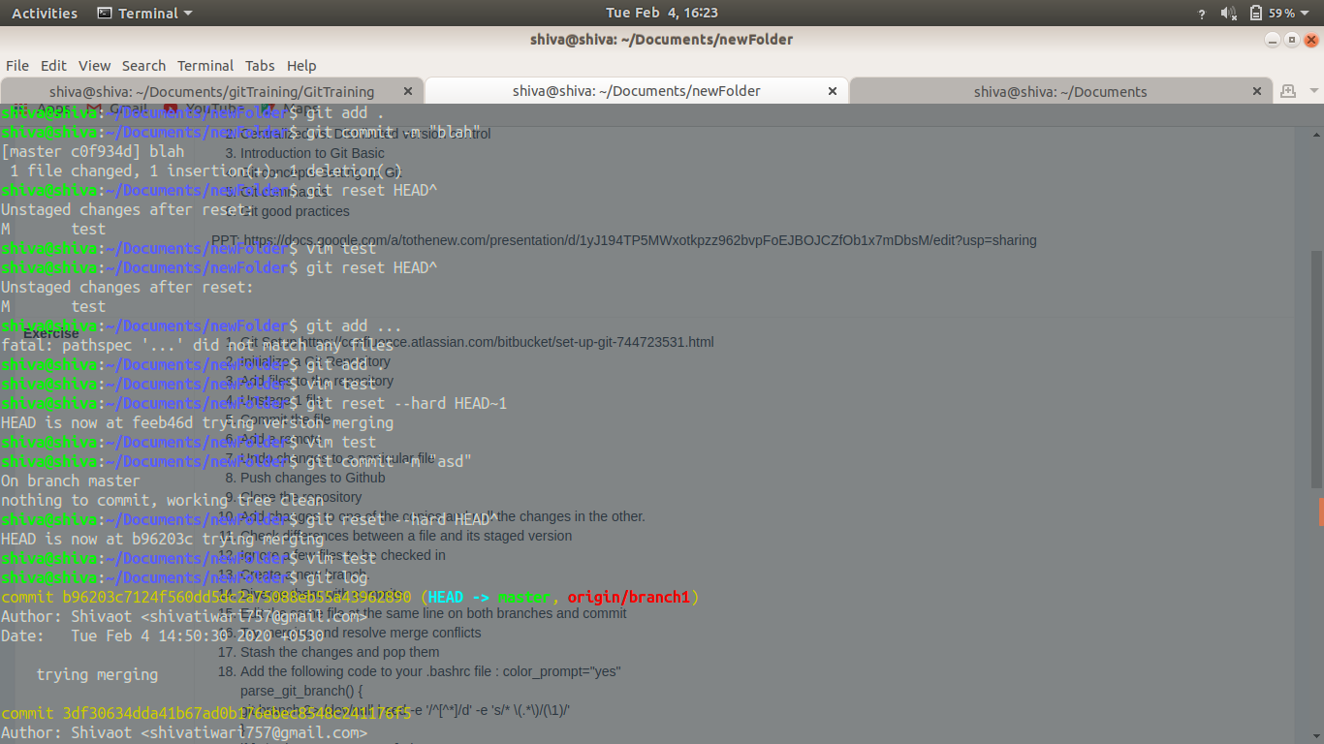

**15)** 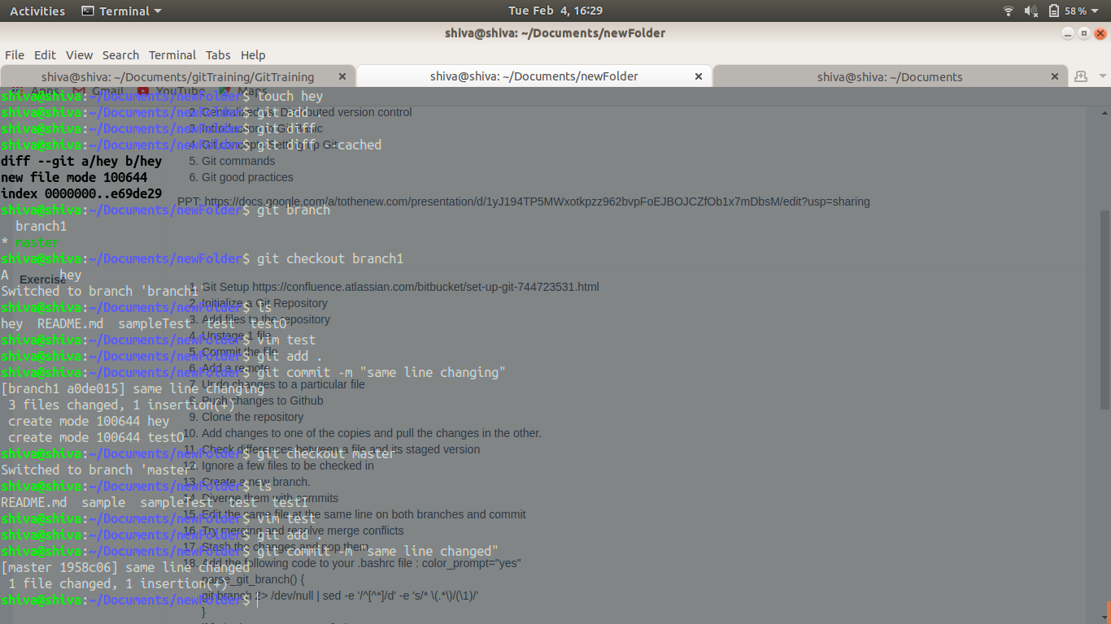

**16)Git checkout branch1**

**Change file**

**Git add .**

**Git commit -m “msg”**

**Git checkout master**

**Change file**

**Git add .**

**Conflict comes**

**Select the one which want to continue with**

**Git add .**

**Git commit -m “msg”**







**17)git stash**

**git stash pop**

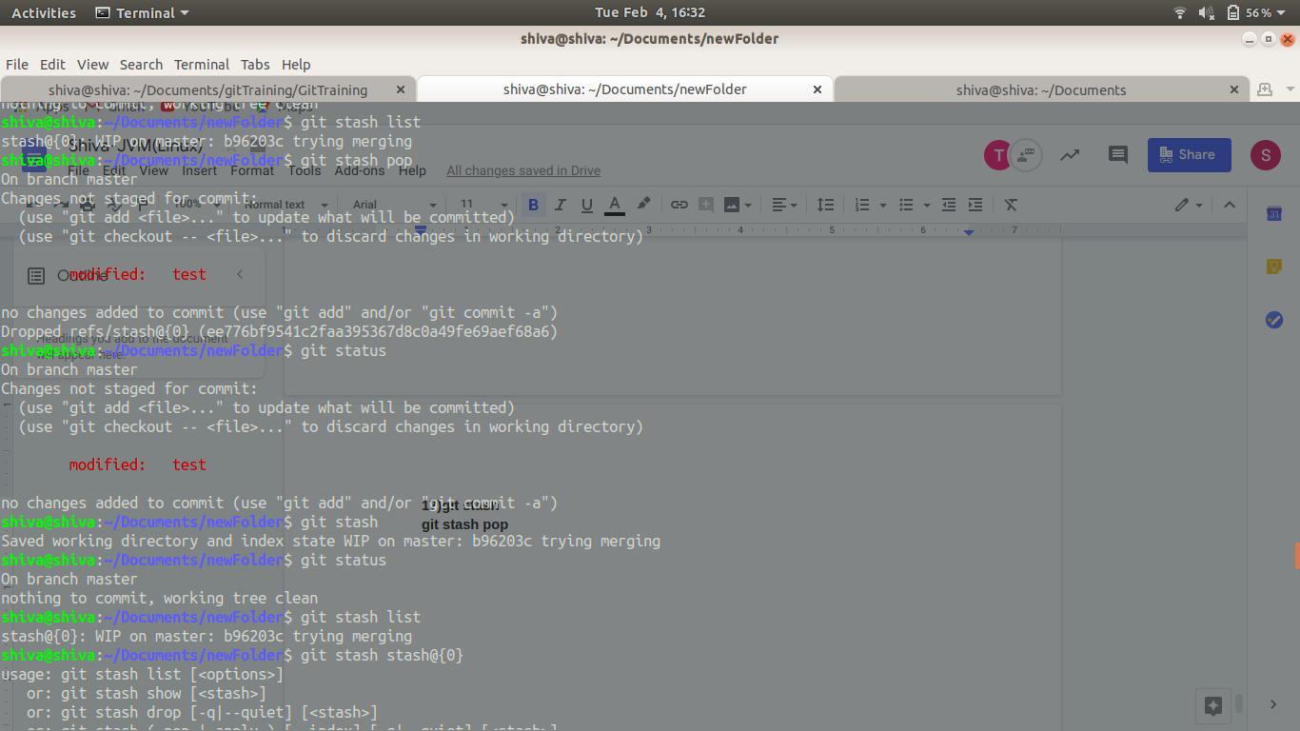

**18)**

