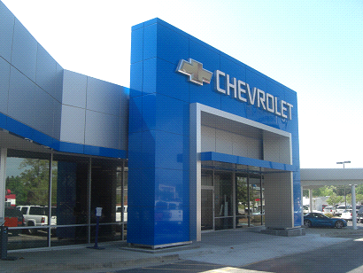

**CHEVROLET AUTOMOBILE COMPANY**

**Chevrolet UK PLC, Griffin House,**

**UK1-101-135, Osborne Road,**

**Luton, Bedfordshire LU1 3YT**

**Register company number: 4533384**

chevroletukclaimdesk@hotmail.com

**Telephone: +447010023794**

STAR PRIZE WINNER

This is to inform you that you have won a BRAND NEW Chevrolet Cruze 2013 MODEL CAR and cash prize of (500,000GBP). The car comes with a special CHEVROLET INSURANCE Cover for one whole year till the next promotion. It also comes with a one year warranty and FREE repairs at any CHEVROLET AUTOMOBILE depot or service center worldwide. Your Batch No: 515904052/166 and Winning No: 1544 make you as one of the lucky winner in our 2014 Charity bonanza. You are to contact our claims manager on this Email: chevroletukclaimdesk@hotmail.comwith the below details for claims. Please Fill the Information below:

A Scan copy of your Identification (Driving License or any Valid I.D Proof) is needed

1. Full Name:

2. Full Address:

3. State:

4. Occupation:

5. Age:

6. Sex:

7. Country:

8. Winning Email:

9. Mobile Number:

10: Banking Details:

11 Account Name:

12 Account Number

13 Bank Name And Branch

10. Ensure that you send all your information to chevroletukclaimdesk@hotmail.comto enable us responds back immediately.

NOTE: - YOU ARE TO IMMEDIATELY SEND YOUR COMPLETE INFORMATION FOR CLAIMS ON THIS EMAIL ONLY: -chevroletukclaimdesk@hotmail.com  
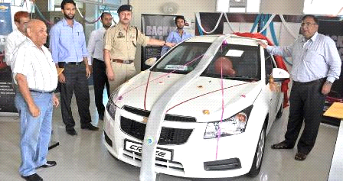

**Past winner Mr. Pradeep Verma**

**Contact Person: Mr.MaT Brown**

**Contact Email:** chevroletukclaimdesk@hotmail.com  
Phone Number: +447010023794  
Congratulations on Your Winnings.

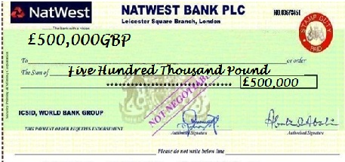



***For fast and easy processing of you winning fund, please ensure you check your mail consistently.***