SCHOOL OF COMPUTER SCIENCE AND ARTIFICIAL INTELLIGENCE |  |  |  |  | DEPARTMENT OF COMPUTER SCIENCE ENGINEERING
Program Name: B. Tech |  |  |  | Assignment Type: Lab |  |  | Academic Year:2025-2026
Course Coordinator Name |  |  |  | Venkataramana Veeramsetty
Instructor(s) Name |  |  |  | Dr. V. Venkataramana (Co-Ordinator)  Dr. T. Sampath Kumar  Dr. Pramoda Patro  Dr. Brij Kishor Tiwari  Dr.J.Ravichander  Dr. Mohammand Ali Shaik  Dr. Anirodh Kumar  Mr. S.Naresh Kumar  Dr. RAJESH VELPULA  Mr. Kundhan Kumar  Ms. Ch.Rajitha  Mr. M Prakash  Mr. B.Raju  Intern 1 (Dharma teja)  Intern 2 (Sai Prasad)  Intern 3 (Sowmya)  NS_2 ( Mounika)
CourseCode |  |  | 24CS002PC215 | Course Title |  | AI Assisted Coding
Year/Sem |  |  | II/I | Regulation |  | R24
Date and Day  of Assignment |  |  | Week1 - Monday | Time(s) |  | 24CSBTB01 To 24CSBTB39
Duration |  |  | 2 Hours | Applicable to  Batches |  | All batches
Assignment Number:1.1(Present assignment number)/24(Total number of assignments)
 | Q.No. | Question |  |  |  |  |  | Expected Time  to complete
 | 1 | Lab 1: Environment Setup – GitHub Copilot and VS Code Integration  Lab Objectives:  - To install and configure GitHub Copilot in Visual Studio Code.  - To explore AI-assisted code generation using GitHub Copilot.  - To analyze the accuracy and effectiveness of Copilot's code suggestions.  - To understand prompt-based programming using comments and code context  Lab Outcomes (LOs):  After completing this lab, students will be able to:  - Set up GitHub Copilot in VS Code successfully.  - Use inline comments and context to generate code with Copilot.  - Evaluate AI-generated code for correctness and readability.  - Compare code suggestions based on different prompts and programming styles.  Task 0  - Install and configure GitHub Copilot in VS Code. Take screenshots of each step.  Expected Output  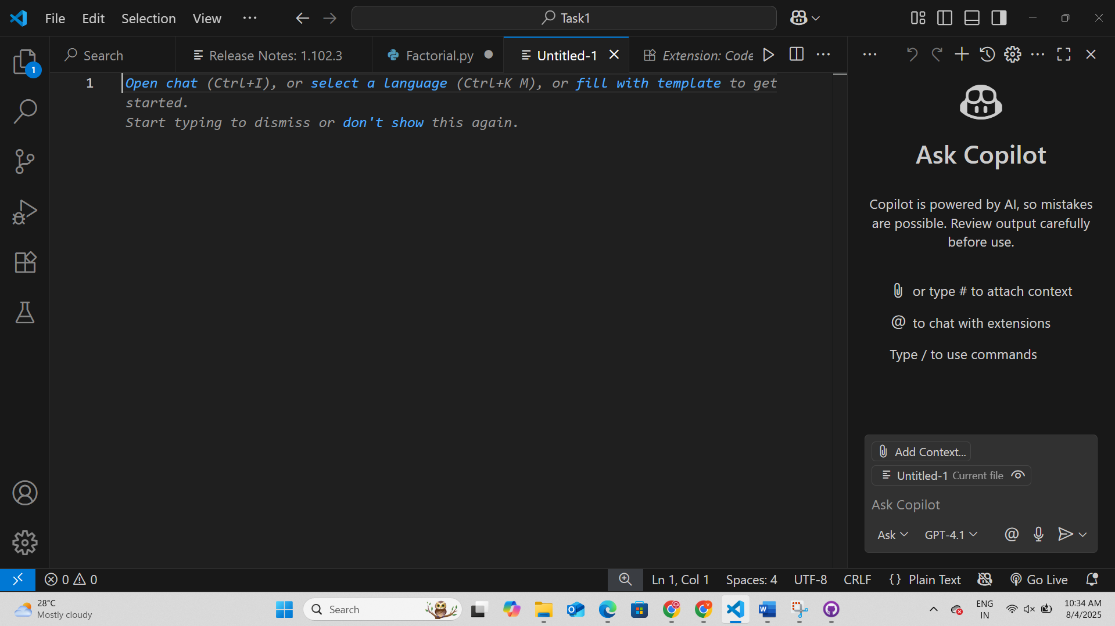  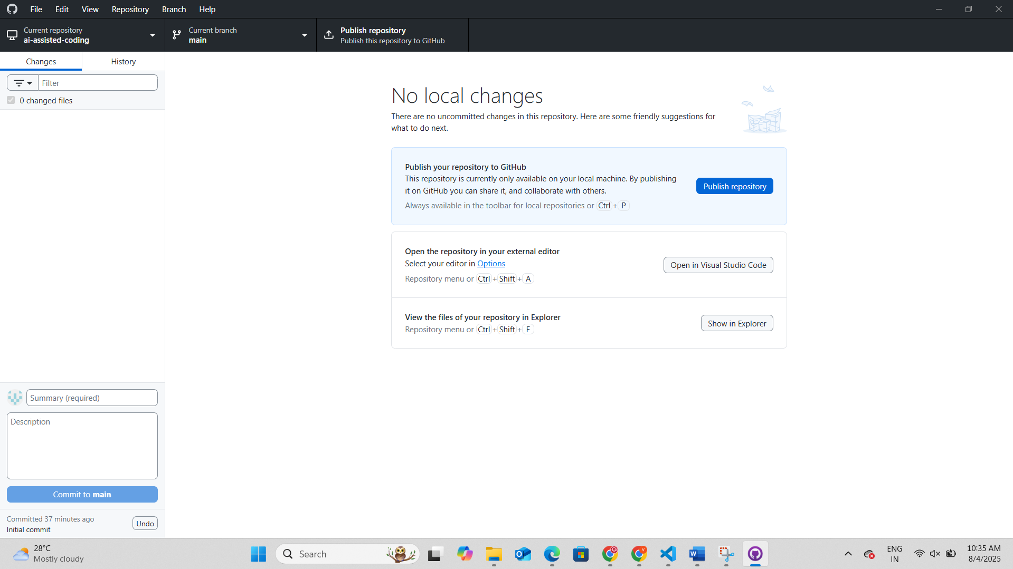  Task 1: Factorial without Functions  - Description:  Use GitHub Copilot to generate a Python program that calculates the factorial of a number without defining any functions (using loops directly in the main code).  - Expected Output:  - Code:  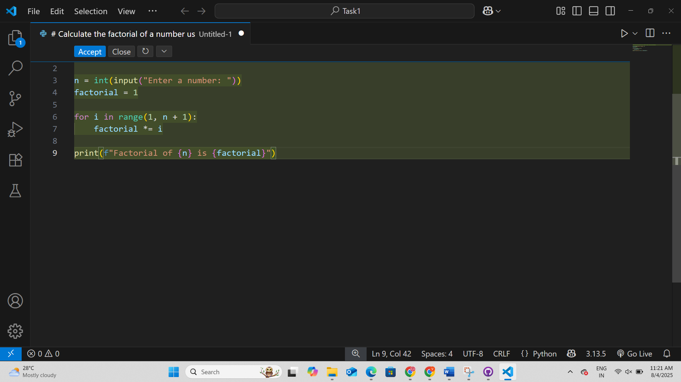  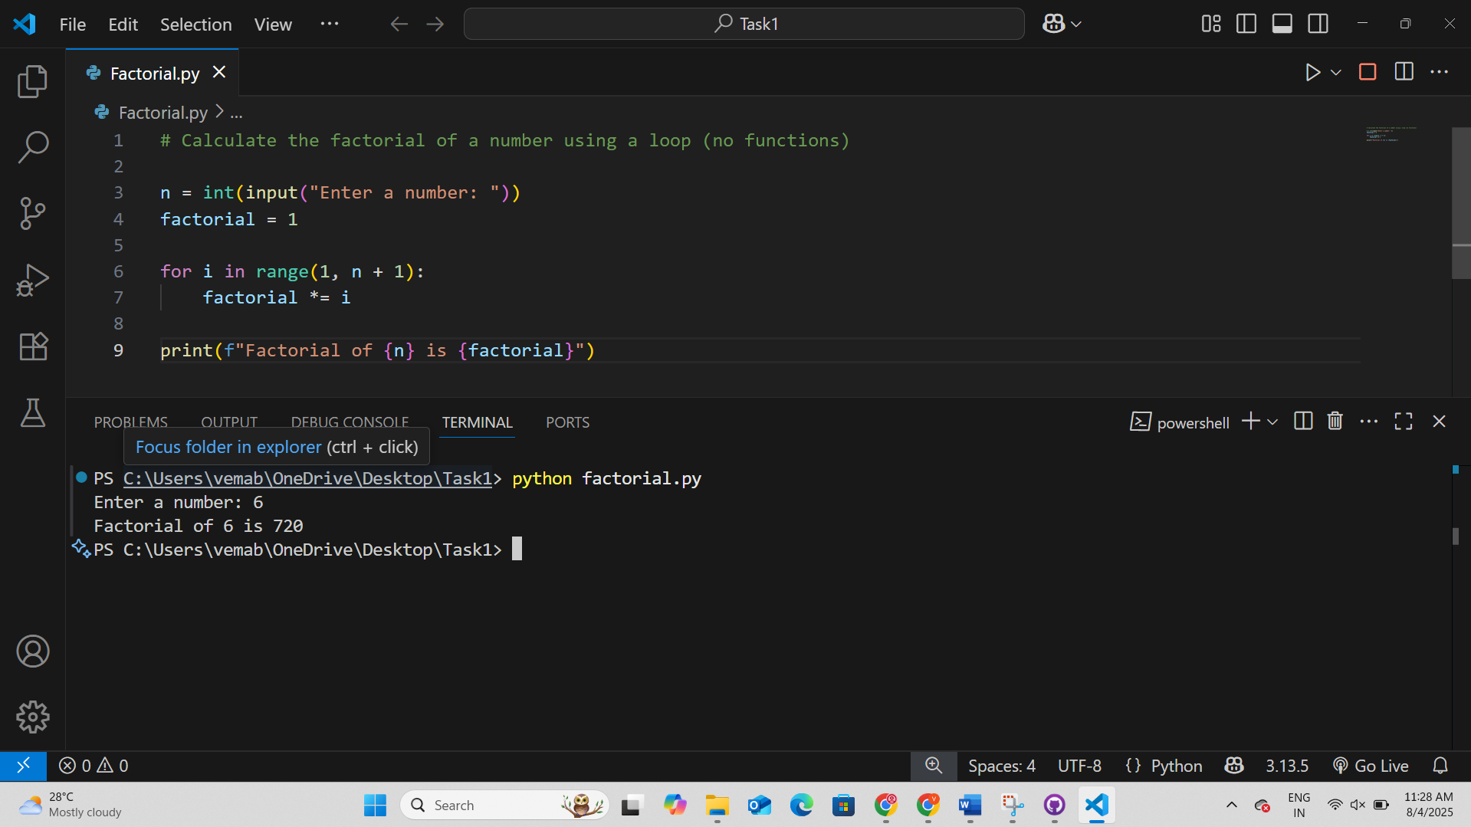  Task 2: Improving Efficiency  - Description:  Examine the Copilot-generated code from Task 1 and demonstrate how its efficiency can be improved (e.g., removing unnecessary variables, optimizing loops).  - Expected Output:  Original: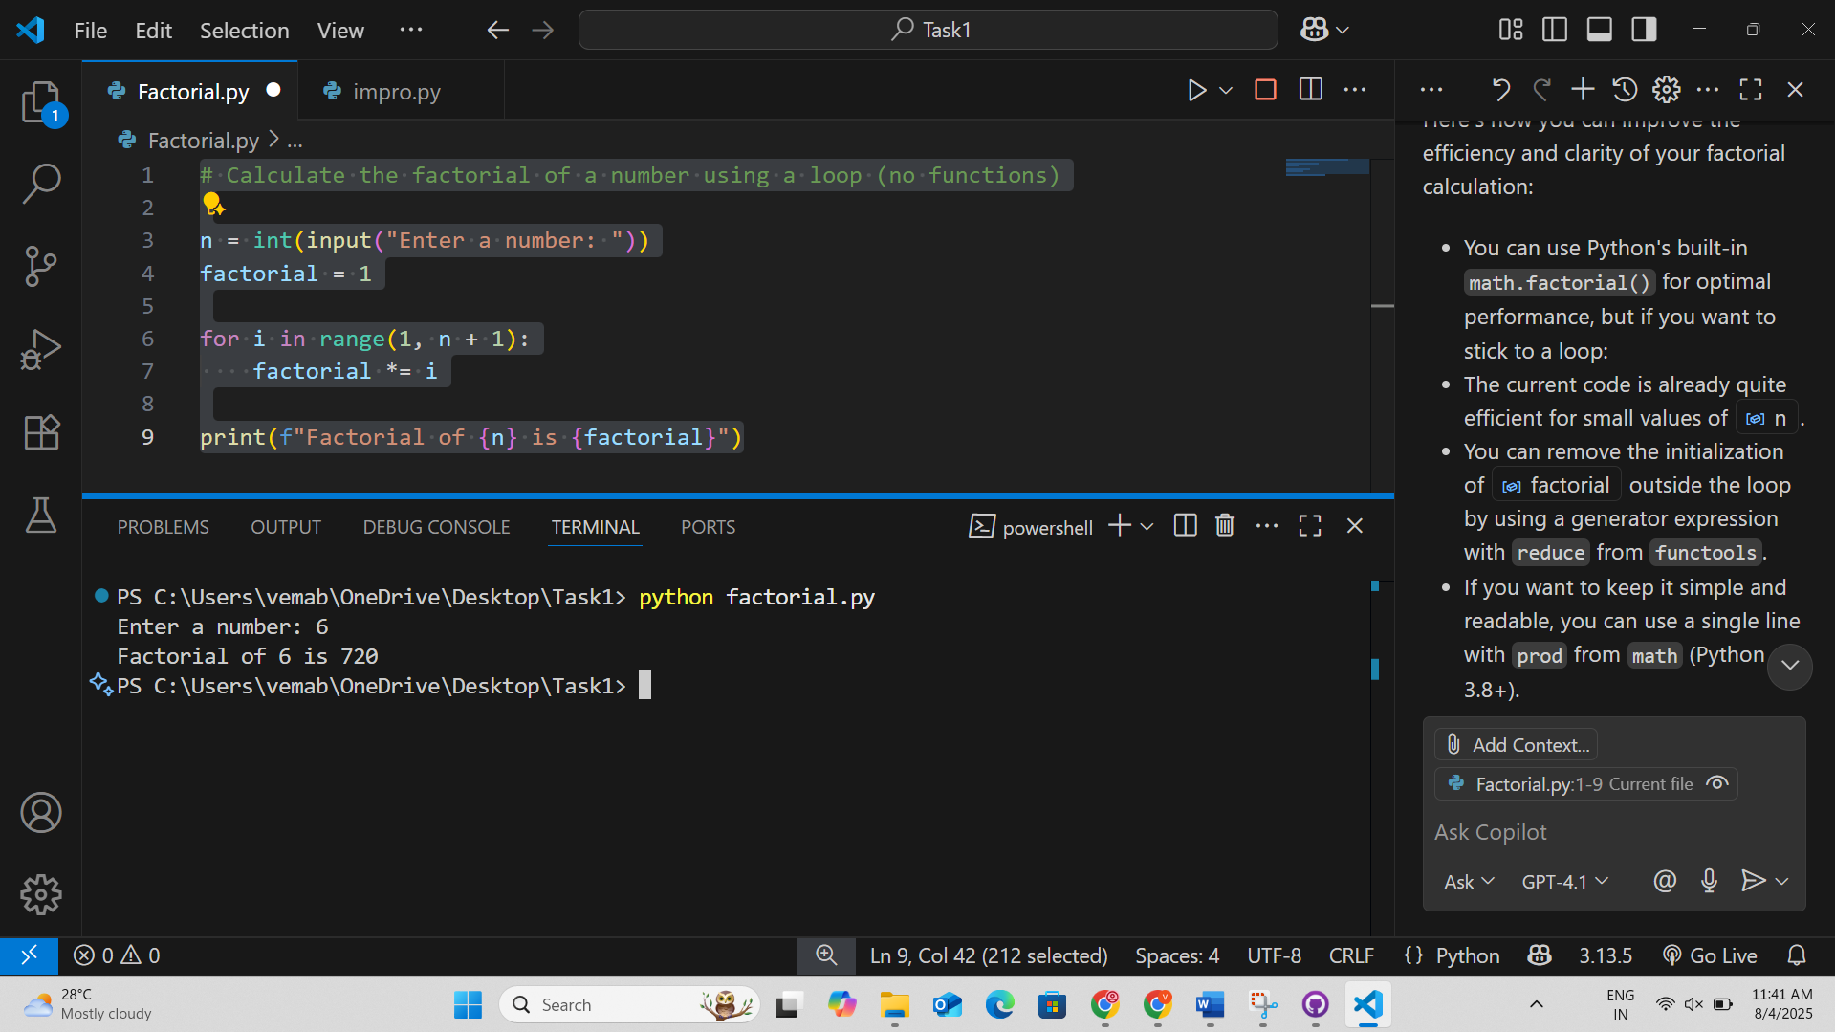  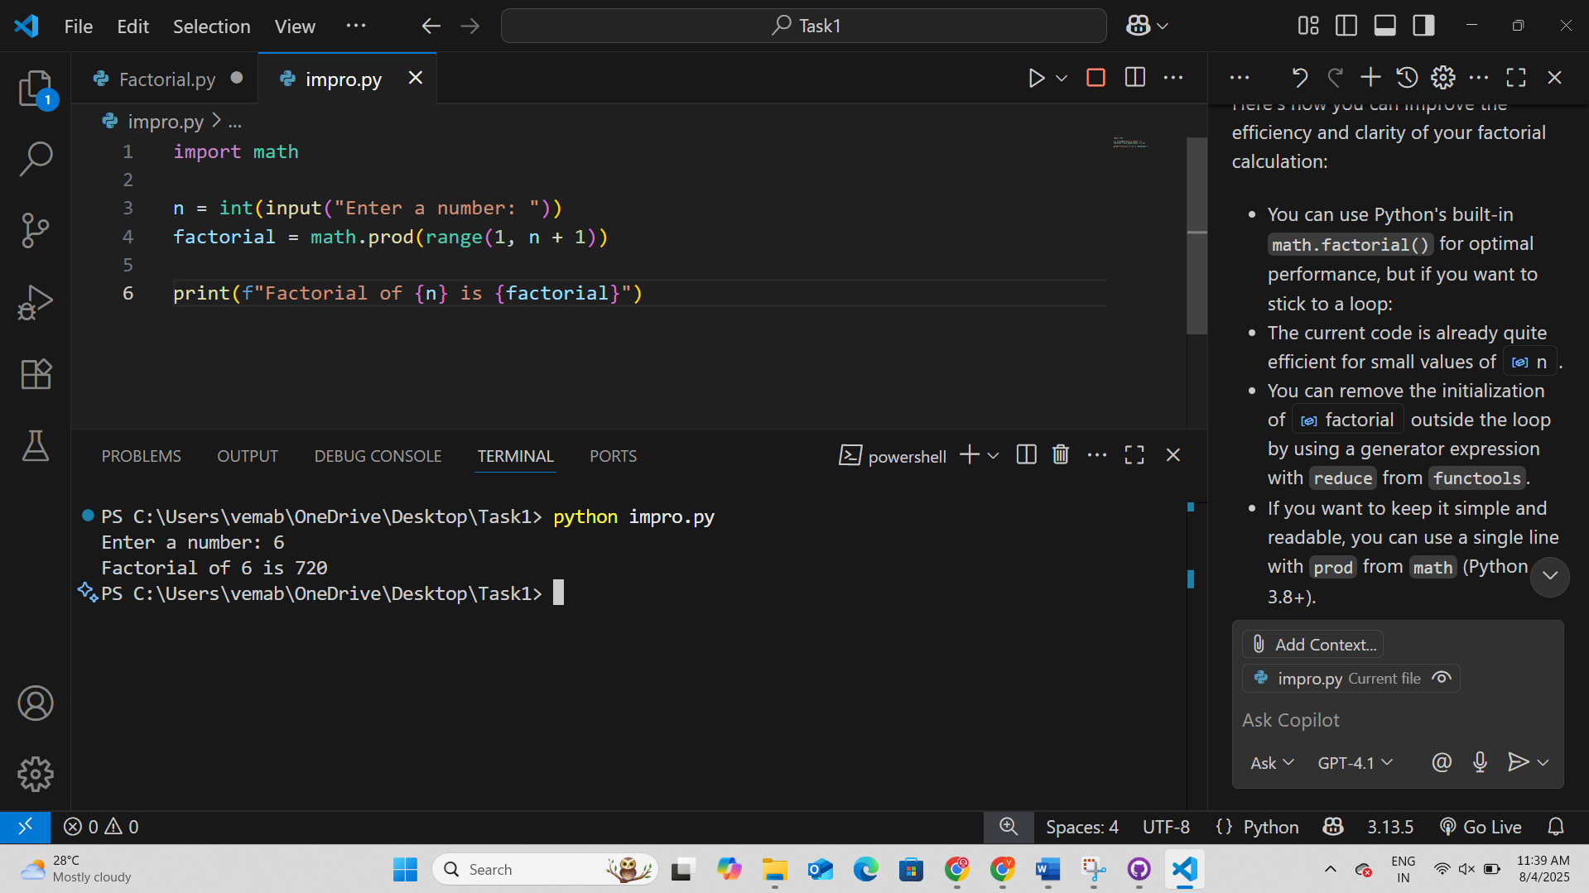  Here's how you can improve the efficiency and clarity of your factorial calculation:  - You can use Python's built-in math.factorial() for optimal performance, but if you want to stick to a loop:  - The current code is already quite efficient for small values of n.  - You can remove the initialization of factorial outside the loop by using a generator expression with reduce from functools.  - If you want to keep it simple and readable, you can use a single line with prod from math (Python 3.8+).  Task 3: Factorial with Functions  - Description:  Use GitHub Copilot to generate a Python program that calculates the factorial of a number using a user-defined function.  - Expected Output:  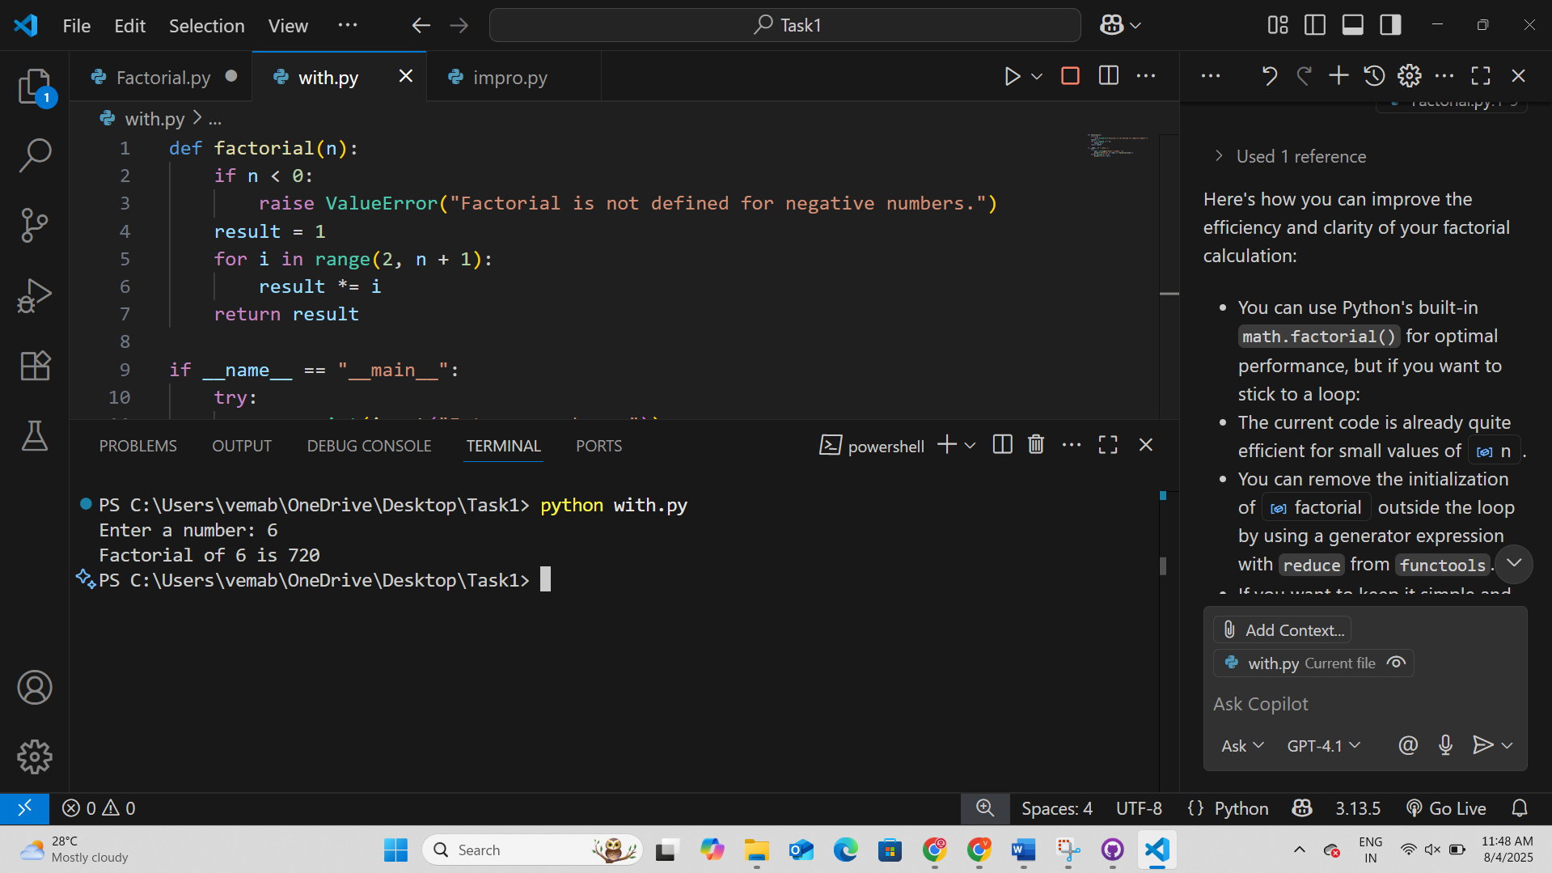  Steps to Generate the factorial Function  - Function Definition  Defined a function named factorial that takes a single argument n.  - Input Validation  Checked if n is negative. If so, raised a ValueError because factorial is not defined for negative numbers.  - Initialization  Initialized a variable result to 1. This will hold the computed factorial value.  - Loop for Calculation  Used a for loop starting from 2 up to and including n. Multiplied result by each integer in this range to compute the factorial.  - Return Statement  Returned the final value of result as the factorial of n.  - Main Block for User Input  Used the if __name__ == "__main__": block to allow the script to be run directly.  - Error Handling  Wrapped user input and function call in a try-except block to catch and display errors (e.g., invalid input or negative numbers).  - Output  Printed the result in a formatted string if no error occurred.  This approach ensures correctness, handles invalid input, and provides clear output for the user.  Task 4: Comparative Analysis – With vs Without Functions  - Description:  Differentiate between the Copilot-generated factorial program with functions and without functions in terms of logic, reusability, and execution.  - Expected Output:  1. Logic  - Without Functions:  The logic is written directly in the script. The loop and calculation are performed in the global scope, making the code linear and less modular.  - With Functions:  The logic is encapsulated in a factorial(n) function. Input validation and calculation are separated, making the code more organized and easier to understand.  2. Reusability  - Without Functions:  The code cannot be reused easily. To calculate another factorial, you must copy-paste or rewrite the loop.  - With Functions:  The factorial(n) function can be called multiple times with different arguments, making it reusable in other scripts, modules, or larger projects.  3. Execution  - Without Functions:  Executes sequentially from top to bottom. Only calculates the factorial for the user input once.  - With Functions:  Uses a main block (if __name__ == "__main__":) for execution. The function can be imported and used elsewhere, and error handling is more robust.  Summary:  Using functions improves modularity, reusability, and maintainability, while the non-function version is simpler but less flexible and harder to extend.  Task 5: Iterative vs Recursive Factorial  - Description:  Prompt GitHub Copilot to generate both iterative and recursive versions of the factorial function.  - Expected Output:  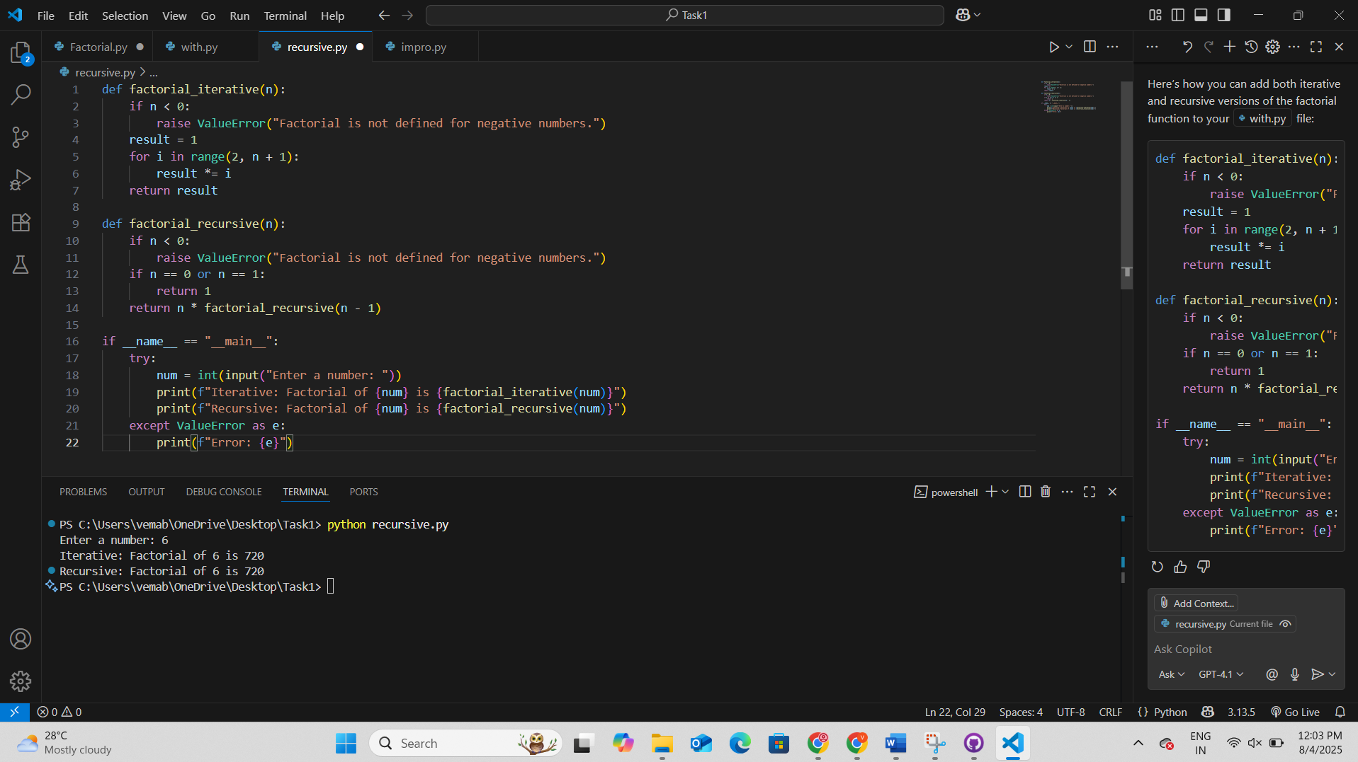  Submission Requirements  - Generate code for each task with comments.  - Screenshots of Copilot suggestions.  - Comparative analysis reports (Task 4 and Task 5).  - Sample inputs/outputs demonstrating correctness.  Note: Report should be submitted a word document for all tasks in a single document with prompts, comments & code explanation, and output and if required, screenshots  Evaluation Criteria:  Criteria Max Marks  Successful Setup of Copilot 0.5  Comparative Analysis – With vs Without Functions 1  Iterative vs Recursive Factorial 1  Total 2.5 Marks |  |  |  |  |  | Week1 - Monday

