Netflix Userbase Analysis

Shiva Priya Ummareddy

Introduction
Netflix is a worldwide and popular entertainment company and a streaming platform which has altered the way in which people across different countries watch movies, TV shows and other content. Netflix was founded in the year 1997 by Reed Hastings and Marc Randolph. Over the years Netflix has become the most popular streaming Platform. The key features like Streaming Library, Original Content, Personalized Recommendations, Offline Viewing, Multiple Device Support and No advertisements made Netflix a very popular streaming platform.
Netflix is a prominent force in the streaming market for its creative content distribution strategy, extensive collection of films and TV episodes, and passion to creating original material of the highest caliber. With millions of customers globally, Netflix continues to influence how people consume entertainment and will likely have a big impact on how the media sector evolves in the future.
Now in this project we are going to analyze the Netflix Userbase dataset.

Dataset
The dataset is collected from Kaggle. The dataset offers a glimpse of an estimated Netflix subscriber base, displaying several aspects of customer subscriptions, revenue, account information, and activity. A unique user is denoted by each row and is identifiable by their User ID. The user's membership type (Basic, Standard, or Premium), the monthly income earned by their subscription, the date they first subscribed to Netflix (Join Date), the date they last made a payment (Last Payment Date), and the country in which they reside are all included in the dataset.
Insights into user activity and preferences are provided by additional columns. Device Type (such as Smart TV, mobile, desktop, or tablet), Total Watch Time (measured in minutes), and Account Status (indicating whether the account is active or inactive) are listed in these columns. The dataset is a fictitious representation and does not correspond to real Netflix subscriber information. Within a fictitious Netflix userbase, it may be utilized for research and modeling to comprehend user patterns, preferences, and income production.

Here is the link for the dataset from Kaggle:
https://www.kaggle.com/datasets/arnavsmayan/netflix-userbase-dataset

Attributes:

There are 10 Attributes in the Dataset. The attributes are,
1.User ID: A unique code for every Netflix customer. This characteristic aids in identifying certain users and monitoring their activity on the platform.
2.Subscription Type: Indicates the user’s subscription type, which might be one of the Netflix subscription categories like Basic, Standard and Premium.
3.Monthly Revenue: This attribute helps in comprehending the revenue earned by various kinds of subscriptions.
4.Join Date: The day the customer started their Netflix subscription. It provides information on customer growth over time.
5.Last Payment Date: The most recent payment date of the user, which might be valuable in assessing user payment pattern and churn rates.
6.Country: The country in which the user is situated or has a Netflix subscription. This attribute aids in analyzing regional preferences and modifying content offers appropriately.
7.Age: The user's age, which might reveal demographic information about the customer base.
8.Gender: The user's gender, which may be utilized for content suggestions and gender-specific analysis.
9.Device: The kind of device such as a smartphone, a smart TV, a laptop, etc., that the user is using to access Netflix. Platform and app development can be improved from knowledge of device preferences.
10.Plan Duration: The length of the user's existing subscription plan, which could differ depending on the subscription type selected (e.g., monthly, quarterly, yearly).

Tools
Python
Tableau
Data Cleaning
Handling Missing Values
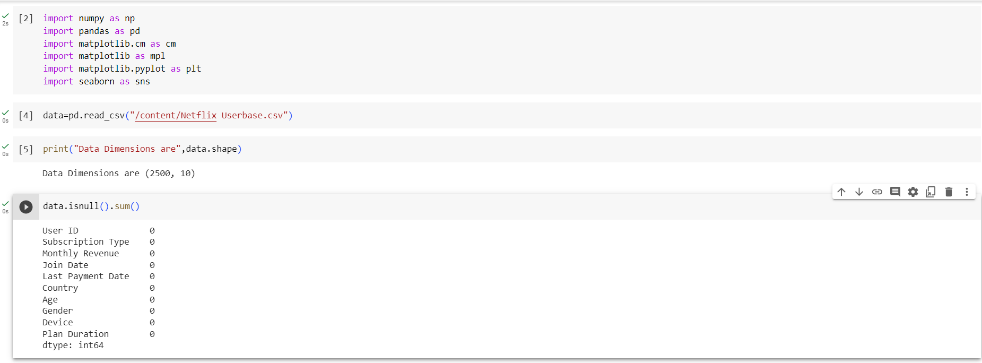
There are no missing values in the dataset.

Removing Duplicates
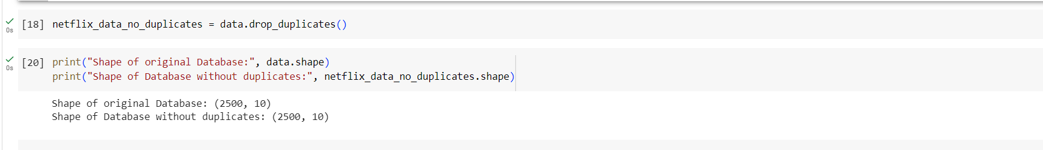

There are no duplicates in the database.

Exploratory Data Analysis
EDA aids in the discovery of patterns, as well as outliers, and interesting topics for further study about the data. In data science projects, it sets the foundation for complex investigations and model building.
1.Statistical Summary of the Numerical Attributes
Statistics of the numerical attributes in the data will be useful to calculate the central tendencies of the data and the spread of the data.
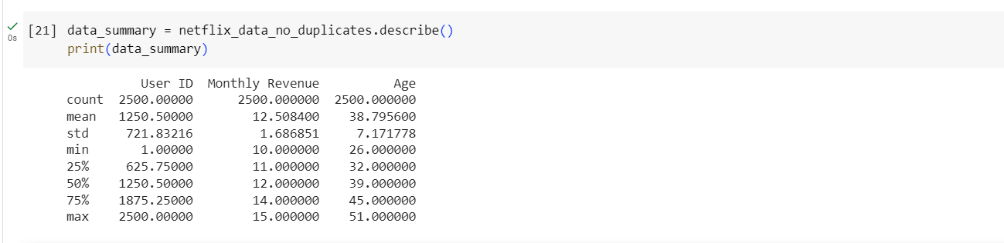
2.Visualization for the distribution of categorical attributes.
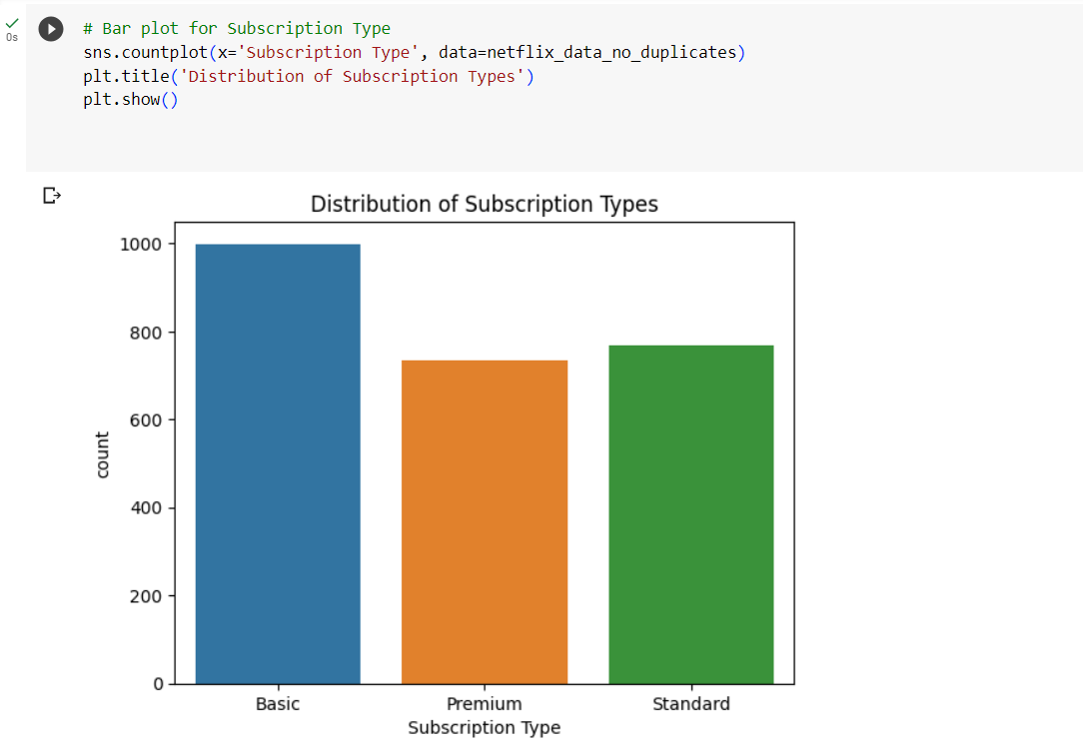

From the above Bar plot, we can conclude that there are more people with Basic subscription type.
3.Distribution of Users by country
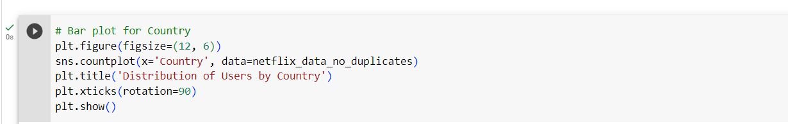
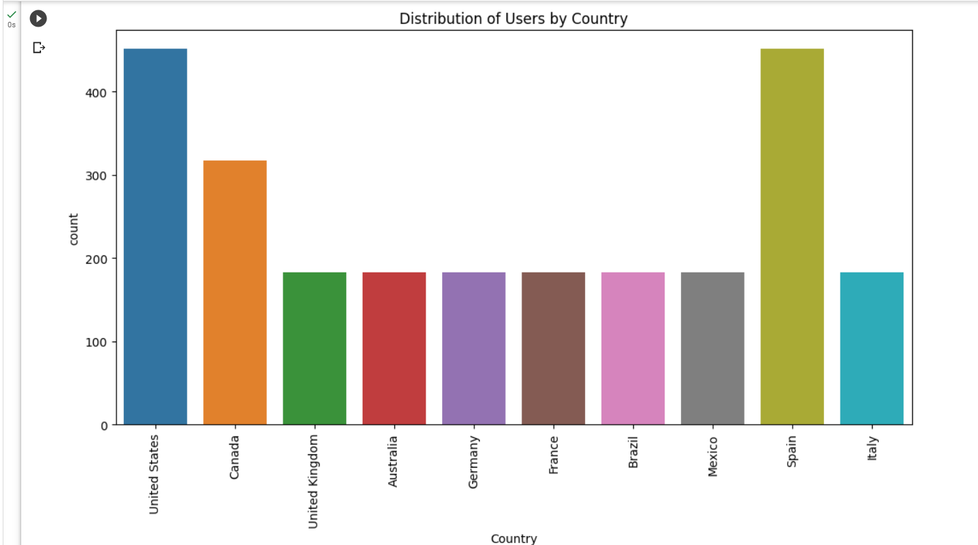

From the above Bar plot, we can conclude that there are almost equal number of users who uses Netflix in Spain and United states.

4.Time based Analysis
We can analyze patterns over a period if the dataset has temporal variables like Join Date and Last Payment Date.

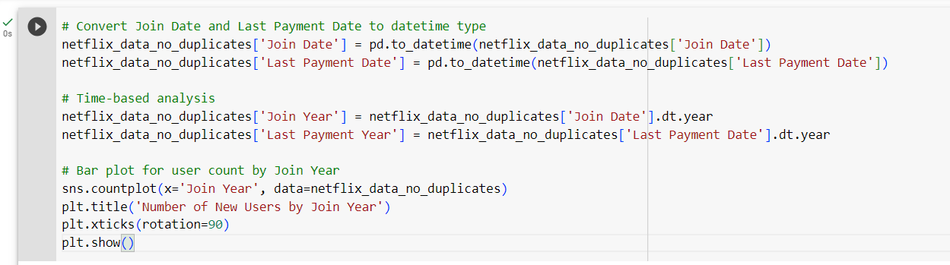

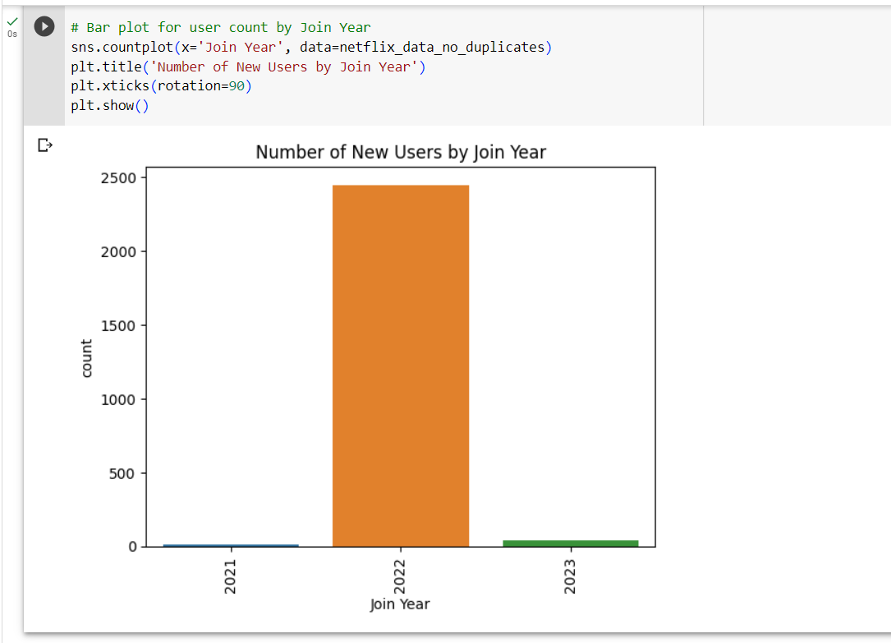

From the above graph we can say that many new users took subscriptions for Netflix in the year 2022.

5.Device Preferences
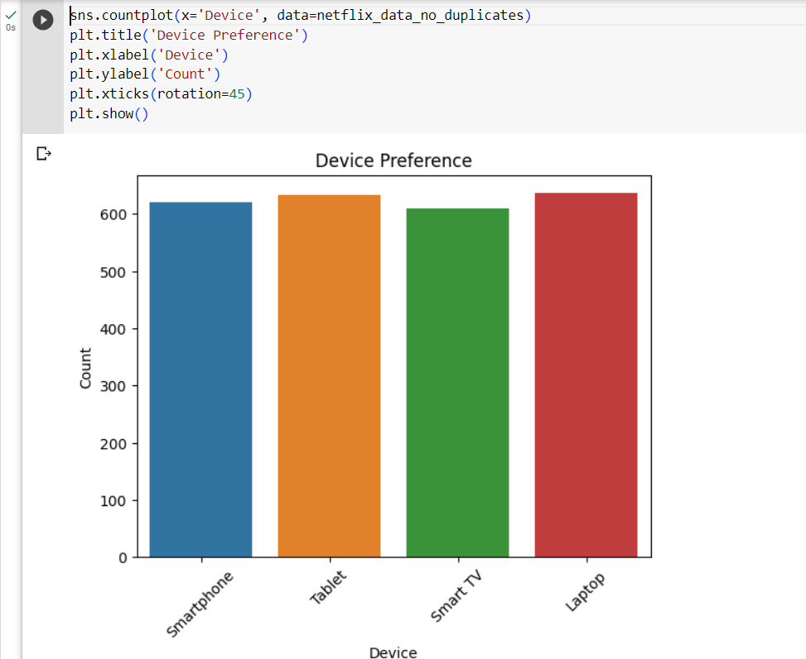

From the above graph we can say that people use almost all devices equally to watch Netflix.

Hypothesis
1. Which Country contributes the highest percentage of revenue to Netflix? What kind of subscription type is more famous in that country, and which gender contributed more towards the monthly revenue in that country?
2. Which subscription type and which gender in that subscription type generate the most revenue? What is the percentage of monthly revenue from that Subscription type, and which gender took most of the subscription, causing that leading revenue?
3. Which age group of people has the most subscriptions? What kind of subscription type is more common in that age group, and which country has the highest subscriptions in that Age group?
Graph-breakthrough-Result

Hypothesis 1
Packed Bubbles
Data is displayed as a series of circles or bubbles using the data visualization technique known as "Packed Bubbles" in Tableau. The size of each bubble represents a different measure.
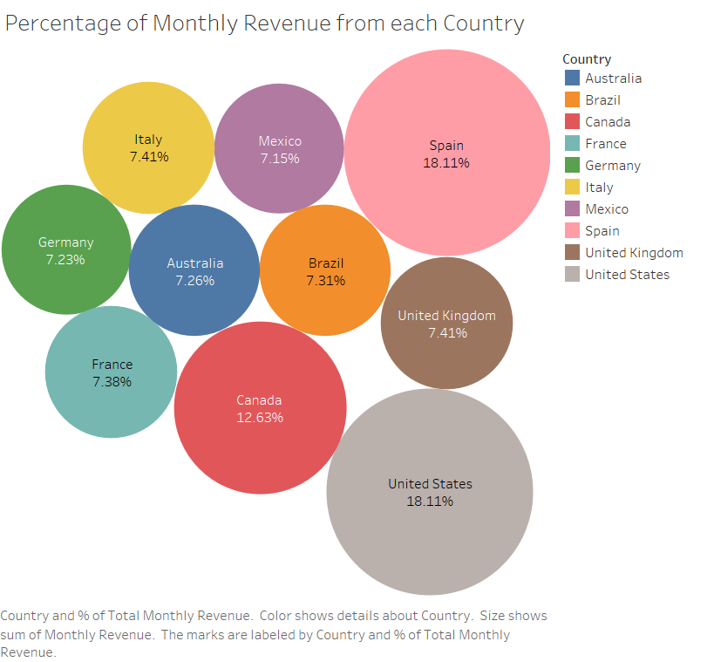
The above visualization is achieved by placing monthly revenue in the size marks , Country in the label ,color and also monthly revenue in the label and then changing the quick table calculation to percent of total.

Result:
The above visualization depicts the percentage of monthly revenue in each country for Netflix. From the visualization we can understand that United states and Spain contribute equally towards the monthly revenue for the Netflix.

Stacked Bars
Stacked bars are used to illustrate and compare the distribution of categories inside a single measure. A stacked bar chart divides each bar into segments or stacks, each of which represents a category and whose height denotes the value of that category's contribution to the overall measure.

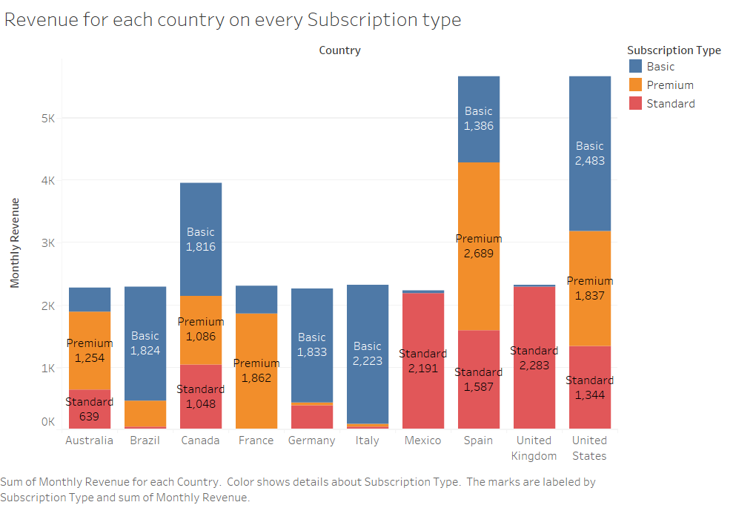
The above graph is achieved by placing Country in the column, Monthly Revenue in the row, Subscription type in the color and label and Monthly Revenue in the label.
Result:
The above graph depicts the Revenue for each country for every subscription type. From the Graph we can conclude that In Spain the highest monthly revenue is from Premium Subscription type and in United states the highest monthly revenue is from Basic subscription type.

Heat Maps
Heat maps are useful tools for data visualization that employ color gradients to show a measure's magnitude. Users can rapidly spot patterns, trends, and areas of concentration in massive datasets using heat maps. They are frequently used to visualize correlations, geographical distributions, and data density and are particularly useful when working with two-dimensional data.
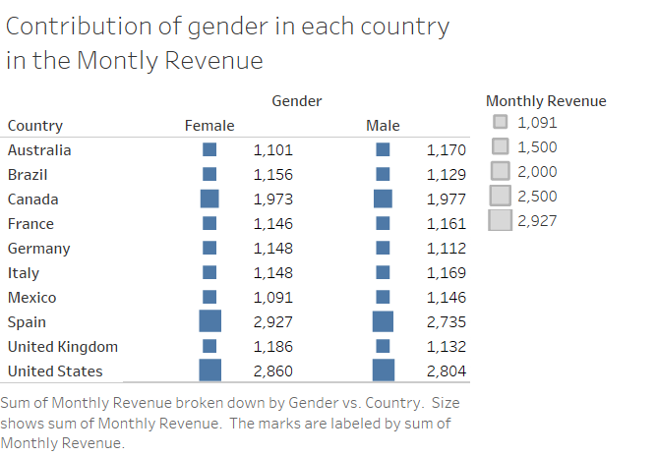

The above heat map is achieved by placing Gender in column, Country in Row and Sum of Monthly Revenue in Size mark and in Label.
Result:
From the above heat map, we can conclude that, Female contributed more towards Monthly revenue in both Spain and United States.

Hypothesis 2
Stacked Bars

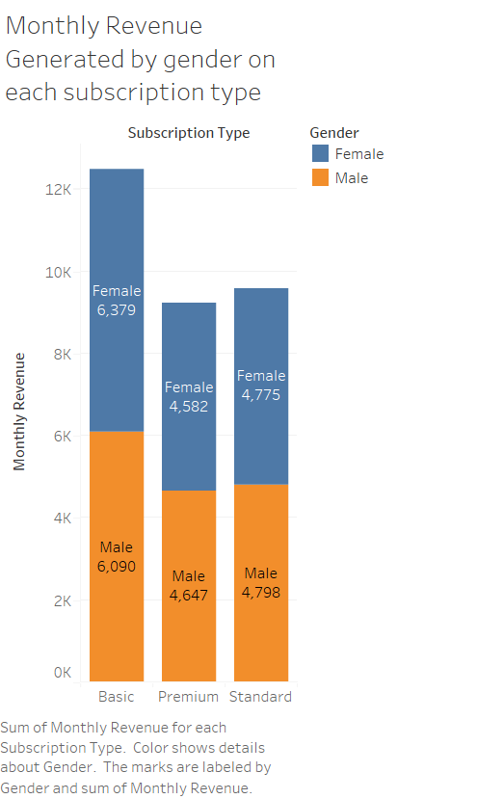

The above graph is achieved by placing the subscription Type in the columns, Sum of Monthly Revenue in the Rows and label and Gender in the color and label.
Result:
From the above graph we can conclude that the Basic Subscription type and Female gender in that subscription type generates the more revenue to the Netflix.

Tree Map
A style of data visualization called a tree map shows hierarchical data as nested rectangles, with the size of each rectangle denoting a numerical value. Using tree maps, we can see how values are distributed proportionately at each level of the hierarchy and depict hierarchical systems.

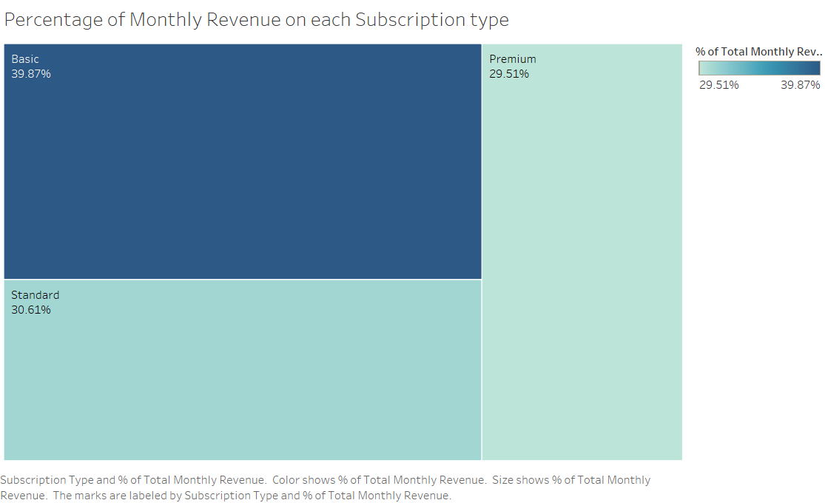
The above tree map is achieved by placing Sum of Monthly Revenue in the Marks like size, color, label and changing the quick table calculation to percent of total in each of these marks and by placing Subscription type in the label.

Result:
From the above graph we can say that 39.87% of Monthly Revenue is generated from Basic Subscription type.

Bar Graph
A bar graph is a popular data visualization approach that uses rectangular bars to display categorical data. The length of each bar, represents a distinct category, reflects the value of a quantitative measure related to that category. For comparing the magnitudes of several categories and spotting patterns and trends in the data, bar graphs are frequently utilized.

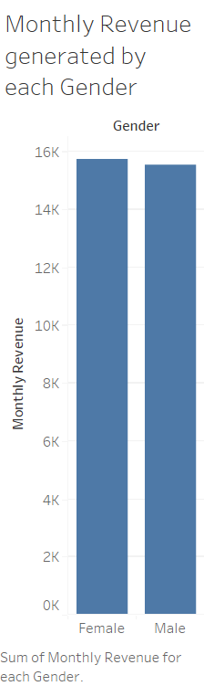
The above graph is achieved by placing Gender in the columns and sum of Monthly Revenue in the Rows.
Result:
From the above graph we can conclude that both Male and Female contributed almost same towards the Monthly Revenue but Females contributed a little more than Male in the Monthly Revenue.

Hypothesis 3
Pie Chart
Pie charts are circular data visualizations that show categorical data as slices of a pie, each indicating the percentage of a certain category in the overall dataset. Each slice's thickness varies in direct proportion to the share of the total that each category makes up. Pie charts are frequently used to demonstrate the part-to-whole connection and the distribution of an individual categorical variable.
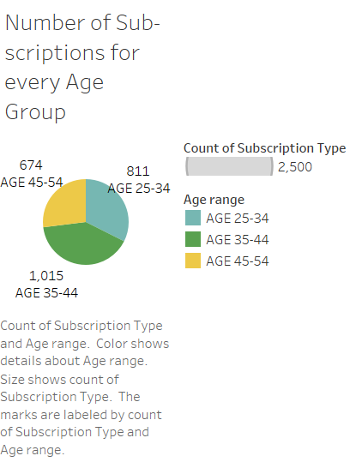
The above graph is achieved by creating the Age Range attribute by creating the calculated field from the Age attribute.
The formula used to generate the Age range attribute is:
IF [Age] >= 18 AND [Age]< 25 THEN "AGE 18-24"
ELSEIF [Age] >= 25 AND [Age] < 35 THEN "AGE 25-34"
ELSEIF [Age] >= 35 AND [Age] < 45 THEN "AGE 35-44"
ELSEIF [Age] >= 45 AND [Age] <55 THEN "AGE 45-54"
ELSE "55+"
END
The pie chart is achieved by placing the Age range in color, label and Subscription Type in marks like Angle, size, label.
Result:
From the above pie chart, we can conclude that there are a greater number of subscriptions between the age of 35-44.

Bar chart
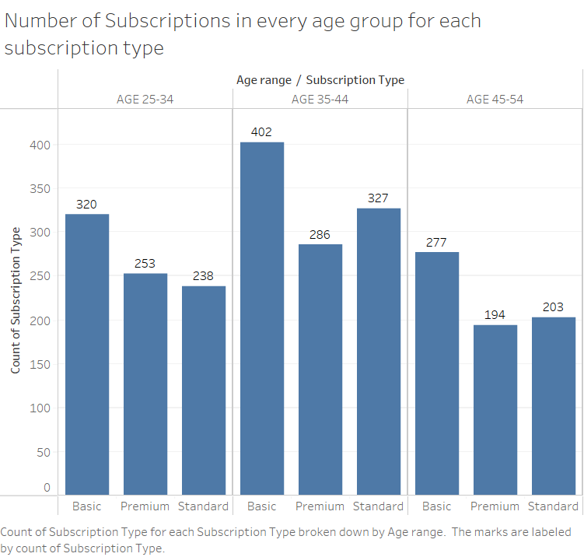

The above graph is achieved by placing Age range and Subscription type in columns and Count of Subscription Type in the rows and in the label.
Result:
From the above graph we can say that the Basic type of subscription is more common in the age group between 35-44.

Bar graph

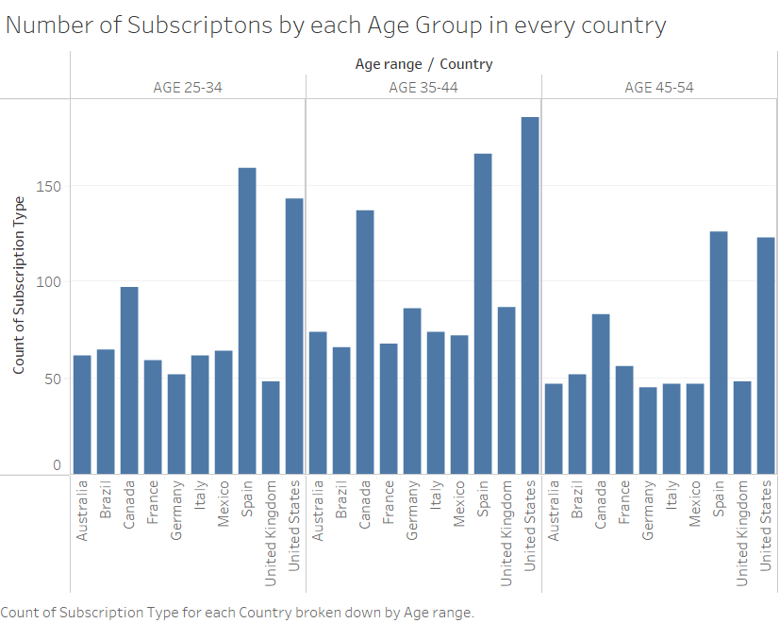
The above graph is achieved by placing the Age range and Country in the Columns and Count of Subscription Type in the Rows.
Result:
From the above graph we can conclude that the more number of Subscribers are from United states in the age range of 35-44

Discussions
United states and Spain contribute equally towards the monthly revenue for the Netflix.
In Spain the highest monthly revenue is from Premium Subscription type and in United states the highest monthly revenue is from Basic subscription type.
Female contributed more towards Monthly revenue in both Spain and United States.
Basic Subscription type and Female gender in that subscription type generates the more revenue to the Netflix.
39.87% of Monthly Revenue is generated from Basic Subscription type.
There are a greater number of subscriptions between the age of 35-44.
Basic type of subscription is more common in the age group between 35-44.
The greater number of Subscribers are from United states in the age range of 35-44.

Conclusion:
In this project we have analyzed the Revenue Contributions, Subscription Types, Gender-based Revenue, Optimal Subscription Type, Revenue distributions, Age Group Preferences, Country wise Analysis. These insights from the analysis like user behavior, Preferences and Revenue generation Patterns are very valuable. To improve user experience and revenue development, Netflix may utilize this information to make wise decisions about content selection, marketing tactics, subscription offers, and customer engagement. Additionally, by having a thorough awareness of the unique preferences of various populations in various countries, Netflix will be able to successfully customize its services to match the various demands of its international audience.

References:
https://www.statista.com/topics/842/netflix/#topicOverview
https://financesonline.com/number-of-netflix-subscribers/
https://en.wikipedia.org/wiki/Netflix

