Non – Programing Classe_01:

1) What is OS and why do we need that?
- An Operating System (OS) is an interface between a computer user and computer hardware. An operating system is a software which performs all the basic tasks like file management, memory management, process management, handling input and output, and controlling peripheral devices such as disk drives and printers.
- OS is the first application which gets loaded into the RAM.

2) What is Programming Language and why do we need any programming Language?
- A programming language is a computer language that is used by programmers (developers) to communicate with computers. It is a set of instructions written in any specific language ( C, C++, Java, Python) to perform a specific task.
- Its is software (Translator) between human laungauge and machince laungauge, which helps to interact with machince.

- The programing language enables us to write efficient programs and develop online solutions such as- mobile applications, web applications, and games, etc.
- Programming is used to automate, maintain, assemble, measure and interpret the processing of the data and information

3) Type of Programming Languages

- High Level : High-level programming languages mean that languages of writing computer instructions in a way that is easily understandable and close to human language. High-level languages are created by developers so that programmers don’t need to know highly difficult low level/machine language. (ex : C, C++, Java and python etc....)

- Low level : low-level-programming languages are complex to learn because it is associated with machine language which every instruction we pass will be in binary format like 0 or 1 (Hardware).

- Problems in Low Level PL
- More closer towards system and less closer towards user.
- Need to know the underlying architecture of the system on which you are coding.
- Management of existing code is not easy n Low Level PL.
- As a programmer we need to manage the memory explicitly.
- Code is not portable(we can not move the code from one platfomr to another)
- Not expressive

Why Python ?
- Python enables quick improvement and can interface with high-performance algorithms written in Fortran or C. IT's also commonly used in data mining, web development, scientific computing, and more.

Source code - The code which we write is called source code or Code written by a programmer in a high-level language and readable by people but not computers.

Byte code - This created after compiling the source code or Bytecode is program code that has been compiled from source code into low-level code designed for a software interpreter. It may be executed by a virtual machine (such as a PVM) or further compiled into machine code, which is recognized by the processor. (Wen you follow the rule for writting syntex, Then bite code will gererate irespective of if you asking somthing whic is not defined in program script – Bite code depends on completly on laungauge syntex )

Machine code - This created after interpreting the byte code.- Binary code – 0&1
(a computer programming language consisting of binary or hexadecimal instructions which a computer can respond to directly.)
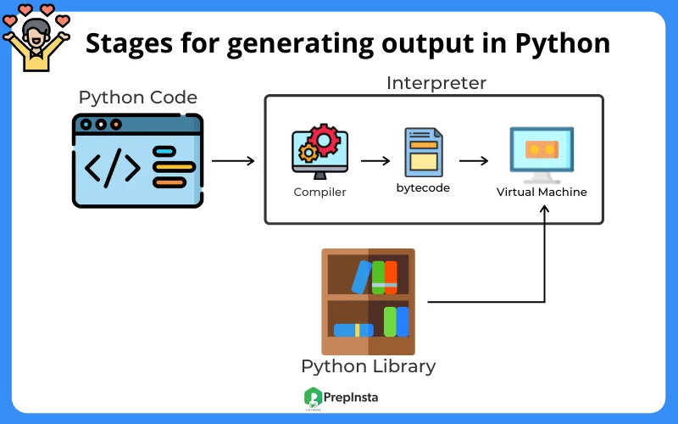

Both compiler and interpreters do the same job which is converting higher level programming language to machine code. However, a compiler will convert the code into machine code (create an exe) before program run. Interpreters convert code into machine code when the program is run.

Category of languages based on translators

Compiled Language - A compiled language is a programming language whose implementations are typically compilers, and not interpreters. (ex : C, C++, Java )
1. Compilation is an explicit process, First compilation happens and then we execute code.
2. Memory allocation and type checking - Compiler/ Compilation stage
3. Statically Typed - Specify the data type

Interpreted Langugae - An interpreted language is a programming language whose implementations execute instructions directly and freely, without previously compiling a program into machine-language instructions. (ex: Python, JS, Perl )
1. Compilation is an implicit process, we run the code directly.
2. Memory allocation and type checking - Interpreter/ Interpretation stage
3. Dynamically Typed - No need to specify the data type
The main difference between interpreted and compiled language is that an interpreted language converts the source code into machine code line by line while a compiled language converts the source code into machine code at once. Means in interpter once the byte code genrated by the compailer (implicit fn) than the code start to run (machine code converstion) line bye line
( easy debug) but in the compailer after genrating byte code or intermediate code the code start to excecute completetly we can interrept.

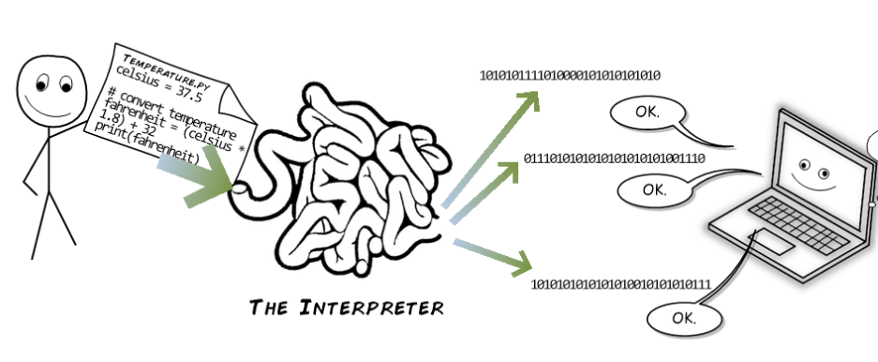

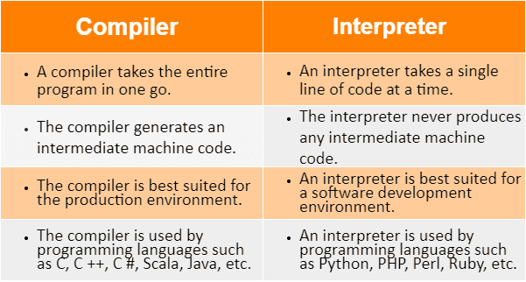

Type of Errors in Python

1. Compile time Errors : that occur when you violate the rules of writing syntax are known as Compile-Time errors. This compiler error indicates something that must be fixed before the code can be compiled. All these errors are detected by the compiler and thus are known as compile-time errors.
- Missing Parenthesis (}), semicolon (terminator) or Indenmtation.
- Printing the value of variable without declaring it
1. Compilation - It check only for compile time Error.
2. If any run time error in your source code then it will not throw any exception.
3. If any compile time error in your source code then byte code will not be created.
4. If any run time error in your source code then also byte code will be created.
5. if no compile time error in your source code then byte code will be created.
2. Run time Error - which occur during program execution(run-time) after successful compilation are called run-time errors. (ex : NameError, ValueError, TypeError etc – Interpretation )

1. Interpretation - It checks only run time error.
2. If any run time error in your byte code then it will partially execute the code.

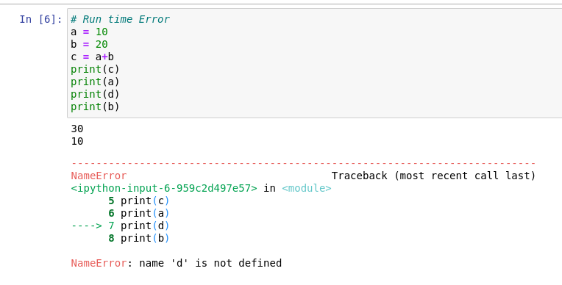
In the above figure bite code is got generated because of syntex is correct but we found run time time error bcoz we asking to print the “d” value, Whic is not defined priviously any where in the above script. So thats reason program got exicuted till the line numbre -6.

Portable PL - We can say, it is a hardware independent language or platform independent language
- If source code can be moved from one platform to another.
- C, C++ Java, Python all HLPL are portable
- Low level PL are not portable

Platform Independent PL
- If intermediate code (Bite code) can be moved from one platform to another.
- Java, Python platfomr independent
- C, C++ are not platfomr independent

Features of Python
1. Python is simple, easy to understand and expressive language.
2. Python is Free and open source (Source code is freely available for evereyone and you felxibility to modifie as per your requirement)
3. Python is general purpose PL.
- Desktop
- Web
- AI/ML
- Embedded or IoT
- Testing or Automation
- Data Analysis
4. Python is portable and platform independent both.
5. Python extensible and embedded.
6. Huge Community Support.
5. Python is dynamically typed Programming language.

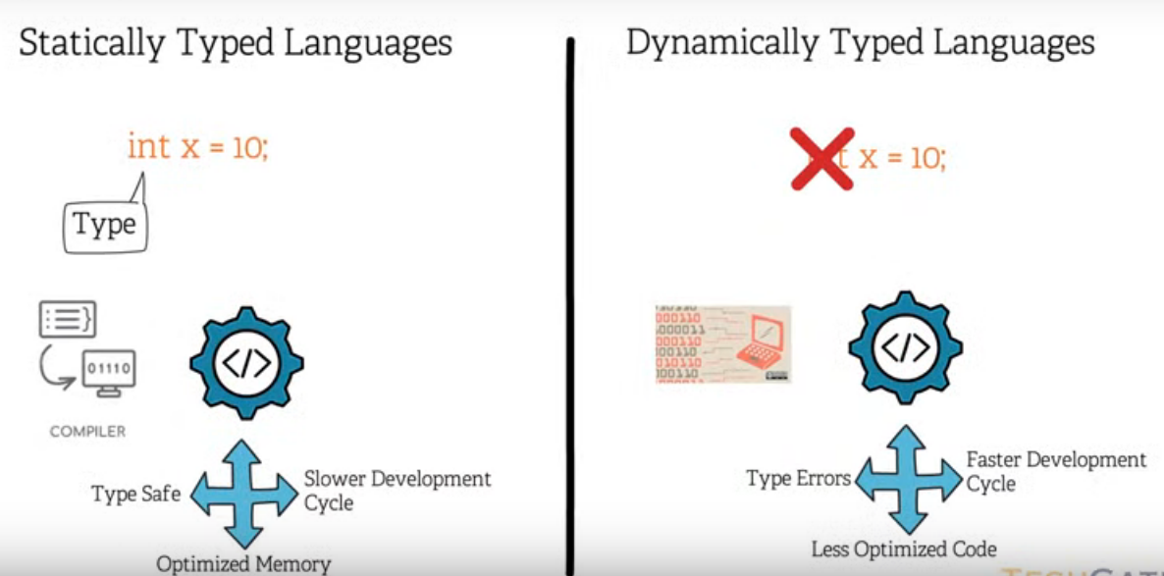
In Statically typed PL data type is defined for the variable, In other words the variable can only store the the data which is predifined by the programer (ex: int a = it can store only int value here ).
In dynamically data type PL is not defined so its be use to store any type of data.

Memory Management in Python - Automatic

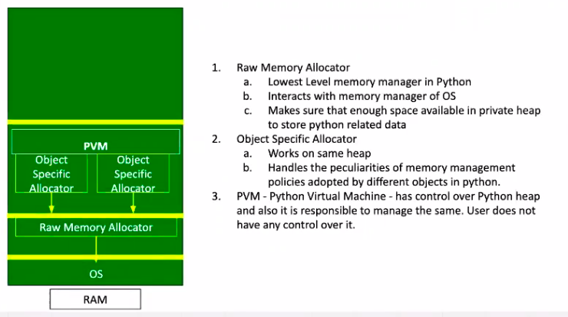
You can begin by thinking of a computer’s memory as an empty book intended for short stories. There’s nothing written on the pages yet. Eventually, different authors will come along. Each author wants some space to write their story in.

The authors are like different applications or processes that need to store data in memory. The manager, who decides where the authors can write in the book, plays the role of a memory manager of sorts. The person who removed the old stories to make room for new ones is a garbage collector.

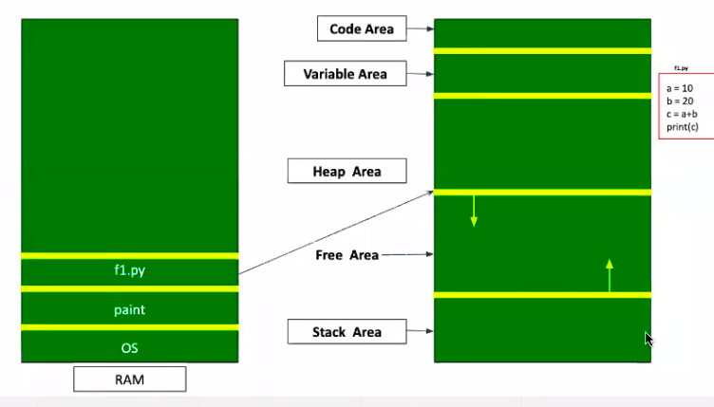
In the above figure we can see different applications are loaded in RAM, First one will be OS and second one may any other application and like the same next one is python file, Everey python application is devided into 4 areas, They are “code area”, “variable area”, Heap area” and “stack area.

Code area : This memory is used to write a scource code.
Variable area : This memory used by programming languages to store global variables.
(ex : a = or b = )
Heap area : What ever the data we using in the python programe that is used to store here and this area is maneged by PVM (ex : 10, 20.5, “hello” )
Stack area : Different functions order (Which line of code need to run first )and local refrences are saved here.
Free space : This area going to use as per the requiarement.
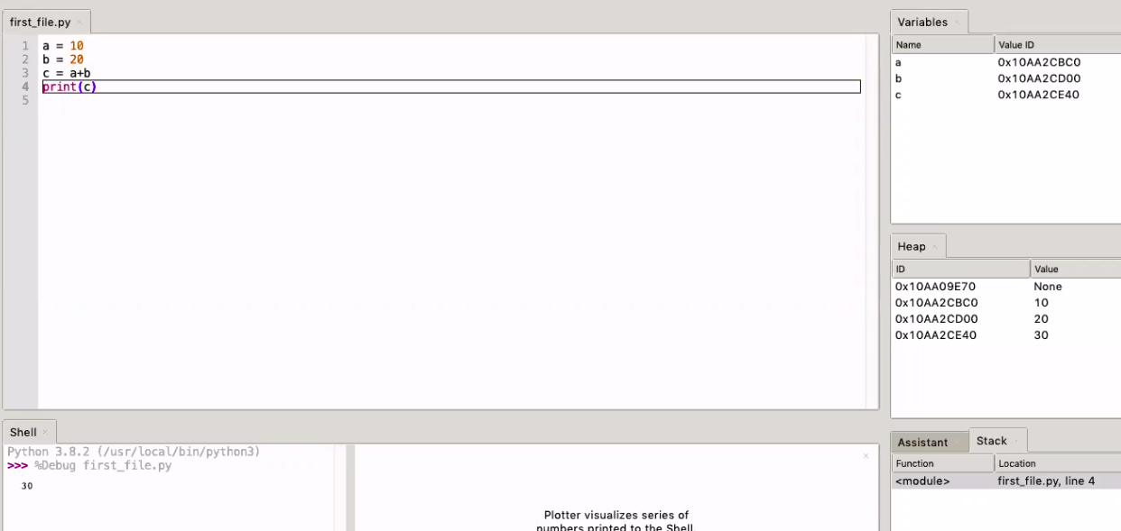

Memory Deallocation : Garbage Collection (GC) is process of reclaiming the runtime unused memory automatically. In other words, it is a way to destroy the unused objects. The GC model works based on the refrence count, When the refrence count rech zero that object will delete from the heap area, In other words For example when the value 10 is stored in the particular momery and different variables are taged to that memory address (a =10, b=10), If we delete the variable a or if we assign new value to “a” , Now the refrence count for value 10 is 1 bcoz still variable “b” is taged with value 10 . When the refrence count reach zero , It will make the GC model will delete the value 10 from the heap area.

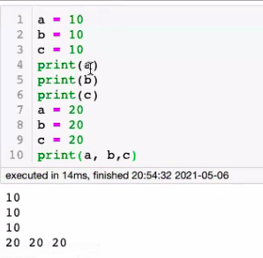
In the figure, We can see intially value 10 is assigned
for variable a,b and c , Later the for the same variable
value 20 is assigned, So now the value 10 is taken by
GC model.

Literals - can be defined as any value in Python.
- int -> 10, -10, 0
- float -> 10.20, -10.20, 0.0001
- complex -> 10+20j, 10-20j
- string -> ' A', "Pytohon", '''Hello World''', """Hello World""", “1245”
- None, True, False,etc.....

Constants, Variable and Identifier
- Constants and Variables are sub set of Identifier.
- Identifier - A Python identifier is a name used to identify a variable, function, class, module or other object.
Rules:-
1. The allowed characters A-Z, a-z, 0-9, _
2. Not allowed characters - Special Characters. (except _ underscore)
3. Identifiers should not start with a number. (ex: 5a = 10)
4. Identifiers are case sensitive. (Upper case and lower case)
5. Reserved words should not be used as an identifier. (ex: if, while,for,else,etc..)
6. Constant should have alphabets and only upper case (juts for our understanding)
7. Class Name should follow pascal notation. (ex: userDefinedClass – word first letter lower case and from next word first letter will be must upper case.)
8. You should not define any name which starts and ends with __. (ex: _name_ bcoz the used define buit in funtions )

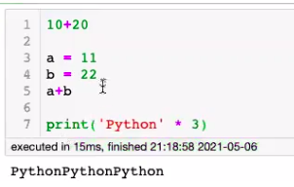
Statements and Expression

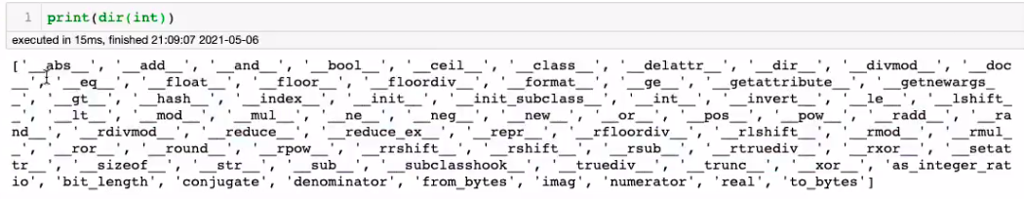
- Expression - group of variables, operators and
values which gives some result.
- A single litral is a simplest expresssion
(ex : 5 ---> o/p 5)

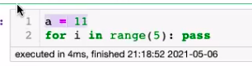
- Statements - group of variables, operators
and values which does not give any result.
If we write statements in print functions we get error.

Git & Git hub installation.

Git : Git is software for tracking changes in any set of files, usually used for coordinating work among programmers collaboratively developing source code during software development.
- Version control tool and its installed in personal loca devices. (laptop or desktop)
- Its act a Local reposiritorary whic is get saved in your local storage.
- It is a DVCS – Distribution version control system.
- Its will help us perform all kind of operation to fetch data from the centeral server (Github) or to push data into it.

Github : is a provider of Internet hosting for software development and version control using Git.
- Its act as a Global repository.
- Its is CVCS : its act as a centerla version controle system.

Installation & Account:
- Install Git into local pc.
- Creat a account in Github.com

In commond line -> Open Git bash for windows and Terminal for linu and mac.

* Type.
- git -> To check the useage.
- git –version --> to check the git installed version.
- git help --> all help
- git help <commomd> --> specific commond help.
- git config --list --> for to check the configuration.

Process to confi intialy.
- git config --global user.name <”name”> (as per git is githu is preferd )
- git config -- global user.email <email id>
- git confir -- list --.> to check again (changes)

Local wroking directory – stateging – commiting (U saving inside git) – pushing to the colud repos (Now u saved with colud repos)

Strarting Git project.

Open the terminal
- pwd --> to check the present working directory
- ls --> list all folders from the current directory
- ls – la --> to list including hidden files.
- cd <directory name> --.> change directory
- pwd --> again check where you are now.
- mkdir <directory name> --> make working directory (to creat the folder )
- cd <directory name> --.> agin move inside created directory.
- git init --> to intialize git folder (converting normal folder to git folder)
- git status --> check the status (the changes which made)
- touch <file name> --> to creat files
- cat > <file name> --> edit in terminal only
- vim <file name> --> edit inside vim editer.
- git remote add origin <URL from github repository> --> connecting fit repo to remote serever (github)
- git remote -v --> to check does its connected with cloud (github).
- git add . (dot) --> add all files to staging area in one shot.
- git add <file name> --> add particular file.
- git add < *.py > --> add all files which have extenstion of py in a one shot.
- git status --> check status again.
- git branch --> check in which branch you area.
- git commint -m --> add a msg to before moving (without adding msg u cant move to github)
- git push -f origin master/main --> for to move all files to github server.
- Than ist will ask user name and password of github account.

Now you can refresh github URL and check the changes............

Literal :
any value we use in python is called literals, (ex: int, float, complex, string etc...)

Identifiers: The name of any variable, function, class, constant and module etc, Mean whic is use identifi or name the the data or function,

Keywords :
Keywords are the reserved words in Python. We cannot use a keyword as a variable name, function name or any other identifier. They are used to define the syntax and structure of the Python language. ... All the keywords except True , False and None are in lowercase and they must be written as they are.

Python Data Types
1. Fundamental – These are base for derived data types.
(ex: Integers, Float, Complex, Boolean, None, Strings
2. Derived - These are drived with help of fundamental data types
(ex; List, Tuple, Set, Frozenset, Dictionary, range.)

Integers - Any real number without a decimal point is called integer (e.g. 10, -10, 0)
a = 10
print (type(a)) - with help of this commond we check type of data.
o/p - < int >

Float - Any numbers with decimal point (ex: 10.20,0.0001, -10.20 )
- Only bitwise operator does not work with Float

Complex - Any number in the format a+bj
- where a is real part
- b is imaginary part
(10 + 20j)
10 is real
20 is imaginary

Boolean - used for creating true/false statements (ex: True, False )
- True == 1
- False == 0

String - Any value kept inside ('...', "...",'''...''',"""...""") (sinle double and tripple quote)

a = "This is Python's class"
a = 'This is "Python" class'
a = '''This is 'Python' "Java" Class'''

Derived Data Types

list - [10,10.20, 10+20j, 'Python']
Tuple - (10,10.20, 10+20j, 'Python')
Set - {10,10.20, 10+20j, 'Python'}
Dictionary - {1:100, 10.20:10+20j, 'a':'Python', True:None}
range - (start, stop, step) its is the difference between highest value and lowest value. The range by default start with zero and end valuse always defined value minus one and step the number of incerements.

Operations
- Arithmetic - +, -, *, /(Float Division), //(Floor Division), %(Modulo), **(Exponent)
- Comparison - ( <, <=, >, >= )
- Equality Operator - ( ==, != )
- Logical Operator - ( and, or, not )
- Bitwise Operators - ( &, |, ^, ~, <<, >> )
- Membership - ( in, not in )
- Identity - ( is, is not )
- Assignment - ( = )
- Compound Assignment - ( +=, -=, *=, /=, //=, %=, **=, &=,|=, ^=, ~=, <<=, >>= )
- Ternary Operator - ( expr1 if cond else expr2 )

Arithmetic - ( +, -, *, /(Float Division), //(Floor Division), %(Modulo), **(Exponent) )

- print(10+20) – adding value
- print(100-20) - substract
- print(10*20) – multification
- print(10 ** 3) # 10 raised to the power 3
- print(10 % 3) # % operator gives the remainder after division
- o/p – 1 (For the above example )
- / - Float Division - Returns Float values after division.
- Print(10/3) - ( o/p – 3.333333 ) or
- print(25/5) – (o/p – 5.0 ) The ourput value will be in float data type.
- // - Floor Division - Returns Floor values after division
- print(10//3) – ( o/p – 3 ) It will consider only left side value as a o/p ex: 5.85 – o/p is 5

Comparison - <, <=, >, >=
- These operators returns boolean values - True or False
- These operators does not work between instances of different type except int and float
- These operators does not work with instances of complex type

- print(10<20) – True or print(10<10.20) - True
- print(10 < 10+20j) - # TypeError: '<' not supported between instances of 'int' and 'complex'
- print((10+20j) < (5+5j)) # TypeError: '<' not supported between instances of 'complex' and 'complex'
- print('A' <= 65) # TypeError: '<=' not supported between instances of 'str' and 'int'

- print('ABC' < 'abc') - True # It will comapre with considering the refernce of Ascii table.
- print('abc' < 'ABC') - False
- print('ABc' < 'ABC') - False
- print('AGK' < 'BFL') – True # It will start from fisrt letter

Equality Operator - ( ==, != )
- These operators also returns Boolean Value -
- It compares whether both the operands are having same content
- This operator works on any data types

- print(10 == 10) - True or print(10 != 10) - False (Here we using not equal to symbol)

- print('A' == 65) - False
- print(ord('A') == 65) - True # ord('A') # returns ASCII value
- print(65 == int('65')) – True
- print(ord('A')) - 65

Combination of operator
- print((10**3 < 100*100) == (10==10)) - True
- print((10 * 20) +100) – o/p 300
- print((10+20) * 100) – o/p 3000

Equalirty Operator - ==, !=
- Also returns Boolean values - True and False
- This operatir compares the content
- This operator works between instances of different type

# a = 10
# b = 10
# print(a == b)
# print(a != b)

a = 65
# b = 'A'
# print(a == b)
# print(a == ord(b))

- ord('char') -> Returns the corresponding code point from ASCII Table
- print(ord('z'))

- chr(asccii code point) -> Coresponding chracters
- print(chr(97)) - o/p ==> a (In ascii table on 97 index we can find alphabt “a”)
- print(chr(61)) o/p ==> =

Logical Operator - and, or, not
- Also returns Boolean Value - True False
- These operators works with Logic
- Logic eventually will be evaluated either as True or False

and Truth Table - False
- True and True = True
- True and False = False
- False and True = False
- False and False = False

or Truth Table – True
- True or True = True
- True or False = True
- False or True = True
- False or False = False

Not Truth Tabel
- not True = False
- not False = True

# year = int(input('Enter an year: '))
# if ((year%400 == 0) or (year%4 == 0 and year%100 != 0)):
# print('Year is Leap Year')
# else:
# print('Year is not a leap Year')

- year = 1600 => (True or (True and False)) => (True or False) => True => 'Year is Leap Year'
- year = 1800 => (False or (True and False)) => (False or False) => False => 'Year is not a Leap Year'
- year = 2004 => (False or (True and True)) => (False or True) => True => 'Year is Leap Year'
- year = 1967 => (False or (False and True)) => (False or False) => False => 'Year is not a Leap Year'

A and B are some data
- A and B => Result is A if A is False else result is B
- A or B => Result is A if A is True else result is B

- Int = Apart from 0 everything is True
- Float = Apart from 0.0 everything is True
- Complex = 0.0+0.0j everything is true
- String = '' is aleays False rest all True
- list, tuple, set, dict = [], (), set(), dict() = False rest all True
- print(bool([]))
- print(bool(''))
- print(bool(0))
- print(bool(0.0+0.0j))

- print(bool(0.1))
- print(bool(0.1j))

print(10 and 20) --> 20
print(10 and 0) --> 0
print(0 and 20) --> 0
print(0 and 0.0) --> 0

print(10 or 20) --> 10
print(10 or 0) --> 10
print(0 or 20) --> 20
print(0 or 0.0) --> 0.0

Bitwise operator : & | ^ ~ << >>
- They work on bits 1 and 0
- Only integer values can be represented in bits.
- Bitwise operators work wonly with integer data types.
- 1 is true and 0 is false
- In the bitwise operator defined int value first converted in boolan value in the form of
(0 and 1) the according bitwise sign the calculation is performed.

OPERATOR | DESCRIPTION | SYNTAX
~ | Bitwise NOT | ~x
^ | Bitwise XOR | x ^ y
>> | Bitwise right shift | x>>
<< | Bitwise left shift | x<<

& Truthe Table
- 0 & 0 = 0
- 0 & 1 = 0
- 1 & 0 = 0
- 1 & 1 = 1

| Truthe Table
- 0 | 0 = 0
- 0 | 1 = 1
- 1 | 0 = 1
- 1 | 1 = 1

^ Truthe Table (Bitwise XOR)
- 0 ^ 0 = 0
- 0 ^ 1 = 1
- 1 ^ 0 = 1
- 1 ^ 1 = 0

10 => 01010
20 => 10100
===========
& => 00000

print(0b00000)
print(10&20) ---> 0

print(36 & 37) --> 37

36 => 100100
37 => 100101
=============
& => 100100

print(0b100100) --> 37

print(36 | 37)

print(36 ^ 37)
print(0b1)

Bitwise Negation - ~
- ~num = -(num+1)
- print(~9)
- print(~-8)

Left shift operation - <<
- print(37 << 3) --> 296 #Formula : 37 * (2**3)
- print(37 * (2**3)) --> 296

Right shift operation - >>
- print(37 >> 3) --> 4 # => 37 // (2**3)
- print(37 // (2**3)) --> 4

Compound Assignment Operator -> +=, -=, *=, /=, //=, %=, **=, &=, |=, ^=, ~=, <<=, >>=
a = 12
print(a)

a += 5 (Means a = a+5 this we writing in short form by using compound assignment Operator)
print(a) --> 17

a &= 2 # a = a*2
print(a) --> 0

print(12 & 2) --> 0

Membership Operator => Works with iterable -> in, not in (in -is there, not in -is not there)
- Whether an given element is part of the iterable (Any object which implements __iter__())
- This operator return boolean vaue.

- my_str = 'This is python class'
- my_lst = [1,2,3,4,4]
- my_tpl = (1,2,3,4,5)
- my_dict = {1:100, 2:200, 3:300, 4:400}
- print(dir(my_dict))
- print('i' in my_str)
- print('i' not in my_str)
- print('is' not in my_str)
- print('is' in my_str)
- print('This is' in my_str)
- print('pn' in my_str)

print('2' in 'Python2.7.8') ---------------------> True
print("Hell" in ["Hello", 25]) ------------------>False (Bcoz in the lst the complet word “hello” in the same 0 index so its comapre with complete)

print(“a” in “abcd”) -----.> True (bcoz here the letter only a in zero index not compelt word)
print(10 in [10,10.20,10+20j,"python"]) ---------------------> True
print(10 in (10,10.20,10+20j,"python")) ---------------------> True
print(2 in {1,2,3}) ---------------------> True
print(3 in {1:100, 2:200, 3:300})---------------------> True
print(10 in range(20)) ---------------------> True

- In dictonary it checks only for keys
- print(1 in my_dict)
- print(100 in my_dict)

Identity operator - is, is not
- It compares the memory address
- is operator returns True if memory address of two objects are same else returns False and 'is not' vice versa

a = 10
b = 10
print(a is b) - True
print(id(a)) - 004525
print(id(b)) - 004525

a = 'Python'
b = 'Python'
print(a is b) -- True
print(id(a)) -- 112288
print(id(b)) –112288

Integer caching
- -5 TO 256 preloaded into memory
- Internally python maintaibns a reference count for each object

from sys import getrefcount
print(getrefcount(10))
a = 10
b = 10
print(getrefcount(10))

String interning
Few value - A-Z, a-z, 0-9, _ preloaded into the memory

Ternary Operator -> expr1 if cond else expr2
-> expr1 if cond1 else expr2 if cond2 else expr3 if cond3 else expr4

a = 10
b = 9
a+b if a<b else a-b

a = 100
b = 10
c = 1000
a if (a>b and a>c) else b if (b>c) else c

Strings : A string in Python is a sequence of characters. It is a derived data type. Strings are immutable. This means that once defined, they cannot be changed.
- Anything that is kept inside '...', "...", '''...''', """...""".
- What is the significance of different quotation in string.
- String is a sequence.
- String Follows +ve and -ve indexing both.
- +ve index starts from 0 from ands with end lenth of string -1 from LHS.
- Negative index starts from -1 from ends with -lenght string RHS.
- Basic Operation - Indexing, Slicing, Concatenation, Repetition, (Membership, len) – Iterable.
- Iterable : If any object in sequence it is an iterrable.

String interning :
When we start python application by default it will store some valse or data in the preloaded memory.
Ex: A-Z, a-z & 0-1
So this is the reason we can see more refrence count for the particular object.

- String is immutable (We cant modifie, If we modifie also the new changes also get save with new memoy address)
- Methods iside a string.

import sys
print(sys.getrefcount(‘python’) ------>10

The usning above code we can find the refrence count for the particular object.

Use case 1
my_str = 'This is Python's class' ---> Error
my_str = 'This is Python\'s class' ---> This is Python's class
(The given string is define in a single clone and we using clone inside a sring actully this will give an error bcoz py get confuse where the string got closed, So to avoid the erro we using an “escape” symbole “/” which will tell the python to escap the particular charecter,)
print(my_str)

my_str = "This is Python's class" (We can use doule clone to avoid the above same error, all there type clone give the same result but its diffre the how they will hadle the inside used special charecters)
my_str = "This is \"Python\" class" (escap symbole)
print(my_str) --> This is a python class.

my_str = "This is 'Python' class" (single clone by using double clone to define the string)
print(my_str) --> This is a python class.

my_str = 'This is "Python" class' (Vice versa as per the above comment)
print(my_str) --> This is a python class.

my_str = '''This is "Python" and 'Java' class'''
print(my_str)

print(‘This is python class in learnbay bangalore’)
print(‘Data science’)
o/p ---> This is python class in learnbay bangalore
Data science

In the above case the python will automatically understand the next line string need to print in new line, Means at the end of print function by defalut its have “\n”, Whic will helps python to undestand the next out put need print in new line. (Ex: print(‘Hello’,end=’\n’)

print(‘This is the python class at \n learnbay bangalore fot data science’)
O/P ----> This is the python class at
learnbay bangalore fot data science

In the above case “\n” is used between the string, So python will understand after the ‘\n’ the next charcrecter need print in the new line.

Use case 2
1. Single and Double quotations are used to define only single line string.
2. triple quotation can be used to write multi line strings.

my_str = “ “ “Lorem Ipsum is simply dummy text of the printing and typesetting industry. Lorem Ipsum has been the \ industrys standard dummy text ever since the 1500s, when an unknown printer took a galley of type and scrambled \ it to make a type specimen boo” “ “

# For to print the multi lines and to print RAW tring (as it is) without using any sprcial symbole.We can use the threple clone.
Alos we use thriple clon for to make comments in python like same as #.

“ “ “my_str = Lorem Ipsum is simply dummy text of the printing and typesetting industry. Lorem Ipsum has been the \ industrys standard dummy text ever since the 1500s, when an unknown printer took a galley of type and scrambled \ it to make a type specimen boo” ” ”

my_str = 'This \
is \
python \
class'
print(my_str)
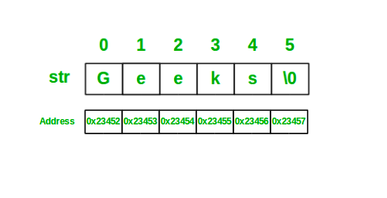
o/p --> This is python class

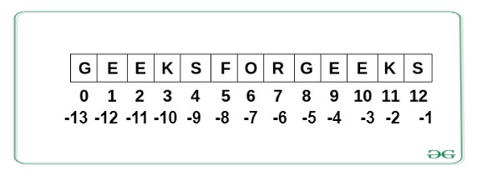

Memory allocation: In the above fig we can see the group of charecters are strored with single memory address and inside the it will create number of slots according to number of chrecters, The every slot will have a different memory addres.

my_str = 'This is Python class at Learnbay in Bangalore'
# Length of string
print(len(my_str)) --> 45

# Accessing first element
print(my_str[0]) --> T
print(my_str[-45]) --> T (from the RHS side we give complete high value whic is mlore the sring range index so it will give the last letter from RHS TO LHS without any error.)
print(my_str[-len(my_str)]) -->T

my_str = 'This is Python class at Learnbay in Bangalore'

# Accessing last element
print(my_str[-1]) --> e
print(my_str[44]) --> e
print(my_str[len(my_str)-1]) --> e
print(my_str[25]) --> e

Code to check refrence count in python
import sys
print(sys.getrefcount('Python Class'))

Slicing :
- Slicing in Python is a feature that enables accessing parts of sequences like strings, tuples, and lists.
- In the index variabl name [start value : end value : step size]
- if we metion -1 in step size u can find the reverse python.
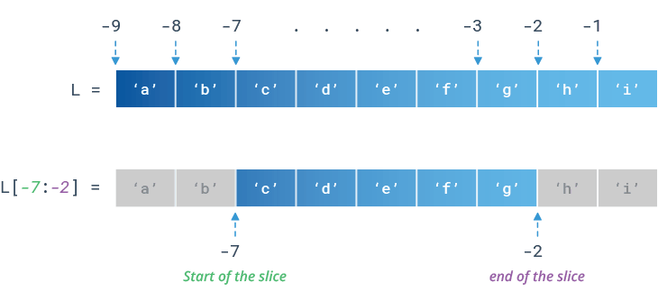

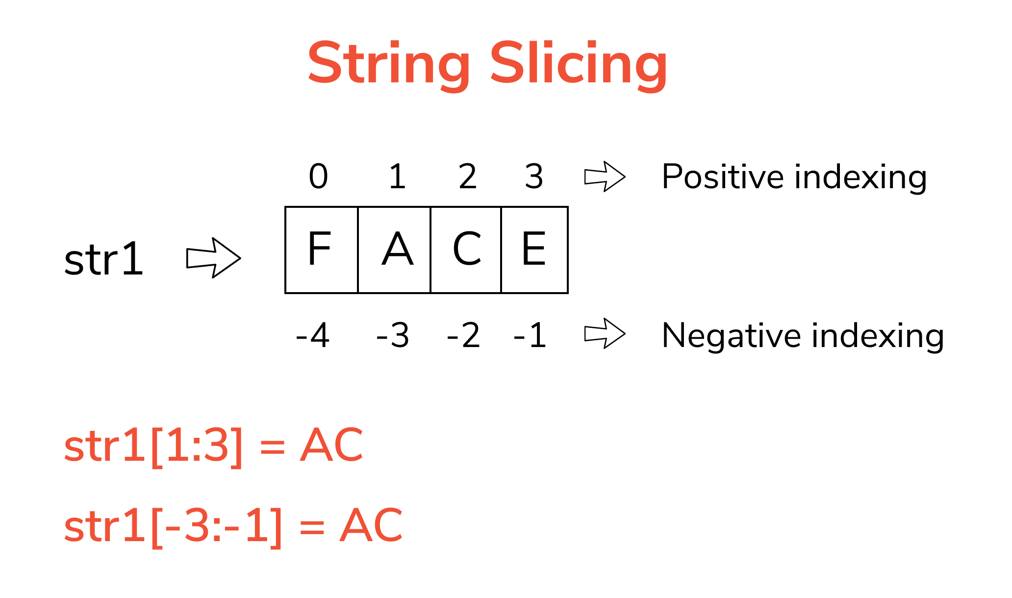
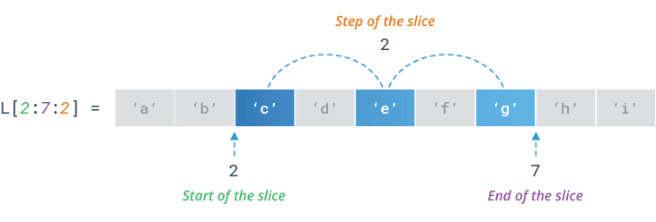

Slicing = my_str[start index : stop index-1:step]
+ve step (1) : Means it will try make step from RHS to LHS no matter what start and step value you given, Only its know that +ve 1 mean RHS to LHS.

-ve step (-1): it wil work from LHS to RHS.

my_str = 'This is Python class at Learnbay in Bangalore'
print(my_str[::1]) --> This is Python class at Learnbay in Bangalore
print(my_str[0:len(my_str):1]) ---> This is Python class at Learnbay in Bangalore
print(my_str[::-1]) --> erolagnaB ni yabnraeL ta ssalc nohtyP si sihT
print(my_str[-1:-len(my_str)-1:-1]) --> erolagnaB ni yabnraeL ta ssalc nohtyP si sihT

print(my_str[8:14:1]) --> Python
print(my_str[13:7:-1]) --> nohtyP

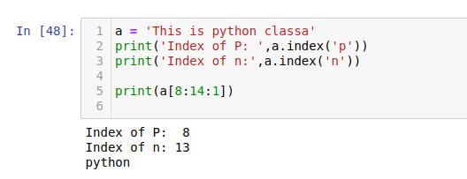
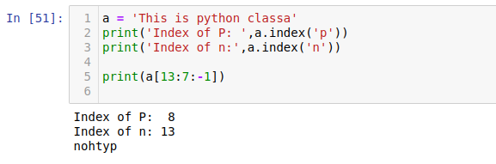
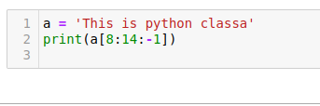

Here i am trying to revers the ‘python’ but i give start index for ‘p’ and stop index+1 for ‘n’ but step in -1. The o/p is empty bcoz -1 means from RHS to LHS, In the index start value is 8 means from ‘p’ but due to step -1 it will start from LHS to RHS (<------- ). indexing is different and step value is diffrent. Means making python to get confused.
If want make ‘nothyp’ means n will your first letter in the o/p so keep that index as your start value.

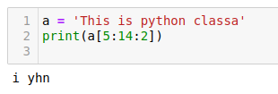

Whe the step is 2, You saying to pyhton from your present charecter plus (+) 2 steps, .Means print after that charecter after taking step.

Concatenation:
- Combine two strings
- It creates a new string object
- We use + operator
- For string concatenation - Both the objects should be string type

f_name = 'Learnbay'
l_name = '''Class'''
full_name = f_name + ' ' + l_name
print(f_name + 10) ---------> # TypeError: can only concatenate str (not "int") to str
print(f_name + '10') ---> Learnbay10 #int coverted into string,
print(f_name) --> Learnbay
print(l_name) --> Class
print(full_name) --> Learnbay class

Repetition operation
- It repeats a string (How many times you want see repeate the string )
- This operation also creates a new string bcoz is string is immutable.
- We use * operator
- For string Repetition - One of the operand should be string and other should be int
print((f_name + ' ') * 3) ---> Learnbay Learnbay Learnbay (string + space concatination) than repetation
print(f_name * 3.0) # TypeError: can't multiply sequence by non-int of type 'float'
print(f_name) ---> Learnbay
print((f_name * 3),l_name, sep = ' ') - ->LearnbayLearnbayLearnbay Class

Mutability vs Immutability

Mutable -> We can modify the object and changes will be done to the existing object, Allows Itemm Assignment => List, Dictionary
Immutable -> We can not modify the object, Does not allow Itemm Assignment => string, tuple

my_str = 'This is Python class at Learnbay in Bangalore'
print('Before Operation')
print(my_str, id(my_str)) -> This is Python class at Learnbay in Bangalore 139978534358832
print()
# my_str[8] = 'J' # TypeError: 'str' object does not support item assignment

new_str = my_str.replace('Python', 'Jython')
print('After Operation')
print(new_str, id(new_str)) --> This is Jython class at Learnbay in Bangalore 139978491177552
print(my_str,id(my_str)) --> This is Python class at Learnbay in Bangalore 139978534358832

- In the above example we can see the the string is immutable, When you modife the exisiting string its create a new id for that and we can use new variable to acess the modifed iterable (string) but the in mutable wen you modifie the iterable its will modifie the original one and its doesnt create a new id for that.
- Note:- In case of immutable objects got changed, They creat a new memory address location to srore the new changes.
- String.replace() : Will only work with string object not for any other derived data types.

my_lst = [10,20,30,40]
print('Before Operation')
print(my_lst, id(my_lst)) --> [10, 20, 30, 40] 139978491912128
my_lst[0] = 111 #same id
print('After Operation')
print(my_lst, id(my_lst)) --> [111, 20, 30, 40] 139978491912128

- we can the modification is happened with exisiting id only.

Two types of methods on any object
1. Magic method -> starts and ends with __ -> OOP
'__add__', '__class__', '__contains__', '__delattr__', '__dir__', '__doc__',
'__eq__', '__format__', '__ge__', '__getattribute__', '__getitem__', '__getnewargs__',
'__gt__', '__hash__', '__init__', '__init_subclass__', '__iter__', '__le__', '__len__',
'__lt__', '__mod__', '__mul__', '__ne__', '__new__', '__reduce__', '__reduce_ex__',
'__repr__', '__rmod__', '__rmul__', '__setattr__', '__sizeof__', '__str__', '__subclasshook__',
2. Normal method -> To manipulate the object (string)
'center', 'count', 'encode', 'endswith', 'expandtabs', 'find',
'format', 'format_map', 'index', 'isalnum', 'isalpha', 'isascii', 'isdecimal', 'isdigit',
'isidentifier', 'islower', 'isnumeric', 'isprintable', 'isspace', 'istitle', 'isupper',
'join', 'ljust', 'lstrip', 'maketrans', 'partition', 'replace', 'rfind', 'rindex',
'rjust', 'rpartition', 'rsplit', 'rstrip', 'split', 'splitlines', 'startswith', 'strip',
'translate', 'zfill'

print(dir(str)) ----To check the directorey of strig.

# Methods used to change the case of strings
# Capitalize, title, upper, lower, casefold, swapcase

my_str = 'this is Python class at Learnbay in Bangalore'

# capitalize - Capitalizes first letter of the string, rest all will be converted to small case
print(my_str.capitalize()) --> This is Python class at Learnbay in Bangalore

# title - Capitalizes first letter of each word in the string
print(my_str.title()) ---> This Is Python Class At Learnbay In Bangalore

# upper - It converts all letters in upper case
print(my_str.upper()) --> THIS IS PYTHON CLASS AT LEARNBAY IN BANGALORE

# lower - It converts all letters in lower case
print(my_str.lower()) --> this is python class at learnbay in bangalore

# casefold - It converts all letters in lower case, It is more aggressive than lower method and used in, Means if any special key word that also converts to lower case, For ex any special word for particular countery.
caseless comparison
print(my_str.casefold()) -->this is python class at learnbay in bangalore

# swapcase - swaps the cases of the characters in the string (Uppper to lower and vice versa)
print(my_str.swapcase()) ---> THIS IS pYTHON CLASS AT lEARNBAY IN bANGALORE

print(my_str[:8] + my_str[8:14].upper() + my_str[14:]) --.> this is PYTHON class at Learnbay in Bangalore

Difference bwteeen lower and casefold method
my_str = 'fließen'
new_str1 = my_str.lower() # Ascii
new_str2 = my_str.casefold() # Unicode -> 6000+

print(my_str) --> fließen
print(new_str1) --> fließen
print(new_str2) --> fliessen

These methods return Boolean values
The below commonds helps us understand its a wat combination of data type.
my_str1 = 'Python class'
my_str2 = 'Python1234'
my_str3 = '12345678'
my_str4 = '&^*%$$%^'
my_str5 = '\n\t \v\f'

isalnum() -> alphabet, numeric, alphanumeric
my_str1.isalnum() ---> False
my_str2.isalnum() ---> True
my_str3.isalnum() ---> False

isnumeric() - numeric
my_str3.isnumeric() --> True

my_str6 = 'fließen'
my_str6.isascii() -->False

my_str = ‘This is python class’
my_str.isalpha() -------------> All letter are alphabhates only still it retruns “False” bczo its comsdier then space also, Space is not an alphabate.

isidentifier() -> valid identifier
'__abc__'.isidentifier()
'for'.isidentifier()
'1num'.isidentifier()
'num%'.isidentifier()

isprintable() -> whether each characters is printable, Means what ever wriiten inside the string including special python cha like \ or \n . completely inside content is printable ?

print('This is Python class')
print('This is \nPython class')
'This is Python class'.isprintable()
'This is \nPython class'.isprintable()

isspace() -> space character
my_str1.isspace() --> False
my_str5.isspace() --> True #if any space beyween the given string and if any python space cha is cha is availabe (ex: \n\t \v\f')

islower() - all characters are in lower case
isupper() - all characters are in upper case
istitle() - all characters are in title case

startswith, endswith
my_str = 'This is Python class'
print(my_str.startswith('T')) --> True
print(my_str.startswith('This')) --> True
print(my_str.startswith('P', 8)) --> False
print(my_str.startswith('P', 3)) --> False
print(my_str.startswith('Python', 8, 10)) --> False (Not correct index)
print(my_str.startswith('Python', 8, 20)) --> True

my_str = 'This is Python class'
print(my_str.endswith('s')) --> True
print(my_str.endswith('class')) --> True
print(my_str.endswith('s', 19)) --> True
print(my_str.endswith('s', 10)) --> True
print(my_str.endswith('class', 8, 10)) --> False
print(my_str.endswith('class', 8, 20)) --> True #If we dont know the end index value, we give index value > len of string,

find(), rfind() -
- Returns the index of the character or word you are looking into a given string
- Find method will return lowest index and rfind method returns highest index.
- If substring is not found then these method returns -1
- find method returns the first occurrence of substring from LHS where
- rfind method returns the first occurrence of substring from RHS

my_str = 'This is Python class'
print(my_str.find('s')) --> 3
print(my_str.rfind('s')) --> 19
print(my_str.find('is')) --> 2
print(my_str.rfind('is')) --> 5
print(my_str.find('is', 4, 10)) --> 5
print(my_str.rfind('is', 10, 15)) --> -1

index(), rindex()) -
- Returns the index of the character or word you are looking into a given string
- index method will return lowest index and rindex method returns highest index.
- If substring is not found then these method returns ValueError
- index method returns the first occurrence of substring from LHS where
- rindex method returns the first occurrence of substring from RHS

The only diffrence b/w index and find methos is
In find & rfind method --- > wen cha or sub string not found it will retrun “-1” as a O/P.
In find & rfind method --- > wen cha or sub string not found it will retrun “Value error” as a O/P.

my_str = 'This is Python class'
print(my_str.index('s')) --> 3
print(my_str.rindex('s')) --> 19
print(my_str.index('is')) --> 2
print(my_str.rindex('is')) --> 5
print(my_str.index('is', 4, 10)) --> 5
print(my_str.rindex('is', 10, 15)) --> ValueError: substring not found.

strip(), rstrip(), lstrip() - They remove the spaces from ends
They dont remove the space from the middle of the string only from both ends.
my_str1 = “ This is Python class. “
print(my_str1.strip()) --> This is Python class. (Removed space from LHS)
print(my_str1.rstrip() --> This is Python class. (Removed space from RHS)
print(my_str1.lstrip()) --> This is Python class. (Removed space both end)

' '.join(my_str1.split()) --> 'This is Python class.'

replace() - replaces the old string with new string

my_str1 = 'This is Python class'
print(my_str1.replace('s', 'z', 2)) --->Thiz iz Python class
print(my_str1) -->This is Python class

count() - repetition of the substring
my_str1 = 'This is Python class'
print(my_str1.count('s', 0, 8)) --> 2 (wat need find : start index : stope index) (B/w mentoned index it will find the repetition of the data (letter))

print(my_str1.count('is')) --> 2 (Wen you dont mention start and stop index it will consider complete lenth.

center(), ljust(), rjust(), zfill()
To is used for justification of the string, Means particular string u want to create center between 20 space or if u want u can fill that empty space with any charecter.
my_str1 = 'Python'
print(my_str1.center(21, 'I')) --> IIIIIIIIPythonIIIIIII
(lenth of idex : wat need fill in the empty space)
print(my_str1.ljust(20, '*')) --> Python**************
print(my_str1.rjust(20, '*')) --> **************Python

my_str1.zfill(20) --> '00000000000000Python'

my_str1 = 'This is Python class'
print(my_str1.partition('is')) --> ('Th', 'is', ' is Python class')
(Devided the given string by “is” word from first acurancy)
print(my_str1.rpartition('is')) --> ('This ', 'is', ' Python class')

# partition wil devaide the particular string with given sub string from LHS.
# rpartition wil devaide the particular string with given sub string from RHS.
#Befor the sub string it will one part after the sub string it will be second part. Means it wil make total 3 partion.

split(), join()

my_str1 = 'Cisco HP SAMSUNG NOKIA MOTOROAL LENOVO'

my_lst = my_str1.split() --> ['Cisco', 'HP', 'SAMSUNG', 'NOKIA', 'MOTOROAL', 'LENOVO']

# Join it back using separator as -->
print('::'.join(my_lst)) --> Cisco::HP::SAMSUNG::NOKIA::MOTOROAL::LENOVO

# Conditional Statements in Python - if, elif, else
What is Python If Statement? Python if Statement is used for decision-making operations. It contains a body of code which runs only when the condition given in the if statement is true. If the condition is false, then the optional else statement runs which contains some code for the else condition.

Indentation:
Python relies on indentation (whitespace at the beginning of a line) to define scope in the code.

# stat1
# stat2
# stat3

# age = 10
# if age <= 12:
# print('You are not able to create the account')
# else:
# print('account creation')

# else is optional
# else always executed when previous if condition is False.

# Take a number from user from 0-5, and print it in words
num1 = int(input('Enter a number[0-5]: '))
if num1 == 0:
print('Zero')
print('Thank you for using the app')
elif num1 == 1:
print('The number you have entered is 1')
print('One')
elif num1 == 2:
print('Two')
elif num1 == 3:
print('Three')
elif num1 == 4:
print('Four')
elif num1 == 5:
print('Five')
else:
print('number is not in range')

elif : Else if mean when the privious above if or elif condition get failed, It will exicute and once the function is true it will come out of the if condition insted of next elif. The elif is a part if statement and you cant write a condition directly by using only elif.
Same rule for else also, When all above elif condition fails than else will exicute the peice of code.

While loop :
In Python, While Loops is used to execute a block of statements repeatedly until a given condition is satisfied. And when the condition becomes false, the line immediately after the loop in the program is executed. While loop falls under the category of indefinite iteration.
Also the while loop is used when we dont the exact condition or how many times we want run the loop.

i = 0
while i < 5:
print('Hi')
i += 1

To check whether a number is even or odd
num1 = eval(input('Enter a number: '))
if num1%2 == 0:
print('Number is even')
else:
print('Number is odd')

num1 = 10 => 0==0 => True => 'Number is even'
num1 = 13 => 1==0 => False => 'Number is Odd'

To check an year entered by user is leap year or not
year = int(input('Enter an year: '))
if year%4 == 0:
if year%100 == 0:
if year%400 == 0:
print('Year is a leap year')
else:
print('Year is not a leap year')
else:
print('Year is a leap year')
else:
print('Year is not a leap year')

year = int(input('Enter an year: '))
if ((year%400 == 0) or ((year%4 == 0) and (year%100!=0))):
print('Year is a leap Year')
else:
print('Year is not a leap year')

1. '%4, %100, %400 == 0 => True => Year is leap year => 1600, 2000'
2. '''%4, %100 == 0 => True
%400 ==0 => False =. Year is not a leap year => 1800, 1900'''
3. '''%4 == 0 => True
%100 == 0 => False => Year is a leap year => 2004, 2020'''
4. %4 == 0 => False => Not a leap year => 1967, 1999

For loop :
A for loop is used for iterating over a sequence (that is either a list, a tuple, a dictionary, a set, or a string).
It is fixed loop, This you can use when know how many times u want run the particular loop.

For loop
Syntax -
for var in iterable: # Only iterable object can acces through for loop.
Stat # Any object which implements __iter__ method -> Iterable object
Stat # print(dir(int))
Stat
expr

for i in 1000: # TypeError: 'int' object is not iterable
print(i)
print(i*2)
print(i*3)
print()

email_lst = ['report@me.com',
'kildjean@mac.com',
'tkrotchko@att.net',
'seano@icloud.com',
'ngedmond@me.com',
'gtewari@yahoo.com',
'konit@att.net',
'mrdvt@gmail.com',
'vertigo@optonline.net',
'bartak@msn.com',
'roamer@me.com',
'nwiger@optonline.net']

# print only those email id whoch has user name more than 5

# Approch – 1
for email in email_lst:
if len(email[:email.index('@')]) > 5:
print(email)

#Approch - 2
for email in email_lst:
if len(email.split('@')[0]) > 5:
print(email)

O/P -
report@me.com
kildjean@mac.com
tkrotchko@att.net
ngedmond@me.com
gtewari@yahoo.com
vertigo@optonline.net
bartak@msn.com
roamer@me.com
nwiger@optonline.net

Range:range function
- range(start, stop, step)
- It will start generating a sequence of number starting from start value
- Values will be incremented by step size and will generate the values till stop - 1
range(stop) #Stop value is mandratory to create range value.
start default = 0
step default = 1
list(range(len('Python')))
list(range(11, 30, 2))
list(range(0, -10,-1))

# Operator precedence
Operators Meaning
() Parentheses
** Exponent
+x, -x, ~x Unary plus, Unary minus, Bitwise NOT
*, /, //, % Multiplication, Division, Floor division, Modulus
+, - Addition, Subtraction
<<, >> Bitwise shift operators
& Bitwise AND
^ Bitwise XOR
| Bitwise OR
==, !=, >, >=, <, <=, is, is not, in, not in ------> Comparisons, Identity, Membership operators
not Logical NOT
and Logical AND
or Logical OR

While Loops in Python
Syntax

my_str = 'Python'
ind = 0 # Initialization
while ind<len(my_str): # Condition Checking
print(my_str[ind])
ind += 1 # Increment/Decerement

my_str = 'Python'
ind = 0
while ind < len(my_str):
print(my_str[ind] * (ind+1))
ind += 1

o/p
# P
# yy
# ttt
# hhhh
# ooooo
# nnnnnn

email_lst = ['report@me.com', 'kildjean@mac.com', 'tkrotchko@att.net', 'seano@icloud.com', 'ngedmond@me.com', 'gtewari@yahoo.com', 'konit@att.net', 'mrdvt@gmail.com',
'vertigo@optonline.net', 'bartak@msn.com', 'roamer@me.com', 'nwiger@optonline.net']

ind = 0
while ind < len(email_lst):
user_name = email_lst[ind][:email_lst[ind].index('@')]
if len(user_name) > 5:
print(user_name)
ind += 1

o/p :

report
kildjean
tkrotchko
ngedmond
gtewari
vertigo
bartak
roamer
nwiger

my_str = 'Python'
for i in enumerate(my_str):
print(i)

o/p:
(0, 'P') #When you use single element ‘i’ in enumerate u can find the
(1, 'y') out put in the form of tuple
(2, 't')
(3, 'h')
(4, 'o')
(5, 'n')

- ist(enumerate(my_str)) : by using this function we can get know on particular index what is element is present or saved. Here we get both index value and element in the form of tuple.
- enumerate(iterable) : Its works on all iter implimeted methods.
- list(enumerate([10,20,30,40,50]))

O/P --> [(0, 10), (1, 20), (2, 30), (3, 40), (4, 50)]

a = 'Hello'
for i,j in enumerate(a):
print(i,j)

0 H #When we use double element i,j we can find the out put with
1 e unpacking way.
2 l
3 l
4 o

my_str1 = 'Python'
my_str2 = 'Learnb'
for i,j in zip(my_str2, my_str1):
print(i,j)

O/p -->
L P
e y
a t
r h
n o
b n
Zip :Python's zip() function creates an iterator that will aggregate elements from two or more iterables.Means it will put togethere the first element from both iterable (string).
When the lenth is different it will consider the least lenth and the zip is done accordingly.

my_str1 = 'Python'
my_str2 = 'Learn'
my_str3 = 'class'
print(list(zip(my_str1, my_str2, my_str3)))

O/P: [('P', 'L', 'c'), ('y', 'e', 'l'), ('t', 'a', 'a'), ('h', 'r', 's'), ('o', 'n', 's')]

Iterating Dictionary
d = {1:100, 20.30:20+30j, 'a':'Python', None:[10,20,30,40]}
for i in d:
print(i)
print(d[i])
print()

O/p: #Dic dont have index value. It will work on key : key value concept.
1 #In dictionary we can acess the value by using key.
100

20.3
(20+30j)

a
Python

None
[10, 20, 30, 40]
Break:
break is used to exit the loop and break exits the current loop.

Continoue:
It will skip the current iteration and continoue with further elements. But in break it will stop there only.

lst_item = ['Python', 1, 10.20, 'Java', 'is', 'OOP', 20, 40]
for i in lst_item:
if i == 'OOP':
continue
print(i)

O/p:
Python # continue function skips the current iteration from surrent loop
1
10.2
Java
is
20

List: In Python programming, a list is created by placing all the items (elements) inside square brackets [ ] , separated by commas. It can have any number of items and they may be of different types (integer, float, string etc.).It will keep the duplicate data and list is also sequence (indexing, slicing, concatenation, repitation, membership, len operations we can apply)
List Indexing.
-8 -7 -6 -5 -4 -3 -2 -1. <------------
[10, 10.20, 10+20j, 'Python', True, [1,2,3,4], (1,2,3), {1:100, 2:200}]
0. 1. 2 3 4 5 6 7 .............>
lst = [10, 10.20, 10+20j, 'Python', True, [1,2,3,4], (1,2,3), {1:100, 2:200}]
print(lst[0]) -------> 10
print(lst[-1]) -----------> {1:100, 2:200}
print(ls[len(lst)-1) -----------> {1:100. 2:200}

repetition: Sometimes we need to repeat the string in the program, and we can do this easily by using the repetition operator in Python.
A = “Hello”
print(a*3) -------> HelloHelloHello

concatenation
We use -> +
Both the operand should be list
lst1 = [10,20,30,40]
lst2 = [1,2,3,4,5,6]
print(lst1 + lst2) ----------> [10,20,30,40,1,2,3,4,5,6]
print(lst1) #Zip will add or join index to idex element of both object but print(lst2) concatenation means just joing the ends of both object or making print(lst1 + 'Python') single object by joing two objects.

Nested list: A nested listis alist within alist.

lst = [10, 10.20, 10+20j, 'Python', True, [1,2,3,4], (1,2,3), {1:100, 2:200}]
print(lst[5][1]) ------------> 2 (first it will reach [1,2,3,4] from there idex 1 --> 2)
print(lst[5][-1]) ----------> 4
print(lst[5][0:len(lst[5]):2]) --------> [1,3]

lst = [10,20,[30,40, [60,[70, [100, 200]], 80]], 50, 90]
print(lst[2][2][1][1][1]) --------------> 200

lst = [10,20,30,40,50]
print(sum(lst)) ------->150
print(max(lst)) --------> 50
print(min(lst)) ---------> 10

print(dir(__builtins__)) #This code help us to know the python built in functions.

Inserting the element inside a list - append, insert, extend:
Apeend:
The append() method in python adds a single item to the existing list. It doesn't return a new list of items but will modify the original list by adding the item to the end of the list.

lst = [10,20,30,40]
print(lst, id(lst)) ------------> 1122558
lst.append(111)
print(lst, id(lst)) ------------> 1122558 (same id as before performingn append function bcoz
lst.append([1,2,3,4]) append is mutable)
print(lst)

lst[0] = 111
print(lst, id(lst)) (By using indexing method we can reasign the new value from existig lst)
lst1 = [10,20,30,40]
lst2 = [1,2,3,4]
print(lst1+lst2)
print(lst1)
print(lst2) # Concatenation operation always creates a new object

O/P: [10, 20, 30, 40, 1, 2, 3, 4] (It will start to add (+) new list from the end)
[10, 20, 30, 40]
[1, 2, 3, 4]

Extend: adds the specified list elements (or any iterable) to the end of the current list.
lst1 = [10,20,30,40]
lst2 = [1,2,3,4] #extend opertaion will modifie the exisiting list only.
lst1.extend(lst2)
print(lst1) -----> [10, 20, 30, 40, 1, 2, 3, 4]
print(lst2) -----> [1,2,3,4]

insert: inserts a given element at a given index in a list.
lst1 = [10,20,30,40]
lst1.insert(2, 'Python')
print(lst1) -------> [10, 20, 'Python', 30, 40]
lst1.insert(4,[1,2,3,4])
print(lst1) -------> [10, 20, 'Python', 30, [1, 2, 3, 4], 40]
print(lst1.insert(-1, 'Helloe')) -------> None (It will retrun none function)
print(lst1) --------> [10, 20, 30, 'Helloe', 40]

Removing an element from a list - pop(), pop(ind), remove(val), clear()
lst = [10,10.20, 10+20j,'Python', True, [1,2,3,4]]
print(lst.pop()) ----> Empty pop function wil remove the last element from the lst
print(lst.pop(4)) ------> (It wil remove the element from lst as per inside pop index and we can print(lst) retrive the removed value. )

[1, 2, 3, 4]
True
[10, 10.2, (10+20j), 'Python']

remove(val) : It will remove the given value from the lst.
lst = [10,10.20, 10+20j,'Python', True, [1,2,3,4]]
lst.remove(10+20j)
print(lst) ----> [10, 10.2, 'Python', True, [1, 2, 3, 4]]

clear() : It does not deletes the list, rather it clear all elements from the list
lst = [10,10.20, 10+20j,'Python', True, [1,2,3,4]]
lst.clear()
print(lst) -----------> [ ]

'count', 'index', : It wil help to the index of the given element.
find, rfind, rindex are not available in list
lst1 = [10,20,100,1,10,20,200,10,111,101,10,10]
print(lst1.count(100)) ---------------> 1
print(lst1.index(20)) ------------------> 1

reverse : It will reverse the lst elements.
Sort :
lst1 = [10,20,100,1,10,20,200,10,111,101,10,10]
lst1.reverse()
print(lst1)
O/p : [10, 10, 101, 111, 10, 200, 20, 10, 1, 100, 20, 10]

lst = [10,10.20, 10+20j,'Python', True, [1,2,3,4]]
lst.reverse()
print(lst) ----------> [[1, 2, 3, 4], True, 'Python', (10+20j), 10.2, 10]

sort() - sorts the list in ascending order.
lst1 = [10,20,100,1,10,20,200,10,111,101,10,10]
lst1.sort()
print(lst1) -----------> [1, 10, 10, 10, 10, 10, 20, 20, 100, 101, 111, 200]

Sorting the list in desceding order
lst1.sort(reverse = True)
print(lst1) ------> [200, 111, 101, 100, 20, 20, 10, 10, 10, 10, 10, 1]

List will not be sorted if list is having heterogeneous elelments
lst = [10,10.20, 10+20j,'Python', True, [1,2,3,4]]
lst.sort()
print(lst) -----> # TypeError: '<' not supported between instances of 'complex' and 'float'

List comprehension
[expr for loop if cond]
[i**3 for i in range(2, 10) if i%2 == 0]
O/p : -------------> [8, 64, 216, 512]
( this will generate a list of cube of all even numbers from 2 to 10 )

# Write a python program to implement index method. If sub_str is found in my_str then it will print the index. of first occurrence of first character of matching string in my_str:-
Input:- my_str = 'Peter Piper Picked A Peck Of Pickled Peppers.', sub_str = 'Pickl'
Output:- 29
'Peter Piper Picked A Peck Of Pickled Peppers.'.index('Peck')
O/p : -------> 29

Write a python program to find below output (implements rjust and ljust):-
Input:- 'Peter Piper Picked A Peck Of Pickled Peppers.', sub_str = 'Peck',
Output:- '*********************Peck********************'

inp_str = 'Peter Piper Picked A Peck Of Pickled Peppers.'
sub_str = 'Peck'
sub_str.rjust((inp_str.index(sub_str)+4), '*').ljust(len(inp_str),'*')
O/p: '*********************Peck********************'

# my_str = "Although 8 that way may not be obvious at first unless you're Dutch"
Write the code to get the total count of 't' in above string. Use find() and index() method.
count_t = 0
pos = -1
while True:
pos = my_str.find('t', pos+1)
if pos == -1:
break
else:
count_t += 1
print(count_t) ----------------> 7
my_str.count('t') ----------------> 7

Aliasing - Since variables refer to objects, if we assign one variable to another, both variables refer to the same object. Giving a different name to an existing object
lst1 = [10,20,30,40,50]
lst2 = lst1 # Aliasing -Giving a different name to an existing object
print(lst1 is lst2) --------> True
print(id(lst1)) ----------> 11225588 (We can find same id bcoz we refring a new variable
print(id(lst2)) -------------> 1122558 to same exiting memory address)
lst2[1] = 222
print(lst1) --------> [10, 222,30,40,50]
print(lst2) --------> [10, 222,30,40,50]

# Shallow copy & deep copy concept is only for the Mutable element.
Shallow copy: So, a shallow copy doesn't create a copy of nested objects, instead it just copies the reference of nested objects. This means, a copy process does not recurse or create copies of nested objects itself. (Shallow means not much deep). We can do shallow copy by respective two methods. 1)Copy and 2) slicing.

lst1 = [10,20,30,40,50]
lst3 = lst1.copy()
print(lst1 is lst3) -------------> False
print(id(lst1)) --------------> 11225588 (Different id we an find bcoz its copied lst1 and
print(id(lst3)) -------------> 1155779 stored with new id )
lst3[2] = 333
print(lst3) ----------> [10,20,333.40,50]
print(lst1) ----------> [10,20,30.40,50]

lst4 = lst1[::] (By using slicing method)
print(lst1 is lst4) ----------> FAlse
print(id(lst1)) ----------> [10,20,30.40,50]
print(id(lst4)) ----------> [10,20,30.40,50]

Problem in shallow copy
lst1 = [10,20,[30,40,60],50]
lst2 = lst1[::]
print(lst1 is lst2) ------------> False
lst2[-1] = 555
print(lst2) ---------------> 10,20,[30,40,60],555]
print(lst1) -------------->10,20,[30,40,60],50]
lst2[-2][-2] = 444
print(lst2) ---------------> 10,20,[30,444,60],555]
print(lst1) ---------------> 10,20,[30,444,60],555]
print(id(lst1[-2])) --------> 11225588
print(id(lst2[-2])) --------> 11225588

In shallow copy it cant copy inside nested elements, After shallow copy the both new variables refere to the same id. So if any changes one object it will reflect in both.

Deep Copy: A deep copy creates a new object and recursively adds the copies of nested objects present in the original elements.

from copy import deepcopy
lst1 = [10,20,[30,40,60],50]
lst4 = deepcopy(lst1)
print(lst4[-2] is lst1[-2]) --------->False
print(id(lst4[-2])) -----------> 115588 (In deepcopy it will copy including nexted elements also,
print(id(lst1[-2])) ------------>558877 (No matter how deep they are)
lst4[-2][-1] = 666
print(lst4) ----------> lst1 = [10,20,[30,40,666],50]
print(lst1) -----------> lst1 = [10,20,[30,40,60],50]

Tuple:
- Tuple - The values kept inside (), seprated by comma.
- Tuple is similar to list, but tuple is immutable
- Tuple is collection of heterogeneous elements.
- Parenthesis are optional. But comma is important

Creating a tuple
tpl = (10,20.30,30+40j,True, 'Python', [1,2,3], (11,22,33))
print(tpl, type(tpl)) -------> Same as above

tpl = 10,20.30,30+40j,True, 'Python', [1,2,3], (11,22,33)
print(tpl, type(tpl))
O/p: (10, 20.3, (30+40j), True, 'Python', [1, 2, 3], (11, 22, 33)) <class 'tuple'>

a = 10,20
print(a, type(a)) -------------> <class 'tuple'>

Creating a tuple with single element
tpl = 10,
print(tpl, type(tpl)) --------------> 10, <class 'tuple'>

tuple(iterable) -----> Any iterable can be convet into to tuple.
print(tuple('Python')) ------------> ('P', 'y', 't', 'h', 'o', 'n')
print(tuple([10,20,30,40])) ------------> (10, 20, 30, 40)
print(tuple({1:100, 2:200, 3:300, 4:400})) ---------------> (1, 2, 3, 4)

Taking tuple as input from user
tpl = eval(input('ENter a tuple: '))
print(tpl, type(tpl))

# Tuple methods
print(dir(tpl))

# 'count', 'index' : Count will count the number of elements from the tuple and index wil find the index value of the given element.

# Tuple is a seq
# Indexing, slicing, concatenation, Repetition, Membership, len
We can perfome the above methods with tuple.

Tuple packing and unpacking

Tuple packing - Assigning multiple values to a single variable
tpl = 10,20.30,30+40j,True, 'Python', [1,2,3], (11,22,33)
print(tpl, type(tpl))
O/p: (10,20.30,30+40j,True, 'Python', [1,2,3], (11,22,33))

Tuple unpacking - taking each element out seprataely from tuple
No of element inside the tuple and no of variable should match in case of unpacking
List unpacking.

tpl = 10,20,30,40
a,b,c,d = tpl # Tuple unpacking
print(a) ----->10
print(b) ----->20
print(c) ----->30
print(d) ----->40 (Wen both element and variable not match its a give an error)

lst = [10,20,30,40]
m,n,o,p = lst
print(m,n,o,p) -------> 10 20 30 40

Dictionary - We store the elemnets in key:vale pair format
- One key:value pair is called item or element
- Key and value are separated by :
- Items are separated by comma
- Key can not be duplicated, but duplicate values can be.
- only immutable object should be used as a key
- Dictionary is not a seq, so - indexing, slicing, concatenation, repetion - not going to work
- len, membership - will work
- Dictionary is mutable

# Creating a dictionary
d = {10:100, 10.20:10+20j, True :None, 'a':'Python', (1,2,3):[10,20,30]}
print(d, type(d))

key value
10 100
10.20 10+20j
True None
'a' 'Python'
(1,2,3) [10,20,30]

print(d[10]) -----------> 100 #Here key as work as index value for the elements.
print(d[‘a’]) -----------> Python

Creating an empty dictionary
d1 = {}
d2 = dict()
print(d1, type(d1)) ------------> {} <class 'dict'>
print(d2, type(d2)) ------------> {} <class 'dict'>

dict()
d4 = dict(([1,100],[2, 200])) #Passing the values in the pair form Passing lsit of tuple.
print(d4)

lst1 = [10,10.20,10+20j, True]
lst2 = [100, 100.33, 100+50j, None]
print(dict(zip(lst1, lst2))) -----------> {10: 100, 10.2: 100.33, (10+20j): (100+50j), True: None}

Dictionary comprehension
{key:expr for loop if cond}
print({num:num**2 for num in range (5, 20) if num%2 != 0})
O/p : {5: 25, 7: 49, 9: 81, 11: 121, 13: 169, 15: 225, 17: 289, 19: 361}
Precedence : Loop -----> Conditon -----> statement.

import random #Generating sample random numbers
print(random.sample(range(10), 10))
O/p : [[9, 3, 2, 0, 8, 4, 1, 7, 6, 5]

Dictionary methods
'clear', 'copy', 'fromkeys', 'get', 'items', 'keys', 'pop', 'popitem', 'setdefault', 'update', 'values'

# keys, values, items
d = {10:100, 10.20:10+20j, True :None, 'a':'Python', (1,2,3):[10,20,30]}
print(d.keys(), type(d.keys()))
O/p: dict_keys([10, 10.2, True, 'a', (1, 2, 3)]) <class 'dict_keys'>

list(d.keys())[0] -------> 10

print(d.values()) --------------> dict_values([100, (10+20j), None, 'Python', [10, 20, 30]])

print(d.items()) ---------------> dict_items([(10, 100), (10.2, (10+20j)), (True, None), ('a', 'Python'), ((1, 2, 3), [10, 20, 30])])

Converting dict into list:
a = {10:100, 20:200, ‘a’=’Hello’}
print(list(a)) -----------> [10, 20, ‘a’]
when we convert dict into list, In the o/p we can see only keys in the list formate but those keys still connected the original key values.
print(a[0]) ---------> 10 #Accesing the key through indexing
print(a[10]) -----------> 100 #Accesing the key values throug key method.

Get method: The get( ) method returns the value of the item / key value with the specified key.
- get(key) -> If key is present thenit will give you the corresponding value else it will retutn None which is default value. It does not make any changes to the dictionary.
- get(key, 'Message') -> If key is present then it will give you the corresponding value else it will retutn Message which you have passed as second Argument. It does not make any changes to the dictionary.

d = {10:100, 10.20:10+20j, True :None, 'a':'Python', (1,2,3):[10,20,30]}
get(key, default = None) ----------> Bydefault its None.
print(d.get('a')) --------------> Python
print(d.get('b')) ---------------> None #When key value not found its retrun None.

print(d.get('a', 'Key is not available in the dictionary')) ----------> Python
print(d.get('b', 'Key is not available in the dictionary')) ----> Key is not available in the dictionary
# When key value not found you can retrun a message and its dont make any changes to the existing dic.
setdefault(key, default = None)
- setdefault(key) -> If key is present then it will give you the corresponding value else it will retutn None which is default value and also it creates a key value pair in the dictionary, where key willbe "key" passed as argument and value will be default which "None"
d = {10:100, 10.20:10+20j, True :None, 'a':'Python', (1,2,3):[10,20,30]}
print(d.setdefault('a')) ------------> Pyhton
print(d.setdefault('b')) --------> None #But it will add None value to existing dic in the form
of key and value (given argument:None )
print(d) ------> {10: 100, 10.2: (10+20j), True: None, 'a': 'Python', (1, 2, 3): [10, 20, 30], 'b': None}

setdefault(key, 'Message') -> If key is present then it will give you the corresponding value else it will retutn "Message" which is default value and also it creates a key value pair in
the dictionary, where key will be "key" passed as argument and value will be default whic "Message".

print(d.setdefault('a', 111)) ---------> Pyhton #No any changes happend with exisiting dic.
print(d.setdefault('b', 333)) ------> 333 #Key not found so msg is value is retruned and added to
the existing dict at the end.
print(d) -------------> {10: 100, 10.2: (10+20j), True: None, 'a': 'Python', (1, 2, 3): [10, 20, 30], 'b': 333}

Nested Dictionary:
emp_info = {101:{"Name":'ABC',
"Sal":10000},
102:{"Name":'XYZ',
"Sal":12000},
103:{"Name":'MNO',
"Sal":14000},
104:{"Name":'PQR',
"Sal":10000}}

print(emp_info[103]) ---------------> {'Name': 'MNO', 'Sal': 14000}
print(emp_info[103]["Sal"]) ---------> 14000 #Nested

'update' => Similar to extend method
It updates a dictionary inside an existing dictionary

emp_info = {101:{"Name":'ABC',
"Sal":10000},
102:{"Name":'XYZ',
"Sal":12000},
104:{"Name":'MNO',
"Sal":14000},
103:{"Name":'PQR',
"Sal":10000}}

emp_det = {101:{"Name":'Joseph',
"Sal":11000},
106:{"Name":'Kirti',
"Sal":13000},
107:{"Name":'Azad',
"Sal":15000},
108:{"Name":'Raj',
"Sal":17000}}
emp_info.update(emp_det)
# Emp_info will be updated with emp_det, but there will be no change in emp_det.
print(emp_det) -------------> same as emp_det
print()
emp_info ------->
{101: {'Name': 'Joseph', 'Sal': 11000},
102: {'Name': 'XYZ', 'Sal': 12000},
104: {'Name': 'MNO', 'Sal': 14000},
103: {'Name': 'PQR', 'Sal': 10000},
106: {'Name': 'Kirti', 'Sal': 13000},
107: {'Name': 'Azad', 'Sal': 15000},
108: {'Name': 'Raj', 'Sal': 17000}}

pop(key) => If key is present, then it will remove that key value pair from the dictionary and return only the value, else if key is not present then it raise KeyError.
d = {10:100, 10.20:10+20j, True :None, 'a':'Python', (1,2,3):[10,20,30]}
print(d.pop(10)) -------------> 100
print(d) ------------> {10.2: (10+20j), True: None, 'a': 'Python', (1, 2, 3): [10, 20, 30]}

pop(key, default) => If key is present, then it will remove that key value pair from the dictionary and return only the value, else if key is not present then it will give you default value as output.
print(d.pop(20)) --------------> Key error
print(d.pop(20,"Key Not Found")) --------------> Key Not Found

a = 10 #By using “isinstance” we can check its type in the form True and False.
isinstance(a, int) ------------> True
isinstance(a, float) --------------> False.

print(d.popitem()) --------> ((1, 2, 3), [10, 20, 30])
print(d) -------> {10: 100, 10.2: (10+20j), True: None, 'a': 'Python'}

# clear() - removes all element from the dictionary and leaves empty dictionary behind
print(d.clear()) ---------> None
print(d) ----------> {}

fromkeys(iterable, default = None)
this function will help to from a keys and the give defalut value is None, If we metion somthing it will applicable for all values.
d = {}
d = d.fromkeys('ABCD', [10,20])
print(d) -----> {'A': [10, 20], 'B': [10, 20], 'C': [10, 20], 'D': [10, 20]}

def <function_name> (<parameter>):
The keyword that informs Python that a function is being defined and A valid Python identifier that names the function. The parameter is an optional, comma-separated list of parameters that may be passed to the function.
- Function definition is not function execution.
- To execute the funcion, you need to call the function.

Types of Function
1. Built-in Functions -> len(), print(), min(), max(), sum(), abs(), all(), any()
2. User defined Functions

print(dir(__builtins__)) -------> Code to check built in function.

def random_func(): ------------> Func defnition.
dict_map = {'a':'#', 'e':'@', 'i':'$', 'o':'%', 'u':'!'}
inp_str = input('Enter a string: ')
out_str = ''
for i in inp_str:
if i in dict_map:
out_str += dict_map[i]
else:
out_str += i
print(out_str) -------------> Func call.
O/p : Enter a string: Python
Pyth%n

parameters and Arguments - Input to the function
- Parameter is equivalent to variable which hold the values passed as argument while calling the function.
- Arguments is value on which you want to do the operation insode the function and passed while calling the function.
def plus(b): ------------> The variable mentioned inside the func defnition it called parameter.
a = 10
c = a + b
print(c)
plus(25) ---------> In the func call giving a argument.

Type of Arguments.
1. Positional Arguments
2. Default Arguments
3. Keyworded Arguments
4. Variable length Argumnet
- Variable length Positional Arguments - *args -> all the arguments will be stored in form out tuple
- Variable Length Keyworded Arguments - **kwargs -> all the arguments will be stored in form of dictionary

1. Positional Arguments
- Order matters - Order in which we have written the parameters in same order arguments should be passed
- No of arguments should match with no of parameters.
def emp_info(emp_name, emp_id):
print(emp_name)
print(emp_id)
emp_info('Joseph', 101) ----------> Joseph 101

2. Default Arguments:
- Default values indicate that the function argument will take that value if no argument value is passed during the function call.
- If you are using positional and default parameter both together then default parameter should follow the non-default(Positional) parameter. Means he default parameter always need to write at the end (after the positional parameter).
- Number does not matter

def emp_info(emp_name, emp_id, emp_loct = ‘Gulbarga’):
print(emp_name)
print(emp_id)
print(emp_loct)
emp_info('Joseph', 101) --> Joseph 101 Gulbarga
#When the loction is passed throug argument that it print the given argument not the defalutt value.
emp_info('Joseph', 101, Bangalore) ----> oseph 101 Bangalore.

3. Keyworded Arguments: Passing the argument with keyword
- Order does not matter
- When you have mix of positional and keyworded argument -
- Keyworded argument should follow positional args.

def emp_info(emp_name, emp_id, emp_loct = ‘Gulbarga’):
print(emp_name)
print(emp_id)
print(emp_loct)
emp_info(emp_id = 101, emp_name = 'Joseph')
O/p: Joseph
101 Gulbarga
4. Variable length Positional argument: We can pass n number of arguments and no need define everything inside the func def or paramete bczo we passing a valusing in the packing from.
Deafault argument also can be added. In this condition default parameter better to add at the end.

Finding the sum of two numbers
def my_sum(a, b, *n,):
print(n)
if len(n) == 0:
c = a+b
else:
c = a+b
for i in n:
c += i
print(c)

my_sum(10,20) --------> 30
my_sum(10, 20, 30, 80, 90)
O/p: (30, 80, 90) the valuse are stored in the tuple for a single variale n.
230 -----------> Sum value

Deafault argument also can be added. In this condition default parameter better to add before the variable length parameter. Bcoz after the default para the remaing values will be considerd as variable length valuse.
def sum(a, b, k=10, *n):
if len(n) == 0:
c = a+b
else:
c =a+b
for i in n:
c += i
print(c, k)
sum(10, 20, 40, 50) ------------> 80, 40 (k)
def sum(a, b, *n, k=10) -----> if define default value at the end that u need pass the parameter in the below from. Sum (10, 20, 30, 40 , k=50) defining the K value by using keyword argument.

5. Variable length Keyworded argument: we use double star ** to define. def
st_det(st_name, st_id, st_marks, **d,):
print(st_name)
print(st_id)
print(st_marks)
print(d)

st_det('ABC', 101, 100) ------> ABC 101 100 {} (Empty dic bcoz no Variable length Keyworded argument )
st_det('ABC', 101, 100, city = 'Gulbarga', Country = 'India' )
O/p : ABC
101
100
{'city': 'Gulbarga', 'Country': 'India'}

return function : A return statement is used to end the execution of the function call and “returns” the result (value of the expression following the return keyword) to the caller. The statements after the return statements are not executed. If the return statement is without any expression, then the special value None is returned.

def even_odd_with_return(num):
if num%2 == 0:
return 'Even
else:
return 'Odd'
a = even_odd_with_return(10) The returned value is stored in the place of func at the end of pro.
print(a) -------> Even

# if we asign the func call with any variable with using the return function it will by default return None value.
def even_odd_without_return(num):
if num%2 == 0:
print('Even')
else:
print('Odd')
a = even_odd_without_return(11) ------> odd (#The o/p only for func cl, The o/p value can’t be stroed with variable without using a return function.)
print(a) ----------> None
Recursion : Python also accepts function recursion, which means a defined function can call itself. Recursion is a common mathematical and programming concept. It means that a function calls itself. This has the benefit of meaning that you can loop through data to reach a result.
- Is a way to solve the problem iteratively.
- Base cond -> You will exit the recursion
Factorial
Find the factorial of 5 = 5X4X3X2X1 = 120
0! = 1, 1! = 1
def fact(num):
if num == 0 or num == 1: #Base conditon whic will help us to exit the function.
return 1
else:
return num * fact(num-1)
f = fact(5)
print(f) ------> 120 (To know how this work, Try to run the code using pythontutor)

lambda : In Python, a lambda function is a single-line function declared with no name, which can have any number of arguments, but it can only have one expression. Such a function is capable of behaving similarly to a regular function declared using the Python's def keyword.
- Annonymous function - A function without name.
- We use lambda keyword to define the Annonymous function.
- Limitation, you can execute only one line of expression.
- No need to write the return statement, expression result will be the returned value.

Syntax:- lambda parm: expr
num : 5
a = (lambda num:'Even' if num%2 == 0 else 'odd')
or
# a = (lambda num:'Even' if num%2 == 0 else 'odd')(5) #Other way of passing func.
print(a) -----------> odd

def sub(num1, num2):
return num1-num2

def mul(num1, num2): #Defined func to pass as argument for other function.
return num1*num2

def calculate(op, num1, num2): # “op” inside a function a passing one more function.
return op(num1,num2)
calculate(mul, 10, 2) -----------> 20

c = calculate(lambda n1, n2:n1-n2, 10,20)
print(c) ----------> -10
# insted of creating seprate function just to pass as a argument, In this situation we ca use lambda func.

Function call vs function reference
def even_odd_with_return(num):
if num%2 == 0:
return 'Even'
else:
return 'Odd'

# even_odd_with_return(11) --------> odd #when we use ( ) infornt of function, This is the
syntex to call the func.
print(even_odd_with_return) ----> <function even_odd_with_return at 0x7fdc882494c0>
- In the above condition we not calling func, insted of just we print its refrence.
print(id(even_odd_with_return)) -----> 140585153631424

Filter: The filter() method filters the given sequence with the help of a function that tests each element in the sequence to be true or not.
syntex ----> filter(function, sequence)
lst = list(range(11, 21))
# Filter the even value from the list
list(filter(lambda num:num%2 == 0, lst))

map : map() function returns a map object(which is an iterator) of the results after applying the given function to each item of a given iterable (list, tuple etc.)
- By using map func we can perform some opertion by passing func as a argument.
- Syntex -------> map(fun, iter)
- Length of resultant map object remains same
lst = list(range(11, 21))
# Get a seq of square of all the numbers
list(map(lambda num : num**2, lst))
O/p : [121, 144, 169, 196, 225, 256, 289, 324, 361, 400]

Example 2:
lst_email = ['support@domain.com',
'sales@domain.com',
'info@domain.com',
'careers@domain.com',
'enquiries@domain.com',
'news@domain.com']

list(filter(lambda email:len(email[:email.index('@')])>4 ,lst_email))
O/p : ['support@domain.com',
'sales@domain.com',
'careers@domain.com',
'enquiries@domain.com']

reduce: The reduce(fun,seq) function is used to apply a particular function passed in its argument to all of the list elements mentioned in the sequence passed along.This function is defined in “functools” module.
- One single valeu of all the element from the iterable (single o/p we get)
- sum, max, min, prod (From these all example we get a single out put.

from functools import reduce
lst = list(range(11, 21))
reduce(lambda x,y:x+y,lst) ---------> 155

# x = 60 #How it will work
# y = 16
# x+y = 75

Controlling numbe decimal of places:
Call str.format(number) with "{:.2f}" as str and a float as number to return a string representation of the number with two decimal places. Call print(string) with the formatted float-string as string to print the float.
a_float = 3.14159
formatted_float = "{:.2f}".format(a_float)
print(formatted_float) --------> 3.14 #Format the float with two decimal places.
Iterable : Iterable is an object, which one can iterate over. It generates an Iterator when passed to iter() method. (ex: list, tuple, dictionary, sorted,set).
- There is no function or method which will can convert non iterable to iterable.
lst = [10,20,30,40]
print(next(lst)) -------> 'list' object is not an iterator.
It is an iterable but not iterator, To conver that we need to use iter( ).

Iterator: Iterator is an object, which is used to iterate over an iterable object using __next__() method. Iterators have __next__() method, which returns the next item of the object.
- Ex: enumerate, zip, filter, map, reversed
- It include both methods, __iter__ and __next__.
- The iterable object is a part of Iterator but not iterator.
lst = [10, 20, 30, 40]
iterator = iter(lst)
print(next(lst)) ----------> 10
print(next(lst)) ----------> 20 #When we cross index value we wil get index error.

A = [10, 20, 30, 40] #For an iterator (‘zip’) we can directly cl next method bcoz its an iterator.
b = [50, 60, 70, 80]
c = zip(a,b)
print(next(c)) ------> (10,50)
print(next(c)) ------> (20,60)

# Implementing our own iterator:
class myIterator:
def __init__(self, word):`
self.word = word
self.pos = 0
def __iter__(self):
return self

def __next__(self):
if self.pos >= len(self.word):
raise StopIteration
word = self.word[self.pos]
self.pos += 1
return word

i = myIterator('Learnbay')
print(next(i)) ------> L
print(next(i)) ------> e
print(next(i)) ------> a
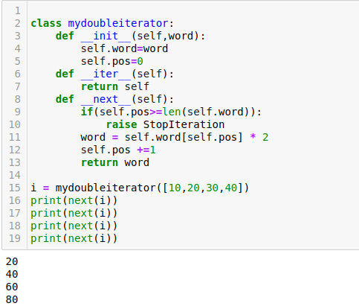

Generators:
Yield: The yield statement suspends function's execution and sends a value back to the caller, but retains enough state to enable function to resume where it is left off. When resumed, the function continues execution immediately after the last yield run.
Return can’t return/genrate the values continously but the yield function can and also its reusme the func where its left last time.

def f1():
yield 10 # If we use return func here the func run get stop for this line only. No matter
yield 10.20 how many time you return it will print the same value.
yield 10+20j
i = f1()
print(next(i)) -------> 10
print(next(i)) -------> 10.20
print(next(i)) -------> 10+20j

Example – 2 (Generator)
# Square of a nunbers
def gen(num):
while True:
yield num**2 # Time and memory efficient both
num +=1

i = gen(1)
print(next(i)) --------->1
print(next(i)) --------->4
print(next(i)) --------->16

import sys
print(sys.getsizeof(i)) ------> 112 byte memory
lst = [1, 4, 9, 16, 25, 36, 49, 64, 81, 100] ----->136 byte again it will going to increase memo
print(sys.getsizeof(lst)) consumption we add the value to list.

# Tuple comprehension creates a generator object
g = (i for i in range(5000))
print(type(g)) -------------> <class 'generator'>
print(sys.getsizeof(g)) -------------> 112 (byte)

g = [i for i in range(5000)]
print(type(g)) -----------> <class 'list'>
print(sys.getsizeof(g)) ------------> 43032

Modules: imply put, a module is a file consisting of Python code. It can define functions, classes, and variables, and can also include runnable code. Any Python file can be referenced as a module

Types of module
1. Builtin module - math, sys, os, pickle, random etc
2. User-defined module - .py #The files which are defined from the user end.

print(dir(__builtins__))
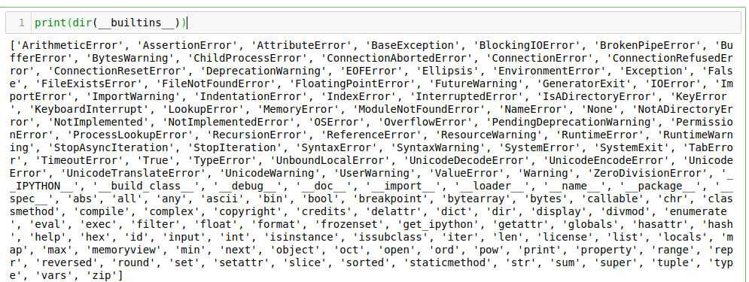
These are the builtin models inside python by defalut, No need to import these modules wen we
use. But there is few user defined modules models which we need import those before we use.
Wen we impot model it refrence created in the global variable.
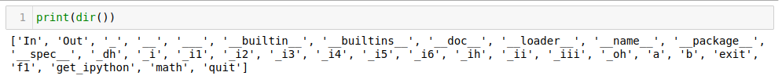
- We can see math name in the global directory bcoz its imported.
- We can cant use func which are not in globle directoty,
- For: sqrt(4) -----> Error bcoz its not a part of global dir, For that we need give the ref of math module, From which we imported.
- Math.sqrt(4) --------> 2

How to import any module in python.
Import math
- Now we can use funcsinsdie math model.

# Another way of importing are aliacing the module for easy use.
print(dir())
import math as mt #From now we can cl math by using mt
import numpy as np

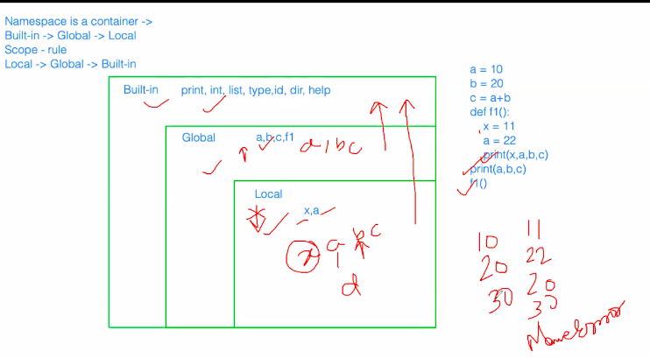
In the above case small a defined in two area, 1)Global (out side the func) 2) Local inside the func def. When we print a whic value it will define from global or local. The pic shows it will follow the rule bottom to top (local ---> Global ----> Builtin). Wen we call a in loacl it will first find inside loact if its dont find that it will move to the globa than to built in. Same wen we cl in global it wil look only in global and built in not local.

File Handling:
1. Text File - In this type of file, Each line of text is terminated with a special character called EOL (End of Line), which is the new line character (‘\n’) in python by default. (Ex: .txt, .csv, .py)
- The data is stored in charecter by charecter and memory is allowcated for every single charecter.
- (Ex: a123 -----> For all 4 cha sep memory is allocated. )

2. Binary File - In this type of file, there is no terminator for a line and the data is stored after converting it into machine understandable binary language. (Ex: .pdf, jpeg, .png, .dat)
- The data is not stored in charecter by charecter and memory is allowcated based on the category they belog.
- (Ex: a123 -------> For a is sep memory and for remaing all 3 integer (123) are stored in same memory address)

The operations we perform in file handling:
- Open a file
- Operations on file - read, write
- Closing of the file.

# To open a file - open('Filename.ext', 'mode')
# open() - will return a file object
# Operations are done on file object
f = open('FIleName.ext', 'mode')
f.write('Hello')
f.read() ----------> .read() help to read the file content.
f.seek(0) -------> .seek() hep set the cursor location ..intialy by defalut on zero postion or beginig
f.tell() -----> .tell() help to find the cursor loaction ----returns index vallue.
f.close() -------> .close() help to close the file.

# Modes of operation on text file
Read mode – 'r' ----------> Only we can read
Write mode – 'w’ -----------> Only we can wriite cant read
Append mode – 'a' -----------> append the data at the end of existing file.
Read and write – 'r+'
Write and read mode - 'w+'
Append and read mode - 'a+'

# Modes of operation on Binary file
Read mode - 'rb'
Write mode - 'wb'
Append mode - 'ab'
Read and write - 'r+b'
Write and read mode - 'w+b'
Append and read mode – 'a+b'

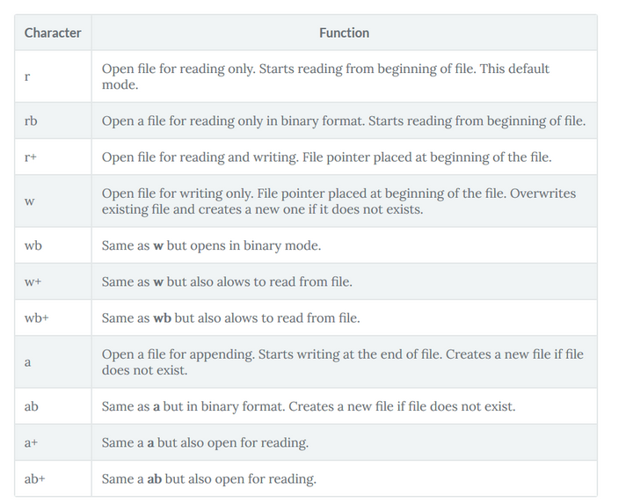
read mode - 'r'
- If file already exist then it opens the file in read mode and places the cursor in the begning of the file.
- IF file does not exist then it will give FileNotFoundError
- In this mode of operation you are allowed only to read from the file not allowed to write into the file.

f = open('my_file.py', 'r')
print(f.tell()) -----------> 0
content = f.read() ----------> File open will not read the content, Its just
open ing the file.
print(content) ---------> file content will be printed
print(type(content)) --------> <class 'str'>
print(f.tell()) ---------> 318 after reading it will reach end (index)
f.close() ---------> without closing we can save upadted thigs,

# f = open('my_file.py', 'r')
# f.write('Hello') ------> Error we can write in reading mode.
# f.close()

read and write mode - 'r+'
- If file already exist then it opens the file in read mode and places the cursor in the begning of the file.
- IF file does not exist then it will give FileNotFoundError
- In this mode of operation you are allowed read and write both.

f = open('my_file.py', 'r+')
f.write('Hello')
f.close()

Write mode - 'w'
- If file already exist then it opens the file in write mode and places the cursor in the begning of the file and deletes the content fo the file.
- IF file does not exist then it will create a file with given name and extension
- In this mode of operation you are allowed only to write into the file not allowed to read from the file.

f = open('f1.py', 'w') ----> If File already exist first it will earase the data.
print(f.tell())
f.write('Hello Python!!! Learnbay classes!!!')
print(f.tell())
f.close()

# f = open('f2.py', 'w') ---> If file does not exist it will create a new file.
# f.close()

Write and read mode - 'w+'
- If file already exist then it opens the file in write mode and places the cursor in the begning of the file and deletes the content fo the file.
- IF file does not exist then it will create a file with given name and extension
- In this mode of operation you are allowed read and write both.

f = open('f1.py', 'w+')
print(f.tell())
f.write('Hello Python!!! Learnbay classes!!!') ---> Writing inside the file.
print(f.tell()) -----> After writing cursor wil reach the end position.
print('Reading at last', f.read())
f.seek(0) -------->If we want read what was write than need set sursor to zero.
print(f.tell()) --------> 0
print(f.read()) ------> Hello Python!!! Learnbay classes!!!
f.close()

Append mode - 'a'
- If file already exist then it opens the file in write mode and places the cursor at the end of the file.
- IF file does not exist then it will create a file with given name and extension
- In this mode of operation you are allowed only to write into the file not allowed to read from the file.
f = open('f1.py', 'a')
print(f.tell())
f.write('\n\nHello Python!!! Learnbay classes!!!')
print(f.tell())
f.close()

Append and read mode - 'a+'
- If file already exist then it opens the file in write mode and places the cursor at the end of the file.
- IF file does not exist then it will create a file with given name and extension
- In this mode of operation you are allowed read and write both.
f = open('f1.py', 'a+')
print(f.tell())
f.seek(0)
print(f.tell())
print(f.read()) -------> We can read also with ‘a+’
f.close()

Note: Binary - file use the above mode of operation rest all remain same.

methods to read from the file
1. read() - Reads the whole content of the file and returns a string object from curent cursor position
2. read(no of char) - Reads specified no of characters from the file and returns a string object from current cursor position onwards.
3. readline() - Reads the current line from curent cursor position and returns a string
4. readlines() - Reads the whole content of teh file and returns a list of string where each string is one line from the file.

f = open('f1.py', 'r')
content = f.read()
print(content)
print(f.read(100)) -------> From the cursor position to hundred charecter.
f.seek(105)
print(f.readline()) -----> It will read the only particular line whrere cursor is present
print(f.readlines()) -----> Fom the cursor postion till end all lines.
f.close()

Methods to write into the file
write('Str1\nstr2\n') - it writes the content to the file
writelines(['str1\n', 'str2\n', 'str3\n']) - it writes the content to the file each string is written into next line, we can write multiple lines using single string.

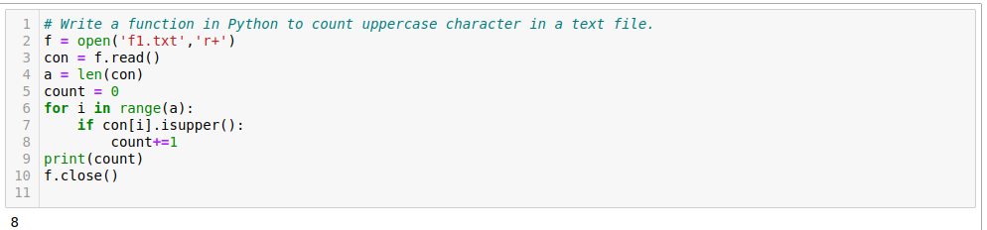
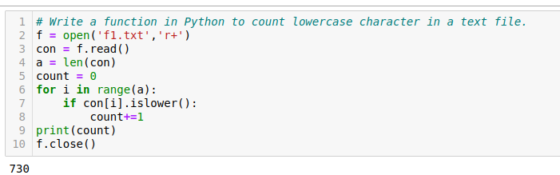
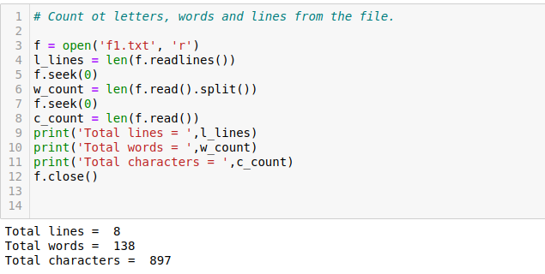
# Copy the content of file from python.jpeg to new.png
with open('python.jpeg', 'rb') as f1:
with open('new.png', 'wb') as f2:
f2.write(f1.read())
When we use ‘with’ func to open the file than no need to close the manually it will close automatcally.

