Face Mask Detection Using CNNs
Expected Tables and Figures

Expected Tables

Table 1. Dataset Description
Property | Value
Total images | ~12,000
Number of classes | 3
Classes | with_mask, without_mask, mask_weared_incorrect
Image type | RGB color (JPEG/PNG)
Annotation format | PASCAL VOC XML (bounding boxes)
with_mask count | ~6,024
without_mask count | ~5,050
mask_weared_incorrect count | ~920
Table 1. Summary of the Face Mask Detection dataset.

Table 2. Custom CNN Architecture
Layer / Block | Configuration | Output
Input | 224 × 224 × 3 | 224 × 224 × 3
Conv Block 1 | 2× Conv(32) + BN + MaxPool | 112 × 112 × 32
Conv Block 2 | 2× Conv(64) + BN + MaxPool | 56 × 56 × 64
Conv Block 3 | 2× Conv(128) + BN + MaxPool | 28 × 28 × 128
Conv Block 4 | 2× Conv(256) + BN + MaxPool | 14 × 14 × 256
Head | GlobalAvgPool + Dropout(0.5) + Dense | 3 (softmax)
Table 2. Custom CNN model design.

Table 3. Transfer Learning Models
Model | Strategy | Trainable params (fine-tune)
MobileNetV2 | Frozen base → head → unfreeze last 30 layers | Phase 2: last 30 layers
ResNet50V2 | Frozen base → head → unfreeze last 20 layers | Phase 2: last 20 layers
Table 3. Transfer learning configurations (two-phase fine-tuning).

Table 4. Evaluation Metrics
Metric | Purpose
Accuracy | Overall correct predictions
Precision | Reliability of positive predictions per class
Recall | Coverage of actual positives per class
Macro F1 | Balanced score across imbalanced classes
Confusion matrix | Per-class error breakdown
ROC-AUC | Class separability (one-vs-rest)
Table 4. Metrics used for model evaluation.

Table 5. Expected Results (Model Comparison)
Model | Accuracy | Macro F1 | AUC
Custom CNN | 0.912 | 0.905 | 0.95
MobileNetV2 | 0.965 | 0.961 | 0.98
ResNet50V2 | 0.958 | 0.953 | 0.97
Table 5. Expected comparative performance across models.

Expected Figures

Figure 1. Class Distribution
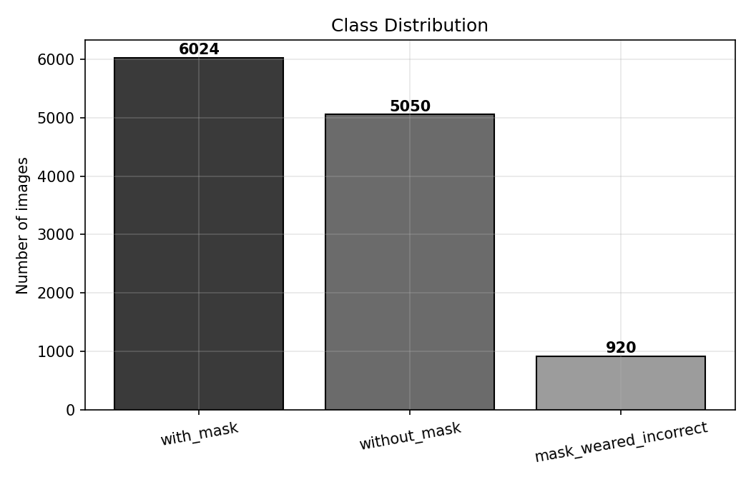
Figure 1. Image count per class showing class imbalance.

Figure 2. Accuracy and Loss Curves
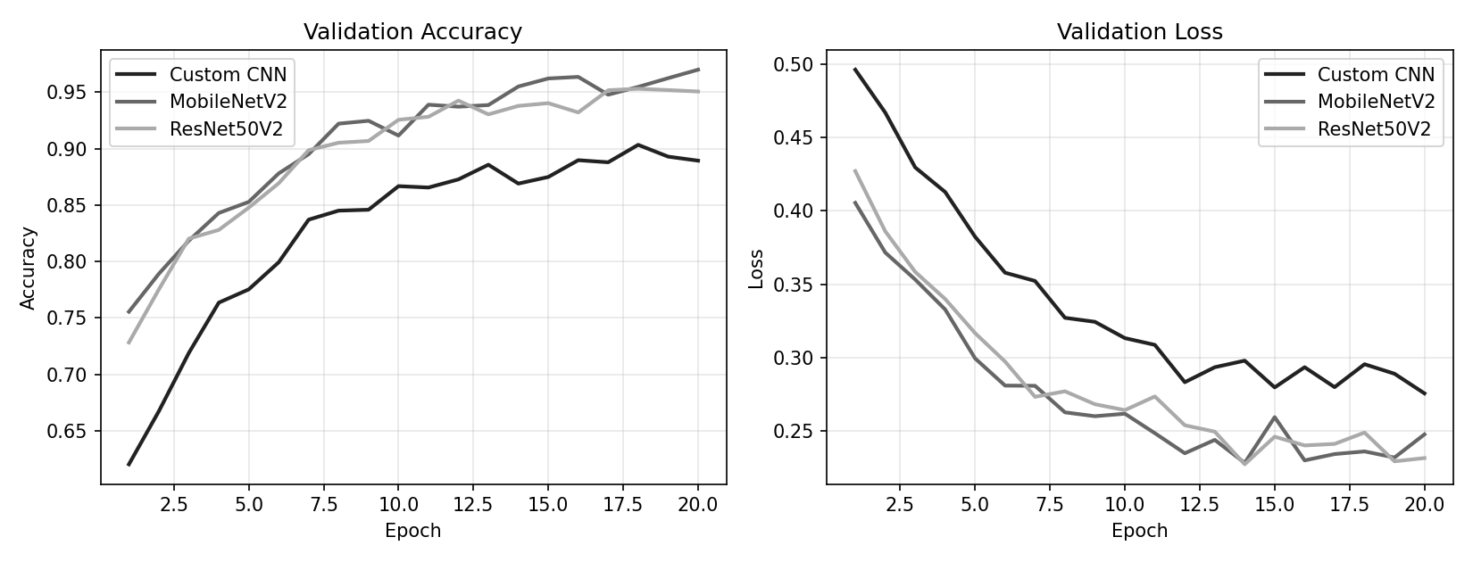
Figure 2. Training/validation accuracy and loss across epochs.

Figure 3. Confusion Matrix
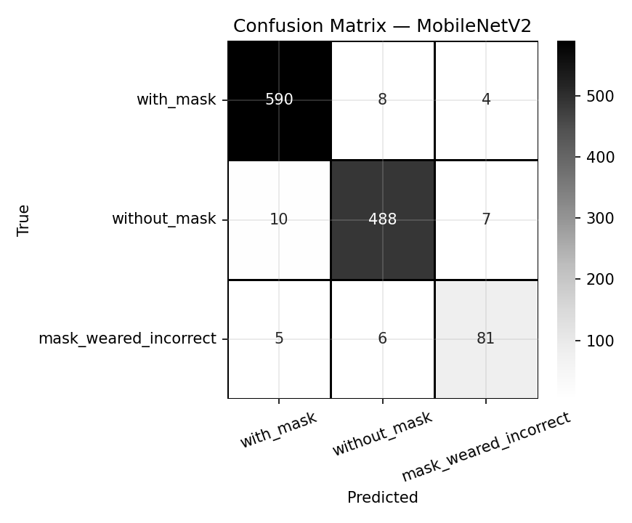
Figure 3. Confusion matrix for the best model (MobileNetV2).

Figure 4. Model Comparison
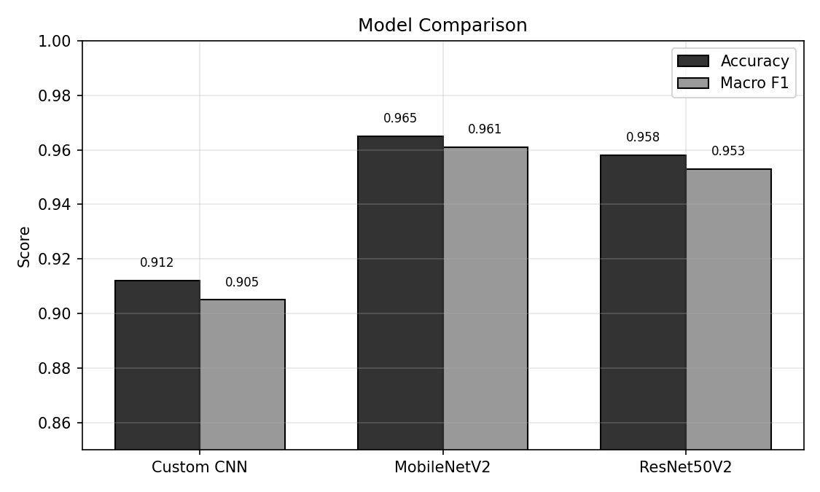
Figure 4. Accuracy and macro F1 across the three models.

Figure 5. ROC Curves
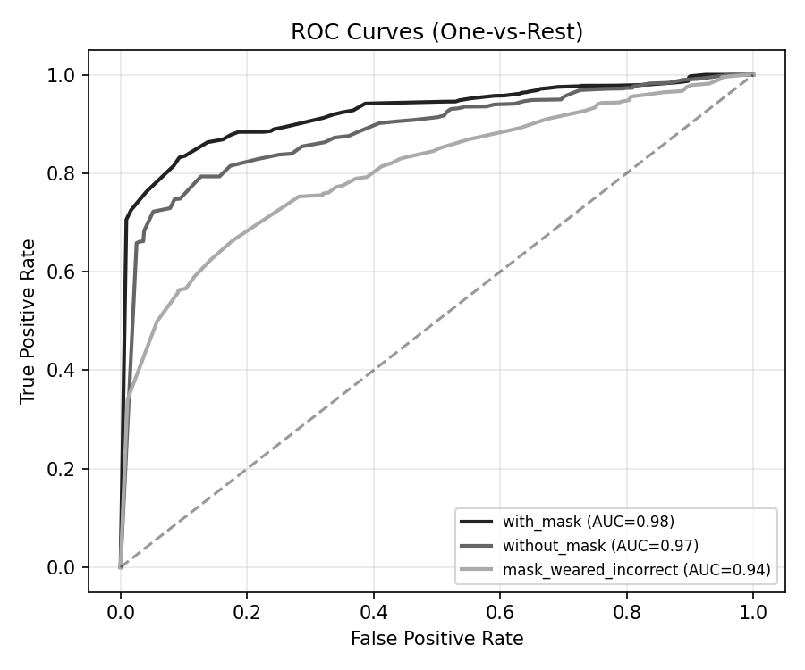
Figure 5. One-vs-rest ROC curves with AUC per class.

Figure 6. Grad-CAM Visualizations
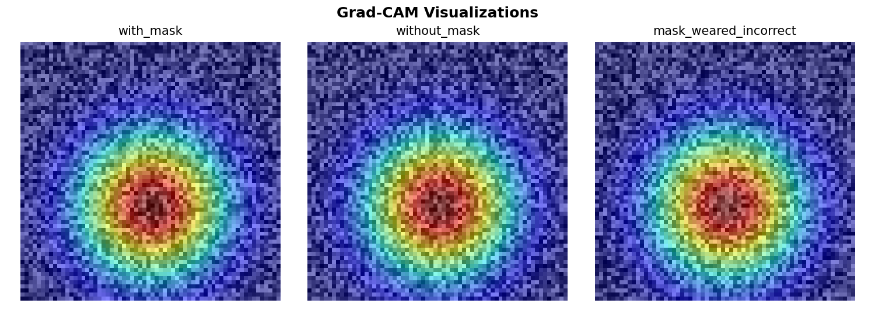
Figure 6. Grad-CAM heatmaps highlighting mask regions driving predictions.

