**Task :** VPN Setup and Understanding Online Privacy  
**Objective:** Understand the role of VPNs in privacy protection and secure communication

**VPN SETUP:**

1. **Chosen VPN:**  
   I selected **ProtonVPN (Free Plan)** as it is trusted, easy to use, and does not log user activity.
2. **Download and Installation:**
   * Visited [protonvpn.com](https://protonvpn.com)
   * Downloaded the ProtonVPN desktop client for Windows.
   * Installed it successfully and created a free account.

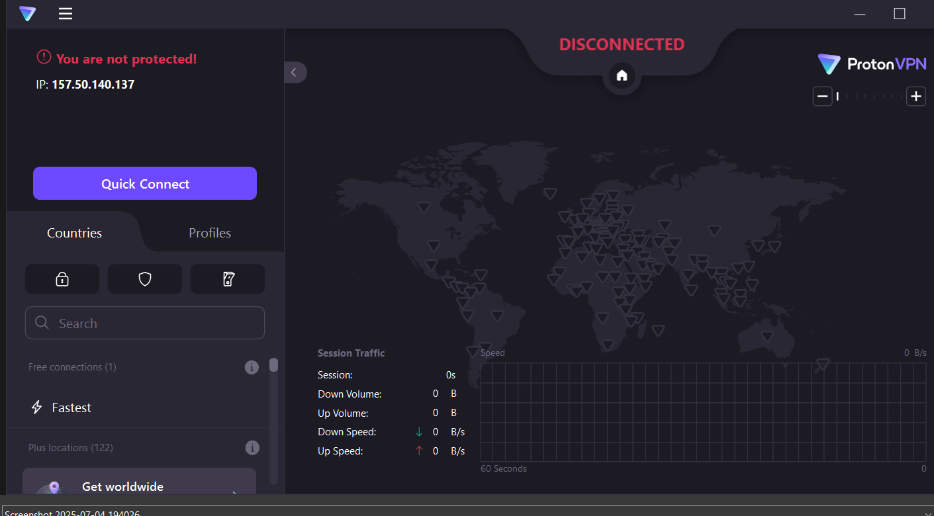

1. **VPN Connection:**
   * Opened the ProtonVPN app.
   * Logged in and connected to the "India – Free Server".
   * Connection was successful, indicated by a green "Connected" status.

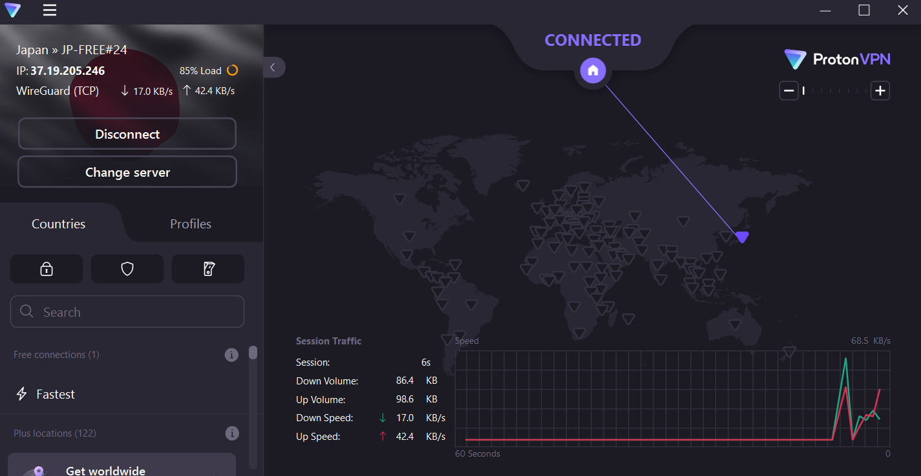

1. **IP Address Verification:**
   * Before connecting: My real IP was shown from my ISP location.
   * After connecting: Used [whatismyipaddress.com](https://whatismyipaddress.com)  
     My IP address was changed to a new location provided by ProtonVPN.

Before connecting vpn: after connecting vpn:

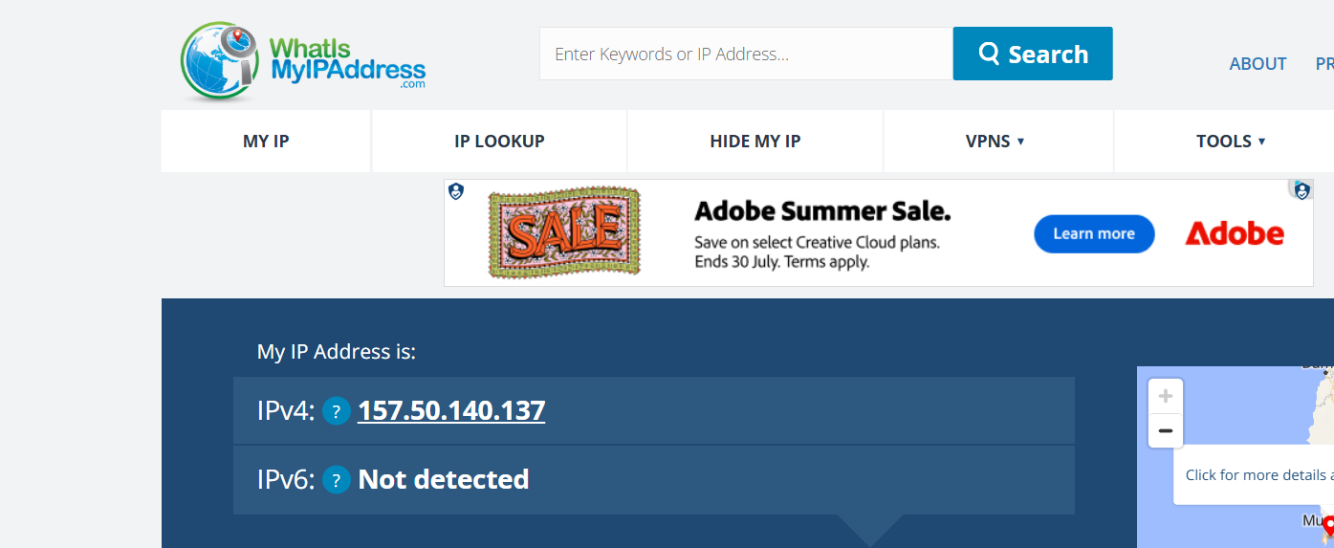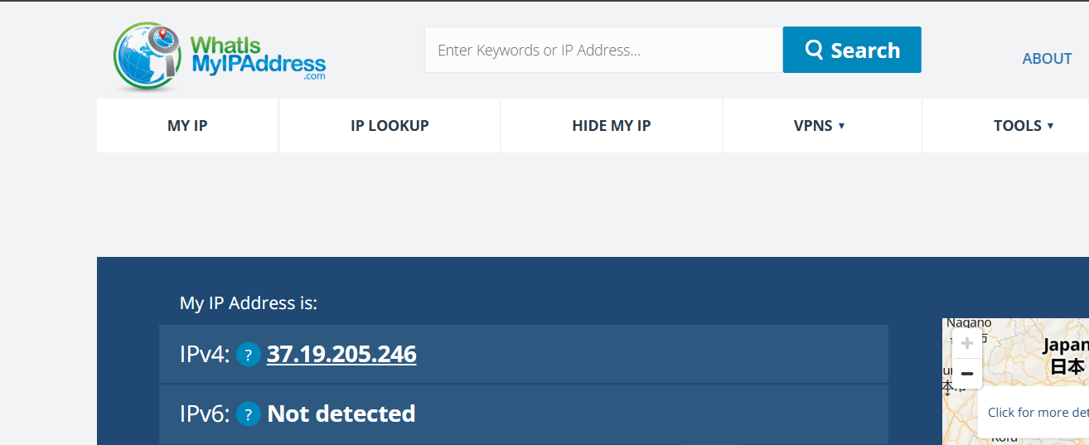

**Encrypted Browsing Test:**

* + Opened websites like https://example.com and verified the padlock icon indicating HTTPS.
  + All traffic was tunneled through the VPN server, ensuring privacy.

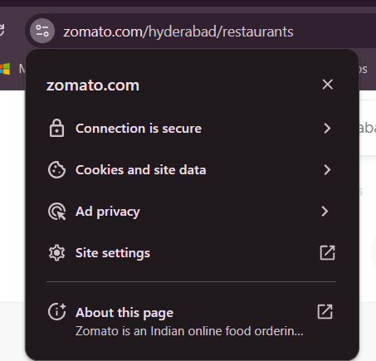

1. **Disconnection & Speed Test:**
   * Disconnected the VPN and compared browsing speed.
   * Browsing was slightly faster without VPN.

After vpn: before vpn:

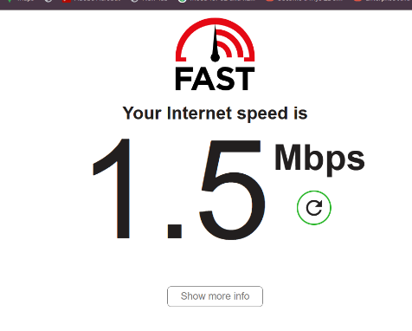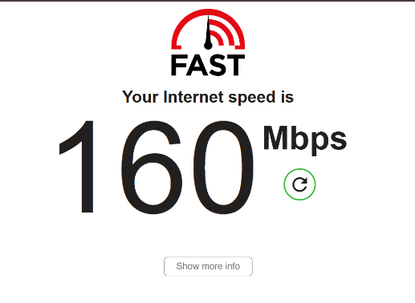

**VPN: Benefits & Limitations**

**Benefits**

* Hides your real IP and location
* Encrypts internet traffic and protects data on public Wi-Fi
* Helps bypass geo-restrictions and censorship
* Shields activity from ISPs and attackers

**Limitations**

* Slower browsing due to encryption
* Free VPNs may offer limited server options and slower speeds
* VPN does **not** protect from phishing or malware attacks

**Summary**

Using a VPN is a crucial step toward online privacy. This hands-on task helped me understand how VPNs work, how to verify encrypted traffic, and how they affect speed. It's an essential cybersecurity tool but not a silver bullet—awareness and safe practices are equally important.