Everybody spends time on youtube. And if you don’t then you have to check these creators who wonderfully explain about the deaf community along with their lifestyles and journey.

**SIGN DUO**

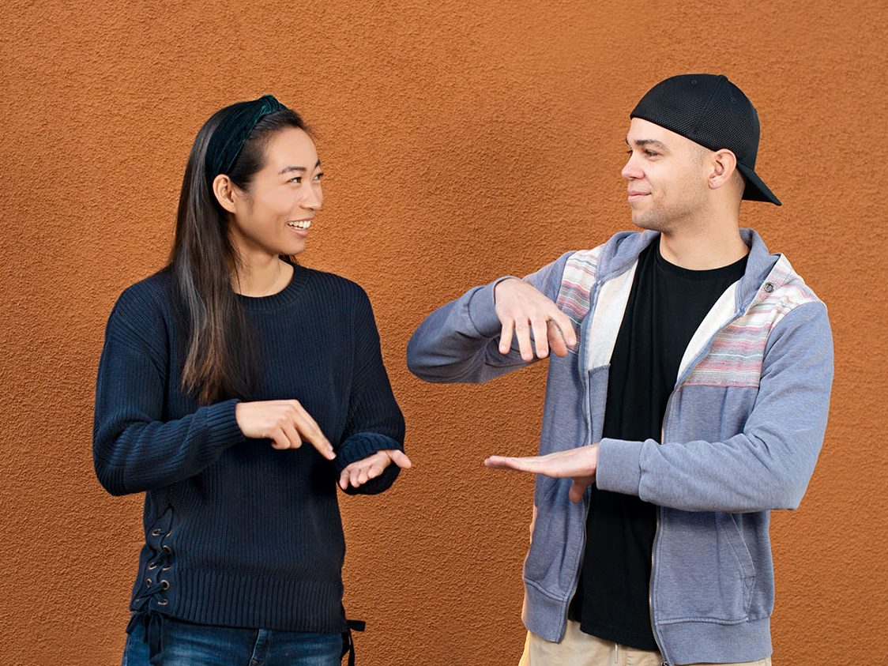

<https://www.youtube.com/channel/UCET0ZgnCFLi1369c3ZWfSFA>

Their personalities are more than a bundle of joy and sunshine. Meet the **SIGN DUO**. Watching their videos make you want to learn sign language the very instant.

**SIGNED WITH HEART**

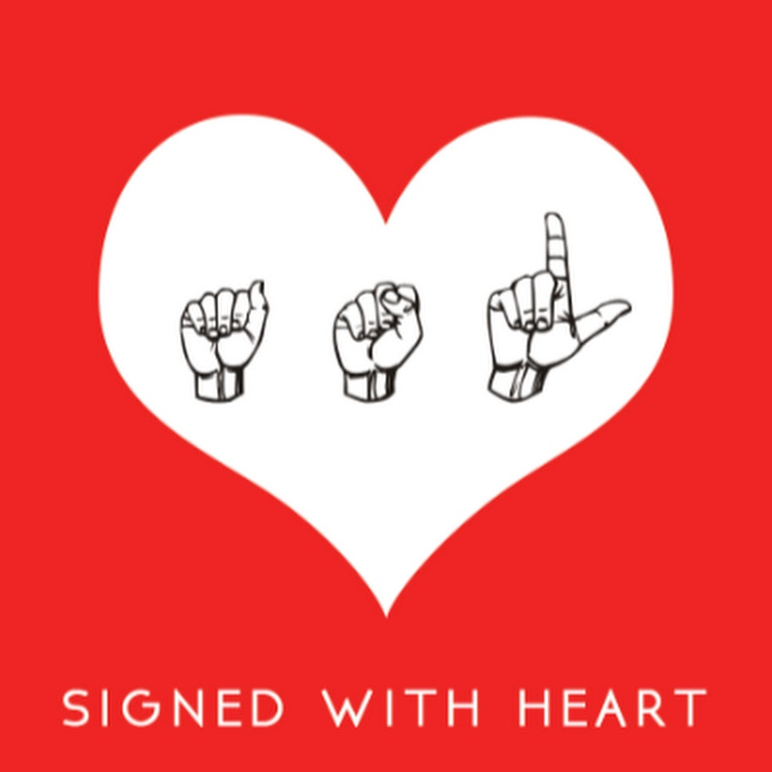

<https://www.youtube.com/channel/UCZrcp5LyFbqp_jIhCKakTKg>

Learn about the basics of ASL and simple verbs everyday with her videos. Just a few short videos with detailed content.

**RIKKI POYNTER**

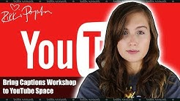

<https://www.youtube.com/user/rikkipoynter>

The 28-year-old’s YouTube Channel is a mix of activism related to Deaf culture, mental health, and feminism. She started a campaign that made proper captions. She breaks down the memes about deaf people and culture and clearly shows where to draw the line.