Everyone loves a good book. Here are some good books that also portray about the deaf community.

1. **El Deafo by Cece Bell**

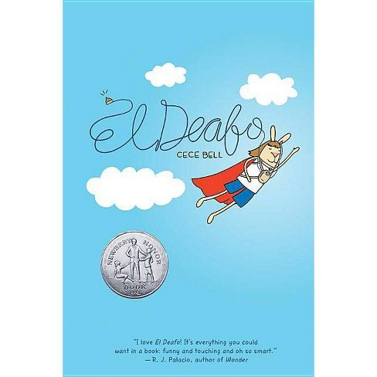

El Deafo is a graphic novel written and illustrated by Cece Bell. The book is a loose autobiographical account of Bell's childhood and living with her deafness. However, the characters in the book are all bunnies.

1. **Signs of Attraction by Laura Brown**

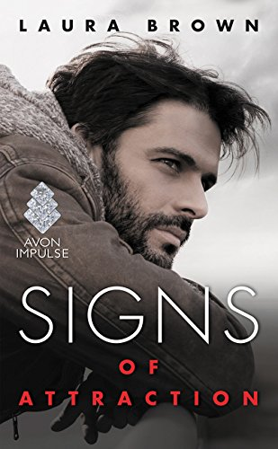

Signs of Attraction is about two college students who have very different histories and experiences with hearing loss. When Reed notices Carli struggling in class, he befriends her and introduces her to his Deaf friends.

1. **Finding Zoe: A Deaf Woman’s Journey of Love, Identity, and Adoption by Brandi Rarus and Gail Harris**

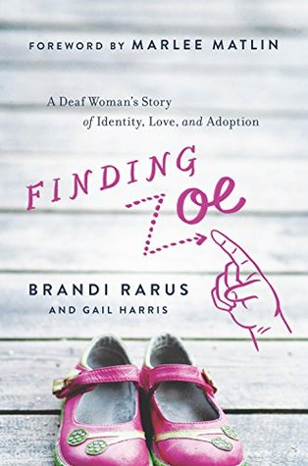

Brandi Rarus lost her hearing at age six. She met her husband Tim after seeing him at the Gallaudet Uprising, and they fell in love a year later, devoting their lives to each other, improving the lives and communication for the Deaf, and later, raising their three hearing sons.

1. **Seeing Voices by Oliver Sacks**

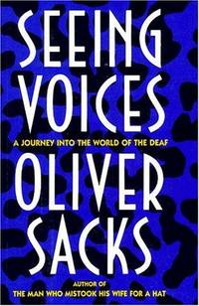

A Journey Into the World of the Deaf is a 1989 book by neurologist Oliver Sacks. The book covers a variety of topics in Deaf studies, including sign language, the neurology of deafness, the history of the treatment of Deaf Americans, and linguistic and social challenges facing the Deaf community.

1. **Teach Me to Love Myself by Holly Elliott**

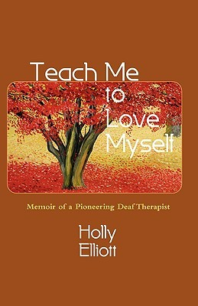

Holly Elliott was familiar with forging new paths. As she describes in her memoir, Teach Me to Love Myself, she was probably the first professionally trained deaf counselor-therapist in the United States.