Are you a movie buff? Then you have come to the right place to see some good films and observe a little about the deaf culture. Of course, things seen on the screen might be exaggerated but few of these are true for some people. Grab a popcorn and a buddy because why experience all the goodness just by yourself?

**A SILENT VOICE**



One of the most beautiful films that has been made. This is not just your average school film where students try to fit in beside the differences with other people. This film shows the most common hurdle, the art of communication. Kids want to be cool and fun but what is the extent one takes and is it really right? Young Shoya realises his mistakes and tries to mend things right but how far will he succeed?

**A MIRACLE WORKER**

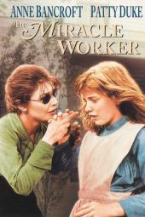

Helen Keller is a brilliant person. Despite the fact she lost her ability to hear and see when she was an infant, she connected the with the world with the help of sign language and braille system. But this movie shows about struggle her teacher, Anne Sullivian went through to teach her how to connect and feel the world.

**MUSIC WITHIN**

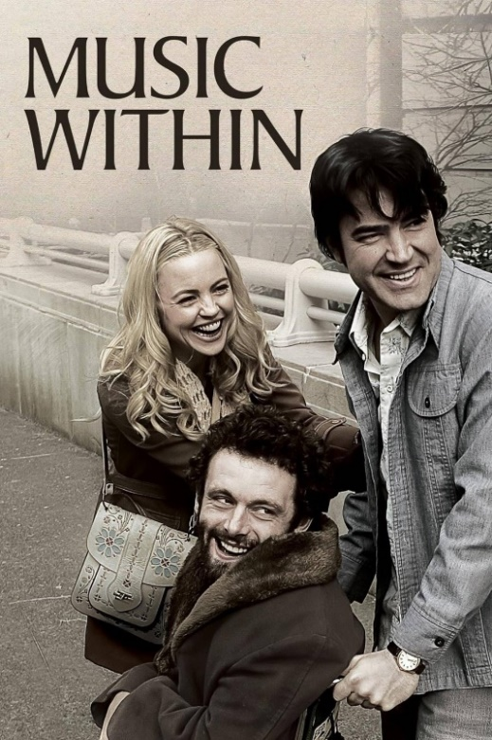

It is based on the **true story** of Richard Pimentel. He lost his ability to hear in the Vietnam war. This film tells us about his passion for public speaking and motivating others. a respected public speaker whose hearing disability attained in the Vietnam War drove him to become an activist for the Americans with Disabilities Act.

**SEE WHAT I’M SAYING**

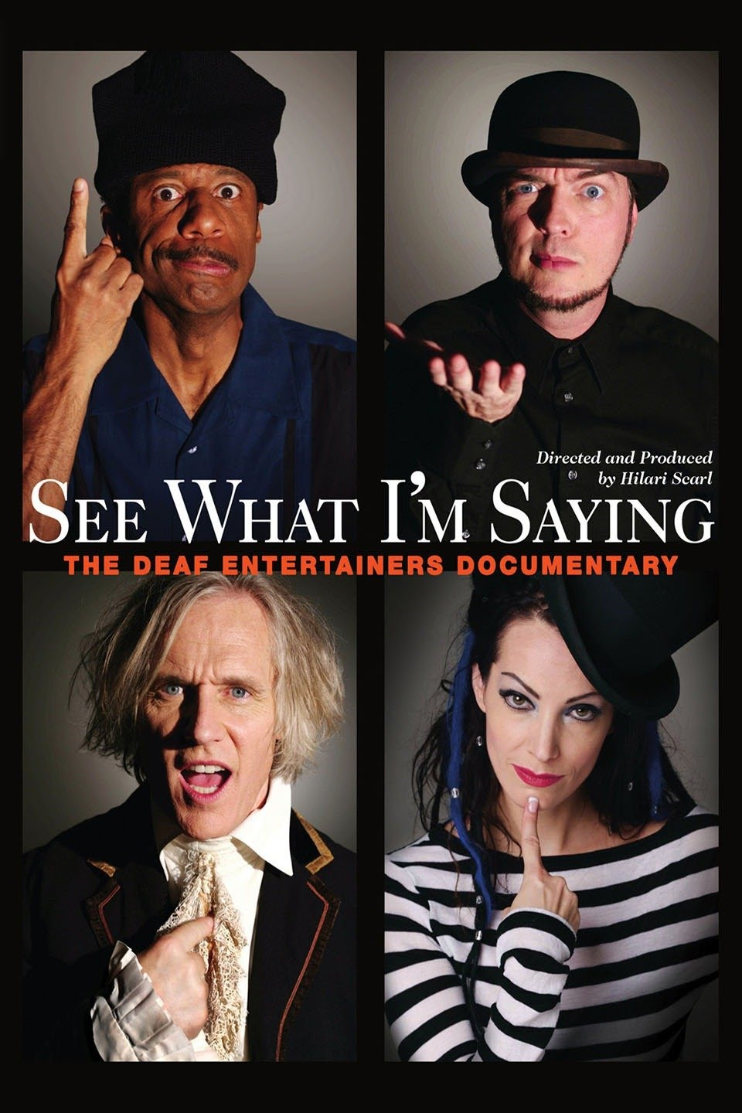

This documentary details the lives, trials and tribulations of several successful entertainers -- all of whom are deaf. Percussionist Bob Hiltermann is a member of a deaf rock band, while comedian C.J. Jones produces an international theater festival utilizing sign language. Singer T.L. Forsberg is torn between the world of the deaf and the hearing while working on her new CD, and Robert DeMayo's acting success is put on hold when he faces HIV and homelessness.

**A QUIET PLACE**

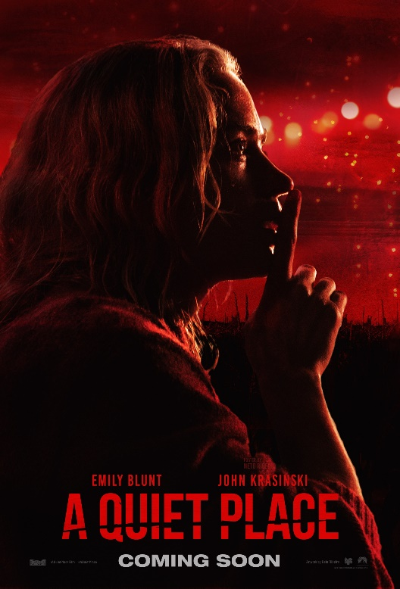

A horror, thriller nerve wrecking movie. This is a perfect way to practice your sign language skills as this film is filled with the beautiful are of sign language. This movie screens the importance of sign language. If you are wondering how then let me explain it to you. Imagine if you get trapped in a world where you get killed for making any noise. Now how will you communicate?