1. In the below elements which of them are values or an expression? eg:- values can be integer or string and expressions will be mathematical operators.

*

'hello'

-87.8

-

/

6

***Answer 1 :***

***Above ‘hello’ , -87.8 and 6 are values and rest are expressions.***

1. What is the difference between string and variable?

***Answer 2:***

***A string is any value enclosed inside single or double quotes like ‘shiv’ , “this is a string” whereas a variable is used to store any value in it, like a indicator used for a value so we can call the variable anytime the value is needed, like a=10 , b= ‘assignment’ .***

1. Describe three different data types.

***Answer 3: Float - Float stores any kind of numerical value in form of decimal or fraction like 3.50 or 4.00***

***List - It is a collection of elements that can be of different types like int, string, complex number etc. Enclosed inside square brackets and should be separated by a comma.***

***Dictionary - Dictionary indicates data type in form of key-value pair enclosed in cur;y brackets separated by comma, key-value individually are separated by a colon. Key should be unique for each pair.***

1. What is an expression made up of? What do all expressions do?

***Answer 4:***

***An expression is a combination of values and functions that are combined and interpreted by the compiler to form a new value. Eg. x=10 , x+3***

1. This assignment statements, like spam = 10. What is the difference between an expression and a statement?

***Answer 5:***

***An expression interprets a value with help of functions and operators whereas a statement dies whatever it is commanded to do like storing a value to a variable or displaying the value.***

6. After running the following code, what does the variable bacon contain?

bacon = 22

bacon + 1

***Answer 6:***

***After running the above code the bacon will contain the same value as 22, reason being we cannot alter the value of a variable we can only reassign it.***

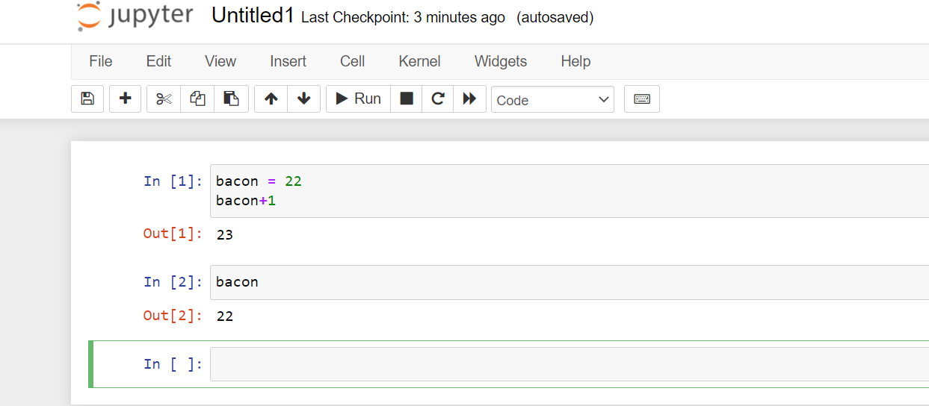

7. What should the values of the following two terms be?

'spam' + 'spamspam'

'spam' * 3

***Answer 7:***

***Both of them would return the same value as ‘spamspamspam’ .***

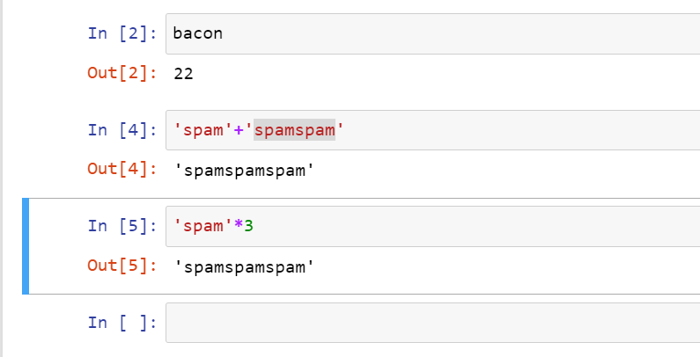

1. Why is eggs a valid variable name while 100 is invalid?

***Answer 8:***

***Reason being we cannot define literal as a variable name it has to be something figurative, like any string value without the quotes.***

1. What three functions can be used to get the integer, floating-point number, or string version of a value?

***Answer 9:***

***We would have to do typecasting with the following functions : int(value), float(value), str(value).***

10. Why does this expression cause an error? How can you fix it?

'I have eaten ' + 99 + ' burritos.'

***Answer 10:***

***Reason for the error is that we cannot concatenate(merge) string with an integer, they all have to be string to perform the expression, we can fix it by typecasting the integer to a string :***

***‘I have eaten’ + str(99)+’burritos’***