1. What are the two values of the Boolean data type? How do you write them?

***Answer 1:***

***Boolean can be of only two types i.e. True and False, they are written with ‘T’ and ‘F’ in uppercase only.***

1. What are the three different types of Boolean operators?

***Answer 2:***

***Three different types of boolean operators are ‘and’, ‘or’ and ‘not’. ‘and’ returns True if both the statements ate true, ‘or’ returns True if one of the statement is true and ‘not’ returns true if the statement is false.***

1. Make a list of each Boolean operator's truth tables (i.e. every possible combination of Boolean values for the operator and what it evaluate ).

Answer 3:

**AND Truth Table**

**x or y Returns**

**True or True True**

**True or False True**

**False or True True**

**False or False False**

**OR Truth Table**

**x and y Returns**

**True and True True**

**True and False False**

**False and True False**

**False and False False**

**NOT Truth Table**

**not x Returns**

**not True False**

**not False True**

4. What are the values of the following expressions?

(5 > 4) and (3 == 5)

not (5 > 4)

(5 > 4) or (3 == 5)

not ((5 > 4) or (3 == 5))

(True and True) and (True == False)

(not False) or (not True)

**Answer 4:**

**(5 > 4) and (3 == 5) returns *False***

**not (5 > 4) returns *False***

**(5 > 4) or (3 == 5) returns *True***

**not ((5 > 4) or (3 == 5)) returns *False***

**(True and True) and (True == False) returns *False***

**(not False) or (not True) returns *True***

1. What are the six comparison operators?

***Answer 4:***

***Six types of comparison operators are less than(<), Greater than(>), less than or equal to(<=), Greater than or equal to(>=), Equal to(==) and Not equal to(!=).***

1. How do you tell the difference between the equal to and assignment operators?Describe a condition and when you would use one.

***Answer 5:***

***Equal to operator is donated by ‘==’ and it is used to compare or relate two values, it returns 1 if both the values are equal otherwise 0. Whereas Assignment operator is donated by ‘=’ and is used to assign some value to a variable .***

***Like we would use the equal to operator to define a condition and assignment operator to assign values to x and y :***

***x=10  
y=10***

***If x==y:  
print(‘True’)***

7. Identify the three blocks in this code:

spam = 0

if spam == 10:

print('eggs')

if spam > 5:

print('bacon')

else:

print('ham')

print('spam')

print('spam')

**Answer 7:**

**Block 1:  
*spam = 0***

***if spam == 10:***

***print('eggs')***

**Block 2:  
*if spam > 5:***

***print('bacon')***

***Block 3:  
else:***

***print('ham')***

***print('spam')***

***print('spam')***

1. Write code that prints Hello if 1 is stored in spam, prints Howdy if 2 is stored in spam, and prints Greetings! if anything else is stored in spam.

***Answer 8:***

***spam=input()***

***if spam=='1':***

***print('hello')***

***elif spam=='2':***

***print('howdy')***

***else:***

***print('Greetings!')***

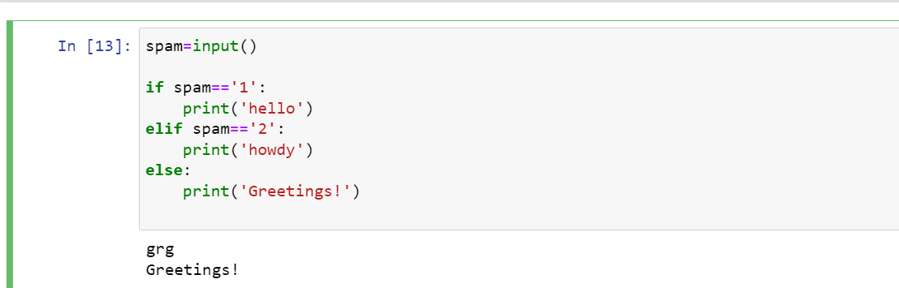

1. If your programme is stuck in an endless loop, what keys you’ll press?

***Answer 9:***

***We can press ctrl+C to interrupt the code.***

1. How can you tell the difference between break and continue?

***Answer 10:***

***Break is used to stop the iteration of the loop after the statement carry on to the next loop, whereas the Continue is used to skip only the current iteration and not the loop, after skipping the current iteration it carry on with with the loop.***

1. In a for loop, what is the difference between range(10), range(0, 10), and range(0, 10, 1)?

***Answer 11.***

***In a for loop all of the above 3 works same and give us the output as iteration from 0 to 9 in range of 10.***

1. Write a short program that prints the numbers 1 to 10 using a for loop. Then write an equivalent program that prints the numbers 1 to 10 using a while loop.

***Answer 12:***

***FOR LOOP  
for i in range(1,11):***

***print(i)***

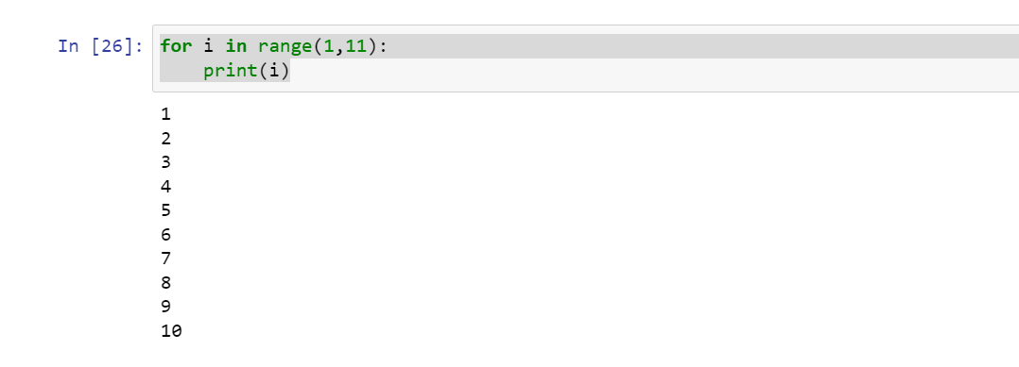

***WHILE LOOP  
i =1***

***while(i<=10):***

***print(i)***

***i=i+1***

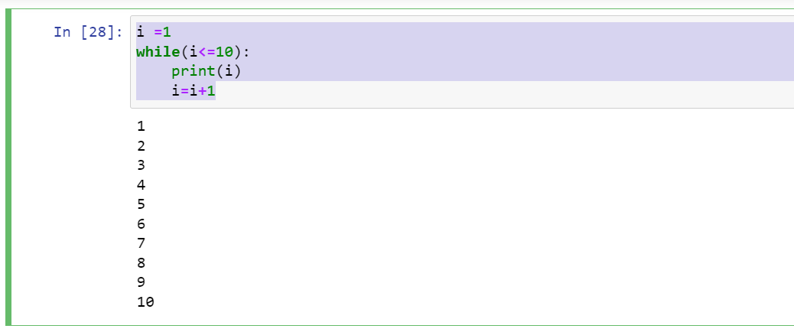

1. If you had a function named bacon() inside a module named spam, how would you call it after importing spam?

***Answer 13:***

***spam.bacon()***