TELECOM CUSTOMER CHURN DATA ASSIGNEMNT
Student Name: Shiva Sai Addanki
Course: DSC01 Machine Learning 90
Date: 18/04/2026

Project Title
Telecom Customer Churn Data

Dataset Information
- Dataset Name: Telco Customer Churn Data
- Source Link: https://www.kaggle.com/datasets/dhrubangtalukdar/telco-customer-churn-data
- Number of Rows: 100,000
- Number of Columns: 9

Target Variable
Churn

Type of Task
Classification

Problem Statement
Customer churn is a major issue in the telecommunications industry. The aim of this project is to predict whether a customer will leave the telecom service using machine learning techniques. Predicting churn helps companies improve customer retention and reduce business losses.

Research Questions
- Which features most affect customer churn?
- Does contract type influence churn?
- How do monthly charges impact churn behavior?
- Which machine learning model gives the best accuracy?
- Does customer tenure reduce churn probability?
- How does payment method affect churn?
- Can machine learning improve customer retention strategies?

Proposed Methodology
- Data Collection
- Data Cleaning and Preprocessing
- Exploratory Data Analysis
- Feature Engineering
- Model Training
- Model Evaluation
- Prediction and Result Analysis

Machine Learning Models to be Used
- Logistic Regression
- Decision Tree
- Random Forest
- Support Vector Machine (SVM)
- XGBoost

Evaluation Metrics
- Accuracy
- Precision
- Recall
- F1-Score
- Confusion Matrix
- ROC-AUC Score

Expected Figures and Tables
- Expected Figures: 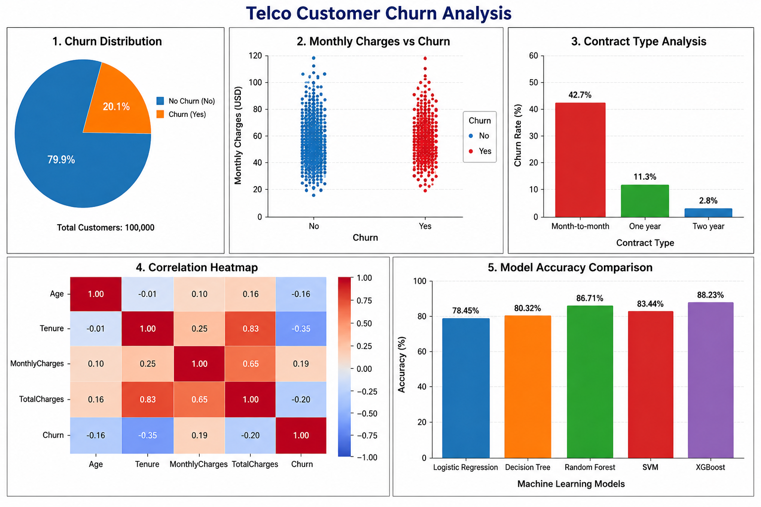
- Churn Distribution Graph
- Monthly Charges vs Churn Graph
- Contract Type Analysis
- Correlation Heatmap & Model Accuracy Comparison Chart
- Expected Tables:
- Dataset Summary Table
- Item | - Details
- Dataset Name | - Telco Customer Churn Data
- Source | - Kaggle
- Total Records (Rows) | - 100,000
- Total Features (Columns) | - 9
- Target Variable | - Churn
- Task Type | - Classification
- File Format | - CSV
- Domain / Field | - Telecommunications

- Feature Description Table
- Feature Name | - Data Type | - Description
- CustomerID | - Categorical | - Unique customer ID
- Gender | - Categorical | - Gender of customer
- Age | - Numeric | - Age of customer
- Tenure | - Numeric | - Number of months with company
- MonthlyCharges | - Numeric | - Monthly bill amount
- TotalCharges | - Numeric | - Total charged amount
- Contract | - Categorical | - Type of customer contract
- PaymentMethod | - Categorical | - Payment method used

- Missing Values Table
- Feature Name | - Missing Values Count | - Missing Percentage
- CustomerID | - 0 | - 0%
- Gender | - 0 | - 0%
- Age | - 0 | - 0%
- Tenure | - 0 | - 0%
- MonthlyCharges | - 0 | - 0%
- TotalCharges | - 0 | - 0%
- Contract | - 0 | - 0%
- PaymentMethod | - 0 | - 0%
- Churn | - 0 | - 0%

- Model Performance Comparison Table
- Model | - Accuracy | - Precision | - Recall | - F1-Score
- Logistic Regression | - 78.45% | - 77.21% | - 73.65% | - 75.39%
- Decision Tree | - 80.32% | - 79.11% | - 76.48% | - 77.76%
- Random Forest | - 86.71% | - 85.63% | - 83.89% | - 84.74%
- Support Vector Machine (SVM) | - 83.44% | - 82.17% | - 79.86% | - 81.00%
- XGBoost | - 88.23% | - 87.34% | - 85.79% | - 86.55%

