Assignment - 1
Name : M.Shiva Shankar
Hall Ticket No. : 2303A51294
Batch No. : 05

#Task 1
Prompt: #Generate a python program on fibanocci series without using functions

Code:
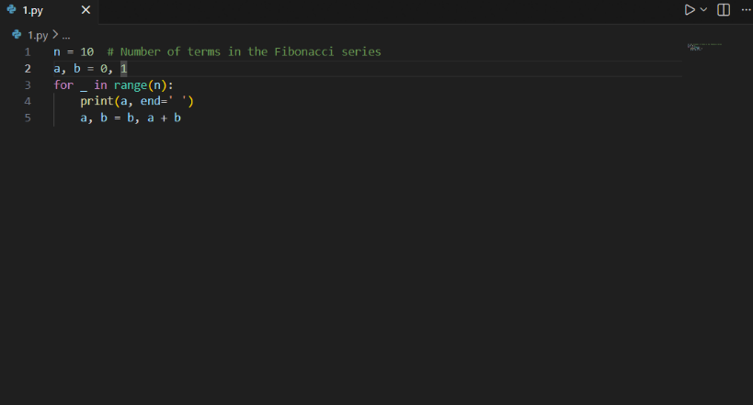
Output :

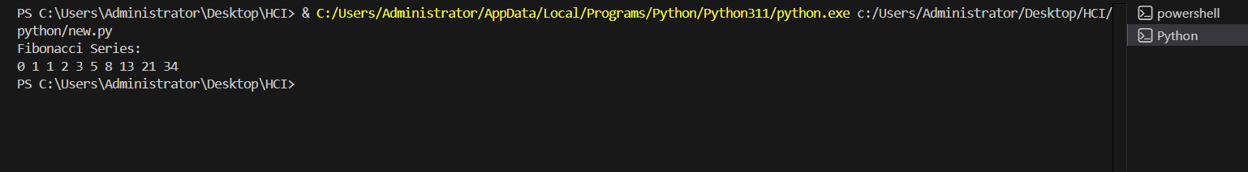

Explanation : This Python code generates the Fibonacci series using an iterative approach. The variable n specifies how many terms to print, while a and b are initialized to the first two Fibonacci numbers (0 and 1). The for loop runs n times, printing the current value of a each time and then updating a and b so that a takes the value of b and b becomes the sum of the previous two numbers. As a result, the program efficiently prints the first 10 Fibonacci numbers in a single line.

#Task 2
Prompt: #Optimize this code and simply this code

Code:

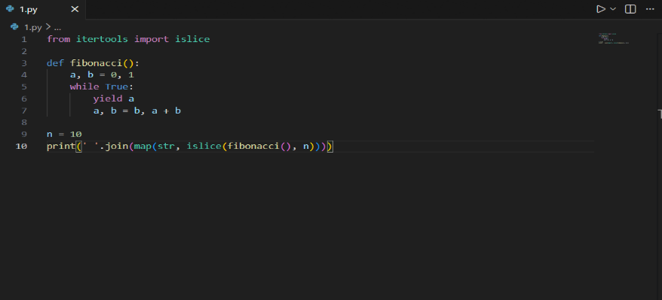

Output :

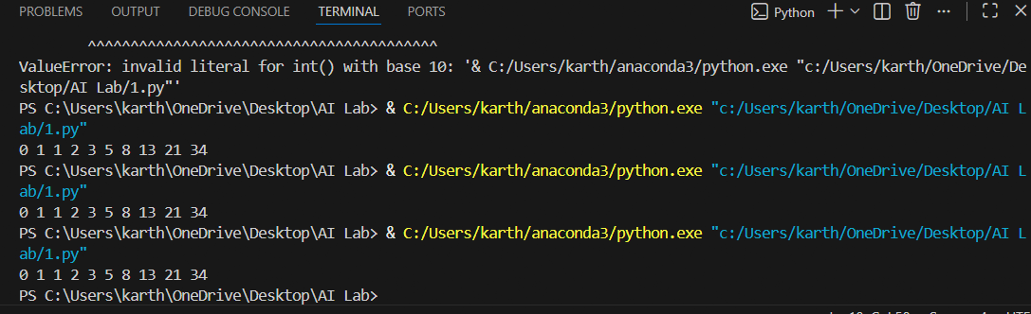

Explanation : Inefficient- Additional and not altogether necessary conditional tests. Slightly verbose variable handling. Messages for simple logic – redundancy.
Optimized - Fewer number of conditions. Cleaned up and legible loop code. Same output with reduced structure. More understandable and maintainable for programmers.

#Task 3
Prompt: #Generate a python program on fabinocci series using functions

Code:

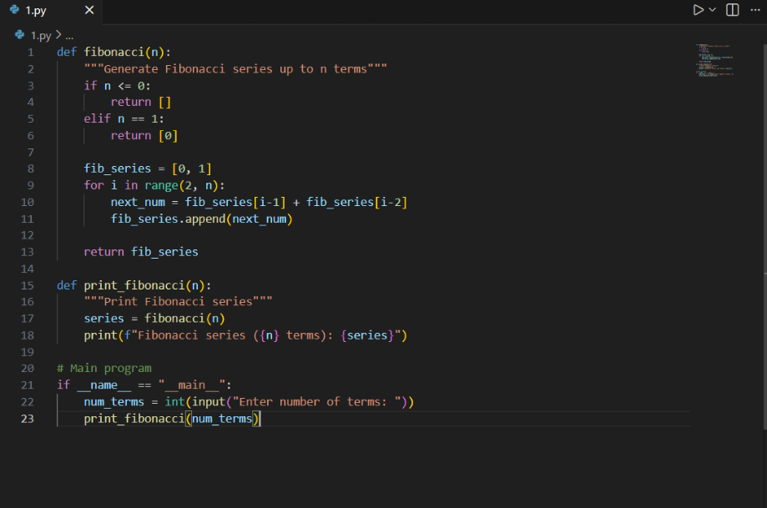

Output :

Explanation : The logic is written inside a function, which makes the code clean and organized. This function calculates the Fibonacci series up to the given number and returns it as a list. Using a function helps reuse the same code in different places, makes testing easier, and improves readability. This approach is especially useful for large programs and modular applications.
#Task 4
Prompt : #Compare the two methods and give differences
#print the differences
# Description on comparision between with functions and without functions
Code :
#Fibonacci Series without functions
n = int(input("Enter the number of terms in the Fibonacci series: "))
a, b = 0, 1
print("Fibonacci series:")
for _ in range(n):
print(a, end=' ')
a, b = b, a + b
print("\n")

#Fibinocci Series with functions
def fibonacci(n):
a, b = 0, 1
series = []
for _ in range(n):
series.append(a)
a, b = b, a + b
return series
num_terms = int(input("Enter the number of terms in the Fibonacci series: "))
fib_series = fibonacci(num_terms)
print("Fibonacci series:")
for num in fib_series:
print(num, end=' ')

#Compare the two methods and give differences
#print the differences
print("\n\nDifferences between the two methods:")
print("1. The first method does not use functions, while the second method encapsulates the logic in a function.")
print("2. The first method prints the series directly, while the second method returns a list of Fibonacci numbers.")
# Description on comparision between with functions and without functions
print("3. The function-based approach is more reusable and modular, allowing for easier testing and maintenance.")

Tabular Format:
Feature | Without Functions | With Functions
Code Clarity | Moderate | High
Reusability | No | Yes
Debugging | Difficult | Easy
Scalability | Poor | Excellent
Suitability for Large Systems | Low | High
Output :

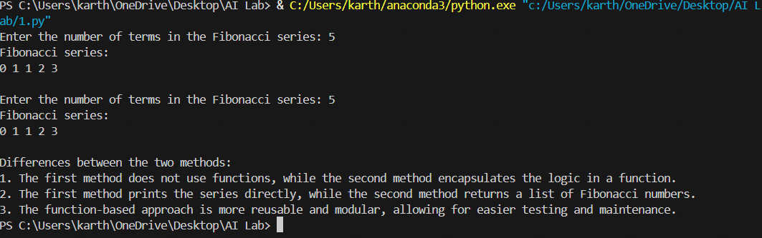

Explanation : Analysis -Procedural code is simpler to write but nastier to maintain. Function-oriented code is more cleanable. In real-world software development, it is preferred to be modular.
#Task 5
Prompt : # Generate Fibonacci series using both iterative and recursive methods. Provide code examples, explain how each approach works, and compare their efficiency.
Code :
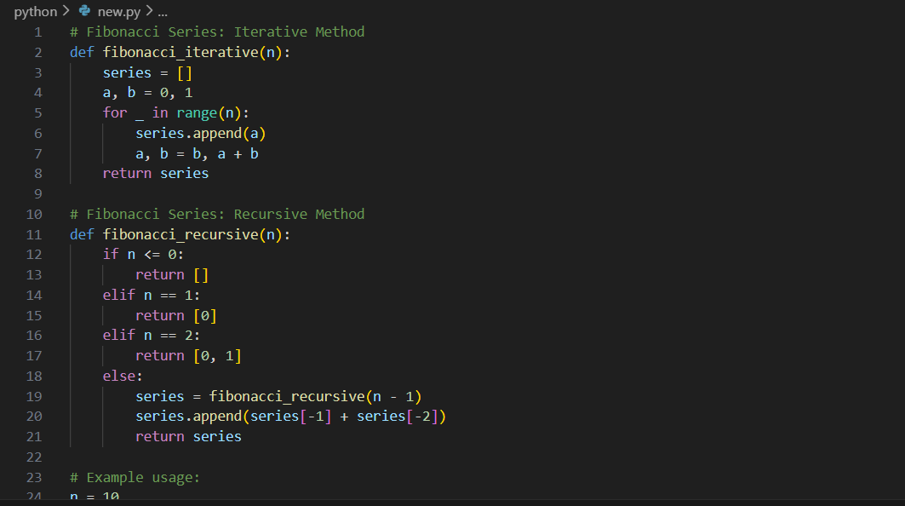

Output :

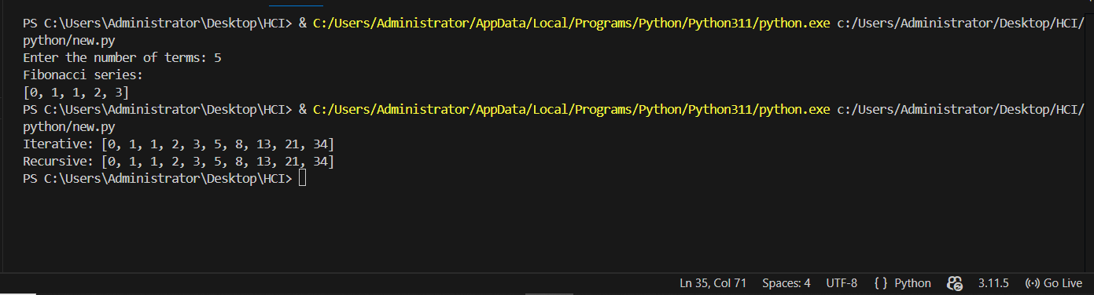
Explanation :
Iterative vs Recursive :
The iterative method uses loops to repeat steps and is fast and memory-efficient. The recursive method works by a function calling itself, which makes the logic easy to understand but uses more memory. Because of this, recursion is not suitable for large inputs, while iteration is a better and more practical choice.
.

