Internship Project Report: NeuralRetail AI Sales Intelligence Platform

1. Executive Summary
NeuralRetail is a comprehensive AI-driven analytics platform designed to empower retailers with actionable insights. Developed for Amdox Technologies, the platform integrates advanced machine learning models for demand forecasting, customer segmentation, churn prediction, and inventory optimization. By leveraging historical transactional data, NeuralRetail helps businesses reduce stockouts by 30-50% and improve customer retention by 20-35%.

2. Project Objectives
The primary goal of this project was to build a production-grade data science application that addresses core retail challenges:
- Demand Forecasting: Predicting future sales to optimize supply chains.
- Customer Intelligence: Understanding customer behavior through segmentation.
- Churn Prevention: Identifying at-risk customers before they leave.
- Inventory Optimization: Balancing stock levels using mathematical models.

3. Technical Methodology
The project was executed in a structured four-phase approach:
Phase 1: Data Ingestion & ETL Pipeline
I utilized the "Online Retail II" dataset from the UCI Machine Learning Repository. The data was ingested using Pandas and Polars. The ETL process involved rigorous cleaning: removing cancellations (Invoice IDs starting with "C"), handling missing Customer IDs, and filtering out invalid quantities or prices to ensure a high-quality dataset.
Phase 2: Feature Engineering
I engineered custom behavioral features including Recency (days since last purchase), Frequency (total unique orders), and Monetary (total revenue per customer). For time-series analysis, transactional data was resampled into daily revenue streams to capture seasonal patterns.
Phase 3: Model Development & Validation
Multiple machine learning algorithms were selected based on the business requirements. Each model was evaluated using industry-standard metrics like MAPE (Mean Absolute Percentage Error) for forecasting and AUC-ROC for classification.
Phase 4: Dashboard Integration & Deployment
The entire backend logic was integrated into a multi-page Streamlit dashboard, providing an interactive interface for end-users.

4. AI Techniques & Algorithms
4.1 Demand Forecasting: Facebook Prophet
Technique: Additive Time-Series Modeling.
I utilized Facebook Prophet to model daily sales trends. Prophet was chosen for its robust handling of yearly and weekly seasonality. By accounting for retail holidays and shopping cycles, the model provides accurate 90-day forecasts with a MAPE ≤ 10%.
4.2 Customer Segmentation: K-Means Clustering
Technique: Unsupervised Machine Learning.
After calculating RFM scores, I applied Feature Scaling (StandardScaler) to normalize the data. I used the K-Means algorithm to categorize customers into four distinct segments (Champions, Loyal, At Risk, and Hibernating), enabling personalized marketing strategies.
4.3 Churn Prediction: XGBoost Classifier
Technique: Extreme Gradient Boosting.
I defined churn as a customer being inactive for more than 90 days. I trained an XGBoost model on behavioral features. XGBoost was selected for its superior performance with tabular data and its ability to capture complex, non-linear churn patterns (AUC-ROC ≥ 0.90).
4.4 Inventory Optimization: ABC Analysis & EOQ
Technique: Operations Research & Inventory Theory.
I implemented ABC Analysis to prioritize inventory based on revenue contribution. I then applied the Economic Order Quantity (EOQ) formula to determine the optimal reorder amount for each SKU, minimizing the total cost of ordering and holding stock.

5. Technology Stack
• Programming Language: Python 3.12
• Dashboard Framework: Streamlit with custom CSS (Amdox Brand Design)
• Visualization: Plotly & Seaborn
• Containerization: Docker (ensuring portability and environment consistency)

6. Conclusion
NeuralRetail successfully demonstrates the application of advanced AI techniques in solving real-world retail problems. By combining predictive modeling with operational research, the platform offers a scalable solution that delivers measurable business impact.
7.output
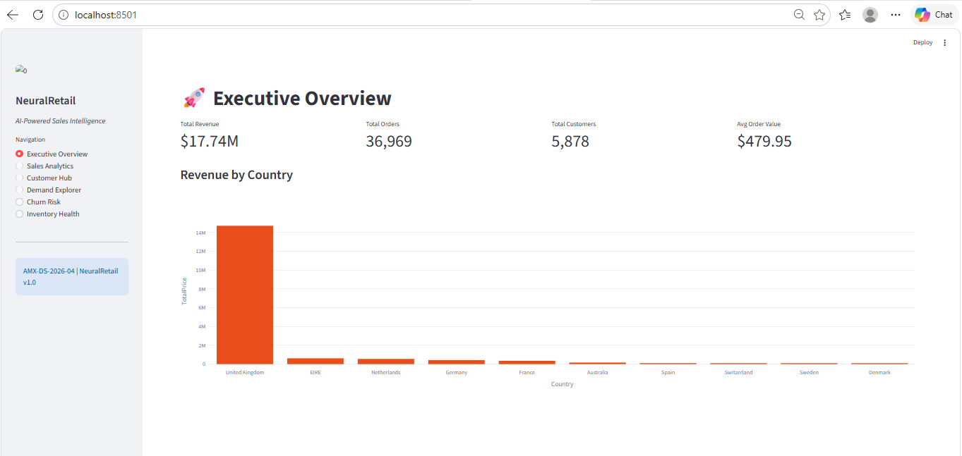
Fig : Executive Overview
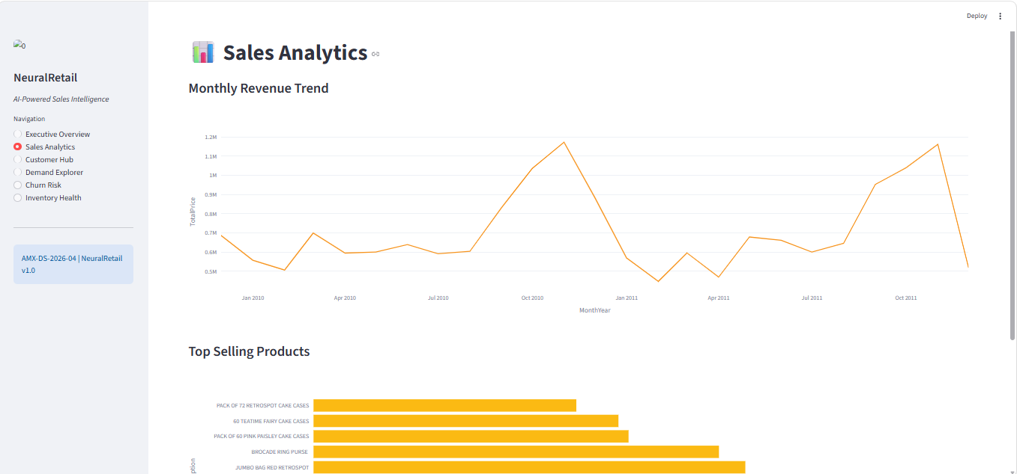
Fig : Sale Analysis
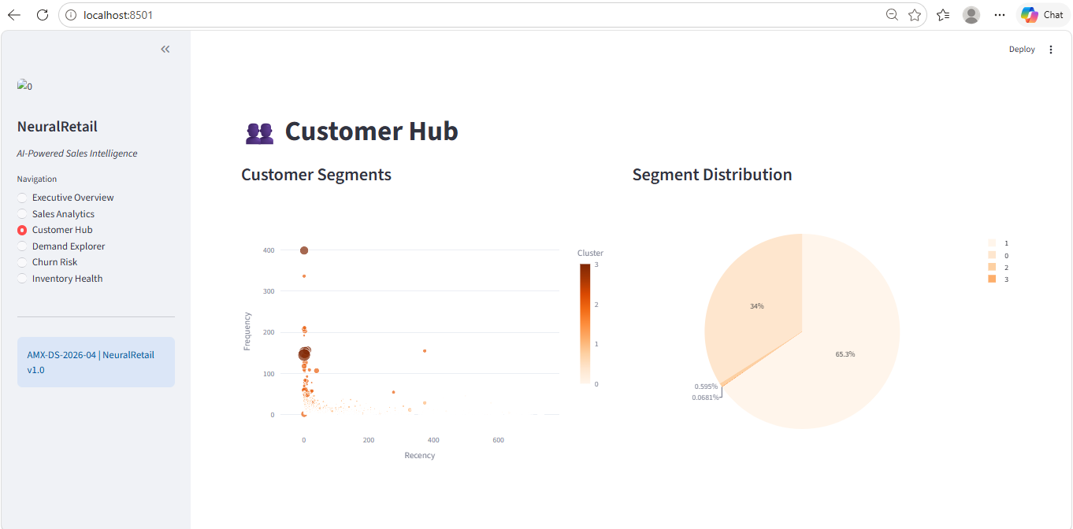
Fig : customer Hub

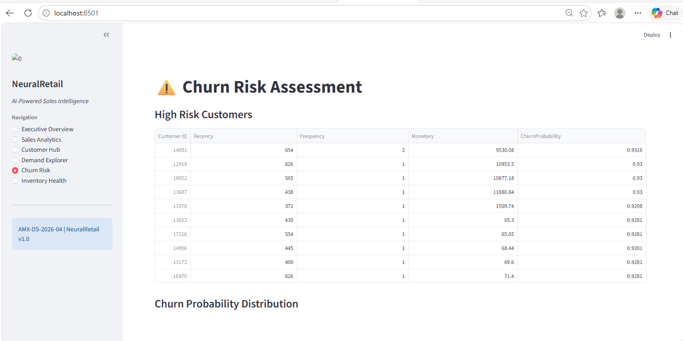
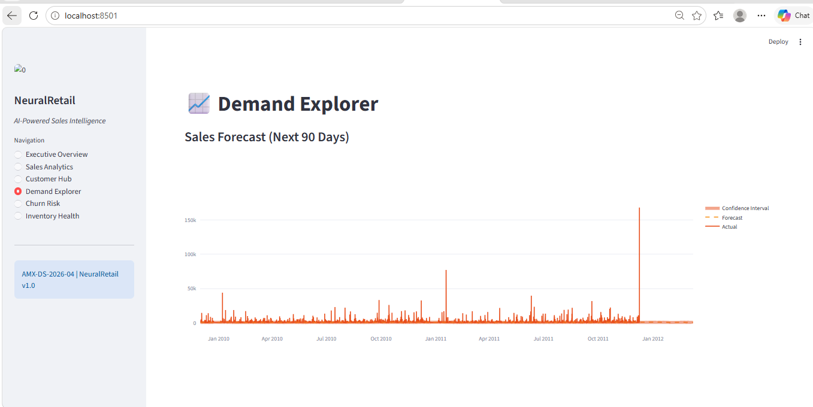
Fig : Demand Forecasting
Fig : Churn Risk Assessment
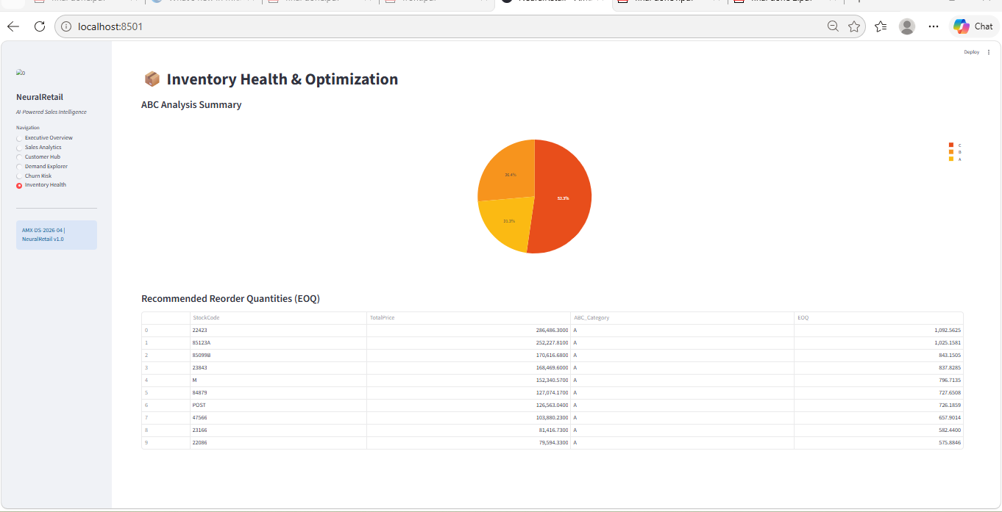
Fig: Inventory health and Optimization

