**AUTOMATIC TRANSMISSION CONTROLLER**

Automatic transmission controller is a part of the drivetrain module. This helps in controlling the speed of the vehicle using effective gear shifting. The figure below shows the power flow in an automotive drivetrain.

*Throttle*

**Engine**

**Vehicle**

**Dynamics**

**Transmission Gear Ratio**

**Torque**

**Converter**

*Brake*

**Transmission**

**Control Unit (Stateflow**)

We implement the model as per the basic block diagram above. We will be going for a 4 speed automatic transmission. Here we implemented the model as per the block diagram. Transmission Control unit alone does not go well with differential equations hence we use stateflow representation to implement the gear shifting action.

The rest of the blocks are modelled with Non-linear ordinary differential equations.

1. The throttle opening is one of the inputs to the engine. The engine is connected to the impeller of the torque converter which couples it to the transmission.

**Equation 1:**

1. The input-output characteristics of the torque converter can be expressed as functions of the engine speed and the turbine speed.

**Equation 2:**

1. The transmission model is implemented via static gear ratios, assuming small shift times.

**Equation 3:**

1. The final drive, inertia, and a dynamically varying load constitute the vehicle dynamics.

**Equation 4:**

1. The load torque includes both the road load and brake torque. The road load is the sum of frictional and aerodynamic losses.

**Equation 5:**

**Simulink Model :**

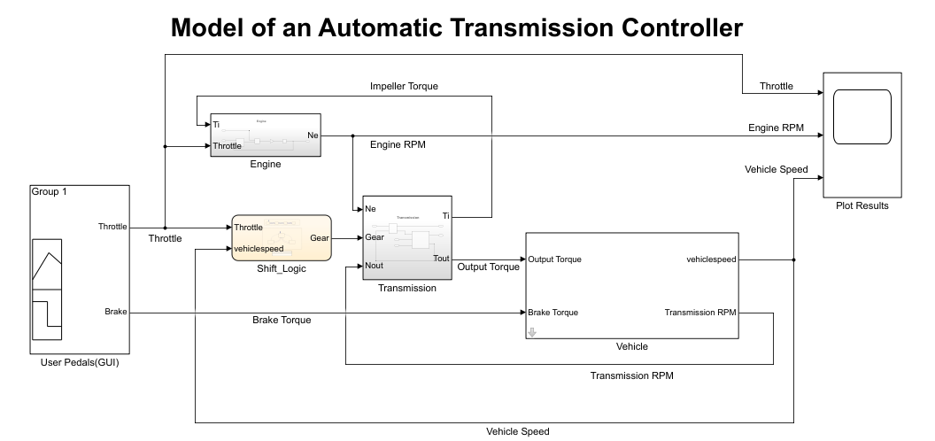

This is the model of Automatic Transmission Controller implemented in the Simulink model file.

**Engine Subsystem**

This takes the inputs Throttle and Impeller torque and gives the output of engine RPM.

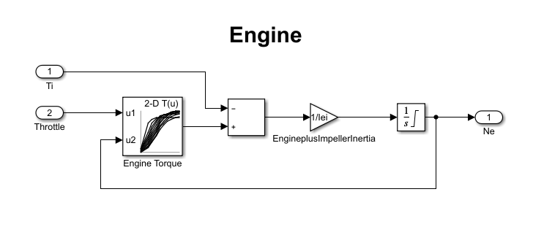

**Transmission Subsytem**

This module is divided into two other subsystems

* Torque Converter
* Transmission Gear Ratio

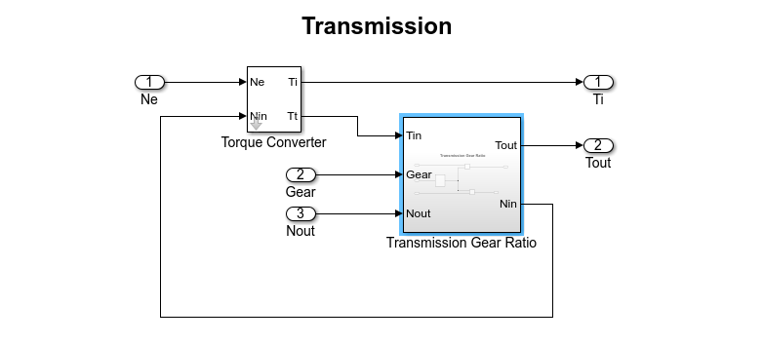

This takes the input of engine speed , Transmission RPM and Gear and provides the output Impeller torque and Output torque.

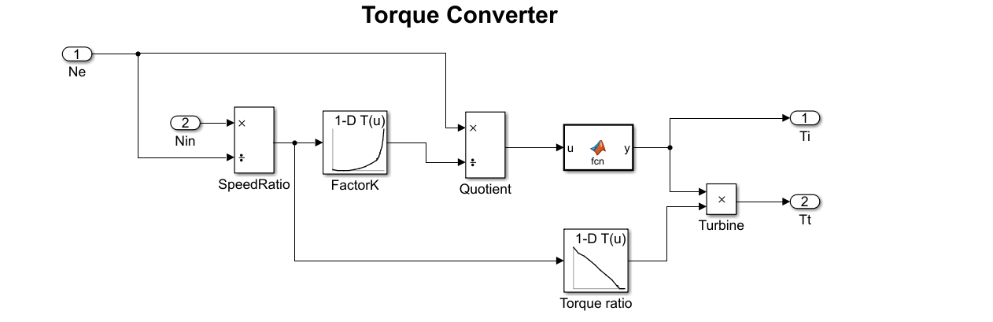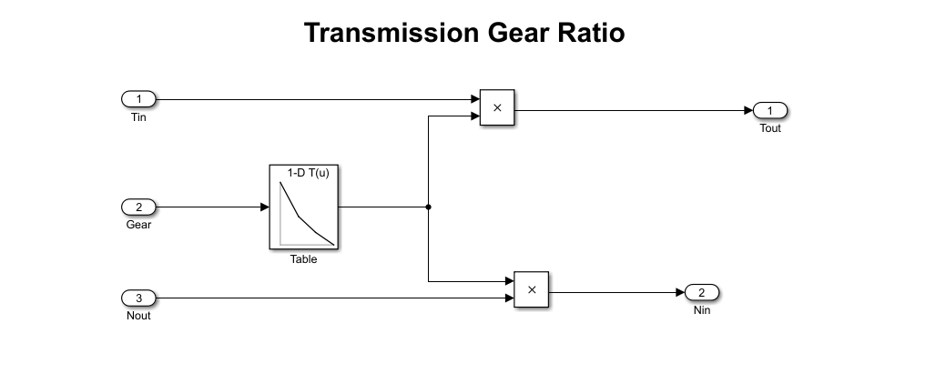

This calculates the transmission gear ratio using the lookup table.

**Vehicle Subsystem**

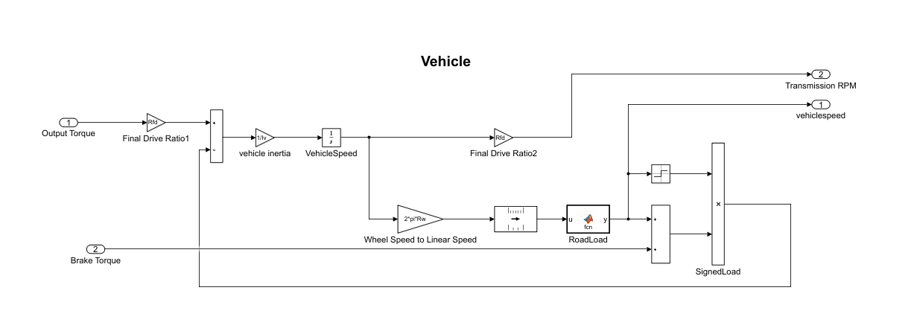

This subsystem takes the input of Output Torque and Brake Torque and provides the output Transmission RPM and vehicle speed.

**Transmission Control Unit (Using Stateflow)**

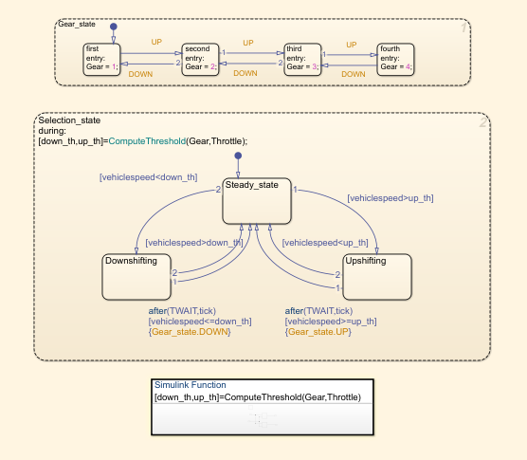

1. **Callbacks**

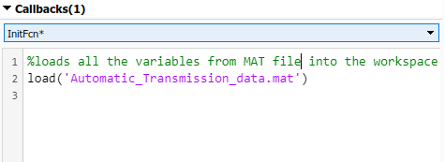

I have used Model callback here to load the variables from MAT file into

the workspace.

1. **Data Inspector**

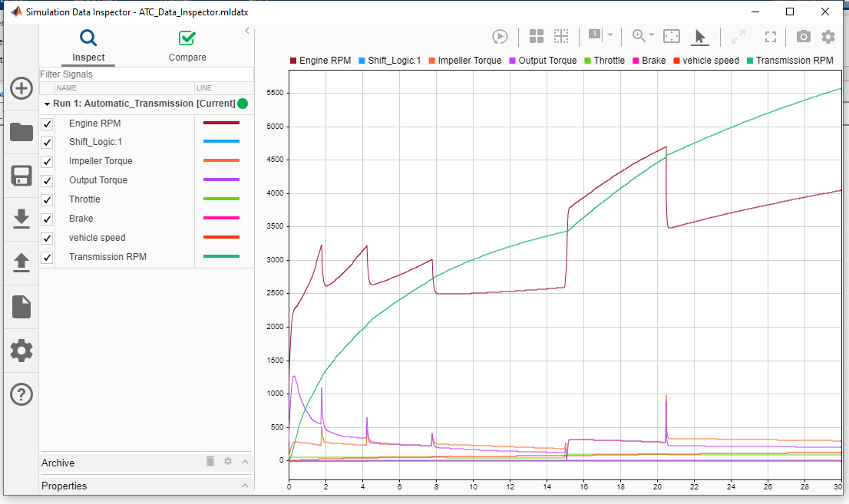

1. **Solver Selection Strategy**

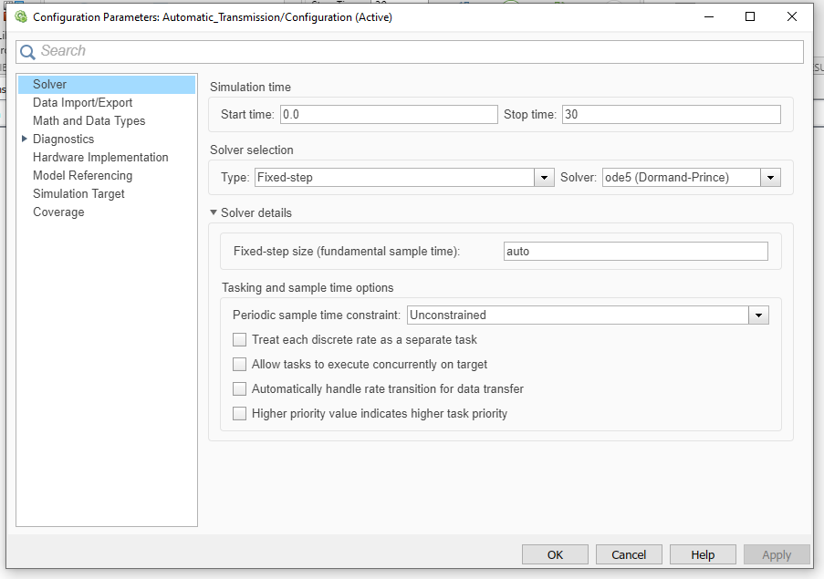

One common case to use a fixed-step solver is for workflows where you plan to generate code from your model and run the code on a real-time system.

With a variable-step solver, the step size can vary from step to step, depending on the model dynamics. In particular, a variable-step solver increases or reduces the step size to meet the error tolerances that you specify and as such, the variable step sizes cannot be mapped to the real-time clock of a target system.

1. **MATLAB function block**

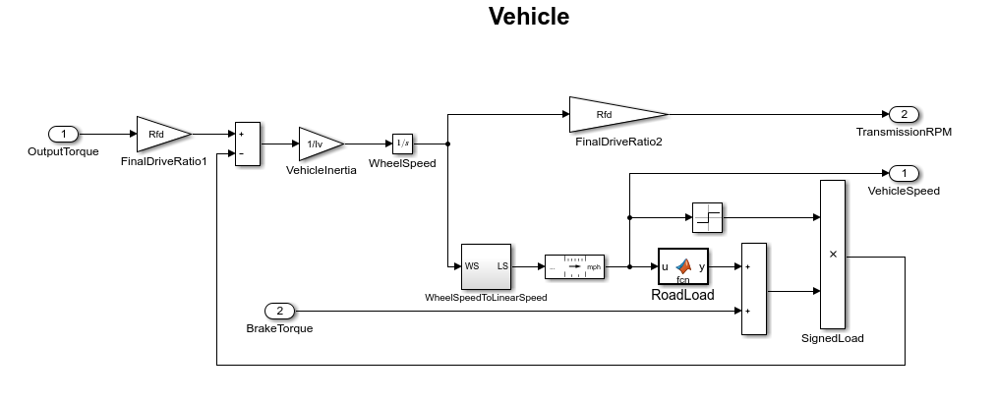

Matlab function block used in vehicle is Road load which takes the input mph and calculates both the friction on road and aerodynamic drag of wheels and couples it to the signed load.

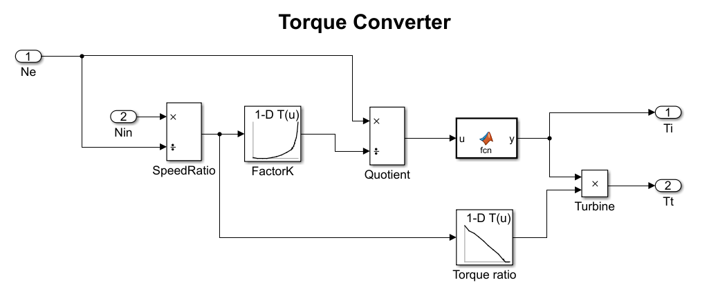

Matlab function used in Torque converter is normal expression of u^2 where u is the input function of the block.This then multiplies with the torque ratios to give the total output torque.

1. **Look-up table**

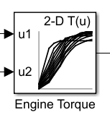

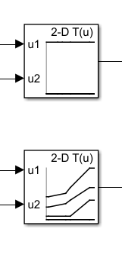

1. (B)

The first lookup table (A) is used in Engine subsystem to determine the Engine Torque. This uses a

2-D lookup table which has table data emap. Breakpoints 1 and Break points 2 are thvec and nevec respectively.

The Second pair of 2-D lookup tables (B) are used in Stateflow chart’s Simulink function to determine the gear up shifting and gear down shifting. They perform operations with the table data up_tab and down_tab respectively and Breakpoints 1 are up_th and down_th.Breakpoint2 remains the same [1:4].

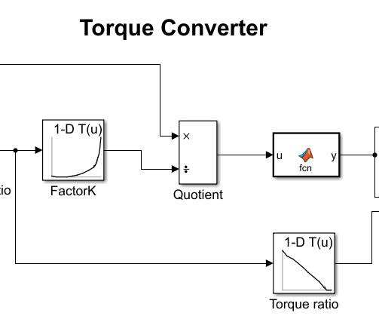

The third pair of lookup tables are used in the torque converter .These are 1-D lookup tables which calculate the K factor and Torque Ratio. The FactorK lookup table takes table data Kfactor and Breakpoint as speedratio. The Torque Ratio lookup table takes the table data Torkratio and breakpoint as speedratio.

1. **Signal Builder**

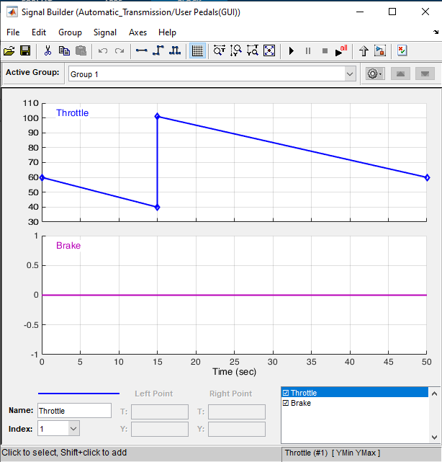

This is the signal used in the signal builder to generate the throttle and

brake signal for which the output is recorded in the scope.

