**Browser commands in the selenium:**

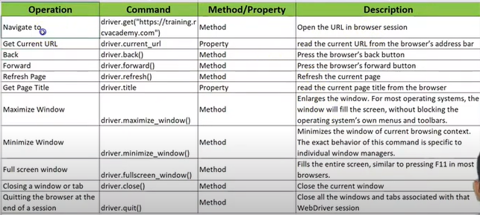

**Getting text data from web page:**

* After locating the web element using selectors then using text property we can get the text data

Ex: text1 = driver.find_element(By.CSS_SELECTOR, "h1[class='paragraphHeading']").text

**Getting attribute value from web page like buttonname like login:**

* Using get_attribute method we can get the value of that attribute

Ex: text1 = driver.find_element(By.XPATH,  
 "selector").get_attribute('value')

**Getting the state of the element i.e. button is enabled or not:**

* We can get the state of the element by using the method is_enabled()

Ex: state1 = driver.find_element(By.XPATH, "//button[@id='edit-submit']").is_enabled()

**Finding hidden elements in web page using is_displayed():**

There can be two possibilities in finding the hidden elements i.e.

* Hidden element which is present in dom i.e. in html code but covered by css stylesheet
* Hidden element which is completely destroyed from dom

in first case is_displayed() method will give true or false whether the element is present or not

in second case it throws exception as it is completely destroyed from dom