**XPATH**

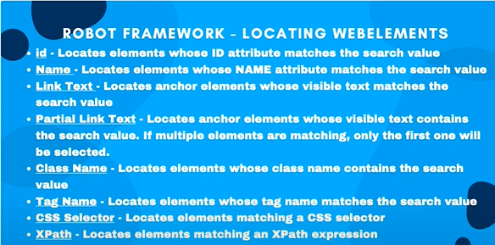



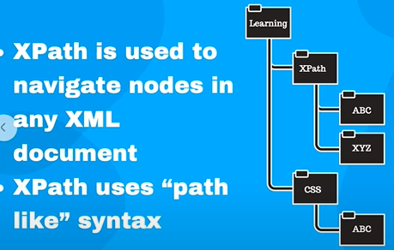

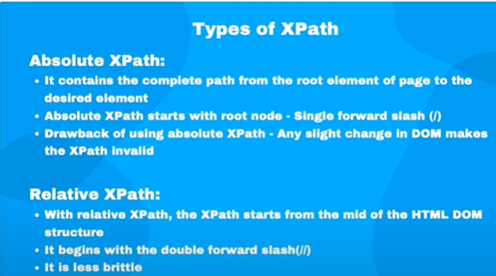

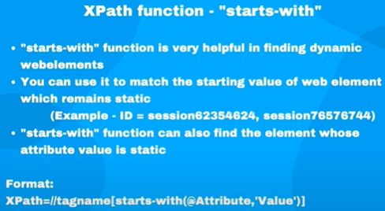

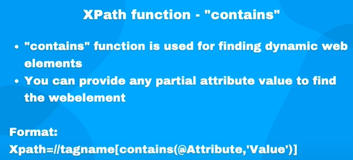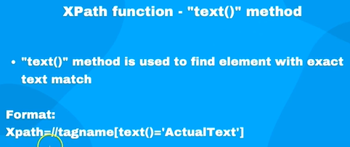

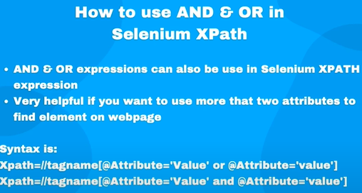

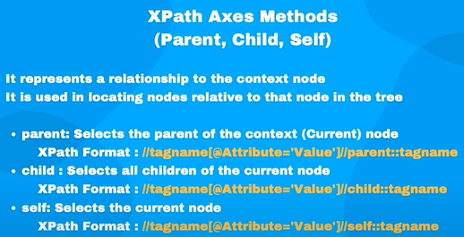

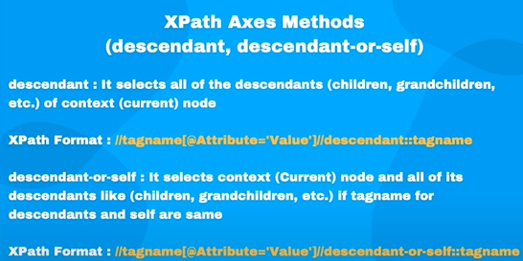



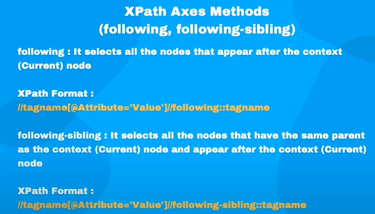

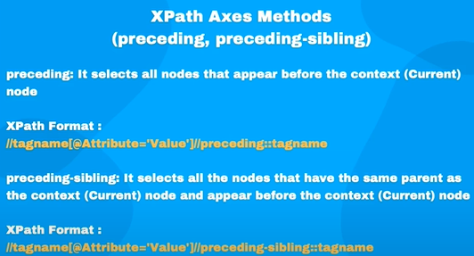

**JavaScript in selenium:**

Javascript execution can be done in selenium using method driver.execute_script() method

Generally when we can’t find or unable to interact with web elements using selenium web driver in that case we can use javascript to find or interact with complex webelements i.e. hidden or can’t get the path in that scenarios.

**Handling multiple windows:**

When there is a scenario that we click on one element which open a new window or tab and then we need to click on another element in that window than we have switch the window handle to perform. So, we can handle multiple window by using method

**driver.switch_to.window()**  in this we have to pass the handle where we want to move the control. We can get current window handle by using property **driver.current_window_handle**  to get on which window the control is.

To get list of all handle that is number of windows which we are working we use

**Driver.window_handles**

**Iframes:**

in a window we can have multiple frame which are created by using iframes tags. the elements which fall inside  
# can be accessed only after switching to that frame

we can switch between frames vy using method:

**driver.switch_to.frame()** we can pass the finding the element by iframe path to switch to that frame.

**Handling javascript alert:**

In windows there are some cases were we need to interact with javascript alert box also.

So to handle javascript alerts with selenium we can use some method like

* **Driver.switch_to.alert.accept()**  to accept the alert
* **Driver.switch_to.alert.dismiss()**  to reject the alert
* **Driver.switch_to.alert.sendkeys()**  to write the data into alert box
* **Driver.switch_to.alert.text**  to get the data in alert box

We can also use Alert class by importing

From selenium.webdriver.common.alert import Alert

Then we can use like

Accepting / Dismissing alert prompts:

Alert(driver).accept()

Alert(driver).dismiss()