**Handling Mouse hover:**

There will be scenarios that when we place the cursor on web element it show small hidden tab like thing. So if we want to perform any action on web element present in that tab we want nouse operation to hoverover it and click on that webelement.

So in selenium like we have **Keys** class to perform keyboard operation like that we have

**ActionChains** class to perform mouse operations. We have to pass driver as parameter to action chain class like object = **ActionChains(driver)**

in this action chain class we have various methods that helps us to perform mouse operation.

**Handing drag and drop:**

We can handling this drag and drop operation by ActionChains class by using method like

**ActionChains(driver).drag_and_drop(source, target)** or

**ActionChains(driver).drag_and_drop_by_offset(source, xaxis, yaxis)**

**Waits:**

**Three types:**

* **Implicitwait**
* **Expilcitwait**
* **Fluentwait**

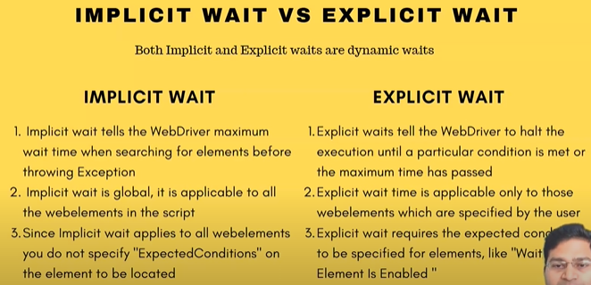

**Fluent wait:**

FluentWait instance defines the maximum amount of time to wait for a condition, as well as the frequency with which to check the condition.

Here implicit wait can be used by driver.implicitly_wait(10)

But for accessing explicit and fluent wait we have import webdriverwait and expected_condition class