**Testing:**

1. Unit testing
2. Integration testing

**Unit Testing:**

The process of testing whether a particular unit is working properly or not is called unit testing.

Developer is responsible for this testing

**Integration testing:**

The process of testing total application (end to end testing)

**QA is** team is responsible for this testing.

We have to remember three terminologies like

**Test scenario**

**Test case**

**Test suite**

Considering Gmail application

Testing the login functionality is one **test scenario**

**Test cases** are like

1. valid user and password

2. Invalid user and password

3. valid user and invalid password

4. invalid user and valid password

5. empty username and empty password

** In single test scenario contain multiple test cases.

Generally, testcases are get executed one after another but **test suite** means a group of test cases that can be executed at once.

**To perform unit testing:**

Import module unittest

Creating child class by inheriting parent class **Testcase**

This class will have 3 instance methods

1. Setup()
2. Test()
3. Teardown()

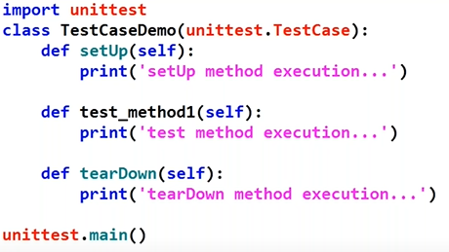

In above setup() and testdown() should be same but middle test method name can be anything but the name start with test.

Setup() method is for environment setting and teardown is for closing connections.

We can include many testcase instance method inside class between setup and teardown method like below.

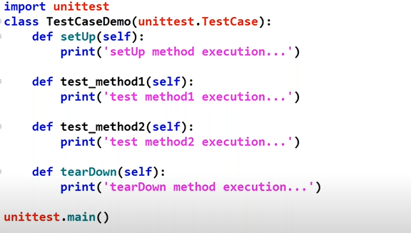

In above code the execution done in below way:

Setup() 🡪 test_method1() 🡪 teardown()

Setup() 🡪 test_method2() 🡪 teardown()

Like above the method will execute in that order.

It is executing in that order because consider below example:

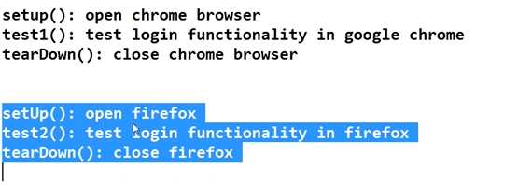

Apart from this three instance methods there are two class methods that are

setUpClass(cls) method and

teardownclass(cls) method

we use these method when the two or more test method need constant setup and teardown method means the environment which the two testmethod wants is same and closing the environment is also same than we use this methods.

Example like below;

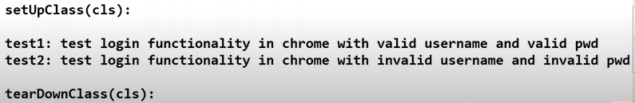

In the setup class we need to open the chrome for two testcases and in teardown method we need to close the chrome for two testcases.

**Limitations of unit testing:**

1. Test results can be displayed only in console and it is not possible to generate reports.
2. Unit test framework always execute test methods in alphabetical order only and it is not possible to customize execution order.
3. As the part of batch execution (test suite), all test methods for specified testcase classes will be executed and it is not possible to specify particular methods.
4. In unit testing only limited setup and teardown methods are available.

**Test suite:**

Group of test case classes is called as test suite.

If we want to perform any activity before executing test suite or after executing test suite, unit test frame work does not define any methods.

To overcome the limitations of unit testing , we can use more advanced testing frame work **pyTest.**

**Pytest framework:**

pyTest is advanced version of unit test framework.

Built on the top of unit test framework.

To use pytest install pytest **pip install pytest**

**pyTest naming conventions:**

1. File name should start or end with test

example: test_google.py or google_test.py

1. Class name should start with “Test”

Example: TestGoogle, TestDemo

1. Test method names should starts with “test_”

Example: test_method1, test_method2

To run all the test scripts we use **py.test** command in terminal

To run particular test script file use **py.test filename.py**

To get display only print statements in console use -s and to get the details of execution use -v

Example: command **py.test -s -v filename.py**