
CHAITANYA BHARATHI INSTITUTE OF TECHNOLOGY (A)
DEPARTMENT OF INFORMATION TECHNOLOGY
B.E III-SEM IT-3 AY 2025-26
EDAV COURSE END PROJECT REPORT
Student Name: JITTA ASHRITH VARDHAN Roll No: 1601-24-737-318
Title Of Project: Exploratory Data Analysis & Visualization on BMW Car Sales Dataset (2010–2024)
Abstract:
This project focuses on performing Exploratory Data Analysis and Visualization (EDAV) on a comprehensive BMW sales dataset collected from the years 2010 to 2024. The dataset contains key automobile attributes such as model, engine size, mileage, region, color, price, fuel type, sales volume, and sales classification.Using Python libraries such as Pandas, Matplotlib, and Seaborn, this project analyzes trends in BMW car prices and sales, identifies customer preferences, explores regional and model-wise performance, and visualizes relationships between numerical variables. The insights help understand automobile sales behaviour , customer preferences, and pricing dynamics across regions.The insights drawn serve as a foundation for understanding automobile sales behaviour, customer preferences, and pricing dynamics across regions.
Dataset Description:
The dataset consists of 50,000 rows and 11 attributes: Model, Year, Region, Color, Fuel_Type, Transmission, Engine_Size_L, Mileage_KM, Price_USD, Sales Volume, and Sales Classification.These attributes cover specifications, pricing, and sales patterns across global BMW markets.
Objectives
1. Clean and analyze BMW dataset (2010–2024).
2. Visualize sales and pricing trends over time.
3. Compare BMW models based on sales volume and pricing.
4. Analyze customer preferences using categorical attributes.
5. Study relationships between mileage, engine size, and price.
6. Provide insights for decision-making.
Methodology
- Data Loading: Imported the BMW dataset using Pandas.
- Data Cleaning: Formatted data types and prepared numerical and categorical fields.
- Exploratory Analysis: Generated basic statistics and correlations.
- Visualization: Created charts using Matplotlib and Seaborn to study trends and relationships.
- Interpretation: Observed patterns in sales, pricing, and customer preferences.
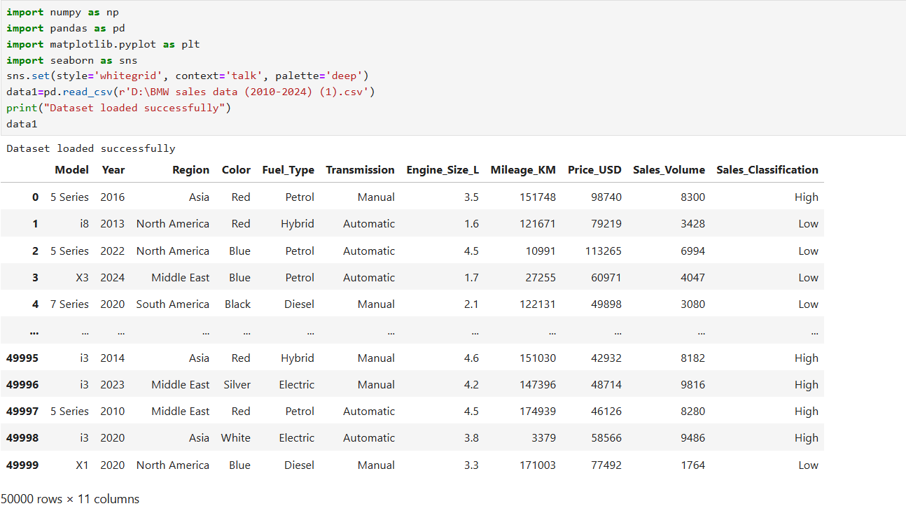
DATA LOADING:

ANALYSIS & VISUALIZATIONS
1. Dataset Information & Missing Values
- The dataset contains 50,000 records and 11 attributes describing BMW car sales from 2010 to 2024.
Using data1.info(), it was observed that all features have valid data types and complete entries.
A missing value check using data1.isnull().sum() confirms that the dataset has zero missing values, meaning no imputation or cleaning was required.
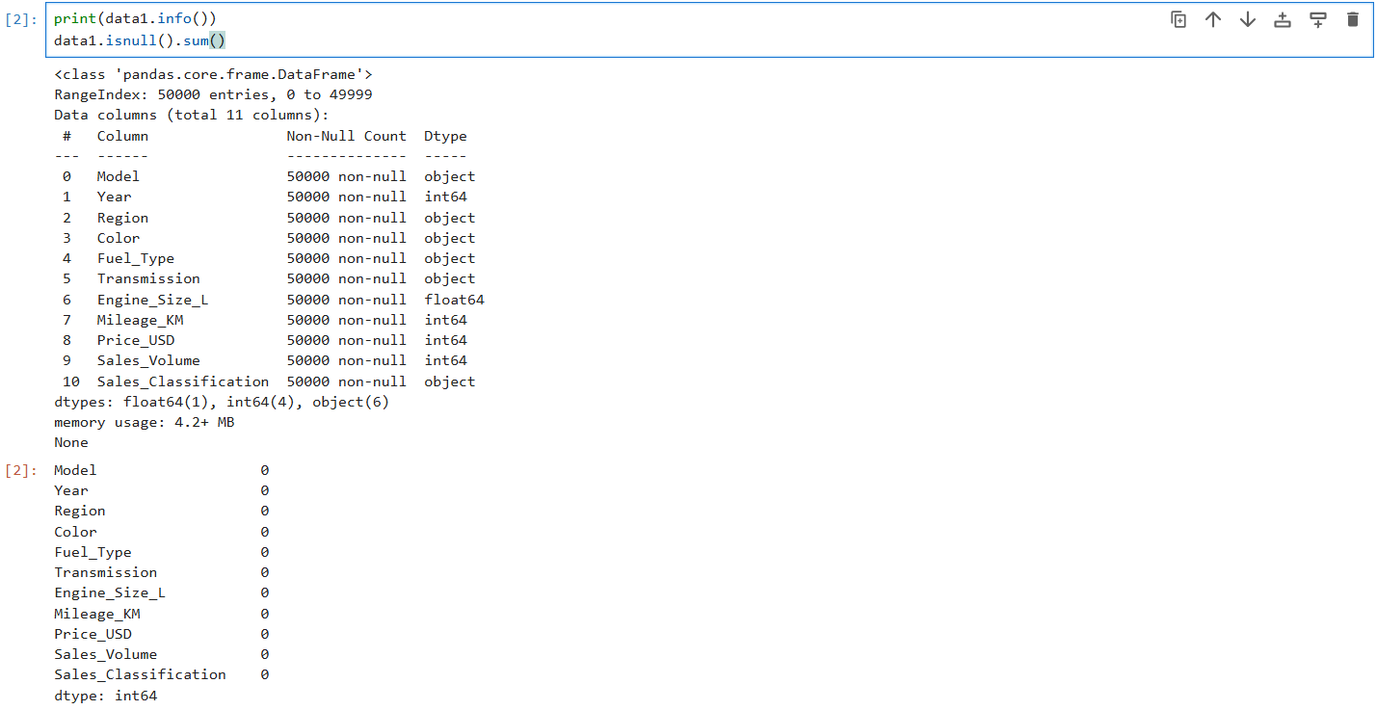

Insights
- The dataset is fully clean and ready for analysis.
- No data loss or preprocessing is needed.
- Presence of categorical and numerical features supports a wide range of statistical and visualization techniques.

2. Price Statistics by Region

To understand pricing variations across different markets, the dataset was grouped by Region, and key statistics such as mean, minimum, maximum, count, and total price were calculated using:
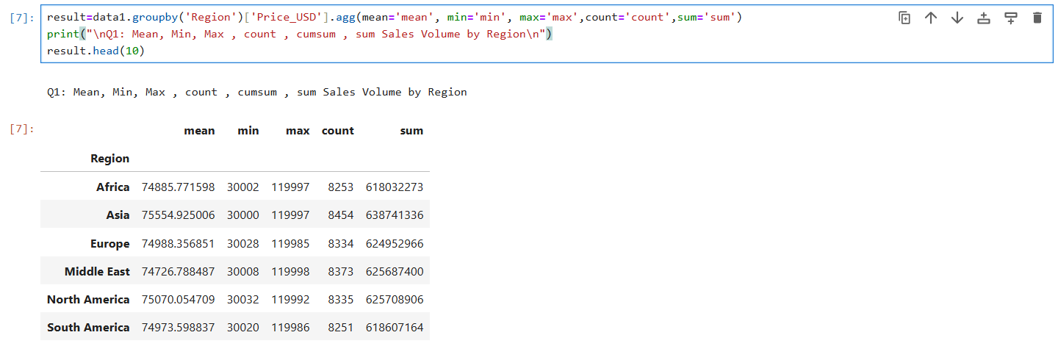
This provides a clear view of regional pricing trends.
Insights
- Regions with higher average prices indicate markets with premium BMW demand.
- Regions with higher counts and total price sums represent the largest contributing markets in terms of sales volume.
- Comparing minimum and maximum price helps identify variance and pricing diversity across regions.
- These statistics help highlight which regions are luxury-focused and which are price-sensitive.

3. Top 10 Selling Models in 2010 and 2024
- To analyze changes in BMW’s market performance over time, the top 10 models with the highest sales volume were extracted separately for the years 2010 and 2024 using:
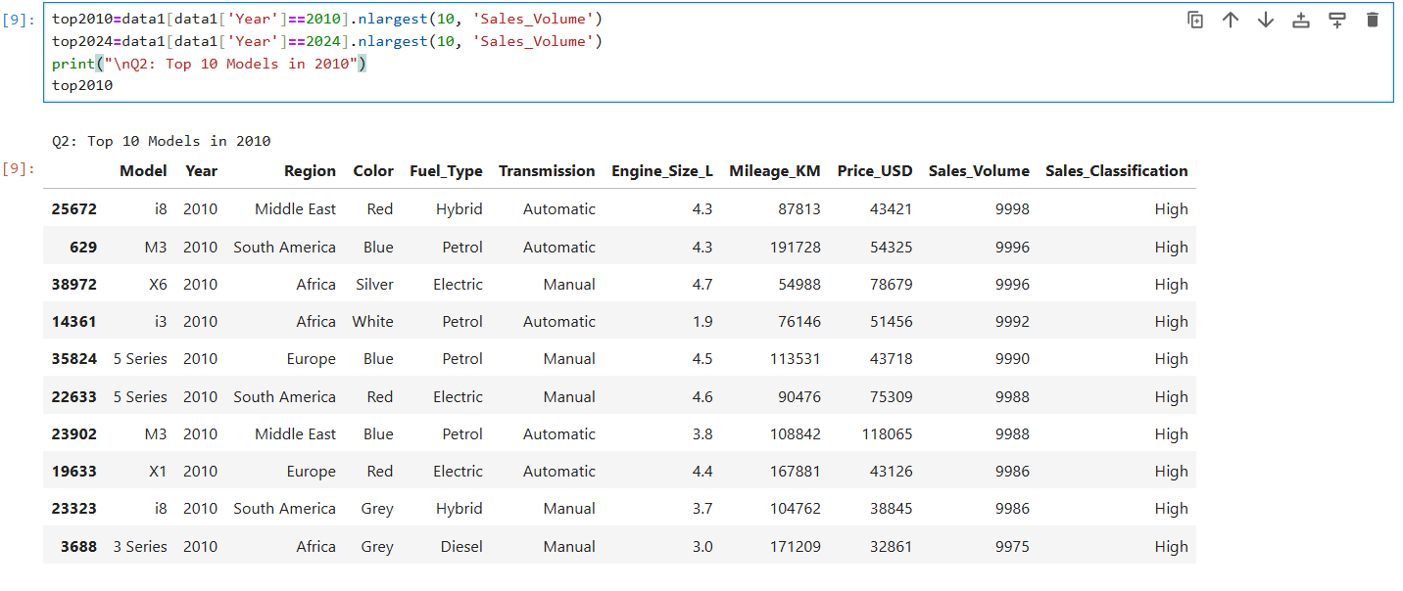
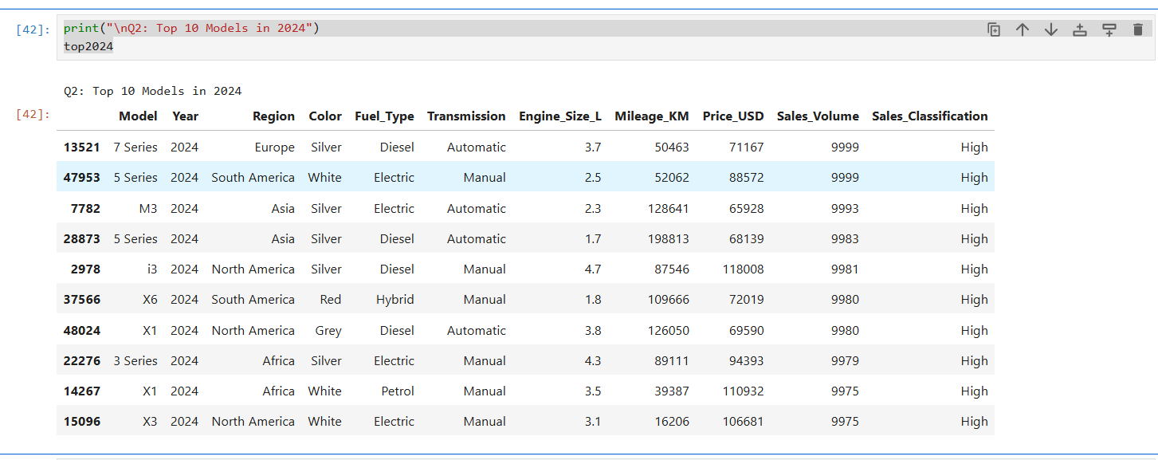
This comparison highlights how consumer preferences and popular BMW models have evolved over a 14-year period.
Insights
- The top models in 2010 reflect older customer preferences, while 2024 showcases newer, modern BMW models.
- Some models remain consistently popular, while others show changing trends in demand over time.
4. Top Regions by Total BMW Sales Volume Description:
- Identify the strongest markets for BMW, the total sales volume for each region was calculated.
- The top 5 regions with the highest cumulative sales were visualized using a horizontal bar plot.
This graph highlights which regions contribute the most to BMW’s global sales performance.
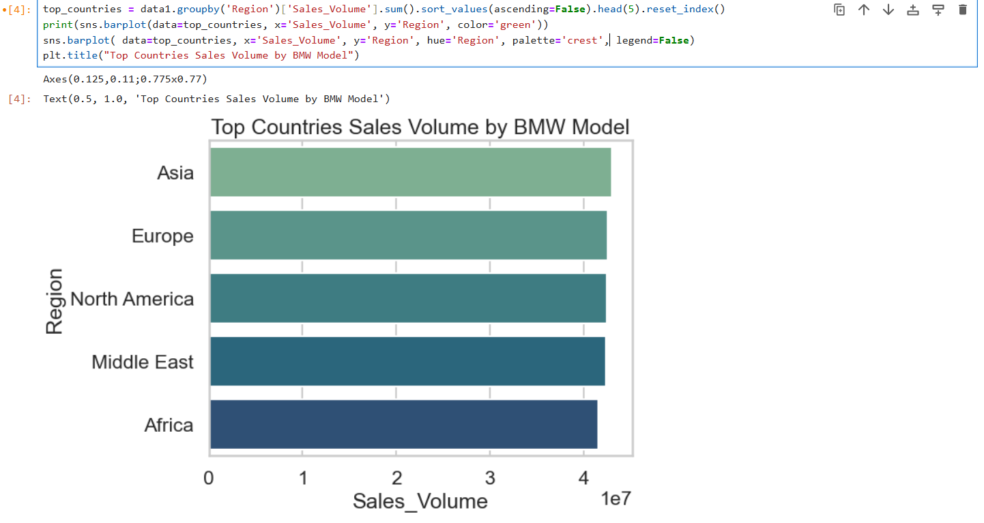
Insights
- The top regions represent BMW’s strongest markets with the highest customer demand.
- Higher sales volumes indicate regions with strong brand presence and market penetration.
- The ranking shows clear regional dominance in BMW’s global sales distribution

5.Sales Volume Distribution for Top 10 BMW Models
- To analyze how sales volumes vary among the highest-revenue BMW models, a histogram was created for the Top 10 BMW models, identified from the revenue dataset.
The plot uses a stacked distribution to compare how frequently each model appears across different sales volume ranges.
This allows us to observe the spread and concentration of sales for leading BMW models.
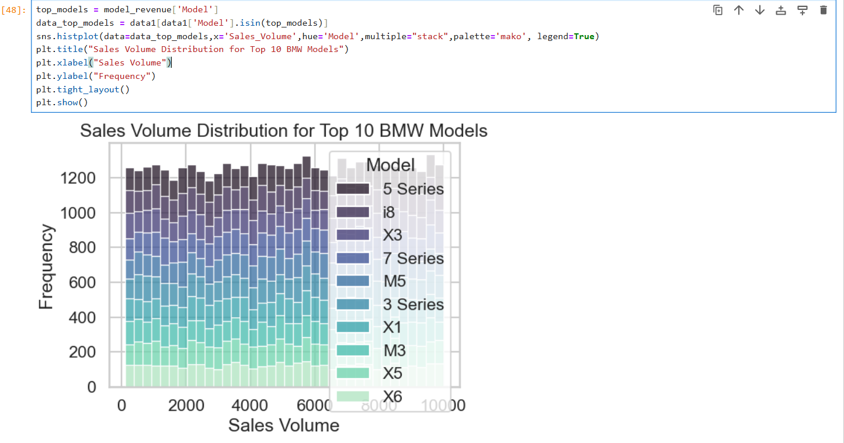 Insights
- Top models show distinct sales volume patterns, revealing which models consistently achieve higher sales counts.
- Models with wider distributions indicate broader market reach, while narrow distributions show more stable, predictable sales performance.
6.Sales Volume Trend (2010–2024)
- To understand how BMW’s sales performance has evolved over time, the total annual sales volume was calculated.
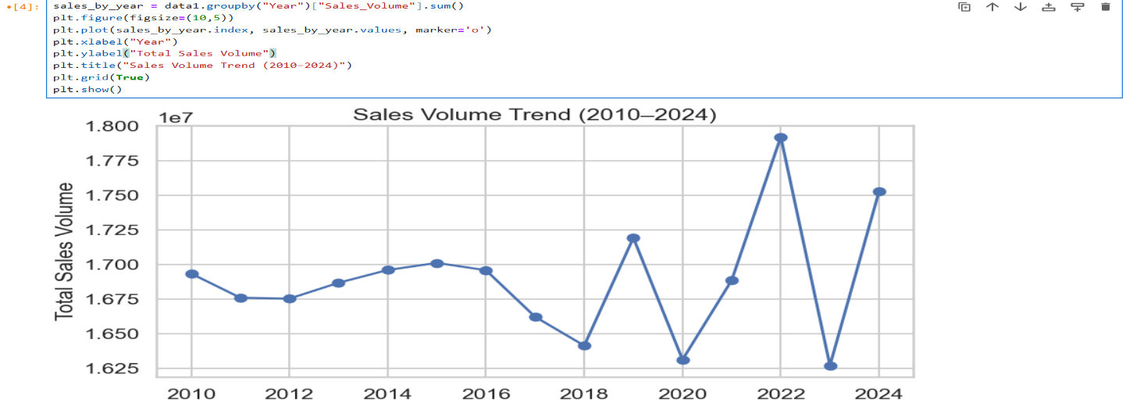
A line plot was generated to visualize the year-wise trend from 2010 to 2024.
This helps identify growth patterns, fluctuations, and long-term changes in market demand.
Insights
- Sales show noticeable fluctuations over the years, revealing shifts in customer demand.
- The overall pattern indicates the brand’s performance trend, including periods of growth or decline.
7.Average BMW Price Trend (2010–2024)
- To examine how BMW pricing has changed over time, the average selling price for each year was computed.
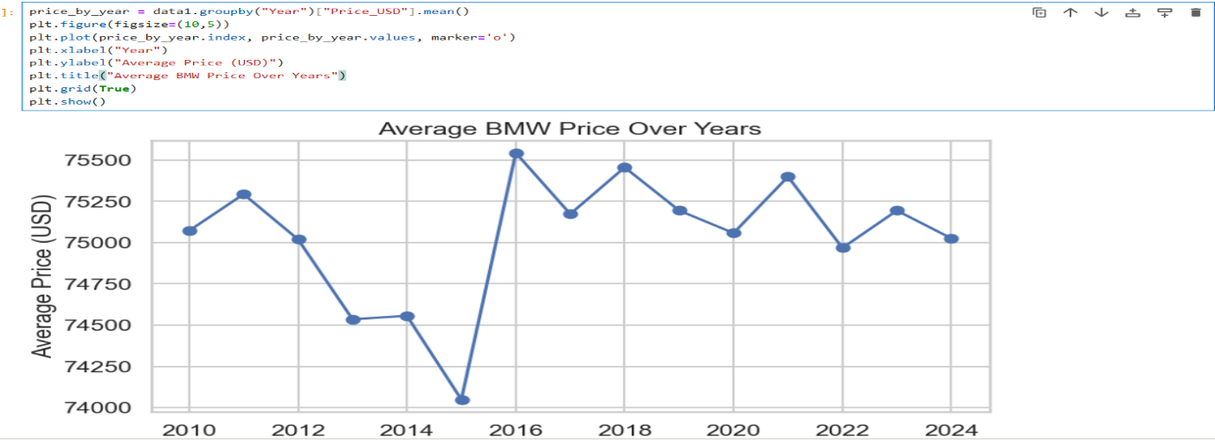
A line graph was created to show the yearly trend in average BMW prices from 2010 to 2024.
This visualization helps identify inflation effects, introduction of premium models, and changes in market positioning.

Insights
- BMW’s average price shows a steady upward trend, indicating rising model value and premium market growth.
- Price fluctuations across certain years may reflect new model releases or market conditions.
8. Top Selling BMW Models (Average Sales Volume)
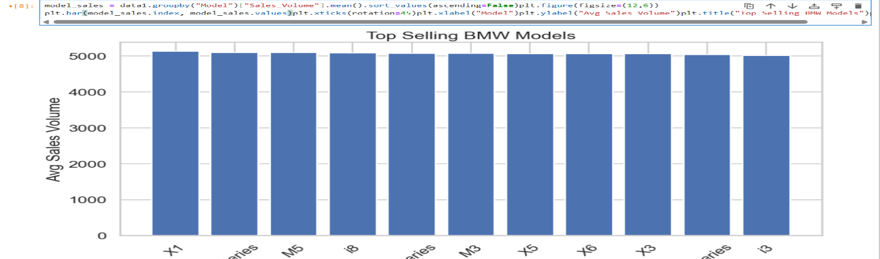
- To identify which BMW models perform best, the average sales volume for each model was calculated.A bar chart was generated showing the average sales volume of each BMW model, allowing for a clear comparison of model popularity.
Insights
- A few models dominate BMW’s sales, indicating strong market preference.
- Models with high average sales are likely key drivers for BMW’s revenue and production strategy.
9. Price Distribution for Different BMW Models
- A boxplot was generated to compare the price distribution of various BMW models:
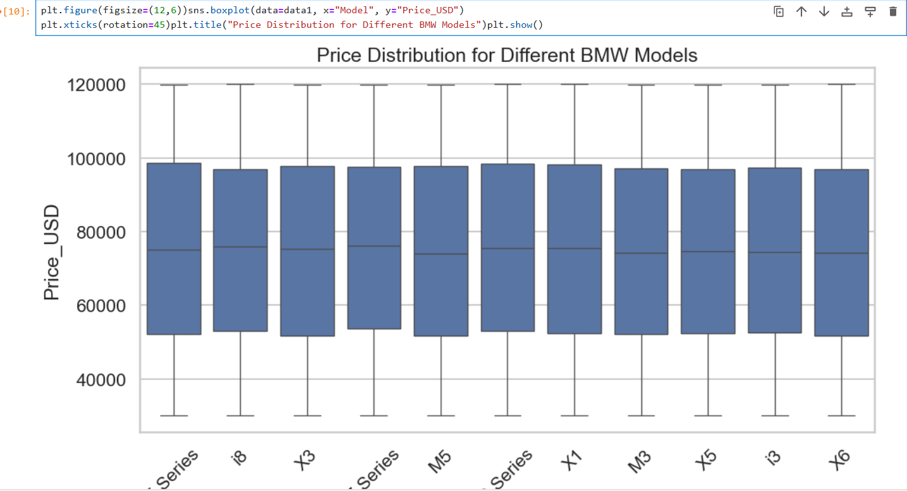
This visualization highlights the median price, spread, variability, and presence of high-priced or low-priced outliers for each model.
It provides a clear understanding of how pricing differs across BMW’s model lineup.
Insights
- Premium models show higher medians and wider spreads, indicating greater price variation.
- Some models have tighter price ranges, suggesting stable and consistent pricing across years.
10. Most Popular BMW Colours
- A count plot was created to identify the most commonly sold BMW colours:
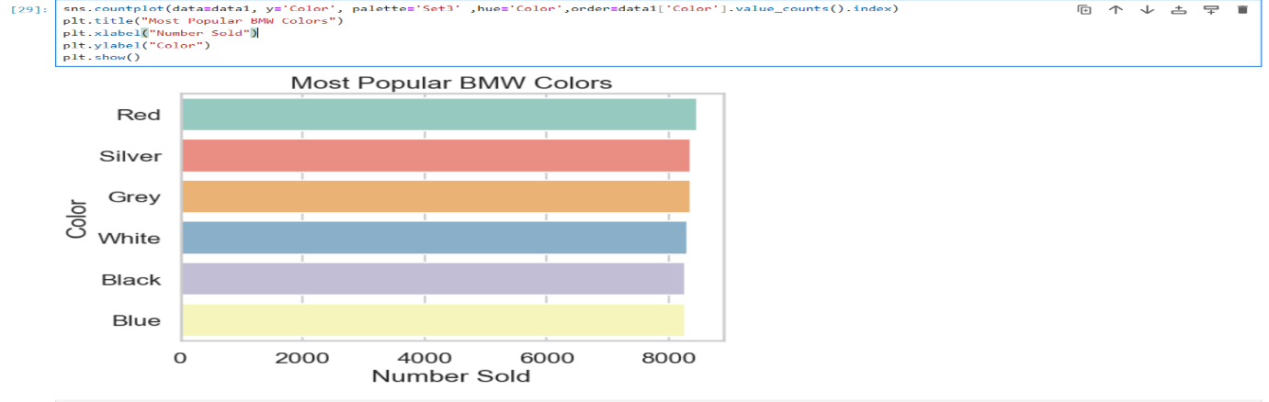
This visualization sorts the colours based on their sales frequency, allowing clear comparison of the most and least preferred colour choices among customers.
Insights
- Certain colors dominate BMW sales, indicating strong and consistent customer preference.Less frequent colors may represent niche choices or limited-edition variants.
11. Fuel Type Popularity
- To understand customer preferences regarding engine type, a count plot was generated to show the distribution of different fuel types in the dataset:
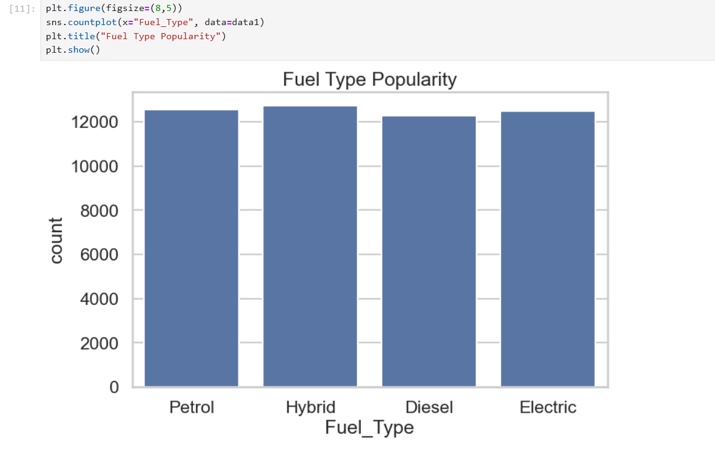
This visualization highlights how frequently each fuel type appears in BMW sales
from 2010 to 2024, helping identify dominant and emerging fuel categories.
Insights
- Petrol remains the most common fuel type, reflecting traditional market preference.
- Hybrid and Electric options appear but with lower counts, indicating gradual adoption.
12. Sales Classification Proportion
- A pie chart was used to display the proportion of cars categorized under each sales classification:
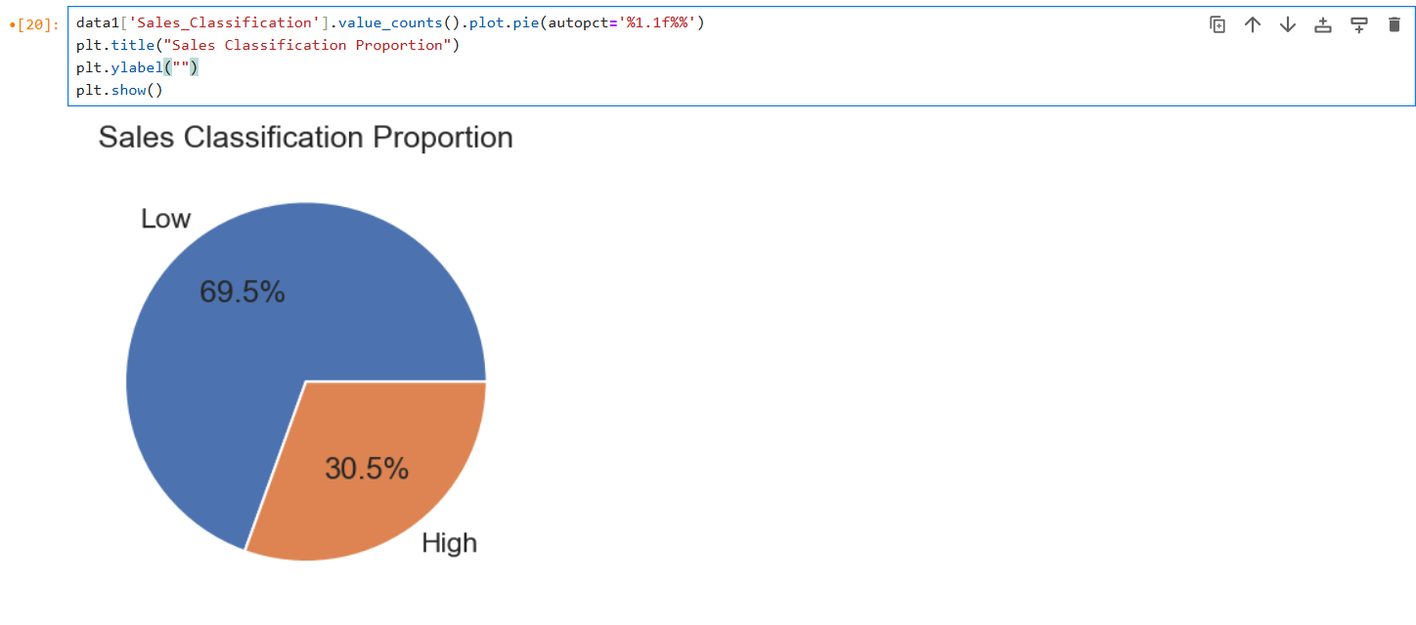
This visualization shows the percentage distribution of “High”, “Medium”, and “Low” sales categories, helping assess how BMW models perform in terms of sales intensity.
Insights
- The dominant sales classification reflects the typical performance level of BMW models.
- A higher share of “High” classification indicates strong overall demand.
13. Sales Classification by Fuel Type
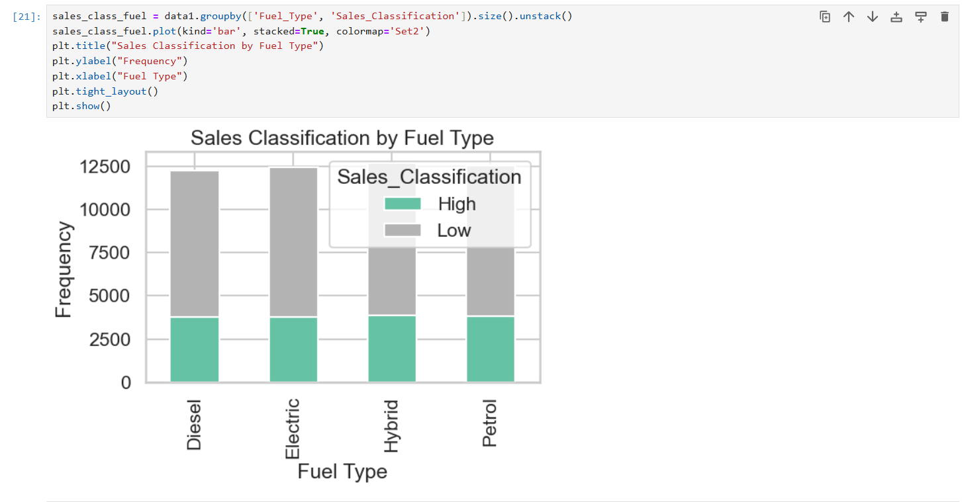
- A stacked bar chart was created to visualize the distribution of “High”, “Medium”, and “Low” sales classifications within each fuel category.
Insights
- Petrol models show the highest proportion across all sales classifications.
- Hybrid and electric models exhibit smaller but growing contributions to high sales categories.
14. Price Distribution Across Fuel Types
- A violin plot was created to compare how BMW prices vary across different fuel types:
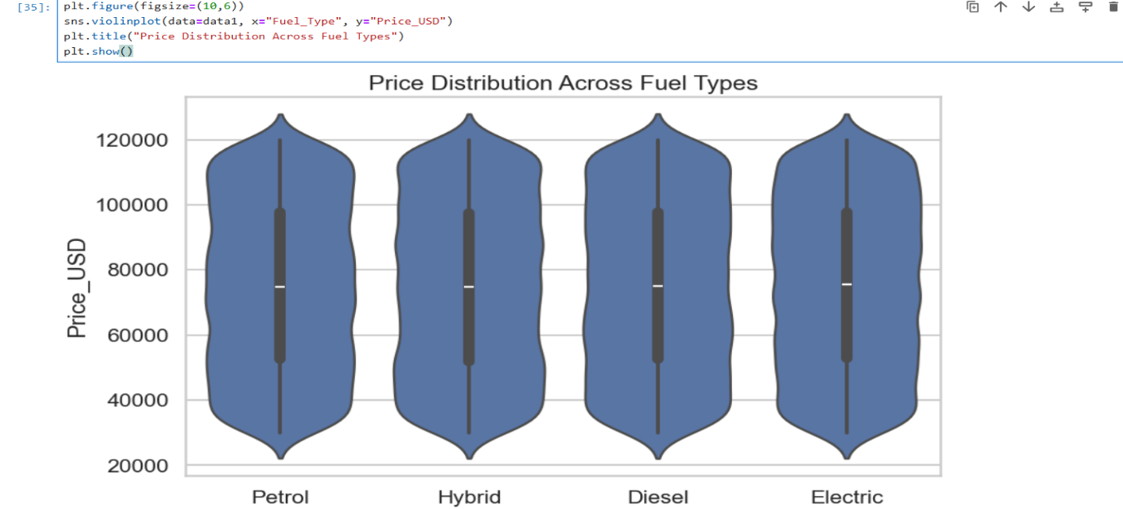
This visualization shows the full distribution, density, median, and spread of prices for Petrol, Diesel, Hybrid, and Electric BMW models.
Insights
- Hybrid and Electric models generally show higher price ranges.
- Petrol and Diesel models have wider price spreads, indicating more diverse options.
15. Engine Size Distribution
- A Kernel Density Estimate (KDE) plot was used to visualize the distribution of engine sizes across all BMW models in the dataset:
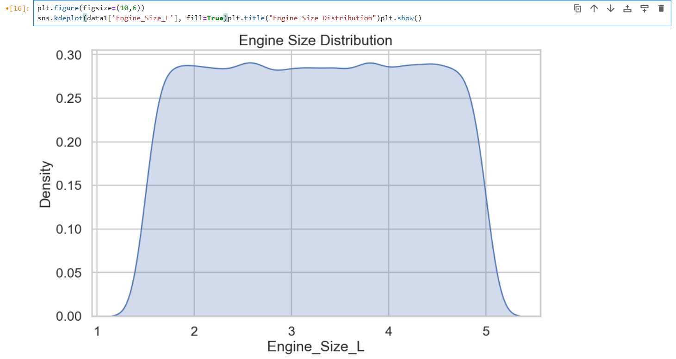
This plot provides a smooth curve showing how engine capacities (in liters) are distributed, helping identify common engine configurations.
Insights
- Most BMW models cluster around mid-range engine sizes.
- The smooth curve indicates the prevalence of certain engine categories over others.
Conclusion:
This EDAV project provides clear insights into BMW’s sales behaviour from 2010 to 2024. The analysis revealed strong model performance, consistent growth in average prices, and noticeable shifts toward modern fuel types. Regional comparisons and distribution patterns highlighted where BMW’s demand is strongest and how customer preferences vary across markets. Overall, the visualizations helped transform the dataset into meaningful insights that reflect BMW’s evolving market position. This project shows how data-driven analysis supports better understanding of sales trends and informed decision-making in the automotive sector.

