Assignment 17.1
K. Shiva Teja
2303A52480
Batch: 44
Task 1: Customer Data Cleaning
Code:
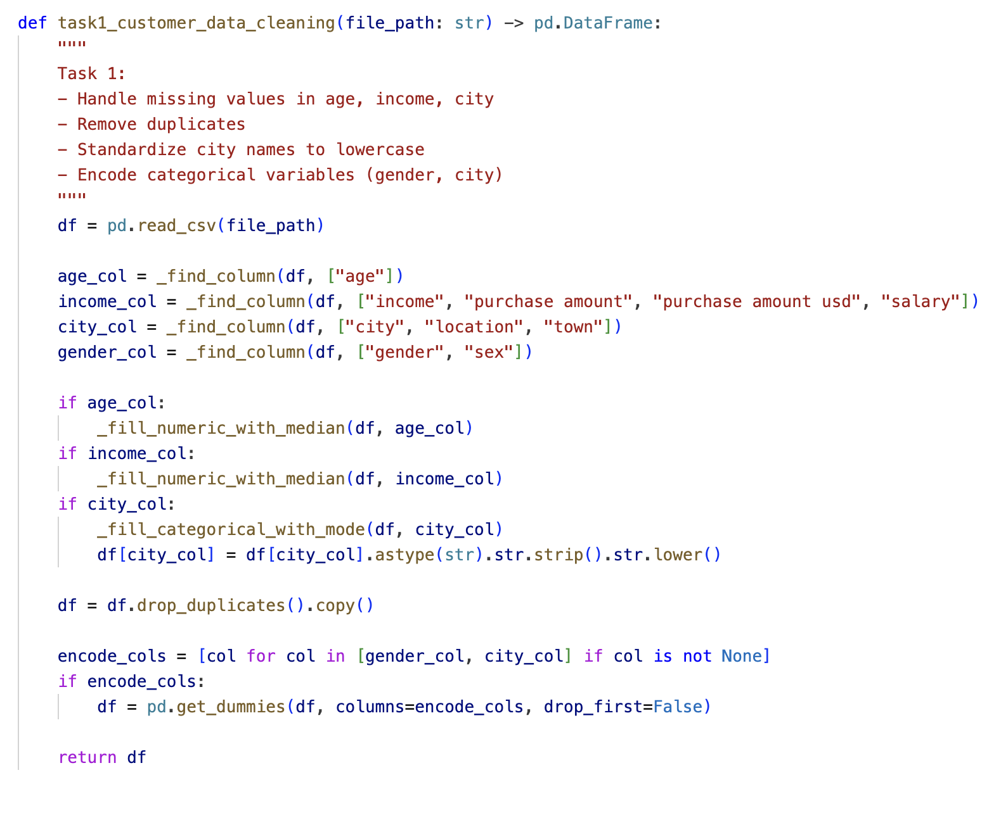
Output:
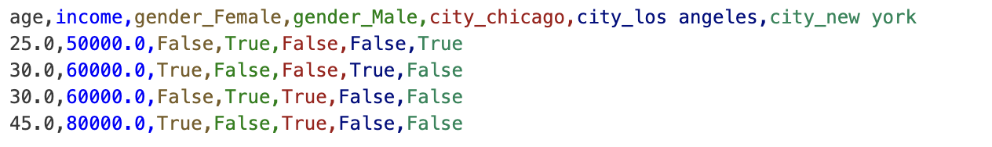
Observation:
Missing values were filled (age and income became numeric values, city gaps were filled), duplicate rows were removed, and city/gender were encoded into separate indicator columns.
Observation: the output is analysis-ready with no raw text categories left for gender/city.
Task 2: Sales Data Preprocessing
Code:
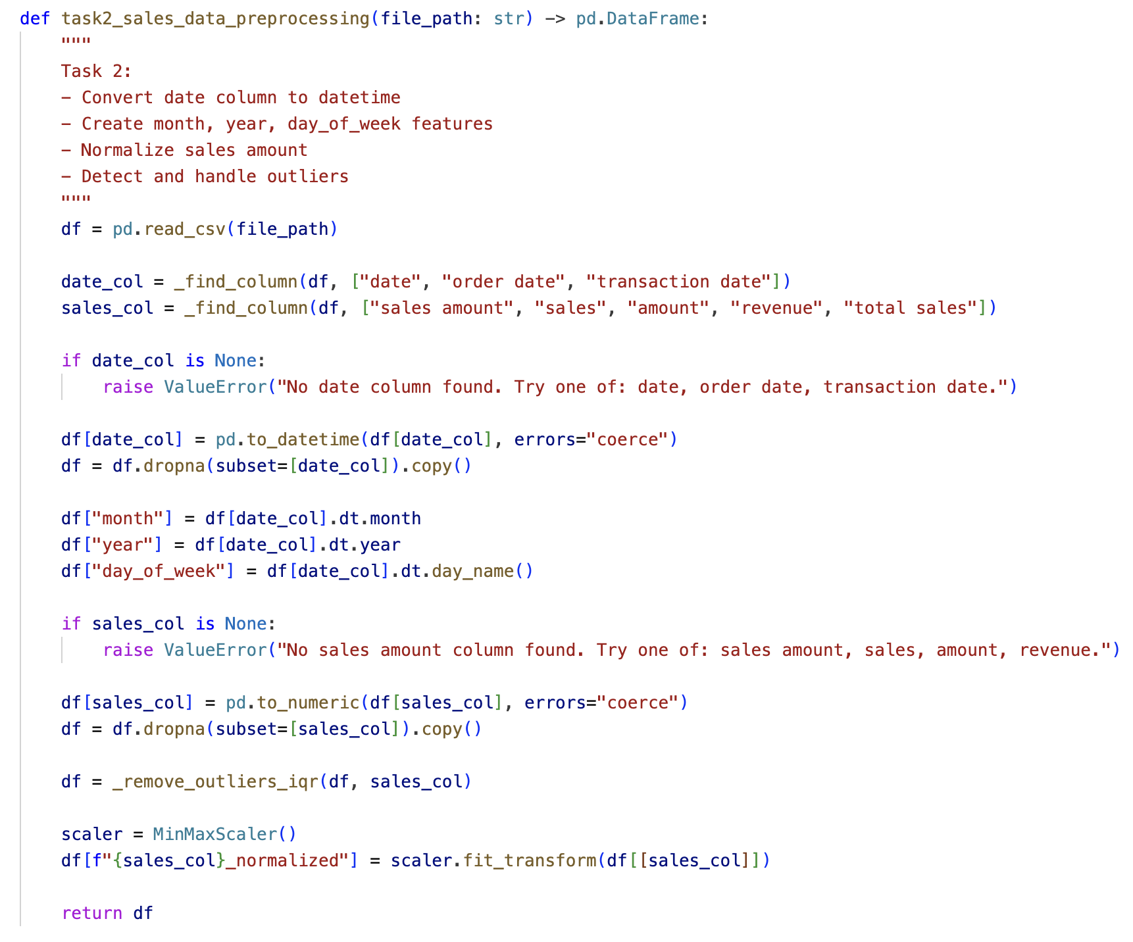
Output:
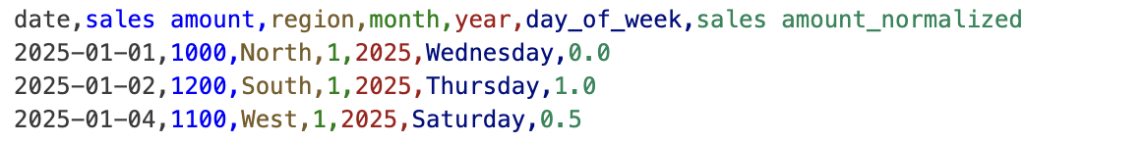
Observation:
Date values were converted and expanded into month, year, and day of week, invalid dates were dropped, extreme sales outliers were removed, and sales were min-max normalized.
Observation: normalization worked as expected (values scaled between 0 and 1), and the high outlier row was excluded.

Task 3: Healthcare Data Preparation
Code: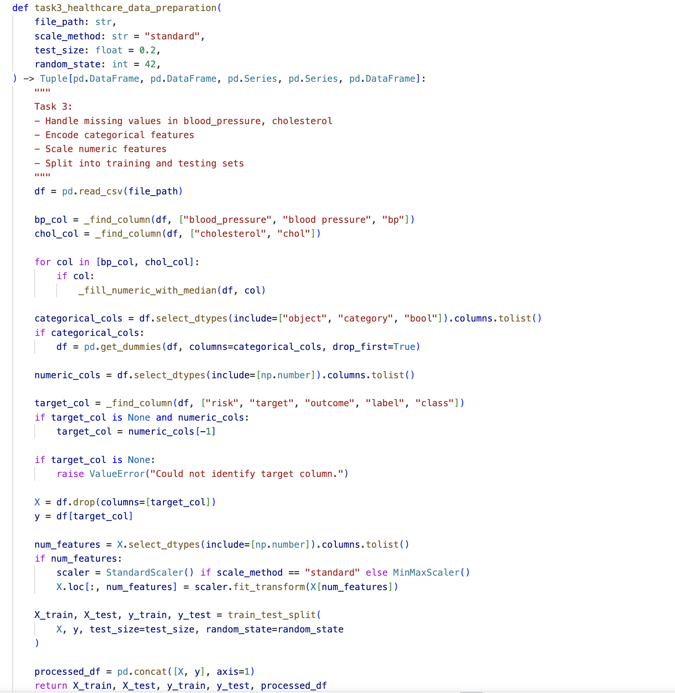

Output:
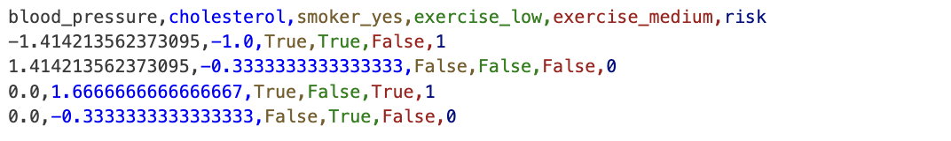

Observation:
Missing blood pressure and cholesterol values were imputed, categorical variables were encoded, and numeric features were scaled (standard scaling).
Observation: scaled features are centred and comparable in magnitude, making the dataset suitable for ML training/testing workflows.

Task 4: Employee Salary Data Preprocessing
Code:
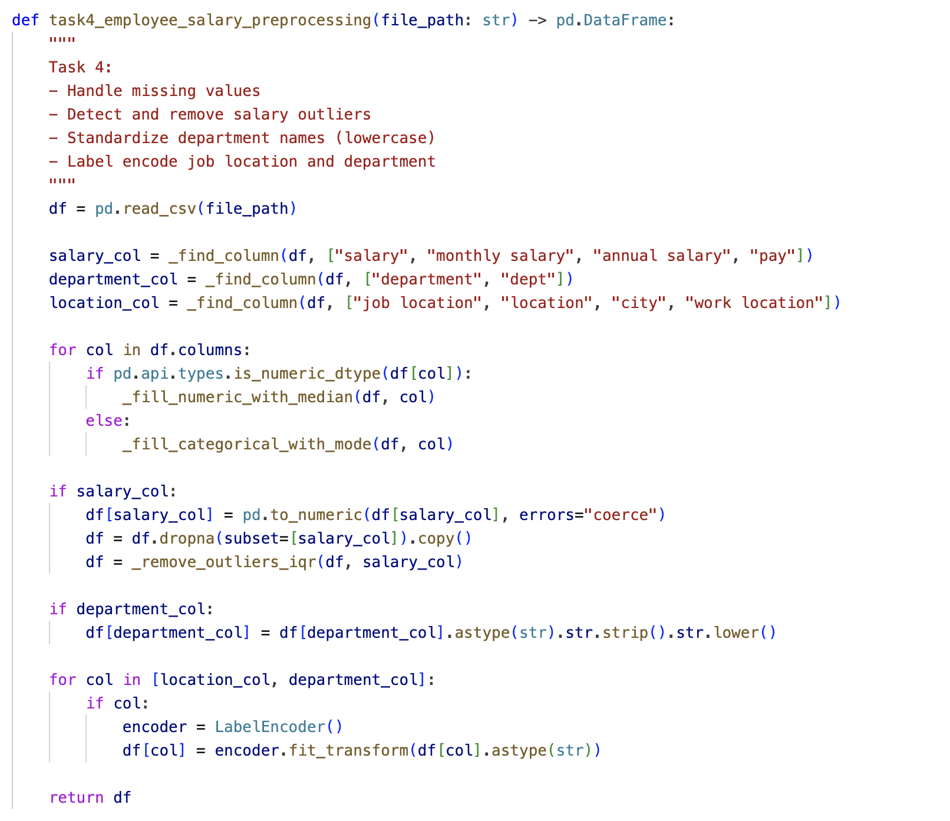

Output:
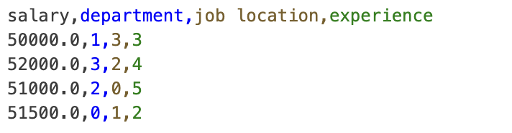

Observation:
Missing values were handled, salary outliers were removed, department text was standardized to lowercase before encoding, and department/location were label-encoded.
Observation: the extreme salary value was removed, and categorical HR fields were converted to numeric format for analytics models.

