Assignment-01
K. Shiva Teja
2303A52480
Batch-44
Task 1: AI-Generated Logic Without Modularization (Prime Number Check Without Functions)
Code:
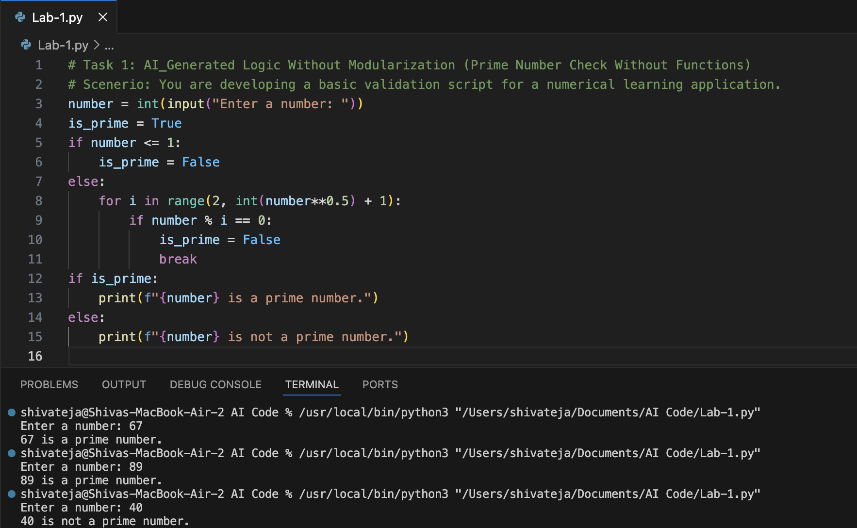
Report: The above code checks if a given number is prime without using functions. It prompts the user for input, checks divisibility from 2 to the square root of the number, and prints whether the number is prime or not. This approach is straightforward but lacks modularity, making it less reusable and harder to maintain for larger applications.

Observation: The code effectively checks if a number is prime by iterating through potential divisors, but lacks modularization which could improve readability and reusability.
Task 2: Efficiency & Logic Optimization (Clean Up)
Code:
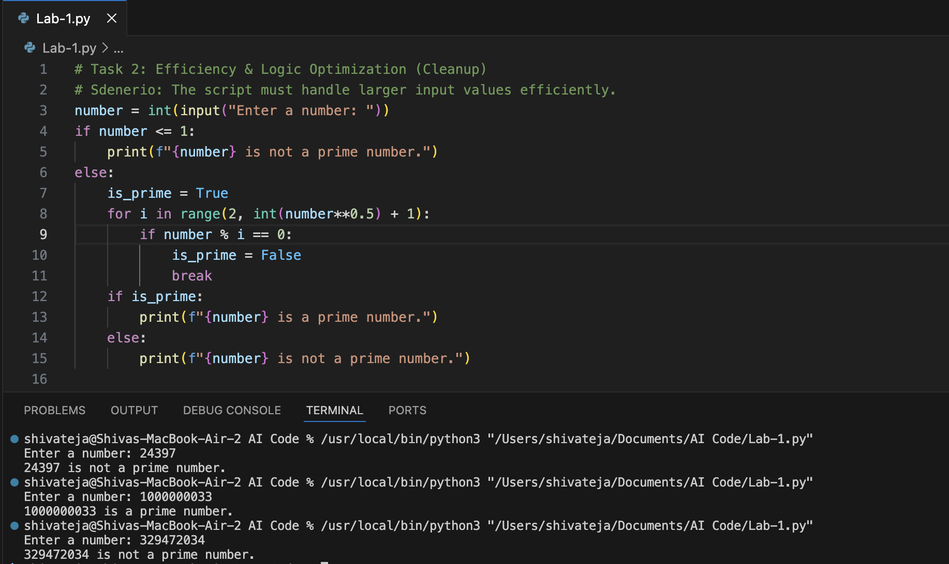

Report: The original code checked for primality by iterating through all numbers from 2 to number-1, which is inefficient for large numbers. The optimized code reduces the number of iterations by only checking up to the square root of the number. This significantly improves efficiency, especially for larger input values, while maintaining the same logical correctness.

Observation: The optimized code reduces the number of iterations by checking divisibility only up to the square root of the input number, significantly improving efficiency for larger values.

Task 3: Modular Design Using AI Assistance (Prime Number checking using Functions)
Code:
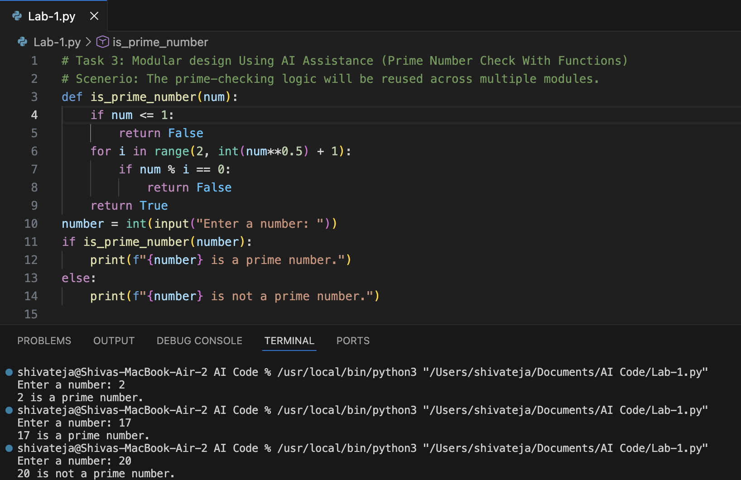

Report: In this task, I created a modular design for checking prime numbers by encapsulating the logic within a function named is prime number. This approach enhances code reusability and maintainability, allowing the prime-checking functionality to be easily integrated into multiple modules or projects without redundancy.

Observation: The function-based approach enhances code reusability and maintainability by encapsulating the prime-checking logic within a function, making it easier to use across multiple modules.
Task 4: Comparative Analysis – With vs Without Functions
Code: 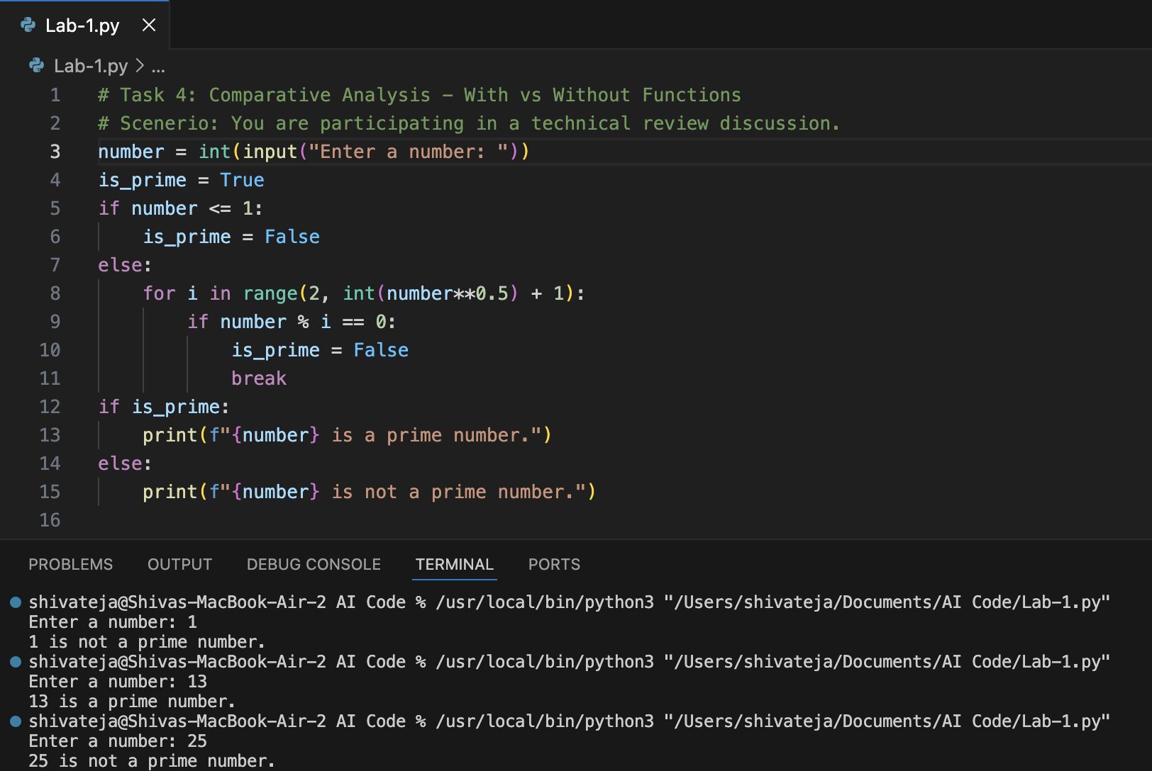

Report: The code without functions is straightforward and easy to understand for small tasks, but it lacks modularity and reusability. Using functions would enhance readability, allow for code reuse, and make it easier to test and maintain, especially as the complexity of the program increases.

Observation: The optimized code reduces the number of iterations by checking divisibility only up to the square root of the input number, significantly improving efficiency for larger values.

Task 5: AI-Generated Iterative vs Recursive Fibonacci Approaches (Different Algorithmic Approaches to Prime Checking)
Code: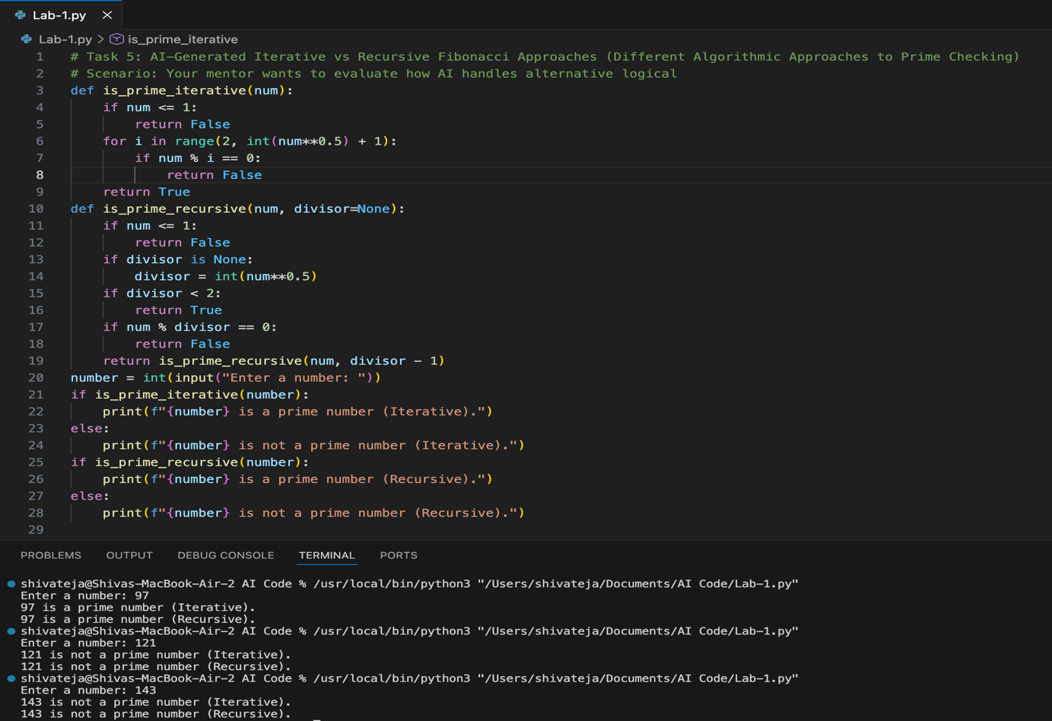
Report: The iterative approach to prime checking uses a loop to test divisibility up to the square root of the number, while the recursive approach reduces the problem size by checking divisibility with decreasing divisors until it reaches the base case, demonstrating two distinct algorithmic strategies for determining primality.
Obervation: Both the iterative and recursive approaches effectively determine if a number is prime, with the iterative method being generally more efficient in terms of memory usage, while the recursive method offers a more elegant and concise solution at the cost of potential stack overflow for large inputs.

