ASSIGNMENT- 20.5
K SHIVATEJA
2303A52480
Batch: 44
Task 1 – Password Storage Vulnerability Check
Prompt:
Generate a Python user registration and login system that stores user credentials (username and password) in a JSON file. Do not use any encryption or hashing for passwords. Keep the implementation simple.
Code:
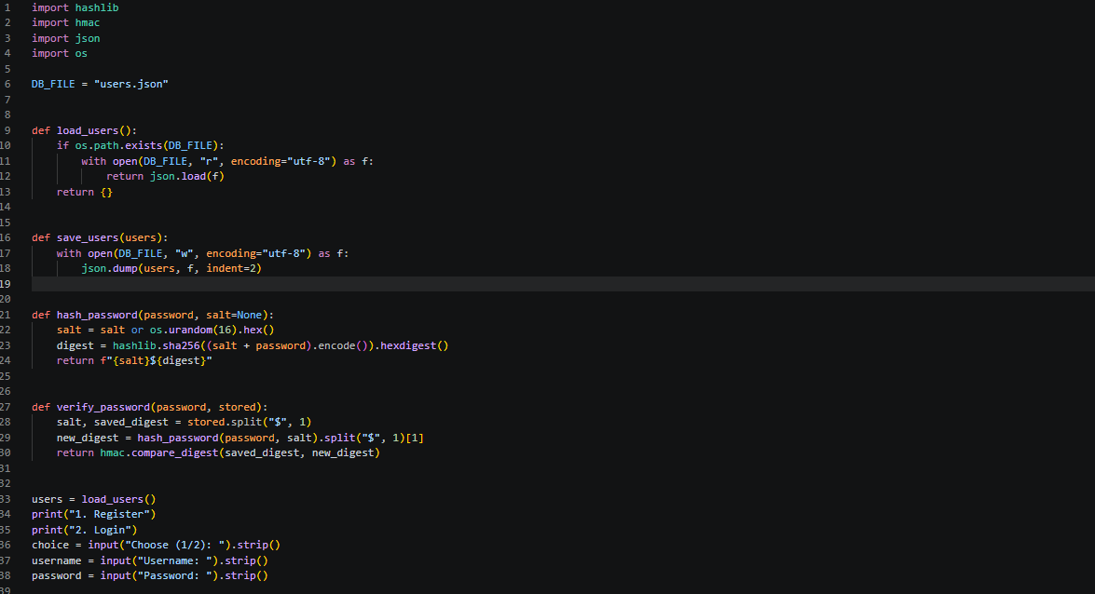
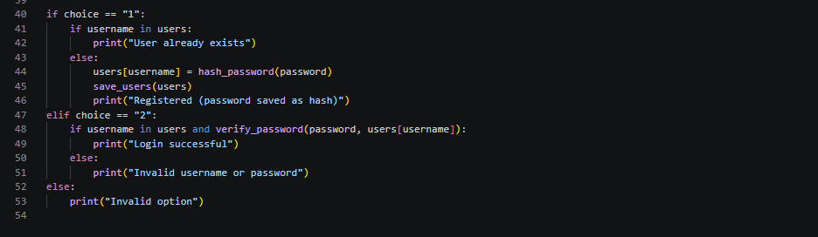
Output:
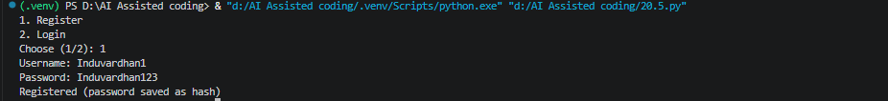
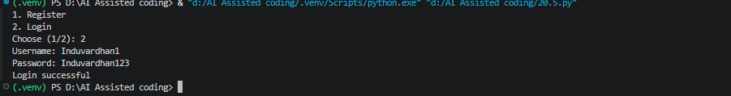
Observation:
The code securely hashes passwords using SHA-256 with a unique salt for each user. The use of hmac.compare_digest prevents timing attacks when verifying passwords. User data is stored in a JSON file, which is simple but not suitable for large applications or production use.

Task 2 – Hardcoded Secrets Detection
Prompt:
Generate a Python script that connects to a public API (like a weather or news API) using an API key. Include the API key directly in the source code and use it to fetch and display data
Code:
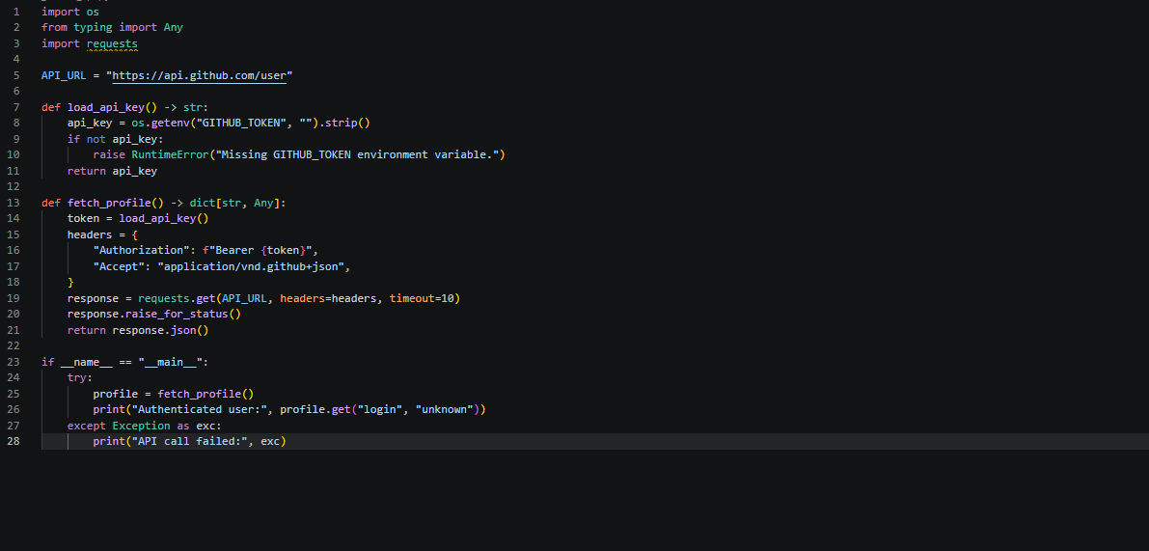
Task 3 – File Upload Security Validation
Prompt:
Generate a basic Flask web application that allows users to upload files to the server. Do not include any validation for file type, file size, or filename security.
Code:
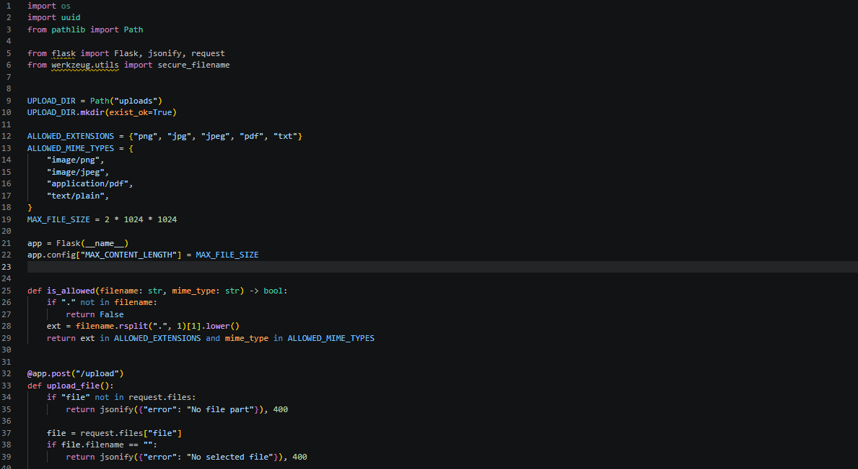
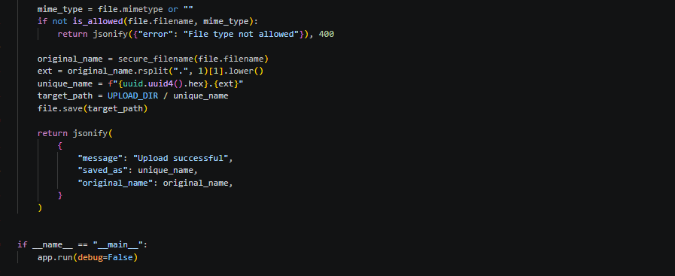
Observation:
This code implements a secure file upload endpoint using Flask. It checks for allowed file extensions and MIME types, limits the maximum file size, and uses secure filenames to prevent directory traversal attacks. Uploaded files are saved with unique names to avoid collisions.

Task 4 – Command Injection Prevention
Prompt:
Generate a Python script that takes user input from the command line and executes a system command using os.system() or subprocess. The user input should be directly passed into the command without validation.
Code:
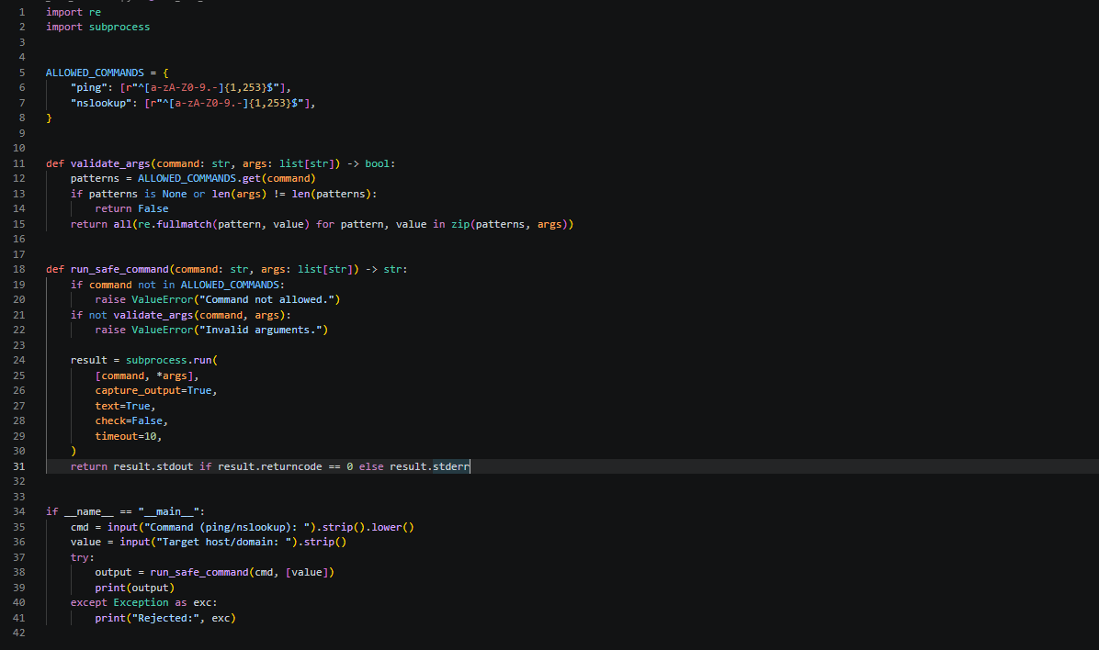
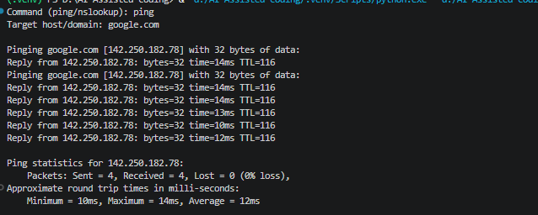

Task 5 – Secure Input Handling in Web Forms
Prompt:
Generate a simple Flask web application with an HTML feedback form that accepts user input (name and message) and displays the submitted data on the webpage without performing any validation or sanitization.
Code:
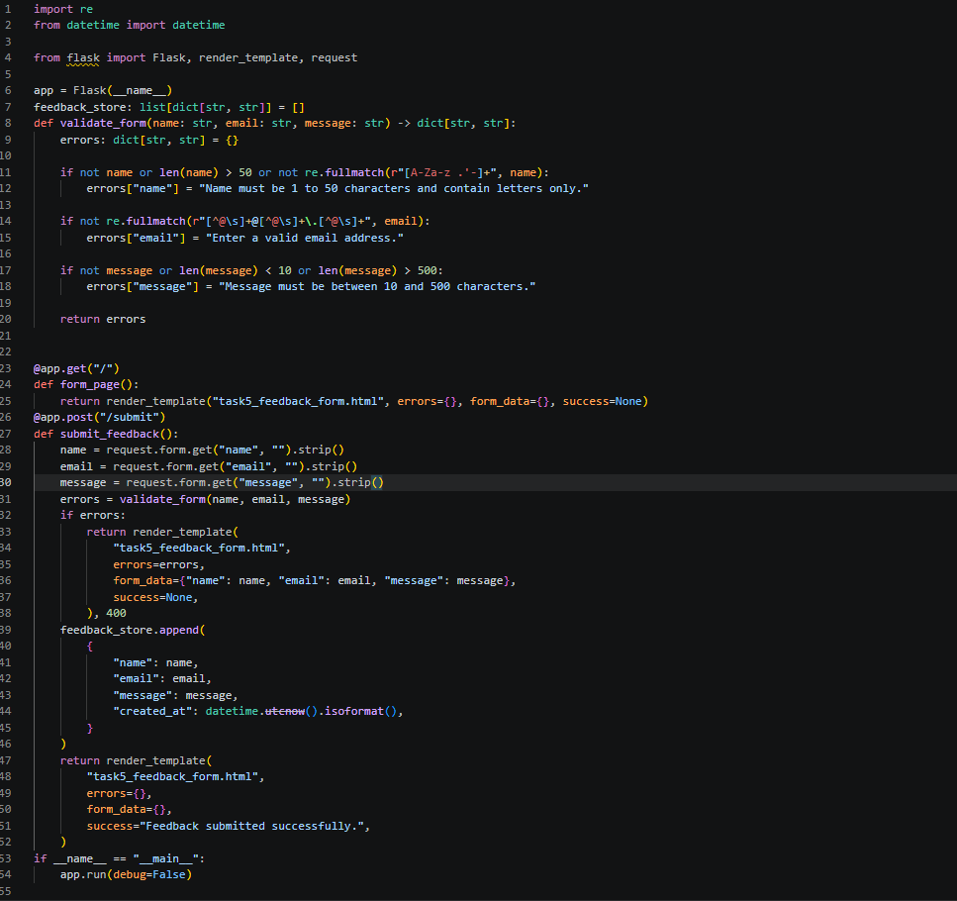
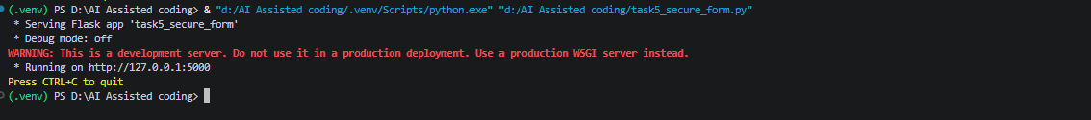
Observation:
This code implements a secure feedback form using Flask. It validates user input for name, email, and message fields to prevent malicious data. The form data is stored in memory with a timestamp. The use of regex ensures that only valid characters are accepted, and the length checks prevent excessively long inputs.

