Assignment 16.4
K. Shiva Teja
2303A52480
Batch: 44
TASK1:
Prompt: Generate SQL CREATE TABLE statements for Instructors, Courses, and Students with primary keys, foreign keys, and proper data types. Keep the schema normalized.
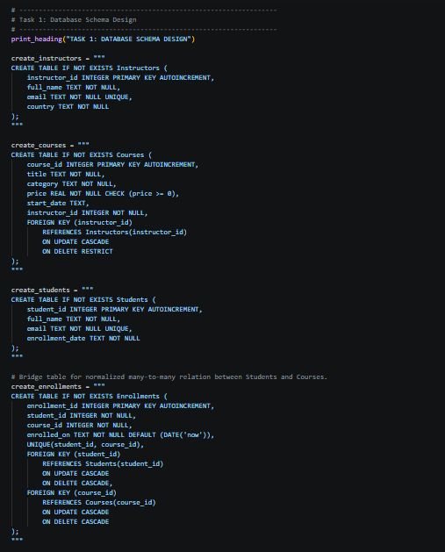

OUTPUT:
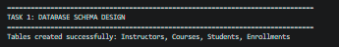
Observation: Tables were created successfully with valid key constraints. A separate Enrollments table was used to model many-to-many student-course relationships, improving normalization and avoiding duplicate data.

Task 2
Prompt: Generate INSERT queries for at least 3 instructors, 4 courses, and 3 students, then verify data using SELECT queries.
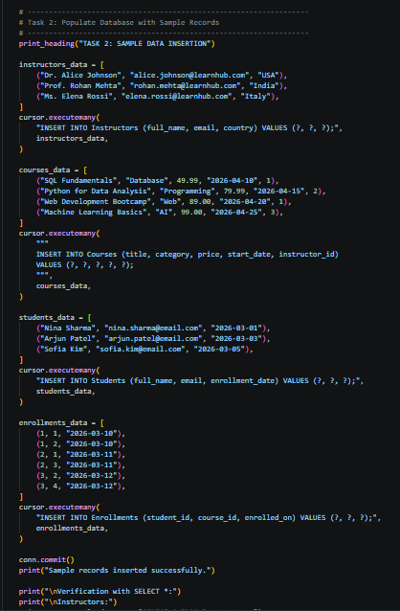
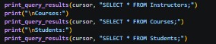

OUTPUT:
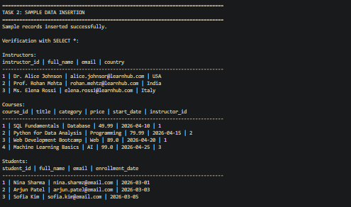
Observation: All sample records inserted without errors. SELECT results displayed all inserted rows correctly for Instructors, Courses, and Students.
Task 3
Prompt: Perform CRUD operations: retrieve all courses, update one student email, delete one course, and verify each change using SELECT.
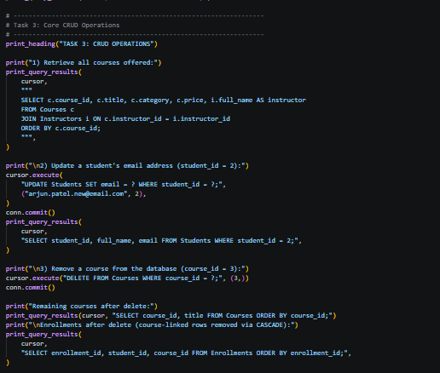
OUTPUT:
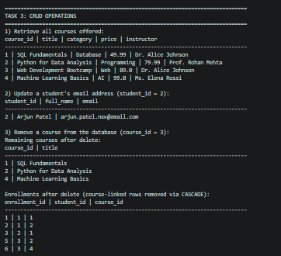
Observation: Course list was retrieved correctly. Student email update reflected immediately. Selected course was deleted successfully, and related enrollment rows were removed through cascading rules with no unintended data loss.
Task 4
Prompt: Create aggregate SQL queries to count enrollments per course and filter courses with enrollments greater than a threshold using GROUP BY and HAVING.
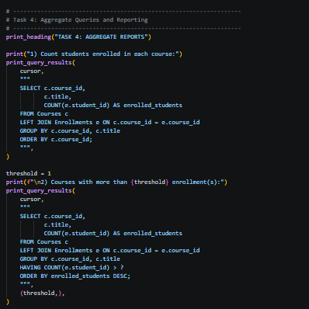

OUTPUT:
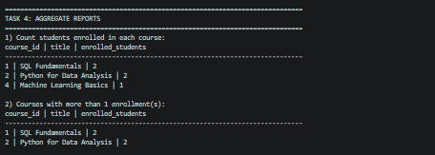
Observation: Aggregate results were accurate. GROUP BY produced per-course counts, and HAVING correctly filtered courses above the given enrollment limit.
Task 5
Prompt: Optimize a query that fetches courses taught by instructors from a specific country using efficient joins and indexing suggestions; compare old and new results.
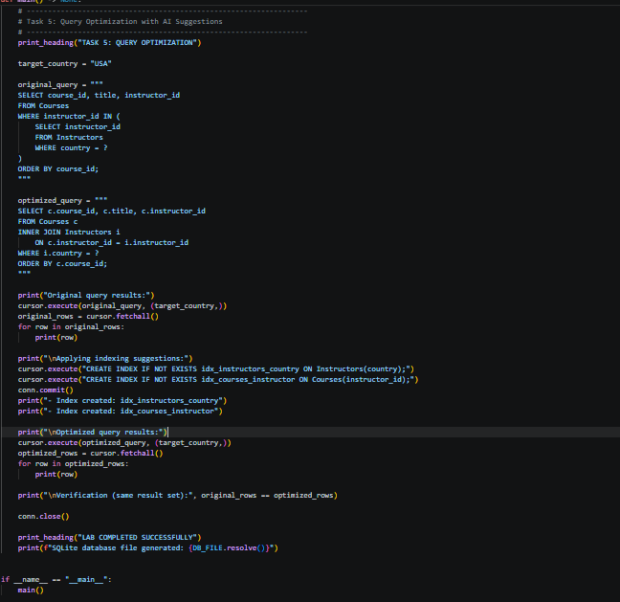
OUTPUT:
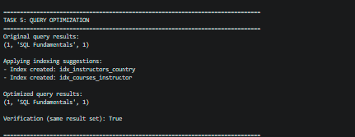
Observation: Optimized JOIN-based query returned the same result as the original subquery version. Suggested indexes improved query design for scalability while preserving correctness (result comparison was True).

