Assignment-5.4
K. Shiva Teja
2303A52480
Batch-44
Task 1:
Prompt GitHub Copilot to generate a Python script that collects
user data (e.g., name, age, email). Then, ask Copilot to add
comments on how to anonymize or protect this data.
Code: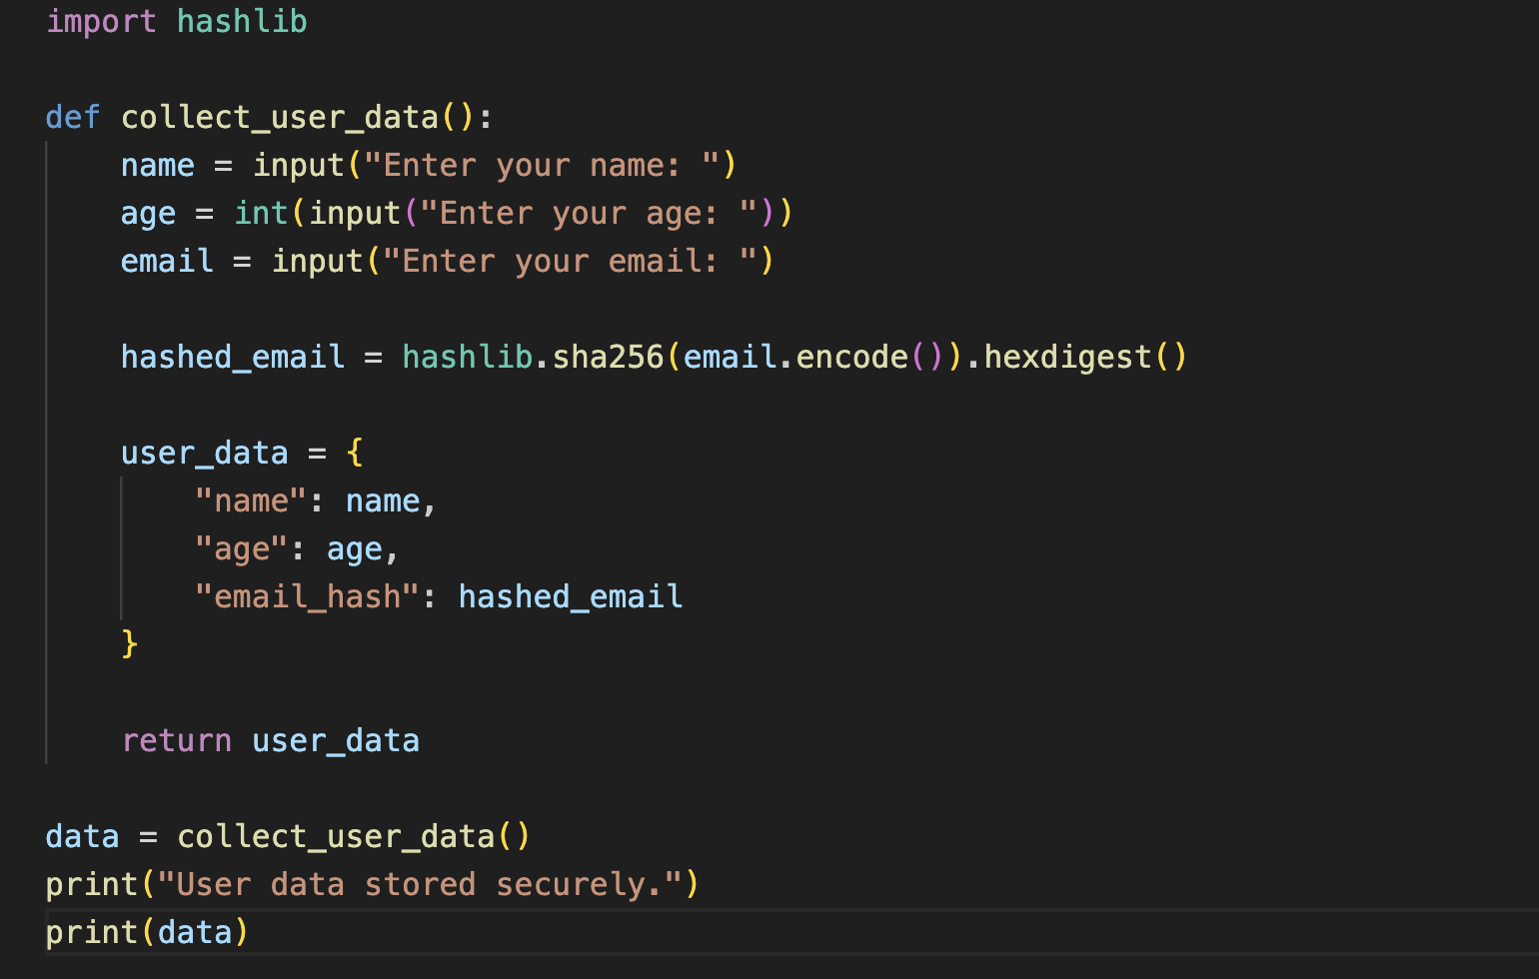
Input: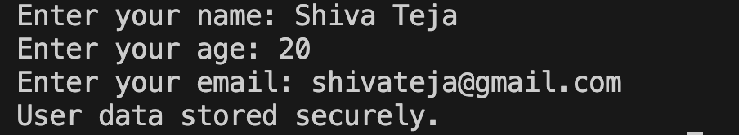
Output:

Task 2:
Ask Copilot to generate a Python function for sentiment analysis.
Then prompt Copilot to identify and handle potential biases in the
data.
Code:
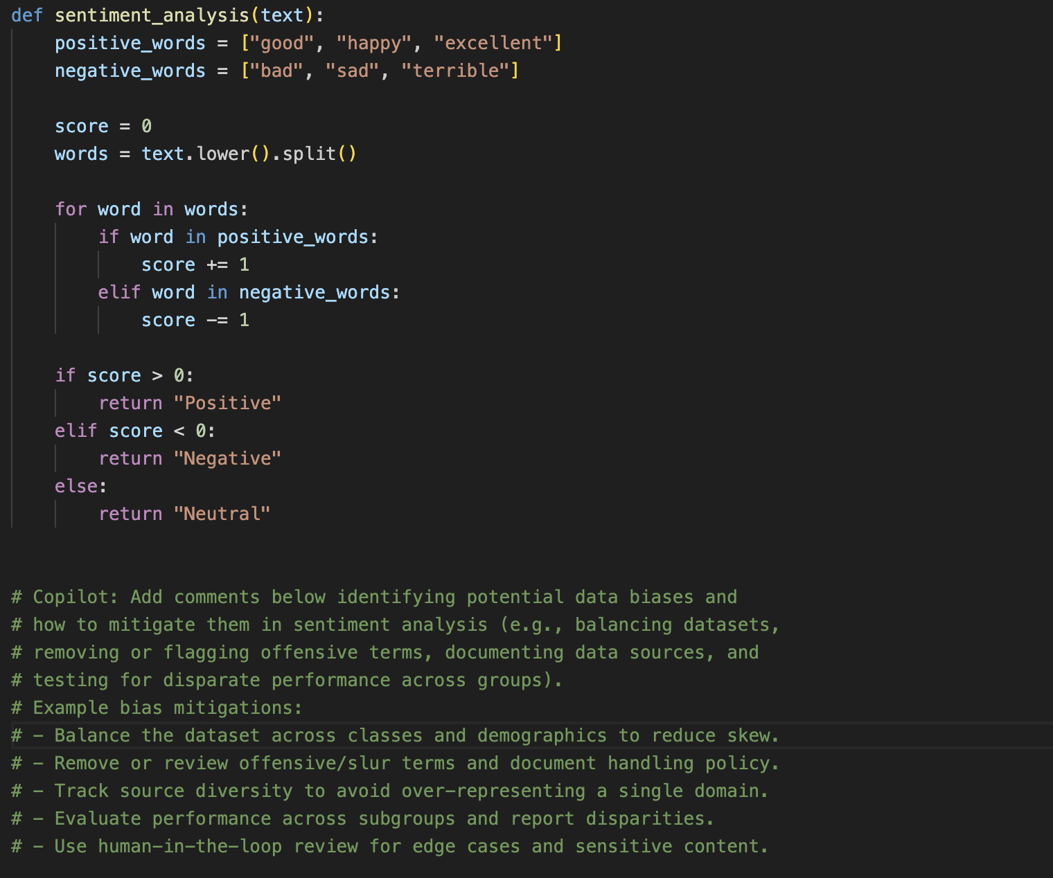
Comments:

Task 3:
Use Copilot to write a Python program that recommends
products based on user history. Ask it to follow ethical guidelines
like transparency and fairness.
Code:
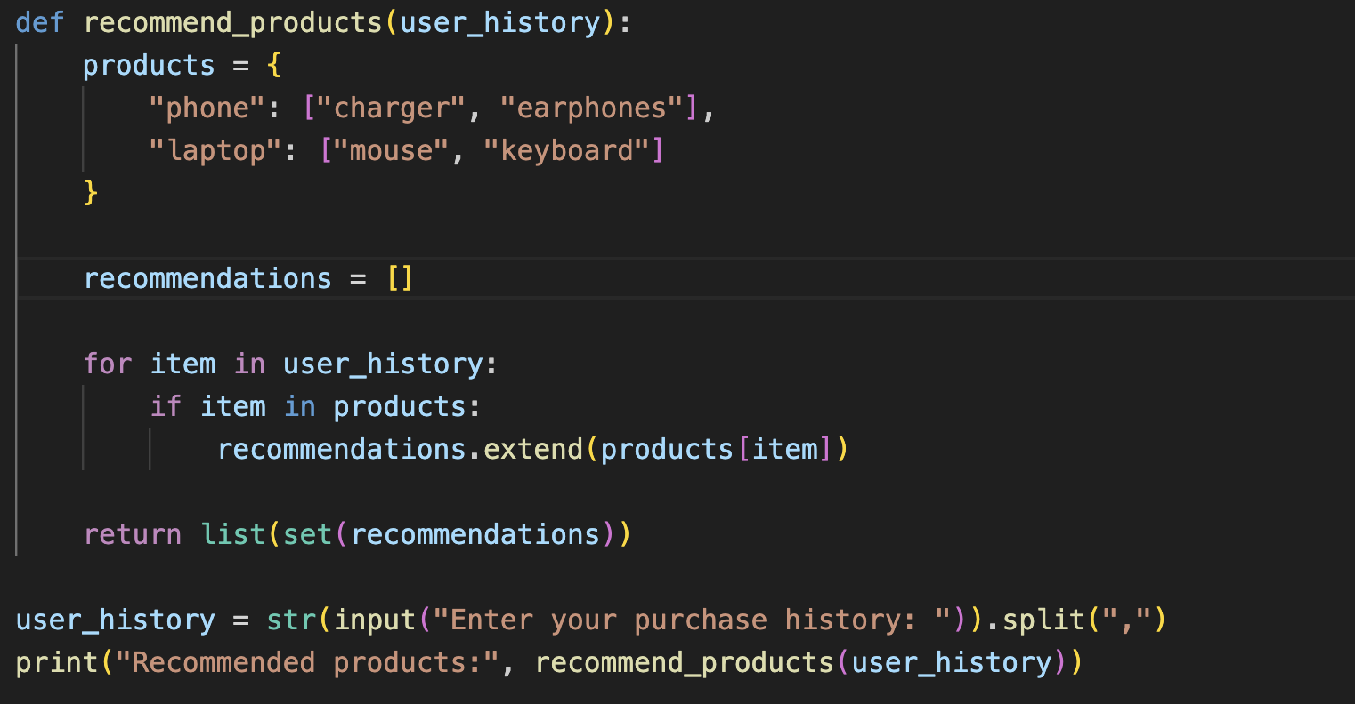
Input 1:
Output 1:

Input 2:
Output 2:

Task 4:
Prompt Copilot to generate logging functionality in a Python web
application. Then, ask it to ensure the logs do not record sensitive
information.

Code:

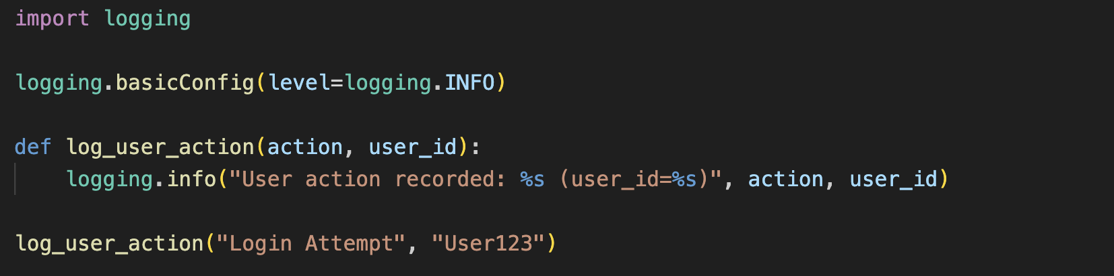

Output:

Task 5:
Ask Copilot to generate a machine learning model. Then, prompt
it to add documentation on how to use the model responsibly
(e.g., explainability, accuracy limits).
Code:
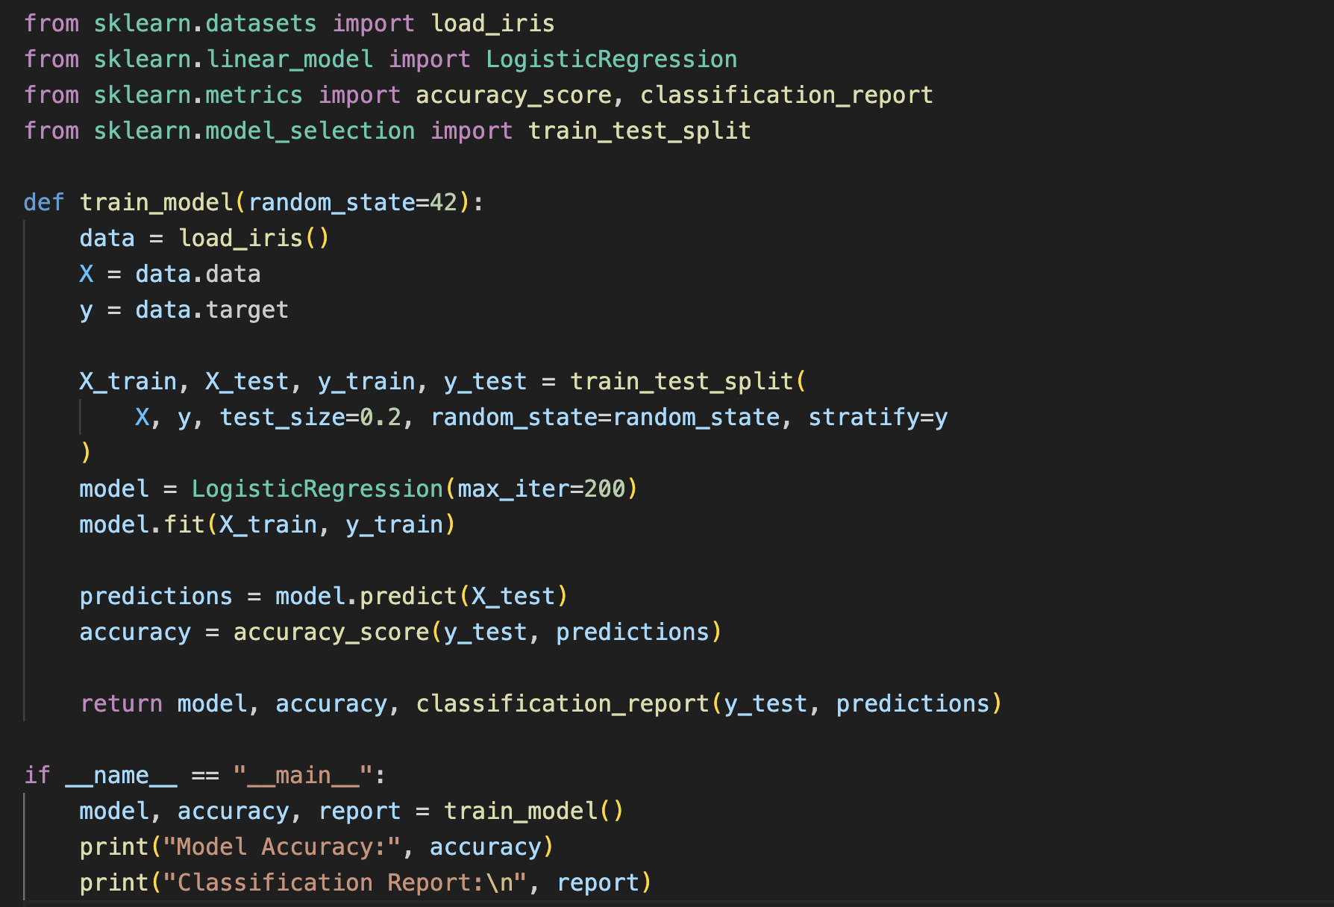

Output:
