Keeper - Website Documentation

By- 2110992079

Shivaksh Sharma

G-19

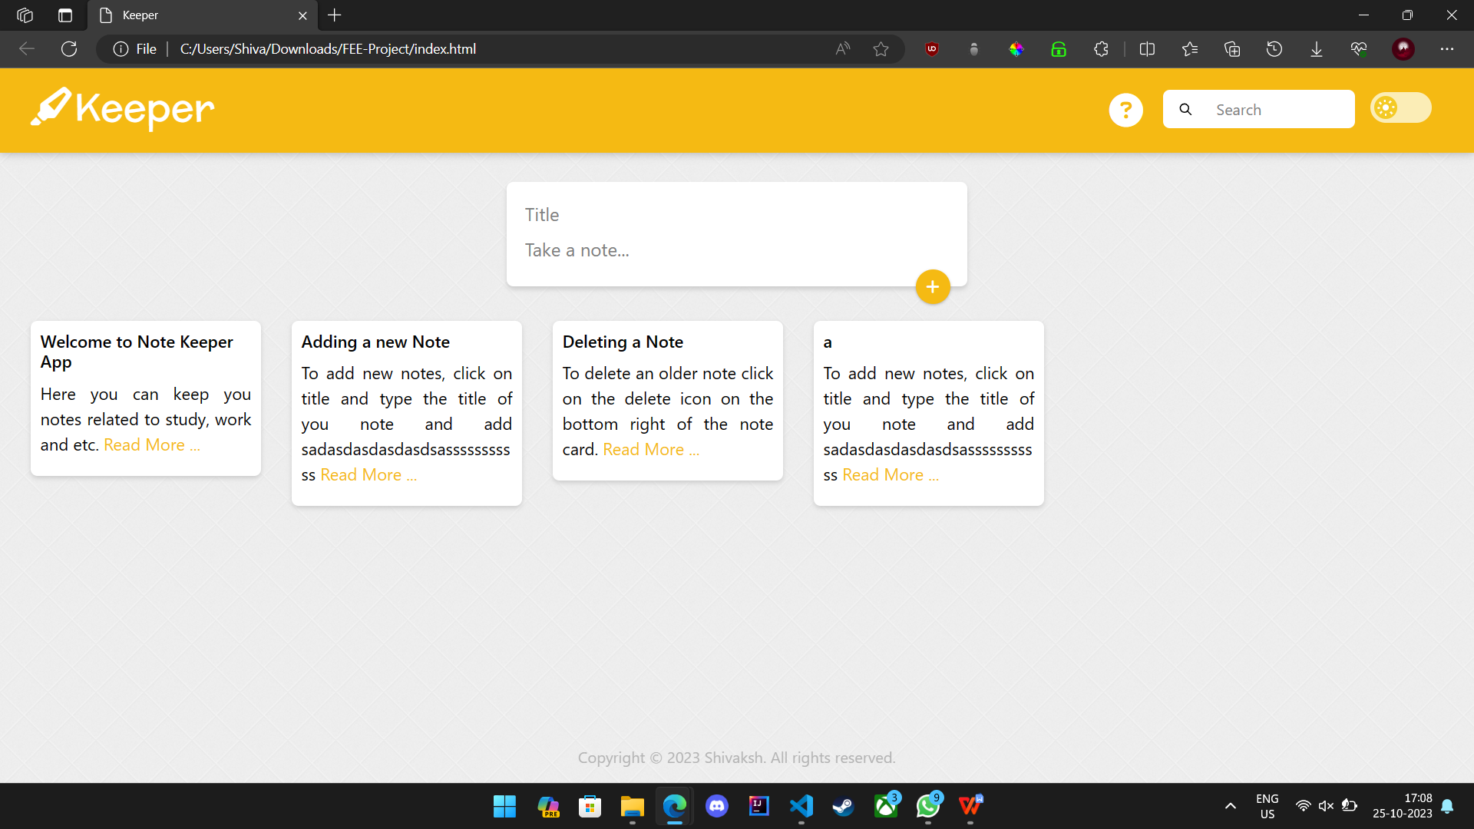

Table of Contents:-

1. Introduction

- 1.1 Purpose

- 1.2 Scope

- 1.3 Audience

2. Getting Started

- 2.1 Accessing Keeper

- 2.2 User Registration

- 2.3 Logging In

3. Features

- 3.1 User-Friendly Interface

4. Note Management

- 4.1 Creating a New Note

- 4.2 Editing and Saving Notes

- 4.3 Organizing Notes

- 4.4 Searching for Notes

5. User Account

- 5.1 User Profile

- 5.2 Security and Privacy

6. **Technical Details**

- 6.1 Technology Stack

- 6.2 Data Storage

7. Troubleshooting

- 7.1 Common Issues and Solutions

8. Conclusion

## 1. Introduction

### 1.1 Purpose

Welcome to the comprehensive documentation for **Keeper**, your go-to web-based note-taking application. This documentation is designed to provide a deep understanding of Keeper's features, functionalities, and how to make the most of the application.

### 1.2 Scope

The documentation covers everything from user registration to advanced note management, technical details, and troubleshooting guidance. By the end of this document, you'll be fully equipped to harness the power of Keeper.

### 1.3 Audience

This documentation is primarily intended for users of Keeper. Whether you're a new user looking to get started or an experienced user seeking advanced tips and insights, this documentation has something for everyone.

## 2. Getting Started

### 2.1 Accessing Keeper

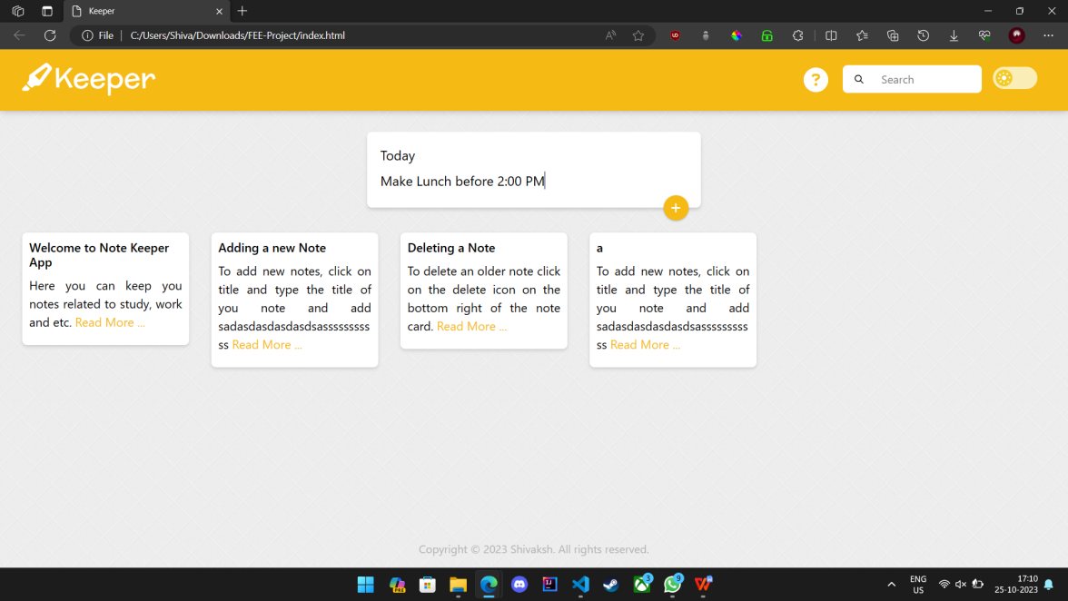

On accessing Keeper, You'll be greeted by our user-friendly interface that makes note-taking a breeze.

### 2.2 User Registration

Before you can start using Keeper, you'll need to create a user account. To register, click the "Sign Up" or "Register" button and provide your:

- Username

- Email Address

- Password

Follow the on-screen prompts to complete the registration process. Keeper takes your privacy and security seriously, so your information is safe with us.

### 2.3 Logging In

Once you have an account, you can log in anytime by clicking the "Log In" button and entering your username and password.

## 3. Features

### 3.1 User-Friendly Interface

Keeper's interface is designed with simplicity and efficiency in mind. The clean layout and intuitive design ensure a user-friendly experience.

## 4. Note Management

### 4.1 Creating a New Note

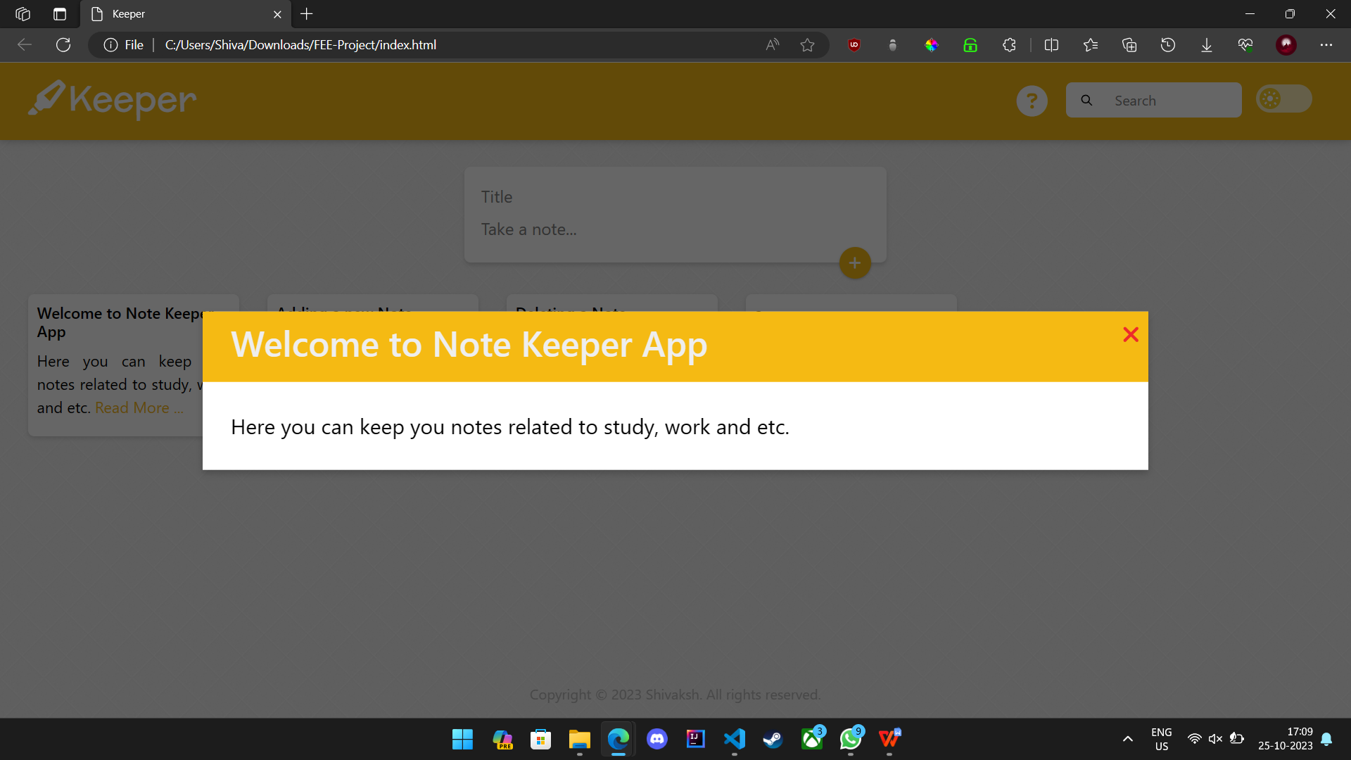

To create a new note, click the "New Note" button. This opens a blank canvas where you can provide a title and start typing your content. Keeper automatically saves your notes, ensuring you never lose your work.

### 4.2 Editing and Saving Notes

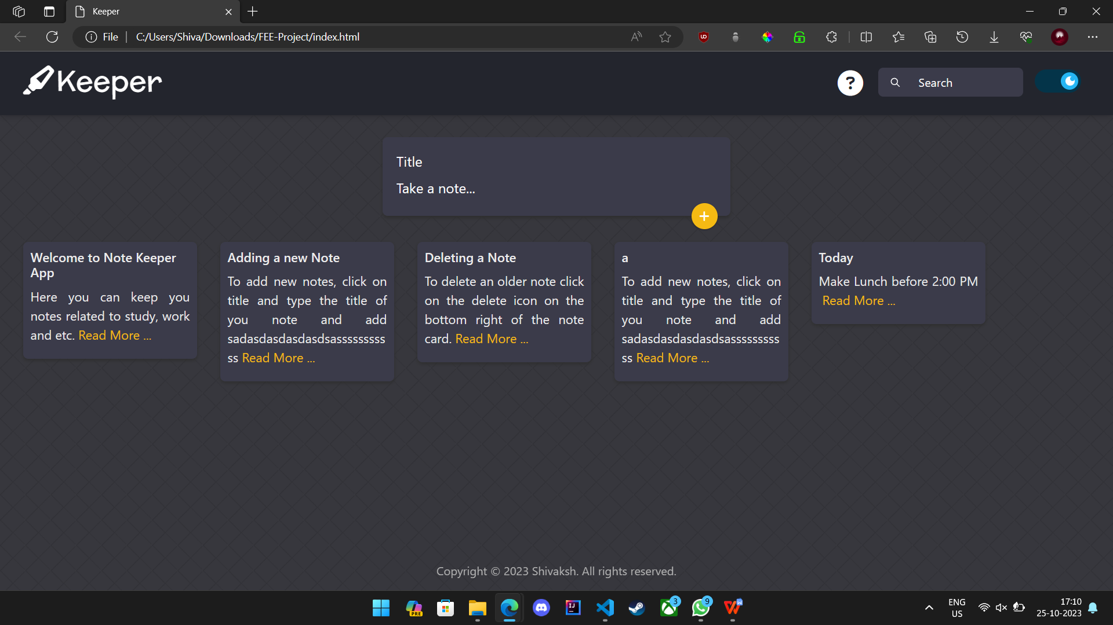

Editing is a breeze with Keeper. Click on the title or content of an existing note, make your changes, and simply click the "Save" button. Your edits are instantly saved, without any extra steps.

### 4.3 Organizing Notes

Stay organized by creating folders and attaching tags to your notes. The "Organize" menu offers easy management of your folders and tags. Keep your notes sorted and accessible.

### 4.4 Searching for Notes

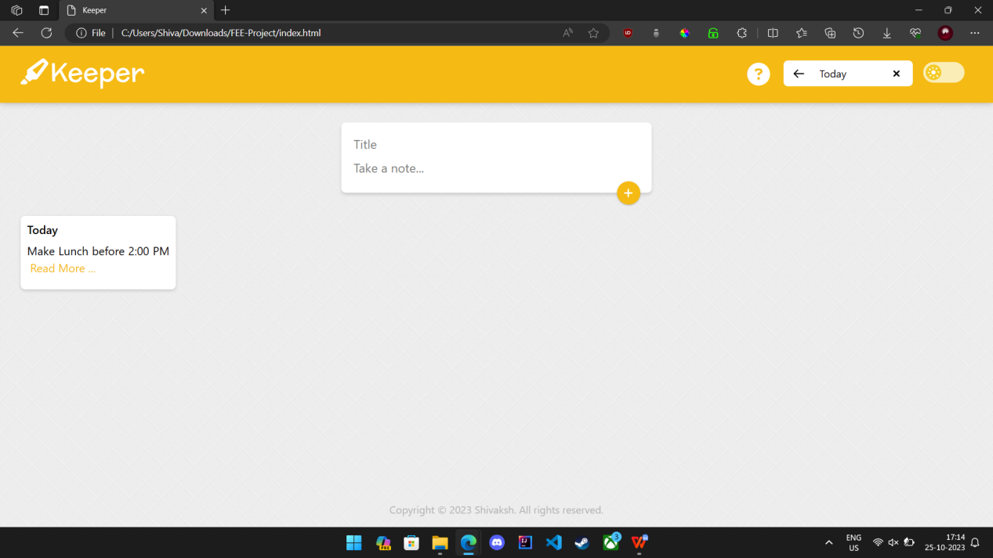

In Keeper, finding specific notes is a snap. Utilize the search bar to search by title, content, or tags. The search function quickly locates your notes, even in extensive collections.

## 5. User Account

### 5.1 User Profile

Your user profile is your personal space in Keeper. Here you can:

- Update personal information

- Change your password

- Customize your account settings

### 5.2 Security and Privacy

At Keeper, we prioritize your data's security and privacy. We employ industry-standard encryption protocols to protect your information and adhere to best practices to ensure data integrity and confidentiality.

## 6. Technical Details

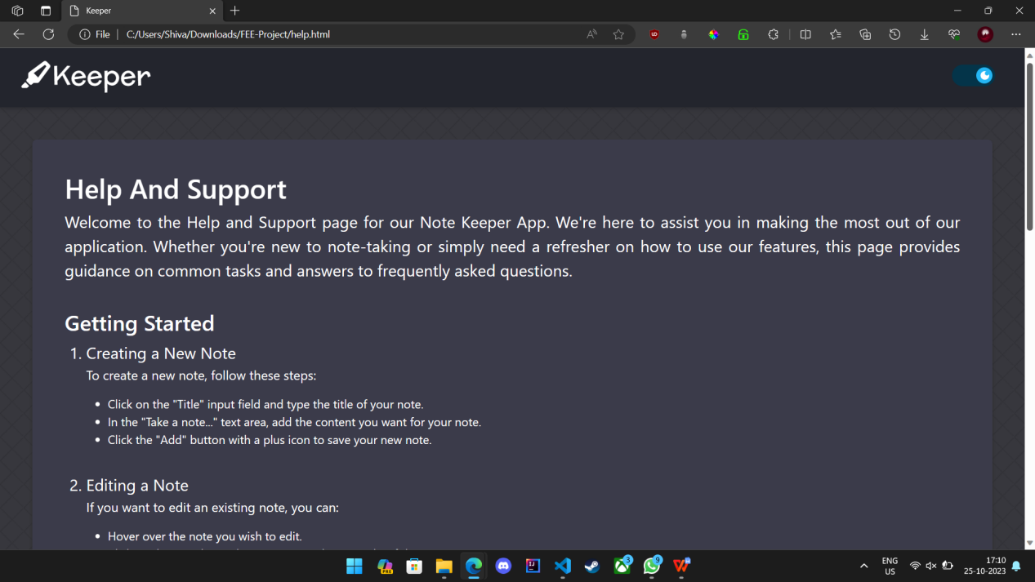

### 6.1 Technology Stack

Keeper is built using modern web technologies, including:

- HTML

- CSS

- JavaScript

On the backend, we use (mention the backend framework and version), and data is stored securely using (mention the database system).

### 6.2 Data Storage

Keeper ensures the safe storage of your notes and personal data. Our data storage system is designed to be reliable, robust, and highly available.

## 7. Troubleshooting

### 7.1 Common Issues and Solutions

If you encounter any problems while using Keeper, consult our troubleshooting guide. It covers common issues and provides step-by-step solutions to help you resolve them quickly.

## 8. Conclusion

Thank you for choosing Keeper as your trusted note-taking solution. This documentation equips you with the knowledge you need to make the most of Keeper's powerful features. Whether you're new to note-taking or a seasoned pro, Keeper is here to enhance your productivity and creativity.

Happy note-taking with Keeper! If you have any questions or need further assistance, don't hesitate to contact our support team.